Task 3 RECONNAISSANCE
Date of allotment: 5/10/2026
Date of completion: 9/10/2026
Deadline: 9/10/2026 (5days)
Basic steps
- Know about your target: use social media platforms to gain basic information about the target, like what type of organisation, how many members, place, etc
We can use social media platforms like Instagram, LinkedIn, Twitter( Now X), etc In to gain some information
- The information I got using Social media Platforms like Instagram, LinkedIn, and Twitter(X) and Facebook

- Instagram: screenshot
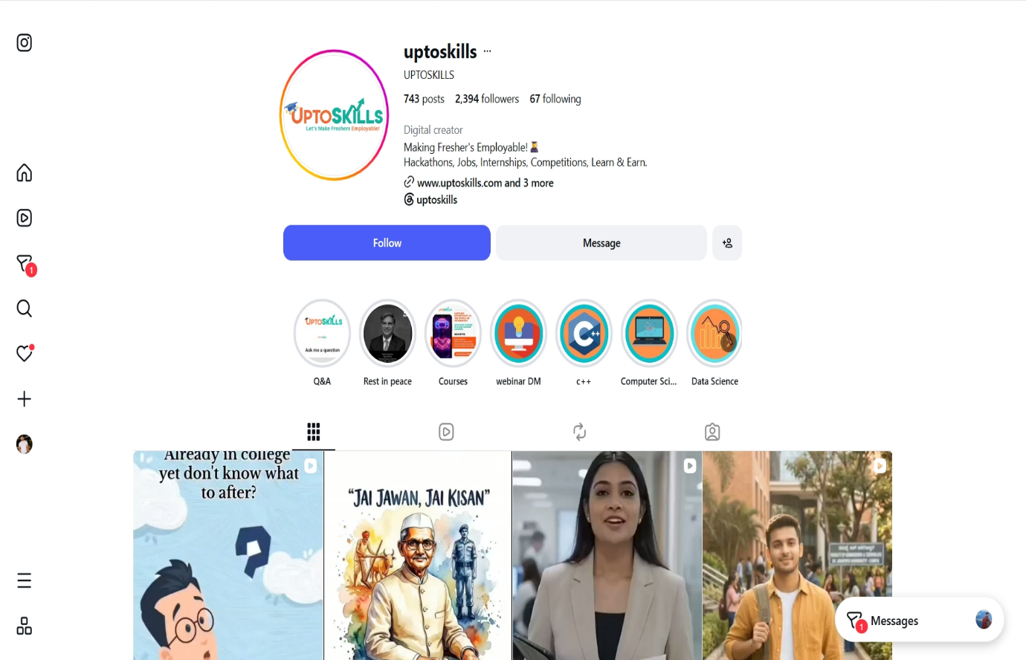
- In the following Screenshot of the Insta page of the, as you can see Only 743 posts and 2394 followers and 67 following and in the bio it is written: Making Freshers Employable Hackathons, Jobs, Internships, Competitions, Learn & Earn. Domain name and etc www.uptoskills.com and 3 more

- LinkedIn screenshot:
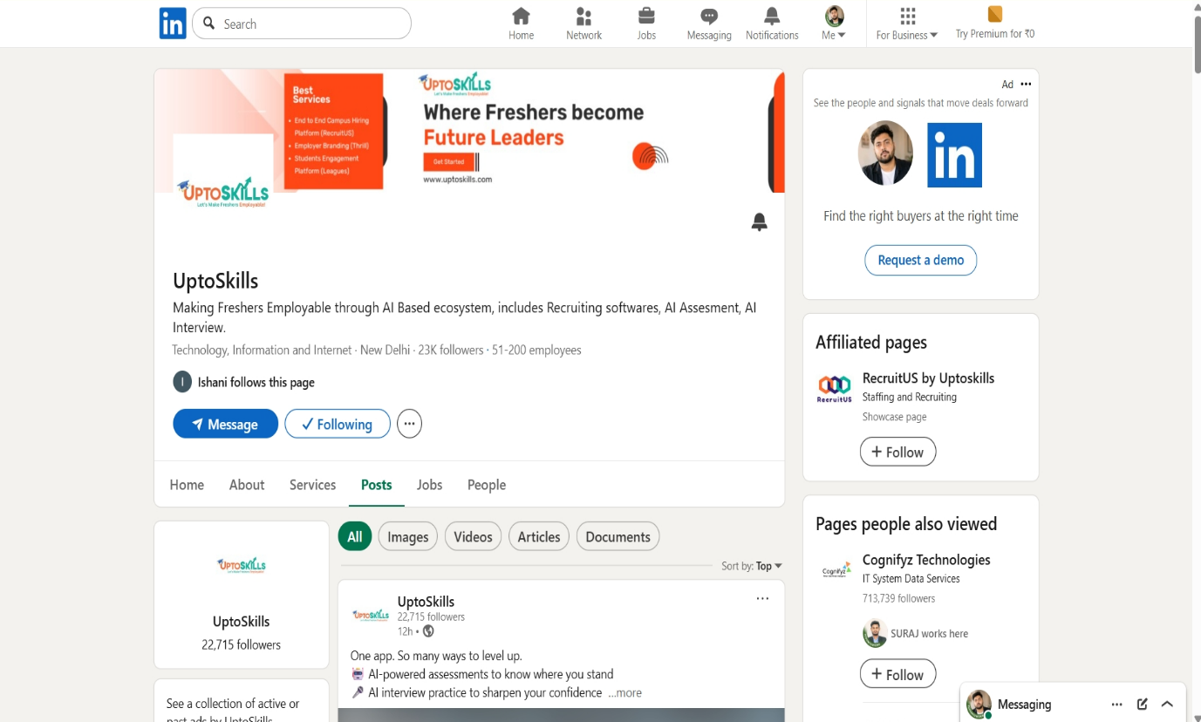

- In the following screenshot of the LinkedIn as you can see in the bio written Making Freshers Employable through Al Based ecosystem, includes Recruiting softwares, Al Assesment, Al Interview.
- Technology, Information and Internet
- Address: New Delhi
- 23K followers . 51-200 employees
Overview
Imagine a world where every fresher walks into their first job, not with fear, but with confidence.
Where colleges don't just graduate students, but nurture employable talent.
Where corporates don't waste months hiring-but discover the right candidates effortlessly.
At UptoSkills, we are making this world a reality.
We are India's Al-powered ecosystem for hiring, engagement, and employer branding-connecting
colleges, candidates, and corporates like never before.
For Corporates: Save time, money, and effort with Al assessments, proctoring, and interviews that ensure
skill-first, bias-free hiring. Build your employer brand across campuses nationwide.
For Colleges: Get dashboards and insights to prepare students, host competitions, and track employability
like never before.
For Freshers: Learn, practice, earn recognition through hackathons, badges, and challenges, and step into
interviews job-ready and confident.

edunet

And what makes UptoSkills different?
We are not just a platform-we are a movement with one mission:
"Let's Make Freshers Employable."
Because talent deserves to be seen.
Because opportunity should be real.
Because every spark deserves its chance to shine.
UptoSkills - One stop solution for Colleges, Candidates & Corporates.

People

A digital ecosystem, where skills meet opportunities.
Website

ntes

https://uptoskills.com/
Phone
7417269505
Industry
Technology, Information and Internet

>

Company size
51-200 employees
907 associated members @
Founded
2016
Specialties
Generic Skill Development Courses, Technical Course, Mechanical Engineering Courses, Soft Skills Trainings,
Personality Development, Mock Interview, Resume Writing, Development, Trainings, Academic
Infrastructure Development, E Learning Courses, Placement Services, Internships, Summer Training, In
House Training, Technical Conferences, Technical Workshops, Online Assessment, Code Fest, hackathon,
and Competition

Locations (1)
Primary
New Delhi, IN

- Twitter(X) screenshot:
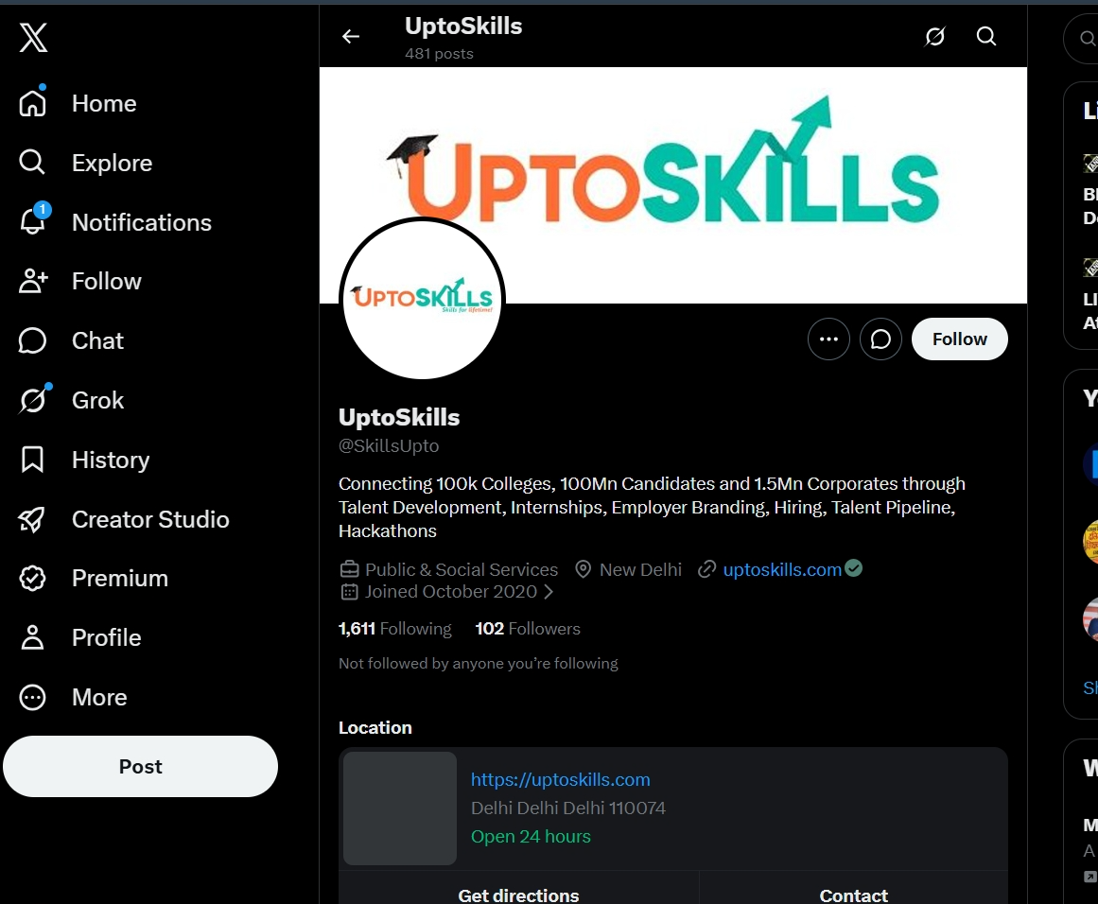
- In the following screenshot of the Twitter (X) as you can see in the bio written Connecting 100k Colleges, 100Mn Candidates and 1.5Mn Corporates through Creator Studio Talent Development, Internships, Employer Branding, Hiring, Talent Pipeline, Hackathons
- Public & Social Services
- Address: New Delhi
- Joined in Twitter(X) Joined October 2020
- Delhi Delhi Delhi 110074
- Domain Name: https://uptoskills.com

- Facebook screenshot:
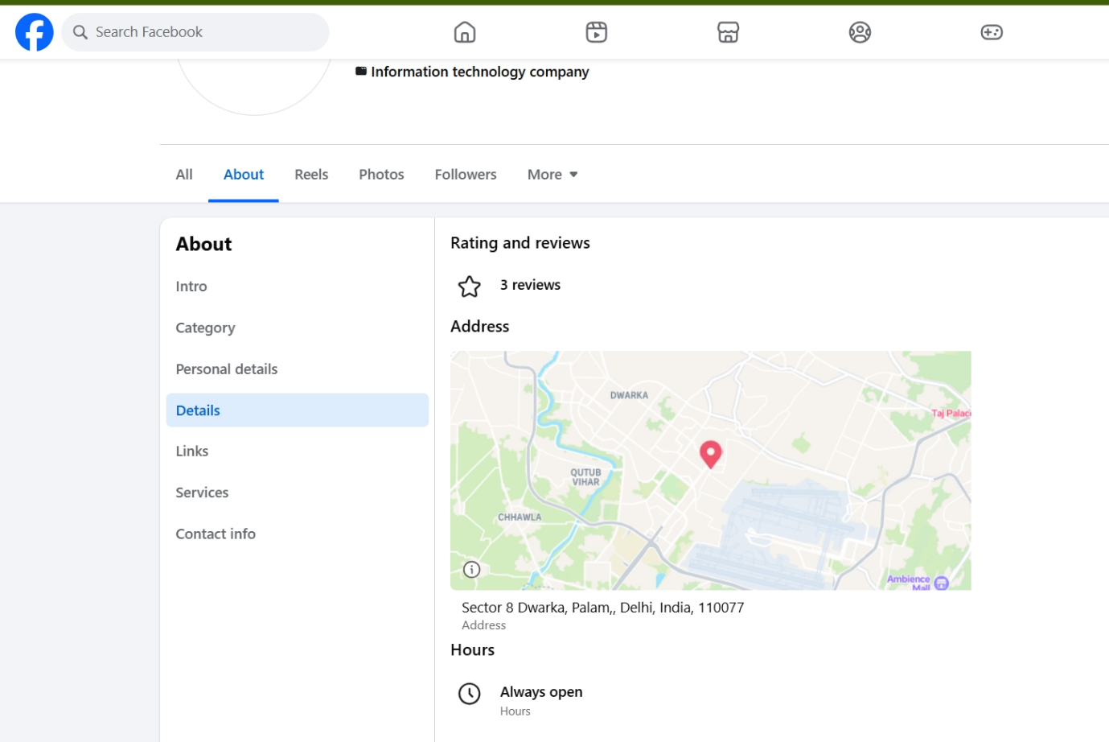
- In the following screenshot of the Facebook
- Address: Sector 8 Dwarka, Palam, Delhi, India, 110077
- Information technology company

- Using NSLOOKUP and Hacking search engines
i)Nslookup
ii)Shodon
iii) Censys
This can show some more information about the target machines, ip address, sometimes open ports and many more.
What is NSLookup?
- NSLookup (Name Server Lookup) is a command-line tool used to query DNS (Domain Name System) information.
- It helps find the IP address associated with a domain name, such as example.com.
- It can retrieve different DNS records, including A, MX, NS, CNAME, TXT, and SOA records.
- It can perform reverse DNS lookups, finding the hostname associated with an IP address.
- In cybersecurity reconnaissance, NSLookup is used to gather basic DNS information about an authorized target.

1)Nslookup Web page tool screenshot
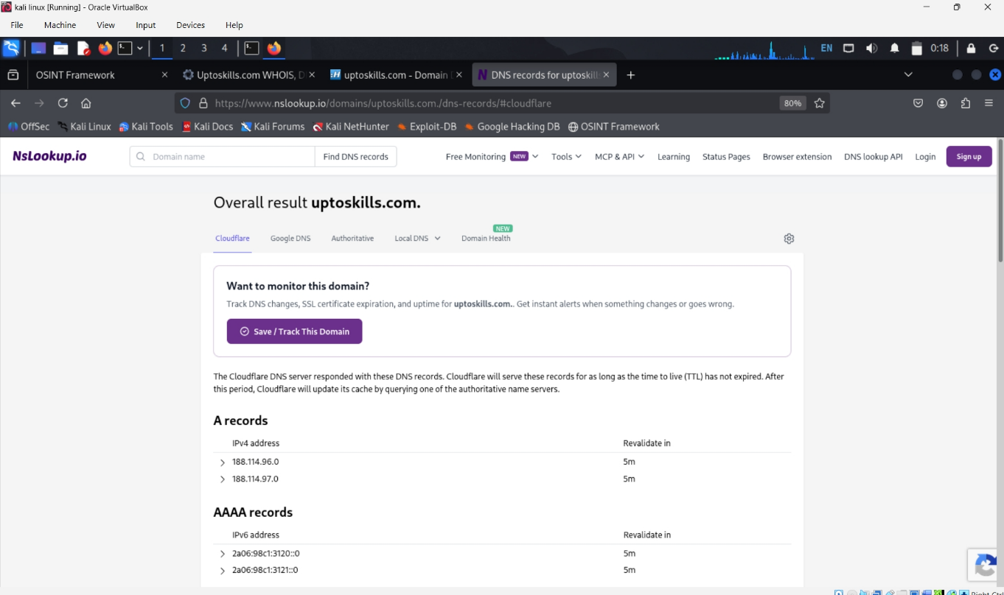
- What is an NSLookup Webpage Tool?
- An NSLookup webpage tool is an online tool that allows users to perform DNS lookups through a web browser.
- It can find the IP address of a domain name without requiring command-line tools.
- It can retrieve different DNS records, such as A, MX, NS, CNAME, TXT, and SOA records.
- It can perform reverse DNS lookups to find the domain/hostname associated with an IP address.
- In cybersecurity reconnaissance, it can be used to collect basic DNS information about a target domain with proper authorization.

    - Nslookup terminal screenshot
- nslookup uptoskills.com: This command is used to find the IP of a domain.
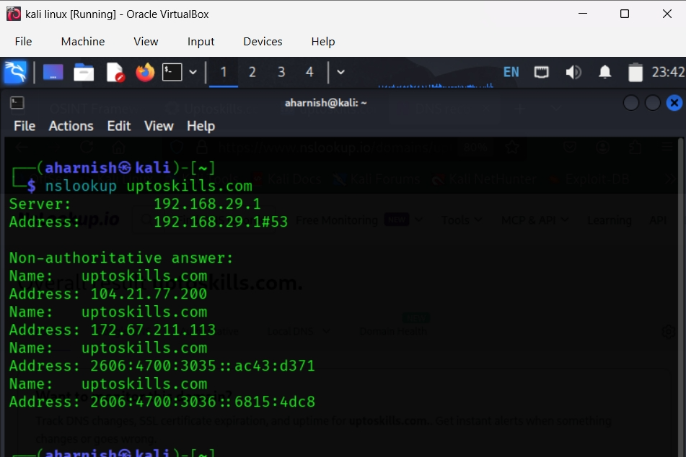

- In the following screenshot of (nslookup uptoskills.com)
- Non-authoritative answer: The “Non-authoritative answer” means your DNS resolver is relaying cached info, not directly from the authoritative DNS server.
- Server: 192.168.29.1
- Address: 192.168.29.1#53
- Name: uptoskills.com - domain name
- Address: 104.21.77.200 - ipv4
- Name: uptoskills.com - domain name
- Address: 172.67.211.133 - ipv4
- Name: uptoskills.com - domain name
- Address: 2606 :4700 : 3035 :: ac43 : d371 - ipv6
- Name: uptoskills.com
- Address: 2606:4700 : 3036 :: 6815: 4dc8 - ipv6

    - nslookup -type=A uptoskilss.com (ipv4 -Address)-screenshot
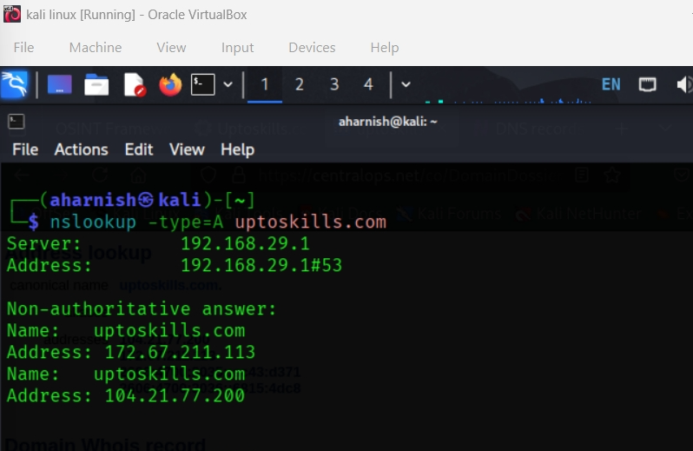

- In the following screenshot as you can see the domain name and ipv4 address are present
- Non-authoritative answer: The “Non-authoritative answer” means your DNS resolver is relaying cached info, not directly from the authoritative DNS server.
- Name: uptoskills.com
- Address: 172.67.211.113
- Name: uptoskills.com
- Address: 104.21.77.200

    - nslookup -type=AAAA uptoskilss.com (ipv6 -Address)-screenshot
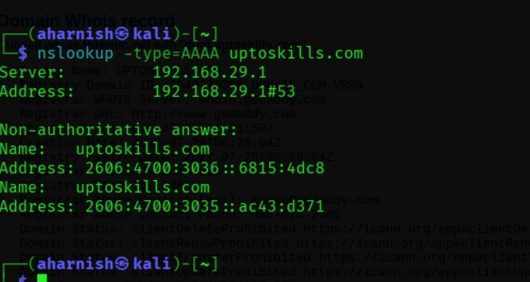
- In the following screenshot as you can see the domain name and ipv6 address are present
- Non-authoritative answer: The “Non-authoritative answer” means your DNS resolver is relaying cached info, not directly from the authoritative DNS server.
- Name: uptoskills.com
- Address: 2606:4700 : 3036 :: 6815: 4dc8
- Name: uptoskills.com
- Address: 2606:4700 : 3035 :: ac43 : d371

    - nslookup -type=MX uptoskills.com screenshot (This command is used to find MX record mail servers)

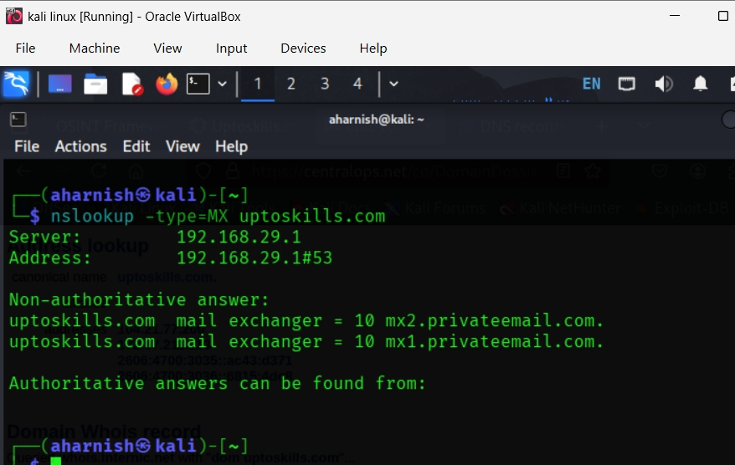

- In the following screenshot you can see the output
- Non-authoritative answer: The “Non-authoritative answer” means your DNS resolver is relaying cached info, not directly from the authoritative DNS server.
- The domain has two mail servers configured: mx2.privateemail.com, mx1.privateemail.com.

    - nslookup -type=NS uptoskills.com screenshot (This command is used for (Find NS records (authoritative name servers).
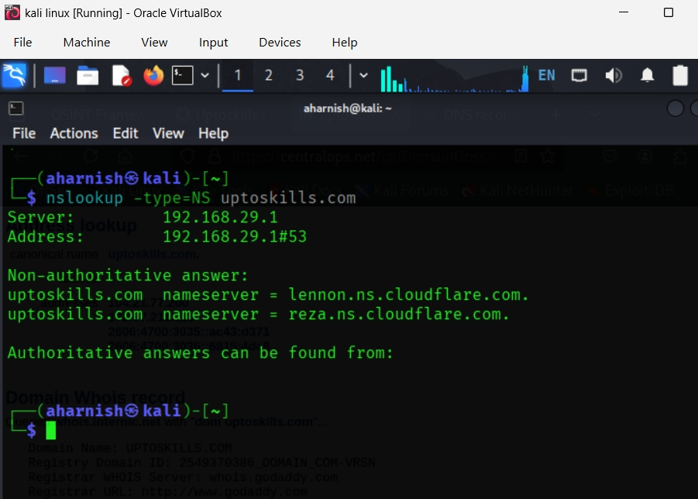
- In the following screenshot you can see the name of the servers.
- uptoskills.com nameserver = lennon. ns. cloudflare.com.
- uptoskills. com nameserver = reza. ns. cloudflare. com.

    - nslookup -type=TXT uptoskills.com screenshot
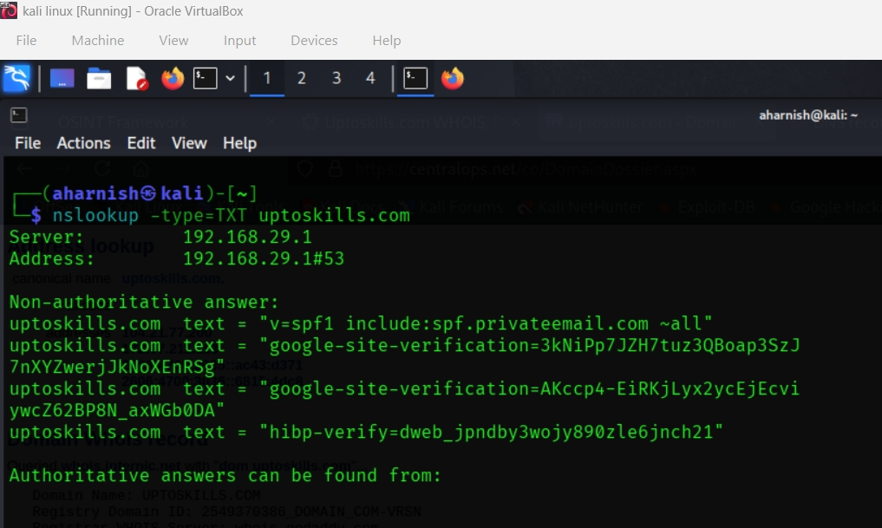

- In the following screenshot you can see the TXT data containing SPF, Google Verification, HIBP verification A TXT record in DNS is a type of resource record that allows domain administrators to store arbitrary text information associated with their domain.
- SPF helps prevent email spoofing and phishing. In the screenshot (SPF: v=spf1 include:spf.privateemail.com ~all)
- Google verification ensures the domain owner can manage analytics, indexing, and other Google services. In the screenshot (Google Site Verification: google-site-verification=3kNiPp7JZH7tuz3QBoap3SzJ7nXYZwerjJkNoXEnRSg) (google-site-verification=AKccp4-EiRKjLyx2ycEjEcviywcZ62BP8N_axWGbODA)
- HIBP verification shows the domain owner is monitoring for compromised accounts. In the screenshot of (HIBP Verification: hibp-verify=dweb_jpndby3wojy890zle6jnch21)

    - nslookup -type=CNAME uptoskills.com screenshot
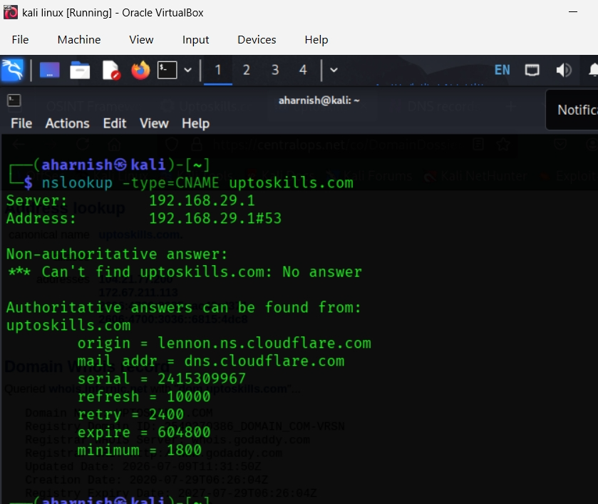

- In the following screenshot you can see the CNAME= Canonical Name Record records, It’s a type of DNS record that maps one domain name (an alias) to another domain name (the “canonical” or true name).
- Instead of pointing directly to an IP address (like an A record does), a CNAME points to another hostname.
- Your lookup for CNAME records of uptoskills.com shows that there is no CNAME configured for the root domain. That’s why you see:
*** Can't find uptoskills.com: No answer
Instead, the output falls back to showing the SOA (Start of Authority) record, which contains administrative details about the domain’s DNS zone:
- Origin → lennon.ns.cloudflare.com (primary authoritative nameserver)
- Mail addr → dns.cloudflare.com (administrator’s contact, written with a dot instead of @)
- Serial → 2415309967 (version number of the zone file; increments when DNS records are updated)
- Refresh → 10000 seconds (how often secondary servers should check for updates)
- Retry → 2400 seconds (how long to wait before retrying if refresh fails)
- Expire → 604800 seconds (time limit before secondary servers discard the zone if no updates)
- Minimum → 1800 seconds (default TTL for records in this zone)
What this means
- Since no CNAME exists, the domain doesn’t alias to another hostname.
- The SOA record confirms Cloudflare is managing DNS for uptoskills.com.
- These values are important for DNS replication and stability across the internet.

    - nslookup -type=SOA uptoskills.com (Find SOA record)
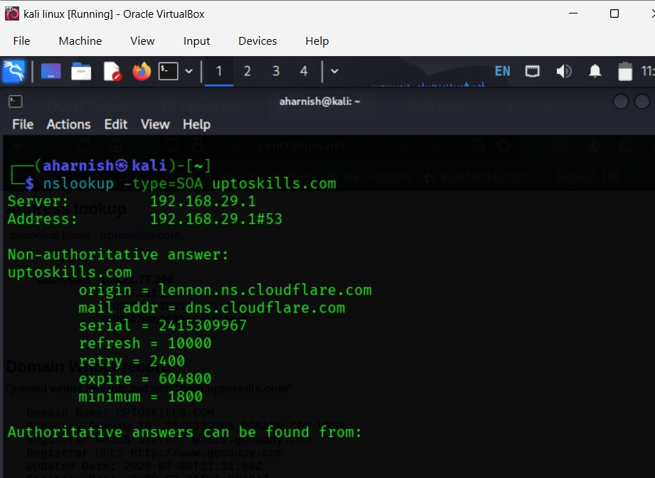

- In the following screenshot you can see the SOA records, An SOA (Start of Authority) record is a mandatory DNS record that defines the administrative details of a domain’s DNS zone, including the primary nameserver, the responsible administrator, and timing parameters for synchronization.

DNS SOA Record Report – uptoskills.com
- Primary Nameserver (Origin): lennon.ns.cloudflare.com
- Responsible Contact (Mail Addr): dns.cloudflare.com
- Serial Number: 2415309967
  - Identifies the current version of the zone file. It increments whenever DNS records are updated.
- Refresh Interval: 10000 seconds (~2.7 hours)
  - Secondary servers check for updates at this interval.
- Retry Interval: 2400 seconds (~40 minutes)
  - If refresh fails, servers retry after this time.
- Expire Time: 604800 seconds (7 days)
  - If no updates are received, secondary servers discard the zone after this period.
- Minimum TTL: 1800 seconds (30 minutes)
  - Default time-to-live for cached records in this zone.
- Summary
- The SOA record confirms that Cloudflare is managing DNS for uptoskills.com. The values define how secondary DNS servers synchronize with the primary server, ensuring consistency and reliability. The serial number shows the zone’s current version, while refresh, retry, and expire values control how often DNS data is checked and updated.

    - Nslookup -type=ANY uptoskills.com screenshot (Query all available record information)
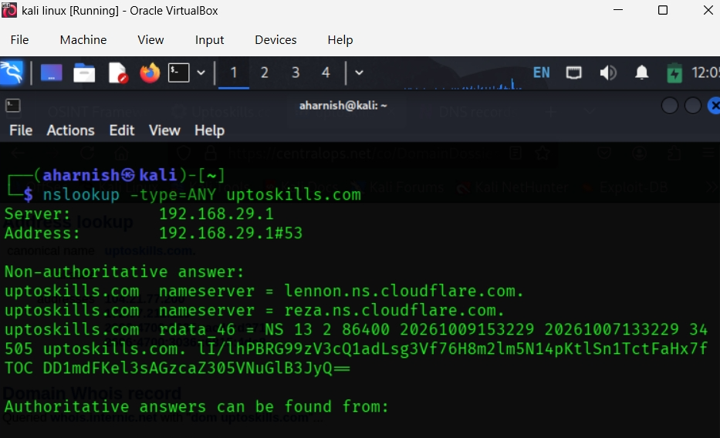

DNS ANY Record Report – uptoskills.com
- Nameservers (NS):
  - lennon.ns.cloudflare.com
  - reza.ns.cloudflare.com → Confirms Cloudflare is managing DNS for the domain.
- Additional RDATA Entry:
rdata_46 = NS 13 2 86400 20261009153229 20261007133229 34505 uptoskills.com.
lI/lhPBRG99zV3cQ1adLsg3Vf76H8m2lm5N14pKtlSn1TctFaHx7f
TOC DD1mdFKel3sAGzcaZ305VNuGlB3JyQ=
- This appears to be an extended DNSSEC-related record (likely an RRSIG or similar cryptographic signature).
- It ensures DNS responses are authenticated and not tampered with.
Summary
The ANY query shows:
- The domain relies on Cloudflare nameservers for DNS resolution.
- DNSSEC is in use, providing cryptographic validation of DNS records.
- This setup enhances both availability (redundant NS records) and security (DNSSEC signatures).

Tool: Shodan
What is Shodon ?
- Shodan is the world’s first search engine for Internet-connected devices, created in 2009 by John Matherly. Unlike Google, which indexes web pages, Shodan indexes devices and services accessible via public IP addresses
- How It Works:
- Runs distributed scanners across the Internet.
- Collects service banners, TLS certificates, and metadata from devices.
- Stores results in a searchable database.
- Queries return IP addresses, open ports, device types, and sometimes vulnerabilities

What It Finds:
- Servers, routers, webcams, IoT devices, industrial control systems, databases, and more.
- Anything with a public IP and open port can appear in Shodan.
- Features: Offers tools like Shodan Monitor (real-time tracking), Maps (geographic visualization), Exploits (links to vulnerabilities), and an API for automation.
- Dual Nature: Helpful for defenders to strengthen security, but can also be misused by attackers to locate weak targets.
- Value: Provides visibility into what is publicly accessible, helping organizations reduce risk.
- Shodan is a powerful cybersecurity search engine that reveals devices and services exposed online, making it both a defensive tool and a potential risk if misused.

Shodan screenshot (domain:uptoskilss.com)
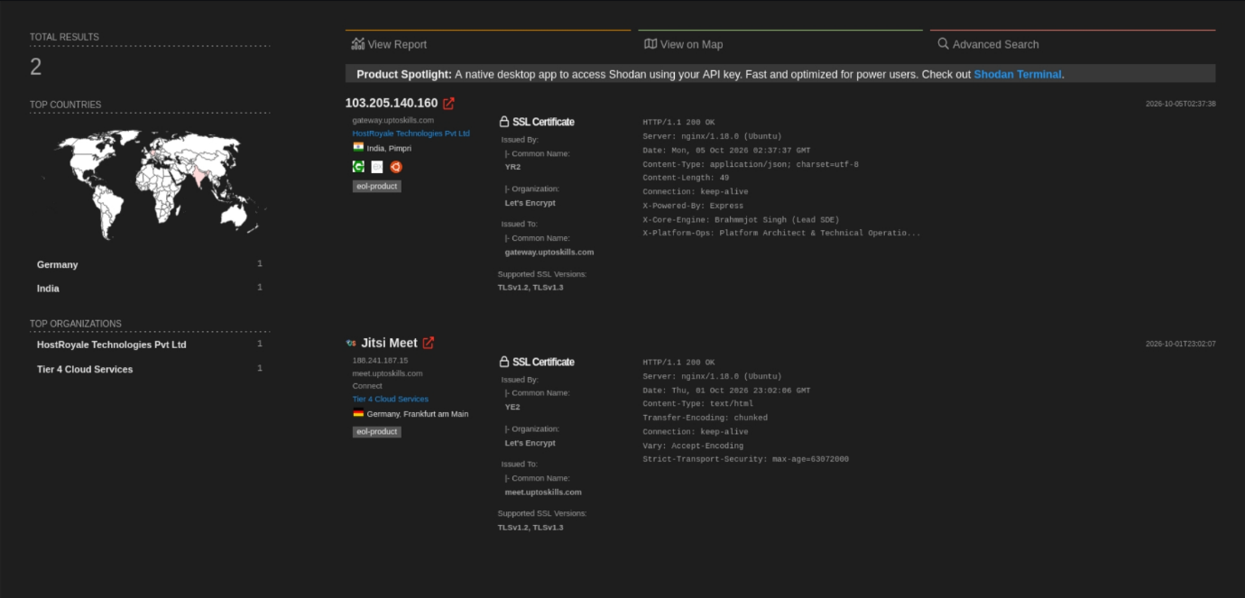
- Total Results: 2 servers found.
- Locations:
  - India (Pimpri) – hosted by HostRoyale Technologies Pvt Ltd.
  - Germany (Frankfurt am Main) – hosted by Tier 4 Cloud Services.
- SSL Certificates:
  - Both servers use Let’s Encrypt certificates.
  - Issued to subdomains:
    - gateway.uptoskills.com (India)
    - meet.uptoskills.com (Germany)
  - Support TLSv1.2 and TLSv1.3.
- Server Details:
  - India server (103.205.140.160):
    - Runs nginx/1.18.0 (Ubuntu).
    - Backend powered by Express.
    - Custom headers show X-Core-Engine: Brahmjot Singh (Lead SE) and X-Platform-Ops: Platform Architect & Technical Operations.
  - Germany server (188.241.187.15):
    - Runs nginx/1.18.0 (Ubuntu).
    - Hosts Jitsi Meet service.
    - Enforces Strict-Transport-Security for HTTPS.

- Summary
- The Shodan scan reveals that uptoskills.com operates at least two servers: one in India and one in Germany. Both use modern TLS encryption via Let’s Encrypt, run on Nginx, and serve different roles (gateway and meet). The India server exposes custom headers identifying developers and platform operations, while the Germany server hosts a video conferencing service (Jitsi Meet) with strong HTTPS security.

Tool: Censys
- Definition: Censys is a search engine and data platform for discovering and analyzing Internet-connected devices and services.
- Function: Continuously scans the entire IPv4 address space and top domains, collecting information about open ports, services, and certificates.
- Focus: Unlike Shodan, Censys emphasizes security research and compliance, providing structured datasets for analysis.
- Finds: Web servers, IoT devices, SSL/TLS certificates, misconfigured services, and exposed infrastructure.

Use Cases:
- Security teams use it for attack surface management.
- Researchers use it for Internet exposure studies.
- Organizations use it for compliance checks (e.g., certificate validity).

- Features:
- Powerful query language for filtering results.
- APIs for integration into security workflows.
- Dashboards for monitoring assets.
- Key Value: Helps identify vulnerabilities and misconfigurations across the Internet, making it a vital tool for cybersecurity professionals.
- Censys is a cybersecurity search engine that scans the Internet and provides structured data about devices, services, and certificates, mainly used for security research and attack surface management.
Cenysys pdf (result of search)
Firefox https://platform.censys.io/search?q=%22uptoskills.com%22
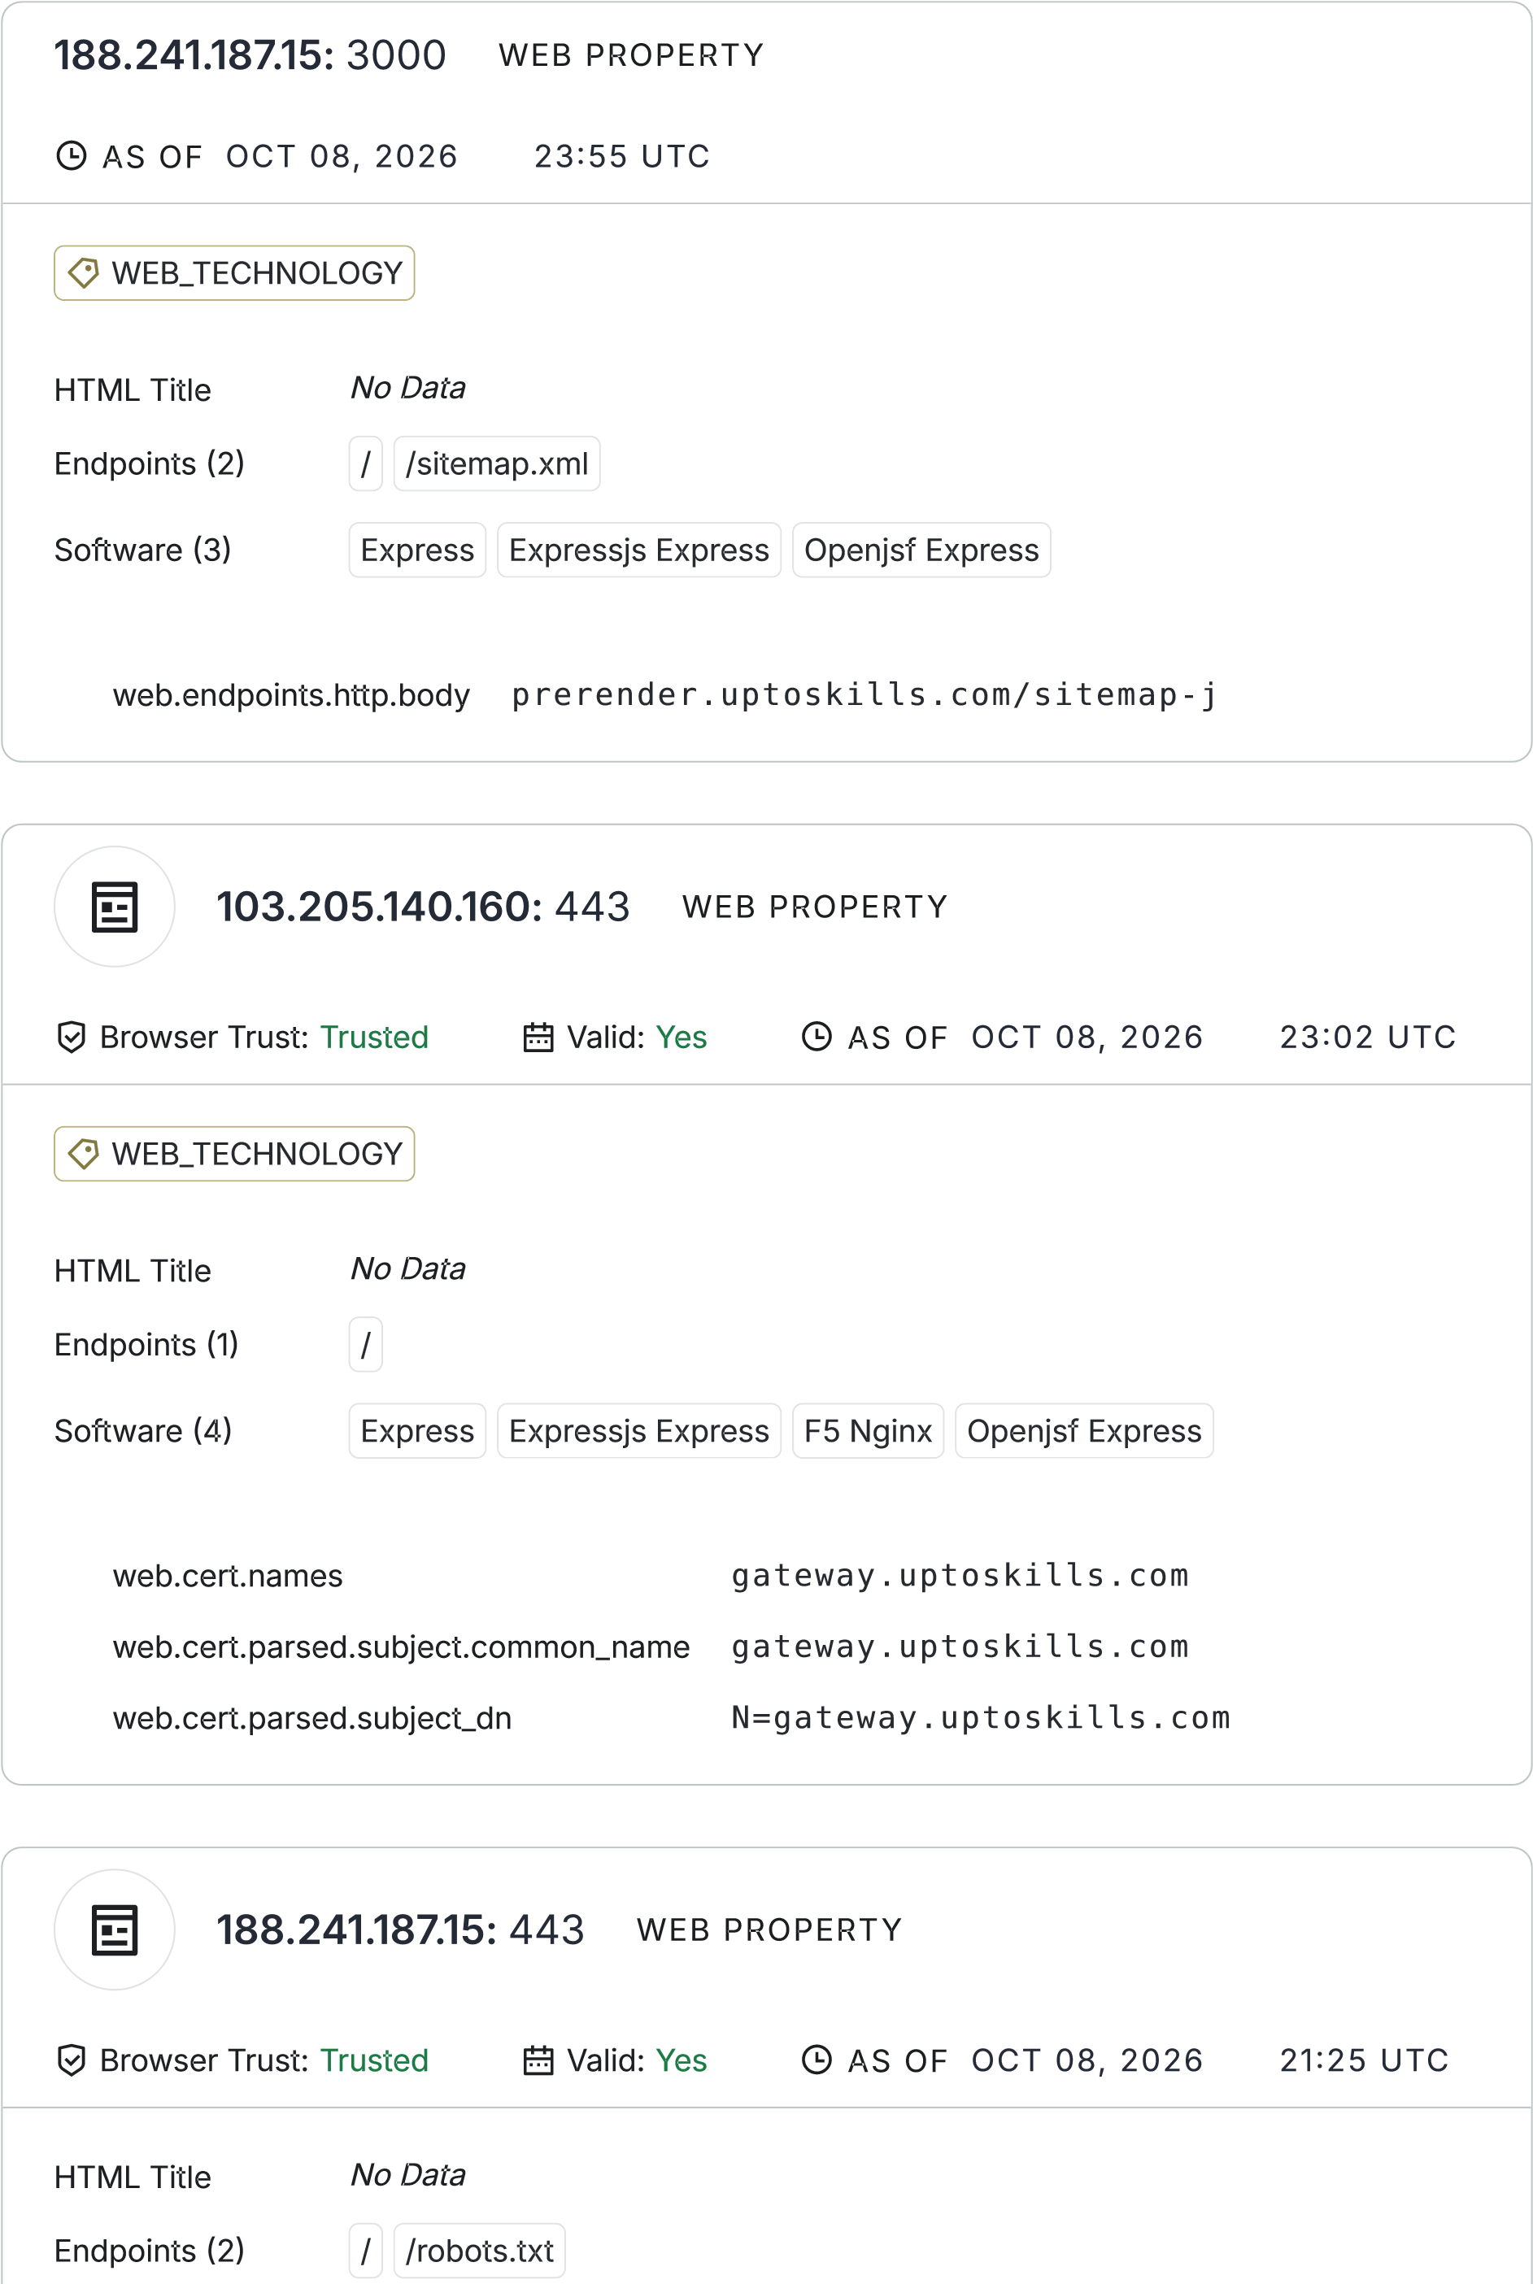
1 of 1 09/10/26, 15:45

Censys Report – Uptoskills.com
- Total Assets Found: Multiple servers associated with uptoskills.com.
- Key IPs:
  - 188.241.187.15 – running services on ports 3000 and 443.
  - 103.205.140.160 – running HTTPS on port 443.
- SSL Certificates:
  - Certificates are trusted and valid, issued to subdomains like gateway.uptoskills.com.
  - Browser trust confirmed for both IPs.
- Web Technologies Detected:
  - Express / ExpressJS (OpenJS Foundation).
  - Nginx (F5).
  - Indicates Node.js-based backend with Nginx as reverse proxy.
- Endpoints Identified:
  - /sitemap.xml, /robots.txt, and root /.
  - Suggests standard web crawling and SEO configurations are in place.
- Observations:
  - Servers are geographically distributed (India and Germany).
  - Use of modern TLS with Let’s Encrypt certificates.
  - Exposure of Express framework details may provide attackers with reconnaissance clues.
- Summary
- Censys confirms that uptoskills.com operates multiple servers with valid SSL certificates, running ExpressJS and Nginx. The infrastructure is distributed across different regions, with endpoints like /sitemap.xml and /robots.txt exposed. Overall, the setup shows good encryption practices but reveals backend technologies that could be leveraged during footprinting.

- Google Dorking
Google Dorking Report – Uptoskills.com
- Purpose: Google Dorking uses advanced search operators to uncover hidden or sensitive information about a target domain.
- Operators Used:
  - filetype: Finds exposed files (e.g., filetype:pdf site:uptoskills.com).
filetype:pdf site:uptoskills.com (screenshot)
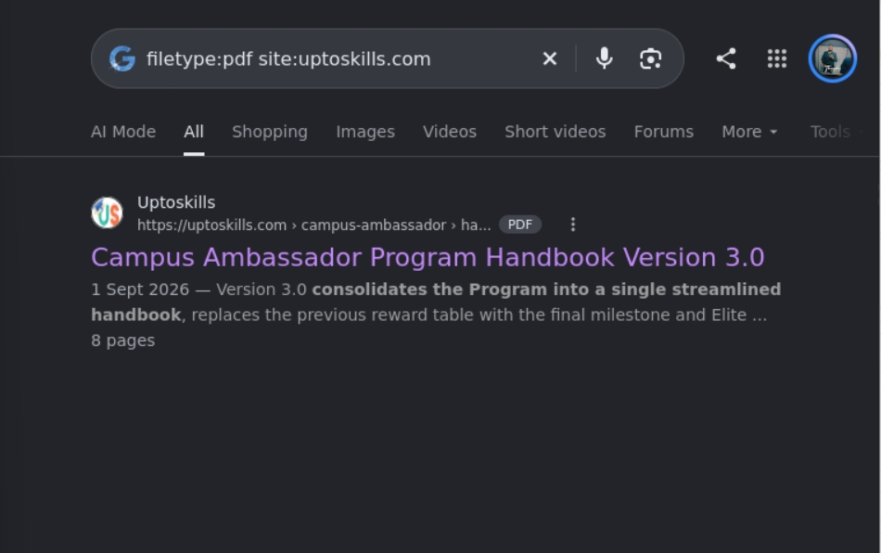
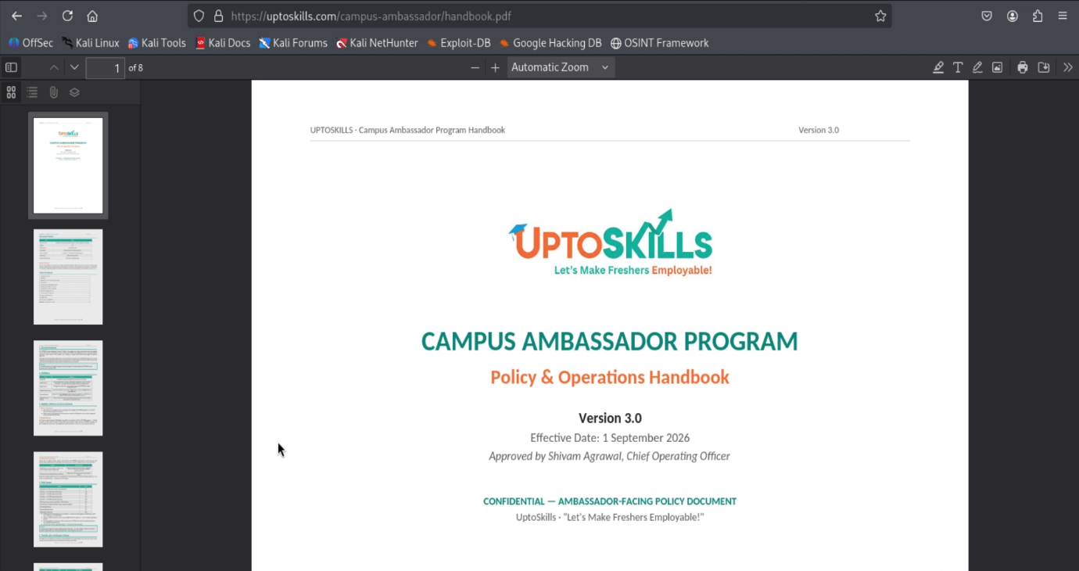

  - cache: Views cached versions of pages (cache:uptoskills.com).
  - intext: Searches for specific text within pages (intext:"password" site:uptoskills.com).
  - inurl / allinurl: Finds URLs containing keywords (inurl:admin site:uptoskills.com).
- Potential Findings:
  - Publicly accessible documents (PDFs, DOCs, XLS).
  - Login portals or admin panels.
  - Error messages or misconfigured directories.
  - Cached pages revealing outdated or deleted content.
- Security Implication:
  - Dorking can expose sensitive data unintentionally indexed by Google.
  - Useful for penetration testers during reconnaissance, but also exploited by attackers.
Summary
Google Dorking on uptoskills.com can reveal hidden files, admin panels, cached content, and sensitive text strings. It’s a powerful OSINT technique for footprinting, highlighting the importance of securing web assets and controlling what gets indexed by search engines.

Advance steps
- To know the web-technologies being used on website.
We can see this, by using the extensions ‘Netcraft’, ‘Wappalyzer’ .
Wappalyzer screenshot:
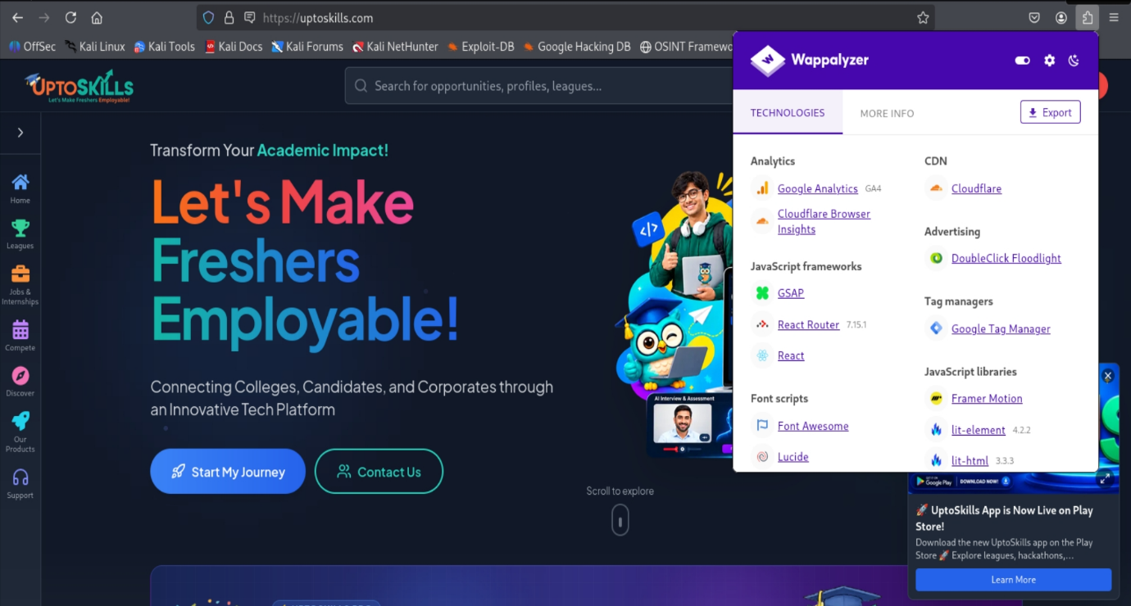
Wappalyzer Report – Uptoskills.com
- Analytics:
  - Google Analytics (GA4)
  - Cloudflare Browser Insights
- CDN:
  - Cloudflare
- Advertising:
  - DoubleClick Floodlight
- Tag Management:
  - Google Tag Manager
- JavaScript Frameworks:
  - GSAP (animation library)
  - React Router (v7.15.1)
  - React
- Font Scripts:
  - Font Awesome
  - Lucide
- JavaScript Libraries:
  - Framer Motion
  - lit-element (v4.2.2)
  - lit-html (v3.3.3)
Summary
The Wappalyzer scan shows that uptoskills.com is built with a modern frontend stack (React, GSAP, Framer Motion) and relies on Cloudflare CDN for performance and security. It integrates Google Analytics, Tag Manager, and DoubleClick Floodlight for tracking and advertising. The presence of multiple libraries (lit-element, lit-html) indicates a modular, interactive design approach.

- Find Subdomains of a site
We can get the subdomains by using website ‘sub-domain finder’.

- Find all the URLs of website
We can get all the links of target by just simply copying the url of target and paste it into website ‘Link-extractor’
- Finding the buffer size of website
We can use terminal to check the maximum buffer size of target.
Ping target_url
Ping -f -l any_size target_url

- Finding more details of security of target website.
‘SSLlabs.com’ in this website, paste the target url and then click on ‘test your server’ .

- Find how security headers of a target is deployed .
We can get this on ‘Security headers.com’

- Using ‘WayBack Machine’ the check previous view of target url’
‘archive.org’ is the website, we have to paste our target url to see the previous view of website.
This is used to see how a particular website looks before 3-5 yrs ago.
We use this, to get some sensitive information of a website, that is been removed after sometime, and not present in today’s interface.

