Preliminary System Design

Table of changes:
Version | Date | Change | Section
1.4 |  | Add phase noise leakage consideration | Phase noise leakage
1.5 |  | Small corrections | Waveforms
1.6 | 22-Oct-25 | Add algorithm outline | Algorithm design and Matlab simulation
1.7.1 | 21-Nov-25 | Resolution parameters update | all

General requirements & geometry
Diagram of projectile hit on ground:

$$α={60}^{o}$$
R
Parameter | Meaning | Value
Pt | transmitted power | 15dBm
Gr, Gt | antenna gain | 7dBi
C | speed of light | 300,000km/sec
$$λ$$ | Wavelength
$$θ_{H}$$ | antenna horizontal beamwidth | $${60}^{0}$$
$$α$$ | Grazing angle | $${60}^{0}, {90}^{0}$$
$$σ_{0}$$ | Normalized RCS of ground | $$-20@{60}^{0},+9@{90}^{0}$$
$$R$$ | Range to ground | 50m
$$B$$ | Chirp Bandwidth | 200MHz
$$Δr$$ | Range resolution | 0.75m
$$ΔR_{acc}$$ | Range accuracy | $$±0.1m$$
$$R_{min}$$ | Minimum height measurement | 1m

The beam projection over the ground is $\frac{Rθ_{H}}{sinα}$ while the pulse length projection is $\frac{ΔR}{cosα}$, therefore, if $\tan{α}<\frac{Rθ_{H}}{ΔR}$ the ground illumination is limited by the pulse length. Taking R=50 and $ΔR=1m$ we get $α<{88}^{o}$. The Matlab simulation switches between pulse limitation and beam limitation according to the incident angle.
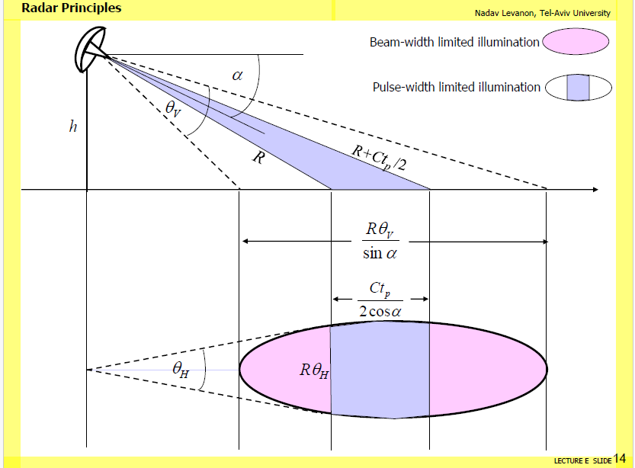
The received power of a pulse- width limited illumination Levanon, Lecture 7 page 17:
$$\operatorname{Pr}{=\frac{P_{t}G_{t}G_{r}λ^{2}}{{\left(4π\right)}^{3}}\frac{θ_{H}σ_{o}\left(α\right)}{\cos{α}}\frac{1}{R^{3}}ΔR}$$
$$ΔR=\frac{c}{2B}=1m$$
This formula is valid if the grazing angle is low enough so that the return from ground is limited by the pulse width projection. This area increases with the grazing angle until it becomes limited by the pulse duration in spherical model:
$L= \sqrt{{\left(R+ΔR\right)}^{2}-R^2}≅\sqrt{2RΔR}$.
So, the ground length taken for the area calculation is the minimum of the two: $x_{l}=min⁡(2L,\frac{ΔR}{cosα})$
$$R+ΔR$$

$$h=R$$

$$L$$

Spherical model when $α$ is close to ${90}^{0}$

$$R+ΔR$$

$$R$$

$$α$$

$$h$$

$$\frac{ΔR}{\cos{α}}$$

The dependency of $σ_{0}\left(α\right)$ on the grazing angle $α$ is according to the formula given in Levanon, Lecture 7, page 5:
$$σ_{0}\left(α\right)=γsinα+β\exp\left[-\frac{\left(\frac{π}{2}-α\right)}{δ^{2}}\right]$$
$$γ=0.01, β=8, δ=\frac{4π}{180}$$
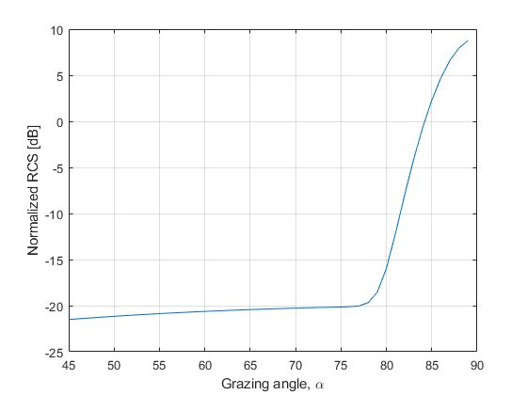
for R=50 m

Receiver requirements
In order to receive the signal at $S_{min}=-97dBm$ (for 50 meters maximum range) keeping SNR>$20$ dB, and integration time of 2 millisecond for each sample batch, B=500Hz, mixer IL = 10, the requirement for the noise figure should satisfy:
$$S_{min}-(kTB{F)}_{dB}=SNR$$
$$SNR=20$$
$$kT=-174\frac{dBm}{Hz}$$
$S_{m}=-97$dBm
$$B=10\log_{10}{500=}27dBHz$$
$$=>F≤-97-\left(-174+27+20\right)=30dB$$
This is a high number for noise figure but we will keep total noise figure F < 17dB in order not to need longer integration times.
Here is a schematic block diagram of the proposed receiver. The gain and noise figure parameters are taken from the calculations in ADC selection & IF gain calculation.
$G_{T}$= 48
$$F_{T}=17dB$$

Equivalent model
Receiver block diagram
Figure 1: Receiver block diagram
L=10dB

HPF
Fc=200KHz

G = 58
F=7dB

LPF
Fc=750KHz

ADC

ADC
Fs=2Msps

$$G_{1}$$

- HPF Filter cutoff frequency is designed to decrease the requirement for the dynamic range of the signal while the projectile approaches the ground. The received power increases as the 3rd power of the range to ground, and because the beat frequency in FMCW is linear with range, the received power also depends on the frequency in the 3rd power. The exact cutoff frequency is chosen by trial and error. Refer to section IF filters requirements for more details.
- LPF cutoff frequency is selected to cut at the highest IF frequency. As calculated below, this frequency is ~737KHz, so Fc=800 KHz is a good choice (allows the filter to decay towards half the sampling rate at 1.4MHz).

Waveforms
- Repeated LFM and noncoherent processing.
  - 5 chirps
  - 300MHz BW
f
t
2ms
BW

- Repeated FMCW chirps for range-Doppler processing:
f
t
2ms
BW
  - 16 chirps of 110 microseconds each (90 micros of valid data + 20 micros for retrace)
  - Bandwidth = 200MHz à 0.75m range resolution

Required IF receiver bandwidth
For FMCW with upchirps
$$f_{beat}=\frac{B_{chirp}}{T_{chirp}}τ_{echo}+f_{doppler}=\frac{2B}{cT}R+\frac{2f}{c}v=αR+f_{doppler}$$
Table 1: waveform parameters
Waveform | $$B_{chirp}$$  $$[MHz]$$ | $$T_{chirp}$$  $$[μs]$$ | $$T_{gap}$$  $$[μs]$$ | #chirps | $$T_{int}$$  $$[μS]$$ | Dop res [m/s] | Dop unfolded [m/s] | $$f_{max}^{*}$$  [KHz]
FMCW train | 200 | 90 | 20 | 16 | 1,760 | 20.3 | 324.7 | 737  (150m/s)
LFM | 300 | 365 | 20 | 5 | 1925 | 18.6 | 92.8 | 270
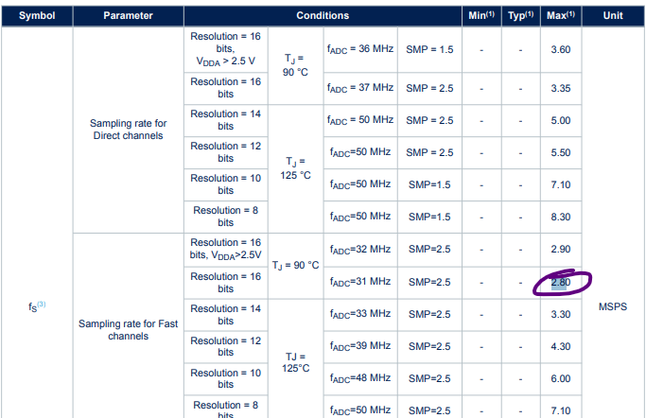
$f_{ADC}$ should be greater than $2.5f_{max}.$ We will use $f_{ADC}=2.8Msps$ of the STMH7A chip.

Waveform parameters
The number of chirps in FMCW is chosen as a compromise between the coherent processing length (chirp) and noncoherent integration (number of chirps). The noncoherent integration is the summation of the absolute value of the IF signal from each chirp. The noncoherent integration helps to reduce the noise, similar to the averaging function in a spectrum analyzer. The total time should be ~2ms to maintain B_{IF} = 500Hz.

The number of chirps in the N-FMCW processing is chosen such there is enough Doppler resolution. The total time should be ~2ms to maintain B_{IF} = 500Hz. The length of the chirp (actually the distance between chirps) is inversely proportional to the maximum doppler that can be measured without folding. For example, 110$μS$ corresponds to 9.1KHz which allows for maximum velocity of 324m/s. This velocity is lower than the maximum velocity needed and therefore folds will appear. To correct these folds, multiple chirp gaps design is needed, or use the CW pulse to get initial “free” velocity measurement.

Doppler resolution (Range-Doppler processing).
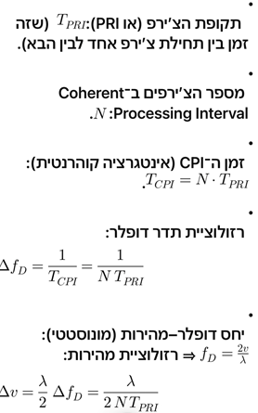
The Doppler resolution in which the velocity can be measured is determined by the pulse repetition rate (PRF) and the number of pulses. In range-Doppler processing, the pulses are the chirps.
$$PRF=\frac{1}{T_{chirp}+T_{retrace}}=\frac{1}{90μS+20μS}=9.1KHz$$
$$Δf_{doppler}=\frac{PRF}{N}⋅\frac{λ}{2}=20.3\left[\frac{m}{s}\right]$$

With these parameters we achieve Range-Doppler map without Doppler ambiguity.

Range resolution and accuracy.
The resolution of 0.75m gives accuracy of ~0.1meter so it is enough accuracy.
See https://www.radartutorial.eu/01.basics/Radars%20Accuracy.en.html
תוספות שלי:
Radar Range Resolution:
S_{r} = c₀ / 2B
B=RF BW
For BW= 200 MHz , Range resolution= 0.75 meter
Accuracy in Range determination:
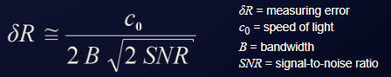

ADC selection & IF gain calculation
Per the above table, we shall use an ADC with the following parameters:
- 2.8Msps
- 16bit
- Low-cost small footprint
Candidate: STM32H7A3 has 16-Bit ADC at 2.8Msps. Typical $SNR_{ADC}$ for these ADC’s is 70dB.
The quantization noise of the ADC is:
$$V_{qntz}=\frac{Vcc}{2\sqrt{2}}⋅{10}^{-\frac{SNR_{ADC}}{20}}=369μV$$
The noise input into the ADC from the RF\IF chain will determine the required gain in the IF chain. We will require that this noise will occupy 3 bits. This is equivalent to say that the noise RMS voltage $v_{n}$ is equal to one LSB. The gain will be determined by:
$G=20\log_{10}{\frac{v_{lsb}}{v_{n}}}$
$$v_{lsb}=\frac{Vcc}{2^{N_{b}}}=\frac{3}{2^{12}}=805μV$$
To calculate the noise voltage (before gain) we shall use:
$$v_{n}=\sqrt{P_{in}R}=\sqrt{kTBFR}$$
Using:
$kT= -174\frac{dBm}{Hz}, B=\frac{Fs}{2}={10}^{6}, R=50Ω, F=17dB$ we get $v_{n}=3.158μV$
Therefore $G_{Total}=20\log_{10}{\frac{805}{3.158}=48dB,}$
and so $G_{1}=G_{total}+IL_{mixer}=48+10=58dB$
The BW of the ADC is Fs/2 = 1.4MHz (Nyquist frequency).
The plot below is a simulation of a thermal noise + quantization noise. Note that the RMS voltage ratio used above ensures 2~3 bits of “noise” in the receiver. A 100KHz signal is embedded in the noise and is easily detected after FFT integration as can be seen in the bottom plot.
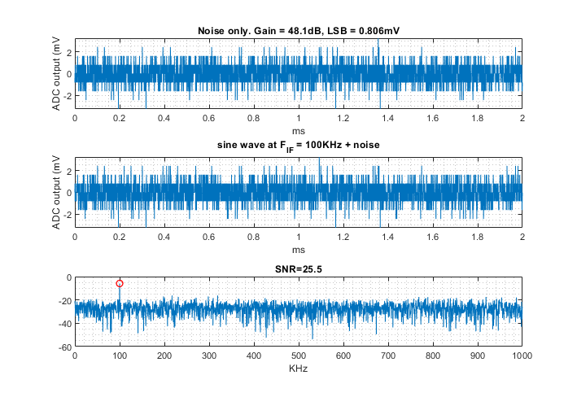
Reference: https://www.analog.com/en/resources/technical-articles/basics-designing-digital-radio-receiver.html

IF filters requirements

Received power vs range
From the two formulas for the received IF frequency and the power vs range we can plot the dependency of the received power in the IF frequency.
$$f_{beat}=\frac{2B}{cT}R+\frac{2f}{c}v$$

$$\operatorname{Pr}{=\frac{P_{t}G_{t}G_{r}λ^{2}}{{\left(4π\right)}^{3}}\frac{θ_{H}σ_{o}\left(α\right)}{\cos{α}}\frac{1}{R^{3}}δR}$$

The plot below show this dependency for two projectile velocities =-550, -100 [m/s] and two angles $α={90}^{o}$ and $α={60}^{o}$.
We also show the HPF response, with a selected cutoff frequency of 200KHz. As can be seen, it reduces the requirements for the dynamic range of the received power. When we decide on the final frequency we shall reoptimize the cutoff frequency.

According to the graph above, taking a HPF with Fc=200KHz, we can reduce the required dynamic range from ~75dB to ~60dB.

PLL Design

It is required that we use ADF4158.
ADISIMPLL software was used to design a sequence of chirps according to the parameters in the WaveformPArametersTable. It is possible to meet the most difficult requirements in this table, even with extension to 300MHz bandwidth.
Here are the simulation results and the circuit.

Note that between chirps, there is an inevitable period of time in which the PLL is unlocked.

The ADF4158 is capable of generating 200MHz chirp in 90microseconds. The next chirp starts after 20 microseconds with a loop filter of 158KHz bandwidth, 45 degrees phase margin – 3 poles.

Phase noise – simulation results with Z-communications V600ME85-LF

Phase noise leakage
In FMCW radar there is always a leakage between Tx and Rx, due to limited isolation of the Tx antenna and Rx antenna, and maybe from reflecting elements in the enclosure itself. We shall assume -25dB isolation \ reflected back power. On the other hand, the transmitted and reflected signals are highly correlated due to the small time delay (order of 1 nanosecond) and it is well known that there is a suppression factor of the IF signal according to:
$$L_{supp}=4\sin^{2}{ (πfτ)}$$
Where $τ$ is the time delay from the close reflector (or time travelled from Tx patch to Rx patch). The results below show the suppression factor and the IF phase noise after mixing, for $τ=1$nano second.

We see that the phase noise is suppressed. To assess its impact on our detection sensitivity, we shall consider the maximum beat frequency 737KHz. We see that the -113.7dBc PLL phase noise is suppressed to -160 dBc due to the decorrelation effect. Let’s calculate the noise and compare it to the target signal power:
$$N_{PLL_phasenoise}=P_{tx}-I_{tx→rx}-{L_{mixer}-L}_{suppression }=$$
$$= 15-25-10-160= -180\frac{dBm}{Hz}→-174\frac{dBm}{Hz}$$
It is in the thermal noise limit and no SNR degradation takes place.
AM noise. Am noise is approximately 40 dB less than phase noise. For 100KHz, we have phase noise level at -94dBc/Hz (before self suppression), so the AM noise is at -134dBc/Hz. At a 500Hz bandwidth this becomes -107dBm. From the plots in section IF filters requirements, we see that the received power is ~-85dBm, so SNR is 22 dB and the signal is likely to be well detected.

ADC and processor requirements
The processing cycle is the following:
- Range Doppler processing
  - Transmit 16 chirps, and take 4096 samples
  - Total time of chirps is ~2ms
  - Calculate range doppler map (processing time = 0.75ms)
  - Evaluate range (processing time = 1.25ms)
So, the processor has to complete all data collection and processing in less than 2 ms, by which the projectile passes 1.1m at maximum speed.
- Sampling rate: >2msps (as indicated above in WaveformPArametersTable
- Number of ADC bits >12
- FFT processing time (4096 points) < 0.75ms
  - 1024 point resl FFT requires ~30K cycles.
  - 4096 point complex FFT requires ~5x more cycles = 150K cycles
    - At 216 MHz it is 0.7ms

Processor Candidates:
- https://www.st.com/resource/en/datasheet/stm32f722ic.pdf
  - LQPF64 package

Algorithm design and Matlab simulation

Overview
This section describes the implementation of a range–Doppler map simulator for the radar head descending toward the ground at a specified grazing angle. The simulation can be run at any grazing angle. The goal is to model the radar signal returns from a ground patch within the antenna beam, apply signal processing (dechirp, windowing, FFT), and visualize the resulting range–Doppler map.
This simulation supports the design and testing of radar processing algorithms without requiring real-world flight data. Obviously, there will be field tests needed to support the design.

Functional Description
The algorithm models a radar transmitting linear frequency-modulated (LFM) chirps toward the ground while the platform moves along a descending trajectory.
The simulation covers three functional domains:
- Scene Geometry
  - Defines the relative positions of the radar, the ground, and the illuminated patch.
  - Computes look vectors, slant ranges, and Doppler frequencies. The slant range can be estimated from the range-Doppler map.
- Signal Generation
  - Generates the transmitted LFM chirp waveform.
  - Simulates echoes from the ground patch based on propagation delay.
  - Applies realistic effects such as clutter, thermal noise, and beam coverage.
- Signal Processing
  - Performs dechirping, windowing, and 2D FFT to produce the Range–Doppler map.
  - Displays both the iso-Doppler lines on the ground and the processed spectral map.

System Geometry
The platform moves along a sloped trajectory:
$$x_{p}=vtcos⁡θ,z_{p}=h_{0}-vtsin⁡θ$$
The radar beam is directed toward the ground at grazing angle $θ$.
The illuminated footprint is approximated as a flat ground patch bounded by the beamwidth.
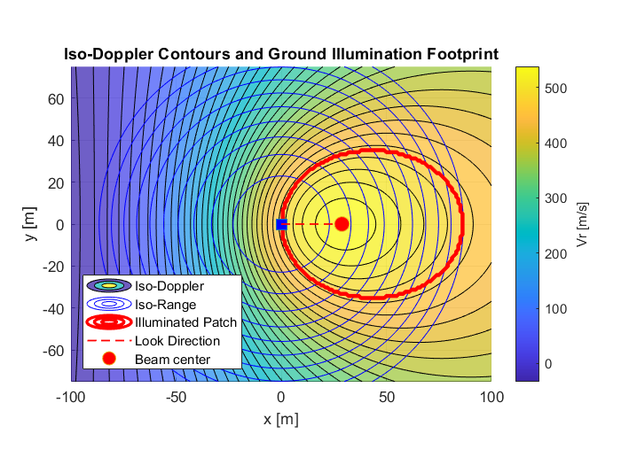

Radar Signal Model

Transmitted Chirp
Each transmitted pulse is an LFM chirp:
$$s_{tx}(t)=e^{jπ(2f_{c}t+μt^{2})},0<t<T_{chirp}$$
where $μ=B/T_{chirp}$is the chirp rate.
Parameter | Symbol | Value
Bandwidth | $$B$$ | 150 MHz
Chirp duration | $$T_{chirp}$$ | 0.0625 ms
Sampling rate | $$F_{s}$$ | 2.5 MHz
Number of chirps | $$N_{chirp}$$ | 32

Echo Model
For each ground scatterer at range $R(x,z)$:
$$s_{rx}(t)=e^{jπ(2f_{c}\left(t-τ\right)+μ(t-τ)^{2})},τ=\frac{2R}{c}$$
All echoes are summed with random phase terms to simulate distributed reflectivity (speckle).

Platform Motion
For each chirp $n$:
- Platform position is updated by:
$$x_{p}(n)=(n-1)vT_{chirp}cos⁡θ,z_{p}(n)=h_{0}-(n-1)vT_{chirp}sin⁡θ$$
- The range $R(x,z,n)$from platform to ground points is recomputed.

Dechirp and Noise Addition
Each received signal is dechirped by mixing with a conjugate of the transmitted waveform:
$$s_{dechirp}(t)=s_{rx}(t)⋅s_{tx}^{*}(t)$$
This produces a beat frequency proportional to target range.
Additive white Gaussian noise (AWGN) is injected at 20 dB SNR to emulate receiver noise:

Windowing and FFT Processing
To suppress sidelobes, Hamming windows are applied along both the fast-time (range) and slow-time (Doppler) dimensions:
signal_win = signal .* hamming(Nsample) .* hamming(Nchirp).';
Then two FFTs are performed:
- Range FFT (across samples per chirp)
- Doppler FFT (across chirps)
$$S(f_{r},f_{d})={\text{FFT}}_{\text{Doppler}}\{{\text{FFT}}_{\text{Range}}\{s_{dechirp}(t,n)\}\}$$

The figure below shows the output range-Doppler map. Currently it is a simplified simulation, nevertheless, it serves the principal algorithm design well. The algorithm first generates the map, then identifies in it the range and velocity towards the ground.
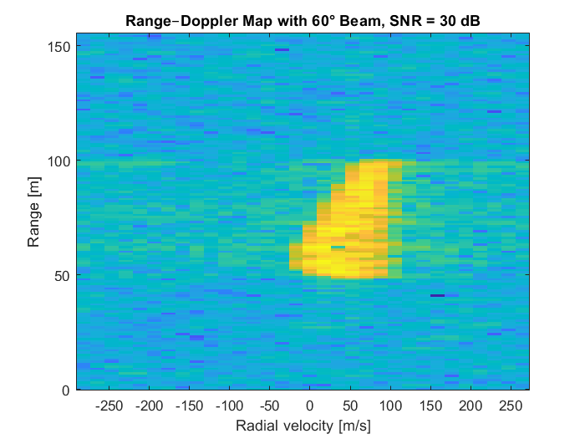
In the example above, the illuminated part of the range-Doppler map extends from 50 meters to 100 meters, corresponding to the beam illumination on the ground plane. The radial velocities of this patch extend from ~0 to ~90 m/s. This can be translated to the true velocities of the object. In this simulation the velocity axis has 32 bins, each with resolution of:
$$v_{res}=\frac{1}{N}⋅\frac{1}{T_{chirp}}⋅\frac{λ}{2} =\frac{1}{32}⋅\frac{1}{62.5μS}⋅\frac{0.0706}{2}=17.6\frac{m}{s}$$
The leftmost cell corresponds to $v=-282\frac{m}{s}$ and the right most cell corresponds to $v=264\frac{m}{s}$. Since the simulated object moves at $v_{object}=-550\frac{m}{s}$, there is a folding that can be resolved. The resolution is ${\hat{v}}_{object}=-282-\left(264-v_{measured}\right)$. As said above our measured velocities extend from 0 to 90 m/s which corresponds to:
$${\hat{v}}_{object}=\left\{\begin{matrix}-547\left[\frac{m}{s}\right] , & v_{measured}=0 \\ -457 \left[\frac{m}{s}\right], & v_{measured}=90\end{matrix}\right.$$

So, we see that by finding the peak cells in the range-Doppler map, we can measure the velocity and range of the object quite accurately.
This process repeats every 2 milliseconds. The range -Doppler map changes according to the height of the platform. Below is a series of range doppler maps for h=45 to h=5 every 5 meters:
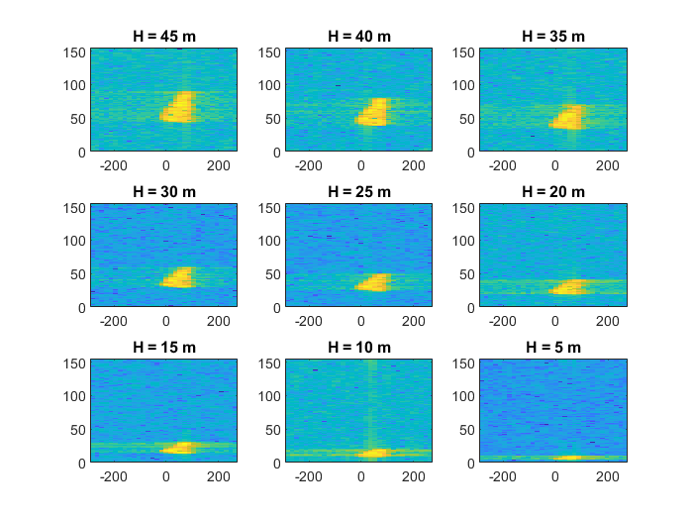

Algorithm steps

  - Collect 4096 samples of current transmitted chirps. It is arranged as a matrix of 32 chirps X 128 samples.
  - Loop 32 times on each chirp samples
    - Multiply each 128 samples by hamming window vector
    - FFT over 128 points and save in memory (refer to it as columns of the range-Doppler matrix)
  - Loop 128 times on every row in the matrix:
    - Multiply each 32 samples row by hamming window vector
    - FFT over 32 points and save in memory
  - Compute absolute value of the above (128 x 32) points. Call the result RDmap.
  - Height and velocity estimation. Find the highest peaks in this RDmap. Identify the limits of the higher-values patch of points in the RDmap in terms of range and velocity.
  - Update Kalman filter of velocity and height with new values from previous step (5)
  - Update time to impact (trigger time)
  - Return to step 1

הכיסוי של האלומה על פני הקרקע תלוי בזווית האלומה ביחס לקרקע, ברוחב האלומה אבל גם ברזולוציה של מדידת הטווח. לפי השרטוטים בעמוד הבא ניתן לראות שבדרך כלל הרזולוציה היא זו שקובעת את גודל תא השטח על פני הקרקע ש"נכנס" לתוך אותו תא רזולוציה במכ"מ. זה מתקבל על ידי הביטוי $\frac{ct_{p}}{2cos{α}}$ מכיוון שהכיסוי של כל האלומה הוא הרבה יותר גדול ומתחלק על פני כמה תאי טווח. ככל שהזווית כלפי הקרקע חדה יותר, כך ישנן יותר תאי טווח באלומה.
ישנן שלוש דרישות במקביל. הראשונה היא רזולוציה של הטווח – זה קובע את רוחב הסרט של הצ'ירפ. השניה היא קצב הצ'ירפים – זה קובע את המהירות המקסימלית שמפת טווח-דופלר תוכל לשאת ללא קיפולים בעקבות המהירות הגבוהה של הטיל. הדרישה השלישית היא זמן כולל של אינטגרציה על מנת לצמצמם את רוחב הסרט של ה-IF ולעמוד בדרישות ה-SNR.
על מנת להבטיח כיסוי מלא של כל מתארי זוויות הפגיעה, נדרש HPF שיקזז את עליית עצמת ההחזר עם התקרבות הפלטפורמה לקרקע.כפי שרואים בגרף, צריך לתמוך בעוצמות שנעות בין -20dBm ל- -97dBm שהם 77dB תחום דינמי. זה מעבר ליכולת של דוגם בעל 12 סיביות. על ידי הוספת מסנן מעביר גבוהים, התחום מצטמצם ל- 57dB שהוא אפשרי עבור דוגם 12 סיביות.
החלק הזה נעשה באופן אנלוגי במקלט על ידי המיקסר.

