**PRACTICAL 3**

**SWITCH-PC**

Aim:- To connect 4 PCs using 1 switch by using cisco packet tracer.

Steps:

1. Take **1** 2960 switches and 4 PC.
2. Connect the switches and PC physically.

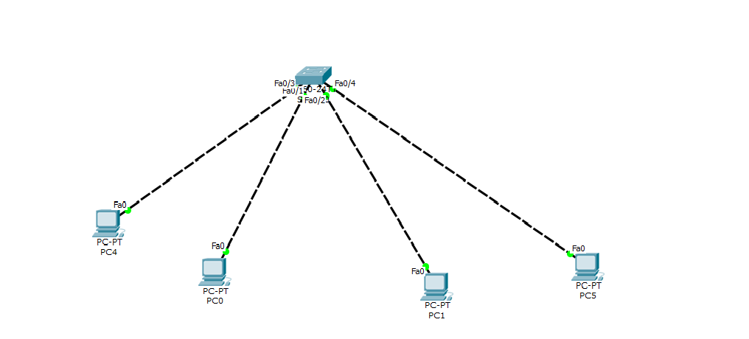

1. Give IP address to the PC and Default gateway as shown below by clicking on pc and selecting desktop submenu.

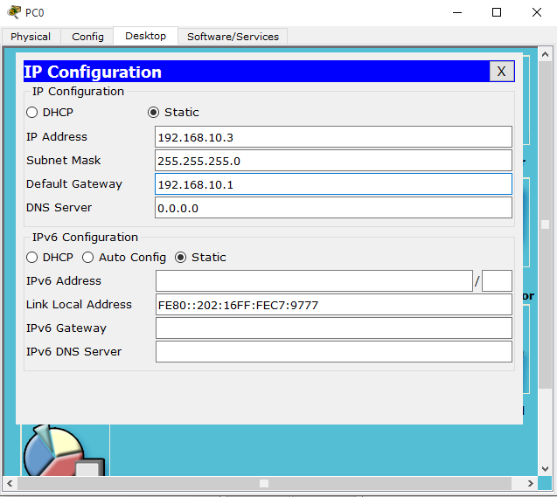

1. Now send message from one pc to another. If it shows successful then the connection is established.

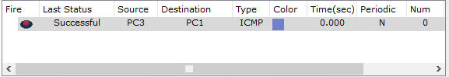

**CONCLUSION:-**

Thus, we learned how to make switch to switch connection in cisco packet tracer.

**PRACTICAL-4**

**Aim:** To connect 4 PCs using 2 Switch and 1 Router in cisco packet tracker.

**Steps:**

1. Connect the PCs , 2960 switches and 2911 router in topology as shown below

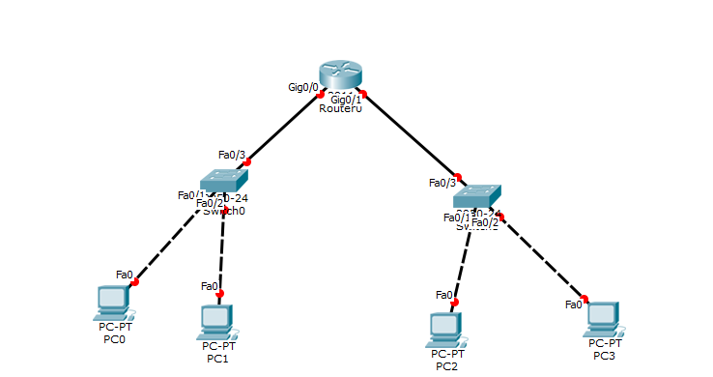

1. Now provide IP to the PCs as shown below



1. Enter the IP of the default gateway by command line in the router configuration and turn it ON.

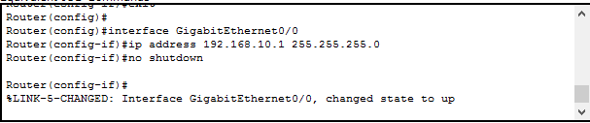

1. When all connection turn green, try to send the message from one network to another. If the message is successful the connection between two network is established. The final network will be as follow:

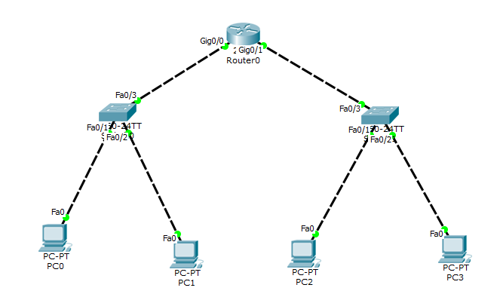



**CONCLUSION:**

Thus, we learned how to connect two different networks via router and using switches.

**PRACTICAL 5**

**Aim:- To study router-router connection using static IP addressing.**

**Apparatus:-**  **3** 2911 routers, **3** 2960 switches and 9 PC.

**Steps:**-

1. Connect the routers, switches and PCs in the below mentioned topology.

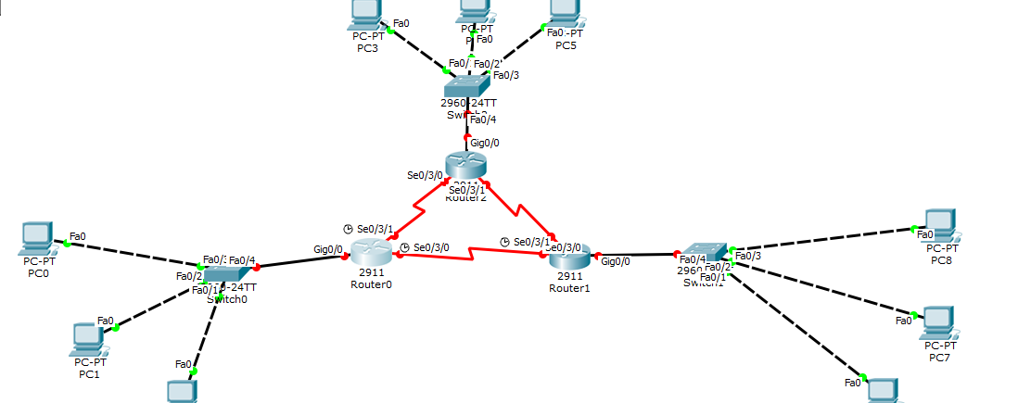

1. Provide IP to PCs and inform router to which network they are connected.

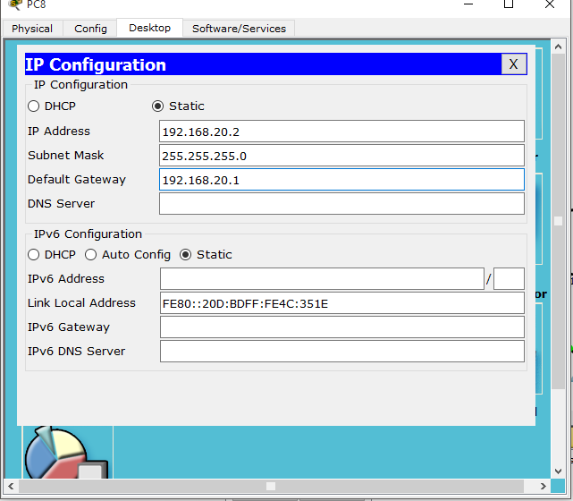

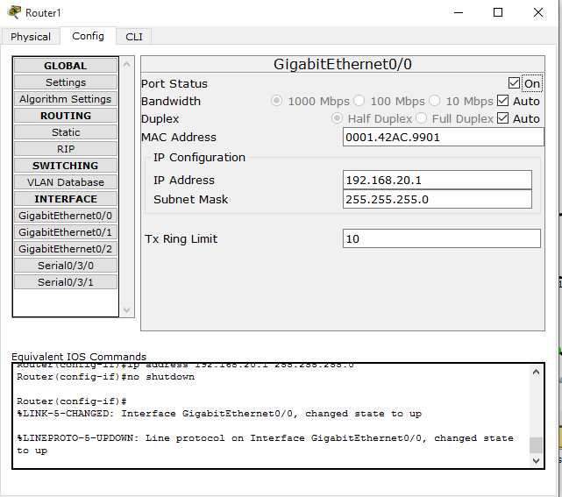

1. Give IP to the network between routers as shown as below and insert serial port by switching the router off. After inserting that switch it ON. 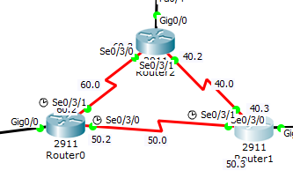

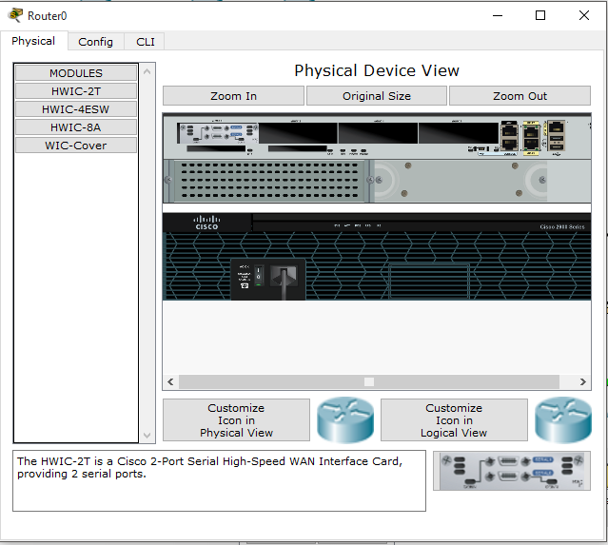

1. Provide next hope to the router as static routing. As shown in figure.

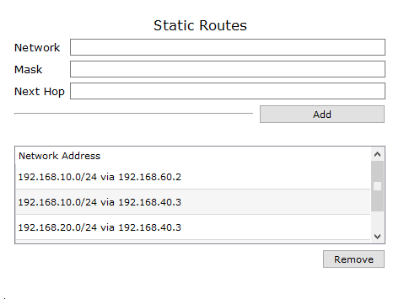

1. After providing the static routing hops. Send messages to PCs and check whether the connection is established. If the connection is established, we have successfully completed the practical.



CONCLUSION:-

Thus, we learned how to make router-router connection using cisco pocket trackers.

**PRACTICAL-6**

**ROUTER-ROUTER USING DHCP**

**Aim: To study router-router connection using DHCP using 18 PCs, 2 servers, 4 switches and 5 routers.**

**Apparatus:** 18 PCs, **2** servers, **4** 2960 switches, 5 2911 routers and connection cables.

**Steps:**

1. Connect all the PCs, Servers switches and router as the following topology shown in below picture.

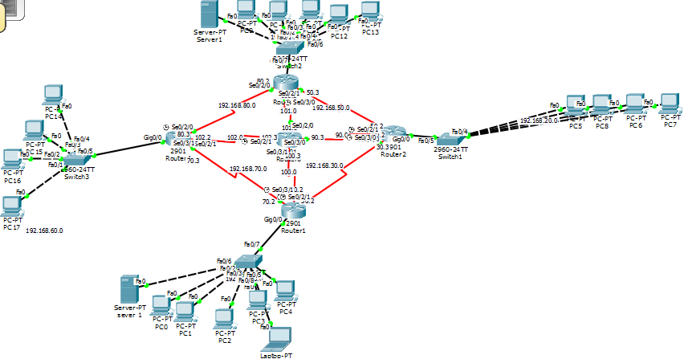

1. Now provide IPs to all the network in the above mentioned topology. Two networks are provided static IP and other two by DHCP Server. Configure the server by giving them IP as 190.168.**.254.

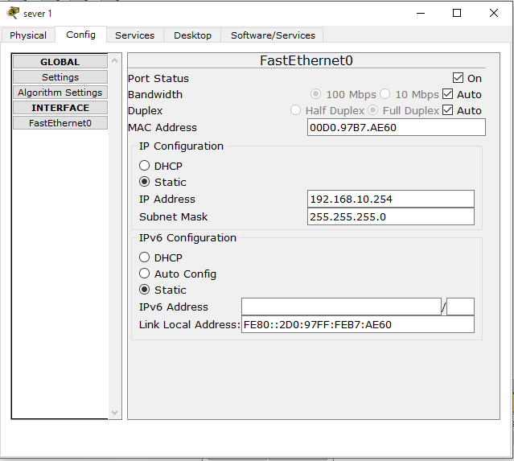

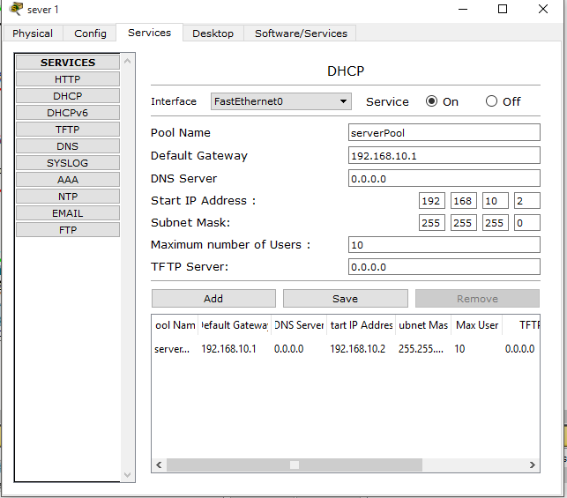

1. Now, configure the routers and provide next hop to the routers.

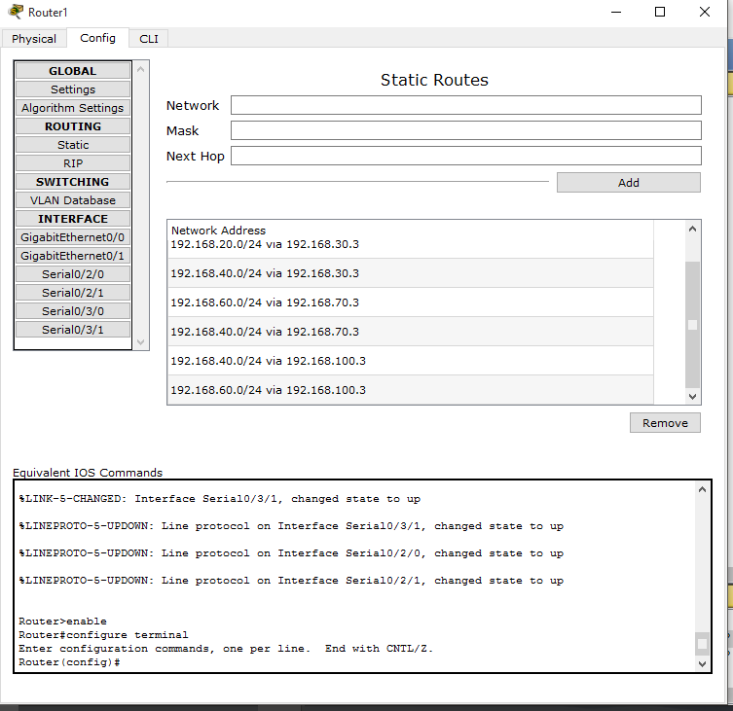

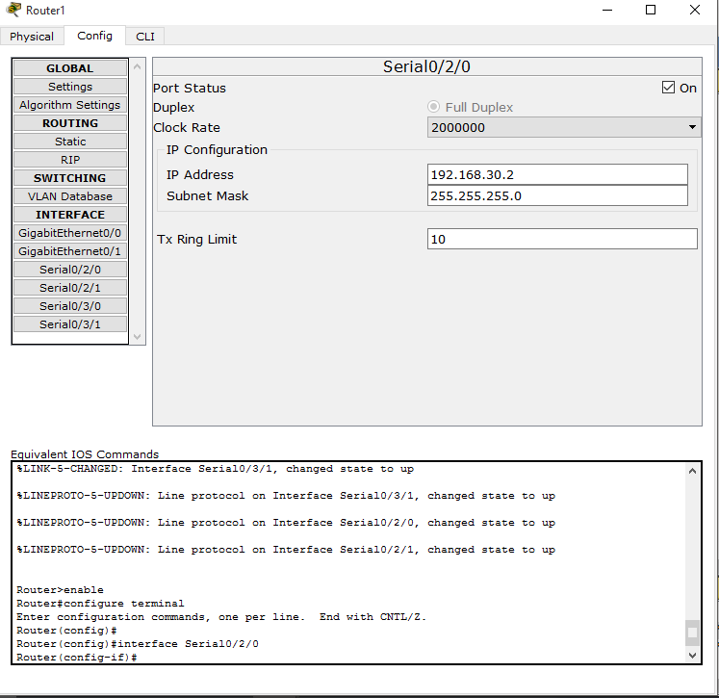

1. When all the signals are turned green, try sending message from one PC to another PC of another network.
2. If the message is sent, then the connection is established and is successful.



**CONCLUSION:**

Thus, we learned how to provide dynamic IP addressing by using DHCP.

**PRACTICAL 7**

**ROUTER-ROUTER USING RIP**

**Aim:** To study dynamic routing using RIP using PCs, and servers.

**Apparatus:** Routers, PCs, switches and cables.

**Steps:**

1. Connect all the PCs, switches and routers as shown in below topology.



1. Now provide IP and default gateways to all the networks. 
2. Configure the router as shown below.

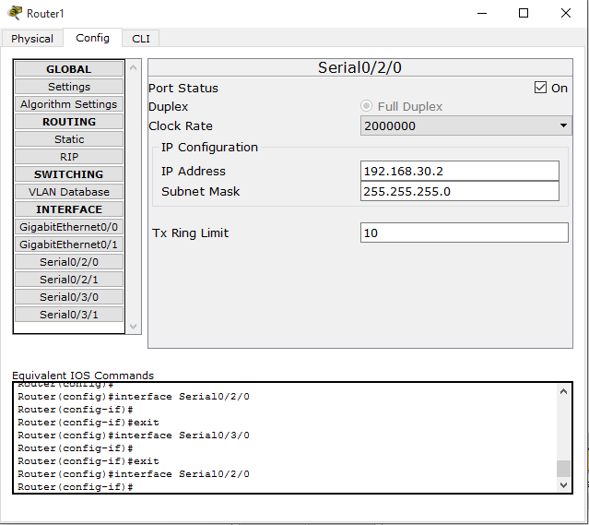

1. If all the connection are turned green then provide each and every router the information about the networks connected to it.

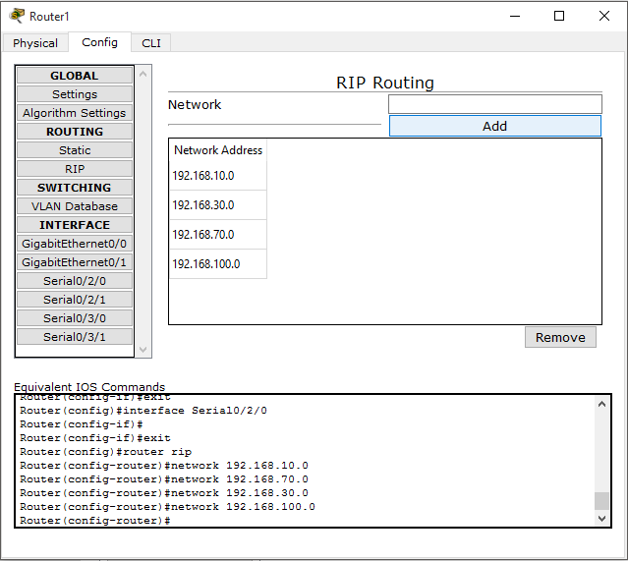

1. After providing the information about networks to router. Try sending the message from one PC to other. If the message is sent, then the topology is connected successfully.



**CONCLUSION:**

Thus, we learnt how to provide dynamic routing through RIP.

**PRACTICAL-8**

**Aim:**  To connect 4 PCs using wireless router.

**Apparatus:** WRT300N wireless router, **4** PCs

**Steps:**

1. Take the above mentioned router and PC. And configure the below given topology.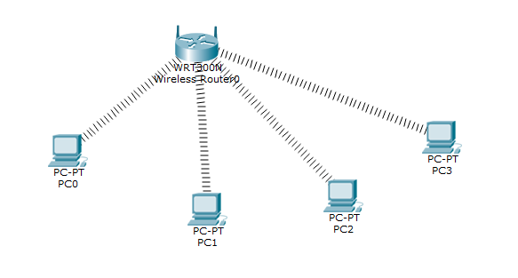
2. Now, click on the PC and open its configuration window. Switch OFF the PC and remove the existing port and install the WMP300N port in it. After wards turn on the PC and close the window.

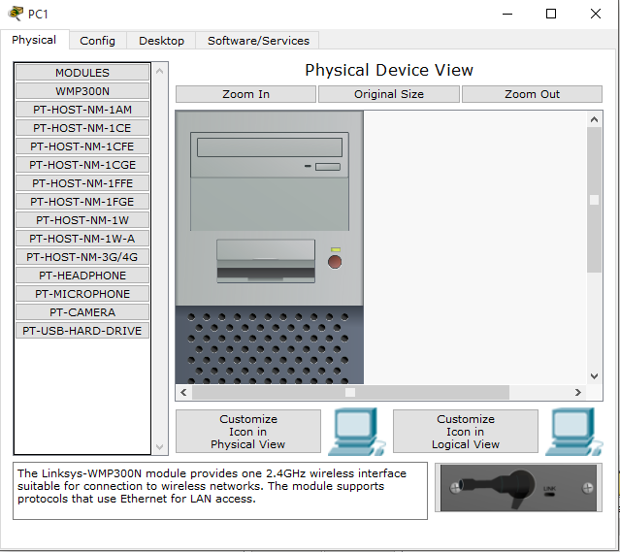

1. Now, turn on the PC configuration window and you will notice that IP are provided to the PC by DHCP.

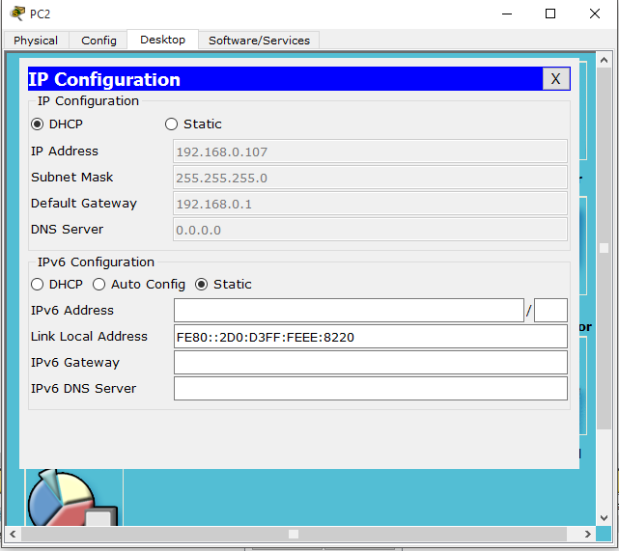

1. Now, you can see that network is established. Try to send the message. If it shows failed, don’t worry, try again. If the message is sent, then our practical has been conducted.

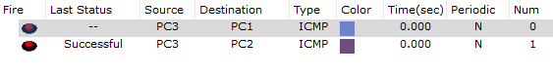

**CONCLUSION:**

Thus, we have learnt the way to connect 4 PCs with wireless WRT300N router.

**PRACTICAL-9**

Write a program to implement error detection technique. (Even or Odd Parity check)

#include<stdio.h>

#include<conio.h>

#include<stdlib.h>

#include<string.h>

void main()

{

char data[100],user[100];

int a[100],b[100];

int i,n,m,c=0,odd=0;

printf("enter sender data:-");

scanf("%s",&data);

n=strlen(data);

for(i=1;i<=n;i++)

{

a[i]=data[i-1]-48;

if(a[i]>1||a[i]<0)

{

printf("incorrect data");

exit(1);

}

}

for(i=1;i<=n;i++)

{

if(a[i]==1)

c++;

}

a[0]=c%2;

printf("data after even parity:-");

for(i=0;i<=n;i++)

printf("%d ",a[i]);

printf("\n");

printf("enter recevied data:-");

scanf("%s",&user);

m=strlen(user);

for(i=0;i<m;i++)

{

b[i]=user[i]-48;

if(b[i]>1||b[i]<0)

{

printf("incorrect data");

exit(1);

}

if(b[i]==1)

odd++;

}

if((n+1)!=m)

{

printf("bits in data does not match");

exit(0);

}

for(i=0;i<m;i++)

odd=odd%2;

if(odd==0)

printf("data has no error");

else

printf("data has error in odd numbers of bits");

getch();

}

**PRACTICAL-10**

Write a program to implement error correction technique. (Hamming code)

#include<stdio.h>

#include<conio.h>

#include<stdlib.h>

#include<string.h>

void main()

{

char data[7],check[7];

int a[7],b[7];

int i,c=0,p,q,r,error;

printf("enter you 4bit data:-");

scanf("%s",data);

if(strlen(data)!=4)

{

printf("this is not 4 bit data");

exit(1);

}

a[2]=data[0]-48;

a[4]=data[1]-48;

a[5]=data[2]-48;

a[6]=data[3]-48;

a[0]=(a[2]+a[4]+a[6])%2;

a[1]=(a[2]+a[5]+a[6])%2;

a[3]=(a[4]+a[5]+a[6])%2;

for(i=1;i<7;i++)

{

if(a[i]>1||a[i]<0)

{

printf("incorrect data");

exit(1);

}

}

printf("data after hamming:-\n");

for(i=0;i<7;i++)

printf("%d ",i+1);

printf("\n");

for(i=0;i<7;i++)

printf("%d ",a[i]);

printf("\n");

printf("enter your data:-");

scanf("%s",check);

for(i=0;i<7;i++)

{

b[i]=check[i]-48;

if(b[i]>1||b[i]<0)

{

printf("incorrect data");

exit(1);

}

}

for(i=0;i<7;i++)

printf("%d",b[i]);

printf("\n");

p=(b[0]+b[2]+b[4]+b[6])%2;

q=(b[1]+b[2]+b[5]+b[6])%2;

r=(b[3]+b[4]+b[5]+b[6])%2;

printf("%d %d %d\n",p,q,r);

error=r*4+q*2+p;

printf("error is in %d's bit",error);

getch();

}