FISH 559: Numerical Computing for the Natural Resources
Homework 3 : Root Finding (Out of 110 points)

Fisheries management decisions are often based on abundance relative to target and limit reference points. The most common reference point is the population size at which MSY is achieved. The fully-selected fishing mortality corresponding to MSY, F_{MSY}, is defined as the instantaneous rate of fishing mortality at which yield is maximized, i.e.:
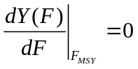 (1)
where 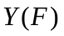 is yield as a function of fully-selected fishing mortality, i.e.:
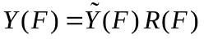 (2)
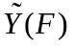 is yield-per-recruit as a function of F, and
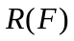 is recruitment as a function of F.
Yield-per-recruit is defined according to the formula:
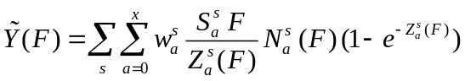 (3)
where 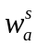 is the weight of an animal of sex s and age a,
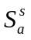 is the selectivity for animals of sex s and age a,
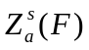 is the total mortality on fish of sex s and age a,
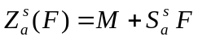 (4)
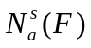is the number of fish of sex s and age a relative to the number of animals of age 0 (both sexes combined):
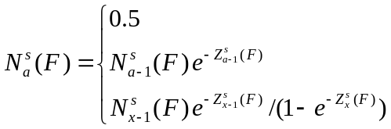 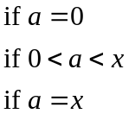 (5)
x is the maximum age-class.
The recruitment as a function of F depends on the assumed form of the stock-recruitment relationship, e.g.:
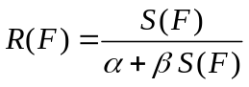 (6)
where 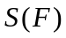 is spawner biomass as a function of F:
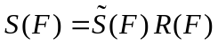 (7)
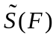 is spawner biomass-per-recruit as a function of F:
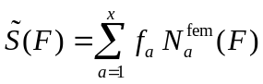 (8)
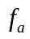 is fecundity as a function of age.
Substituting Equation (7) into Equation (6) and solving for leads to:
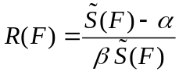 (9)

Question 1 (10 points)
Find the relationship between recruitment and spawner biomass-per-recruit (see Equation 9) for the Ricker and Pella-Tomlinson stock-recruitment relationships:

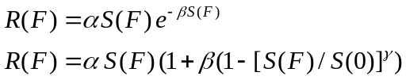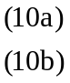

Question 2 (10 points)
Reparameterize the Beverton-Holt, Ricker and Pella-Tomlinson models in terms of 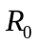 (the number of age-0 animals in the absence of exploitation), spawner biomass-per-recruit in the absence of exploitation, and steepness (the fraction of to be expected when the spawner biomass is reduced to 20% of that in the absence of exploitation). When reparameterizing the Pella-Tomlinson model, assume that γ remains one of the parameters.

Question 3 (75 points)
Write R functions that take information on natural mortality, fecundity-at-age, weight-at-age, selectivity, , steepness, the form of the stock-recruitment relationship and γ and produce:
- a plot of the relationship between recruitment and spawning biomass (show the replacement line on this plot), spawning biomass and yield, fishing mortality and yield, and fishing mortality and spawner biomass (four panels on one figure); and
- estimates of F_{MSY}, MSY, and the lowest fishing mortality corresponding to extinction, (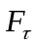 or 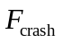).
Question 4 (15 points)
Compare the ratio 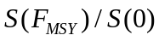 across different values for steepness for the Ricker, Beverton-Holt and Pella-Tomlinson forms. The target depletion for many west coast groundfish resources, including widow rockfish, is 0.4S(0). Comment on the implications of your results for how west coast groundfish species are managed. Hint: you may wish to review some recent groundfish stock assessments.

Hints:
- Develop separate functions to calculate the numbers-at-age matrix, yield-per-recruit and spawner biomass-per-recruit before writing code to implement Equation 9.
- Use defaults in your function definition / pass a code for the stock-recruitment relationship to each function.
- Show your results for Question 3 by the results when steepness is 0.5 (Figures for each form for the stock-recruitment relationship; Tables of estimates of F_{MSY}, MSY, and ).
- Show your results for Question 4 by a plot with three panels (one for each stock-recruitment relationship) and a table of against steepness values from 0.25 to 0.95 in steps of 0.05.
- Think about ways of testing your functions when you are coding them.
- Base your tests on the data for widow rockfish off the U.S. west coast (Table 1). Assume that =1 for your calculations.

Table 1. Biological parameters for widow rockfish (Alec MacCall, NWFS, pers. commn). M for widow rockfish is assumed to 0.15yr⁻¹ for all ages.

Age | Fecundity | Weight  (f) | Weight  (m) | Selec  (f) | Selec  (m)
0 | 0.0000 | 0.0000 | 0.0000 | 0.0000 | 0.0000
1 | 0.0000 | 0.0000 | 0.0000 | 0.0000 | 0.0000
2 | 0.0000 | 0.0000 | 0.0000 | 0.0000 | 0.0000
3 | 0.0001 | 0.2606 | 0.3034 | 0.0006 | 0.0006
4 | 0.0002 | 0.3824 | 0.4101 | 0.0057 | 0.0056
5 | 0.0150 | 0.5161 | 0.5157 | 0.0548 | 0.0542
6 | 0.0642 | 0.6546 | 0.6153 | 0.3626 | 0.3598
7 | 0.1612 | 0.7922 | 0.7062 | 0.8465 | 0.8449
8 | 0.2766 | 0.9249 | 0.7871 | 0.9981 | 0.9982
9 | 0.3687 | 1.0499 | 0.8580 | 0.9636 | 0.9628
10 | 0.4412 | 1.1659 | 0.9192 | 0.9050 | 0.9029
11 | 0.5085 | 1.2719 | 0.9717 | 0.8477 | 0.8445
12 | 0.5666 | 1.3678 | 1.0162 | 0.7939 | 0.7897
13 | 0.6188 | 1.4538 | 1.0540 | 0.7433 | 0.7382
14 | 0.6652 | 1.5305 | 1.0857 | 0.6953 | 0.6894
15 | 0.7064 | 1.5985 | 1.1123 | 0.6491 | 0.6427
16 | 0.7428 | 1.6585 | 1.1346 | 0.6041 | 0.5972
17 | 0.7747 | 1.7114 | 1.1532 | 0.5593 | 0.5522
18 | 0.8028 | 1.7577 | 1.1687 | 0.5139 | 0.5068
19 | 0.8274 | 1.7983 | 1.1816 | 0.4670 | 0.4601
20 | 0.8839 | 1.8916 | 1.2089 | 0.4180 | 0.4117

