Instructions for using the RESSForLabMA and RESSForLabPS UMATs in Abaqus
  - A Hartloper, 3 September 2018

Model Usage
The RESSForLab material is an update to the nonlinear isotropic/kinematic material model in Abaqus (Dassault Systèmes 2014) to simulate the response of mild steel materials under cyclic loading. The implementation is based on the nonlinear isotropic/kinematic material model proposed by Lemaitre and Chaboche (1990), that is updated to take into account the discontinuous yielding phenomenon that is observed in mild steels. The DInf and a parameters constitute the updates to the Chaboche model. The -MA suffix is to be used with general 3D stress states (e.g., solid elements), while the -PS suffix is to be used with plane-stress stress states (e.g., shell elements).

The parameters to define are as follows:
- E Elastic modulus of the steel material.
- nu Poisson’s ratio.
- fy Initial yield stress of the steel material.
- QInf Maximum increase in yield stress due to cyclic hardening (isotropic hardening).
- b Isotropic hardening saturation rate, b > 0.
- DInf Difference between initial and steady-state yield stresses, to neglect the model updates set DInf = 0.
- a Saturation rate of yield stress difference, a > 0. If DInf == 0, then a is arbitrary (but still a > 0).
- C1 Kinematic hardening parameter associated with backstress component 1, at least 1 backstress needs to be defined (set C1 = 0 for no kinematic hardening).
- gamma1 Saturation rate of kinematic hardening associated with backstress component 1.
- <C2 gamma2 C3 gamma3 … CN gammaN> Additional backstress parameters, must be compatible the number of specified mechanical constants. If C is specified, then the corresponding gamma must also be specified.

Using the RESSForLab UMAT
- Ensure that you have correctly set-up the Fortran compiler with Abaqus to run user subroutines
- Make a user defined material behavior “General -> User Material”, the user material should be of type “Mechanical”
  - Set the 9 + 2(N-1) material properties as “Mechanical constants” in the order listed above, where N is the number of backstresses
- In the material behaviors, assign space for the internal variables using “General -> Depvar”
  - The stored variables are the equivalent plastic strain, plastic strain vector and the backstress components (vectors)
  - Set “Number of solution-dependent state variables” as follows:
    - RESSForLabPS: 4 + 3*N
    - RESSForLabMA: 7 + 6*N
- In the Job for the analysis, specify the location of the “RESSForLabMA.for” or “RESSForLabPS.for” file in the “General -> User subroutine file” field
- If you are using reduced integration elements (e.g., S4R, C3D8R) then use the “enhanced hourglass control”
  - Go to “Element Type”, then choose Hourglass Control > Enhanced for all the elements that will be assigned the UMAT
- If you are using shell elements then set the transverse shear stiffness as follows:
  - Under Sections > Edit Section, under the Advanced tab, in the Transverse Shear Stiffnesses box check “Specify Values”
  - Set K11 = 5/6 * G * t, K12 = 0, K22 = 5/6 * G * t, where G = E / (2 * (1 + nu)) is the shear modulus of the material, and t is the thickness of the section

Model Parameters
The parameters of RESSForLabMA(PS) can be obtained for specific materials if coupon data is available. Sousa and Lignos (2017) implemented a preconditioned Newton-Trust Region (NTR) optimization scheme to calibrate the Chaboche model parameters from an arbitrary number of coupon tests. Alternatively, if coupon data is not available, parameters for common steel materials are provided Sousa and Lignos (2017). No procedure exists at the moment to calibrate the DInf and a parameters.

Examples

Input parameters, Chaboche material model
Assume an S355 steel with an elastic modulus of 179800.0 MPa, Poisson’s ratio of 0.3, and yield stress of 318.5 MPa. The hardening parameters for this steel are: QInf = 100.7, b = 8.0, C1 = 11608.2, gamma1 = 145.2, C2 = 1026.0, gamma2 = 4.7. Note that DInf = 0.0, and a = 1.0.

Using these properties, Figures 1a and b show the stress-strain response for a cyclic biaxial displacement history applied to unit solid and unit shell elements, respectively. There is very good agreement when comparing the response of the UMAT with that of the equivalent built-in nonlinear isotropic/kinematic material model in Abaqus (Dassault Systèmes 2014). The relative error is less than 0.1% over the entire loading histories in these two cases.

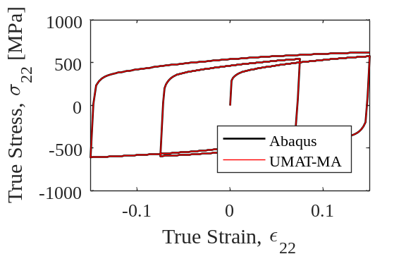 | 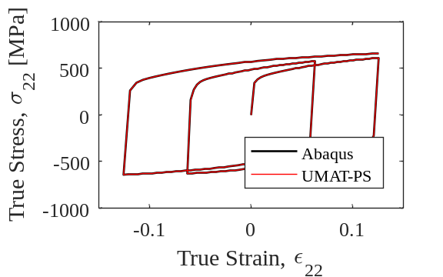
- Unit solid, multiaxial | - Unit shell, plane-stress
Figure 1: Comparison of the RESSForLabMA and RESSForLabPS UMATs in Abaqus with the equivalent nonlinear isotropic/kinematic material model in Abaqus.

Input parameters, updated material model
The uniaxial formulation (RESSForLab) is used to demonstrate the effect of the additional parameters. The material model update is used with DInf = 50.0 MPa, a = 200.0. Correspondingly, the yield stress is increased by 50.0 MPa (to 368.5 MPa). Using the updated material model with these properties, Figure 2b shows the stress-strain response of RESSForLab UMAT with the updated model parameters (Abaqus-UMAT-Upd.) for the same cyclic loading history as previously outlined. Comparing the updated and original models (Abaqus-UMAT) responses, there is a noticeable difference between the models immediately after yielding. However, the response of the two models converge at larger plastic strains as the influence of the discontinuous yield phenomenon diminishes.

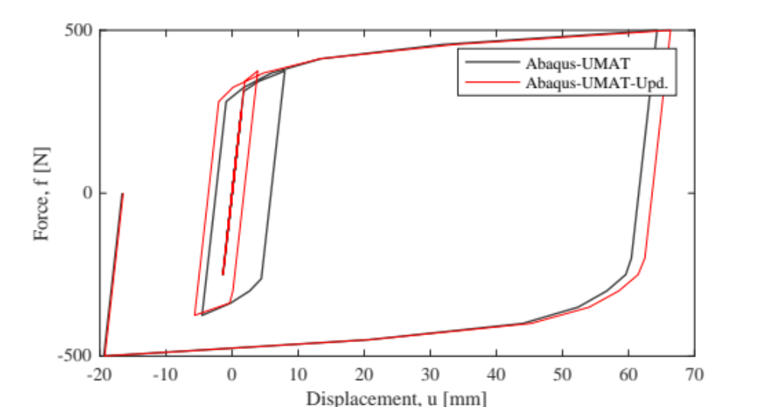
Figure 2: Comparison of updated material model (DInf = 50 MPa, a = 200) with the original model in Abaqus.

References
Dassault Systèmes. (2014). Abaqus Standard and Abaqus Documentation for version 6.14. Dassault Systèmes Simulia Corp., Providence, RI, USA.
Lemaitre, J., and Chaboche, J.-L. (1990). Mechanics of Solid Materials. Cambridge University Press, Cambridge, UK.
Sousa, A., and Lignos, D. G. (2017). On the inverse problem of classic nonlinear plasticity models: An application to cyclically loaded structural steels. Technical Report, EPFL, Resilient steel structures laboratory, Lausanne, Switzerland.

