Bangladesh University of Engineering and Technology
Department of Electrical and Electronic Engineering

EEE 306 (January 2026)
Power System I Laboratory
Final Project Report
Section: B2 Group: 05

Mitigating Transmission Losses and Fast Voltage Stability Index (FVSI) Evaluated Collapse using Genetic Algorithm and Particle Swarm Optimization in PSS®E

Course Instructors:
Azazul Islam, Lecturer, Department of EEE, BUET
Asikul Islam Asik, Lecturer, Department of EEE, BUET

Signature of Instructor: ___________________________________________________

Academic Honesty Statement:
IMPORTANT! Please carefully read and sign the Academic Honesty Statement, below. Type the student ID and name, and put your signature. You will not receive credit for this project experiment unless this statement is signed in the presence of your lab instructor.
“In signing this statement, We hereby certify that the work on this project is our own and that we have not copied the work of any other students (past or present), and cited all relevant sources while completing this project. We understand that if we fail to honor this agreement, We will each receive a score of ZERO for this project and be subject to failure of this course.”
Signature: ______________________________  Full Name: Mahfuz Alam Tonmoy  Student ID: 2206116 | Signature: ______________________________  Full Name: Md. Shibli Noman  Student ID: 2206117
Signature: ______________________________  Full Name: Md. Abdullah Al-Noman  Student ID: 2206118 | Signature: ______________________________  Full Name: Md. Ahasan Habib Kawsar  Student ID: 2206119
Signature: ______________________________  Full Name: Md. Kawsar Ahmed  Student ID: 2206122 | Signature: ______________________________  Full Name: Sadiq Sayeed Raha  Student ID: 2206128
Signature: ______________________________
Full Name: Aritra Chowdhury
Student ID: 2206129

Table of Contents
1 Abstract 1
2 Introduction 1
3 Design 2
3.1 Problem Formulation (PO(b)) 2
3.1.1 Identification of Scope 2
3.1.2 Literature Review 3
3.1.3 Formulation of Problem 3
3.1.4 Analysis 4
3.2 Design Method (PO(a)) 4
3.3 Circuit Diagram 8
3.4 Simulation Model 9
4 Implementation 11
4.1 Description 11
5 Design Analysis and Evaluation 13
5.1 Novelty 13
5.2 Design Considerations (PO(c)) 14
5.2.1 Considerations to public health and safety 14
5.2.2 Considerations to environment 14
5.2.3 Considerations to cultural and societal needs 14
5.3 Investigations (PO(d)) 14
5.3.1 Design of Experiment 14
5.3.2 Data Collection 14
5.3.3 Results and Analysis 15
5.3.4 Interpretation and Conclusions on Data 26
5.4 Limitations of Tools (PO(e)) 27
5.5 Impact Assessment (PO(f)) 27
5.5.1 Assessment of Legal Issues 27
5.6 Sustainability Evaluation (PO(g)) 27
6 Reflection on Individual and Team work (PO(i)) 28
6.1 Individual Contribution of Each Member 28
6.2 Mode of TeamWork 28
6.3 Log Book of Project Implementation 29
7 Communication to External Stakeholders (PO(j)) 29
7.1 Executive Summary 29
7.2 User Manual 29
7.3 Github Link 30
7.4 YouTube Link 30
8 Project Management and Cost Analysis (PO(k)) 30
9 Future Work 30
10 References 30

Abstract
Modern power transmission networks frequently operate near their voltage stability limits due to increasing load demands and restrictive physical transmission capacities. This project develops a metaheuristic optimization framework utilizing Python and the Siemens PSS®E Xplore solver (psspy API) to enhance steady-state voltage stability and minimize active power losses ($P_{loss}$). The framework is applied to the IEEE 14-bus and IEEE 39-bus (New England) transmission systems under heavily stressed base-case conditions. A discrete Genetic Algorithm (GA) optimizes the transformer tap ratios, and a Constriction-Factor Particle Swarm Optimization (PSO) determines the optimal sizing and location of discrete shunt capacitor banks; both controls are tested independently on the same stressed base case. A lexicographic constraint-handling engine strictly prioritizes constraint-violation minimization before active power loss minimization, giving a “Best-Effort” optimization when absolute feasibility ($0.95≤V_{i}≤1.05$ pu) cannot be reached, and the algorithms map continuous search spaces to discrete hardware steps (5.0 MVAr capacitor blocks and discrete transformer taps). The PSO reduced active power loss by 33.2 % on the IEEE 14-bus system (71.03 → 47.42 MW) and by 31.9 % on the IEEE 39-bus system (124.75 → 85.02 MW); the GA reduced it by 12.5 % and 20.5 %. The Fast Voltage Stability Index (FVSI) of the most critical corridor fell from 0.3727 to 0.1208 (IEEE 14) and from 0.2479 to 0.1005 (IEEE 39), while the final states remain “Best-Effort / Infeasible” because of the extreme load profiles.

Introduction
Background. Voltage stability is a fundamental requirement for the secure operation of an interconnected power system. It refers to the ability of a power system to maintain acceptable and stable voltage profiles at all buses under normal operating conditions and after being subjected to a disturbance. In stressed systems, inadequate reactive power ($Q$) support leads to severe voltage sags and increases active power ($I^{2}R$) losses. If the reactive power margin is completely exhausted, the system risks voltage collapse. To mitigate this, power system engineers utilize reactive power compensation devices, specifically discrete shunt capacitors, and optimize transformer tap settings to control reactive power flow.
Problem statement (complex engineering problem). Optimizing transformer taps and placing shunt capacitors is a highly non-linear, mixed-integer and non-convex engineering problem. The decision variables are strictly discrete: capacitors are deployed in fixed hardware modules (5.0 MVAr increments), and transformer taps operate in fixed, predefined step ratios governed by $R_{min}$, $R_{max}$ and the total number of tap positions ($N_{tp}$). Furthermore, reactive power and voltage magnitude are deeply cross-coupled through the Jacobian matrix of the Newton–Raphson power-flow equations: injecting reactive power at one bus non-linearly impacts the voltage at all neighbouring buses, and improperly sized or located compensation can cause localized overvoltages and higher losses.
Alternative solutions and motivation. Traditional analytical methods, such as sensitivity analysis, gradient descent or linear programming, struggle with discrete variables and frequently become trapped in local minima when applied to non-convex power-system problems. Metaheuristic optimization algorithms – specifically the Genetic Algorithm (GA) and Particle Swarm Optimization (PSO) – were therefore used to explore this large combinatorial search space, through a fully automated Python-to-PSS®E framework that avoids load-flow divergence and adheres to physical hardware limits.
Objectives. The specific objectives of this project are to:
1. develop an automated load-flow and stability-assessment pipeline using the Siemens PSS®E API (psspy);
2. calculate the Fast Voltage Stability Index (FVSI) across all branches to identify critical, collapse-prone corridors before and after optimization;
3. implement a discrete Genetic Algorithm (GA) to optimize the existing transformer tap ratios;
4. implement a continuous-to-discrete Particle Swarm Optimization (PSO) to locate and size a user-defined number of discrete shunt capacitor banks;
5. evaluate both algorithms on the IEEE 14-bus and IEEE 39-bus networks using a lexicographic fitness function for infeasible (over-stressed) conditions.
Course outcome mapping. Table 1 lists the EEE 306 course outcomes (CO) and program outcomes (PO) addressed by this project.
Table 1: Course outcome (CO) and program outcome (PO) mapping
CO | Corresponding PO(s) | How this lab and project address it
CO3 | PO(e) | Used Siemens PSS®E as the core power-flow analysis tool to model, simulate and study voltage profiles and losses on the IEEE 14-bus and 39-bus systems.
CO4 | PO(c) | Investigated the impact of modifying transformer taps and adding shunt capacitor banks, then designed the GA/PSO-based system upgrade to correct the identified deficiencies.
CO5 | PO(c), PO(f), PO(g) | Weighed technical feasibility, hardware cost, and environmental/safety impact of voltage violations while formulating the optimization objectives and constraints.
CO6 | PO(i) | Worked as a team, dividing GA development, PSO development, testing and result validation among members throughout the project.
CO7 | PO(j) | Communicated the design, methodology and results through the final presentation and this project report.
CO8 | PO(k) | Managed project milestones and evaluated computational cost, tracking up to 14,400 load-flow evaluations across both algorithms and both test systems.

Design

Problem Formulation (PO(b))

Identification of Scope
• Primary objective: minimize total power transmission loss on a stressed transmission network while restoring bus voltages toward the statutory band $0.95≤V_{i}≤1.05$ pu.
• Control 1 – transformer taps: a discrete Genetic Algorithm (GA) selects the tap position of every adjustable transformer.
• Control 2 – shunt capacitors: a discrete Particle Swarm Optimization (PSO) chooses the location and size of shunt capacitor banks.
• Stability check: every transmission line is screened with the Fast Voltage Stability Index (FVSI) before and after each optimization.
• Validation scope: both controls are tested independently, on the same stressed base case, on the IEEE 14-bus and IEEE 39-bus (New England) systems. Capacitor installation is capped at 50 MVAr per bus for IEEE 14 and 100 MVAr per bus for IEEE 39.

Literature Review
The project is based on the papers collected in our reference folder. Musirin and Abdul Rahman [2] proposed the Fast Voltage Stability Index (FVSI), simplified from a line stability index derived from the voltage quadratic equation of a two-bus line equivalent, to identify the maximum loadability and the weakest lines before voltage collapse. Hassim, Musirin and Abdul Rahman [3] used Evolutionary Programming for optimal reactive power support to enhance the voltage stability margin. Mohammad Kamal, Abdul Rahman and Musirin [4] applied an Improved Genetic Algorithm with elitism to reactive power planning for loss minimisation. Bakirtzis et al. [5] solved the optimal power flow with discrete transformer-tap and switchable-shunt variables using an enhanced GA, and Devaraj and Roselyn [6] used a GA with generator voltages, switchable VAR sources and transformer tap changers as control variables for voltage stability improvement. Nadimi-Shahraki et al. [7] was consulted for transformer tap limits in OPF problems, and Clerc and Kennedy [8] for the constriction-factor PSO used in this work.

Formulation of Problem
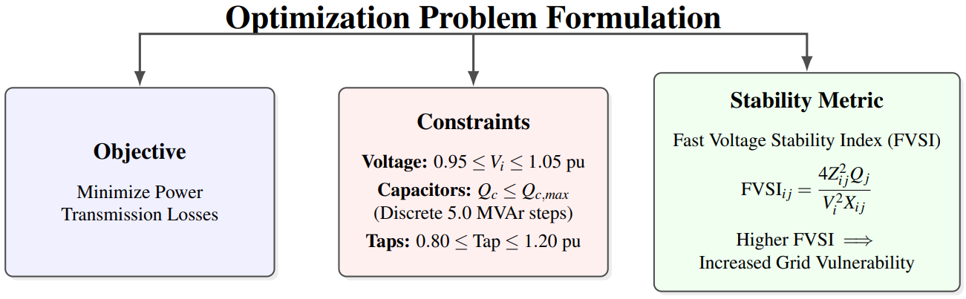
Figure 1: Optimization problem formulation: objective, constraints and stability metric.
Power-flow equations. For any bus $i$ of an $N_{B}$-bus network, the injected active and reactive power must satisfy [1]:
$$P_{i}=P_{Gi}−P_{Di}=\left|V_{i}\right|\sum_{j=1}^{N_{B}}{\left|V_{j}\right|}\left(G_{ij}cosδ_{ij}+B_{ij}sinδ_{ij}\right)$$ | (1)
$$Q_{i}=Q_{Gi}−Q_{Di}=\left|V_{i}\right|\sum_{j=1}^{N_{B}}{\left|V_{j}\right|}\left(G_{ij}sinδ_{ij}−B_{ij}cosδ_{ij}\right)$$ | (2)
where $P_{Gi},Q_{Gi}$ and $P_{Di},Q_{Di}$ are the generated and demanded powers, $V_{i},V_{j}$ the voltage magnitudes, $δ_{ij}=δ_{i}−δ_{j}$, and $G_{ij},B_{ij}$ the conductance and susceptance elements of the nodal admittance matrix $Y_{bus}$. Both networks are solved with the full AC Newton–Raphson method.
Objective function. Minimize the total active power loss over all $N_{L}$ lines, where $G_{k}$ is the conductance of line $k$:
$$\text{Minimize }P_{loss}=\sum_{k=1}^{N_{L}}{G_{k}}\left[V_{i}^{2}+V_{j}^{2}−2V_{i}V_{j}cos\left(δ_{i}−δ_{j}\right)\right]$$ | (3)
Constraints. Bus voltage (statutory limits $V_{min}=0.95$ pu, $V_{max}=1.05$ pu), generator reactive power, transformer tap (GA variables, discrete with $N_{tp}$ positions) and shunt capacitor (PSO variables) constraints, with capacitors installed at a maximum of $K$ locations:
$$V_{min}≤V_{i}≤V_{max} ∀i∈N_{B}$$ | (4)
$$Q_{G,min}≤Q_{Gi}≤Q_{G,max} ∀i∈N_{G}$$ | (5)
$$T_{k,min}≤T_{k}≤T_{k,max} ∀k∈N_{T}$$ | (6)
$$Q_{ci}∈\left\{0, 5.0, 10.0,…,Q_{c,max}\right\} \text{MVAr}, \sum_{i=1}^{N_{PQ}}{\text{count}}\left(Q_{ci}>0\right)≤K$$ | (7)
Stability metric. The Fast Voltage Stability Index of the line between sending bus $i$ and receiving bus $j$ [2]:
$$FVSI_{ij}=\frac{4Z_{ij}^{2}Q_{j}}{V_{i}^{2}X_{ij}}$$ | (8)
where $Z_{ij}$ is the line impedance (pu), $X_{ij}$ the line reactance (pu), $Q_{j}$ the reactive power flowing into the receiving end (pu on a 100 MVA base) and $V_{i}$ the sending-end voltage (pu).

Analysis
FVSI interpretation. $FVSI_{ij}<1.0$ indicates stable operation. As FVSI approaches 1.0, the line’s reactive margin approaches zero and the derivative of the receiving-end voltage with respect to the receiving-end reactive load approaches $−∞$, indicating imminent voltage collapse. Lines with the highest FVSI values therefore dictate the critical locations for reactive support. The FVSI script also reports the actual reactive margin $Q_{margin}=Q_{max}−Q_{base}$ of each line, found by increasing the receiving-end reactive load until the load flow no longer converges.
Lexicographic constraint handling. In highly stressed systems, satisfying all voltage constraints is sometimes impossible with reactive compensation alone, and penalty functions require careful tuning of the penalty factor. Every candidate solution is therefore assigned the fitness tuple
$$\text{Fitness}=\left(\text{Is_Infeasible}, ΔV_{viol}, P_{loss}\right)$$ | (9)
where Is_Infeasible flags a diverged load flow or a voltage outside the band, $ΔV_{viol}$ is the sum of all voltage deviations outside 0.95–1.05 pu and $P_{loss}$ is the active loss in MW. Feasibility is compared first, then violation, then loss. If no feasible solution exists, the search shifts to a “Best-Effort” state with the minimum voltage violation.
Search-space size. With a 100 MVAr limit and 5 MVAr steps, every candidate bus has 21 possible states (0, 5, …, 100 MVAr). Searching 12 sizes gives ${21}^{12}≈7.4×{10}^{15}$ combinations, while all 29 PQ buses of IEEE 39 give ${21}^{29}≈2.2×{10}^{38}$. Each optimization run has a budget of 120 × 120 = 14,400 evaluations, which is why the number of capacitor sites K strongly affects the result (Section 5.3.3).

Design Method (PO(a))
The computational workflow is automated in Python, which interacts directly with the PSS®E engine through the psspy library. This eliminates manual GUI interaction and allows the metaheuristic algorithms to evaluate thousands of candidate power-flow solutions. Figure 2 summarizes the design method.
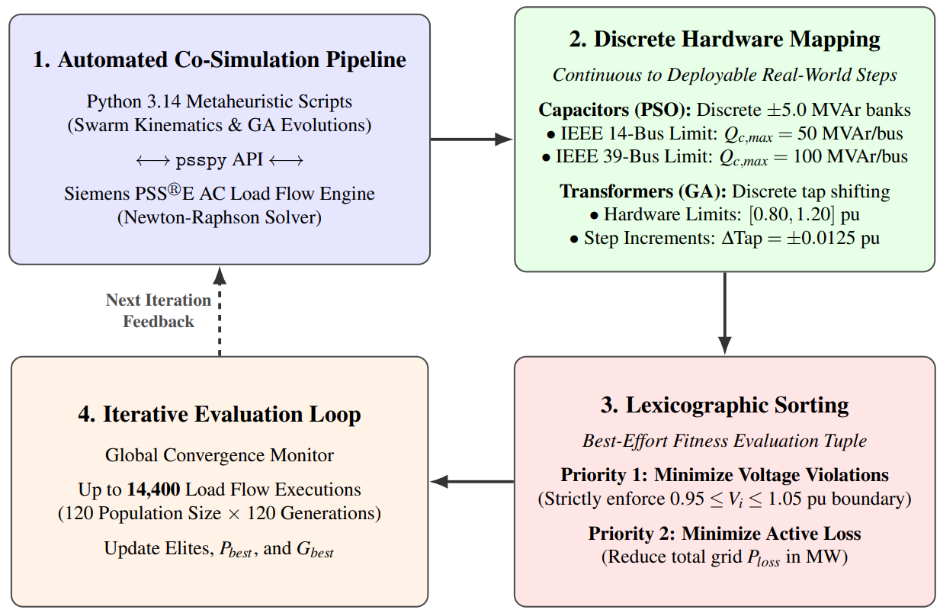
Figure 2: Design method: co-simulation pipeline, discrete hardware mapping, lexicographic sorting and iterative evaluation loop.
Genetic Algorithm (GA) for transformer tap optimization. The algorithm queries the PSS®E case to discover all two-winding transformers and extracts their physical parameters ($R_{min}$, $R_{max}$, $N_{tp}$). A chromosome is an array of integers [idx_1, idx_2, …, idx_n], each pointing to a discrete tap-ratio grid of one transformer. The first chromosome of the initial population is anchored to the existing base-case settings. The parameters are listed in Table 2 and the flowchart in Figure 3.
Table 2: GA operational parameters
Parameter | Value | Functional role
Population size | 120 | Number of candidate grid states evaluated per generation
Generations | 120 | Total iterations, resulting in 14,400 load-flow evaluations
Crossover probability ($P_{c}$) | 0.95 | Encourages mixing of successful tap combinations
Mutation probability ($P_{m}$) | 0.35 | Shifts a tap index by exactly ±1 step to explore adjacent hardware settings
Elitism | 6 | Preserves the top 6 chromosomes unchanged in the next generation
Selection | Tournament, K = 5 | Prevents weak solutions from dominating the mating pool

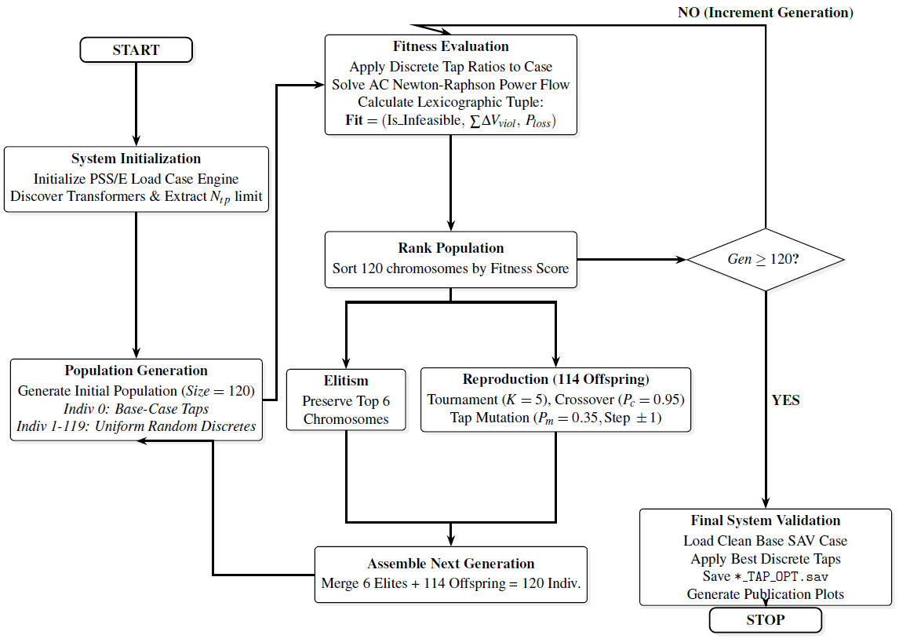
Figure 3: Flowchart of the discrete Genetic Algorithm applied to transformer tap optimization.
Particle Swarm Optimization (PSO) for capacitor sizing. A constriction factor $χ$ is applied to the velocity update to ensure stable convergence without velocity explosion:
$$V_{i}^{k+1}=χ\left[V_{i}^{k}+C_{1}r_{1}\left(P_{best,i}−X_{i}^{k}\right)+C_{2}r_{2}\left(G_{best}−X_{i}^{k}\right)\right], X_{i}^{k+1}=X_{i}^{k}+V_{i}^{k+1}$$ | (10)
$$χ=\frac{2}{\left|2−φ−\sqrt{φ^{2}−4φ}\right|}≈0.7298, φ=C_{1}+C_{2}=4.10$$ | (11)
where $r_{1},r_{2}$ are uniform random vectors, $P_{best,i}$ is the particle’s historical best position and $G_{best}$ the swarm’s global best position. The parameters are listed in Table 3.
Table 3: PSO operational parameters
Parameter | Value | Functional role
Swarm size | 120 | Diversity across the candidate load buses
Max iterations | 120 | Deep search trajectory allowing particles to settle
Acceleration ($C_{1}=C_{2}$) | 2.05 | Balances cognitive (personal) and social (global) learning
Constriction factor ($χ$) | 0.7298 | Damps particle velocity and guarantees convergence
Velocity limit | $0.5×Q_{max}$ | Prevents violent MW/MVAr load-flow oscillations
Discrete step | 5.0 MVAr | Realistic capacitor bank size
Base anchoring | Particle 0 = 0 MVAr | Preserves the base network state as a performance floor

Continuous-to-discrete mapping. The decode_position() function (i) selects the top K magnitudes of the continuous position vector as the installation sites, (ii) rounds them to the nearest multiple of 5.0 MVAr and (iii) clips them between 0 and $Q_{max}$. Clipping at 0 allows the algorithm to decide that no capacitor is required at a bus (Figure 4):
def decode_position(continuous_pos, num_capacitors, max_mvar):
discrete_pos = np.zeros_like(continuous_pos)
top_indices = np.argsort(continuous_pos)[-num_capacitors:]
for idx in top_indices:
val = np.round(continuous_pos[idx] / STEP_MVAR) * STEP_MVAR
val = np.clip(val, 0.0, max_mvar)
discrete_pos[idx] = val
return discrete_pos

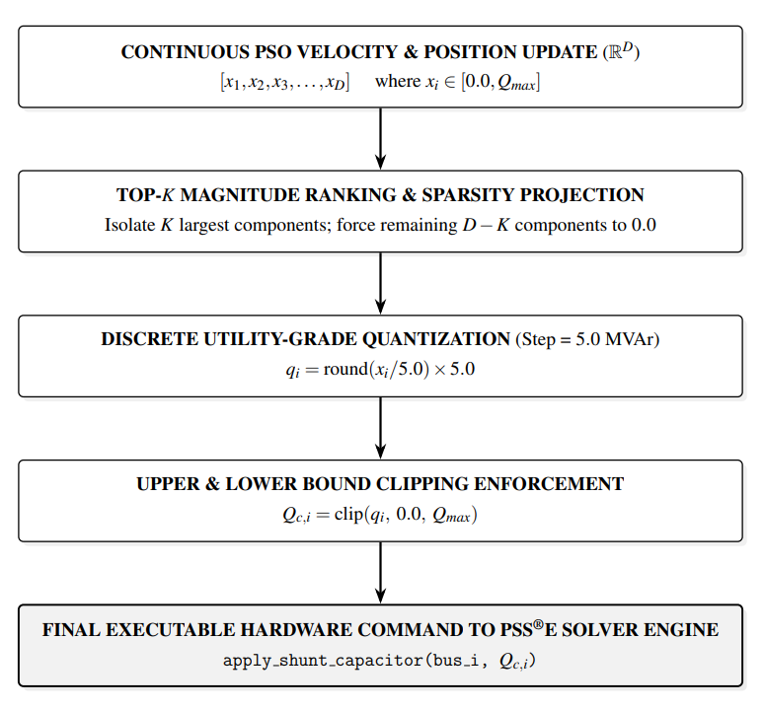
Figure 4: Continuous-to-discrete mapping of the PSO position vector to capacitor hardware.
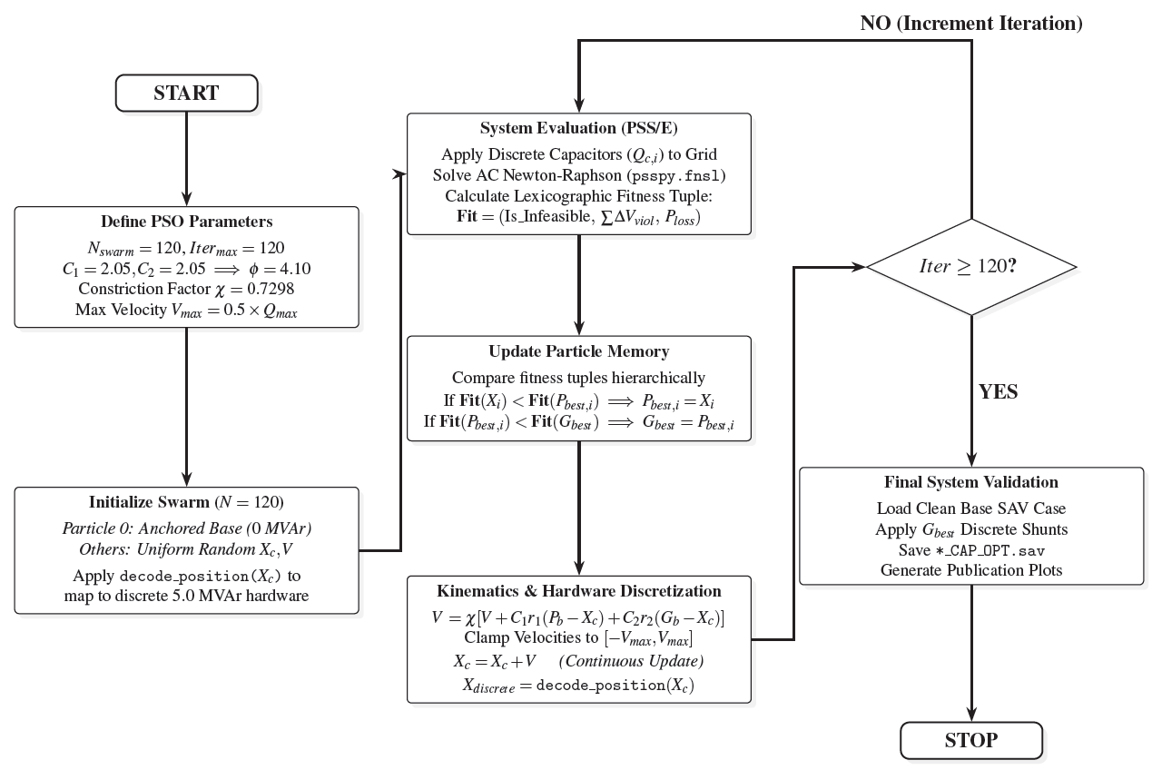
Figure 5: Flowchart of the Constriction-Factor Particle Swarm Optimization for discrete capacitor allocation.

Circuit Diagram
IEEE 14-bus system: a tightly coupled sub-transmission loop with 14 buses (5 generator/synchronous-condenser buses and 9 PQ load buses), 17 transmission lines and 3 tap-changing transformers on branches 4–7, 4–9 and 5–6 (Figure 6).
IEEE 39-bus system (New England): a bulk transmission grid with 39 buses (10 generator buses and 29 PQ load buses) and 46 branches (34 transmission lines and 12 two-winding transformers with tap-ratio adjustment) (Figure 7).
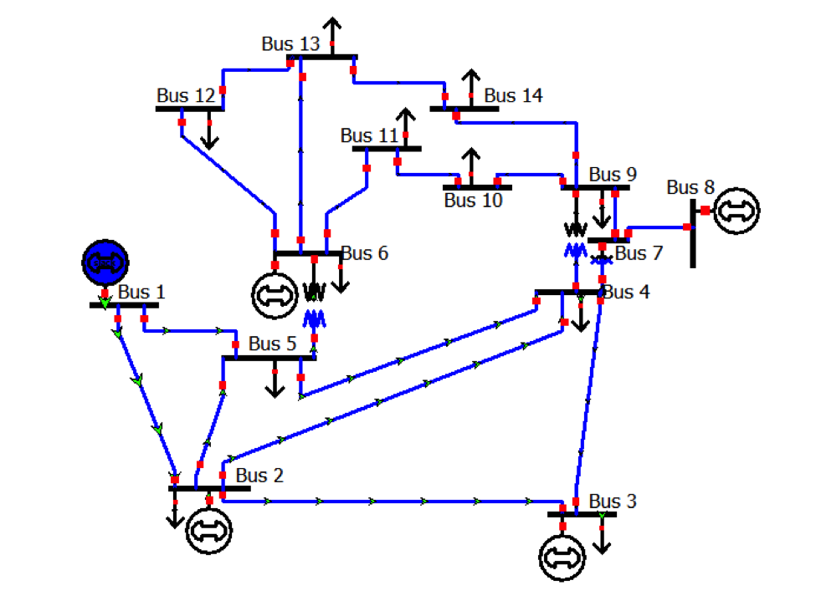
Figure 6: IEEE 14-bus network schematic.
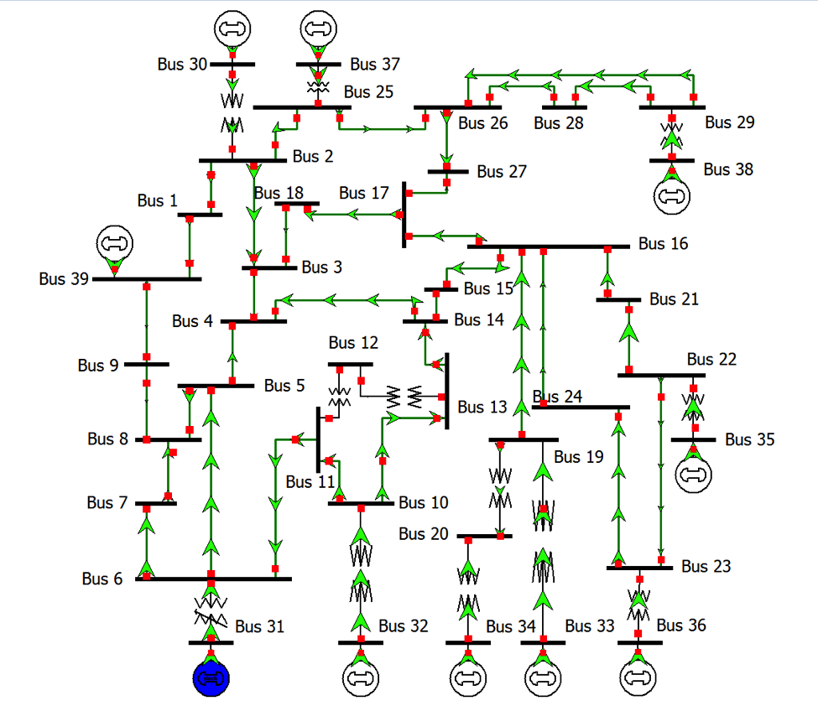
Figure 7: IEEE 39-bus (New England) network schematic.

Simulation Model
The engine links the Python optimization layer with the AC power-flow solver of Siemens PTI PSS®E Xplore (v36) through psspy and redirect [9] (Figure 8). Manual GUI execution is not viable: 120 iterations with a population of 120 require 14,400 independent, fully converged AC load flows per study. PSS®E is initialized as follows, with the terminal output streams suppressed:
def initialize_psse():
redirect.psse2py()
psspy.psseinit(80000)
psspy.progress_output(2, "NUL", [0, 0])
psspy.alert_output(2, "NUL", [0, 0])
psspy.prompt_output(2, "NUL", [0, 0])

Every evaluation reloads the base .sav case, applies the candidate taps (psspy.two_winding_chng_6) or capacitors (psspy.shunt_data), and solves the full Newton–Raphson load flow with psspy.fnsl([0,0,0,0,1,0,0,0]); a case for which psspy.solved() is not 0 is treated as diverged and penalized in the fitness evaluator.
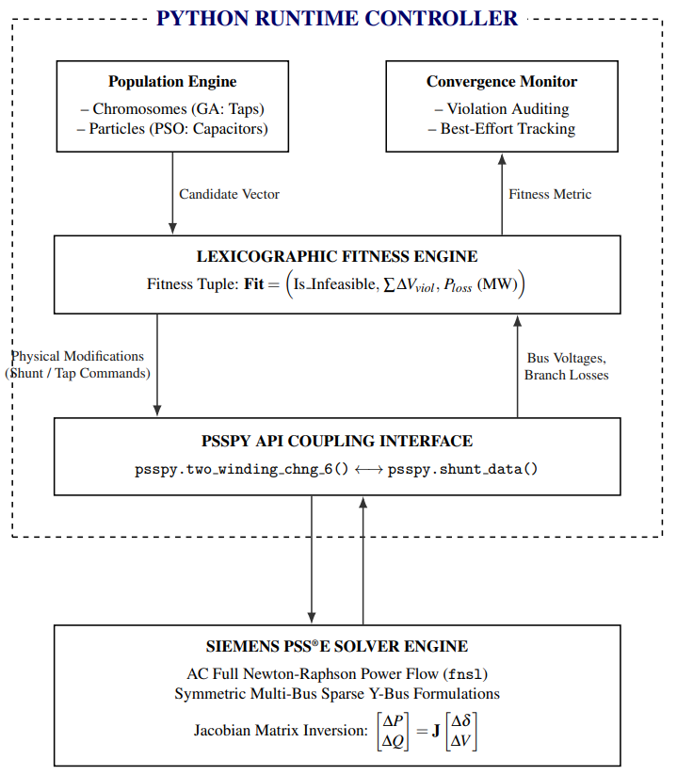
Figure 8: Python–PSS®E co-simulation platform architecture.
FVSI engine. Before optimization, FVSI-Collapse Analysis.py screens the baseline grid: it extracts the bus voltages and branch data, determines the power-flow direction, computes the FVSI of every active branch, then raises the receiving-end reactive load in 3 MVAr steps until the Newton–Raphson solver fails, giving $Q_{max}$ and $Q_{margin}$, and finally ranks all corridors by FVSI (Figure 9). The same script is re-run on the optimized cases.
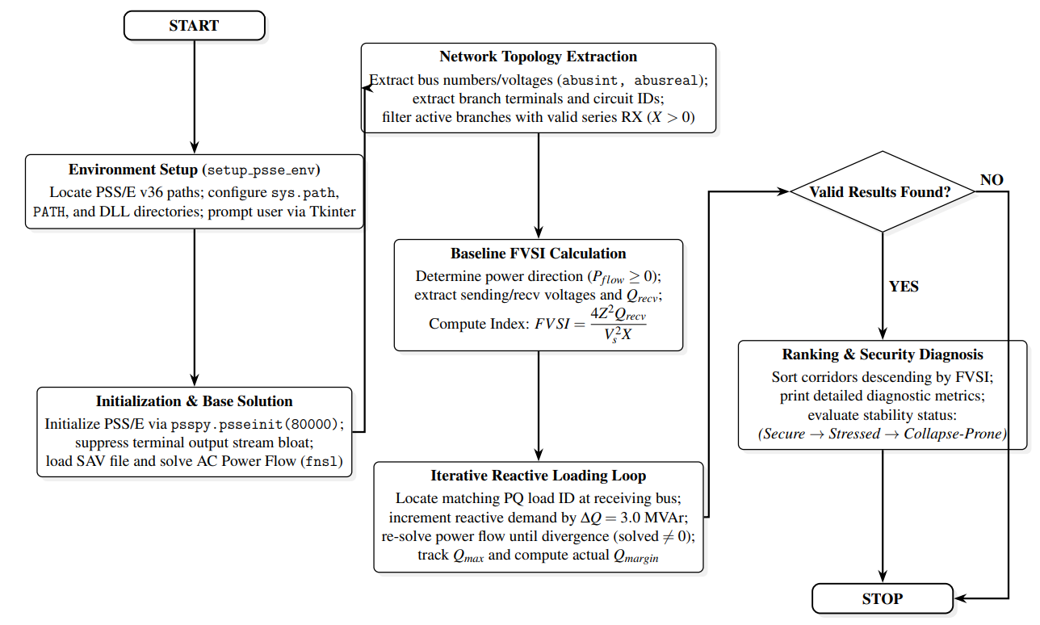
Figure 9: Fast Voltage Stability Index (FVSI) evaluation flowchart.
Load stressing. The baseline systems were driven into heavily stressed states by manually increasing the reactive power demand (MVAr) at critical load buses. After each increase the PSS®E load flow was solved and the FVSI script executed; the reactive load was increased until the FVSI of the weakest corridor increased and the reactive margin reported in the console approached 0.0 MVAr. This established a boundary condition just short of voltage collapse for testing the GA and PSO.

Implementation

Description
The design is implemented in three Python programs; the full source code, the PSS®E cases and all result files are available in the project GitHub repository (Section 7.3):
• FVSI-Collapse Analysis.py – FVSI ranking and reactive-margin ($Q_{max}$, $Q_{margin}$) of every loaded line;
• IEEEtxfTapGE.py – discrete GA for transformer tap ratios; saves *_TAP_OPTIMIZED.sav and the result plots;
• PSOcapacitor.py – discrete PSO for shunt capacitors; asks for the maximum number of capacitors and the maximum MVAr per installation, and saves *_CAPACITOR_OPTIMIZED.sav, Optimization_Report.txt and the result plots.
The runs carried out are listed in Table 4.
Table 4: Simulation runs
System | Program | Settings | Output
IEEE 14-bus | FVSI-Collapse Analysis.py | Base, after GA, after PSO | FVSI ranking, $Q_{margin}$
IEEE 14-bus | IEEEtxfTapGE.py | 3 transformers, 120 × 120 | Tap settings, losses, voltages
IEEE 14-bus | PSOcapacitor.py | 3 capacitors, 50 MVAr max | Capacitor plan, losses, voltages
IEEE 14-bus | PSOcapacitor.py | 9 capacitors (all PQ), 50 MVAr max | Capacitor plan, losses, voltages
IEEE 39-bus | FVSI-Collapse Analysis.py | Base, after GA, after PSO | FVSI ranking, $Q_{margin}$
IEEE 39-bus | IEEEtxfTapGE.py | 12 transformers, 120 × 120 | Tap settings, losses, voltages
IEEE 39-bus | PSOcapacitor.py | 12 capacitors, 100 MVAr max | Capacitor plan, losses, voltages
IEEE 39-bus | PSOcapacitor.py | 29 capacitors (all PQ), 100 MVAr max | Capacitor plan, losses, voltages

The convergence curves produced by the programs are shown in Figures 10 and 11. In all runs no strictly feasible solution was found, so the curves show the best-effort trajectory of the active power loss.
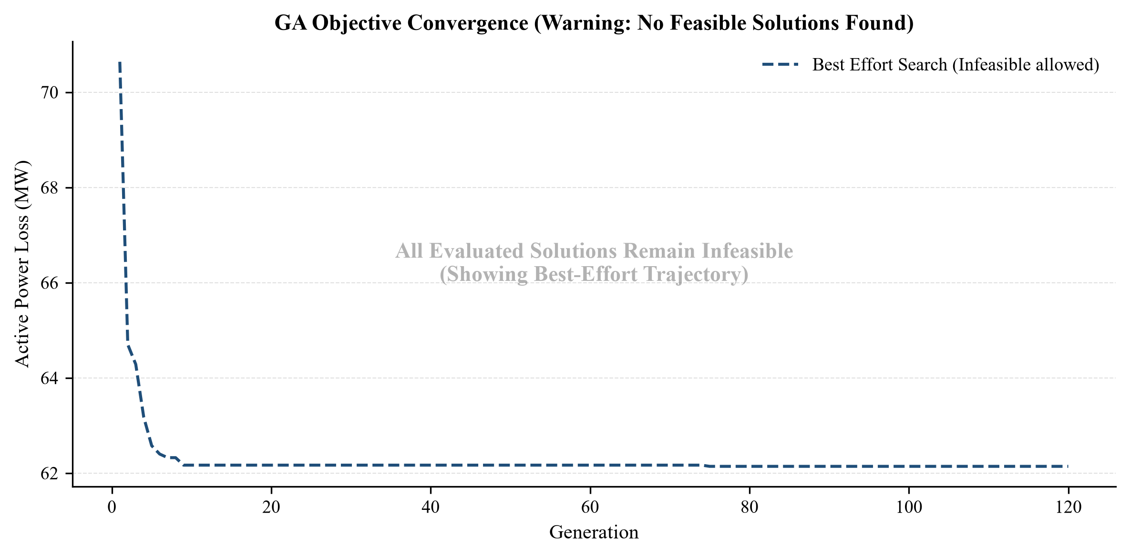
(a)
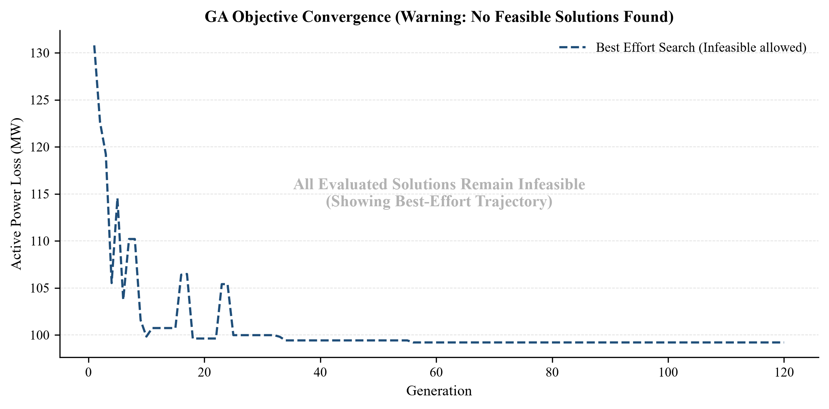
(b)
Figure 10: GA objective convergence: (a) IEEE 14-bus, (b) IEEE 39-bus.
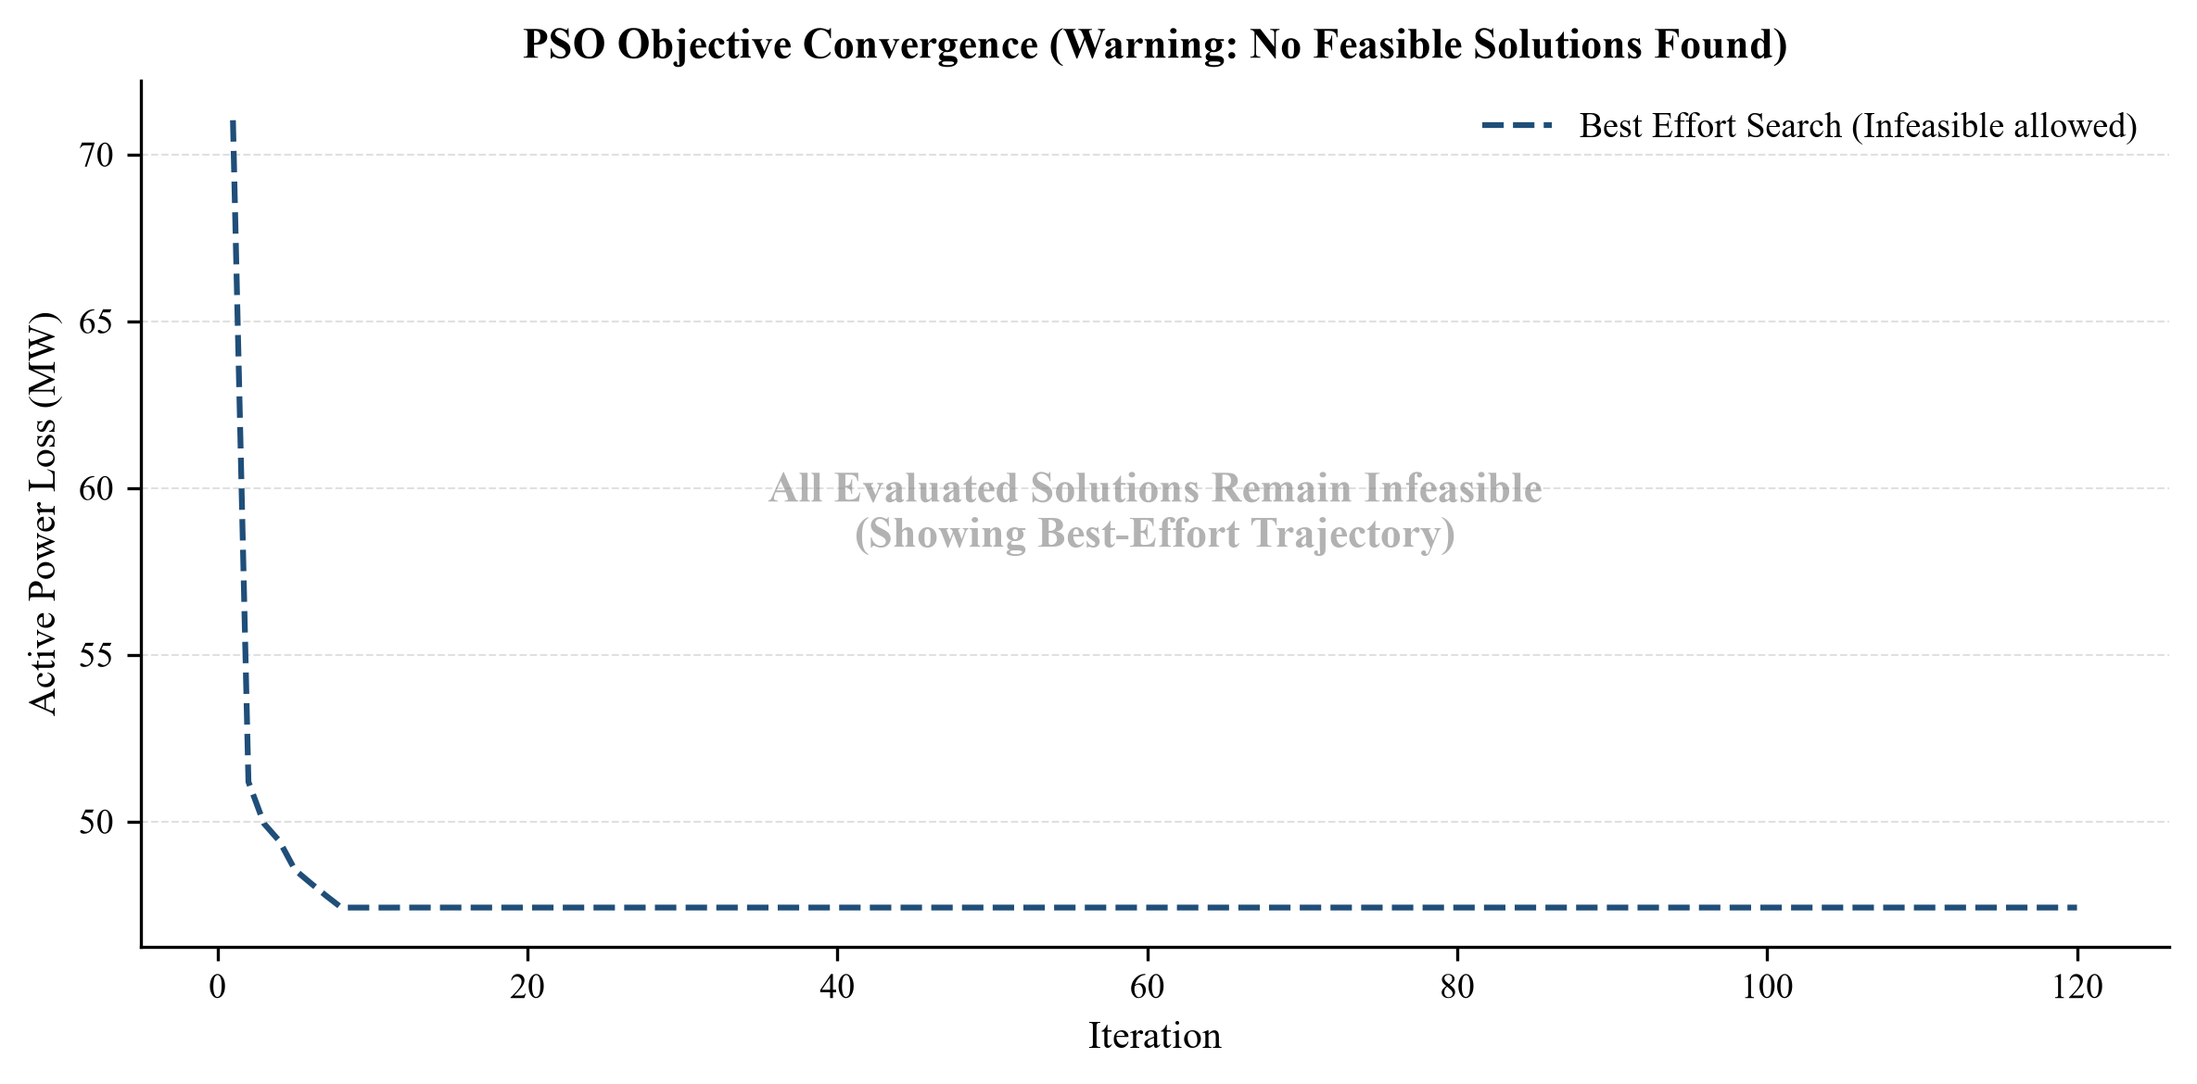
(a)
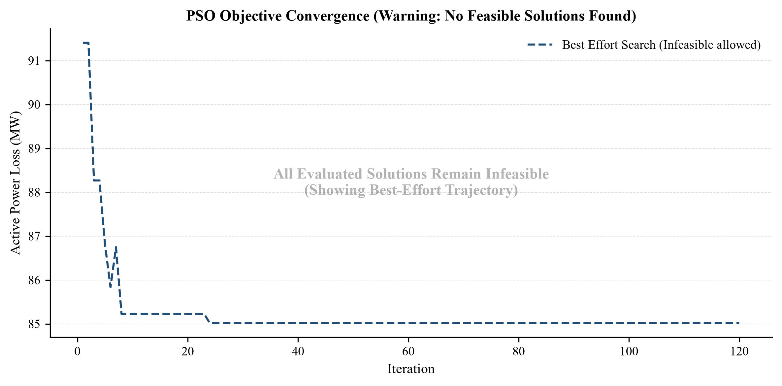
(b)
Figure 11: PSO objective convergence: (a) IEEE 14-bus (3 capacitors), (b) IEEE 39-bus (12 capacitors).

Design Analysis and Evaluation

Novelty
Traditional reactive power dispatch methods rely on continuous variables and gradient-based derivatives, which frequently fail in highly stressed networks. The novelty of this project is a fully automated Python–PSS®E co-simulation platform that strictly enforces discrete, utility-grade hardware constraints (5.0 MVAr capacitor steps and discrete transformer tap ratios) during the search. The lexicographic “Best-Effort” constraint-handling engine allows the algorithms to work in infeasible grid states by prioritizing voltage-security restoration above active-loss reduction.

Design Considerations (PO(c))

Considerations to public health and safety
Voltage collapse can trigger cascading regional blackouts, disabling critical infrastructure such as hospitals, emergency response networks and water purification facilities. By strategically deploying reactive support at critical nodes, the Constriction-Factor PSO raised the severe baseline undervoltage of 0.8193 pu on the IEEE 39-bus system to a minimum of 0.9820 pu, bringing every load bus into the 0.95–1.05 pu band and directly reducing the blackout risk.

Considerations to environment
Every megawatt of transmission loss must be generated. The reduction in active power loss (39.73 MW in the IEEE 39-bus system and 23.61 MW in the IEEE 14-bus system with the PSO) directly reduces fuel consumption at the generator buses (Section 5.6).

Considerations to cultural and societal needs
Modern society relies on uninterrupted electrical power. The optimization ensures that weak load pockets receive better-quality voltage – for example, Bus 4 of the IEEE 14-bus system was raised from 0.7833 pu to 0.9525 pu by the PSO – which prevents damage to consumer electronics and industrial motors.

Investigations (PO(d))

Design of Experiment
Both test systems were first driven into a heavily stressed base case (Section 3.4). On each stressed case: (i) the FVSI script was run to rank the critical lines, (ii) the GA optimized the transformer taps, (iii) the PSO optimized the capacitor locations and sizes, each starting from the same stressed base case, and (iv) the FVSI script was re-run on the optimized cases. The PSO was run with a limited number of capacitors (3 for IEEE 14, 12 for IEEE 39) and with all PQ buses allowed (9 and 29). The compared quantities are active and reactive losses, minimum and maximum voltage, total voltage violation, FVSI and reactive margin.

Data Collection
All values below are taken from the program outputs (Optimization_Report.txt and the FVSI console logs). Table 5 summarizes the stressed base cases.
Table 5: Baseline load-flow and operating parameters
Operational parameter | IEEE 14-bus (stressed base) | IEEE 39-bus (stressed base)
Total active generation (MW) | 507.0703 | 8500.3398
Total reactive generation (MVAr) | 413.3333 | 5909.6392
Total active load (MW) | 436.0036 | 8375.5898
Total reactive load (MVAr) | 144.5947 | 1902.1029
Active power loss (MW) | 71.0311 | 124.7506
Reactive power loss (MVAr) | 296.6196 | 5210.9014
Minimum bus voltage (pu) | 0.6474 (Bus 14) | 0.8193 (Bus 7)
Maximum bus voltage (pu) | 1.0600 (Bus 1) | 1.0635 (Bus 36)
Total voltage violation (pu) | 2.6229 | 1.0267
Statutory feasibility status | NON-COMPLIANT | NON-COMPLIANT

Table 6 gives the ten most stressed lines found by the FVSI script for each stressed base case.
Table 6: Branch stability ranking via FVSI (stressed base cases)
Rank | IEEE 14 line | FVSI | $Q_{margin}$ (MVAr) | IEEE 39 line | FVSI | $Q_{margin}$ (MVAr)
1 | 1–5 | 0.3727 | 0.0000 | 2–3 | 0.2479 | 0.0000
2 | 1–2 | 0.2492 | 3.7302 | 19–16 | 0.2015 | 1.0590
3 | 7–9 | 0.2229 | 0.0000 | 29–26 | 0.1841 | 0.9427
4 | 2–5 | 0.2214 | 0.0000 | 22–21 | 0.1297 | 1.5741
5 | 2–4 | 0.1829 | 0.0000 | 28–26 | 0.1283 | 0.9522
6 | 6–13 | 0.1671 | 0.0000 | 23–24 | 0.1147 | 0.7568
7 | 9–14 | 0.1555 | 0.0000 | 26–27 | 0.1023 | 1.3593
8 | 6–11 | 0.1402 | 0.0000 | 14–4 | 0.0731 | 0.0000
9 | 13–14 | 0.1388 | 0.0000 | 21–16 | 0.0584 | 0.7362
10 | 6–12 | 0.1117 | 0.0000 | 1–39 | 0.0553 | 0.0000

In the IEEE 14-bus network, Line 1–5 has the highest FVSI (0.3727) with a reactive margin of 0.00 MVAr; in the IEEE 39-bus network, Line 2–3 is the primary bottleneck (FVSI 0.2479, margin 0.00 MVAr). These lines can absorb no more reactive load before the load flow fails to converge. The bus voltages of the stressed cases are listed with the results in Tables 8 and 10.

Results and Analysis
(a) GA – IEEE 14-bus tap optimization.
Table 7: IEEE 14-bus transformer tap settings before and after GA
Transformer | Base tap ratio (pu) | Optimized tap ratio (pu) | Change (pu)
4–7 | 0.9780 | 0.8797 | -0.0983
4–9 | 0.9690 | 0.9486 | -0.0204
5–6 | 0.9320 | 0.8734 | -0.0586

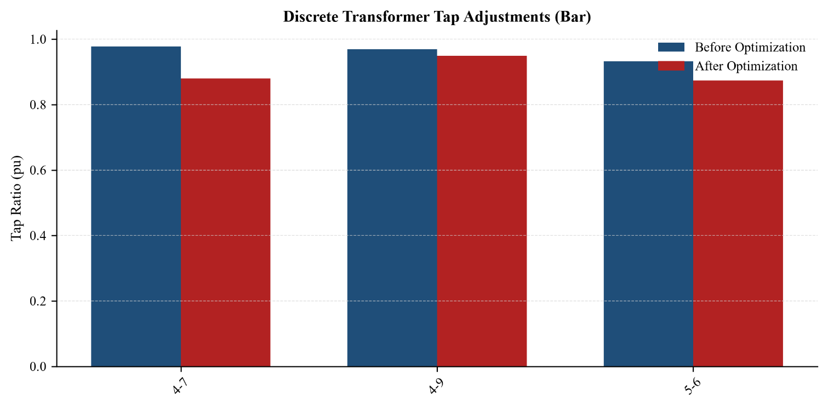
(a)
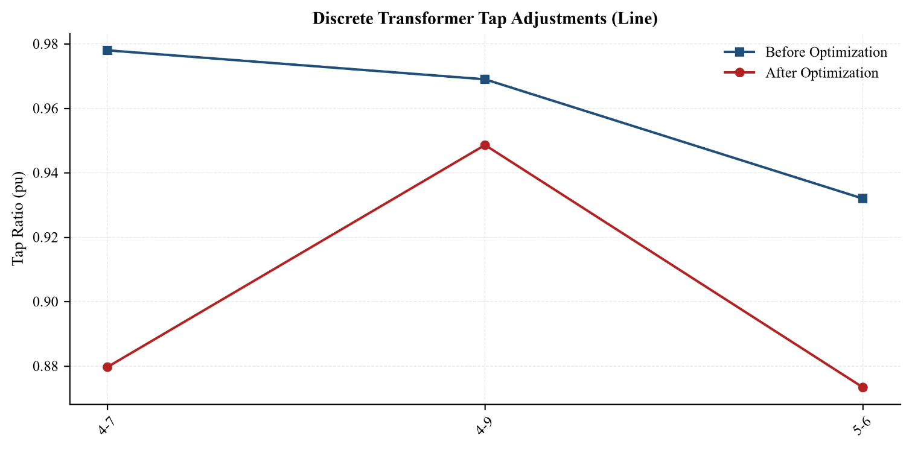
(b)
Figure 12: IEEE 14-bus discrete transformer tap adjustments: (a) bar, (b) line.
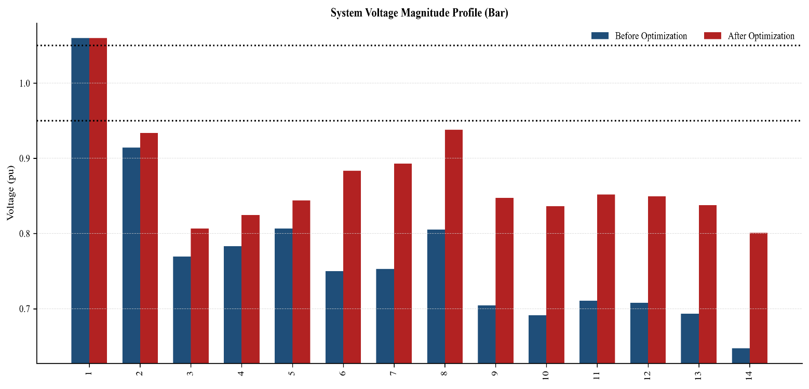
(a)
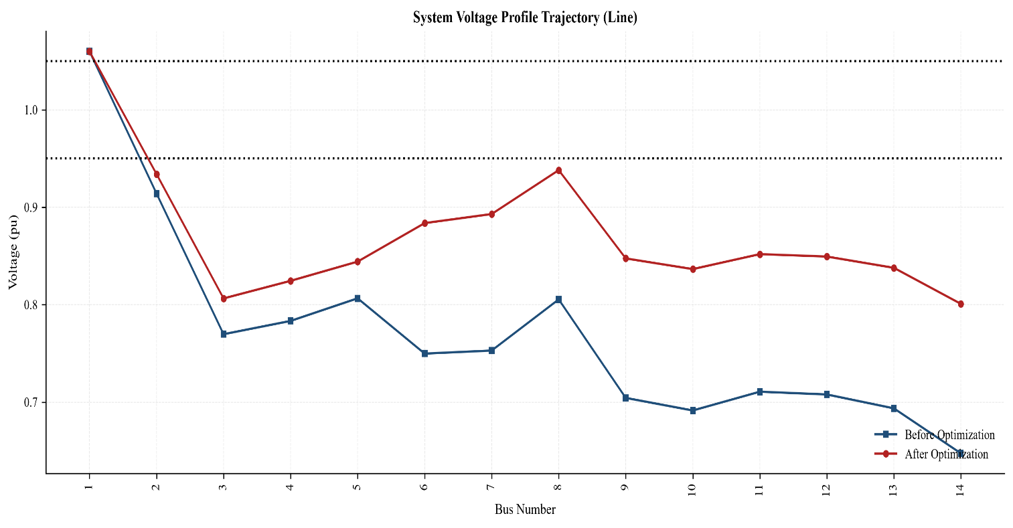
(b)
Figure 13: IEEE 14-bus voltage profile before and after GA: (a) bar, (b) line.
Table 8: IEEE 14-bus individual bus voltages (base, after GA, after PSO)
Bus | Base (pu) | After GA (pu) | After PSO (pu) | Bus | Base (pu) | After GA (pu) | After PSO (pu)
1 | 1.0600 | 1.0600 | 1.0600 | 8 | 0.8054 | 0.9381 | 1.0070
2 | 0.9141 | 0.9341 | 0.9940 | 9 | 0.7043 | 0.8475 | 0.9332
3 | 0.7697 | 0.8064 | 0.9152 | 10 | 0.6914 | 0.8365 | 0.9229
4 | 0.7833 | 0.8245 | 0.9525 | 11 | 0.7107 | 0.8519 | 0.9357
5 | 0.8065 | 0.8442 | 0.9619 | 12 | 0.7079 | 0.8494 | 0.9326
6 | 0.7498 | 0.8837 | 0.9635 | 13 | 0.6936 | 0.8378 | 0.9224
7 | 0.7529 | 0.8930 | 0.9650 | 14 | 0.6474 | 0.8008 | 0.8905

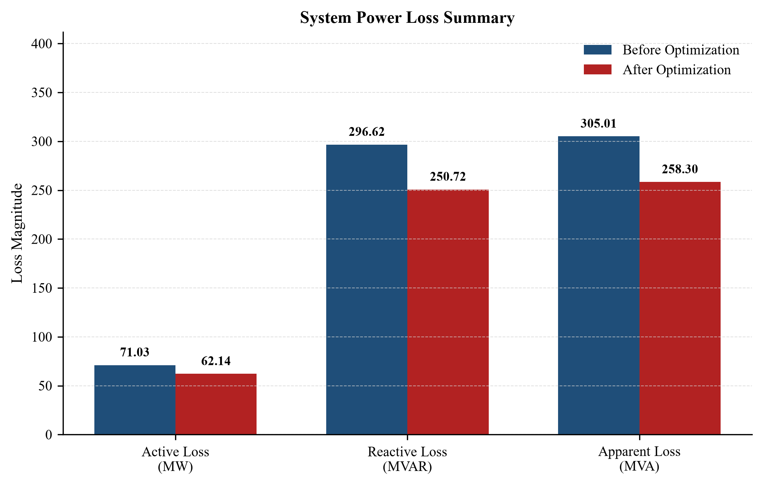
Figure 14: IEEE 14-bus system power loss summary before and after GA.
The GA lowered all three taps; the largest change was at transformer 4–7 (0.9780 → 0.8797). Active power loss fell from 71.03 MW to 62.14 MW (−12.51 %), reactive loss from 296.62 to 250.72 MVAr (−15.47 %), and the total voltage violation from 2.6229 to 1.2121 pu (−53.79 %). The minimum voltage at Bus 14 rose from 0.6474 to 0.8008 pu (+23.70 %). Because many load buses remain below 0.95 pu, the final state is Best-Effort / Infeasible: discrete tap shifting alone cannot fully rescue this heavily stressed grid.
(b) GA – IEEE 39-bus tap optimization.
Table 9: IEEE 39-bus transformer tap settings before and after GA
Transformer | Base tap ratio (pu) | Optimized tap ratio (pu) | Change (pu) | Direction
2–30 | 1.0250 | 1.0857 | +0.0607 | Boost
6–31 | 0.8571 | 0.8000 | -0.0571 | Buck
10–32 | 1.0700 | 1.0286 | -0.0414 | Buck
11–12 | 1.0060 | 1.0857 | +0.0797 | Boost
12–13 | 1.0060 | 1.0857 | +0.0797 | Boost
19–20 | 1.0600 | 1.0857 | +0.0257 | Boost
19–33 | 1.0700 | 1.1429 | +0.0729 | Boost
20–34 | 1.0090 | 1.0286 | +0.0196 | Boost
22–35 | 1.0250 | 1.0286 | +0.0036 | Boost
23–36 | 1.0000 | 1.0286 | +0.0286 | Boost
25–37 | 1.0250 | 1.0286 | +0.0036 | Boost
29–38 | 1.0250 | 1.0286 | +0.0036 | Boost

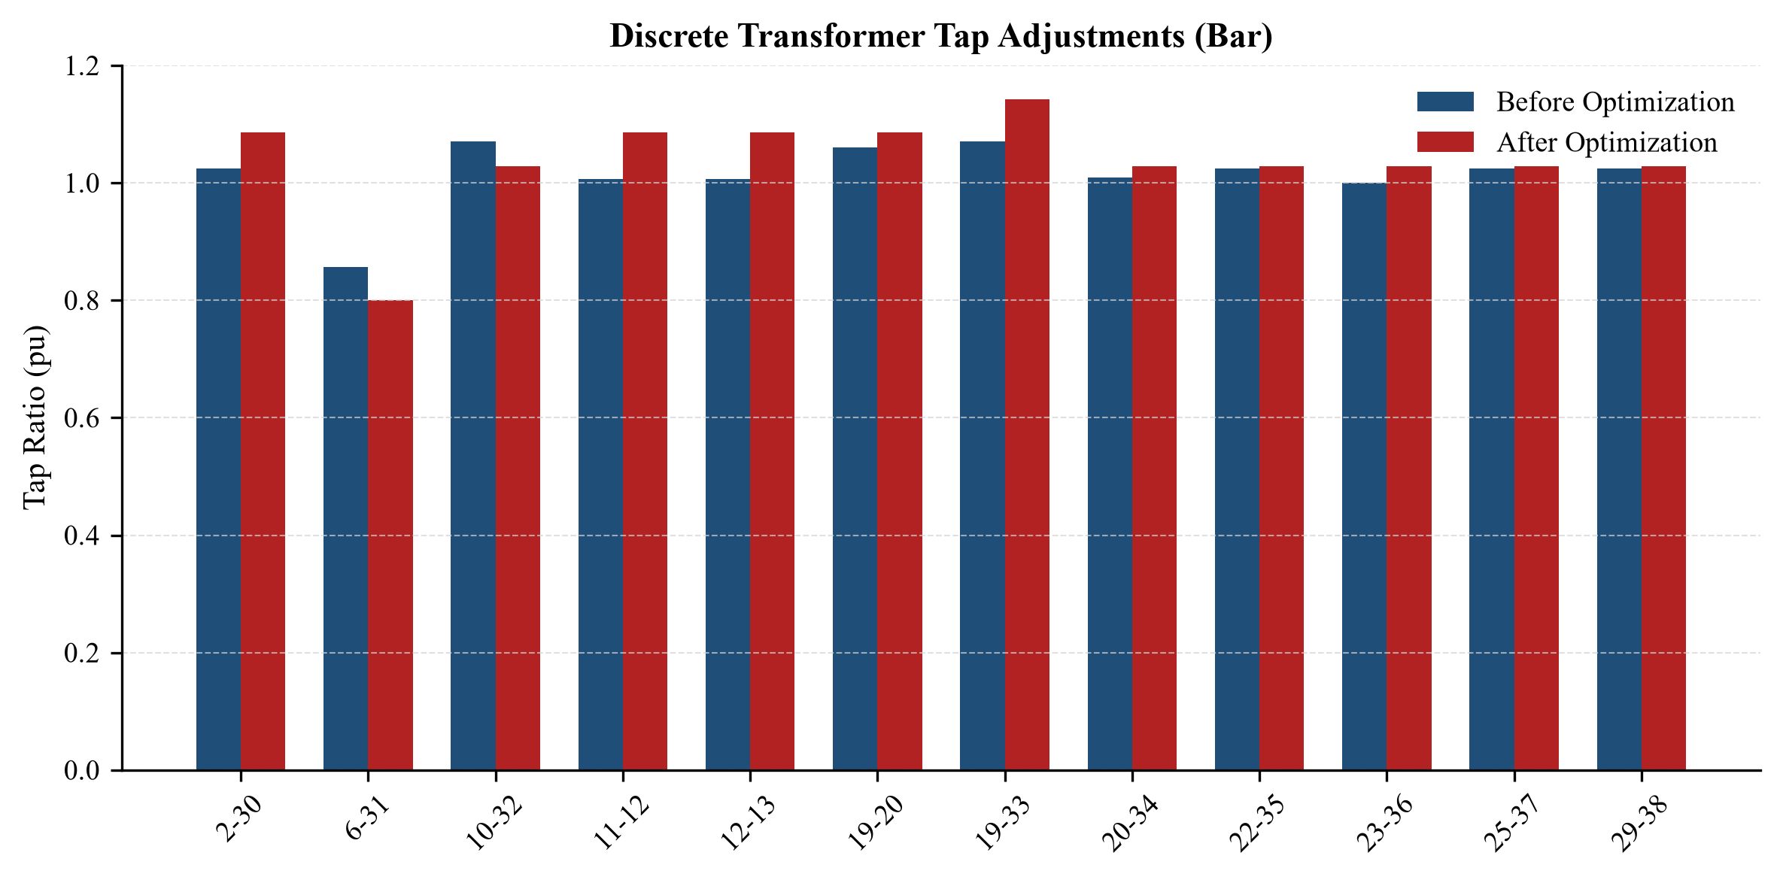
(a)
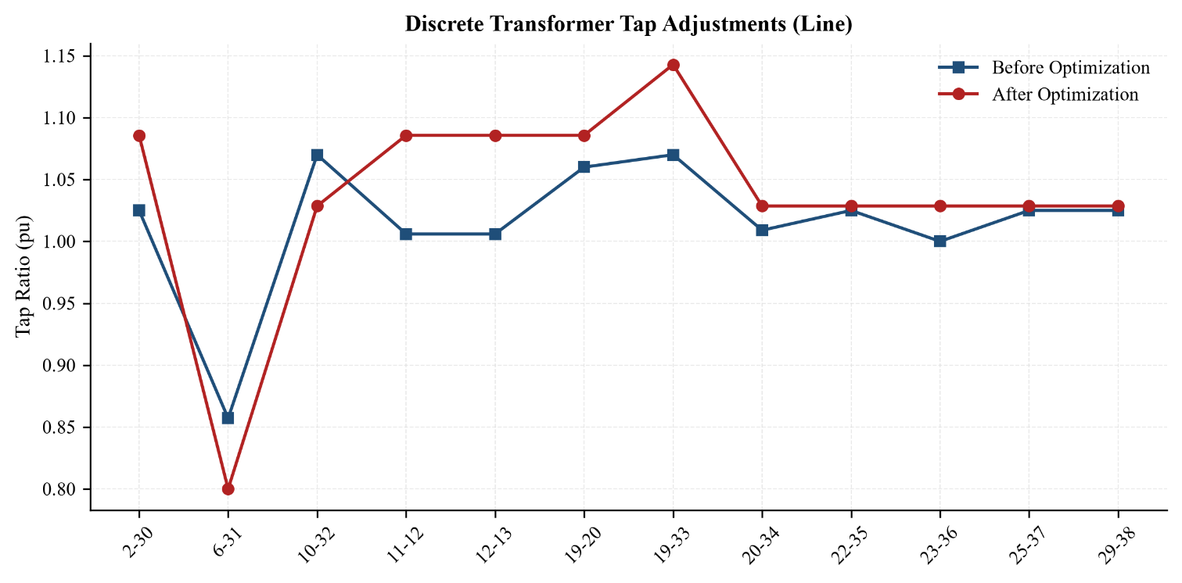
(b)
Figure 15: IEEE 39-bus discrete transformer tap adjustments: (a) bar, (b) line.
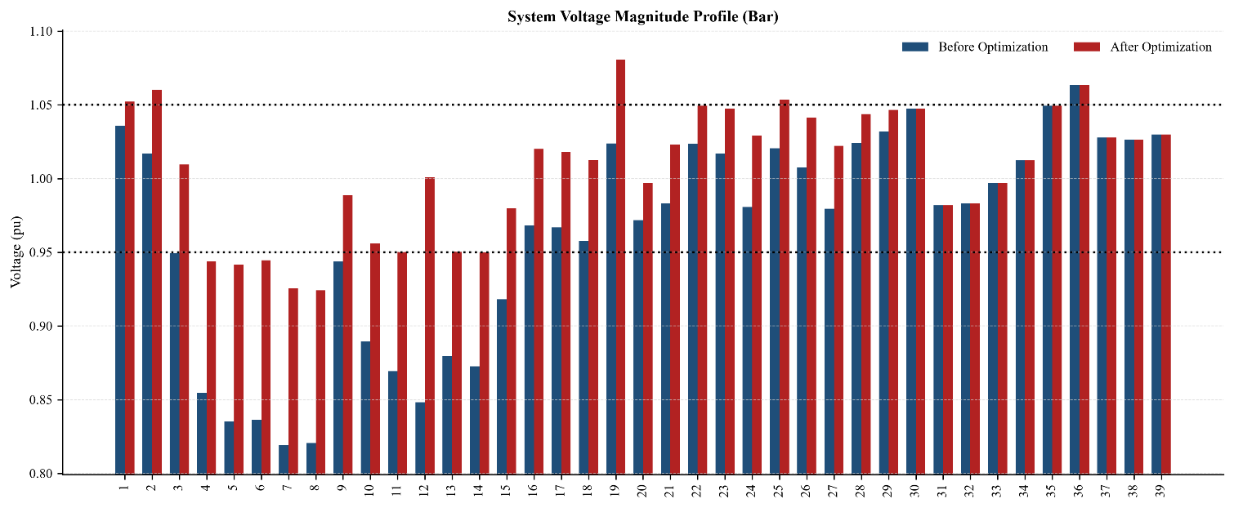
(a)
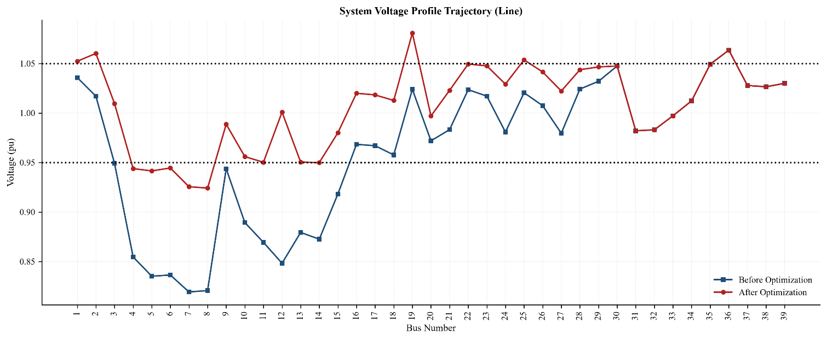
(b)
Figure 16: IEEE 39-bus voltage profile before and after GA: (a) bar, (b) line.
Table 10: IEEE 39-bus individual bus voltages in pu (base, after GA, after PSO with 12 capacitors)
Bus | Base | GA | PSO | Bus | Base | GA | PSO | Bus | Base | GA | PSO
1 | 1.0358 | 1.0523 | 1.0482 | 14 | 0.8726 | 0.9499 | 1.0098 | 27 | 0.9796 | 1.0222 | 1.0327
2 | 1.0170 | 1.0602 | 1.0496 | 15 | 0.9182 | 0.9801 | 1.0088 | 28 | 1.0242 | 1.0437 | 1.0437
3 | 0.9493 | 1.0096 | 1.0256 | 16 | 0.9684 | 1.0200 | 1.0337 | 29 | 1.0320 | 1.0466 | 1.0454
4 | 0.8547 | 0.9439 | 0.9939 | 17 | 0.9669 | 1.0183 | 1.0364 | 30 | 1.0475 | 1.0475 | 1.0475
5 | 0.8352 | 0.9415 | 0.9962 | 18 | 0.9577 | 1.0127 | 1.0301 | 31 | 0.9820 | 0.9820 | 0.9820
6 | 0.8364 | 0.9445 | 0.9947 | 19 | 1.0239 | 1.0807 | 1.0480 | 32 | 0.9831 | 0.9831 | 0.9831
7 | 0.8193 | 0.9256 | 0.9873 | 20 | 0.9719 | 0.9970 | 0.9852 | 33 | 0.9972 | 0.9972 | 0.9972
8 | 0.8207 | 0.9242 | 0.9864 | 21 | 0.9832 | 1.0229 | 1.0321 | 34 | 1.0123 | 1.0123 | 1.0123
9 | 0.9437 | 0.9887 | 1.0311 | 22 | 1.0236 | 1.0495 | 1.0494 | 35 | 1.0493 | 1.0493 | 1.0493
10 | 0.8894 | 0.9560 | 1.0230 | 23 | 1.0171 | 1.0476 | 1.0433 | 36 | 1.0635 | 1.0635 | 1.0635
11 | 0.8694 | 0.9503 | 1.0158 | 24 | 0.9808 | 1.0292 | 1.0403 | 37 | 1.0278 | 1.0278 | 1.0278
12 | 0.8483 | 1.0009 | 1.0158 | 25 | 1.0205 | 1.0537 | 1.0471 | 38 | 1.0265 | 1.0265 | 1.0265
13 | 0.8794 | 0.9504 | 1.0200 | 26 | 1.0074 | 1.0414 | 1.0451 | 39 | 1.0300 | 1.0300 | 1.0300

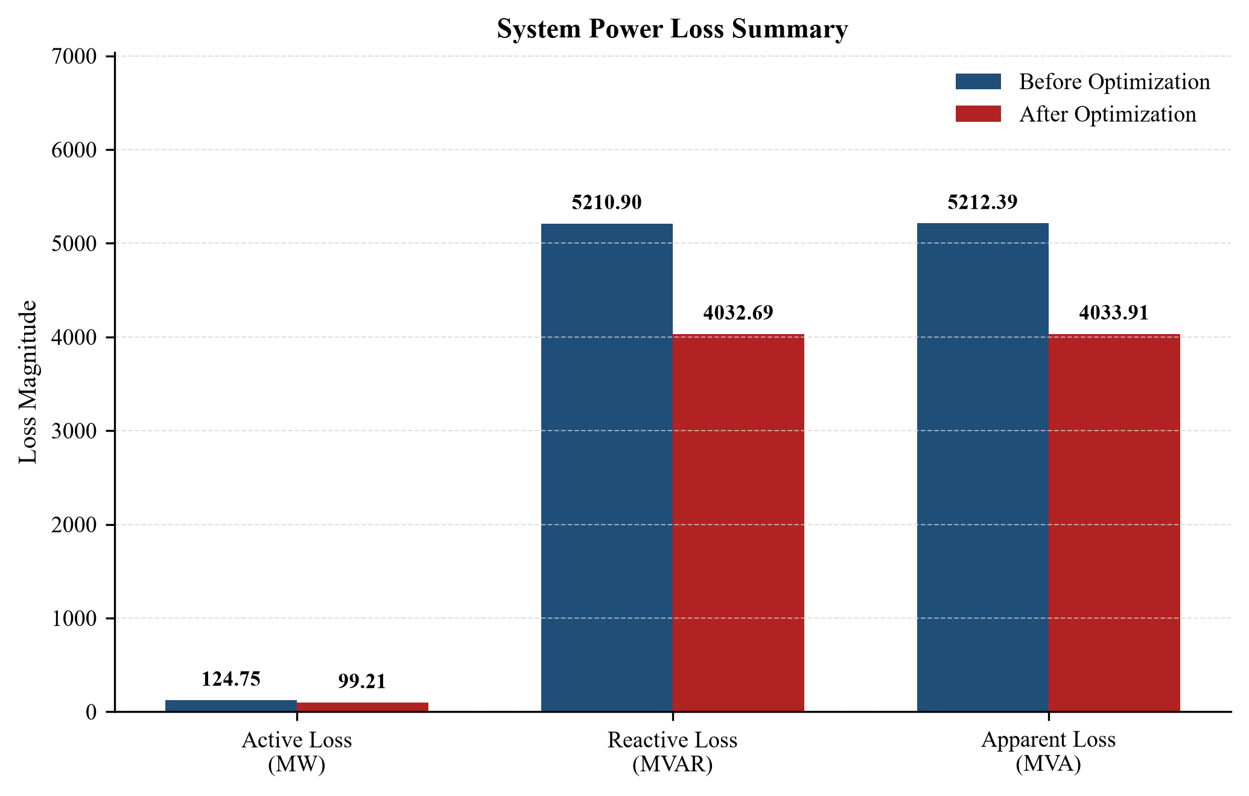
Figure 17: IEEE 39-bus system power loss summary before and after GA.
All 12 transformer taps were changed: 10 were boosted and two (6–31 and 10–32) were bucked; the largest shift was 19–33 (1.0700 → 1.1429). Active power loss fell from 124.75 MW to 99.21 MW (−20.47 %), reactive loss from 5210.90 to 4032.69 MVAr (−22.61 %) and the total voltage violation from 1.0267 to 0.1307 pu (−87.27 %). The minimum voltage rose from 0.8193 pu (Bus 7) to 0.9242 pu (Bus 8), but the maximum voltage rose to 1.0807 pu at Bus 19, so the state remains Best-Effort / Infeasible.
(c) PSO – IEEE 14-bus capacitor allocation (3 capacitors, 50 MVAr maximum).
Table 11: IEEE 14-bus optimal capacitor bank allocation
Bus | Bus type | Installed capacity (MVAr) | Discrete 5 MVAr steps
4 | PQ | 50.0 | 10
5 | PQ | 45.0 | 9
7 | PQ | 5.0 | 1
Total | — | 100.0 | 20

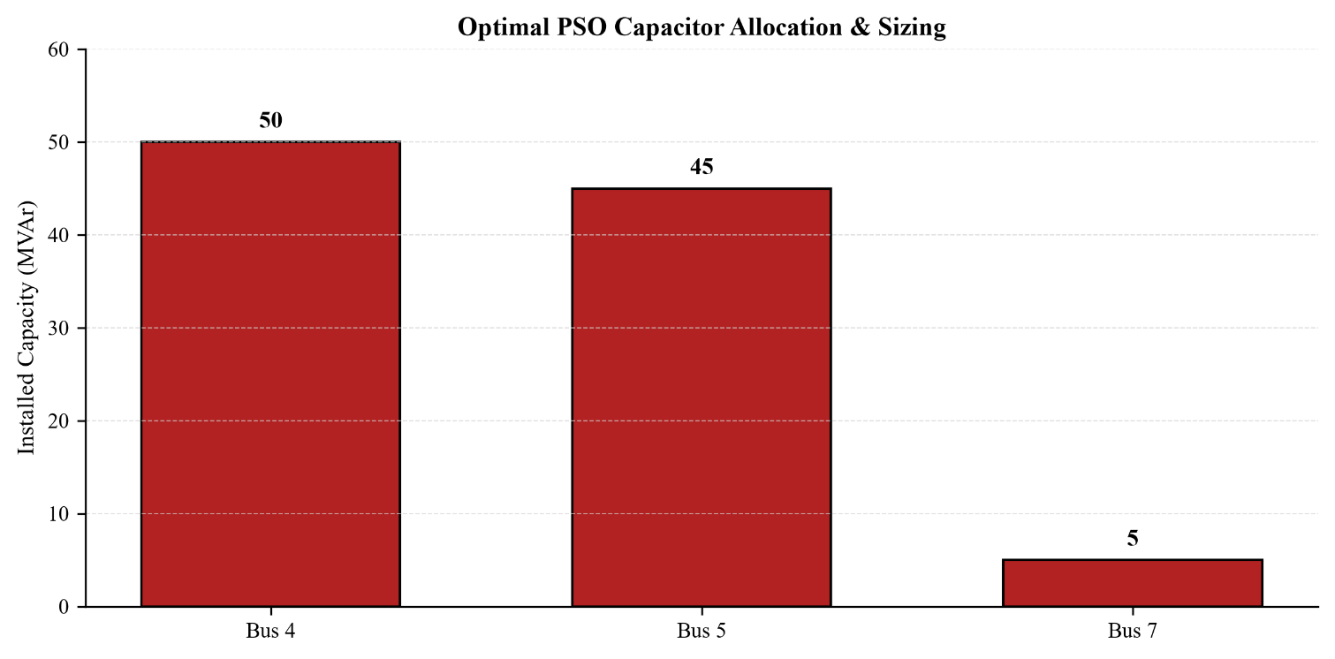
Figure 18: IEEE 14-bus optimal PSO capacitor allocation and sizing.
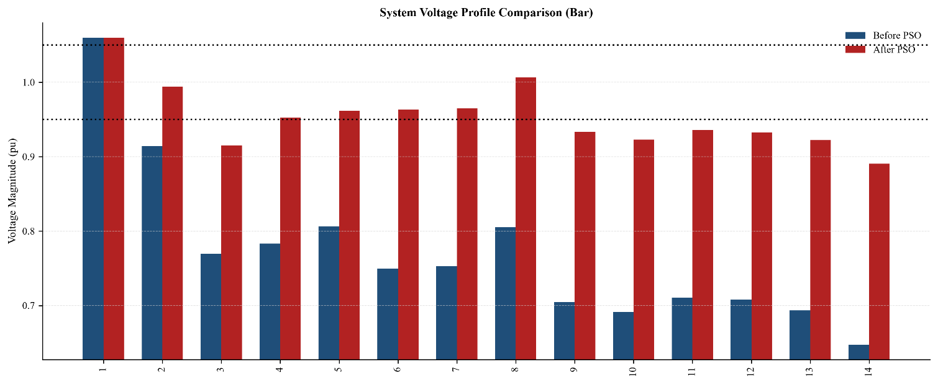
(a)
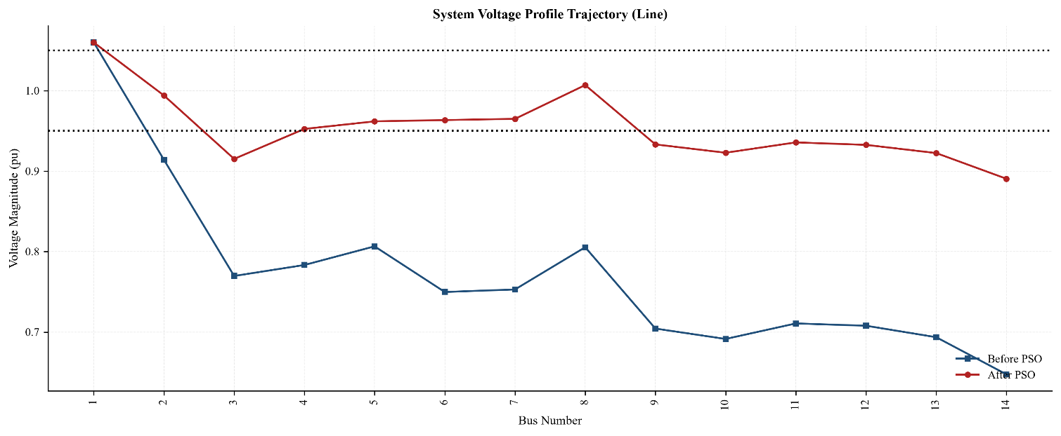
(b)
Figure 19: IEEE 14-bus voltage profile before and after PSO: (a) bar, (b) line.
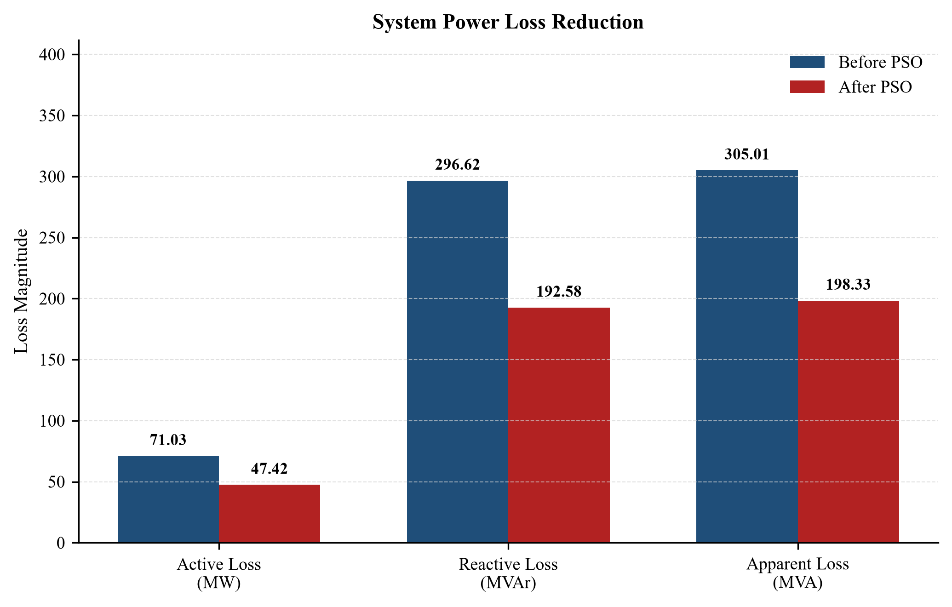
Figure 20: IEEE 14-bus system power loss reduction with PSO.
The PSO concentrated the reactive injection at Bus 4 (50 MVAr, the per-bus limit) and Bus 5 (45 MVAr), with 5 MVAr at Bus 7. Active power loss fell from 71.03 MW to 47.42 MW (−33.24 %), reactive loss from 296.62 to 192.58 MVAr (−35.08 %) and the total voltage violation from 2.6229 to 0.2074 pu (−92.09 %). The minimum voltage rose from 0.6474 to 0.8905 pu (Bus 14, +37.55 %); the final state remains Best-Effort / Infeasible.
(d) PSO – IEEE 39-bus capacitor allocation (12 capacitors, 100 MVAr maximum).
Table 12: IEEE 39-bus optimal capacitor bank allocation
Bus | Bus type | Installed capacity (MVAr) | Discrete configuration
5 | PQ | 100.0 | 20 × 5.0 MVAr
7 | PQ | 100.0 | 20 × 5.0 MVAr
8 | PQ | 100.0 | 20 × 5.0 MVAr
9 | PQ | 100.0 | 20 × 5.0 MVAr
10 | PQ | 100.0 | 20 × 5.0 MVAr
11 | PQ | 100.0 | 20 × 5.0 MVAr
12 | PQ | 80.0 | 16 × 5.0 MVAr
13 | PQ | 100.0 | 20 × 5.0 MVAr
14 | PQ | 100.0 | 20 × 5.0 MVAr
16 | PQ | 100.0 | 20 × 5.0 MVAr
17 | PQ | 100.0 | 20 × 5.0 MVAr
21 | PQ | 30.0 | 6 × 5.0 MVAr
Total | — | 1110.0 | 12 locations

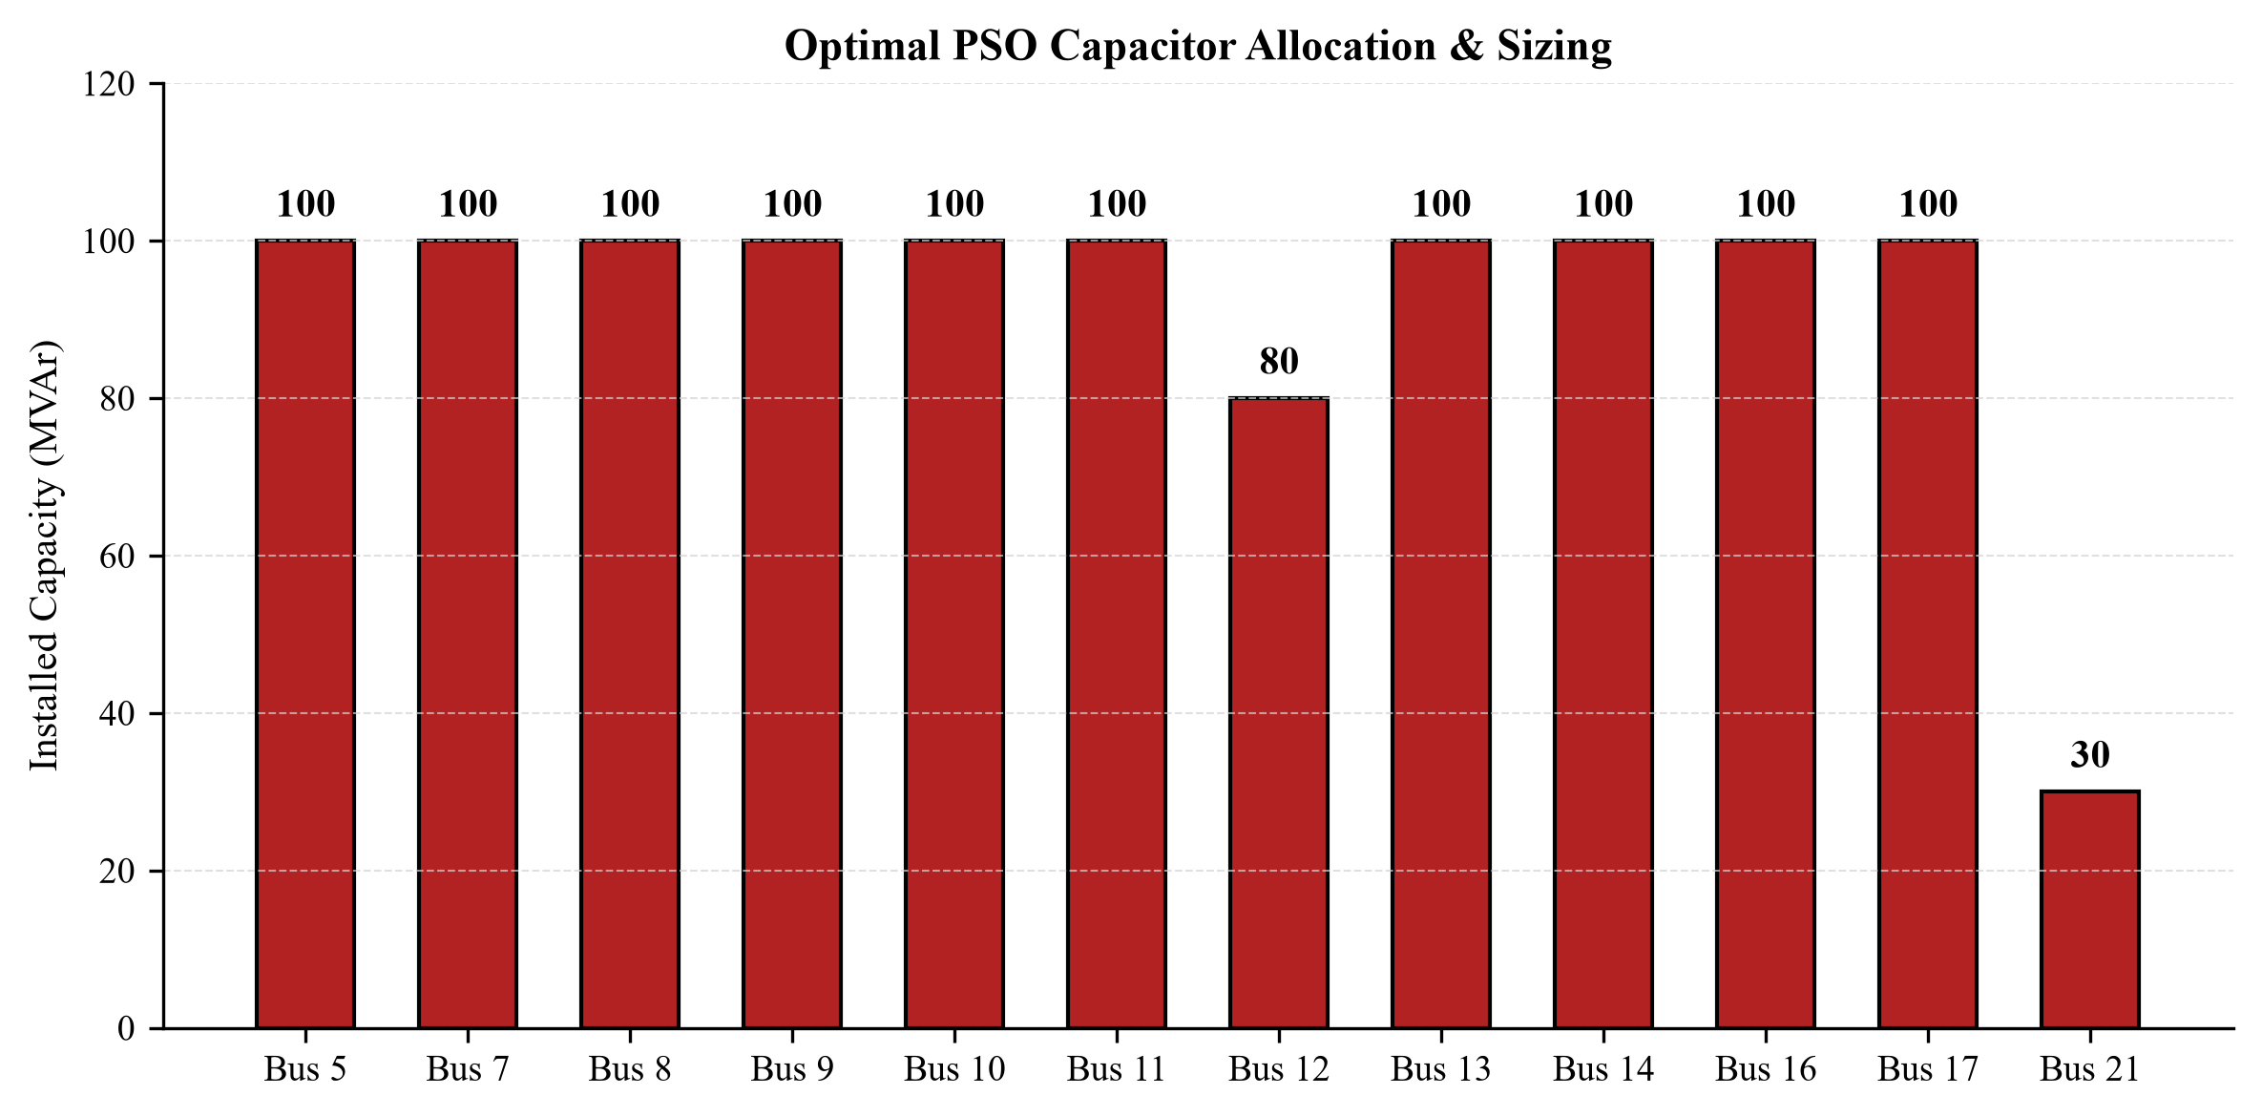
Figure 21: IEEE 39-bus optimal PSO capacitor allocation and sizing.
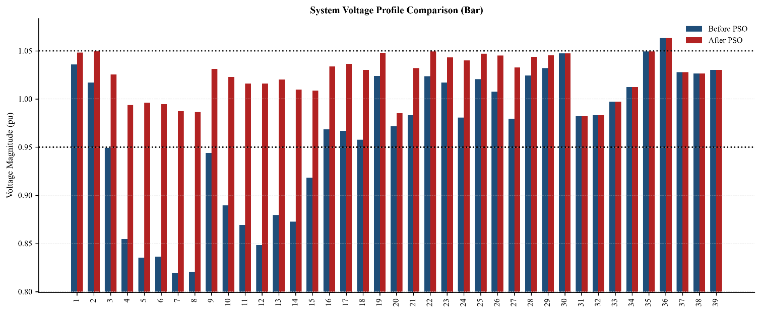
(a)
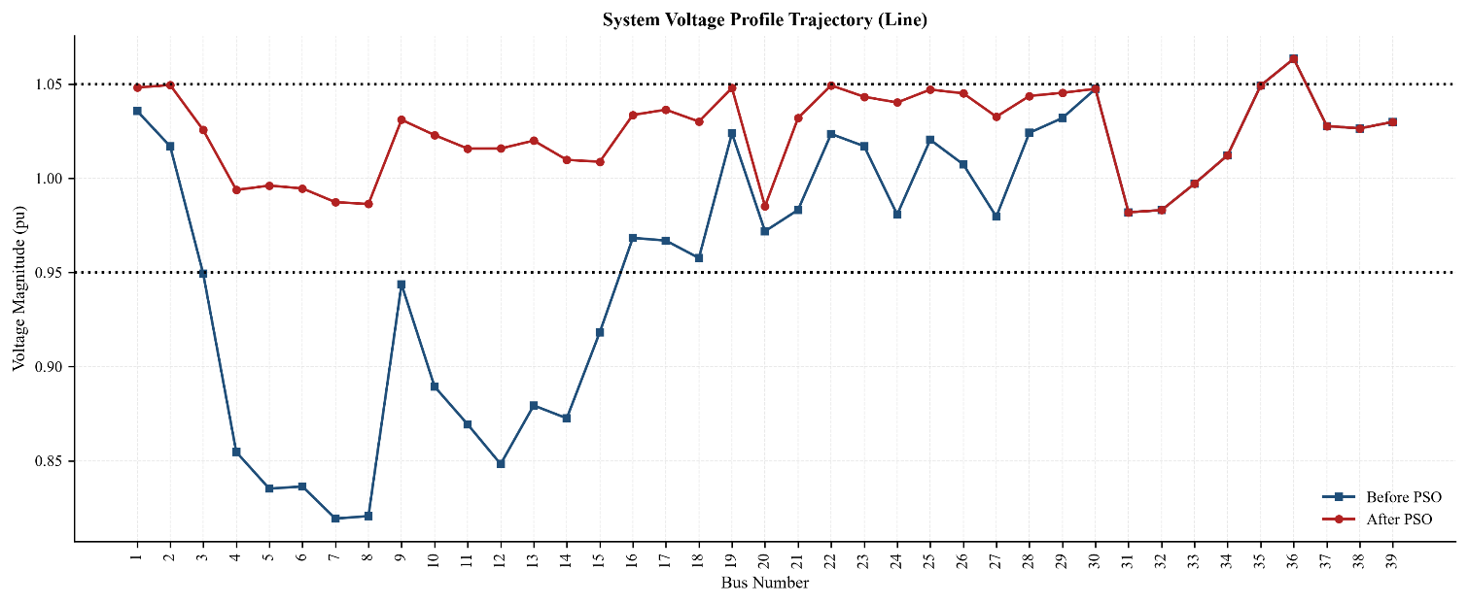
(b)
Figure 22: IEEE 39-bus voltage profile before and after PSO: (a) bar, (b) line.
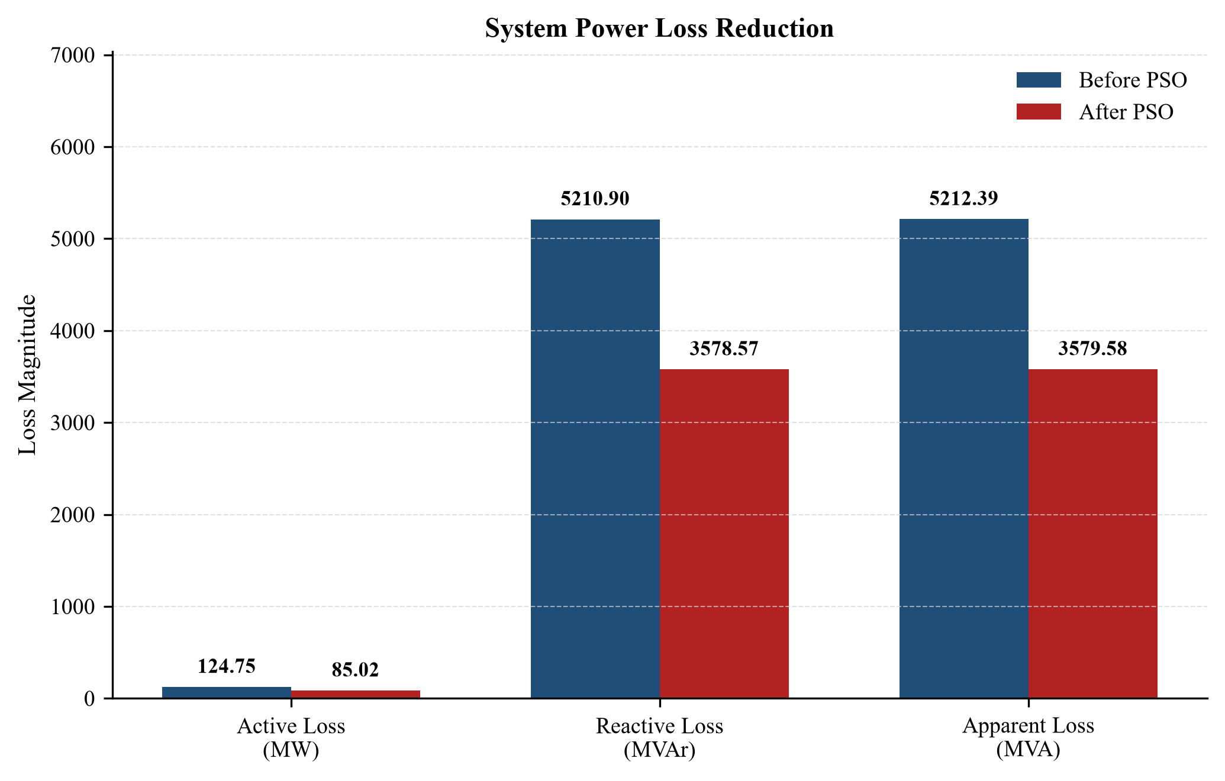
Figure 23: IEEE 39-bus system power loss reduction with PSO.
Active power loss fell from 124.75 MW to 85.02 MW (−31.85 %) and reactive loss from 5210.90 to 3578.57 MVAr (−31.33 %). Every load bus cleared 0.95 pu and the total voltage violation fell by 98.69 % (1.0267 → 0.0135 pu). The one remaining violation is generator Bus 36 at 1.0635 pu, which no capacitor can move.
(e) Line stability after optimization. The FVSI script was re-run on the optimized cases (Table 13).
Table 13: Most critical line before and after optimization (FVSI script output)
System / state | Most critical line | Max FVSI | $Q_{margin}$ of that line (MVAr) | Classification
IEEE 14 – base | 1–5 | 0.3727 | 0.00 | Corridor is stressed
IEEE 14 – GA | 1–5 | 0.2896 | 19.15 | Corridor is stressed
IEEE 14 – PSO (3 cap.) | 7–9 | 0.1208 | 17.48 | System is highly secure
IEEE 39 – base | 2–3 | 0.2479 | 0.00 | Corridor is stressed
IEEE 39 – GA | 19–16 | 0.2104 | 418.44 | Corridor is stressed
IEEE 39 – PSO (12 cap.) | 1–39 | 0.1005 | 205.57 | System is highly secure
IEEE 39 – PSO (29 cap.) | 29–26 | 0.1148 | 205.66 | System is highly secure

Before optimization, the critical corridors had zero reactive margin. After the PSO, the IEEE 14-bus critical corridor shifted to Line 7–9 with FVSI 0.1208 and 17.48 MVAr of margin, and the IEEE 39-bus critical corridor shifted to Line 1–39 with FVSI 0.1005 and 205.57 MVAr of margin; both systems are classified as highly secure by the script.
(f) Effect of the number of capacitors. Table 14 compares the PSO runs with a limited number of capacitors and with all PQ buses allowed.
Table 14: PSO with limited vs. all PQ buses allowed
Run | Capacitors installed | Total (MVAr) | $P_{loss}$ (MW) | $V_{min}$ (pu) | $ΔV_{viol}$ (pu)
IEEE 14, 3 capacitors | 3 buses | 100 | 47.42 | 0.8905 | 0.2074
IEEE 14, 9 capacitors | 3 buses | 100 | 47.42 | 0.8905 | 0.2074
IEEE 39, 12 capacitors | 12 buses | 1110 | 85.02 | 0.9820 | 0.0135
IEEE 39, 29 capacitors | 14 buses | 1105 | 86.28 | 0.9709 | 0.0135

For IEEE 14, allowing all 9 PQ buses gave exactly the same result as 3 capacitors (Buses 4, 5 and 7; 47.42 MW): the swarm assigned 0 MVAr to the other six buses. For IEEE 39, allowing all 29 buses gave a slightly worse result (86.28 MW, 1105 MVAr at 14 buses) than 12 capacitors (85.02 MW). This is the curse of dimensionality: with the same budget of 14,400 evaluations the much larger search space (${21}^{29}$ vs ${21}^{12}$ combinations) makes the swarm converge to a local optimum.
(a)
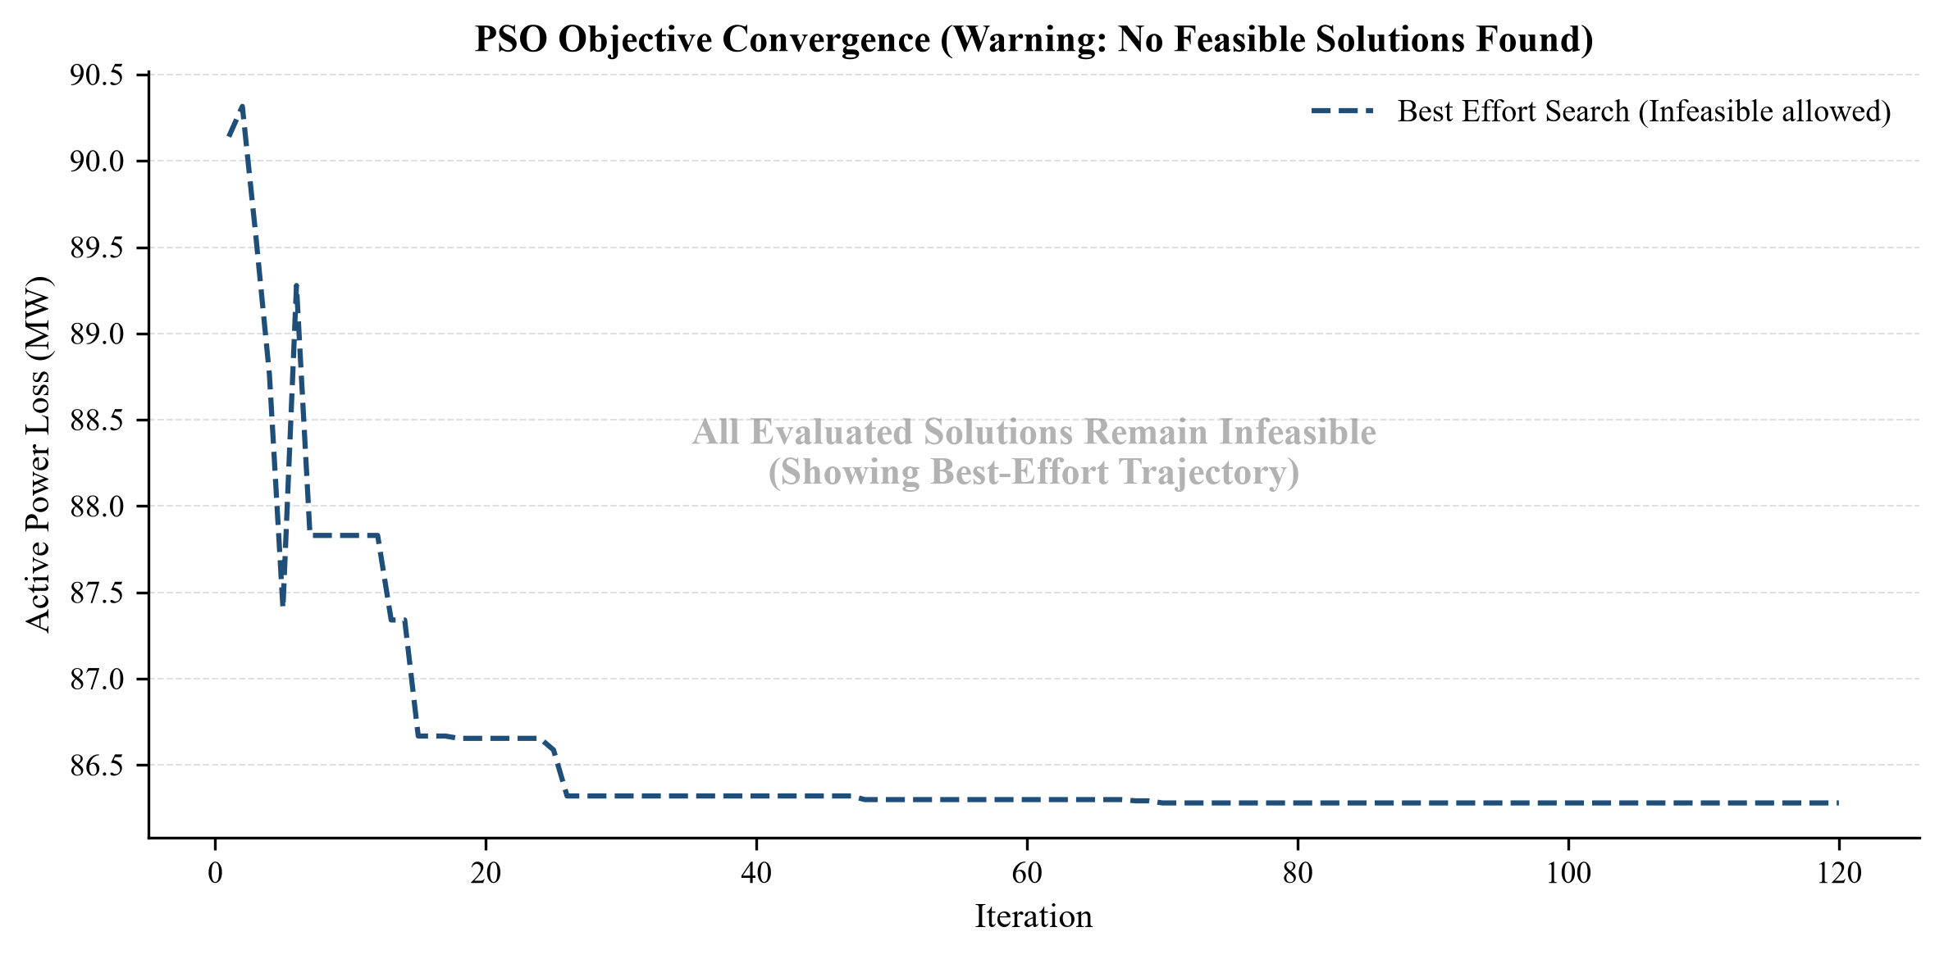
(b)
Figure 24: IEEE 39-bus PSO convergence: (a) 12 capacitors, (b) 29 capacitors (all PQ buses).

Interpretation and Conclusions on Data
Table 15: Results and analysis summary
Network & algorithm | Active loss $P_{loss}$ (MW) | Reactive loss $Q_{loss}$ (MVAr) | Min voltage (pu) | Peak line FVSI | Critical-corridor $Q_{margin}$ (MVAr)
IEEE 14-bus GA (transformer taps) | 71.03 → 62.14 | 296.62 → 250.72 | 0.6474 → 0.8008 | 0.3727 → 0.2896 | 0.00 → 19.15
IEEE 14-bus PSO (3 capacitors) | 71.03 → 47.42 | 296.62 → 192.58 | 0.6474 → 0.8905 | 0.3727 → 0.1208 | 0.00 → 17.48
IEEE 39-bus GA (transformer taps) | 124.75 → 99.21 | 5210.90 → 4032.69 | 0.8193 → 0.9242 | 0.2479 → 0.2104 | 0.00 → 418.44
IEEE 39-bus PSO (12 capacitors) | 124.75 → 85.02 | 5210.90 → 3578.57 | 0.8193 → 0.9820 | 0.2479 → 0.1005 | 0.00 → 205.57

• Both algorithms reduced active and reactive losses and voltage violation on both systems; the PSO capacitor allocation gave the larger improvement (33.2 % and 31.9 % active-loss reduction) than the GA tap optimization (12.5 % and 20.5 %).
• The PSO moved both systems from a stressed state with zero reactive margin on the critical corridor to a state classified as highly secure by the FVSI script (peak FVSI 0.1208 and 0.1005).
• No run reached strict feasibility. The “Infeasible” status reflects the severity of the stressed base cases (minimum voltages 0.6474 and 0.8193 pu); in the IEEE 39-bus PSO result the only remaining violation is generator Bus 36 (1.0635 pu), which capacitors cannot move.
• Allowing all PQ buses did not improve the result; a limited number of capacitor sites (3 for IEEE 14, 12 for IEEE 39) is the definitive result.

Limitations of Tools (PO(e))
• API memory and output overflow: evaluating a population of 120 over 120 generations requires 14,400 consecutive calls to the PSS®E Newton–Raphson solver; without suppressing the terminal streams (psspy.progress_output etc.) the Python console buffer overflowed and crashed the IDE.
• Single-threaded execution: psspy is single-threaded and locks the active .sav case in memory, so the GA and PSO could not be multi-processed; each candidate had to be evaluated sequentially (about 45 minutes for the IEEE 39-bus network on our laptop).
• Stochastic uncertainty: GA and PSO do not use gradient information, so there is no mathematical proof that the final solution is the absolute global minimum; the algorithms can settle in high-quality local minima (as seen with 29 capacitors).
• Bus limit: PSS®E Xplore is limited to 50 buses, which restricts the study to test systems of this size.

Impact Assessment (PO(f))

Assessment of Legal Issues
Grid codes require transmission system operators to maintain bus voltages within specified operational bands to prevent equipment damage. The stressed base cases were non-compliant (total voltage violations of 2.6229 pu and 1.0267 pu). The PSO allocations reduced these violations by 92.09 % and 98.69 %; full compliance was not reached because voltages at generator buses (Bus 1 of IEEE 14 at 1.0600 pu and Bus 36 of IEEE 39 at 1.0635 pu) remain above the upper limit.

Sustainability Evaluation (PO(g))
The PSO reduced the active transmission loss of the IEEE 39-bus network by 31.85 %, from 124.75 MW to 85.02 MW. Assuming this 39.73 MW reduction is sustained for a full year and a standard combined-cycle gas turbine emission factor of 0.4 metric tons of CO₂ per MWh, the optimization avoids approximately 139,227 metric tons of CO₂ emissions annually (39.73 MW × 8760 h × 0.4 t/MWh), reducing fuel consumption at the swing and PV generator buses.

Reflection on Individual and Team work (PO(i))

Individual Contribution of Each Member
Table 16: Individual contribution of each member
Team member | Student ID | Contribution to the project | CO
Mahfuz Alam Tonmoy | 2206116 | FVSI weak-line screening and modeling/validation of the IEEE 14-bus and 39-bus test systems. | CO6, CO8
Md. Shibli Noman | 2206117 | Project coordination, Python–PSS®E (psspy) co-simulation bridge: automated load-flow calls and stressed base-case setup. | CO3
Md. Abdullah Al-Noman | 2206118 | GA transformer-tap optimization: chromosome encoding, tournament selection, crossover, mutation and elitism. | CO4
Md. Ahasan Habib Kawsar | 2206119 | PSO capacitor allocation: swarm design, 5 MVAr discretization and constriction-factor tuning. | CO4
Md. Kawsar Ahmed | 2206122 | Project coordination: work planning, milestone tracking, and integration of the GA and PSO modules into one pipeline. | CO3
Sadiq Sayeed Raha | 2206128 | Results analysis and plots, plus the societal, environmental and ethical impact assessment. | CO5
Aritra Chowdhury | 2206129 | Result analysis, project report, slide design and references; effective communication of the design and results. | CO7

Mode of TeamWork
The project was executed by a seven-member team. Tasks were divided according to individual strengths (Table 16): Md. Shibli Noman and Md. Kawsar Ahmed coordinated the project, and the modelling, FVSI, GA, PSO, result-analysis and reporting work was assigned to individual members. Weekly meetings were held to merge the discrete mapping functions with the core load-flow evaluation engine.

Log Book of Project Implementation
Table 17: Log book of project implementation
Date | Milestone achieved | Individual role | Team role | Comments
Week 1–2 | Literature review and algorithm selection | All members | Review of papers | Decided on discrete hardware mapping approach
Week 3–4 | IEEE 14 & 39 bus base cases modeled | Mahfuz Alam Tonmoy, Md. Shibli Noman | Built and verified AC load flows in PSS®E | Baseline stress conditions established manually
Week 5–6 | Python psspy API integration | Md. Shibli Noman | Bridged Python with PSS®E solver | Overcame terminal buffer and memory issues
Week 7–8 | FVSI script developed; critical lines found | Mahfuz Alam Tonmoy | Analytical stability ranking | Line 1–5 and Line 2–3 flagged as primary bottlenecks
Week 9–10 | GA for transformer taps coded/tested | Md. Abdullah Al-Noman | Tuned hyperparameters ($P_{c}$ = 0.95, $P_{m}$ = 0.35) | —
Week 11–12 | PSO for capacitor sizing coded/tested | Md. Ahasan Habib Kawsar | Implemented constriction factor | Mapped continuous particles to 5.0 MVAr discrete steps
Week 13 | Final simulation runs and data tabulation | Md. Kawsar Ahmed, Sadiq Sayeed Raha | Integrated GA/PSO; compiled voltage and loss data | Best-effort results obtained
Week 14 | Project defense and final report | Aritra Chowdhury, Sadiq Sayeed Raha | Formatted final report and slides | Ready for academic submission

Communication to External Stakeholders (PO(j))

Executive Summary
What we did: We developed a Python program that controls the PSS®E power system simulator to fix voltage drops and reduce power losses in stressed power grids. The methods: We used a Genetic Algorithm (GA) to find the best transformer tap settings and Particle Swarm Optimization (PSO) to find the best sizes and locations for capacitor banks. The testing: We tested our code on the IEEE 14-bus and IEEE 39-bus systems. The results: We achieved large active power loss reductions (33.2 % on IEEE-14 and 31.9 % on IEEE-39) and significantly restored voltage margins, settling in a validated “Best-Effort / Infeasible” state due to extreme load profiles.

User Manual
1. Install Siemens PSS®E 36.6 (Xplore) and Python with numpy and matplotlib; set PSSPY_PATH and PSSBIN_PATH at the top of the scripts if PSS®E is installed in another folder.
2. Run FVSI-Collapse Analysis.py and select the .sav case to obtain the FVSI ranking and reactive margins.
3. Run IEEEtxfTapGE.py and select the .sav case; the optimized taps, losses and bus voltages are printed and *_TAP_OPTIMIZED.sav is saved.
4. Run PSOcapacitor.py, select the .sav case and enter the maximum number of capacitors and the maximum MVAr per installation; the results folder contains Optimization_Report.txt, *_CAPACITOR_OPTIMIZED.sav and the plots.
5. Re-run the FVSI script on the optimized .sav file to verify line stability.

Github Link
Source code, PSS®E cases and results: https://github.com/ahasanhabibkawsar/EEE-306-Group-05-Project-Mitigating-Transmission-Losses-and-Fast-Voltage-Stability-Index-

YouTube Link
Project presentation material (Google Drive): https://drive.google.com/file/d/1S16e6D9CnCVc4tx-kQVD8_oTBZiHku-k/view?usp=sharing
YouTube video: [link to be added]

Project Management and Cost Analysis (PO(k))
Project milestones were managed with the weekly plan recorded in the log book (Table 17). The computational cost was tracked for every study: each GA or PSO run evaluates a population of 120 over 120 iterations, i.e. up to 14,400 full AC load flows, across both algorithms and both test systems; one IEEE 39-bus run took about 45 minutes because psspy evaluates candidates sequentially. The study used the PSS®E Xplore academic edition and Python.

Future Work
• Dynamic ZIP load modeling: transition from static constant-power (PQ) load models to voltage-dependent ZIP (impedance, current, power) models to evaluate optimization performance under non-linear load variations.
• N−1 contingency optimization: integrate the PSS®E ACCC (AC Contingency Calculation) module into the Python fitness function, so that the PSO allocates capacitor banks such that the grid remains stable even if the largest generator or a transmission line trips.
• Parallel processing: circumvent the single-thread limitation of psspy by running the algorithm across multiple independent Python environments or Docker containers, evaluating multiple load flows simultaneously to reduce execution time.

References
[1] J. J. Grainger and W. D. Stevenson, Power System Analysis. New York, NY, USA: McGraw-Hill, 1994.
[2] I. Musirin and T. K. Abdul Rahman, “Novel fast voltage stability index (FVSI) for voltage stability analysis in power transmission system,” in Proc. Student Conf. Research and Development (SCOReD 2002), Shah Alam, Malaysia, 2002.
[3] F. I. Hj Hassim, I. Musirin and T. K. Abdul Rahman, “Voltage stability margin enhancement using evolutionary programming (EP),” in Proc. 4th Student Conf. Research and Development (SCOReD 2006), Shah Alam, Malaysia, Jun. 2006.
[4] M. F. Mohammad Kamal, T. K. Abdul Rahman and I. Musirin, “Application of improved genetic algorithms for loss minimisation in power system,” in Proc. National Power & Energy Conf. (PECon 2004), Kuala Lumpur, Malaysia, 2004.
[5] A. G. Bakirtzis, P. N. Biskas, C. E. Zoumas and V. Petridis, “Optimal power flow by enhanced genetic algorithm,” IEEE Trans. Power Systems, vol. 17, no. 2, pp. 229–236, May 2002.
[6] D. Devaraj and J. Preetha Roselyn, “Genetic algorithm based reactive power dispatch for voltage stability improvement,” Int. J. Electrical Power & Energy Systems, vol. 32, pp. 1151–1156, 2010.
[7] M. H. Nadimi-Shahraki, A. Fatahi, H. Zamani, S. Mirjalili and D. Oliva, “Hybridizing of whale and moth-flame optimization algorithms to solve diverse scales of optimal power flow problem,” Electronics, vol. 11, no. 5, p. 831, 2022.
[8] M. Clerc and J. Kennedy, “The particle swarm – explosion, stability, and convergence in a multidimensional complex space,” IEEE Trans. Evolutionary Computation, vol. 6, no. 1, pp. 58–73, Feb. 2002.
[9] Siemens PTI, PSS®E 36.0 Program Application Guide. Siemens Power Technologies International, 2024.

