Bangladesh University of Engineering and Technology
Department of Electrical and Electronic Engineering

EEE 312 (January 2026)
Digital Signal Processing I Laboratory
Final Project Report
Section: B2 Group: 04

Digital Signal Processing and Deep Learning-Based Urban Change Detection Using Satellite Imagery

Course Instructors:
Full Name 1, Assistant Professor
Full Name 2, Part-Time Lecturer

Signature of Instructor: ___________________________________________________

Academic Honesty Statement:
IMPORTANT! Please carefully read and sign the Academic Honesty Statement, below. Type the student ID and name, and put your signature. You will not receive credit for this project experiment unless this statement is signed in the presence of your lab instructor.
“In signing this statement, We hereby certify that the work on this project is our own and that we have not copied the work of any other students (past or present), and cited all relevant sources while completing this project. We understand that if we fail to honor this agreement, We will each receive a score of ZERO for this project and be subject to failure of this course.”
Signature: ____________________________  Full Name: Mustasin Rahman  Student ID: 2206104 | Signature: ____________________________  Full Name: Fahim Shahriyar  Student ID: 2206114
Signature: ____________________________  Full Name: Md. Ahasan Habib Kawsar  Student ID: 2206119 | Signature: ____________________________  Full Name: Md. Kawsar Ahmed  Student ID: 2206122

Table of Contents
1 Abstract 1
2 Introduction 1
3 Design 2
3.1 Problem Formulation (PO(b)) 2
3.1.1 Identification of Scope 2
3.1.2 Literature Review 2
3.1.3 Formulation of Problem 3
3.1.4 Analysis 3
3.2 Design Method (PO(a)) 4
3.2.1 Data Preparation and Preprocessing 4
3.2.2 DSP Front-End 5
3.2.3 Siamese U-Net Architecture 6
3.2.4 Spatial-Temporal Attention and Siam-Concat Fusion 6
3.2.5 Loss Function 6
3.2.6 Training Procedure 7
3.2.7 Inference, Thresholding and Post-Processing 7
3.2.8 Evaluation Metrics 7
3.3 Source Code (Core Modules) 8
4 Implementation 9
4.1 Description 9
5 Design Analysis and Evaluation 11
5.1 Novelty 11
5.2 Design Considerations (PO(c)) 12
5.2.1 Considerations to public health and safety 12
5.2.2 Considerations to environment 12
5.2.3 Considerations to cultural and societal needs 12
5.3 Investigations (PO(d)) 12
5.3.1 Design of Experiment 12
5.3.2 Data Collection 13
5.3.3 Results and Analysis 13
5.3.4 Interpretation and Conclusions on Data 16
5.4 Limitations of Tools (PO(e)) 17
5.5 Ethical Issues (PO(h)) 17
6 Reflection on Individual and Team work (PO(i)) 18
6.1 Individual Contribution of Each Member 18
6.2 Mode of TeamWork 18
6.3 Diversity Statement of Team 18
6.4 Log Book of Project Implementation 18
7 Communication to External Stakeholders (PO(j)) 19
7.1 Executive Summary 19
7.2 User Manual 19
7.3 Github Link 20
7.4 YouTube Link 20
8 Future Work (PO(l)) 20
9 References 20

Abstract
Rapid, unplanned urban growth in cities such as Dhaka makes manual mapping of new construction slow and costly. This project presents an automatic urban change-detection system that takes two co-registered satellite images of the same area, acquired at different times, and marks every pixel where a building has appeared or disappeared. The design combines a classical digital-signal-processing (DSP) front-end, grayscale conversion, Gaussian low-pass filtering and Canny edge detection, with a Siamese ResNet-34 U-Net that uses spatial-temporal attention, Siam-Concat feature fusion and an edge-guided decoder supervised by Sobel-derived boundaries. The network is trained on native-resolution 256 × 256 crops of the LEVIR-CD dataset (637 image pairs, 0.5 m/pixel) and predicts full 1024 × 1024 scenes with an overlapping, cosine-blended sliding window and test-time augmentation.
On the 128 unseen test images the system achieves a precision of 91.8 %, recall of 90.6 %, F1-score of 91.2 %, intersection-over-union of 83.8 %, overall accuracy of 99.1 % and Cohen’s κ of 0.907, a 14-point F1 improvement over our first prototype. A controlled ablation shows that removing the Canny channel does not reduce accuracy (F1 91.6 %), indicating that a pre-trained encoder already learns equivalent edge filters. The system is deployed as a multithreaded PyQt5 desktop application with live thresholding and polygon post-processing, and all code is publicly available on GitHub.

Introduction
Bangladesh is urbanising rapidly. Dhaka and its surrounding municipalities add new residential blocks, factories and roads every year, often faster than planning authorities can survey them. Knowing where and when buildings appear is essential for detecting unauthorised construction, monitoring encroachment on wetlands and flood-flow zones, updating utility and census maps, and assessing damage after floods or cyclones. Very-high-resolution satellite imagery is now available regularly, so the bottleneck is no longer data acquisition but its analysis [1].
Change detection compares two images of the same place taken at times T₁ (before) and T₂ (after) and produces a binary change map. Although the task sounds simple, it is a complex engineering problem:
- Depth of knowledge (WP1): it requires 2-D signal processing (filtering, convolution, gradient operators), statistics (class imbalance, thresholds) and deep learning (convolutional networks, attention, optimisation).
- Conflicting requirements (WP2): precision versus recall (false alarms versus missed buildings), resolution versus memory, and accuracy versus inference time on a laptop GPU.
- Depth of analysis (WP3): there is no closed-form solution; the design must be found through modelling, experiments and ablations.
- Interdependence (WP7): preprocessing, network architecture, loss function, threshold and post-processing interact; a defect in one stage (for example input scaling) silently degrades the whole system.
Real imagery adds further difficulty: illumination, season, shadows and sensor colour change between dates even when nothing is built (pseudo-changes); only about 4.6 % of pixels actually change (extreme class imbalance); and at 0.5 m/pixel a house is only 10–20 pixels wide (small objects). Figure 1 shows a typical pair from the LEVIR-CD dataset.
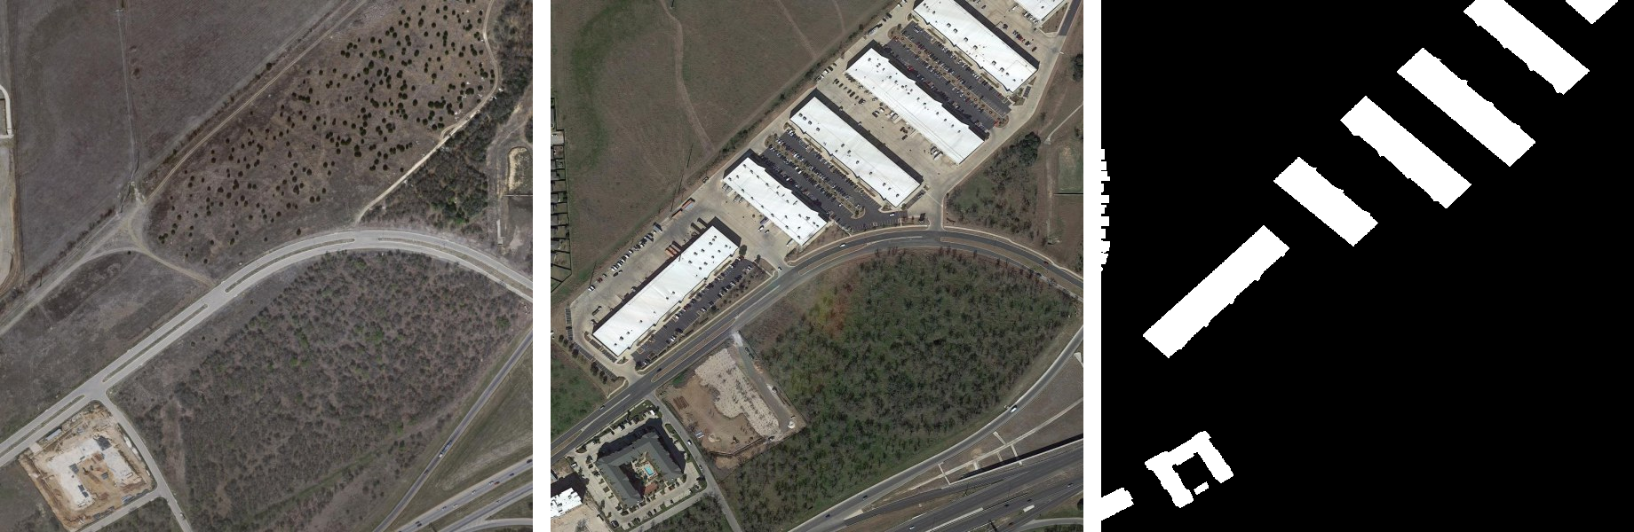
Figure 1: A LEVIR-CD image pair (test_102): (left) T₁ before, (middle) T₂ after, (right) ground-truth change mask (white = new buildings).
Possible alternative solutions include: (i) manual photo-interpretation, which is accurate but slow and expensive; (ii) pixel-based methods such as image differencing, image ratioing and change-vector analysis, which are fast but very sensitive to illumination [1]; (iii) PCA/k-means and object-based methods, which need hand-tuned features; (iv) Siamese convolutional networks [2]; and (v) attention and transformer networks [3], [4], [5], which are accurate but computationally heavy. We chose a hybrid of (ii)–(v): an explicit DSP edge front-end feeding a lightweight Siamese CNN with attention that can be trained on a laptop, and we tested experimentally whether the DSP stage helps.

Design

Problem Formulation (PO(b))

Identification of Scope
- Input: two co-registered RGB satellite images of the same area (T₁, T₂), any size; primary resolution 0.5 m/pixel.
- Output: a per-pixel change-probability map, a binary change mask, building-footprint polygons and the changed-area percentage.
- Change type: building construction and demolition (the classes annotated in LEVIR-CD); roads and vegetation are out of scope.
- Data: LEVIR-CD for training, validation and testing [3]; real Bangladeshi imagery (Bashundhara/Purbachal) for a qualitative domain-shift test.
- Platform constraint: training and inference on an Apple-silicon laptop GPU (PyTorch MPS backend), no cloud GPU.
- Deliverables: trained model, evaluation reports, a desktop GUI, public source code and this report.

Literature Review
Early change detection relied on algebraic operations on co-registered images, image differencing, ratioing and change-vector analysis, followed by a threshold [1]. These methods are fast but respond to any radiometric difference, so seasonal and illumination changes produce many false alarms. Edge-based DSP operators, the Marr–Hildreth Laplacian-of-Gaussian [6] and the Canny detector [7], capture structural boundaries that are more stable than raw intensities.
Deep learning changed the field. Daudt et al. introduced fully convolutional Siamese networks (FC-EF, FC-Siam-conc, FC-Siam-diff) in which weight-sharing encoders process both dates and the decoder operates on concatenated or differenced features [2]. Chen and Shi proposed STANet, with a spatial-temporal attention module (BAM), and released the LEVIR-CD benchmark [3]. Transformer-based models such as BIT [4] and ChangeFormer [5] model global context and currently reach about 89–90 % F1 on LEVIR-CD, at a higher computational cost. Edge supervision with class-balanced losses, as in holistically-nested edge detection (HED) [8], is known to sharpen predicted boundaries. Table 1 summarises published results on the LEVIR-CD test set.
Table 1: Published LEVIR-CD test results (values as reported in [5]) and this work. Our figure uses sliding-window inference with test-time augmentation on the same 128 test images, so the comparison is indicative.
Method | Type | F1 (%) | IoU (%)
FC-EF [2] | Early-fusion CNN | 83.40 | 71.53
FC-Siam-diff [2] | Siamese CNN | 86.31 | 75.92
STANet [3] | Siamese CNN + attention | 87.26 | 77.40
BIT [4] | CNN + transformer | 89.31 | 80.68
ChangeFormer [5] | Transformer | 90.40 | 82.48
This work (final model) | Siamese CNN + attention + DSP edges | 91.17 | 83.78

Gap addressed: most published models do not use explicit DSP features, and most assume server-class GPUs. We investigate whether a classical, interpretable edge channel can be fused with a pre-trained CNN, and design the whole pipeline to train and run on a laptop.

Formulation of Problem
Let I₁, I₂ ∈ ℝ^{H×W×3} be the co-registered images and Y ∈ {0,1}^{H×W} the ground-truth change mask. We seek a function f_{θ} with learnable parameters θ that outputs a change probability for every pixel:
P = f_{θ}(φ(I₁), φ(I₂)) ∈ [0,1]^{H×W}, Ŷ = 1[P ≥ t] (1)
where φ(·) is the DSP front-end that maps an RGB image to a four-channel tensor (RGB + edge) and t is a decision threshold. θ is found by minimising a loss L(P, Y) on the training set, and t is selected on the validation set to maximise the F1-score. The design objectives are: (1) maximise F1 and IoU on unseen test images; (2) keep false alarms and misses balanced; (3) train within a few hours and predict a 1024 × 1024 scene within seconds on a laptop GPU; (4) provide an interactive tool for non-experts.

Analysis
- Class imbalance: in a sample of 60 LEVIR-CD training images only 4.6 % of pixels are changed, and 18 % of images contain no change at all. A plain pixel-wise loss would be dominated by the background, so an overlap-based (Dice) loss and change-focused sampling are required.
- Resolution: the dataset images are 1024 × 1024 pixels. Down-sampling them to 256 × 256 (our first prototype) shrinks a 16-pixel house to 4 pixels. We therefore train on native-resolution crops and predict full images with a sliding window.
- Attention cost: full self-attention over two 64 × 64 feature maps would need an (8192 × 8192) attention matrix per image pair. Pooling the keys and values by 4 reduces it to 8192 × 512, which fits in laptop memory.
- Input scaling: RGB pixel values lie in [0, 255] while a binary edge map lies in {0, 1}. Without standardisation the edge channel is about 255 times smaller than the colour channels and is effectively ignored by the network.
- Edge statistics: measured on 120 LEVIR-CD images, Canny marks 12.1 % of pixels as edges, so the edge channel has mean 0.12 and standard deviation √(0.121 × 0.879) ≈ 0.33; these values are used to standardise it.

Design Method (PO(a))
Figure 2 shows the complete design flow. Each stage applies specific knowledge of mathematics, signal processing and machine learning, described in the following subsections.
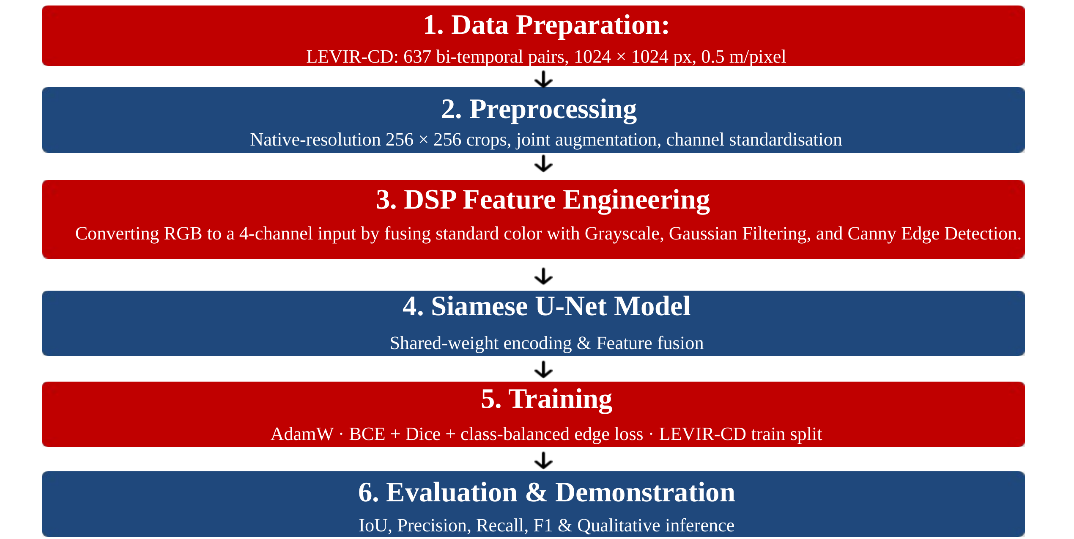
Figure 2: Overall design flow of the urban change-detection system.

Data Preparation and Preprocessing
LEVIR-CD contains 637 bi-temporal Google Earth image pairs of 1024 × 1024 pixels at 0.5 m/pixel, collected over several cities in Texas between 2002 and 2018, with pixel-level building-change annotations [3], [9]. We use the official split of 445 training, 64 validation and 128 test pairs (Table 2).
Table 2: LEVIR-CD dataset split.
Split | Image pairs | Pixels per image | Use
Train | 445 | 1024 × 1024 | Weight learning (random 256 × 256 crops)
Validation | 64 | 1024 × 1024 | Model selection and threshold choice
Test | 128 | 1024 × 1024 | Final evaluation only (never used for tuning)

During training, four random 256 × 256 crops are drawn from every image in each epoch; 30 % of the crops are centred on a randomly chosen changed pixel to counter class imbalance. Horizontal and vertical flips and 90° rotations are applied identically to T₁, T₂ and the mask to preserve spatial correspondence, while brightness, contrast and colour are jittered independently for each date (contrast 0.8–1.2, brightness ±20, per-channel shift ±8) so that the network learns that illumination differences are not change (Figure 3).
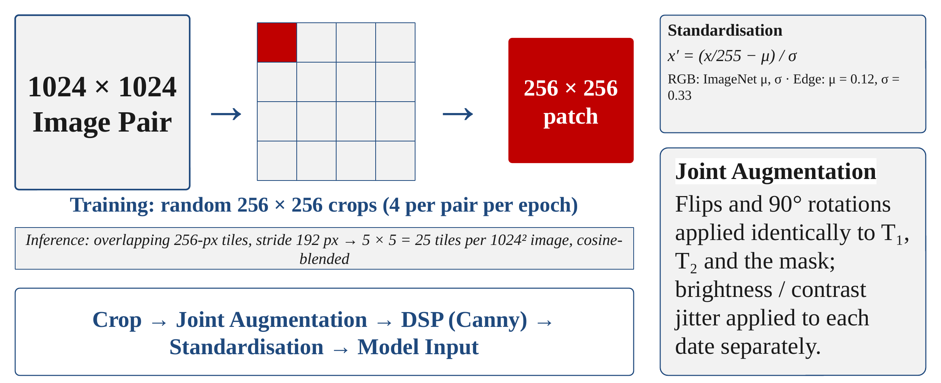
Figure 3: Preprocessing: native-resolution cropping for training, overlapping tiles for inference, joint augmentation and channel standardisation.

DSP Front-End
Each RGB image passes through a classical edge-extraction chain (Figure 4) [10]. First, luminance is computed with the ITU-R BT.601 weights [11]:
Y(x,y) = 0.299 R(x,y) + 0.587 G(x,y) + 0.114 B(x,y) (2)
The grayscale image is then smoothed by 2-D convolution with a 5 × 5 Gaussian kernel of σ = 1, a low-pass filter that removes high-frequency sensor noise which would otherwise produce spurious gradients [6]:
G(x,y) = (1 / 2πσ²) · exp(−(x² + y²) / 2σ²) (3)
I_{G}(x,y) = (G ∗ Y)(x,y) = Σ_{m} Σ_{n} G(m,n) · Y(x−m, y−n) (4)
The Canny detector [7] estimates the gradient with Sobel kernels, computes its magnitude and direction, thins edges by non-maximum suppression along the gradient direction, and applies hysteresis thresholding with a low threshold of 50 and a high threshold of 150 (pixels above 150 are strong edges; pixels between 50 and 150 are kept only if connected to a strong edge):
G_{x} = S_{x} ∗ I_{G}, G_{y} = S_{y} ∗ I_{G}, S_{x} = [−1 0 1; −2 0 2; −1 0 1], S_{y} = S_{x}ᵀ (5)
M(x,y) = √(G_{x}² + G_{y}²), θ(x,y) = atan2(G_{y}, G_{x}) (6)
The binary edge map E ∈ {0,1} is appended to the RGB image as a fourth channel, and every channel is standardised to zero mean and unit variance (ImageNet statistics for RGB; μ = 0.12, σ = 0.33 for the edge channel, see Section 3.1.4):
x′_{c} = (x_{c} − μ_{c}) / σ_{c}, c ∈ {R, G, B, E} (7)
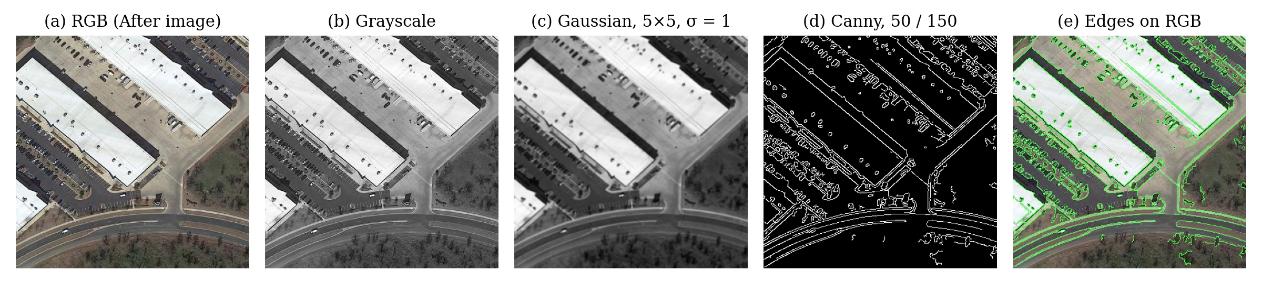
Figure 4: DSP front-end on a LEVIR-CD crop: (a) RGB, (b) grayscale, (c) Gaussian-filtered, (d) Canny edge map, (e) edges overlaid on the RGB image.

Siamese U-Net Architecture
Figure 5 shows the network (26.0 million parameters). Both four-channel inputs pass through the same ResNet-34 encoder [12] pre-trained on ImageNet (shared weights, i.e. a Siamese encoder), producing features at five scales (1/2 to 1/32 of the input, 64 to 512 channels). To accept four channels without discarding the pre-trained weights, the first convolution is widened as
W_{new}[:, 1:3] = W_{ImageNet}, W_{new}[:, 4] = (1/3) Σ_{c} W_{ImageNet}[:, c] (8)
At every scale the two feature maps are fused (Section 3.2.4), and a U-Net decoder [13] with skip connections up-samples the fused features from 1/32 to 1/2 resolution, followed by a ×2 up-sampling and a 3 × 3 full-resolution refinement layer. An auxiliary edge head receives the fused 1/2- and 1/4-scale features plus global context from the bottleneck and predicts the outlines of changed buildings; its features are concatenated into the last decoder stage (edge-guided fusion).
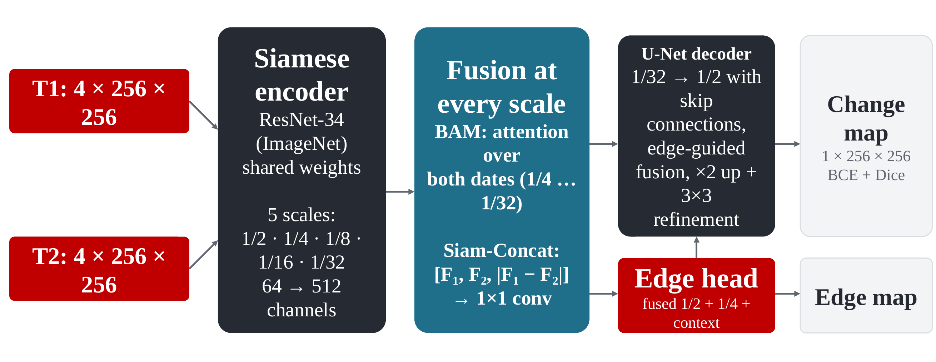
Figure 5: Siamese U-Net with attention-based fusion and an edge-guided decoder.

Spatial-Temporal Attention and Siam-Concat Fusion
The basic spatial-temporal attention module (BAM) of STANet [3] is applied at scales 1/4 to 1/32. The two feature maps F₁, F₂ ∈ ℝ^{C×H×W} are placed side by side, X = [F₁ ‖ F₂] ∈ ℝ^{C×H×2W}, so every pixel of either date can attend to every pixel of both dates. With 1 × 1 convolutions producing queries Q, keys K and values V (keys and values average-pooled by r = 4 or 2 at high-resolution scales), scaled dot-product attention [14] gives
A = softmax(QᵀK / √d), X′ = X + γ · V Aᵀ (9)
where d = C/8 is the key dimension and γ is a learnable scalar initialised to 0, so that the module starts as an identity mapping and does not disturb the pre-trained features. The attended features are then fused by concatenating both dates and their absolute difference (Siam-Concat) and compressing with a 1 × 1 convolution, batch normalisation and ReLU:
D = |F′₁ − F′₂|, F = ReLU(BN(W_{1×1} ∗ [F′₁, F′₂, D])) (10)

Loss Function
The network is trained with a multi-task loss combining binary cross-entropy (BCE), Dice loss [15] and a class-balanced edge loss [8]:
L = L_{BCE} + L_{Dice} + 0.4 · L_{edge} (11)
L_{BCE} = −(1/N) Σ_{i} [ y_{i} log p_{i} + (1 − y_{i}) log(1 − p_{i}) ] (12)
L_{Dice} = 1 − (2 Σ_{i} p_{i} y_{i} + 1) / (Σ_{i} p_{i} + Σ_{i} y_{i} + 1) (13)
BCE penalises each pixel independently, whereas the Dice term measures the overlap of the changed region directly and is therefore insensitive to the 95 % unchanged background. The edge target is obtained by applying the Sobel operator to the ground-truth mask, E = 1[√((S_{x} ∗ Y)² + (S_{y} ∗ Y)²) > 0.5]. Because boundary pixels are only 1–2 % of all pixels, the edge BCE is weighted by β = |E⁻| / |E| (the fraction of non-edge pixels) for edge pixels and 1 − β for non-edge pixels.

Training Procedure
Table 3 lists the training settings. The learning rate follows a one-epoch linear warm-up and a cosine decay stepped every iteration:
η(k) = η₀ · [ ρ + (1 − ρ) · ½ (1 + cos(π (k − k_{w}) / (K − k_{w}))) ], k ≥ k_{w} (14)
where η₀ = 10⁻⁴, ρ = 0.01, k_{w} is the number of warm-up iterations and K the total number of iterations. After every epoch the model predicts the full-resolution validation images; the checkpoint with the highest validation F1 (over a threshold sweep) is kept, and training stops if validation F1 does not improve for 15 epochs.
Table 3: Training settings.
Setting | Value
Input | 4 × 256 × 256 crops (RGB + Canny), 4 crops per image per epoch
Batch size / iterations per epoch | 4 / 445
Optimiser | AdamW [16], learning rate 1 × 10⁻⁴, weight decay 1 × 10⁻⁴
Schedule | 1-epoch warm-up + cosine decay; gradient clipping at norm 1.0
Loss weights | BCE 1.0, Dice 1.0, edge 0.4
Maximum epochs / early stopping | 50 / patience 15 on validation F1
Hardware | Apple-silicon MacBook GPU (PyTorch MPS), ≈ 6.3 min per epoch
Result | best validation F1 0.9107 at epoch 32; stopped at epoch 47 (≈ 5 h)

Inference, Thresholding and Post-Processing
A full scene is predicted with overlapping 256 × 256 tiles (stride 192 px, i.e. 25 tiles for a 1024 × 1024 image). Tile logits are blended with a separable raised-cosine window w that tapers over the 64-pixel overlap, which removes seams and down-weights tile borders that see less context:
z(x,y) = Σ_{k} w_{k}(x,y) z_{k}(x,y) / Σ_{k} w_{k}(x,y) (15)
Test-time augmentation (TTA) averages the probabilities of the identity, horizontal-flip, vertical-flip and 180°-rotation views, each mapped back to the original orientation. A pixel is labelled changed when its probability is at least t = 0.41, the threshold that maximised F1 on the validation set. In the GUI the mask can optionally be cleaned by a 3 × 3 morphological opening, removal of regions smaller than 20 pixels, and Douglas–Peucker polygon simplification [17] with a tolerance of 1 % of each contour’s perimeter; an image-specific Otsu threshold [18] is also offered.

Evaluation Metrics
With TP, FP, FN and TN counted over all pixels of all test images (dataset-level, the convention of the literature), the metrics are:
P = TP / (TP + FP), R = TP / (TP + FN), F1 = 2PR / (P + R) (16)
IoU = TP / (TP + FP + FN) = F1 / (2 − F1) (17)
OA = (TP + TN) / (TP + TN + FP + FN) (18)
Overall accuracy (OA) is reported for completeness but is not used for design decisions: because about 95 % of pixels are unchanged, a model that predicts “no change” everywhere would already score about 95 % OA. Cohen’s κ is also reported as a chance-corrected agreement measure.

Source Code (Core Modules)
The complete source code (about 30 Python modules: data pipeline, DSP front-end, model, losses, training, evaluation, analysis scripts and GUI) is available in the project repository (Section 7.3). Table 4 lists the core DSP and model routines.
Table 4: Core source code: DSP front-end, 4-channel encoder, attention, fusion, loss and sliding-window inference (excerpts).
# preprocessing/dsp_processing.py (DSP front-end)
def rgb_to_grayscale(image):
# Y = 0.299 R + 0.587 G + 0.114 B (ITU-R BT.601)
return cv2.cvtColor(image, cv2.COLOR_RGB2GRAY)

def apply_gaussian_filter(gray, kernel_size=5, sigma=1.0):
# 2-D low-pass convolution with a Gaussian kernel
return cv2.GaussianBlur(gray, (kernel_size, kernel_size),
sigmaX=sigma)

def detect_canny_edges(blurred, low=50, high=150):
# Sobel gradients -> non-max suppression -> hysteresis
return cv2.Canny(blurred, threshold1=low, threshold2=high)

def compute_edge_map(rgb_image):
gray = rgb_to_grayscale(rgb_image)
blurred = apply_gaussian_filter(gray)
edges = detect_canny_edges(blurred)
return edges.astype(np.float32) / 255.0 # {0, 1}

def prepare_model_input(rgb_image, use_canny=True):
# RGB: ImageNet standardisation
rgb = rgb_image.astype(np.float32) / 255.0
rgb = (rgb - IMAGENET_MEAN) / IMAGENET_STD
if not use_canny:
return rgb # H x W x 3
# Edge: standardised with measured statistics
edge = (compute_edge_map(rgb_image) - 0.12) / 0.33
return np.concatenate([rgb, edge[..., None]], -1) # H x W x 4

# models/encoder.py (4-channel ImageNet encoder)
new_conv.weight[:, :3] = old_conv.weight # RGB filters
new_conv.weight[:, 3:] = old_conv.weight.mean(1, keepdim=True)
# models/fusion.py (spatial-temporal attention, BAM)
class BAM(nn.Module):
def forward(self, before, after):
B, C, H, W = before.shape
x = torch.cat([before, after], dim=3) # dates side by side
x_kv = torch.cat([self._pool(before),
self._pool(after)], dim=3)
q = self.q_conv(x).flatten(2) # [B, d, N]
k = self.k_conv(x_kv).flatten(2) # [B, d, M]
v = self.v_conv(x_kv).flatten(2) # [B, C, M]
a = torch.bmm(q.transpose(1, 2), k) * self.key_channels ** -0.5
a = a.softmax(dim=-1) # [B, N, M]
out = torch.bmm(v, a.transpose(1, 2)).view(B, C, H, 2 * W)
out = x + self.gamma * out # gamma = 0 at start
return out[..., :W], out[..., W:]

# Siam-Concat fusion at every scale
d = torch.abs(bf - af)
fused = reduce_conv(torch.cat([bf, af, d], dim=1)) # 3C -> C

# losses/losses.py (multi-task loss)
bce = F.binary_cross_entropy_with_logits(change_logits, mask)
dice = 1 - (2 * (p * y).sum() + 1) / (p.sum() + y.sum() + 1)
edge_target = sobel_edge_detection(mask) # |grad| > 0.5
beta = (edge_target == 0).float().mean()
w = beta * edge_target + (1 - beta) * (1 - edge_target)
edge = F.binary_cross_entropy_with_logits(edge_logits, edge_target,
weight=w)
loss = bce + dice + 0.4 * edge

# models/siamese_unet.py (sliding-window inference)
for (y, x) in tile_positions(H, W, tile=256, stride=192):
out = model(before[..., y:y+256, x:x+256],
after[..., y:y+256, x:x+256])
acc[..., y:y+256, x:x+256] += out * cosine_window
wsum[..., y:y+256, x:x+256] += cosine_window
logits = acc / wsum

Implementation

Description
The system is implemented in Python 3 with PyTorch [19] for the neural network, OpenCV [20] for the DSP operations and PyQt5 for the user interface. Table 5 gives the software organisation.
Table 5: Software modules.
Module | Function
config.py | All settings: paths, DSP parameters, normalisation statistics, training hyper-parameters, threshold
preprocessing/ | Grayscale, Gaussian and Canny DSP chain; channel standardisation
dataset/ | LEVIR-CD loader, random / change-focused cropping, synchronised and photometric augmentation
models/ | Siamese ResNet-34 encoder, BAM + Siam-Concat fusion, U-Net decoder, edge head, sliding-window inference
losses/, training/ | Multi-task loss, training loop, dataset-level metrics, threshold sweep
train.py, evaluate.py | Training (with resume and ablation flags) and full-resolution test evaluation with reports
inference/, gui/app.py | Prediction on any image pair, post-processing and the PyQt5 desktop application
sanity_check.py | 16 automated checks of shapes, normalisation, batch independence, loss and checkpoints

Graphical user interface. The desktop application (Figure 6) loads the before and after images and, optionally, a ground-truth mask. The model is loaded once in a background thread and inference runs in a separate QThread, so the window never freezes. The user can enable test-time augmentation, choose the input resolution, move a threshold slider (or use the validation or Otsu threshold) and switch polygon post-processing on or off; the probability map, the mask, an overlay on the after image and live F1/IoU/precision/recall values update instantly. On test image test_102 the GUI reaches F1 = 0.958 and IoU = 0.919.
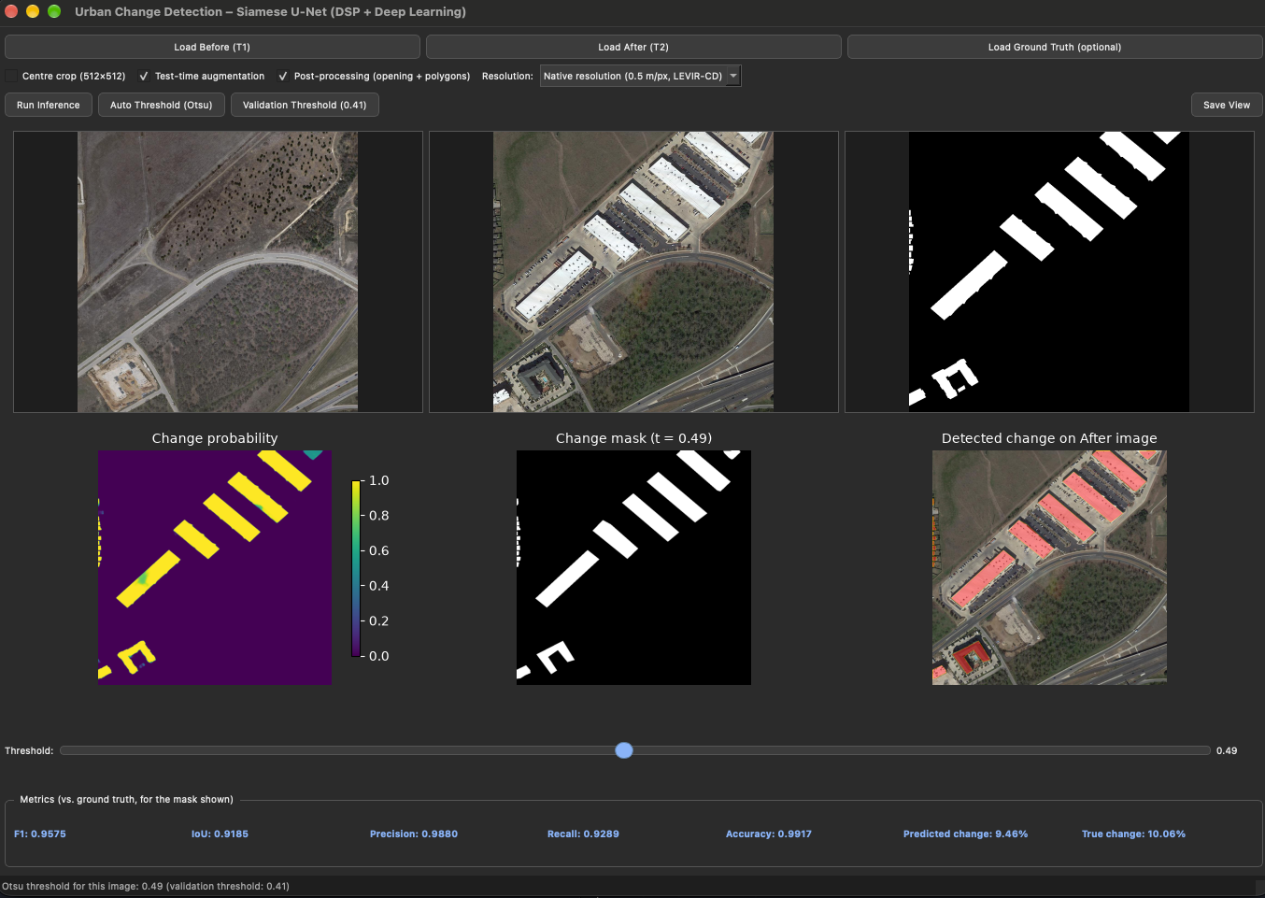
Figure 6: PyQt5 desktop application running on LEVIR-CD test image test_102.
Qualitative results. Figure 7 shows three test scenes: a warehouse development, a new housing estate and a curved suburban layout. The error maps are almost entirely white (correct), with red (false alarm) and cyan (miss) limited to 1–2-pixel rims along building outlines; closely spaced houses are separated.
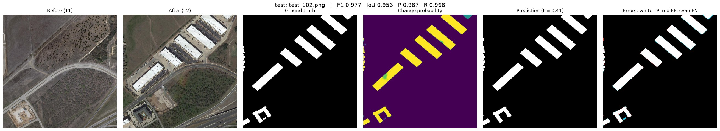
Figure 7: test_102 (F1 0.977, IoU 0.956). Columns: before, after, ground truth, probability, prediction, error map (white TP, red FP, cyan FN).
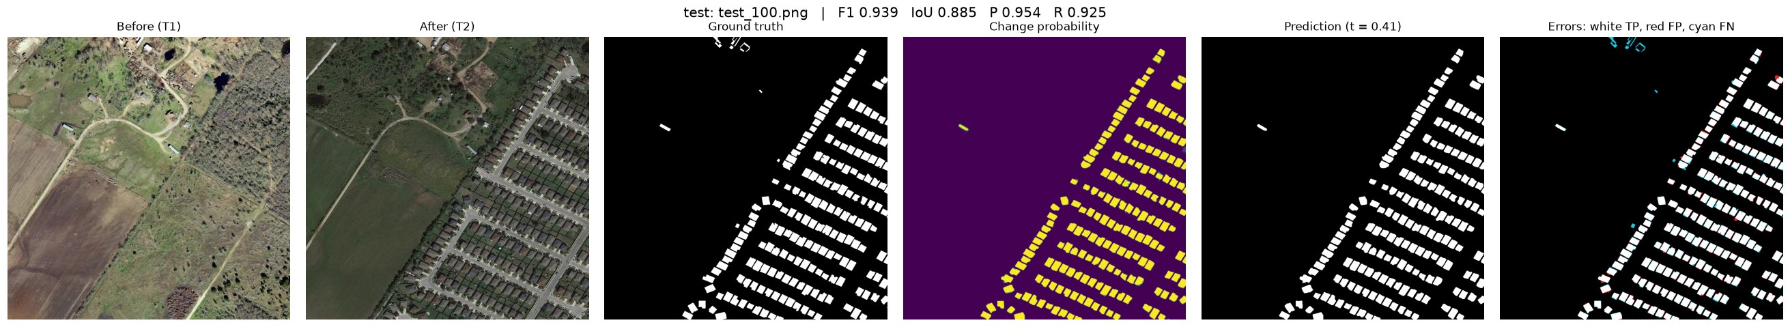
Figure 8: test_100, new housing estate (F1 0.939, IoU 0.885).
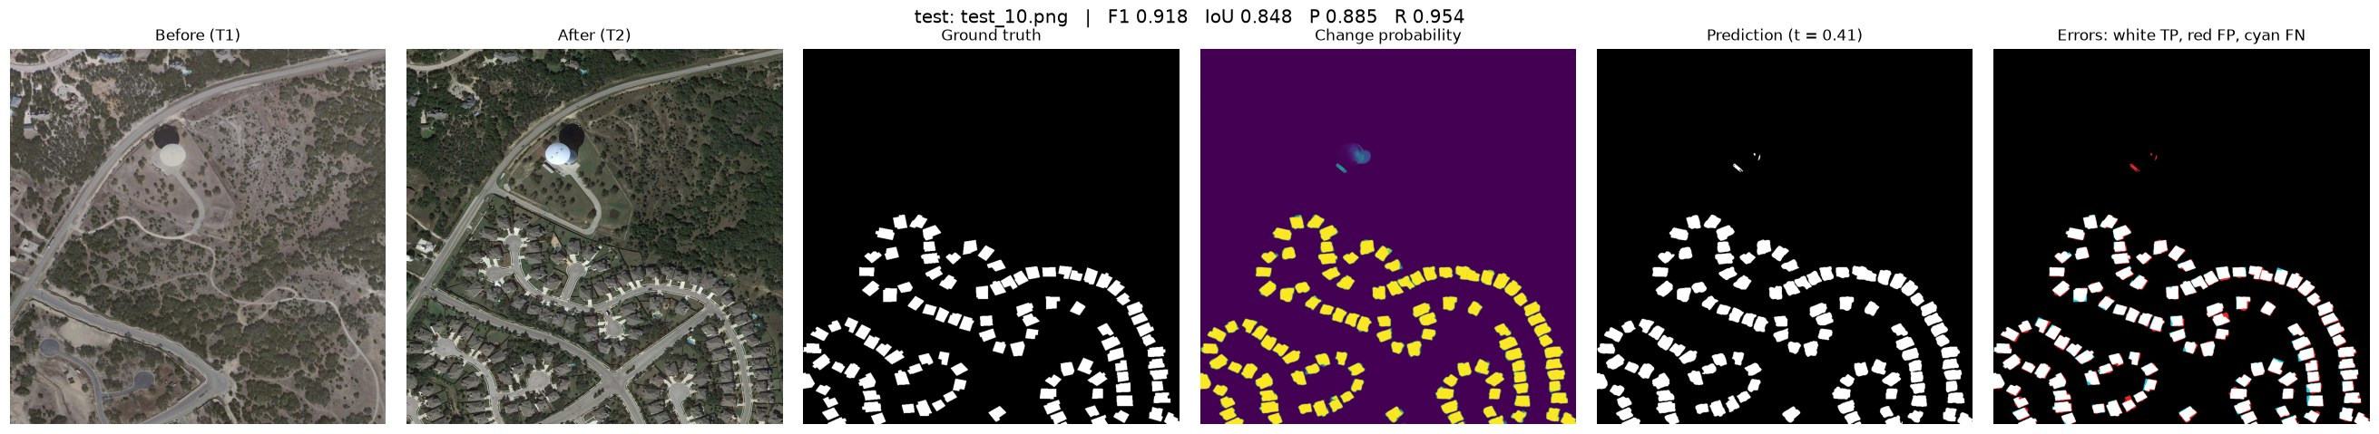
Figure 9: test_10, suburban cul-de-sacs (F1 0.918, IoU 0.848).
Bangladeshi imagery. To test generalisation, the system was applied to bi-temporal images of Bashundhara R/A, Dhaka (Figure 10). The model detects only a few scattered changes near construction sites and misses much of the real change. Dense layouts, high-rise buildings with long shadows and local roofing materials differ strongly from the low-density US suburbs of LEVIR-CD; this domain shift is discussed in Section 5.4.
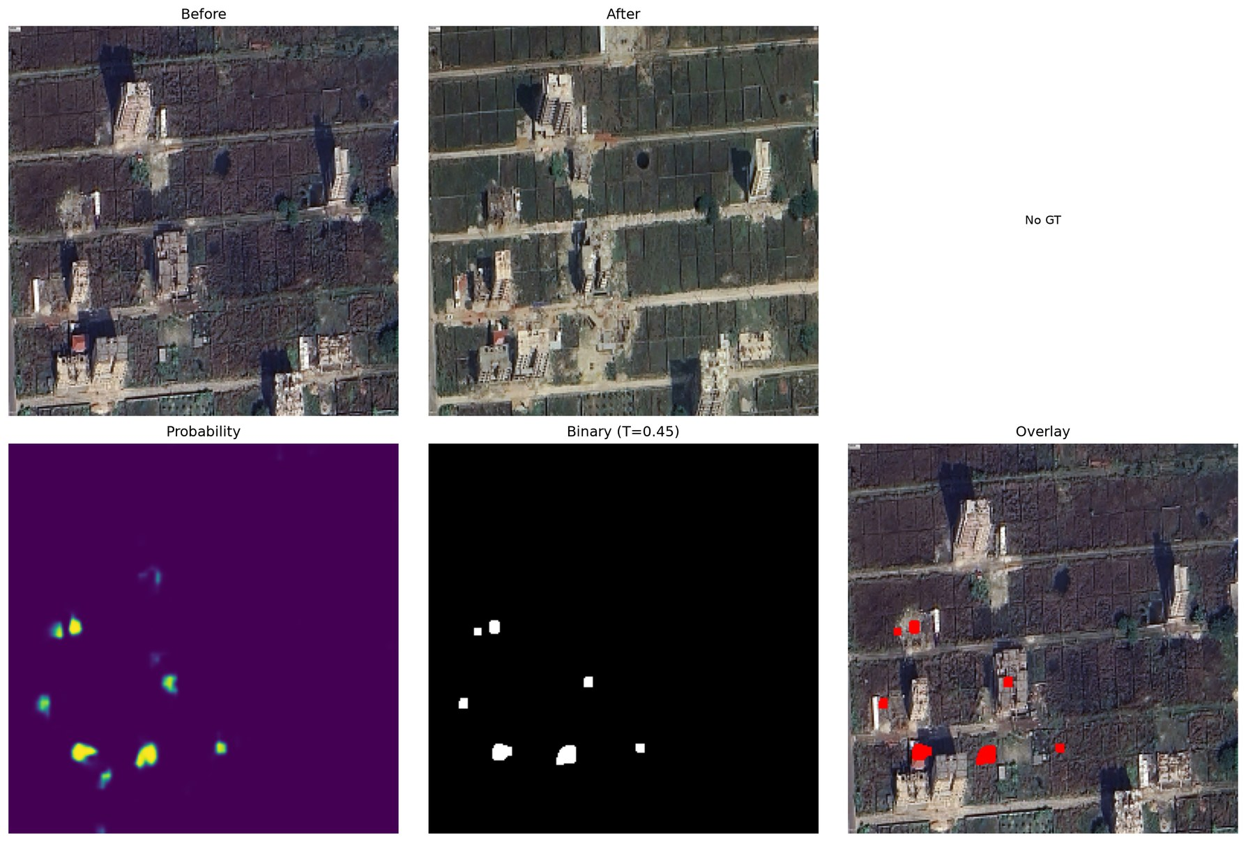
Figure 10: Inference on Bashundhara R/A, Dhaka (first prototype model). Top: before / after; bottom: probability, binary mask, overlay.

Design Analysis and Evaluation

Novelty
- Hybrid DSP–deep-learning input: a classical Gaussian/Canny edge map, standardised with measured statistics, is fused with RGB inside an ImageNet-pre-trained encoder whose first layer is analytically extended to four channels.
- Attention and Siam-Concat fusion at every scale, with spatial-reduction attention that makes spatial-temporal attention affordable on a laptop GPU.
- Edge-guided decoding: a DSP operator (Sobel) generates the supervision for an auxiliary boundary head whose features steer the change decoder.
- Native-resolution deployment: cosine-blended sliding-window inference, a validation-selected threshold and a real-time desktop application for non-experts.
- Engineering investigation: three silent defects of the first prototype were diagnosed with controlled tests and fixed, and the contribution of the DSP channel was measured by ablation rather than assumed.

Design Considerations (PO(c))

Considerations to public health and safety
- The system can flag unauthorised construction in flood-flow zones, on wetlands and in earthquake-sensitive areas of Dhaka for inspection, and can rapidly map damaged or new structures after floods and cyclones.
- A missed building (false negative) could hide a hazard, so the tool is designed as decision support: results are shown with probabilities and overlays for a human to verify, and the threshold slider lets the user favour recall when safety matters.
- Precision and recall were balanced (91.8 % and 90.6 %) rather than maximising one at the expense of the other.

Considerations to environment
- Monitoring encroachment on wetlands, agricultural land and green cover supports environmental protection.
- Remote analysis replaces repeated field-survey trips, reducing travel and fuel use.
- The model was deliberately kept lightweight (26 M parameters) and trained on a laptop in about five hours, a small energy footprint compared with large transformer models; the whole system runs offline.

Considerations to cultural and societal needs
- Up-to-date change maps help planning bodies such as RAJUK and city corporations make informed decisions.
- The GUI requires no programming knowledge, produces polygons usable in GIS software, and reports the changed-area percentage in plain terms.
- Informal settlements are home to many low-income families; the report and user manual state that the tool must not be used to target such communities for eviction.

Investigations (PO(d))

Design of Experiment
The following controlled experiments were designed. Unless stated otherwise, all use the same 128 LEVIR-CD test images, dataset-level metrics and the validation-selected threshold 0.41; only one factor is changed at a time.
Table 6: Designed experiments.
ID | Experiment | Factor varied | Purpose
E1 | Final evaluation | – | Performance of the final RGB + Canny model with TTA
E2 | TTA ablation | TTA on / off | Effect of test-time augmentation
E3 | DSP ablation | Canny channel on / off (retrained) | Does the explicit edge channel help?
E4 | Prototype comparison | v1 (resized, defective) vs v2 | Effect of the design corrections
E5 | Threshold sensitivity | t from 0.05 to 0.95 | Robustness of the chosen threshold
E6 | Batch-independence test | Batch composition | Verify the attention module does not mix samples
E7 | Error analysis | Amount of change per image | Where and why the model fails

Data Collection
- For every experiment, each of the 128 test images (1024 × 1024 = 1,048,576 pixels) was predicted at full resolution, giving 134,217,728 labelled pixels in total.
- The confusion counts TP, FP, FN, TN were accumulated over all pixels. Probabilities were binned into 1,000 bins separately for changed and unchanged pixels, so precision, recall, F1 and IoU could be computed exactly for any threshold from one pass.
- Per-image metrics, the ground-truth changed-area percentage and the false-positive / false-negative pixel counts were saved to CSV files for the error analysis.
- Training and validation losses, validation F1 and the best validation threshold were logged every epoch for both the RGB + Canny and the RGB-only models.

Results and Analysis
E1 – Final evaluation. Table 7 and Figure 11 give the final test results.
Table 7: Final test-set results (E1, RGB + Canny, TTA, threshold 0.41).
Metric | Value | Metric | Value
Precision | 91.76 % | True positives | 6,194,312
Recall | 90.59 % | False positives | 556,557
F1-score | 91.17 % | False negatives | 643,092
IoU | 83.78 % | True negatives | 126,823,767
Overall accuracy | 99.11 % | Cohen’s κ | 0.907

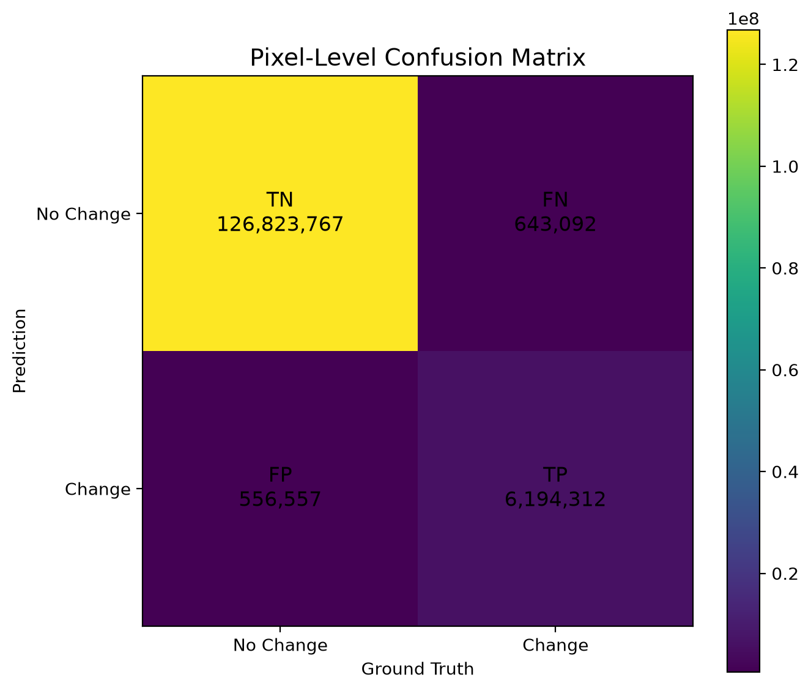
Figure 11: Pixel-level confusion matrix on the test set.
As a consistency check, substituting the measured counts into (16) gives P = 6,194,312 / 6,750,869 = 0.9176, R = 6,194,312 / 6,837,404 = 0.9059, F1 = 0.9117 and IoU = 6,194,312 / 7,393,961 = 0.8378, and the theoretical relation IoU = F1 / (2 − F1) = 0.9117 / 1.0883 = 0.8378 agrees exactly with the measurement.
Learning behaviour. Figure 12 shows that the training loss falls from 1.28 to 0.17 while validation F1 rises quickly to about 0.89 by epoch 9 and saturates near 0.91; the validation loss decreases smoothly without divergence, indicating no harmful over-fitting.
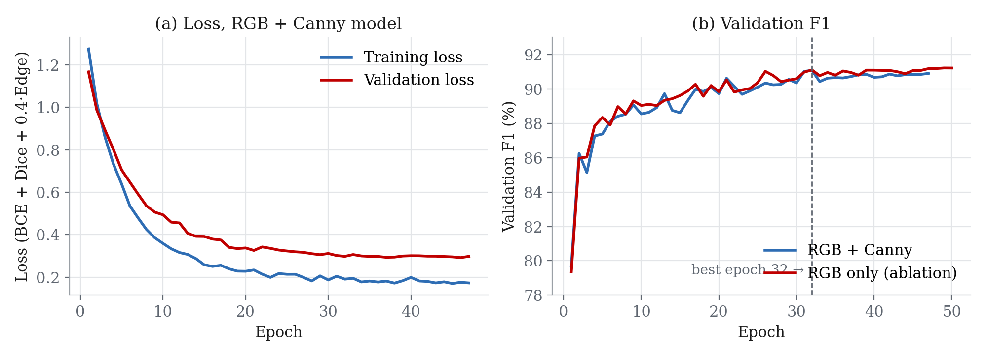
Figure 12: (a) Training and validation loss of the RGB + Canny model; (b) validation F1 of the RGB + Canny and RGB-only models.
E2–E4 – Ablations and prototype comparison. Table 8 and Figure 13 compare the configurations.
Table 8: Ablation results on the 128 test images (threshold 0.41).
Configuration | Input | P (%) | R (%) | F1 (%) | IoU (%)
v1 prototype (256² resized, 3 defects) | RGB + Canny | 75.78 | 78.50 | 77.12 | 62.76
v2, no TTA (E2) | RGB + Canny | 91.83 | 89.74 | 90.77 | 83.10
v2 + TTA, final (E1) | RGB + Canny | 91.76 | 90.59 | 91.17 | 83.78
v2 + TTA, DSP ablation (E3) | RGB only | 91.78 | 91.48 | 91.63 | 84.56

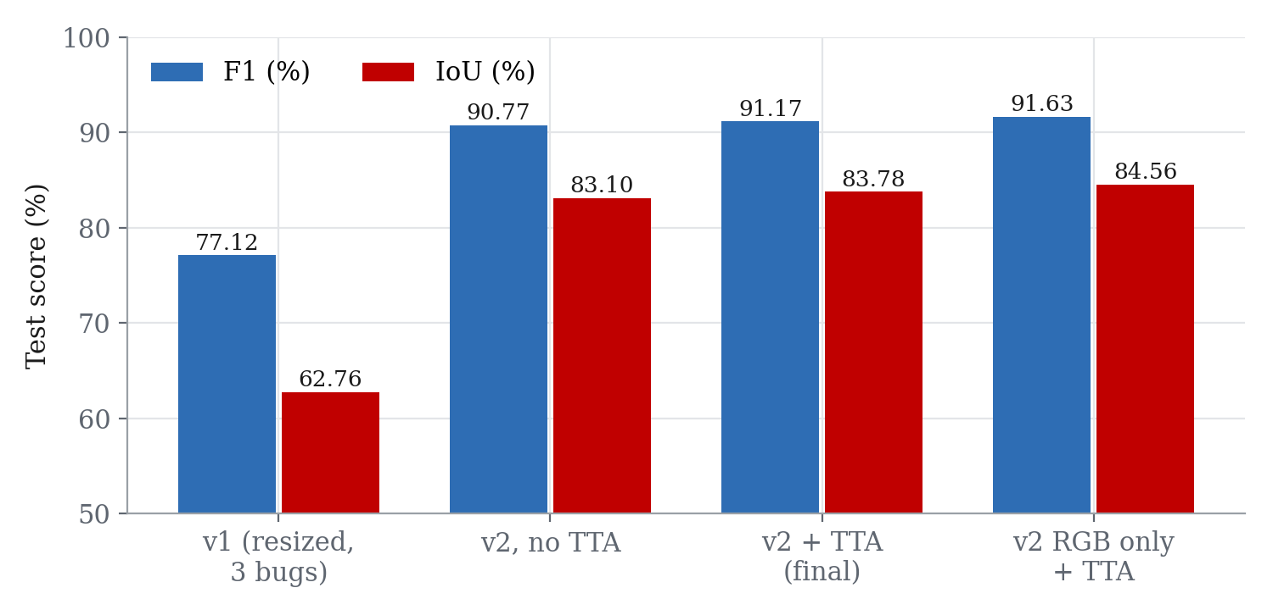
Figure 13: Test F1 and IoU of the four configurations.
E5 – Threshold sensitivity. Figure 14 plots the test metrics against the threshold. F1 is flat between about 0.3 and 0.6: the validation-selected threshold (0.41) gives F1 = 0.9117, while the best threshold that could be chosen on the test set (0.36) would give only 0.9118, so the result is not over-tuned.
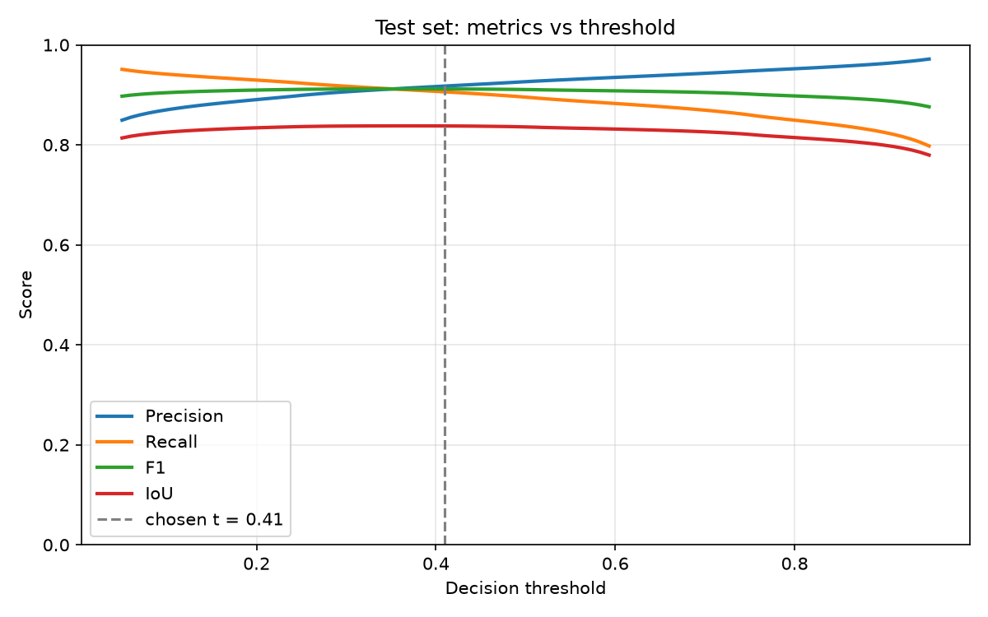
Figure 14: Precision, recall, F1 and IoU on the test set versus the decision threshold.
E6 – Batch independence. With the attention output forced active, the first prototype changed a sample’s prediction by up to 0.241 depending on which other images were in the same batch; the corrected module gives a difference of exactly 0, and a sliding-window prediction on a single tile matches the direct prediction to within 3 × 10⁻⁸.
E7 – Error analysis. Figure 15 groups the test images by the share of changed pixels. F1 rises from 84.5 % for images with less than 1 % change to 92.4 % for images with more than 10 % change; all 10 images without any change produced zero false-alarm pixels. Figure 16 shows that most images have less than 0.5 % false-positive and less than 0.5 % false-negative pixels, and that the two error types are balanced overall (0.41 % and 0.48 % of all pixels). The worst image (Figure 17) combines both failure modes: mobile homes only 3–5 pixels wide are missed, and re-roofed buildings are detected as new.
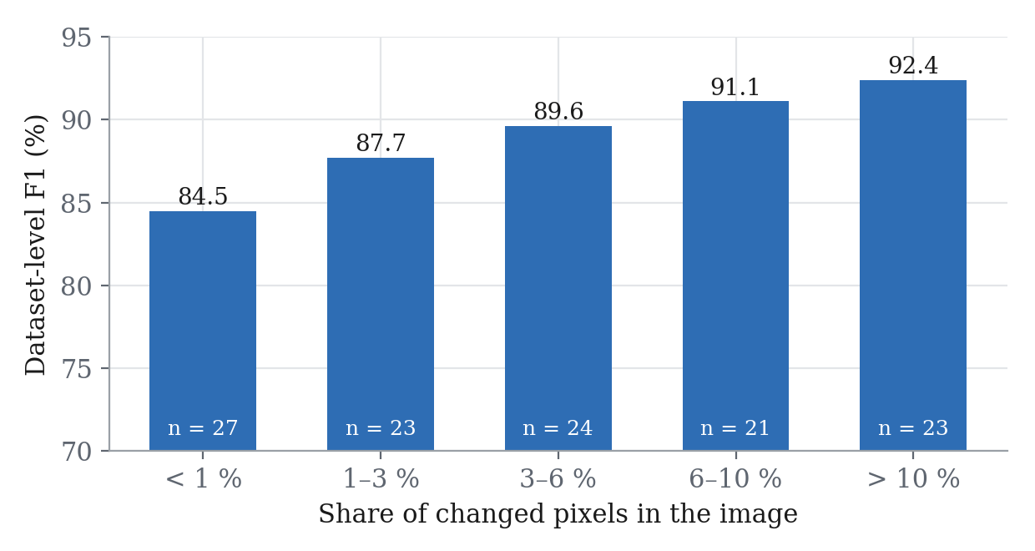
Figure 15: Dataset-level F1 versus the share of changed pixels per image (n = number of test images).
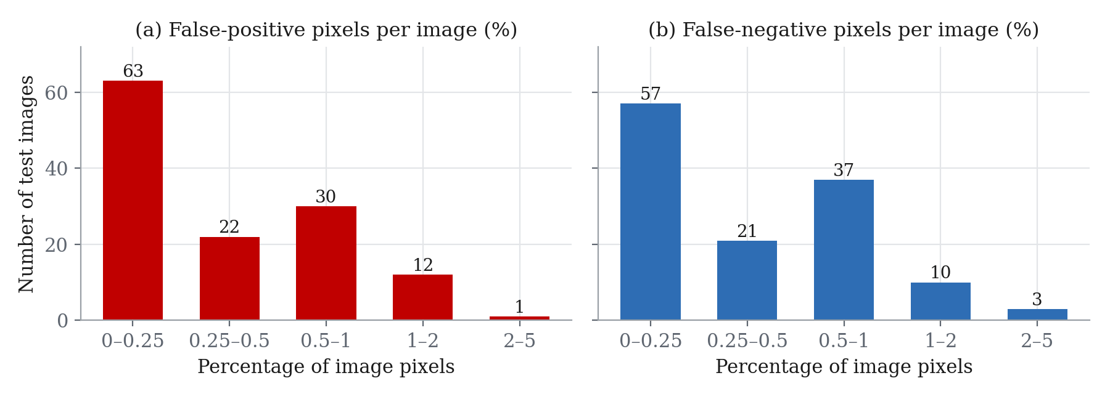
Figure 16: Distribution of false-positive and false-negative pixel percentages over the 128 test images.
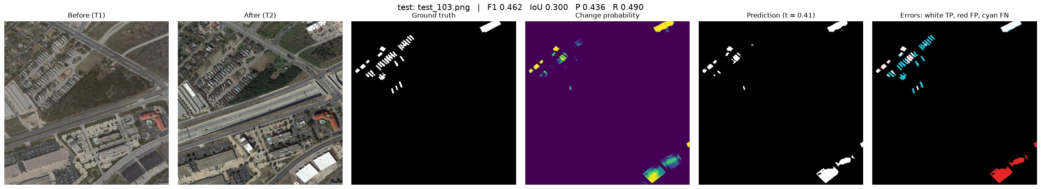
Figure 17: Worst test image, test_103 (F1 0.46): small mobile homes are missed (cyan) and re-roofed buildings produce false alarms (red).

Interpretation and Conclusions on Data
- The final design meets its objectives: 91.2 % F1 and 83.8 % IoU with balanced errors, competitive with published transformer models while training on a laptop in about five hours and predicting a 1024 × 1024 scene in about 3 s with TTA.
- The largest gain (+14 F1 points) came from correct engineering of the pipeline, native-resolution processing, correct input standardisation and a batch-independent attention module, rather than from a larger network.
- Test-time augmentation adds a small but consistent improvement (+0.40 F1, +0.68 IoU) at four times the inference cost.
- The explicit Canny channel gives no measurable gain on LEVIR-CD (F1 91.63 % without it versus 91.17 % with it). The first convolutional layer of an ImageNet-pre-trained encoder already learns oriented edge detectors, so a fixed-threshold edge map adds little information. DSP remains central to the system (Gaussian and Sobel filtering for supervision, cosine-window blending, morphological post-processing), and replacing the fixed Canny thresholds with learnable filters is left as future work.
- Remaining errors are concentrated on very small objects and on appearance changes of existing roofs, and the model does not transfer to dense South-Asian scenes without local training data.

Limitations of Tools (PO(e))
Table 9: Limitations of the tools used.
Tool / resource | Limitation | Effect and tolerance
Laptop GPU (Apple MPS) | Shared memory; no float64 support | Batch size limited to 4; ≈ 6.3 min per epoch; metric histograms computed on the CPU
LEVIR-CD dataset | US suburbs only, 0.5 m/pixel, buildings only | No road / vegetation classes; weak transfer to dense Dhaka scenes; some label noise (e.g. re-roofed buildings)
Canny detector (OpenCV) | Fixed thresholds 50 / 150 | Edge density depends on image contrast; no measurable accuracy gain on LEVIR-CD
Network input size | 256 × 256 tiles | Context limited to 128 m × 128 m; objects smaller than ≈ 4 × 4 px (2 m) are unreliable
Image registration | Pairs assumed co-registered | A shift of a few pixels between dates creates false alarms along edges
Single training run | No repeated seeds | Differences below ≈ 0.5 F1 point (e.g. RGB vs RGB + Canny) are within run-to-run variation
Threshold selection | Chosen on 64 validation images | Optimal test threshold differs (0.36 vs 0.41) but costs only 0.0001 F1

Ethical Issues (PO(h))
- Data licence and credit: LEVIR-CD is used for academic research under the terms of its authors and is not redistributed; every dataset, paper and software library used is cited.
- Privacy and dual use: very-high-resolution imagery can reveal private property. The intended uses are urban planning, environmental monitoring and disaster response, not surveillance of individuals or forced eviction; this is stated in the report and the user manual.
- Honest evaluation: the test set was never used for training, model selection or threshold choice; results are reported with the literature’s dataset-level convention, and per-image averages are labelled separately.
- Reporting negative results: the defects of our first prototype and the finding that the Canny channel gives no measurable gain are reported openly rather than hidden, and the comparison with published methods is marked as indicative.
- Transparency: all code, the trained model and the evaluation outputs are public on GitHub. AI assistance used during code review, debugging and document preparation is disclosed here; all results were produced and verified by the team.

Reflection on Individual and Team work (PO(i))

Individual Contribution of Each Member
Table 10: Individual contributions.
Member | Student ID | Main contributions
Mustasin Rahman | 2206104 | Dataset preparation and splits; DSP pre-processing (grayscale, Gaussian, Canny); augmentation; DSP visualisations
Fahim Shahriyar | 2206114 | Literature review; results, error-type and spatial analyses; failure-mode study; report writing
Md. Ahasan Habib Kawsar | 2206119 | Network architecture; training pipeline; v2 debugging and re-training; evaluation and ablation experiments
Md. Kawsar Ahmed | 2206122 | PyQt5 GUI; inference and post-processing; presentation, video and GitHub repository

Mode of TeamWork
The team met weekly to review progress and assign tasks, kept a shared task list, and worked in a single shared code folder that was later published as a Git repository. Every module was reviewed and tested by a second member before it was merged. Long training runs were shared across members’ laptops, and design decisions (for example the switch to native-resolution training and the ablation study) were discussed and recorded in the log book below.

Diversity Statement of Team
The team combines members with different strengths: signal processing, machine learning, software and user-interface development, and technical writing. Tasks were assigned according to interest and then rotated for reviews, so that every member understood the whole pipeline. All members had an equal voice in decisions, and disagreements were resolved with experiments rather than opinions.

Log Book of Project Implementation
Table 11: Project log book.
Date | Milestone achieved | Individual role | Team role | Comments
Early Aug 2026 | Topic, proposal and literature survey | Fahim: survey; Ahasan: scope | All: topic selection | LEVIR-CD selected
10 Aug 2026 | Data pipeline and DSP front-end | Mustasin: loader, Canny | Review by Ahasan | 4-channel input created
11–12 Aug 2026 | First Siamese U-Net trained; loss ablation; analysis scripts | Ahasan: model; Fahim: analyses | All: result review | Purbachal imagery collected
30 Aug – 2 Sep 2026 | Training variants (simple, weighted, fast) | Ahasan | Mustasin: augmentation | v1 at 256 × 256 resolution
3–4 Sep 2026 | v1 model (F1 0.771); full test inference; GUI with TTA | Kawsar: GUI; Ahasan: evaluation | All: testing | Dhaka domain-shift test
7 Sep 2026 | DSP visualisations for presentation | Mustasin | – | Stage-by-stage figures
28 Sep 2026 | Code review: 3 defects found; v2 re-trained (≈ 5 h) | Ahasan: fixes, training | All: sanity check | Test F1 0.912
29 Sep 2026 | TTA and RGB-only ablations; presentation; GitHub | Ahasan: ablations; Kawsar: GitHub | Fahim: result slides | Canny gives no measurable gain
30 Sep 2026 | Final report | Fahim: writing | All: proofreading | Video link to be added

Communication to External Stakeholders (PO(j))

Executive Summary
BUET students build an AI tool that spots new buildings from space. A team of four Electrical and Electronic Engineering students at BUET has developed software that compares two satellite photos of the same area, taken years apart, and automatically highlights every new building. The tool combines classic image-processing filters with a modern neural network and correctly identifies about 91 % of changed areas on a public benchmark. It runs on an ordinary laptop through a simple point-and-click window. City planners could use it to find unauthorised construction, track the loss of wetlands and map damage after floods, while a human expert always confirms the results.

User Manual
Requirements: Python 3.10 or newer; macOS (Apple silicon), Windows or Linux; about 2 GB of free disk space (plus 5 GB for the dataset if training).
Installation
- Download the code: git clone https://github.com/ahasanhabibkawsar/EEE-312-Group-04-Urban-change-detection-DSP-deep-learning-.git
- Create a virtual environment: python3 -m venv .venv, then activate it (source .venv/bin/activate on macOS/Linux).
- Install the libraries: pip install -r requirements.txt
- Download best_model.pth and best_threshold.json from the repository’s Releases page and place them in the checkpoints/ folder.
- Optional check: python sanity_check.py (all checks should pass in 1–3 minutes).
Using the desktop application
- Start the application: python app.py. The status bar shows “Model ready” when the model has loaded.
- Click Load Before (T1) and Load After (T2) and select two co-registered images of the same area (PNG, JPG or TIFF).
- Optionally click Load Ground Truth to see accuracy figures for a labelled image.
- Choose options: Test-time augmentation (more accurate, about four times slower), Post-processing (clean polygons), Centre crop, and Resolution (select the option matching the image’s ground resolution; LEVIR-CD is 0.5 m/pixel).
- Click Run Inference. The probability map, change mask and red overlay on the after image appear after a few seconds.
- Move the Threshold slider to trade false alarms against missed buildings; Validation Threshold restores 0.41 and Auto Threshold (Otsu) chooses a value for the current image.
- Read the changed-area percentage (and F1, IoU, precision and recall if a ground truth was loaded) in the metrics panel.
- Click Save View to export a six-panel PNG figure.
Command-line use: python train.py (training; --resume to continue, --no-canny for the RGB-only model); python evaluate.py --tta (test evaluation and reports); python test_all_inference.py --data-dir <folder> (predict every pair in a folder with A/ and B/ sub-folders). Troubleshooting: if the model file is missing, download it from Releases; if images have different sizes, the after image is resized automatically; for imagery of a different resolution, use the Resolution option.

Github Link
https://github.com/ahasanhabibkawsar/EEE-312-Group-04-Urban-change-detection-DSP-deep-learning-

YouTube Link
[YouTube link of the project video to be added]

Future Work (PO(l))
- Local dataset: collect and annotate bi-temporal high-resolution images of Dhaka, Purbachal and other Bangladeshi cities to build a region-specific benchmark.
- Domain adaptation: fine-tune the LEVIR-CD model on local data and study unsupervised domain adaptation for dense, high-rise scenes.
- Adaptive DSP features: replace fixed Canny thresholds with learnable, multi-scale edge filters initialised from Sobel/Gabor kernels, and repeat the ablation with several random seeds.
- Semantic change detection: classify the type of change (new construction, demolition, extension) and add roads and vegetation.
- Multi-temporal analysis: use time series of more than two images to suppress seasonal pseudo-changes.
- Deployment: faster inference for city-scale scenes and a GIS plug-in (e.g. QGIS) with GeoTIFF input and polygon export.

References
[1] A. Singh, “Digital change detection techniques using remotely-sensed data,” Int. J. Remote Sensing, vol. 10, no. 6, pp. 989–1003, 1989.
[2] R. C. Daudt, B. Le Saux, and A. Boulch, “Fully convolutional Siamese networks for change detection,” in Proc. IEEE Int. Conf. Image Processing (ICIP), 2018, pp. 4063–4067.
[3] H. Chen and Z. Shi, “A spatial-temporal attention-based method and a new dataset for remote sensing image change detection,” Remote Sensing, vol. 12, no. 10, p. 1662, 2020.
[4] H. Chen, Z. Qi, and Z. Shi, “Remote sensing image change detection with transformers,” IEEE Trans. Geoscience and Remote Sensing, vol. 60, pp. 1–14, 2022.
[5] W. G. C. Bandara and V. M. Patel, “A transformer-based Siamese network for change detection,” in Proc. IEEE Int. Geoscience and Remote Sensing Symp. (IGARSS), 2022, pp. 207–210.
[6] D. Marr and E. Hildreth, “Theory of edge detection,” Proc. Royal Society of London B, vol. 207, no. 1167, pp. 187–217, 1980.
[7] J. Canny, “A computational approach to edge detection,” IEEE Trans. Pattern Analysis and Machine Intelligence, vol. PAMI-8, no. 6, pp. 679–698, 1986.
[8] S. Xie and Z. Tu, “Holistically-nested edge detection,” in Proc. IEEE Int. Conf. Computer Vision (ICCV), 2015, pp. 1395–1403.
[9] LEVIR-CD: A large-scale remote sensing building change detection dataset. [Online]. Available: https://justchenhao.github.io/LEVIR/
[10] R. C. Gonzalez and R. E. Woods, Digital Image Processing, 4th ed. New York, NY, USA: Pearson, 2018.
[11] ITU-R Recommendation BT.601-7, “Studio encoding parameters of digital television for standard 4:3 and wide-screen 16:9 aspect ratios,” International Telecommunication Union, 2011.
[12] K. He, X. Zhang, S. Ren, and J. Sun, “Deep residual learning for image recognition,” in Proc. IEEE Conf. Computer Vision and Pattern Recognition (CVPR), 2016, pp. 770–778.
[13] O. Ronneberger, P. Fischer, and T. Brox, “U-Net: Convolutional networks for biomedical image segmentation,” in Proc. MICCAI, 2015, pp. 234–241.
[14] A. Vaswani et al., “Attention is all you need,” in Advances in Neural Information Processing Systems (NeurIPS), 2017.
[15] F. Milletari, N. Navab, and S.-A. Ahmadi, “V-Net: Fully convolutional neural networks for volumetric medical image segmentation,” in Proc. Int. Conf. 3D Vision (3DV), 2016, pp. 565–571.
[16] I. Loshchilov and F. Hutter, “Decoupled weight decay regularization,” in Proc. Int. Conf. Learning Representations (ICLR), 2019.
[17] D. H. Douglas and T. K. Peucker, “Algorithms for the reduction of the number of points required to represent a digitized line or its caricature,” The Canadian Cartographer, vol. 10, no. 2, pp. 112–122, 1973.
[18] N. Otsu, “A threshold selection method from gray-level histograms,” IEEE Trans. Systems, Man, and Cybernetics, vol. 9, no. 1, pp. 62–66, 1979.
[19] A. Paszke et al., “PyTorch: An imperative style, high-performance deep learning library,” in Advances in Neural Information Processing Systems (NeurIPS), 2019.
[20] G. Bradski, “The OpenCV library,” Dr. Dobb’s Journal of Software Tools, 2000.

