SKILLS SCIENCE ACADEMY
Computer Science — First Year
CHAPTER 1
Computer Systems
Comprehensive Student Notes
Topics Covered:
1.1 Data Representation in a Digital Computer
1.2 Analog and Digital Signals
1.3 Digital Logic and Logic Gates
1.4 Software Development Life Cycle (SDLC)
1.5 Network Topology
1.6 Cybersecurity

1.1 Data Representation in a Digital Computer

Overview
A digital computer can be thought of as a huge collection of tiny electronic switches. Each switch can only be in one of two positions:
- ON — electricity flows — represents 1
- OFF — no electricity flows — represents 0
Computers only understand these two states, 0 and 1. Everything a computer processes — photos, videos, text, and games — is ultimately represented as a pattern of 0s and 1s.

What is a Bit?
A bit is a single binary digit — either a 0 or a 1.
Analogy: If a light switch is a bit, then a byte (8 bits) is like a row of 8 light switches. With 8 switches, 256 different ON/OFF combinations are possible (2⁸ = 256).

What is Binary Code?
When bits are grouped together, they form binary code. For example:
- 1000100 may represent the letter D
- 1000001 may represent the letter A

What is ASCII?
ASCII (American Standard Code for Information Interchange) is a standard that assigns a unique number to every character.

Character | ASCII Code
A | 65
B | 66
a | 97
0 | 48
Space | 32

Key facts about ASCII:
- Uses 7 or 8 bits per character
- Can represent 128 characters (2⁷ = 128)
- Includes uppercase letters, lowercase letters, digits 0–9, and special symbols (%, $, &, #, +, etc.)
Exam Tip: “How many bits does ASCII use?” → 7 or 8 bits. “How many characters?” → 128.

What is an Alphanumeric Code?
Any code that represents letters and numbers (and special characters) is called an alphanumeric code. ASCII is the most common example.

1.2 Analog and Digital Signals

Overview
An analog signal is a smooth, continuous wave that can take any value, such as a sine wave. A digital signal is a square wave that jumps between just two levels, HIGH and LOW — like a light switch that is either fully ON or fully OFF.

Key Differences
Feature | Analog Signals | Digital Signals
What it looks like | Smooth, continuous wave | Square wave (ON/OFF)
Values possible | Infinite values in a range | Only 0 or 1
Noise resistance | Easily affected by noise | Very resistant to noise
Long distance | Degrades over distance | Travels far with less degradation
Copying | Quality loss when copied | Perfect copies every time
Examples | Cassette tapes, VHS, human speech | MP3, JPEG, MP4, computer data

Real-Life Examples
Analog:
- Old cassette tape music
- VHS video tapes
- Your voice when you speak
- Mercury thermometer
Digital:
- MP3 songs on your phone
- Photos taken with a digital camera
- YouTube videos
- Data on your laptop
Why digital is better: Copying an analog cassette tape repeatedly reduces its quality each time. Copying a digital MP3 file, even 1000 times, produces an exact copy every time — this is why digital formats are preferred.

1.3 Digital Logic and Logic Gates

Overview
Logic gates are the tiny decision-makers inside a computer. They take one or more inputs, each either 0 (OFF) or 1 (ON), and produce an output based on a fixed rule. For example, an AND gate turns ON only if all its inputs are ON, an OR gate turns ON if any input is ON, and a NOT gate always produces the opposite of its input.

3. NOT Gate (Inverter)
Rule: Output is the opposite of the input.
Expression: F = x̄ (x-bar)
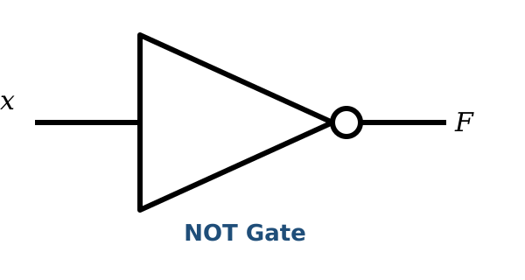
x | F
0 | 1
1 | 0
Analogy: A NOT gate behaves like a rebellious teenager — whatever you tell it, it does the opposite.

1. AND Gate
Rule: Output is 1 only when ALL inputs are 1.
Expression: F = x · y (or simply xy)
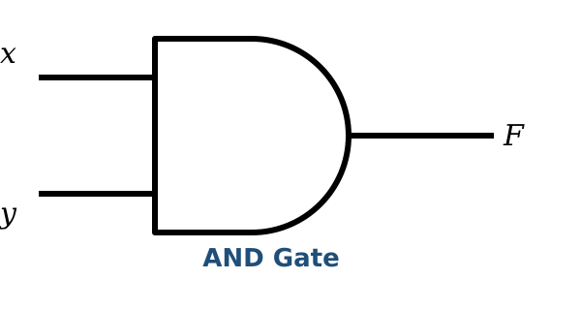
x | y | F
0 | 0 | 0
0 | 1 | 0
1 | 0 | 0
1 | 1 | 1
Analogy: Two switches wired in series — both must be ON for the light to turn on.

2. OR Gate
Rule: Output is 1 when ANY input is 1.
Expression: F = x + y
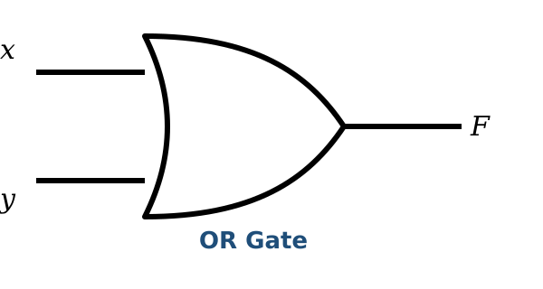
x | y | F
0 | 0 | 0
0 | 1 | 1
1 | 0 | 1
1 | 1 | 1
Analogy: Two switches wired in parallel — either one can turn on the light.

4. NAND Gate (NOT + AND)
Rule: Output is 0 only when ALL inputs are 1 (opposite of AND).
Expression: F = (xy)′
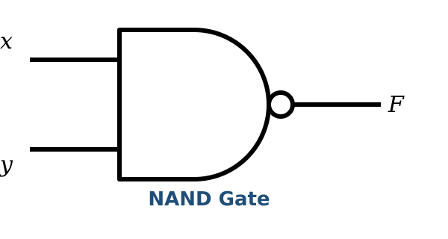
x | y | F
0 | 0 | 1
0 | 1 | 1
1 | 0 | 1
1 | 1 | 0

5. NOR Gate (NOT + OR)
Rule: Output is 0 when ANY input is 1 (opposite of OR).
Expression: F = (x + y)′
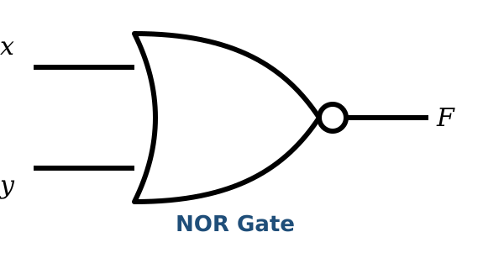
x | y | F
0 | 0 | 1
0 | 1 | 0
1 | 0 | 0
1 | 1 | 0

6. XOR Gate (Exclusive OR)
Rule: Output is 1 when the inputs are DIFFERENT.
Expression: F = x ⊕ y
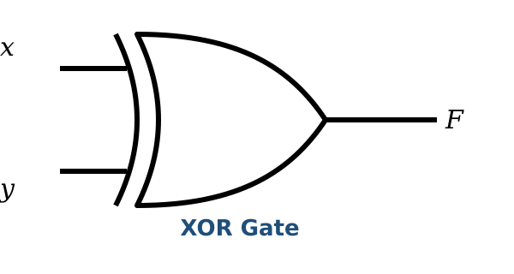
x | y | F
0 | 0 | 0
0 | 1 | 1
1 | 0 | 1
1 | 1 | 0
Analogy: “We agree to disagree” — output is 1 only when the inputs disagree.

7. XNOR Gate (Exclusive NOR)
Rule: Output is 1 when the inputs are the SAME (opposite of XOR).
Expression: F = (x ⊕ y)′
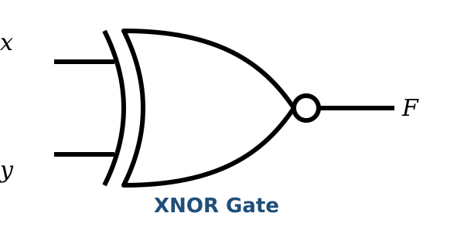
x | y | F
0 | 0 | 1
0 | 1 | 0
1 | 0 | 0
1 | 1 | 1

What is a Truth Table?
A truth table shows the output of a logic gate or circuit for every possible combination of inputs.
Rules for constructing a truth table:
- List all input combinations (count in binary: 00, 01, 10, 11 for two inputs)
- Add columns for any intermediate working
- Add a final output column
- Fill in the results based on the gate's rule
Exam Tip: For 2 inputs → 4 rows. For 3 inputs → 8 rows. For n inputs → 2ⁿ rows.

Boolean Identities (Laws)
These identities are always true and are used to simplify complex Boolean expressions.
Identity | Name
A + 0 = A | Identity Law
A · 1 = A | Identity Law
A + 1 = 1 | Domination Law
A · 0 = 0 | Domination Law
A + A = A | Idempotent Law
A · A = A | Idempotent Law
A + A′ = 1 | Complement Law
A · A′ = 0 | Complement Law
(A′)′ = A | Double Negation
Model Paper Q1(49): Simplify A + A·B → A(1 + B) = A · 1 = A

Principle of Duality
The dual of any Boolean expression is obtained by:
- Swapping AND (·) and OR (+)
- Swapping 0 and 1
Original | Dual
1 = 0 | 0 = 1
A · 0 = 0 | A + 1 = 1
A + B = B + A | A · B = B · A
A + (B · C) = (A + B) · (A + C) | A · (B + C) = (A · B) + (A · C)
Exam Tip: Duality is simply “swap AND/OR and swap 0/1.” The resulting expression remains valid.

Karnaugh Map (K-Map)
A Karnaugh Map is a visual tool used to simplify Boolean expressions without lengthy algebra. Using a K-Map reduces the number of gates required, which lowers the cost of a circuit.
Rules for K-Map simplification:
- Plot 1s — place a 1 in the cell corresponding to each term in the function
- Group 1s into groups of 2, 4, 8, etc. (powers of 2)
- Groups must be adjacent — horizontal or vertical (never diagonal)
- Groups can overlap and can wrap around the edges of the map
- Eliminate any variable that appears in both normal and complemented form within a group
- Write the simplified expression as the sum of the remaining variables

Worked Example: Simplify F = A′B + AB′ + AB
Step 1 — Plot the 1s on a 2-variable K-Map:
A \ B | B′ | B
A′ | 0 | 1 (A′B)
A | 1 (AB′) | 1 (AB)
Step 2 — Group the adjacent 1s:
- Group 1: A′B and AB (vertical pair) → eliminates A → gives B
- Group 2: AB′ and AB (horizontal pair) → eliminates B → gives A
Step 3 — Final simplified answer:
F = A + B
Exam Tip: K-Maps are a guaranteed extended-response question (ERQ) in the exam. Practice 3-variable K-Maps thoroughly.

Uses of Logic Gates
Logic gates are used in:
- Memory circuits (flip-flops, latches)
- Calculators (arithmetic operations)
- Traffic light controllers
- Robots (movement and decision-making)
- Security systems (alarms, access control)
- Home automation (smart lighting, temperature control)
- Medical monitoring devices
- Aerospace navigation and autopilot systems

1.4 Software Development Life Cycle (SDLC)

Overview
The Software Development Life Cycle (SDLC) is the step-by-step process followed to build software. Just as building a house requires planning, designing, constructing, and inspecting, building software follows a similarly structured approach.

The Eleven Phases of SDLC
1. Defining the Problem → 2. Planning → 3. Feasibility Study → 4. Analysis → 5. Requirement Engineering → 6. Design → 7. Development/Coding → 8. Testing/Verification → 9. Deployment → 10. Documentation → 11. Maintenance

Phase 1: Defining the Problem
Clearly identify what problem the software will solve. Example: “We need a Students' Examination System that handles exam-taking and result generation.”

Phase 2: Planning
Set goals and estimate resources such as people, money, and time, then create a project plan. Example: “We need 3 developers, 2 testers, 6 months, and Rs. 5,00,000.”

Phase 3: Feasibility Study
A feasibility study checks whether the project is actually achievable.
Type | Question
Technical | Do we have the required technology?
Economic | Can we afford it? Will the benefits outweigh the costs?
Operational | Will it work well within our organization?
Legal | Is it legal? Does it comply with regulations?
Schedule | Can it be completed on time?
Exam Tip: Legal feasibility refers to compliance with laws and regulations (MCQ Q1(52)).

Phase 4: Analysis
Study the existing system and consult users to understand their needs. Key questions: Can this be built with available resources? Will it improve the organization? Does the existing system need replacing?

Phase 5: Requirement Engineering
This phase involves gathering, validating, and managing requirements. Common techniques for gathering requirements include:
- Interviews — direct conversation with stakeholders
- Surveys/Questionnaires — written questions for large groups
- Observation — watching users in their working environment
- Document Analysis — reviewing existing documents

Phase 6: Design
This phase creates the blueprint of the system, including algorithms, flowcharts, database structure, and user interface.
Flowchart symbols:
Symbol | Name | Function
 | Terminal | Start / End
 | Input/Output | Data entry or display
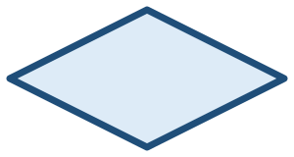 | Decision | Yes/No question
 | Process | Calculations
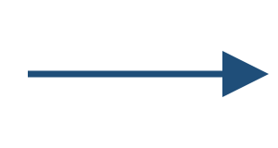 | Flow Line | Direction
 | Connector | Links parts of the flowchart

Phase 7: Development/Coding
The actual code is written using programming languages such as Python, C++, or Java.

Phase 8: Testing/Verification
This phase finds and fixes bugs (errors) in the software.
Black Box Testing | White Box Testing
Tester does not see the internal code | Tester knows the internal code
Tests input → output behavior | Tests internal logic and paths
Focus on functionality | Focus on code quality
Exam Tip: White-box testing means examining the internal code structure (MCQ Q1(35)).

Phase 9: Deployment/Implementation
This phase involves installing the software, training users, and switching from the old system to the new one.
Method | Description | When to Use
Direct | Old system replaced immediately | Small systems, low risk
Parallel | Both systems run together for a while | High-risk, critical systems
Phased | Gradual transition, part by part | Large systems
Pilot | Tested with a small group first | New or innovative systems
Exam Tip: The parallel method means the old and new systems run simultaneously (MCQ Q1(23)).

Phase 10: Documentation
User manuals, technical guides, and system documentation are created in this phase. Good documentation supports maintenance, training, and future development.

Phase 11: Maintenance/Support
After release, this phase covers fixing bugs, updating features, and adapting to changing needs.
- Corrective — fixes errors found after release
- Adaptive — updates the system for new environments
- Perfective — improves performance or adds features

Software Development Models
Waterfall Model:
A sequential, linear approach in which each phase must finish before the next begins (Requirements → Design → Development → Testing → Deployment → Maintenance).
Advantages | Disadvantages
Easy to understand and implement | Inflexible to changes
Clear milestones | Long delivery time
Well documented | Late testing means late bug detection
Good for projects with fixed requirements | High risk if requirements change
Best for: building construction and weather-forecasting systems, where requirements are fixed.

Agile Model:
An iterative, incremental approach in which work is completed in short cycles called “sprints.”
Advantages | Disadvantages
Flexible and adaptable | Depends on customer availability
Continuous client involvement | Scope creep is possible
Early delivery of working software | Less documentation
Regular feedback and improvement | Not ideal for fixed requirements
Best for: web applications, mobile apps, and learning management systems, where requirements change frequently.
Exam Tip: Waterfall suits fixed requirements; Agile suits changing requirements (ERQ Q1).

1.5 Network Topology

Overview
Network topology refers to the arrangement or layout of computers and devices in a network — much like arranging desks in a classroom, where different layouts bring different advantages and drawbacks.

Bus Topology
Layout: All devices are connected to a single main cable (the “bus”).
Advantages | Disadvantages
Cheap — only one cable is needed | If the main cable breaks, the whole network fails
Easy to install | Congestion increases with more devices
Fast for small networks | Difficult to troubleshoot
Used in: Small office and home networks

Star Topology
Layout: All devices connect to a central hub or switch.
Advantages | Disadvantages
Reliable — one device failure does not affect others | If the central hub fails, the whole network fails
Easy to install and manage | More expensive — requires a hub/switch
High performance
Used in: Large offices, campus networks, homes

Ring Topology
Layout: Devices are connected in a circular loop; data travels in one direction.
Advantages | Disadvantages
High reliability with a dual-ring option | If one device or connection breaks, the whole ring fails
Cost-effective | Limited bandwidth
No data collisions | Difficult to troubleshoot
Used in: LANs and fibre-optic networks (FDDI)

Mesh Topology
Layout: Every device connects directly to every other device.
Advantages | Disadvantages
Highly reliable — multiple paths available | Very expensive — requires many cables
Redundant — data can take another route if one path fails | Complex to set up
Scalable | Difficult to maintain
Used in: Military, corporate data centres, critical systems

Tree Topology
Layout: A hierarchical layout, like a tree with branches — multiple star networks connected together.
Advantages | Disadvantages
Scalable | Complex installation
Reliable | Difficult to troubleshoot
Cost-effective
Used in: Large corporate environments

Hybrid Topology
Layout: A combination of two or more topologies.
Advantages | Disadvantages
Flexible | Complex
Reliable | Expensive
Scalable | Difficult to troubleshoot
Secure
Used in: Large enterprise networks

Scalability and Reliability Comparison
Topology | Scalability | Reliability
Bus | Low | Low
Star | Moderate | Good
Ring | Moderate | High
Mesh | High | Very High
Hybrid | High | Varies
Exam Tip: Mesh topology is the most reliable due to multiple paths. Star is the most common. Bus is the cheapest.

Cloud Computing
Cloud computing means using computing resources — servers, storage, and software — over the internet instead of owning them directly.
Service Models:
Model | What It Provides | Example
IaaS | Virtual machines, storage, networks | AWS EC2
PaaS | Development platforms and tools | Google App Engine
SaaS | Software applications | Gmail, Microsoft 365

Deployment Models:
Model | Description
Public | Open to everyone (e.g., AWS, Azure)
Private | Used by a single organization only
Hybrid | A mix of public and private cloud
Community | Shared by organizations with common needs

Scalability:
- Horizontal (Scaling Out): adding more servers
- Vertical (Scaling Up): upgrading an existing server (more RAM, CPU)
Reliability: high availability, redundancy, fault tolerance, and disaster recovery.
Exam Tip: SaaS delivers software over the internet (e.g., Gmail). Private cloud is the most secure. Horizontal scaling means adding more machines.

1.6 Cybersecurity

Overview
Cybersecurity is the practice of protecting computers, networks, and data from digital attacks — much like locking doors and installing alarms to protect a home.

Why is Cybersecurity Important?
- Protects sensitive data such as personal and financial information
- Prevents cyber attacks such as malware, phishing, and DDoS
- Safeguards critical infrastructure such as power grids and hospitals
- Maintains business continuity by avoiding downtime
- Ensures legal compliance with regulations
- Protects national security, including government systems
- Preserves the privacy of personal information

Types of Cyber Threats
Threat | Description | Example
Virus | Attaches to files and spreads when opened | Email attachments
Worm | Self-replicating; spreads automatically | Network infection
Trojan | Disguised as legitimate software | Fake antivirus
Ransomware | Encrypts files and demands payment | WannaCry
Spyware | Collects user information secretly | Keyloggers
Phishing | Fake emails/websites used to steal information | Fake bank email
DoS/DDoS | Overwhelms a system with traffic | Website crash
Insider Threat | An employee misuses their access | Data theft
Exam Tip: A worm spreads automatically without any user action (MCQ Q1(5)).

Protection Methods
Method | How It Works
Strong Passwords | 12+ characters, mixing upper/lowercase, numbers, and symbols
Software Updates | Patch known security holes
Two-Factor Authentication (2FA) | Requires two verification methods (password + OTP)
Suspicious Email Awareness | Avoid clicking unknown links
Education | Stay informed about current threats
Firewalls | Filter incoming and outgoing traffic
Antivirus | Detect and remove malware
Encryption | Convert data into an unreadable format
Backup | Keep regular copies of data
Cryptography | Secure communication
Exam Tip: 2FA combines something you know (password) with something you have (OTP).

Encryption
Encryption is the process of converting readable data (plaintext) into unreadable data (ciphertext) to protect it.
Process: Plaintext → [Encryption Algorithm + Key] → Ciphertext → [Decryption Algorithm + Key] → Plaintext
Symmetric Encryption:
- Uses one key for both encryption and decryption
- Fast and efficient
- Challenge: securely sharing the key
Analogy: A single key that both locks and unlocks the same box.
Asymmetric Encryption:
- Uses two keys: a public key (encrypts) and a private key (decrypts)
- Slower, but more secure
- Solves the key-distribution problem
Analogy: Anyone can place a letter in your mailbox using the public key, but only you hold the private key needed to open it.
Symmetric | Asymmetric
Single shared key | Public and private key pair
Fast | Slow
Same key for both operations | Different keys for encryption and decryption
Key distribution is difficult | Key distribution is easier
Good for large data volumes | Good for small data / key exchange
Exam Tip: Symmetric encryption uses one key and is fast. Asymmetric encryption uses two keys and is more secure (ERQ Q2).

Summary — Key Takeaways for the Exam

Must-Know Definitions
- Bit — a single binary digit
- ASCII — a 7/8-bit code representing 128 characters
- Logic Gate — the basic building block of digital circuits
- Truth Table — shows all input/output combinations
- Duality — swap AND/OR and swap 0/1
- K-Map — a visual Boolean-simplification tool
- SDLC — the 11-phase software development process
- Waterfall — a sequential development model
- Agile — an iterative development model
- Topology — the arrangement of a network
- Cloud Computing — internet-based computing resources
- Cybersecurity — protection from digital attacks
- Symmetric Encryption — uses one key
- Asymmetric Encryption — uses two keys (public/private)
- 2FA — two-factor authentication

Must-Know Comparisons
- Analog vs Digital signals
- Waterfall vs Agile
- Symmetric vs Asymmetric encryption
- Bus vs Star vs Ring vs Mesh topology
- Black box vs White box testing
- Horizontal vs Vertical scaling

Must-Know Lists
- The 7 logic gates and their truth tables
- The 11 SDLC phases
- 4 deployment methods
- 4 cloud deployment models
- 3 cloud service models
- Types of cyber threats
- Methods of protection

Must-Know Skills
- Draw truth tables for any logic gate
- Simplify Boolean expressions using identities
- Simplify expressions using K-Maps (2 and 3 variables)
- Draw logic circuits from a Boolean expression
- Identify SDLC phases in a given scenario
- Choose the appropriate network topology for a situation
- Compare encryption methods

These notes cover Unit 1 comprehensively. Practice K-Maps and SDLC phases especially — they are guaranteed exam topics.

