Evaluating Multilingual LLMs for Depression Detection
in Culturally Diverse Social Media Text

Authors: Taha Rana, Abdul Muqit Afzal, Harsh Patel, Daniyal Lilani
Course: CSCI 4055: Natural Language Processing | Ontario Tech University | April 2026
GitHub: https://github.com/ahatanar/multilingual-mental-health

Abstract. We present a comprehensive evaluation of six large language models (LLMs) — three commercial API-based and three local open-weight — for depression detection in Arabic, Romanized Urdu, and Chinese social media posts. Using a balanced dataset of 5,000 samples per language (15,000 total), we run three experiments: (1) raw binary classification with culturally grounded V3 few-shot prompts, (2) keyword-level reasoning transparency, and (3) cross-lingual label consistency. Best F1: Urdu 0.9016 (Gemini), Arabic 0.8600 (Gemini), Chinese 0.6606 (Gemini). Local open-weight models match commercial APIs on Arabic and Urdu. Gemini shows 83–94% cross-lingual consistency vs. GPT-4o-mini's 80–83%.

1. Introduction
Mental health detection in social media text has emerged as one of the most active applications of NLP, with potential to assist clinical screening at population scale. However, the vast majority of existing work focuses on English-language data, leaving speakers of Arabic (420M+), Urdu (230M+), and Chinese (1.3B+) severely underserved.
These languages present distinct challenges. Arabic involves dialectal variation, rich morphology, and cultural norms around emotional expression tied to religious idiom. Romanized Urdu involves code-switching between Roman script, native vocabulary, and English, encoded through poetic metaphors. Chinese involves tonal ambiguity, regional variation, and culturally embedded distress expressions that differ substantially from Western clinical vocabulary.
This report evaluates six LLMs — GPT-4o-mini, Gemini 2.0 Flash, Claude Haiku 4.5, LLaMA 3 8B, Gemma 8B, and DeepSeek 8B — across three experiments spanning 90,000 individual classifications. Our primary contributions are:
- Largest comparative LLM evaluation for multilingual mental health classification: 6 models × 3 languages × 5,000 samples (90,000 total).
- Keyword transparency analysis: surfacing lexical signals driving model decisions, including native-language keyword comparison.
- Cross-lingual label consistency analysis: tests whether classifications are robust across language presentations of the same content.
- Evidence that local open-weight models can match commercial APIs on Arabic and Urdu, with implications for privacy-preserving deployment.

2. Background and Related Work
Milestone 2 evaluated Gemini 2.0 Flash on Arabic using a 50-sample pilot (90.0% accuracy). Milestone 3 expanded to a 500-sample Urdu evaluation across four models and four prompting strategies, finding that V3 few-shot outperformed zero-shot by 2.8–8.3%, translate-then-classify caused 8–14% accuracy drops, and model behavioural profiles (Gemini=high-recall, GPT-4o-mini=balanced, Claude=ultra-conservative) were consistent across scale.

3. Data Preparation and Translation Pipeline

3.1 Dataset Sourcing
- Arabic: CairoDep and related Arabic social media corpora, covering Egyptian dialect and MSA.
- Romanized Urdu: Roman Urdu Depression Assessment dataset (Mohmand et al.), severity labels collapsed to binary.
- Chinese: Weibo-based mental health datasets (Simplified Chinese).

3.2 Translation and Cleaning
6,000 samples per language were translated to English using Cohere Command R (command-r-08-2024). Translation served as a cleaning pass and produced English inputs for Experiment 3. Final samples: 5,000 per language, balanced 50/50.
Language | Total Translated | Final Sample | Depressed | Not Depressed
Arabic | 6,000 | 5,000 | 2,500 | 2,500
Romanized Urdu | 6,000 | 5,000 | 2,500 | 2,500
Chinese | 6,000 | 5,000 | 2,500 | 2,500
Total | 18,000 | 15,000 | 7,500 | 7,500
Table 1: Dataset composition after translation and filtering.

4. Model Selection
Model | Type | Provider | Parameters | Role
GPT-4o-mini | Commercial | OpenAI | ~8B | Strong multilingual baseline; conservative
Gemini 2.0 Flash | Commercial | Google DeepMind | Unknown | High-recall reference; top performer
Claude Haiku 4.5 | Commercial | Anthropic | Unknown | Ultra-high precision, very low recall
LLaMA 3 8B | Local | Meta AI via LM Studio | 8B | Primary open-weight candidate
Gemma 8B | Local | Google via LM Studio | 8B | Lightweight open-weight candidate
DeepSeek 8B | Local | DeepSeek AI via LM Studio | 8B | Multilingual-tuned open-weight
Table 2: Models evaluated. Local models run via LM Studio.

5. Experimental Design
Experiment | Input | Task | Models | Output
Exp 1 | Original-language post | Binary classify | All 6 | Label + metrics
Exp 2 | Post + Exp1 label | Identify 1–2 keywords + translation | All 6 | Keywords
Exp 3 | English-translated post + Exp1 label | Confirm/reject label | All 6 except Claude | Agreement + keywords
Table 3: Summary of the three experimental paradigms.

6. Experiment 1 Results: Classification Performance

6.1 Full Results Table
Model | Type | Language | Accuracy | Precision | Recall | F1 | TP | FP | TN | FN
Gemini 2.0 Flash | Online | Arabic | 0.8665 | 0.9046 | 0.8196 | 0.8600 | 2049 | 216 | 2282 | 451
Gemini 2.0 Flash | Online | Urdu | 0.8984 | 0.8744 | 0.9304 | 0.9016 | 2326 | 334 | 2166 | 174
Gemini 2.0 Flash | Online | Chinese | 0.7112 | 0.8010 | 0.5620 | 0.6606 | 1405 | 349 | 2151 | 1095
GPT-4o-mini | Online | Arabic | 0.8018 | 0.9660 | 0.6256 | 0.7594 | 1564 | 55 | 2445 | 936
GPT-4o-mini | Online | Urdu | 0.8944 | 0.9595 | 0.8236 | 0.8864 | 2059 | 87 | 2413 | 441
GPT-4o-mini | Online | Chinese | 0.6398 | 0.8787 | 0.3244 | 0.4739 | 811 | 112 | 2388 | 1689
Claude Haiku 4.5 | Online | Arabic | 0.7992 | 0.9431 | 0.6368 | 0.7603 | 1592 | 96 | 2404 | 908
Claude Haiku 4.5 | Online | Urdu | 0.7056 | 0.9795 | 0.4200 | 0.5879 | 1050 | 22 | 2478 | 1450
Claude Haiku 4.5 | Online | Chinese | 0.6096 | 0.9322 | 0.2364 | 0.3772 | 591 | 43 | 2457 | 1909
LLaMA 3 8B | Local | Arabic | 0.8234 | 0.8159 | 0.8352 | 0.8255 | 2088 | 471 | 2029 | 412
LLaMA 3 8B | Local | Urdu | 0.8536 | 0.8110 | 0.9220 | 0.8630 | 2305 | 537 | 1963 | 195
LLaMA 3 8B | Local | Chinese | 0.6826 | 0.8029 | 0.4840 | 0.6039 | 1210 | 297 | 2203 | 1290
Gemma 8B | Local | Arabic | 0.8344 | 0.8519 | 0.8095 | 0.8302 | 2019 | 351 | 2143 | 475
Gemma 8B | Local | Urdu | 0.8726 | 0.8752 | 0.8692 | 0.8722 | 2173 | 310 | 2190 | 327
Gemma 8B | Local | Chinese | 0.6308 | 0.8998 | 0.2944 | 0.4436 | 736 | 82 | 2418 | 1764
DeepSeek 8B | Local | Arabic | 0.7907 | 0.8428 | 0.7149 | 0.7736 | 1785 | 333 | 2164 | 712
DeepSeek 8B | Local | Urdu | 0.7188 | 0.7966 | 0.5885 | 0.6770 | 1469 | 375 | 2114 | 1027
DeepSeek 8B | Local | Chinese | 0.6476 | 0.8261 | 0.3750 | 0.5158 | 936 | 197 | 2293 | 1560
Table 4: Complete Experiment 1 results — all 6 models × 3 languages (n=5,000 per cell).

6.2 Model Rankings and Heatmaps
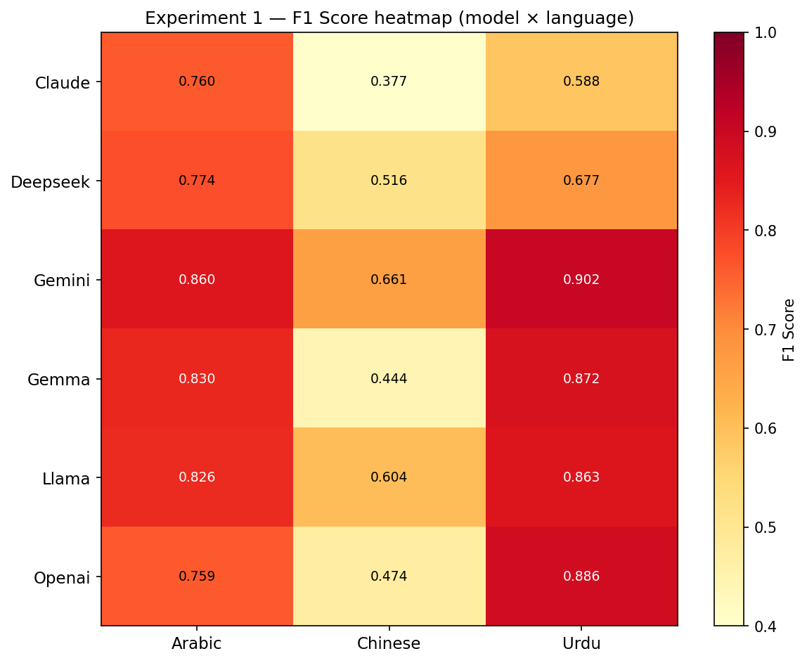 | 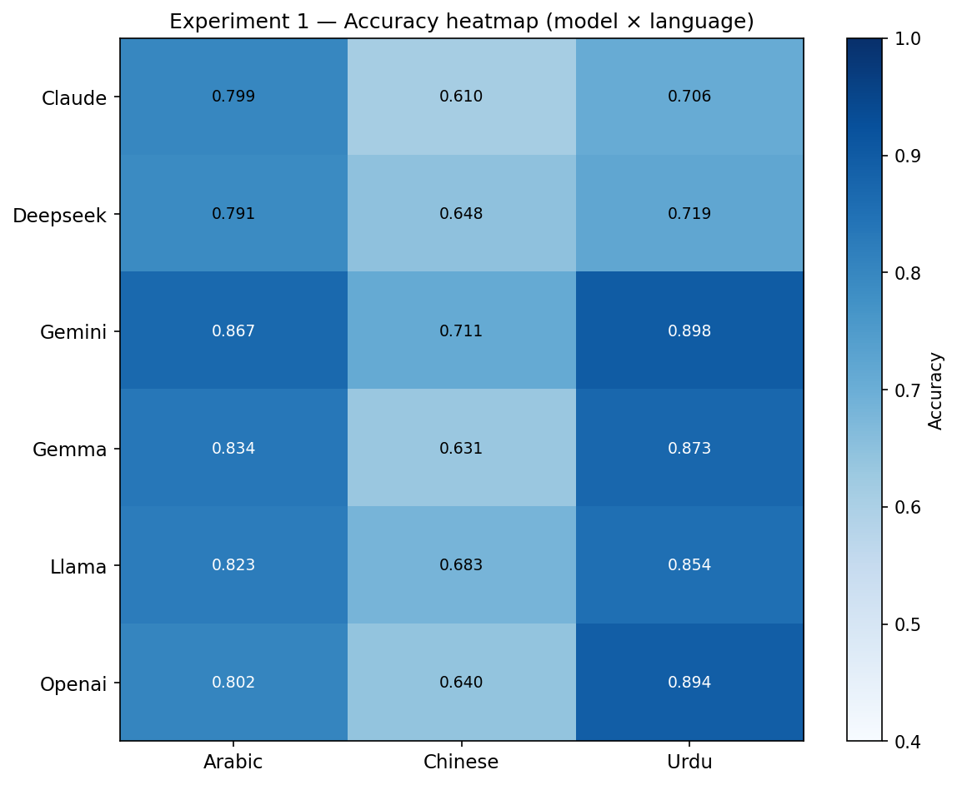

Figure 1 (left): F1 heatmap. Figure 2 (right): Accuracy heatmap. Chinese column is visibly colder.

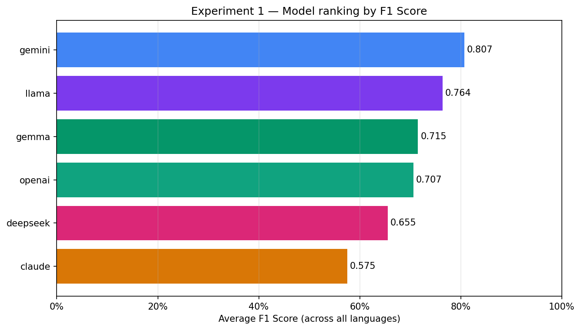
Figure 3: Models ranked by average F1 across all three languages.

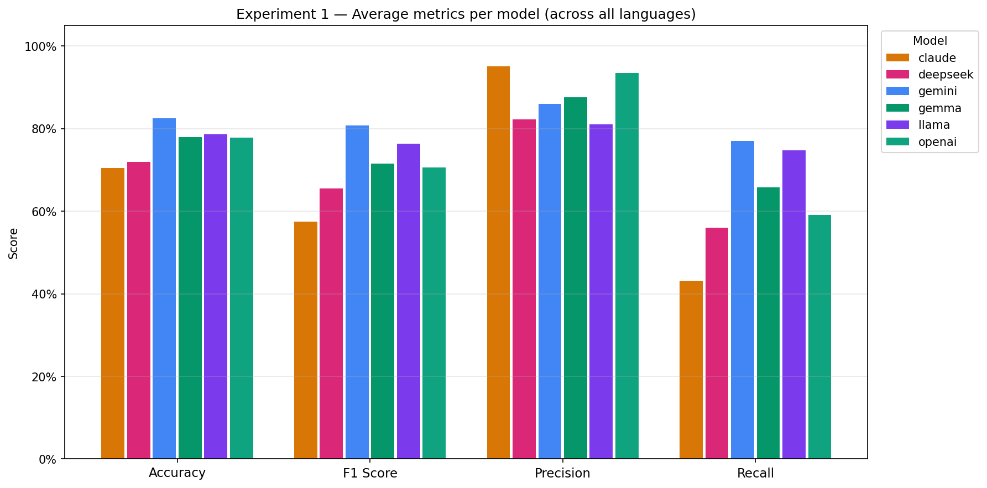
Figure 4: All four metrics per model (averaged across languages). Claude's precision spike and recall trough are clearly visible.

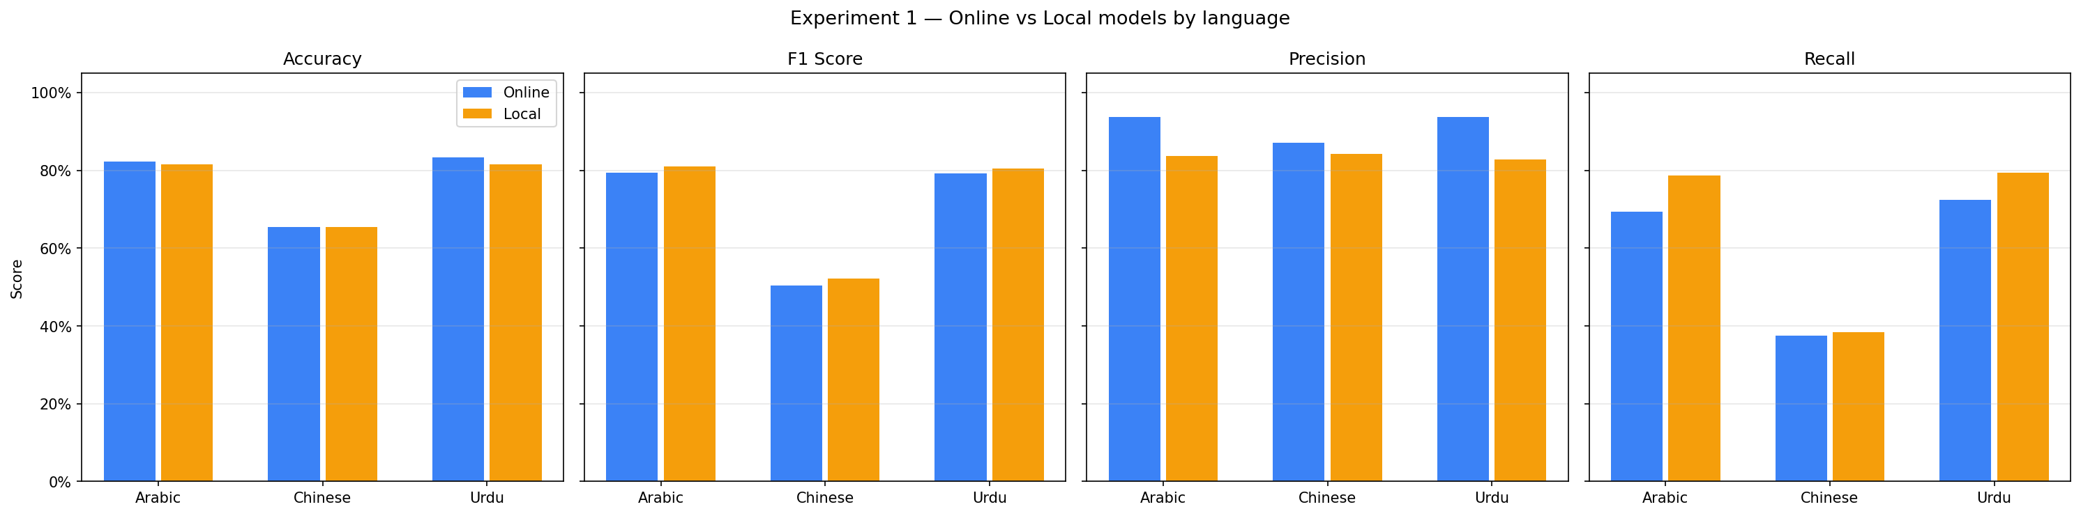
Figure 5: Online vs. local model performance. Gap is modest on Arabic/Urdu, widens on Chinese.

6.3 Per-Language Performance
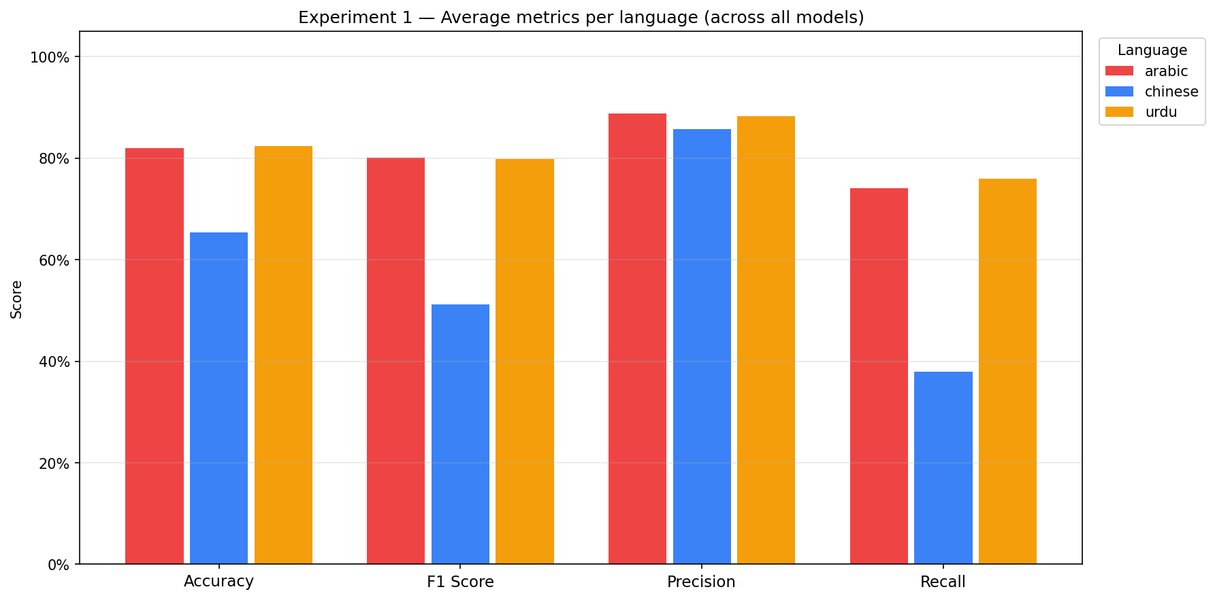
Figure 6: Average metrics by language. Chinese consistently lags on recall and F1.

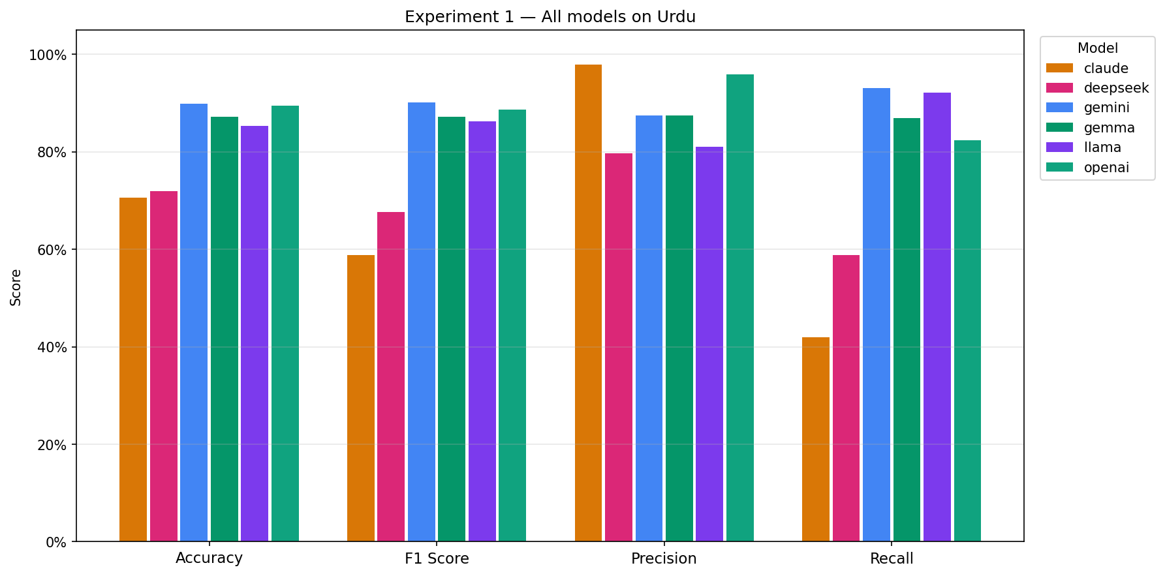
Figure 7: All models on Romanized Urdu. Local models within 3–4 F1 points of Gemini.

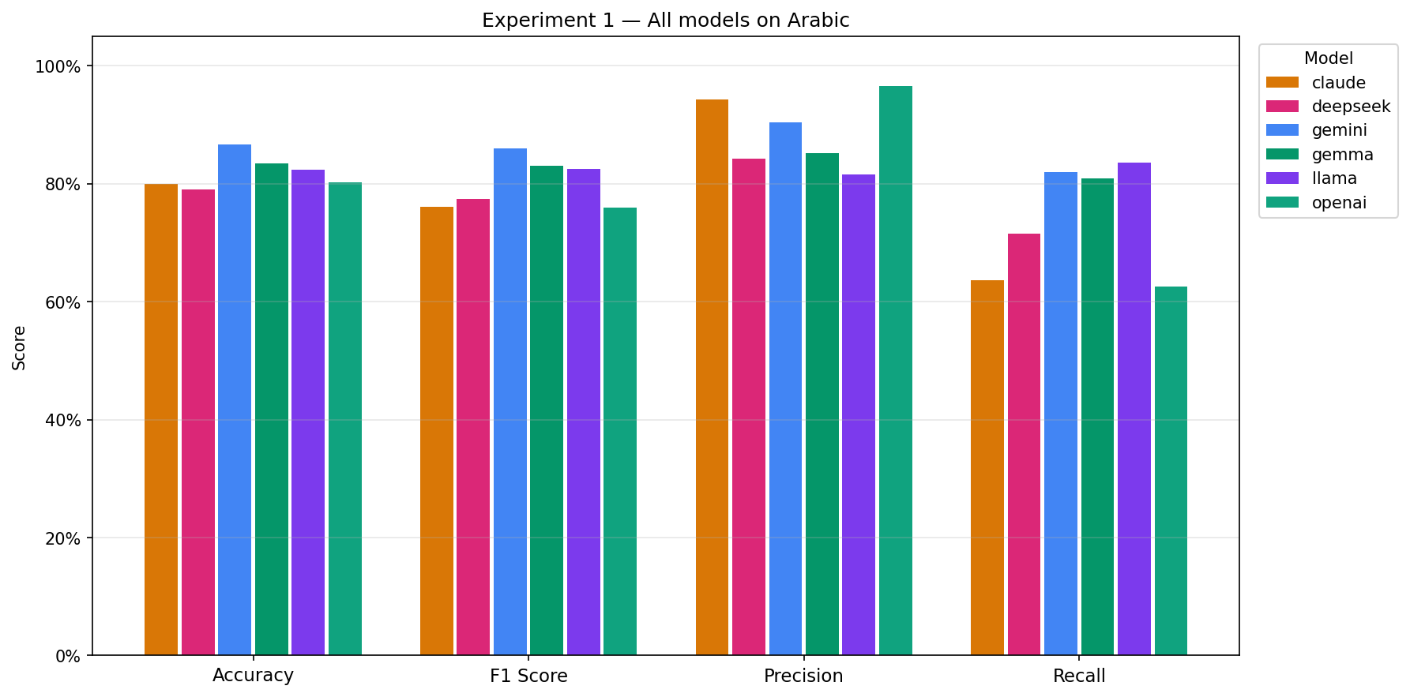
Figure 8: All models on Arabic. LLaMA and Gemma outperform Claude and GPT-4o-mini.

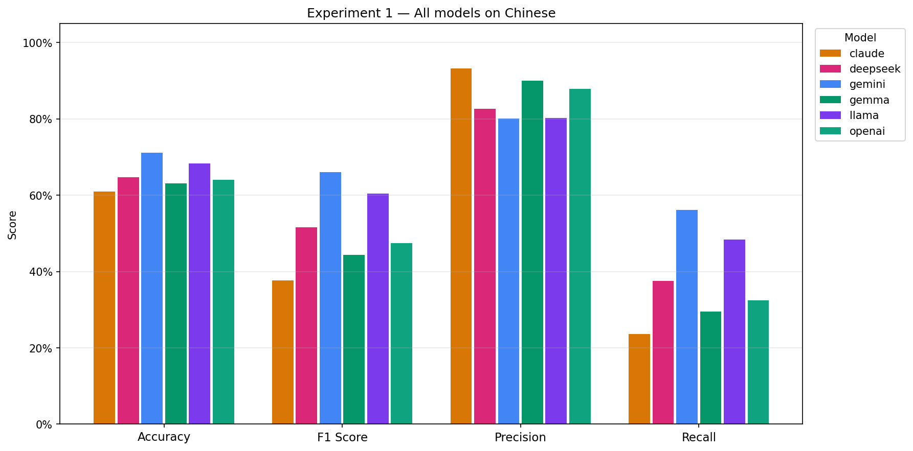
Figure 9: All models on Chinese. All models struggle; LLaMA is the best local model.

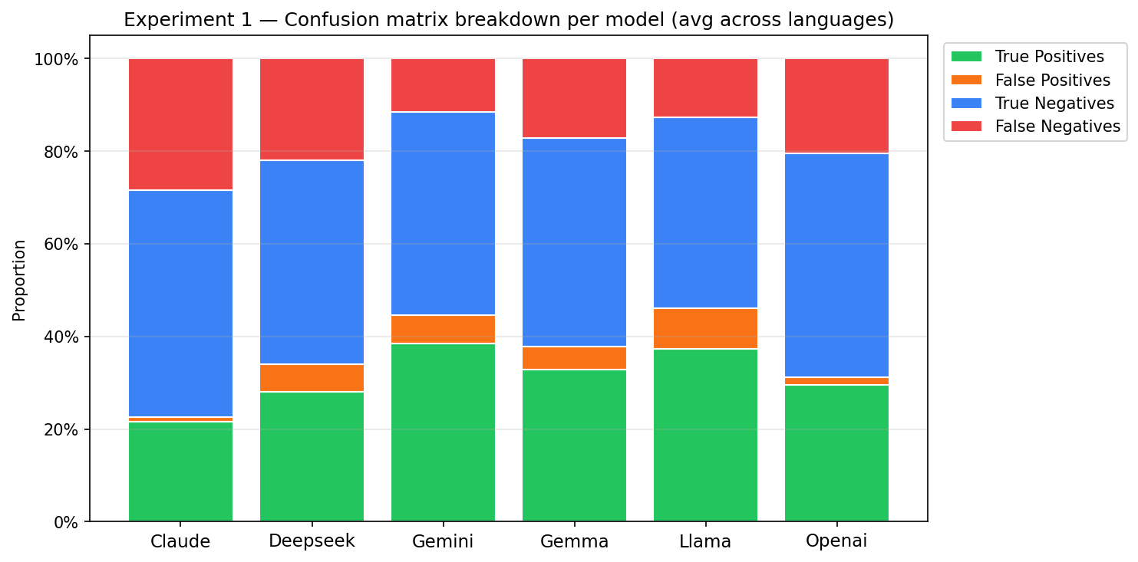
Figure 10: TP/FP/TN/FN breakdown per model. Claude's extreme false-negative skew is clearly visible.

6.4 Key Findings
- Chinese is consistently the most difficult language. Best Chinese F1=0.6606 (Gemini) vs. Arabic 0.8600 and Urdu 0.9016. Average recall on Chinese is 0.38 vs. 0.74 Arabic, 0.76 Urdu.
- Local open-weight models are competitive on Arabic and Urdu. LLaMA (F1=0.863 Urdu) and Gemma (F1=0.872 Urdu) within 3–4 points of Gemini — viable for privacy-preserving deployment.
- Claude Haiku 4.5: ultra-high-precision anomaly. Recall 23.6% on Chinese — only 591 of 2,500 depressed posts detected. Unsuitable for screening.
- GPT-4o-mini: high precision, low recall. Conservative across all languages; near-parity with Gemini on Urdu but poor on Chinese (F1=0.474).
- DeepSeek 8B underperforms other local models. Despite 'multilingual-tuned' designation, consistently below LLaMA and Gemma on all languages.

7. Experiment 2 Results: Keyword Extraction and Reasoning Transparency

7.1 Keyword Coverage and Volume
Model | Language | Entries w/ KWs | Avg KWs/Entry | Unique KWs
Gemini | Arabic | 4,996 (99.9%) | 2.29 | 4,236
Gemini | Urdu | 5,000 (100%) | 2.25 | 3,524
Gemini | Chinese | 5,000 (100%) | 2.17 | 5,238
GPT-4o-mini | Arabic | 4,950 (99.0%) | 2.85 | 5,570
GPT-4o-mini | Urdu | 4,958 (99.2%) | 2.52 | 4,073
GPT-4o-mini | Chinese | 4,970 (99.4%) | 2.85 | 7,602
Claude | Arabic | 5,000 (100%) | 2.94 | 7,221
Claude | Urdu | 5,000 (100%) | 2.25 | 4,356
Claude | Chinese | 5,000 (100%) | 2.66 | 7,592
LLaMA 3 8B | Arabic | 5,000 (100%) | 1.88 | 4,235
LLaMA 3 8B | Urdu | 5,000 (100%) | 2.01 | 3,089
LLaMA 3 8B | Chinese | 5,000 (100%) | 1.87 | 7,695
Gemma 8B | Arabic | 4,988 (99.8%) | 3.68 | 8,857
Gemma 8B | Urdu | 4,999 (100%) | 2.85 | 5,121
Gemma 8B | Chinese | 5,000 (100%) | 3.65 | 11,101
DeepSeek 8B | Arabic | 3,450 (69.0%) | 0.93 | 3,846
DeepSeek 8B | Urdu | 3,456 (69.1%) | 1.66 | 4,093
DeepSeek 8B | Chinese | 3,388 (67.8%) | 1.19 | 4,862
Table 5: Keyword stats. DeepSeek 8B provided keywords for approx. 69% of entries per language (noticeably sparser than other models).

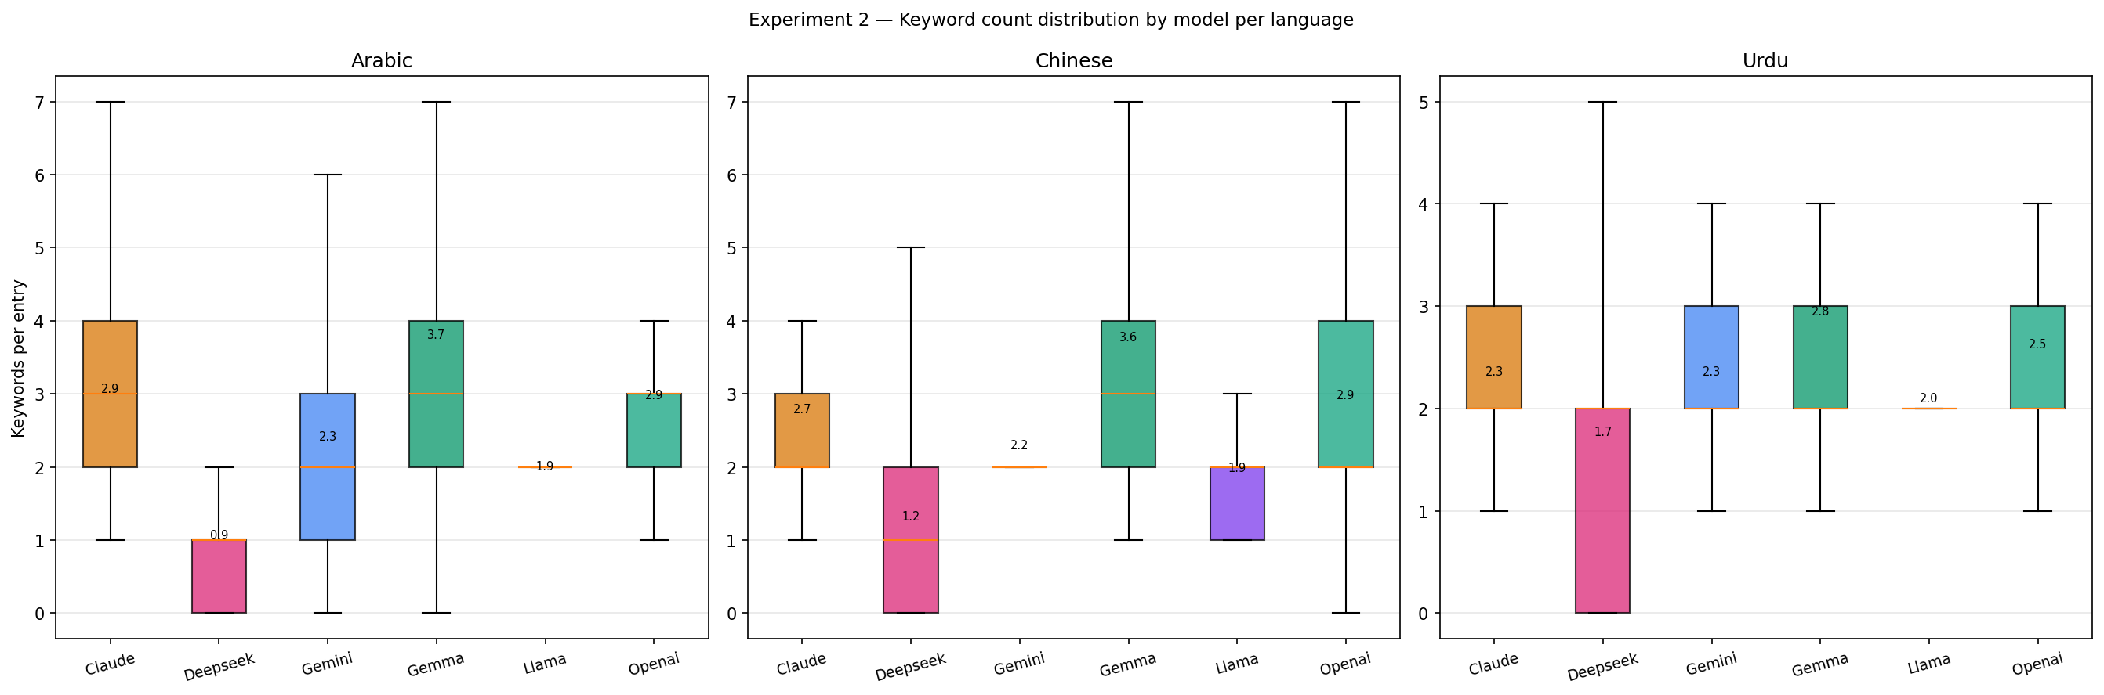
Figure 11: Distribution of keyword counts per entry by language.

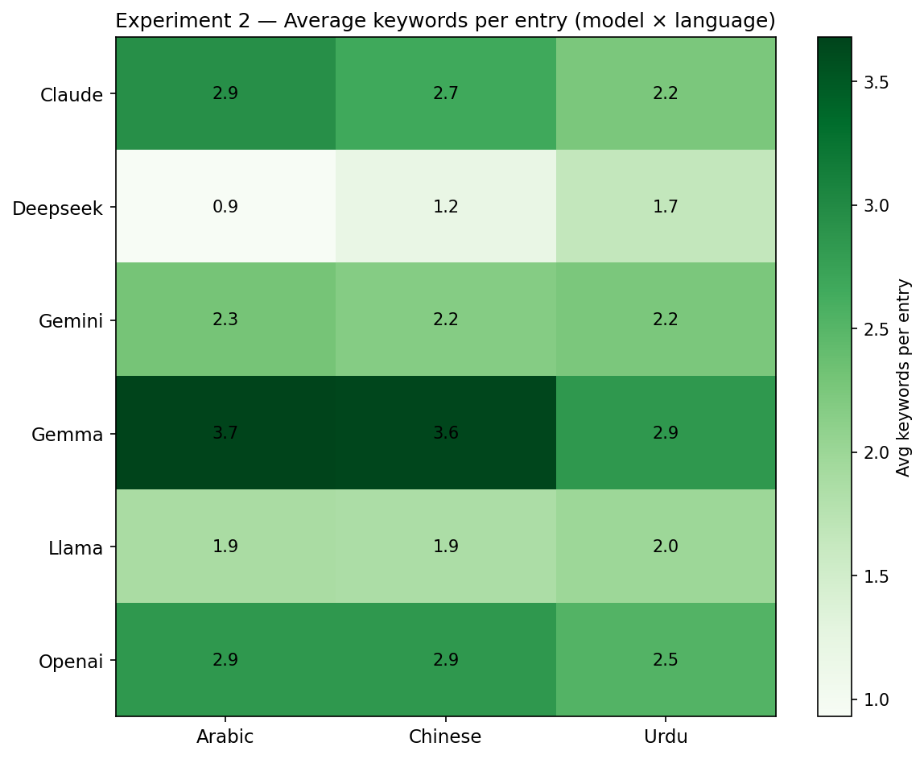
Figure 12: Average keyword count per model × language.

7.2 Most Frequent Keywords
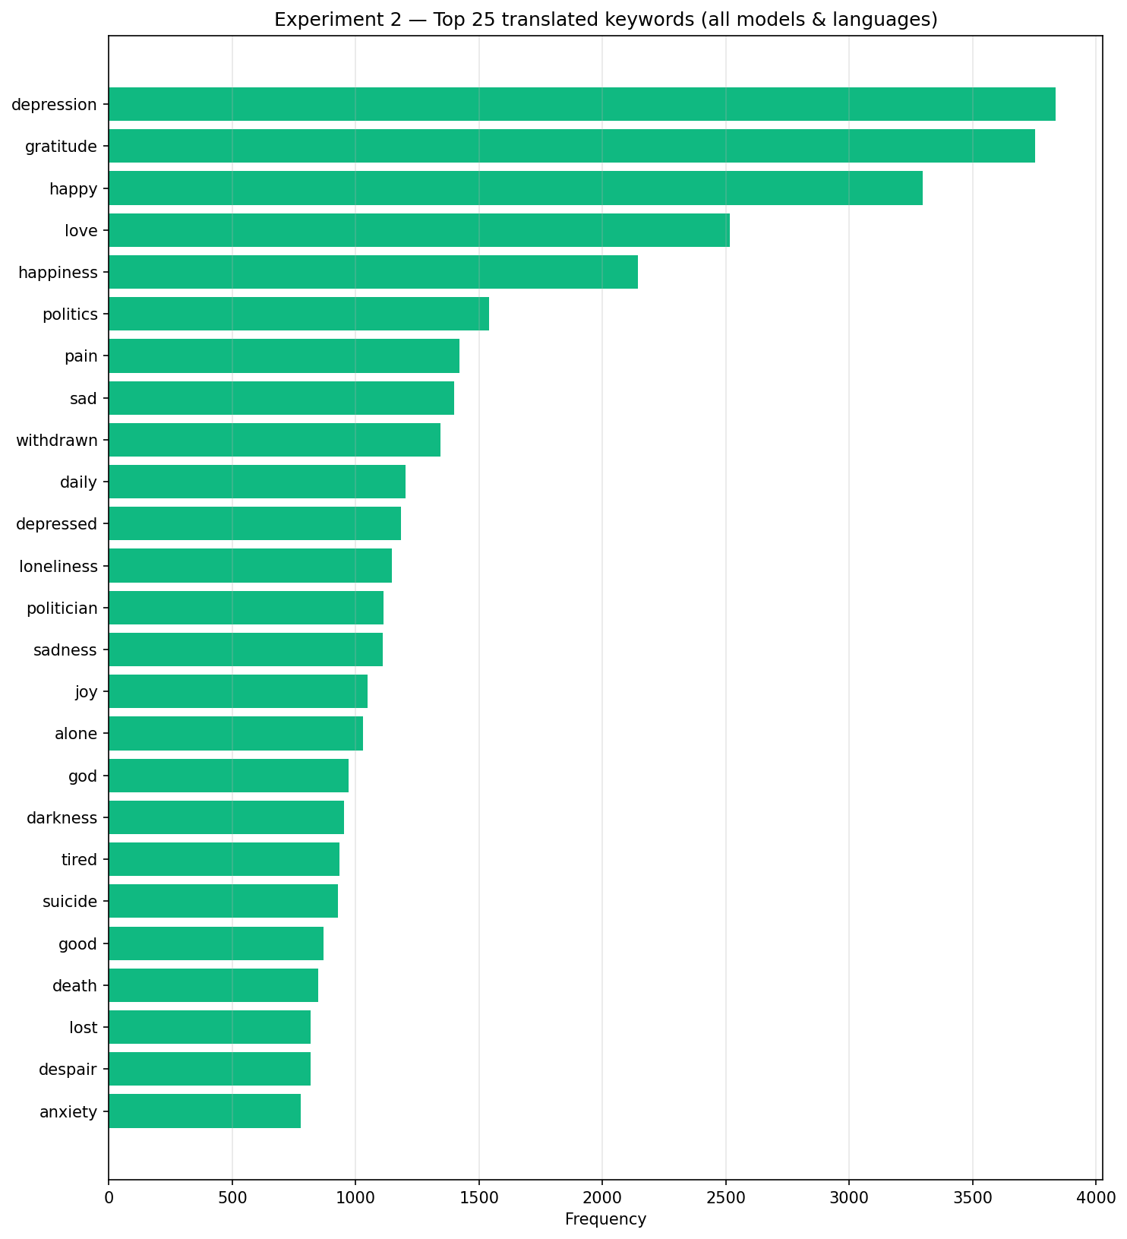
Figure 13: Top 25 most frequent translated keywords. 'Gratitude' leads (3,744), then 'depression' (3,613).

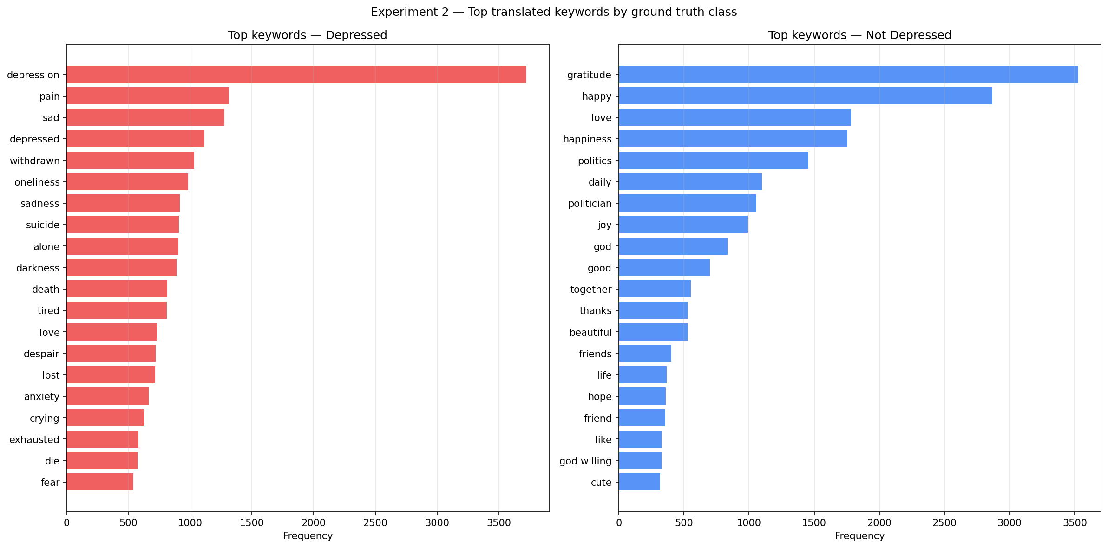
Figure 14: Top keywords by ground truth class.

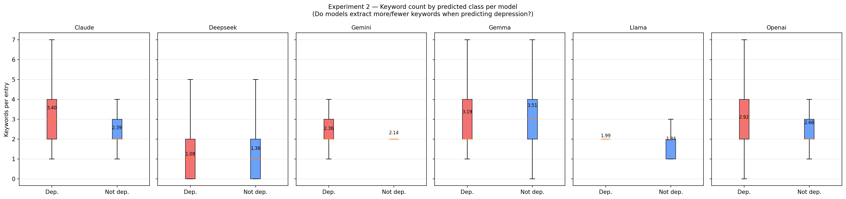
Figure 15: Keyword count for Depressed vs. Not Depressed predictions.

7.3 Keywords in Correct vs. Incorrect Predictions
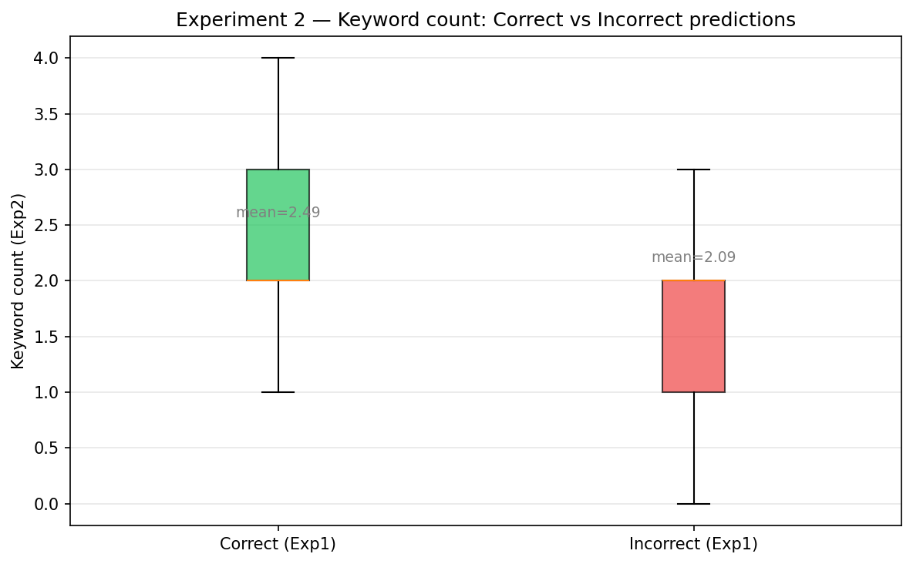
Figure 16: Keyword counts for correctly vs. incorrectly classified posts, by model and language.

7.4 Native-Language Keyword Analysis

Arabic Native Keywords
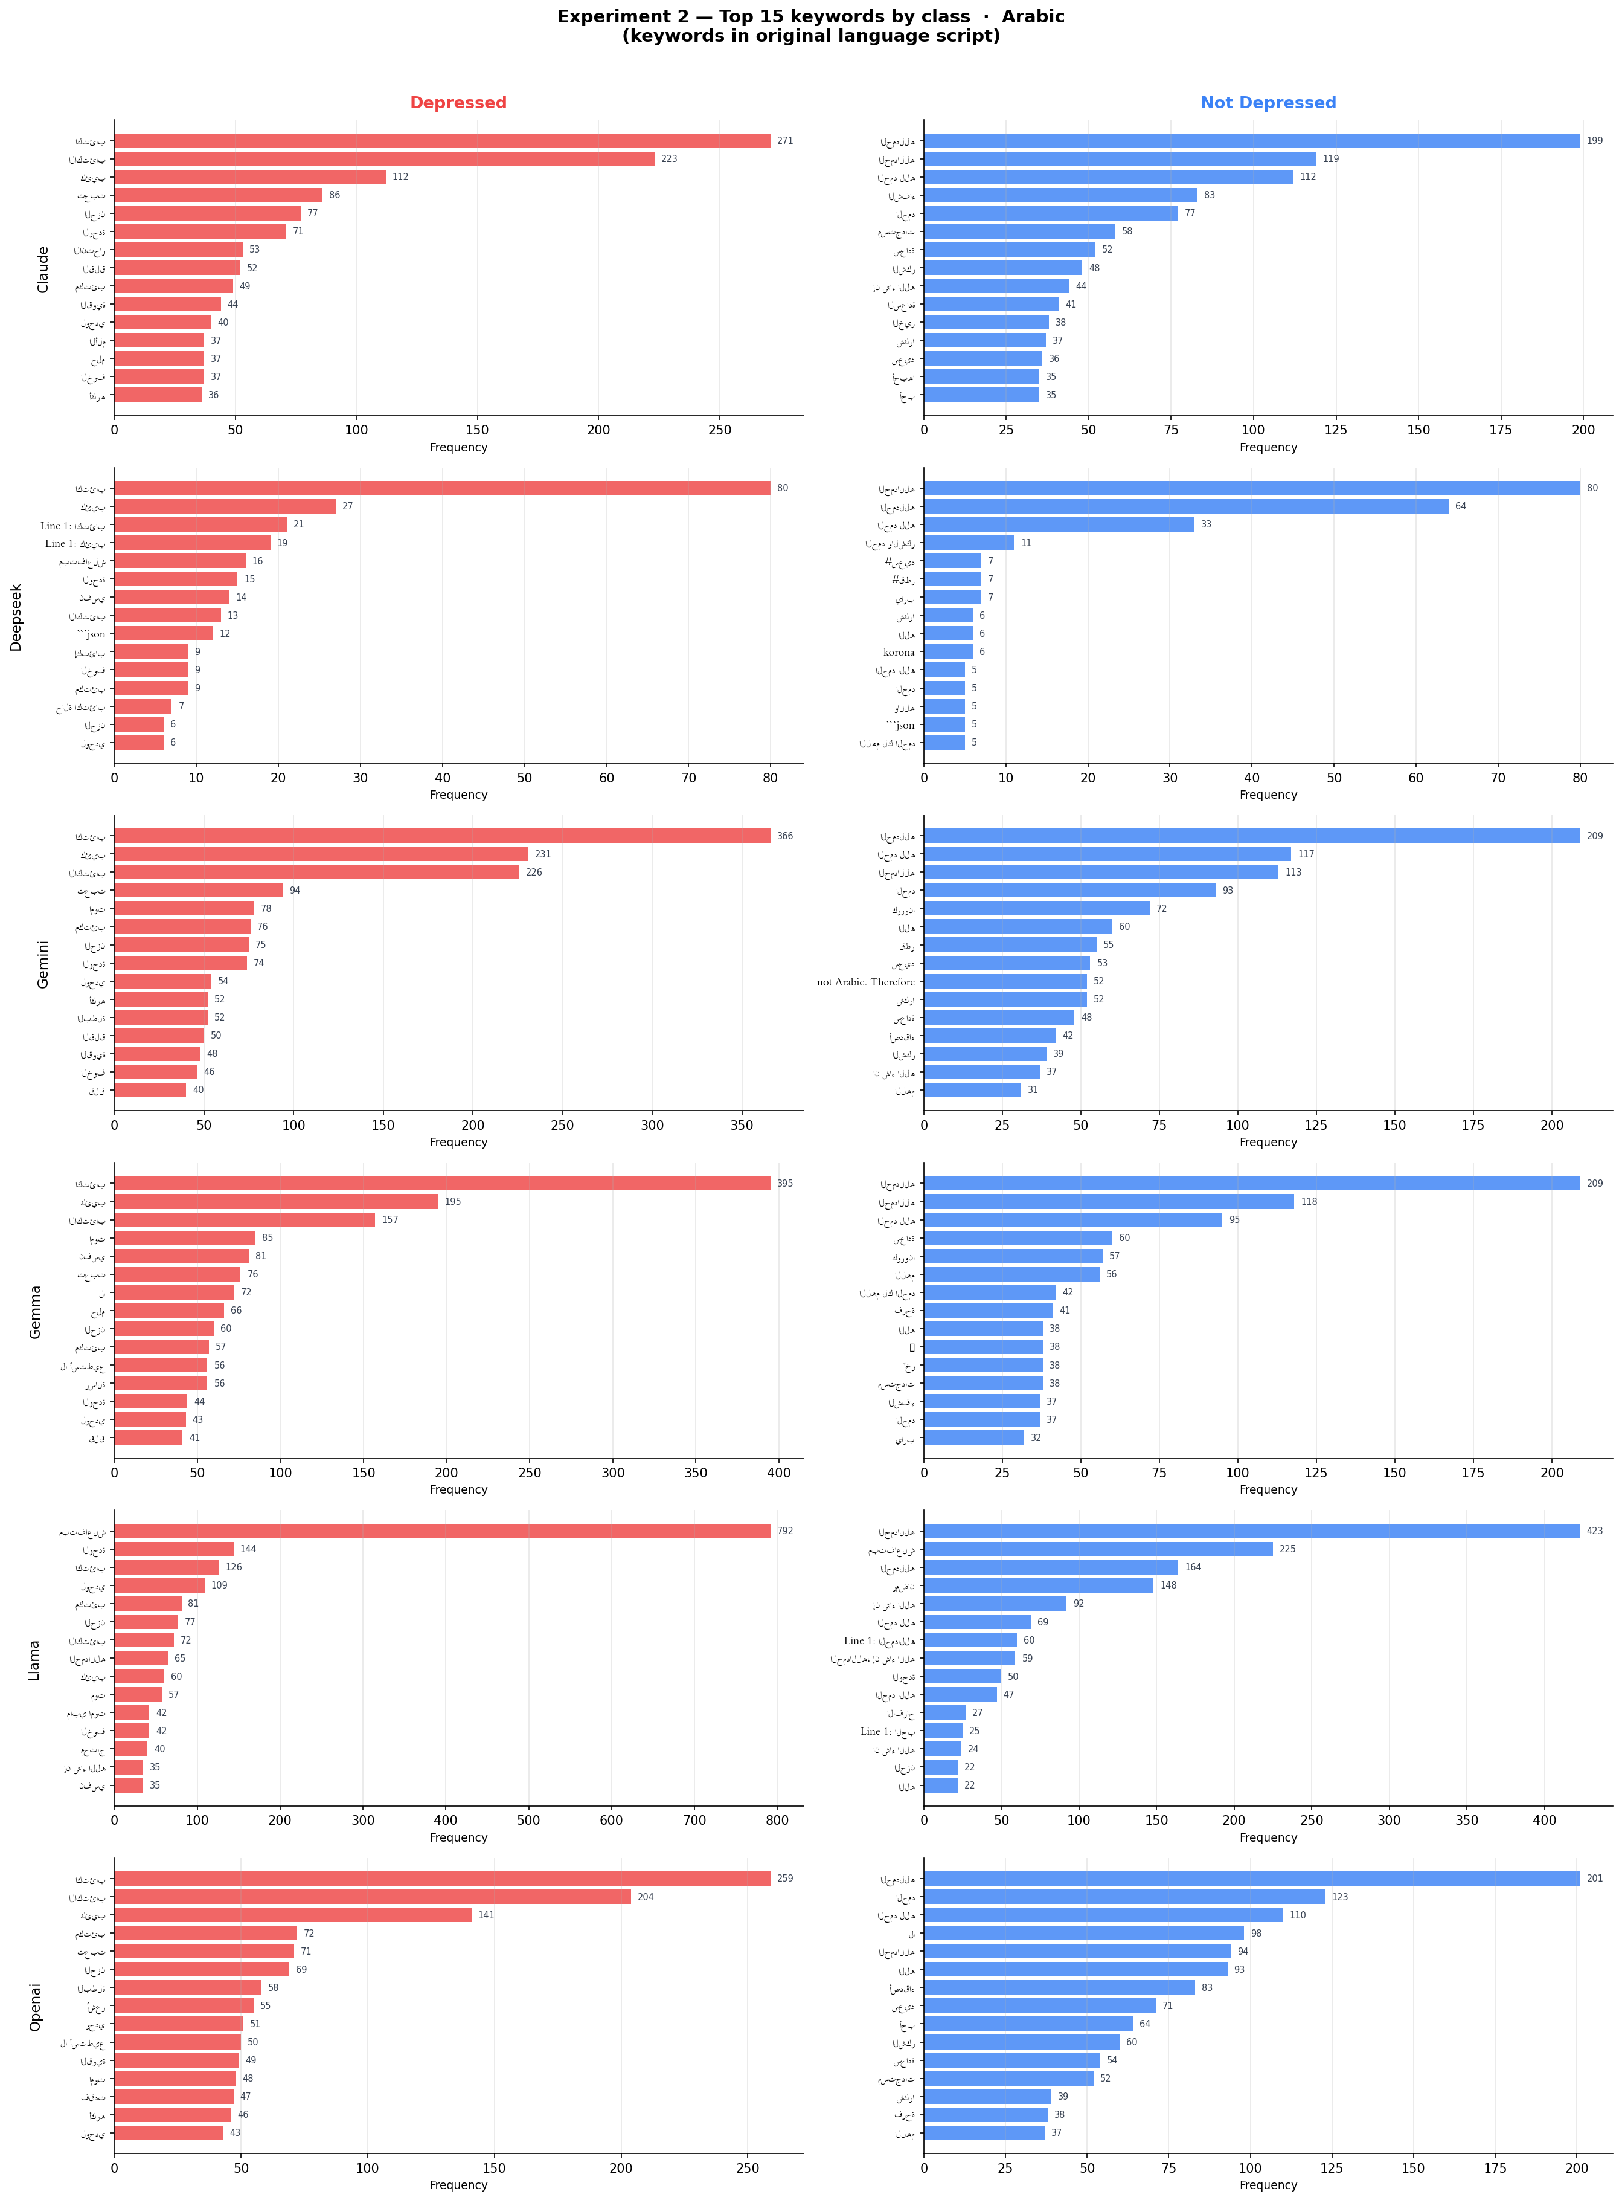 | 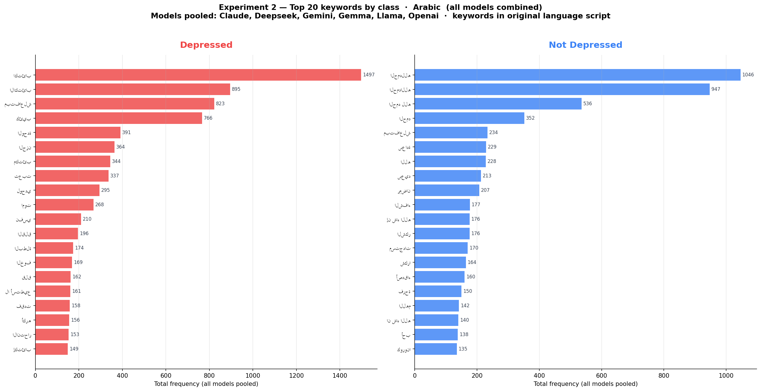

Figure 17 (left): Top native Arabic keywords. Figure 18 (right): Combined view with English translations.

Urdu Native Keywords
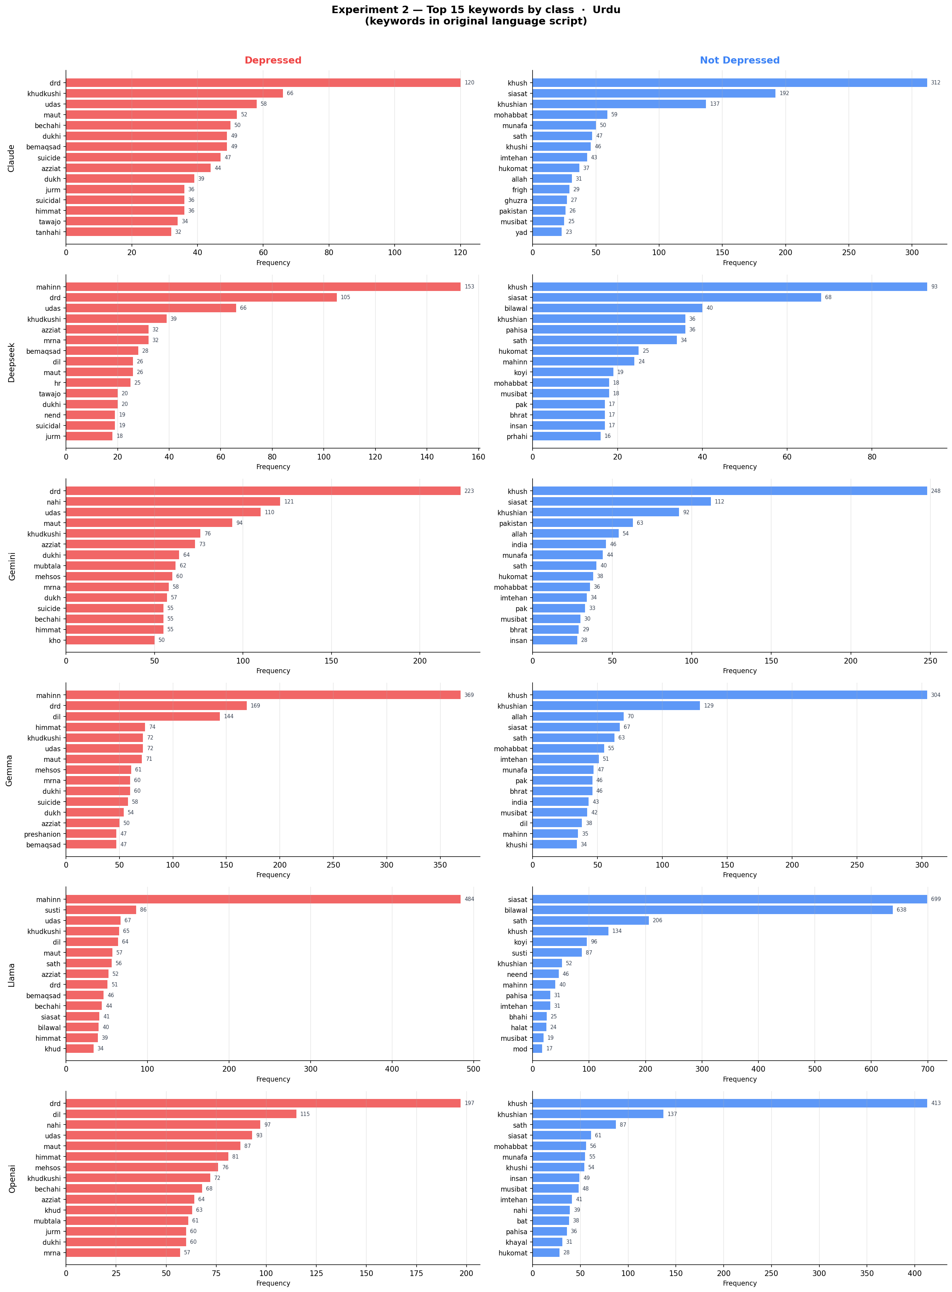 | 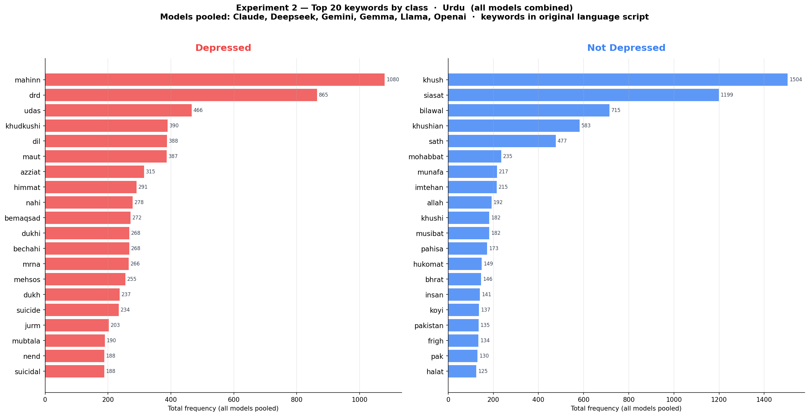

Figure 19 (left): Top native Urdu keywords. Figure 20 (right): Combined view with translations.

Chinese Native Keywords
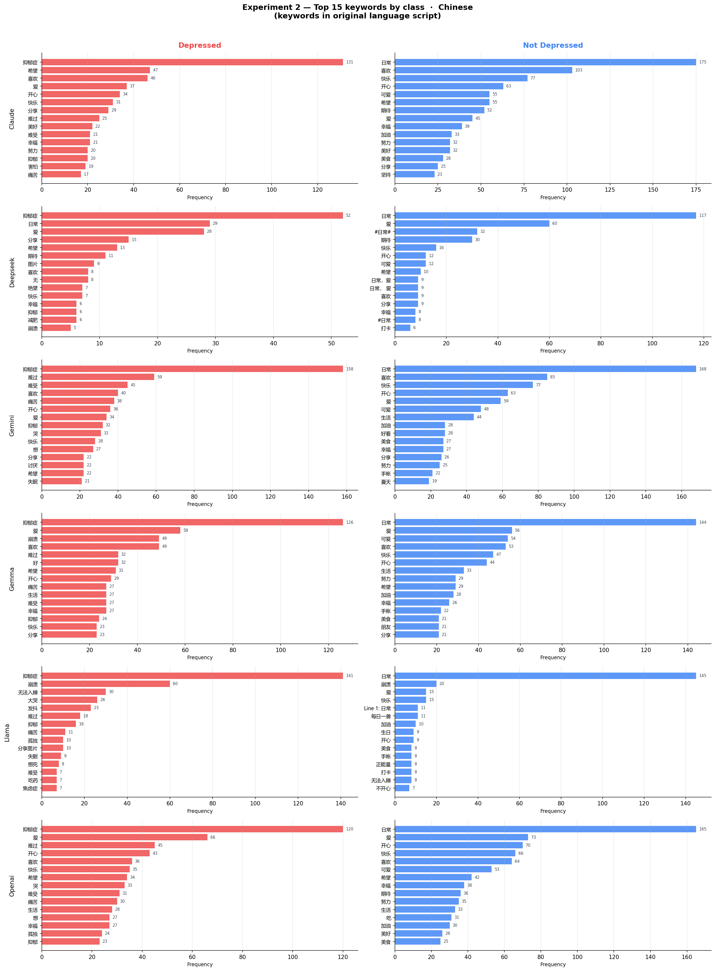 | 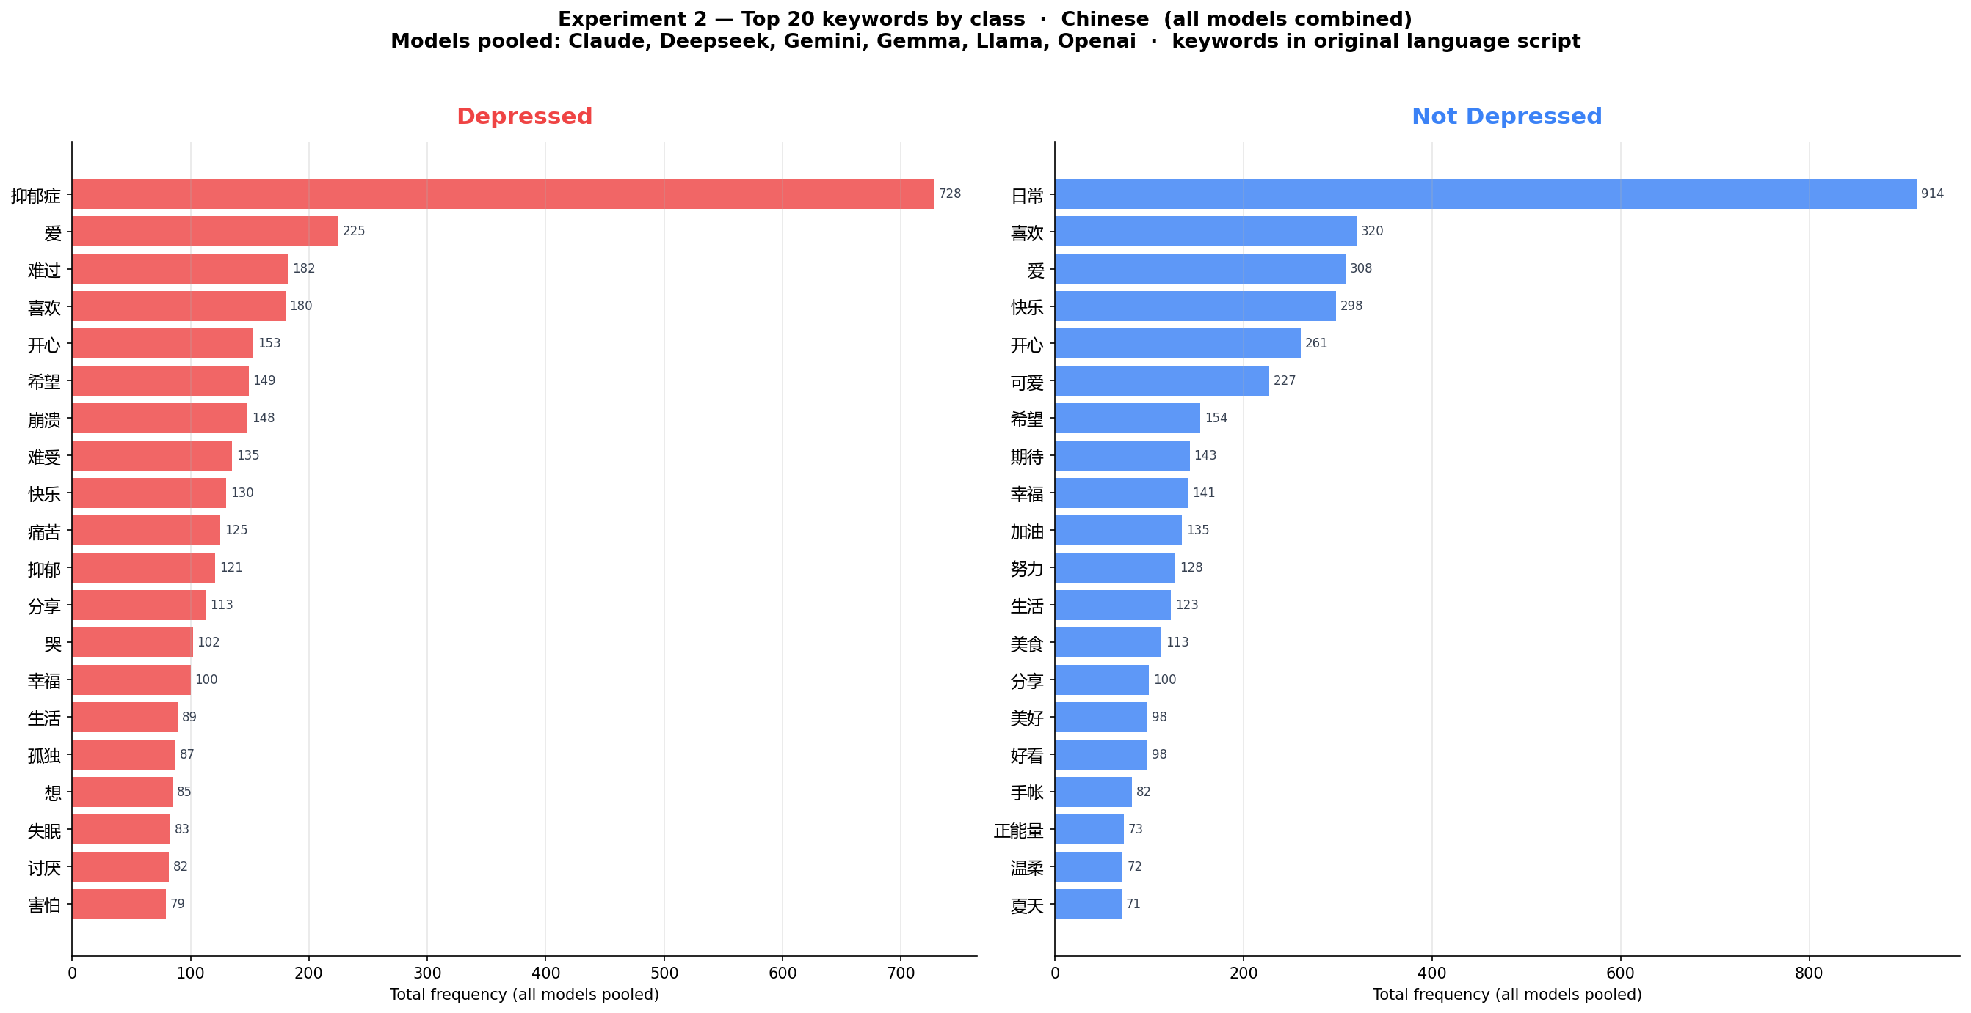

Figure 21 (left): Top native Chinese keywords. Figure 22 (right): Combined view with translations.

7.5 Qualitative Examples: Semantic Misalignment

Example A — Arabic FN: Denial Language Overrides Content (GPT-4o-mini)
GT: Depressed | Predicted: Not Depressed | Keyword: 'lost'
Post: 'Don't call me depressed because I am lost, not depressed.' The model extracts 'lost' but anchors on the surface negation rather than reading the clinical subtext.

Example B — Arabic FP: Social Content Without Distress (GPT-4o-mini)
GT: Not Depressed | Predicted: Depressed | Keywords: 'lonely, I can't, I have no, no one'
Pattern-matches isolation vocabulary. Post represents a momentary social complaint, not clinical distress.

Example C — Arabic Religious Expression: Correct Handling (Gemini)
GT: Not Depressed | Predicted: Not Depressed | Keywords: 'O God, forgive'
Successful application of V3 exclusion rule — Islamic prayer recognised as religious expression, not despair.

Example D — Urdu FN: Semantic Collapse on Distress Keywords (Claude)
GT: Depressed | Predicted: Not Depressed | Keywords: 'exhaustion, sleep'
Claude identifies clinically relevant keywords but safety prior overrides the clinical inference.

Example E — Urdu FN: Poetry Exclusion Rule Misapplied (Claude)
GT: Depressed | Predicted: Not Depressed | Keyword: 'poetry'
Poetry exclusion rule over-applied to personal post using poetic register to express genuine suffering.

8. Experiment 3 Results: Cross-Lingual Label Consistency
Model | Language | Total | Agree | Disagree | Agreement Rate | Flip Rate
DeepSeek 8B | Arabic | 5,000 | 4,215 | 167 | 96.19% | 3.34%
DeepSeek 8B | Chinese | 5,000 | 3,888 | 159 | 96.07% | 3.18%
DeepSeek 8B | Urdu | 5,000 | 12 | 0 | — (failed*) | -
Gemini 2.0 Flash | Arabic | 5,000 | 4,688 | 308 | 93.84% | 6.16%
Gemini 2.0 Flash | Chinese | 5,000 | 4,657 | 339 | 93.21% | 6.78%
Gemini 2.0 Flash | Urdu | 5,000 | 4,186 | 807 | 83.84% | 16.14%
Gemma 8B | Arabic | 5,000 | 4,581 | 375 | 92.43% | 7.50%
Gemma 8B | Chinese | 5,000 | 4,375 | 579 | 88.31% | 11.58%
Gemma 8B | Urdu | 5,000 | 8 | 5 | — (failed*) | -
GPT-4o-mini | Arabic | 5,000 | 4,106 | 865 | 82.60% | 17.30%
GPT-4o-mini | Chinese | 5,000 | 4,107 | 890 | 82.19% | 17.80%
GPT-4o-mini | Urdu | 5,000 | 3,983 | 1,013 | 79.72% | 20.26%
LLaMA 3 8B | Arabic | 5,000 | 3,648 | 1,020 | 78.15% | 20.40%
LLaMA 3 8B | Chinese | 5,000 | 2,400 | 2,179 | 52.41% | 43.58%
LLaMA 3 8B | Urdu | 5,000 | 3,003 | 1,710 | 63.72% | 34.20%
Table 6: Experiment 3 agreement summary (all 5 models; Claude excluded). *DeepSeek and Gemma Urdu: model process failed after <15 samples — rates excluded from analysis.

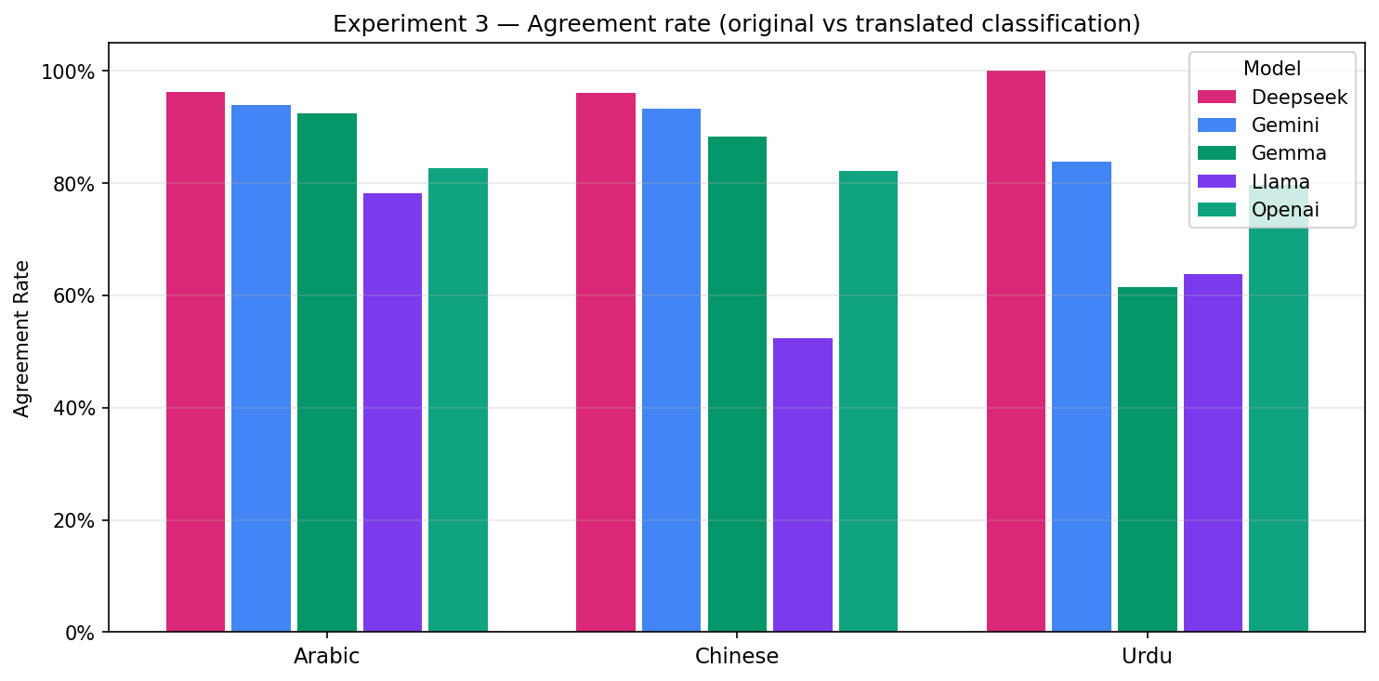
Figure 23: Agreement rates per model and language (all 5 models). DeepSeek leads on Arabic/Chinese (~96%); LLaMA lowest on Chinese (52%). Urdu results for DeepSeek and Gemma excluded (model failures, <15 samples).

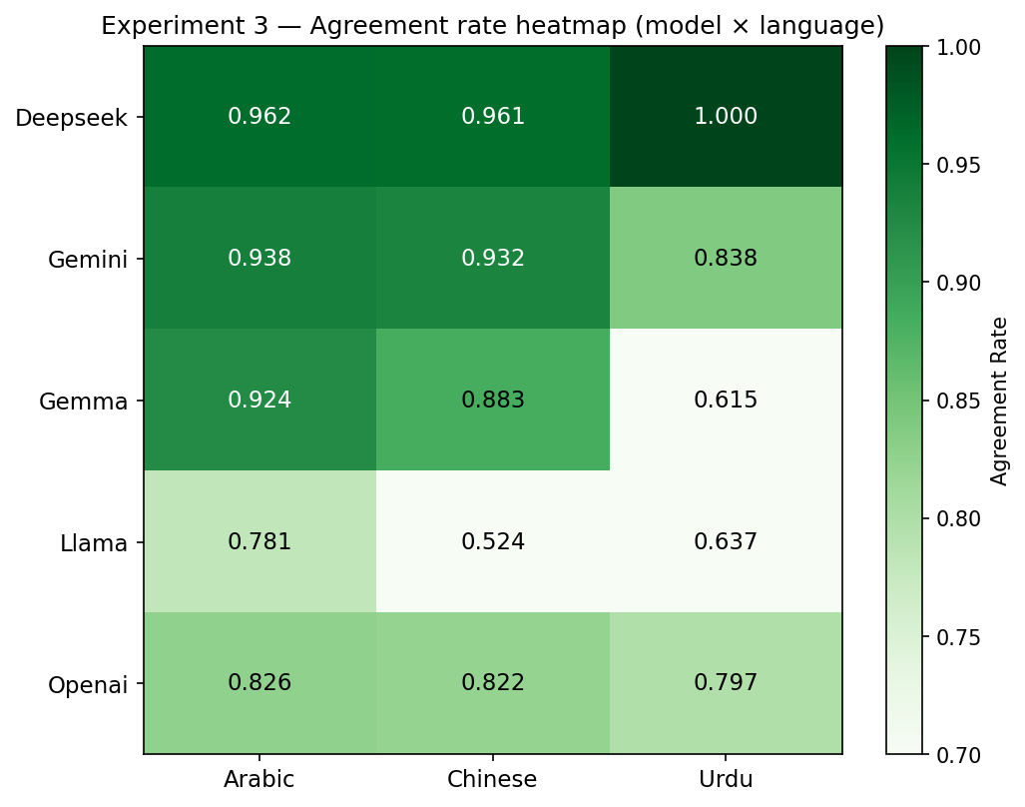
Figure 24: Agreement rate heatmap. DeepSeek/Gemini top rows show highest consistency; LLaMA bottom row is lightest.

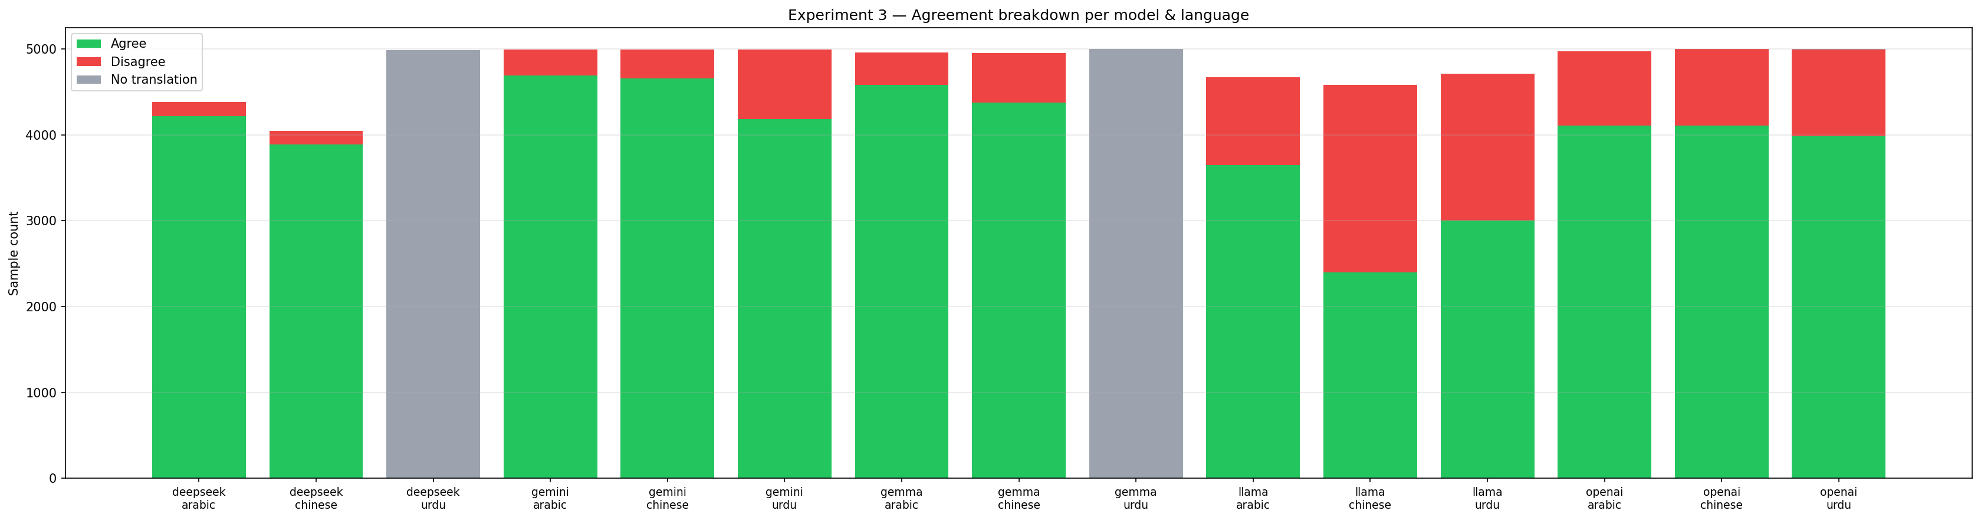
Figure 25: Agree/disagree counts stacked bar. LLaMA on Chinese (2,179 flips) shows the most disagreement.

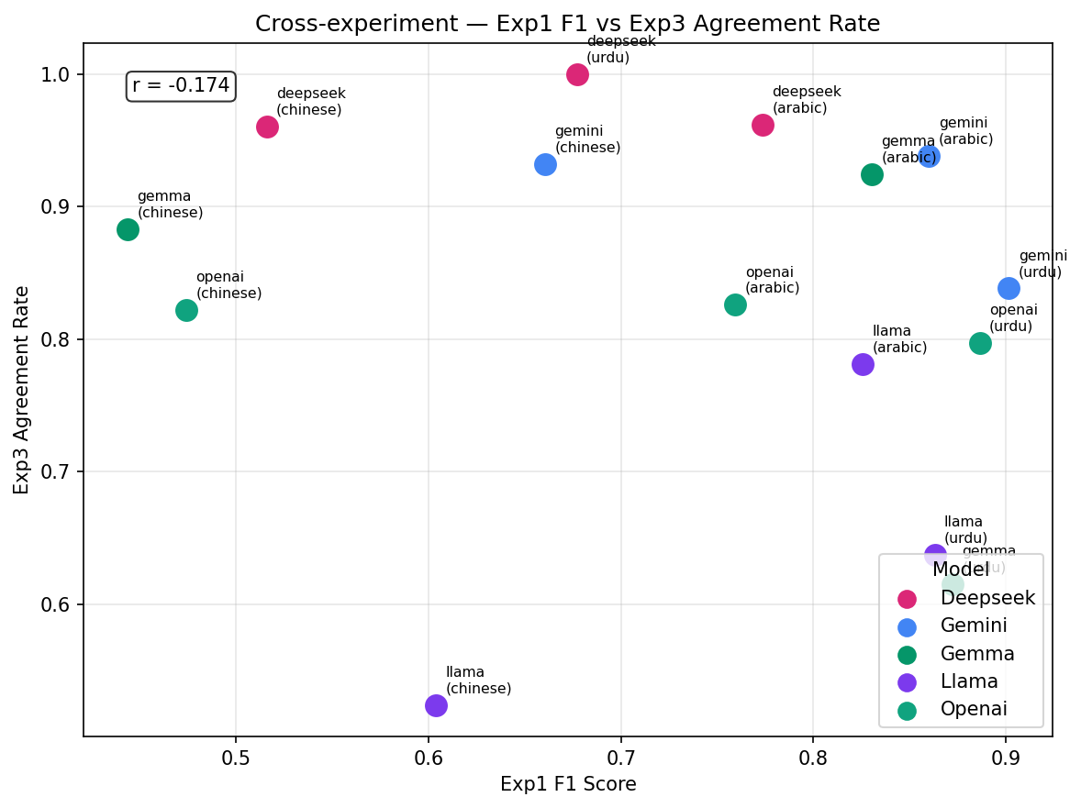
Figure 26: Exp1 F1 vs. Exp3 agreement rate scatter (all 5 models). DeepSeek and Gemini cluster top-right; LLaMA Chinese sits lower-left.

8.3 Four-Category Flip Analysis
- A: Correct + Upheld — Model was right and stays right. Best case.
- B: Correct + Overruled (Harmful flip) — Model was right but changes to wrong label on translation.
- C: Wrong + Corrected (Beneficial flip) — Model was wrong but self-corrects on translation.
- D: Wrong + Upheld — Model was wrong and remains wrong. Translation did not help.
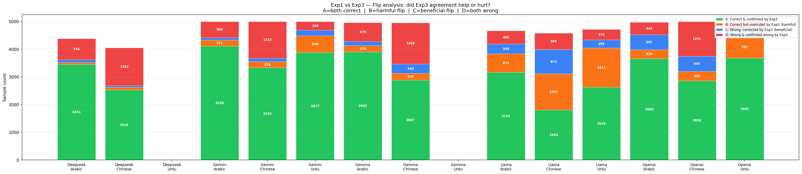
Figure 27: Four flip categories per model and language.

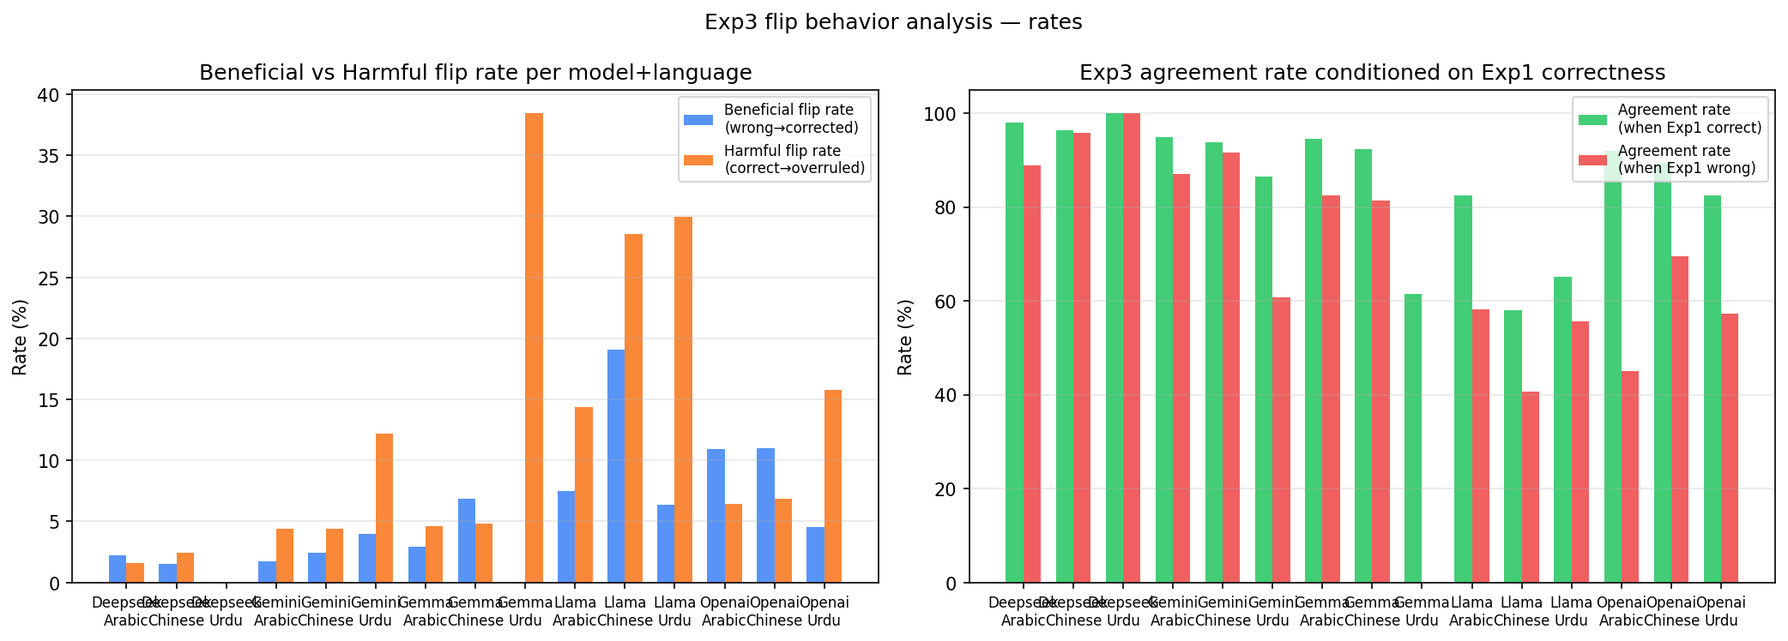
Figure 28: Harmful (B) and beneficial (C) flip rates.

9. Cross-Experiment Analysis
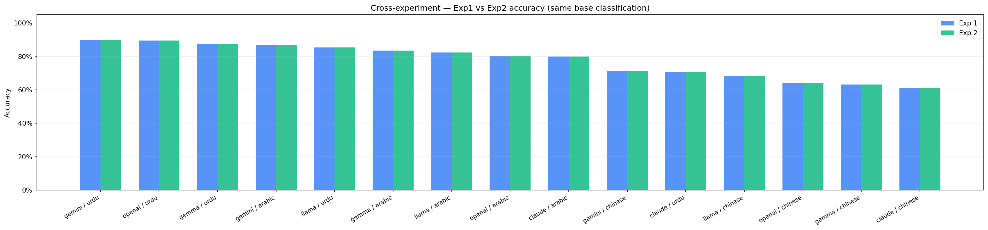
Figure 29: Exp1 vs. Exp2 accuracy (identical by design — confirms pipeline consistency).

For posts misclassified in Exp1 and their fate in Exp3, see the four-category flip analysis in Section 8.3 (Figures 27–28), which decomposes all disagreements into confirmed-correct, harmful-flip, beneficial-flip, and confirmed-wrong categories.
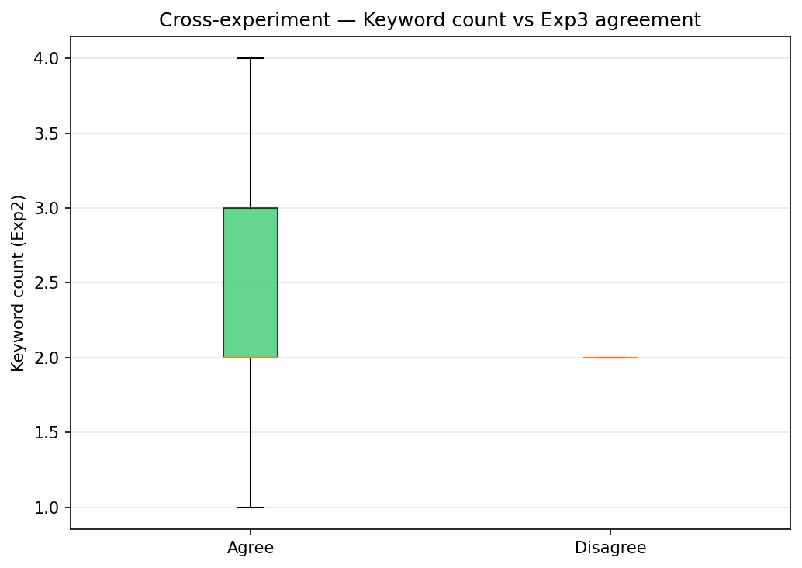
Figure 30: Keyword count (Exp2) vs. agreement rate (Exp3) per model-language.

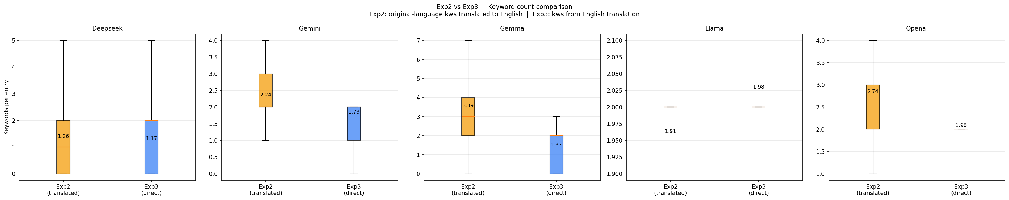
Figure 31: Keyword counts Exp2 vs. Exp3 side-by-side (box plots).

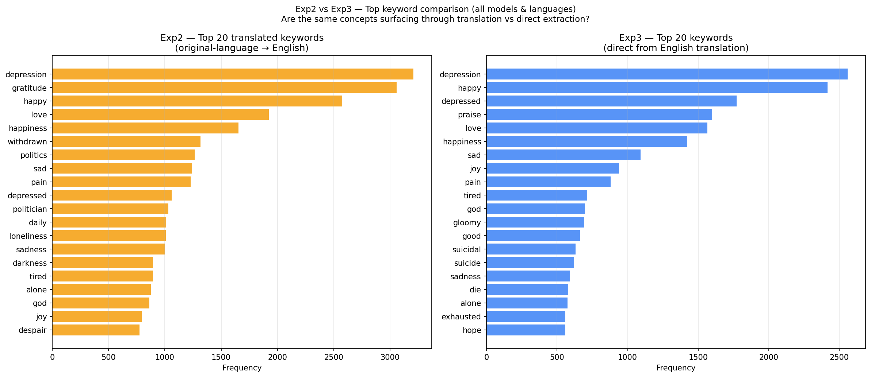
Figure 32: Top keywords cited in Exp2 vs. Exp3.

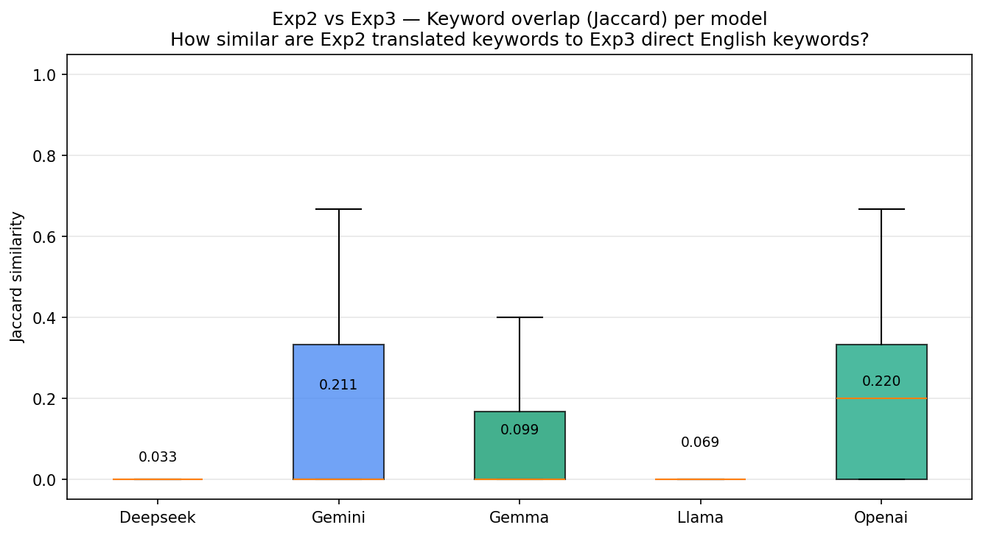
Figure 33: Jaccard similarity between Exp2 and Exp3 keyword sets. Among online models, Gemini > GPT-4o-mini.

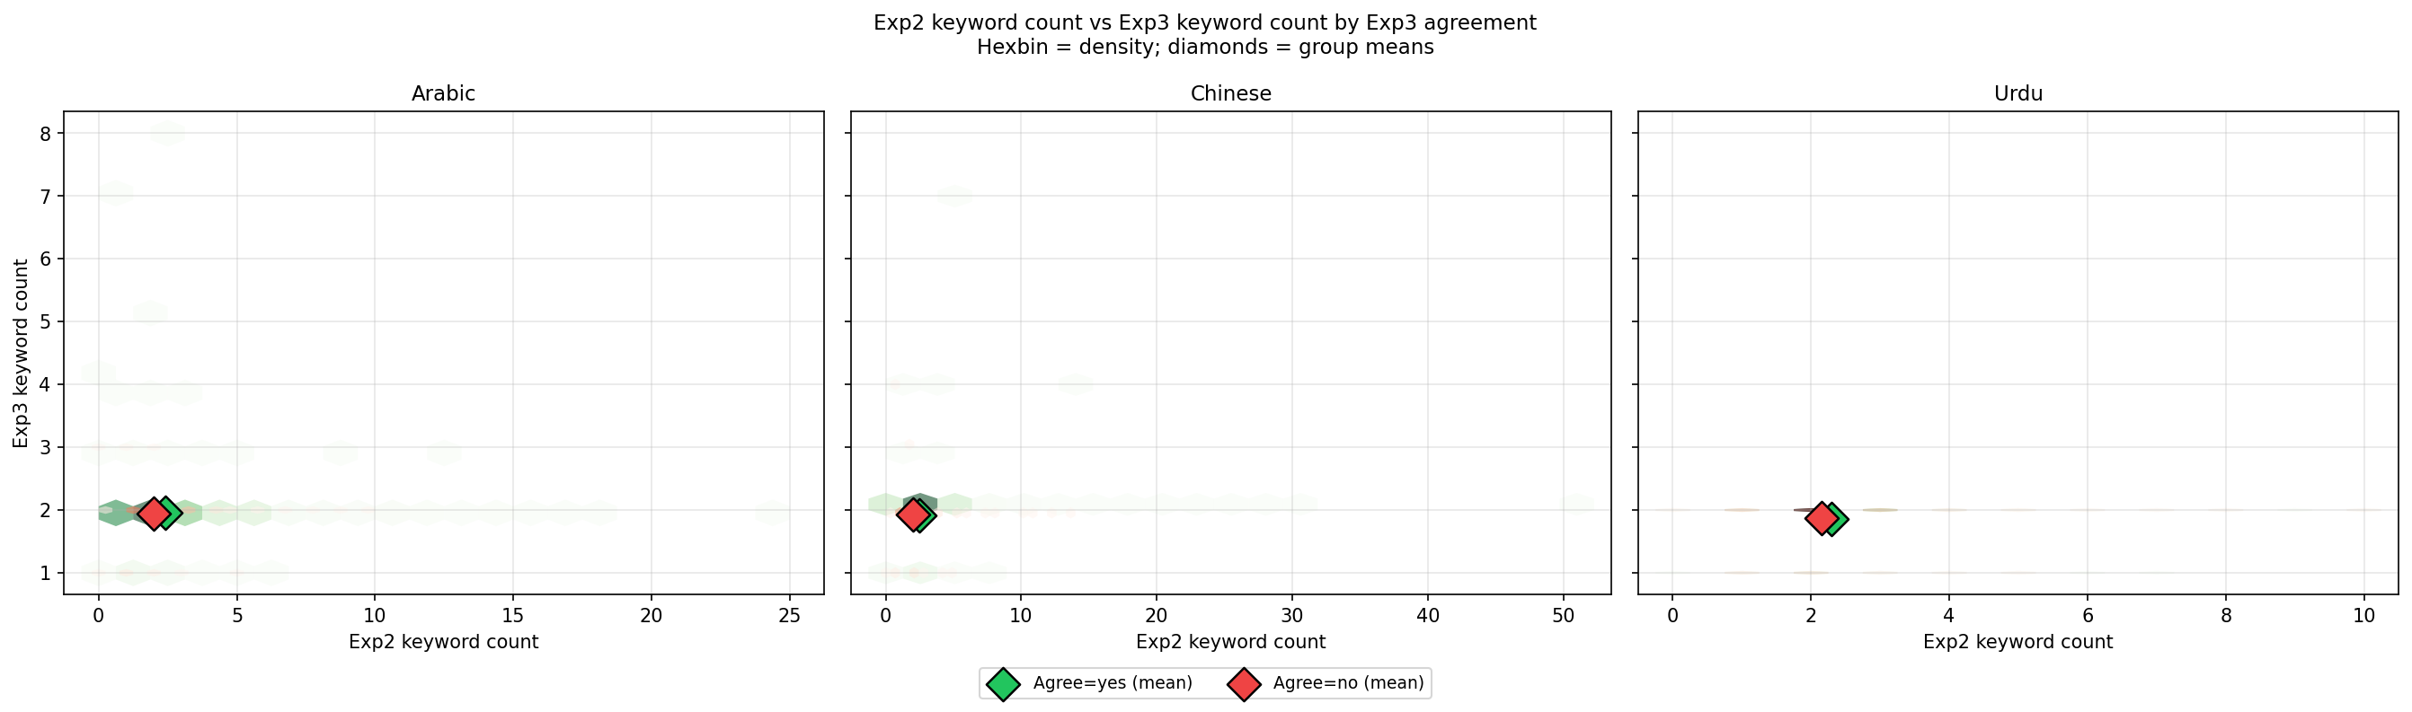
Figure 34: Hexbin: Exp2 keyword count vs. Exp3 keyword count, coloured by agreement.

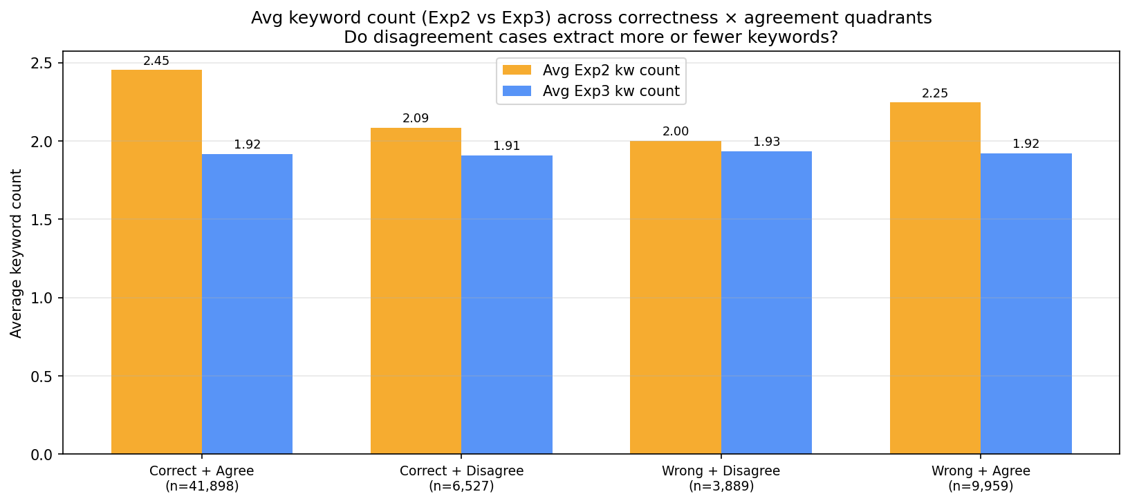
Figure 35: Quadrant bars: high/low Exp2 vs. Exp3 keyword counts.

10. Discussion

10.1 Overall Reliability and Trust
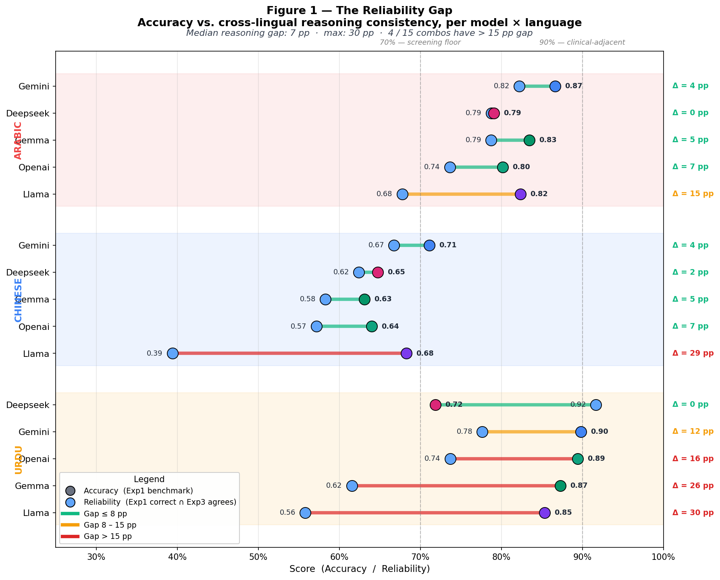 | 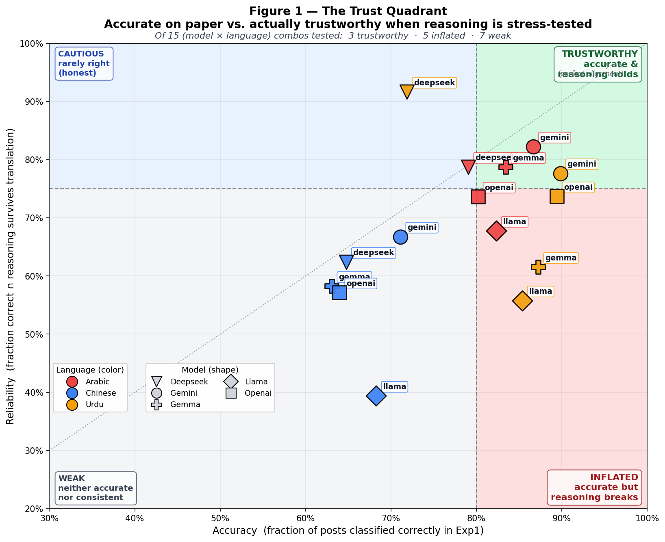

Figure 36 (left): Reliability gap — F1 difference between Chinese and Arabic/Urdu. Figure 37 (right): Trust quadrant — F1 vs. cross-lingual consistency (valid Exp3 results only). Gemini and DeepSeek cluster top-right; LLaMA lower-left; Claude excluded from Exp3.

10.2 Commercial APIs vs. Local Open-Weight Models
LLaMA 3 8B and Gemma 8B achieve F1 within 3–8 points of Gemini on Arabic and Urdu — viable privacy-preserving alternatives for clinical settings with data sovereignty requirements. For Chinese the gap widens to 5.7 points. DeepSeek 8B underperforms unexpectedly.

10.3 The Precision-Recall Trade-off in Clinical Context
False negatives (missed depression) are far more costly than false positives in screening. Gemini (high recall) is best-suited for initial screening. LLaMA 3 8B (recall=0.922 on Urdu) is the best local screening option. Claude Haiku 4.5 is entirely unsuitable. GPT-4o-mini is suitable for secondary confirmation only.

10.4 Cultural and Linguistic Failure Modes
- Denial language: Surface negation overrides clinical subtext.
- Religious expression false suppression: Islamic and other religious phrases suppress depression classification even with genuine distress signals.
- Poetry exclusion over-generalisation: V3 exclusion rule applied to personal posts using poetic register.
- Chinese cultural vocabulary gap: Indirect, metaphorical distress expressions systematically under-detected.

10.5 Cross-Lingual Consistency as Reasoning Quality Measure
Among all models with valid Exp3 results, DeepSeek 8B achieves the highest consistency on Arabic and Chinese (96%), followed by Gemini (84-94%), Gemma (88-92%), GPT-4o-mini (80-83%), and LLaMA (52-78%). LLaMA's 52% agreement on Chinese is barely above chance — effectively re-randomising its classification when shown a translation of the same post. Among online models, Gemini's higher consistency than GPT-4o-mini suggests deeper semantic grounding. A model changing its classification 17-20% of the time on translation exhibits reasoning instability with real deployment implications, even when aggregate accuracy appears high.

11. Conclusion
- Chinese is hardest for all models. Average recall 0.38 vs. Arabic 0.74 and Urdu 0.76.
- Local models match commercial APIs on Arabic/Urdu. LLaMA and Gemma within 3–8 F1 points of Gemini — viable for privacy-preserving deployment.
- Claude Haiku 4.5 is unsuitable for screening. Recall as low as 23.6% on Chinese.
- Keyword analysis reveals systematic misalignment. Denial language, religious expression, poetry, Chinese cultural vocabulary.
- DeepSeek shows the highest cross-lingual consistency; LLaMA the lowest. DeepSeek 96% on Arabic/Chinese; LLaMA only 52% on Chinese (barely above chance). Among online models, Gemini (83-94%) > GPT-4o-mini (80-83%).
- Culturally grounded prompting is essential but insufficient. V3 improved performance substantially; systematic errors persist.
Future work: Chinese-specific prompt engineering, ensemble approaches combining Gemini (low FN) and GPT-4o-mini (low FP), and native-speaker mental health professional annotation.

References
- Mohmand, R. et al. (2023). Depression Assessment in Romanized Urdu. GitHub: https://github.com/RubaMohmand/Depression-Assessment-in-RU
- CairoDep: Arabic Social Media Depression Dataset (Cairo University).
- Weibo Mental Health Datasets: Chinese Social Media Mental Health Corpora.
- Cohere. (2024). Command R (command-r-08-2024). Multilingual Translation API.
- Rana, T., Afzal, A.M., Patel, H., Lilani, D. (2026). Milestone 3. CSCI 4055, Ontario Tech University.
- Meta AI. (2024). LLaMA 3 8B (meta-llama-3.1-8b-instruct). Open-weight language model.
- Google DeepMind. (2024). Gemma 8B. Open-weight language model.
- DeepSeek AI. (2024). DeepSeek 8B (deepseek-r1-0528-qwen3-8b). Open-weight multilingual model.
- OpenAI. (2024). GPT-4o-mini. Commercial API language model.
- Google DeepMind. (2024). Gemini 2.0 Flash. Commercial API language model.
- Anthropic. (2025). Claude Haiku 4.5. Commercial API language model.

Appendices

Appendix A: Phase 1 Pilot Study Overview
Phase 1 was a 500-sample pilot (February–March 2026) designed to: validate the evaluation pipeline, compare three prompt strategies (V1, V2, V3) against each other, test a translate-then-classify approach, and characterise model behavioural profiles to inform Phase 2 design decisions.

A.1 Dataset
Language | Sample Size | Depressed | Not Depressed | Severity Labels
Romanized Urdu | 500 | 250 | 250 | 85 mild / 86 moderate / 79 severe
Arabic (pilot) | 50 | 25 | 25 | Binary only
Table A.1: Phase 1 dataset.

A.2 Models and Experiments
- Exp 1 — V1 Prompt (Zero-Shot Baseline): Minimal zero-shot instruction. Establishes baseline performance.
- Exp 2 — V2 Prompt (Clinical Framework): Enhanced with clinical indicators and exclusion rules. No examples.
- Exp 3 — V2 Prompt on English Translation: Tests whether translate-then-classify is viable (Cohere translations).
- Exp 4 — V3 Prompt (6-Example Few-Shot): V2 augmented with six labeled Urdu examples targeting Phase 1 failure modes. Examples verified not in test set.

A.3 Summary Results — Phase 1 Urdu (500 samples)
Model | V1 Acc | V1 F1 | V2 Acc | V2 F1 | V2 (Translated EN) F1 | V3 Acc | V3 F1
Gemini 2.0 Flash | 0.838 | 0.849 | 0.828 | 0.842 | 0.700 | 0.898 | 0.903
GPT-4o-mini | 0.844 | 0.851 | 0.840 | 0.823 | 0.651 | 0.886 | 0.878
DeepSeek Chat | 0.840 | 0.839 | 0.870 | 0.865 | 0.649 | 0.898 | 0.893
Claude Haiku 4.5 | 0.740 | 0.668 | 0.623 | 0.397 | 0.404 | — | —
Table A.2: Phase 1 Urdu results. V3 for Claude incomplete (rate-limited).

Key Phase 1 findings that shaped Phase 2:
• V3 few-shot outperformed V2 by +3 to +7% accuracy — confirmed V3 as Phase 2 strategy.
• Translation dropped F1 by 14–22 points — confirmed native-language processing as essential.
• Claude's catastrophic V2 collapse (recall 52% → 25%) revealed deep safety alignment issues.
• Model behavioural profiles confirmed and held at 5,000-sample scale in Phase 2.
• Nine error categories identified and addressed in V3 prompt design.

A.4 Severity Detection Rates (Phase 1 V2)
Severity | Total | Gemini | GPT-4o-mini | DeepSeek | Claude
Severe | 79 | 98.7% | 93.7% | 94.9% | 74.7%
Moderate | 86 | 89.5% | 95.3% | 88.4% | 50.0%
Mild | 85 | 84.7% | 77.6% | 68.2% | 34.1%
Non-Depression | 250 | 74.0% spec. | 93.6% spec. | 90.4% spec. | 99.6% spec.
Table A.3: Severity-stratified detection rates (V2 prompt, 500 Urdu samples).

A.5 Translation Impact (V2 Native Urdu vs. English)
Model | Native F1 | Translated F1 | F1 Drop | Native Recall | Translated Recall | Recall Drop
Gemini | 0.842 | 0.700 | −0.142 | 0.916 | 0.596 | −0.320
GPT-4o-mini | 0.823 | 0.651 | −0.172 | 0.744 | 0.512 | −0.232
DeepSeek | 0.865 | 0.649 | −0.216 | 0.836 | 0.500 | −0.336
Claude | 0.397 | 0.404 | +0.007 | 0.249 | 0.256 | +0.007
Table A.4: Translation experiment results. Best native performers suffer largest drops.

Appendix B: Prompt Development History (V1 → V2 → V3)
All prompts are defined in evaluation/prompts.py. The following subsections present each classification prompt in full, in development order.

B.1 Prompt V1 — Zero-Shot Baseline
Minimal zero-shot instruction. No clinical framework, no examples, no language-specific guidance. Used as the V1 baseline condition in Phase 1.
evaluation/prompts.py — CLASSIFICATION_PROMPT_V1
You are evaluating a social media post for signs of depression.
Read the following post carefully and classify whether the author is expressing signs of depression or not.
Respond with ONLY one of these two labels, nothing else:
- Depressed
- Not Depressed
Post:
"{post_text}"
Classification:

B.2 Prompt V2 — Enhanced Clinical Framework (Zero-Shot)
First major revision: added explicit clinical depression indicators, exclusion rules for common false positive patterns, and multilingual awareness. Still zero-shot (no examples). Helped DeepSeek (+3%) but made Claude dramatically more conservative (recall 52% → 25%). Used as the V2 condition in Phase 1 and default prompt in the phase1 runner.
evaluation/prompts.py — CLASSIFICATION_PROMPT_V2
You are a mental health text classifier analyzing social media posts for signs of depression.
Consider these indicators of depression:
- Expressions of hopelessness, worthlessness, or emptiness
- Social withdrawal or isolation ("no one cares", "always alone")
- Loss of interest or pleasure in activities
- Sleep disturbances, fatigue, or low energy
- Negative self-talk or self-harm references
- Persistent sadness beyond normal situational reactions
Do NOT classify as depressed:
- Sarcasm or dark humor without genuine distress
- Temporary frustration or complaining about a specific event
- Song lyrics, quotes, or reposted content
- Using the word "depressed" casually ("this weather is depressing")
The post may be in any language or script (including transliterated text).
Classify the following post. Respond with ONLY one label:
- Depressed
- Not Depressed
Post:
"{post_text}"
Classification:

B.3 Prompt V3 — Few-Shot with Romanized Urdu Examples
Phase 2 production prompt for Romanized Urdu. Extends V2 with six labeled examples targeting Phase 1 failure modes: behavioral/somatic depression (Ex. 1, 4, 6), political commentary FPs (Ex. 2), shayri/ghazal FPs (Ex. 3), short ambiguous posts (Ex. 5). All examples verified not present in the 5,000-sample test set (no data leakage).
evaluation/prompts.py — CLASSIFICATION_PROMPT_V3 (Urdu)
You are a mental health text classifier analyzing social media posts for signs of depression.
Consider these indicators of depression:
- Expressions of hopelessness, worthlessness, or emptiness
- Social withdrawal or isolation ("no one cares", "always alone")
- Loss of interest or pleasure in activities
- Sleep disturbances, fatigue, or low energy
- Negative self-talk or self-harm references
- Persistent sadness beyond normal situational reactions
- Behavioral symptoms: lethargy, neglecting self-care, appetite/sleep changes — even without explicitly sad language
Do NOT classify as depressed:
- Sarcasm or dark humor without genuine distress
- Temporary frustration or complaining about a specific event
- Song lyrics, quotes, poetry, or reposted content
- Using emotional words casually ("this weather is depressing")
- Political/societal commentary that uses intense emotional language but is not self-directed
- Third-person references to someone else's suffering
The post may be in any language or script (including Roman Urdu, transliterated text, or code-switched text mixing languages).
Here are examples to guide your classification:
Example 1:
Post: "aj mujhe bahut susti mehsos rahi kuch krne bilkul mod nahy"
Classification: Depressed
(Describes lethargy and complete lack of motivation — behavioral indicators of depression even without explicitly sad language.)
Example 2:
Post: "lakh g lanat hoggahi bilawal pehingi siasat j lahi wrri sindh khe mqm khe wikro krahi dio paya lanat hojahi tohinjahi taqder te begherat insan"
Classification: Not Depressed
(Political commentary expressing frustration about politicians. Uses strong emotional language but is about societal issues, not personal mental health.)
Example 3:
Post: "mera hr din teri hr rat acha hoga meri hr bat teri shayri achi hohi dekh lena gamgen ankho ek din mera janaza teri brat acha hoga"
Classification: Not Depressed
(Ghazal/shayri-style romantic poetry. Despite mentioning "gamgen ankho" (sorrowful eyes) and "janaza" (funeral), this is literary expression using conventional poetic vocabulary, not personal distress.)
Example 4:
Post: "hr pal hr sans mayosii andheron mahinn doba hahi mera dil"
Classification: Depressed
(Every moment, every breath, the heart drowning in despair and darkness. Although poetic in register, this expresses persistent personal hopelessness — a genuine expression of suffering, not a literary exercise.)
Example 5:
Post: "koyi hahi mere sath"
Classification: Not Depressed
(A short, ambiguous post meaning "is anyone with me" — this is a casual social query, not an expression of isolation or distress.)
Example 6:
Post: "mayosion saya meri zindagi hahi hr kadam thokr khata hon"
Classification: Depressed
(The shadow of hopelessness over my life, stumbling at every step. Expresses persistent despair and helplessness about one's own life.)
Now classify the following post. Respond with ONLY one label:
- Depressed
- Not Depressed
Post:
"{post_text}"
Classification:

B.4 Prompt V3 Arabic — Few-Shot with Egyptian Arabic Examples
Phase 2 production prompt for Arabic. Key Arabic-specific additions: explicit exclusion of religious phrases (الحمدالله, إن شاء الله) as everyday expressions; seasonal community posts (Ramadan, Eid) as non-personal; behavioral absence words (مبتفاعلش, مبقتش) as strong depression signals. Examples drawn from CairoDep corpus.
evaluation/prompts.py — CLASSIFICATION_PROMPT_V3_ARABIC
You are a mental health text classifier analyzing social media posts for signs of depression.
Consider these indicators of depression:
- Expressions of hopelessness, worthlessness, or emptiness
- Social withdrawal or isolation ("no one cares", "always alone")
- Loss of interest or pleasure in activities
- Sleep disturbances, fatigue, or low energy
- Negative self-talk or self-harm references
- Persistent sadness beyond normal situational reactions
- Behavioral symptoms: loss of passion, neglecting responsibilities, inability to engage — even without explicitly sad language
Do NOT classify as depressed:
- Religious expressions or phrases (الحمد لله، إن شاء الله، السلام عليكم، يارب) — these are everyday Arabic greetings and expressions of faith, not distress
- Seasonal or community posts (Ramadan greetings, holiday posts, religious hashtags) — celebratory or communal, not personal suffering
- Relationship advice or venting about situational problems — temporary frustration, not clinical depression
- Interactive/rhetorical questions directed at followers — social engagement, not isolation
- Arabic poetry, song lyrics, or romantic language — literary expression, not personal distress
- Sarcasm or dark humor without genuine emotional distress
The post may be in Arabic script, Egyptian dialect (slang), standard Arabic, or a mix.
Here are examples to guide your classification:
Example 1:
Post: "فقدت الشغف تجاه مجال عملي بسبب كذا صدمة متتالية خاصة اخر صدمة دي دمرتني نفسيا خلتني كرهت كل حاجه كنت بحب مجالي جدا وبطور نفسي فيه باستمرار حاليا مبقتش اطيق افتح كتاب او اقعد قدام فيديو"
Classification: Depressed
(Lost all passion for work after repeated psychological shocks — behavioral depression indicator even without the word "sad".)
Example 2:
Post: "الحمدالله حمدا كثيرا"
Classification: Not Depressed
(A short religious phrase meaning "Praise be to God." Common in Arabic social media as a simple expression of gratitude or faith.)
Example 3:
Post: "#رمضان_كريم يارب شهر الخير اقبل بالافراح لا تحرم اللي يرتجي منك غفران انزل علينا رحمة منك نرتاح"
Classification: Not Depressed
(Ramadan greeting with religious prayer. Seasonal community post — celebratory and collective, not personal distress.)
Example 4:
Post: "أشعر بالحزن الشديد بعد وفاة أمي وأشعر بالوحدة لأني لا أملك أصدقاء وأشعر بالخوف من أبي"
Classification: Depressed
(Intense sadness after bereavement, compounded by total social isolation and fear. Multiple simultaneous depression indicators.)
Example 5:
Post: "ايه الحاجه اللي لو حصلتك دلوقتي تخليك #سعيد"
Classification: Not Depressed
(Casual interactive question to followers with a happiness hashtag. Social engagement post, not personal distress.)
Example 6:
Post: "والحقيقة آه طلعت وقتها كنت وحشة، مش وحشة بالمعنى الحرفي، انا بس مبتفاعلش معاهم.. بخرج عشان اقعد اسمع اغاني لوحدي"
Classification: Depressed
(Persistent social withdrawal — not interacting with others, choosing to be alone. Behavioral isolation is a key depression indicator.)
Now classify the following post. Respond with ONLY one label:
- Depressed
- Not Depressed
Post:
"{post_text}"
Classification:

B.5 Prompt V3 Chinese — Few-Shot with Weibo Examples
Phase 2 production prompt for Chinese. Addresses Chinese-specific failure modes: physical illness posts, fandom/celebrity content, philosophical quotes, lifestyle posts. Also adds clinical self-disclosure vocabulary (双向情感障碍, 抑郁症, 复发) to positive indicators. Examples drawn from Weibo Depression Dataset.
evaluation/prompts.py — CLASSIFICATION_PROMPT_V3_CHINESE
You are a mental health text classifier analyzing social media posts for signs of depression.
Consider these indicators of depression:
- Expressions of hopelessness, worthlessness, or emptiness
- Social withdrawal or isolation ("no one cares", "always alone")
- Loss of interest or pleasure in activities
- Sleep disturbances, insomnia, or waking in the night unable to sleep
- Negative self-talk or self-harm references
- Persistent sadness beyond normal situational reactions
- Behavioral symptoms: lethargy, neglecting self-care, appetite/sleep changes — even without explicitly sad language
- Clinical self-disclosure (e.g., 双向情感障碍, 抑郁症) combined with helplessness signals
- Relapse language (复发) combined with emotional distress
Do NOT classify as depressed:
- Temporary physical illness complaints (感冒, 发烧) — bodily discomfort is not depression
- Fandom, celebrity, or online community posts — social engagement content, not personal mental health
- Philosophical quotes or inspirational sayings being shared with appreciation
- Lifestyle, beauty, skincare, food, or hobby posts — engaged daily life, not distress
- Sarcasm or dark humor without genuine emotional suffering
- Song lyrics, poetry, or quoted content
- Using emotional words casually or in internet slang context
The post may be in Simplified Chinese, Traditional Chinese, Pinyin, or code-switched text mixing Chinese with English.
Here are examples to guide your classification:
Example 1:
Post: "我离崩溃只差一片羽毛的重量，多梦就罢了为什么又在凌晨醒来无法入睡，身体还一直发抖，我真的想大哭，我真的受不了了，我好可笑啊我我居然变成了这副模样"
Classification: Depressed
(On the verge of breakdown — persistent insomnia, trembling, overwhelming urge to cry, self-deprecation.)
Example 2:
Post: "生病了也要臭美一下[挖鼻屎][挖鼻屎]"
Classification: Not Depressed
(Lighthearted selfie while sick, with playful emoji. Physical illness with humor — not emotional distress.)
Example 3:
Post: "左眼泪流复发，or可能只是累了break"
Classification: Depressed
(The word 复发 (relapse) signals a recurring condition; tearing up acknowledging an emotional episode.)
Example 4:
Post: "双向情感障碍症 顺其自然的意思就是 我也很无奈随他妈便吧."
Classification: Depressed
(Explicit self-report of bipolar disorder combined with 无奈 (helplessness) and resigned frustration.)
Example 5:
Post: "开学 week9 #日常#日常这周格外爱胶片风！"
Classification: Not Depressed
(School week update with enthusiastic hashtags — active, engaged daily life post.)
Example 6:
Post: "在与粉刺斗争的道路上一去不复返简单总结下就是Dr.wu杏仁酸与理肤泉k乳都能让闭口变成痘爆出来，有用是有用但忍不住去挤会留下无数痘印，下一步：菌菇水！期待烂脸恢复的那天呐"
Classification: Not Depressed
(Skincare product review and routine planning — lifestyle content, not mental health distress.)
Now classify the following post. Respond with ONLY one label:
- Depressed
- Not Depressed
Post:
"{post_text}"
Classification:

Appendix C: Experiment 2 — Keyword Attribution Prompts
Experiment 2 prompts do not re-classify posts — the Experiment 1 classification is given as input. Models identify the 1–2 keywords most supporting the given label, plus English translations. Output format is exactly two lines for automated parsing.

C.1 Urdu Attribution Prompt
evaluation/prompts.py — ATTRIBUTION_PROMPT_V3_EXP2 (Urdu)
You are analyzing a mental health text classification.
A social media post in Roman Urdu has already been classified as "{prediction}".
Your task is to identify the specific word(s) in the post that support this classification.
Notes on Roman Urdu social media:
- Behavioral words (susti = lethargy, neend = sleep) are valid depression signals even without explicitly sad language
- Political commentary words (siasat, bilawal, lanat) indicate non-personal context
- Poetic vocabulary (shayri, janaza, gamgen) may indicate literary register, not personal distress
- Short ambiguous words alone are weak signals
Here are examples. Each shows the post, its classification, and the EXACT two-line response you must produce:
Example 1:
Post: "aj mujhe bahut susti mehsos rahi kuch krne bilkul mod nahy"
Classification: Depressed
susti, mod
lethargy, motivation
Example 2:
Post: "lakh g lanat hoggahi bilawal pehingi siasat..."
Classification: Not Depressed
lanat, siasat, bilawal
curse, politics, politician
Example 3:
Post: "mera hr din teri hr rat acha hoga..."
Classification: Not Depressed
janaza, shayri, gamgen
funeral, poetry, sorrowful
Example 4:
Post: "hr pal hr sans mayosii andheron mahinn doba hahi mera dil"
Classification: Depressed
mayosii, andheron, doba
despair, darkness, drowning
Example 5:
Post: "koyi hahi mere sath"
Classification: Not Depressed
koyi, sath
someone, together
Example 6:
Post: "mayosion saya meri zindagi hahi hr kadam thokr khata hon"
Classification: Depressed
mayosion, saya, thokr
hopelessness, shadow, stumble
Now respond for the following. Produce EXACTLY two lines — nothing else:
Line 1: the word(s) from the post that support the classification "{prediction}", in the original Roman Urdu, comma-separated
Line 2: one-word English translation of each, in the same order, comma-separated
Post:
"{post_text}"
Response:

C.2 Arabic Attribution Prompt
evaluation/prompts.py — ATTRIBUTION_PROMPT_V3_ARABIC_EXP2
You are analyzing a mental health text classification.
A social media post in Arabic (Egyptian dialect) has already been classified as "{prediction}".
Your task is to identify the specific word(s) in the post that support this classification.
Notes on Arabic social media:
- Religious phrases (الحمدالله، إن شاء الله) are everyday expressions, not depression signals
- Seasonal/hashtag posts (رمضان, عيد) indicate community context, not personal distress
- Behavioral absence words (مبتفاعلش = not interacting, مبقتش = no longer) are strong depression signals
- Grief and isolation words (الحزن، الوحدة، الخوف) are direct depression indicators
- Rhetorical questions to followers are social engagement, not isolation
[Six labeled examples follow — same format as Urdu attribution prompt]
Now respond for the following. Produce EXACTLY two lines — nothing else:
Line 1: the word(s) from the post that support the classification "{prediction}", in the original Arabic, comma-separated
Line 2: one-word English translation of each, in the same order, comma-separated
Post:
"{post_text}"
Response:

C.3 Chinese Attribution Prompt
evaluation/prompts.py — ATTRIBUTION_PROMPT_V3_CHINESE_EXP2
You are analyzing a mental health text classification.
A social media post in Chinese (Weibo) has already been classified as "{prediction}".
Your task is to identify the specific word(s) in the post that support this classification.
Notes on Chinese social media:
- Clinical terms (双向情感障碍, 抑郁症) combined with helplessness are strong depression signals
- Relapse language (复发) combined with distress words are strong signals
- Physical illness words (感冒, 发烧) without emotional context are NOT depression signals
- Lifestyle/beauty/hobby content words indicate non-depressed context
[Six labeled examples follow — same format as Urdu attribution prompt]
Now respond for the following. Produce EXACTLY two lines — nothing else:
Line 1: the word(s) from the post that support the classification "{prediction}", in the original Chinese, comma-separated
Line 2: one-word English translation of each, in the same order, comma-separated
Post:
"{post_text}"
Response:

Appendix D: Experiment 3 — Cross-Lingual Consistency Prompt
A single universal prompt is used for Experiment 3 across all three languages. The model is given its own Experiment 1 prediction and asked whether the English translation still supports it, and to identify 1–2 central English keywords from the translation.
evaluation/prompts.py — CONSISTENCY_PROMPT_EXP3 (Universal — all languages)
You are reviewing a mental health text classification for cross-lingual consistency.
A social media post originally written in {original_language} was previously classified as "{prediction}".
You are now shown the English translation of that same post.
Does the English translation support the "{prediction}" classification?
Identify 1-2 key English words from the translation that are most central to the "{prediction}" decision.
Produce EXACTLY two lines — nothing else:
Line 1: 1-2 key English words from the translation, comma-separated
Line 2: yes (the translation supports "{prediction}") or no (it does not)
Translation:
"{post_text}"
Response:

Placeholders: {prediction} = model's own Exp1 label (Depressed / Not Depressed); {original_language} = Arabic / Romanized Urdu / Chinese; {post_text} = Cohere English translation of the original post.
Output: Line 1 = 1–2 key English words. Line 2 = 'yes' (supports original label) or 'no' (flip). A 'no' response constitutes a flip in the Experiment 3 agreement analysis.

D.1 Prompt Registry Summary
Key | Prompt | Used In | Language(s)
v1 | CLASSIFICATION_PROMPT_V1 | Phase 1 Exp 1 | All (universal)
v2 | CLASSIFICATION_PROMPT_V2 | Phase 1 Exp 2 & Translation | All (universal)
v3 | CLASSIFICATION_PROMPT_V3 | Phase 1 Exp 4 & Phase 2 Exp 1–3 | Romanized Urdu
v3_arabic | CLASSIFICATION_PROMPT_V3_ARABIC | Phase 2 Exp 1–3 | Arabic
v3_chinese | CLASSIFICATION_PROMPT_V3_CHINESE | Phase 2 Exp 1–3 | Chinese
v3_exp2 | ATTRIBUTION_PROMPT_V3_EXP2 | Phase 2 Exp 2 | Romanized Urdu
v3_arabic_exp2 | ATTRIBUTION_PROMPT_V3_ARABIC_EXP2 | Phase 2 Exp 2 | Arabic
v3_chinese_exp2 | ATTRIBUTION_PROMPT_V3_CHINESE_EXP2 | Phase 2 Exp 2 | Chinese
v3_exp3 | CONSISTENCY_PROMPT_EXP3 | Phase 2 Exp 3 | All (universal)
Table D.1: Complete prompt registry. Nine distinct prompts used across the full project.

Appendix E: Phase 1 Error Taxonomy (Urdu Pilot)
Following Phase 1 V2 evaluation on 500 Urdu samples, a comprehensive error analysis examined all false positives and false negatives across all four models. Nine error categories were identified, directly informing V3 prompt design.

E.1 Error Category Summary
Category | Est. Posts | Type | Most Affected
1. Short post / insufficient context | ~58 | Both FP & FN | All models, esp. Claude (FN)
2. Cultural/poetic expression | ~35 | Both | Gemini, DeepSeek (FP); OpenAI, Claude (FN)
3. Transliteration ambiguity | ~25 | Both | All models
4. Sociopolitical / news commentary | ~22 | FP | Gemini (dominant)
5. Non-Urdu foreign language posts | ~12 | FP | Gemini (dominant)
6. Empathy / third-person references | ~10 | FP | Gemini, DeepSeek
7. Sarcasm / dark humor | ~15 | FP | Gemini, DeepSeek, OpenAI
8. Behavioral / somatic symptoms | ~30 | FN | OpenAI, DeepSeek, Claude
9. Code-switching (Urdu-English) | ~12 | Both | OpenAI, Claude
Table E.1: Phase 1 Urdu error taxonomy (V2 prompt, 500 samples).

E.2 Selected Error Examples by Category

Category 1: Short Post / Insufficient Context
FP: 'sath mei mrte' (die together with me, 3 words, GT: Not Depressed) — 'mrte' triggers detection but is likely casual/playful. Misclassified by Gemini, OpenAI, DeepSeek.
FN: 'hr bat bhol hu' (I keep forgetting everything, 4 words, GT: Depressed mild) — genuine symptom but too brief. Missed by all four models.
FN: 'mayosiat iblesiat' (despair, devilishness, 2 words, GT: Depressed mild) — despite containing 'despair', brevity prevents detection. Missed by all four models.

Category 2: Cultural / Poetic / Philosophical Expressions
FP: 'kismat yah mera imtehan rahi tadap yah mujhe drd rahi...' — classic ghazal language about romantic betrayal. Misclassified by Gemini, OpenAI, DeepSeek.
FP: 'zindagi ahik imtehan' (life is a great trial) — common Islamic philosophical expression. Misclassified by Gemini, DeepSeek.
FN: 'drd bhra dil shayri mahinn izhr nahy' (A pain-filled heart cannot express in poetry) — poetic register masks genuine distress. Missed by Gemini, OpenAI, DeepSeek.

Category 4: Sociopolitical / News Commentary
FP: 'ap chup rahahi ap kay bap nay is mulk ka behad nuqsan kia...' — political anger about national damage, not depression. Gemini only.
FP: 'ghreb sab ziada pis hy bhahi is hukomat mein' (The poor suffer most in this government) — political complaint. Gemini only.

Category 7: Sarcasm / Dark Humor
FP: 'zindagi itne rang dikhae k sirf black colour acha igta' (Life showed so many colors that only black looks good now) — popular Urdu social media meme. Misclassified by ALL FOUR models — Claude's sole false positive.

Category 8: Behavioral / Somatic Symptoms
FN: 'sust hokr apni diet bhi khayal nahi rakhta hon' (Being lazy, I don't take care of diet) — appetite neglect + lethargy. Missed by OpenAI, DeepSeek.
FN: 'sust hokr apne financial goals achieve krne mahinn lahid back hon' — avolition. Missed by ALL FOUR models.
FN: 'sra din bas layta rahu kam kru' (All day just lying down, not working) — hypersomnia/avolition. Missed by Gemini, OpenAI, DeepSeek.

E.3 Inter-Model Agreement (Phase 1)
Model Pair | Agreement (/500) | Agreement Rate
Gemini – OpenAI | ~422 | 84.4%
Gemini – DeepSeek | ~429 | 85.8%
Gemini – Claude | ~337 | 67.4%
OpenAI – DeepSeek | ~455 | 91.0%
OpenAI – Claude | ~377 | 75.4%
DeepSeek – Claude | ~395 | 79.0%
Table E.2: Pairwise inter-model agreement on Phase 1 Urdu V2 predictions.

E.4 Prompt Impact: V1 → V2
Model | Acc Δ | F1 Δ | FP Δ | FN Δ | Interpretation
Gemini | −0.010 | −0.007 | +7 | −2 | Largely unaffected; classification behaviour robust to prompt changes
GPT-4o-mini | −0.004 | −0.028 | −34 | +36 | Major shift to conservative; 34 fewer FPs but 36 more FNs
DeepSeek | +0.030 | +0.026 | −15 | 0 | Only model to benefit cleanly from V2 without sacrificing recall
Claude | −0.117 | −0.271 | −10 | +68 | Dramatic collapse; V2 wording triggered extreme over-conservatism
Table E.3: Effect of V1 → V2 prompt change. Asymmetric response confirmed model-specific tuning is necessary.

The V1→V2 analysis revealed a core tension: instructions that discourage false positives necessarily increase false negatives in models with conservative priors. Claude's collapse (recall 52.4% → 24.9%) is the most extreme example. Only DeepSeek extracted a net benefit. This asymmetric response motivated V3's few-shot approach — providing behavioural examples rather than negative instructions — which proved far more effective across all models.

CSCI 4055: Natural Language Processing — Ontario Tech University — April 2026

