Help File for nova folder creator

****

1. Installing the Software

* Extract the provided “.zip” file.

1. Formatting the names

* 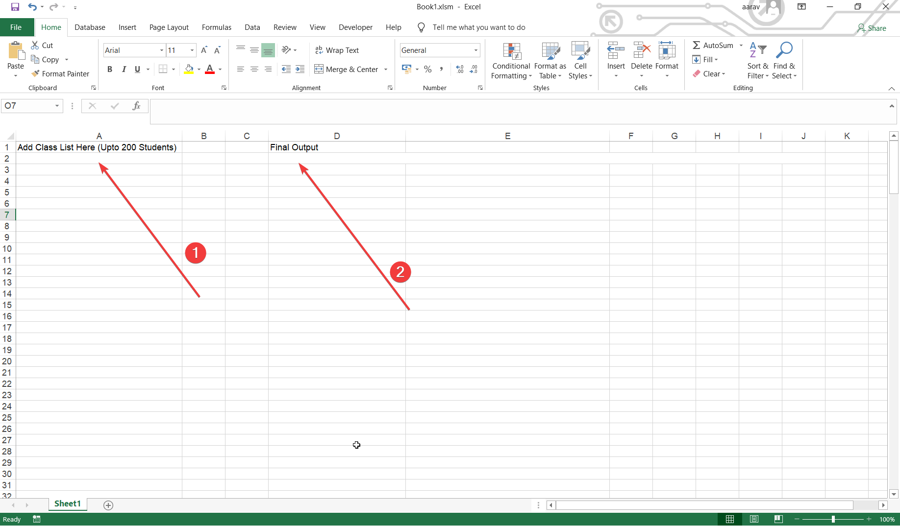To format the names, first copy the list of names from an excel sheet.
* Paste the names into the cell below the “Add Class List here” cell (Figure 2.1).
* Copy the final output from the cell below the “Final Output” cell (Figure 2.2).

1. Creating the folders

* Once you have copied the Final Output, double-click on Nova Folder Creator.
* Paste the final output (Ctrl + V).
* Click enter (if showing “Enter Name of Class”, then do not click enter”).
* Enter the name of the class.
* Click enter.
* Wait for the operation to complete; a message will be displayed to inform you of the same (at end of section).
* Click enter to end the program.

1. Using the profiles created

Everytime you create folders, a config profile is created in Nova Folder Creator\Nova Folder Maker\Nova Profiles

To use these profiles, open the Nova Profiles folder in File Explorer / Windows Explorer.

Open the specific file for the profile you want to use (e.g. VI-A.txt).

Copy the contents of the file (Ctrl+A and then Ctrl+C).

Follow Section 3 — Creating the Folders.