Alarm clock radio

# System requirements

The following table displays the requirements for the system :

|  |  |  |
| --- | --- | --- |
| ID | Abstract | Description |
| REQ_001 | Automated alarm clock | The alarm clock radio shall wake up the user automatically at the right time, through radio or buzzer. |
| REQ_002 | Radio management | The user shall be able to modify easily the radio station and the volume. |
| REQ_003 | Clock management | The user shall be able to update easily the time displayed by the clock or the alarm. |
| REQ_004 | Radio station management | The user shall be able to modify easily the radio station. |
| REQ_005 | Volume management | The user shall be able to modify easily the volume. |
| REQ_006 | Radio frequency modes | The alarm clock radio shall provide a way to select either AM or FM frequencies for radio. |
| REQ_007 | Radio frequencies | FM frequencies shall be between 88MHz and 108MHz and AM frequencies shall be between 5300kHz and 1600kHz. |
| REQ_008 | Power | The alarm clock radio shall be plugged for power supply. |
| REQ_009 | Backup | A backup battery shall keep the settings, even when power is off. |
| REQ_010 | Voltage | The alarm clock voltage shall be 230V – 50Hz. |
| REQ_011 | Backup battery | The backup battery shall be a 9V battery. |
| REQ_012 | Snooze | Hitting the snooze button during alarm shall make the alarm start again after 9 minutes. |
| REQ_013 | Listen to radio | The user shall be able to listen to the radio at any time |
| REQ_014 | Display time | The right time shall be displayed by the alarm clock at any time |

# Context

The following use case diagram illustrates the context of the system ***UseCaseDiagram :***

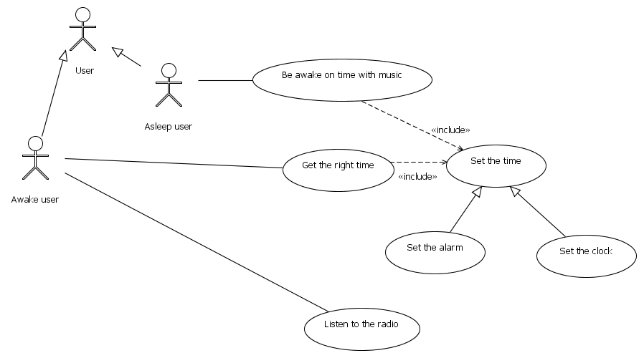

The following actors are displayed:

* Asleep user

*A user that is sleeping uses the Alarm-Clock-Radio as an alarm-clock*

* Awake user

*A user that is awake uses the alarm-clock radio as a clock or as a radio*

* User

*A user of the alarm clock can be either asleep or awake*

The following use cases are displayed:

* Listen to the radio
* Set the alarm
* Be awake on time with music

*Being awake on time supposes that the correct alarm time has been set by the user*

* Get the right time

*Displaying the right time is a function of the "clock" part of the system*

* Set the clock

### Behavior diagrams

This use case is described by the following behavior diagram ***SetClockTime :***

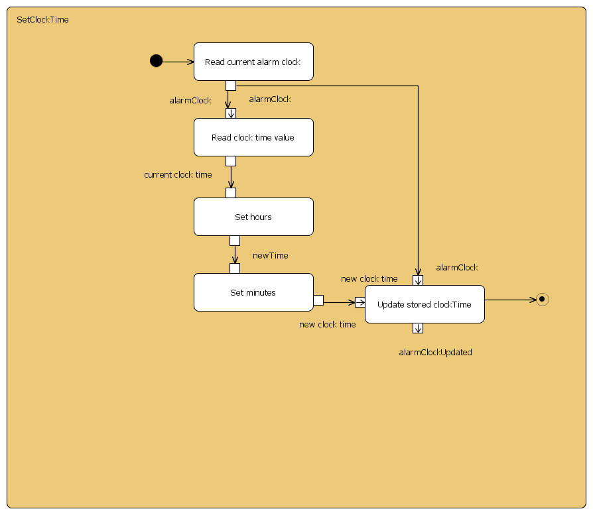

* Set the time

*Getting the right time displayed supposes that the correct time has been set by the user on the clock.*

# System structure breakdown

## Block definition diagram

***AlarmClockRadio***

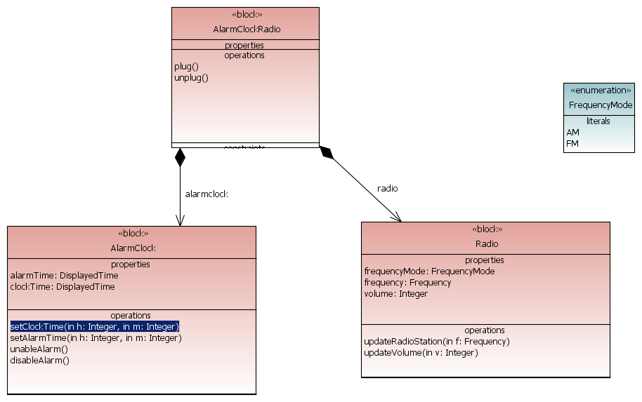

## Block AlarmClock

### Block properties

* alarmTime : *DisplayedTime*
* backupBattery : *BackupBattery*
* clock : *Clock*
* clockTime : *DisplayedTime*
* displayer : *Displayer*

### Block ports

* alarm ON/OFF button : *User*
* **out** display : *Light*
* **in** power : *DC Power*

### Internal block diagram

This block is described by the following internal block diagram ***AlarmClock_internal :***

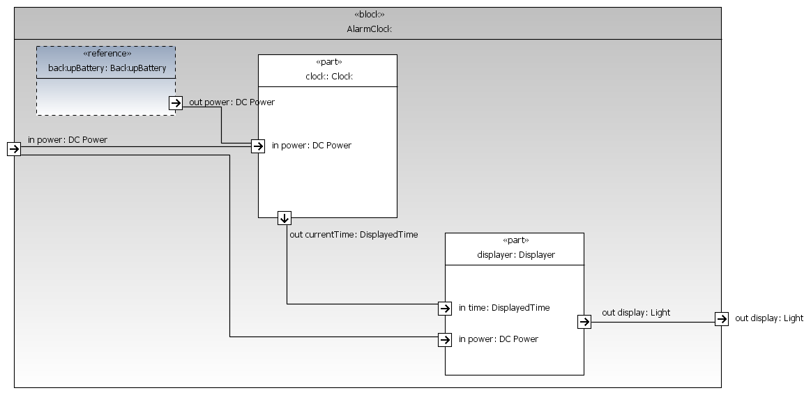

## Block AlarmClockRadio

### Block properties

* alarmclock : *AlarmClock*
* radio : *Radio*
* transformer : *Transformer*

### Block ports

* alarm ON/OFF button : *User*
* **out** display : *Light*
* **in** powerSupply : *AC Power*
* **in** radio : *HF Signal*
* radio ON/OFF button : *User*
* **out** soundSystem : *Sound*

### Internal block diagram

This block is described by the following internal block diagram ***AlarmClockRadio_Internal :***

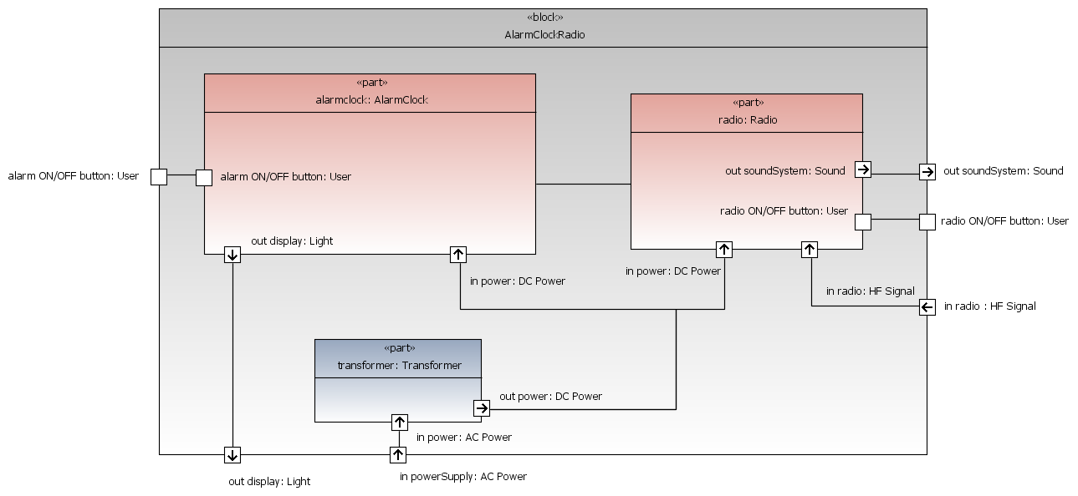

## Block BackupBattery

### Block ports

* **out** power : *DC Power*

## Block Clock

### Block ports

* **out** currentTime : *DisplayedTime*
* **in** power : *DC Power*

## Block Displayer

### Block ports

* **out** display : *Light*
* **in** power : *DC Power*
* **in** time : *DisplayedTime*

## Block Radio

### Block properties

* frequency : *Frequency*
* frequencyMode : *FrequencyMode*
* volume : *Integer*

### Block ports

* **in** power : *DC Power*
* **in** radio : *HF Signal*
* radio ON/OFF button : *User*
* **out** soundSystem : *Sound*

### Behavior diagrams

This block is described by the following behavior diagram ***Radio_stateMachine :***

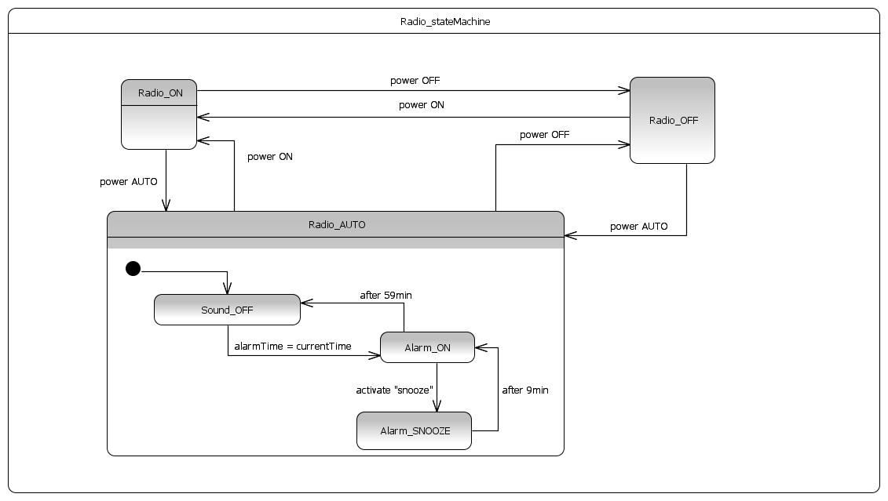

## Block Transformer

### Block ports

* **in** power : *AC Power*
* **out** power : *DC Power*