

Toolkit In OPen source for Critical Applications and SystEms Development

This document has been generated using **gendoc2** : More information available here :

<http://www.topcased.org/index.php>

<http://marketplace.eclipse.org/content/gendoc2>

|  |  |  |  |
| --- | --- | --- | --- |
|  | Author(s) | Checked by | Approbation |
| Name |  |  |  |
| Compagny |  |  |  |
| Department |  |  |  |
| Date |  |  |  |
| Visa |  |  |  |
| summary |  |  |  |

|  |
| --- |
| **Attention** : la responsabilité des entreprises et des organismes ayant participé à l'élaboration de ce document ne peut en aucun cas être engagée en cas de dommages ou de pertes résultant de l'utilisation ou de l'exploitation des informations qui y sont contenues.  **Disclaimer** : Contractors participating to this report shall incur no liability whatsoever for any damage or loss which may result from the use or exploitation of information and/or Rights contained in this report. |

Sommaire

1 Diagram : [d.name/] 2

1.1 [clean(getText(e))/] 2

# Diagram : UseCaseDiagram

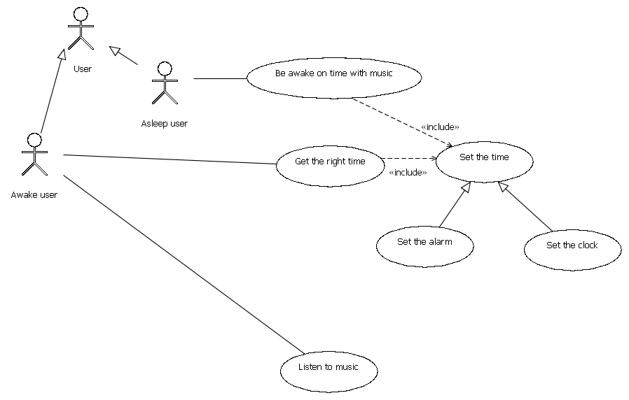

# Diagram : AlarmClockRadio

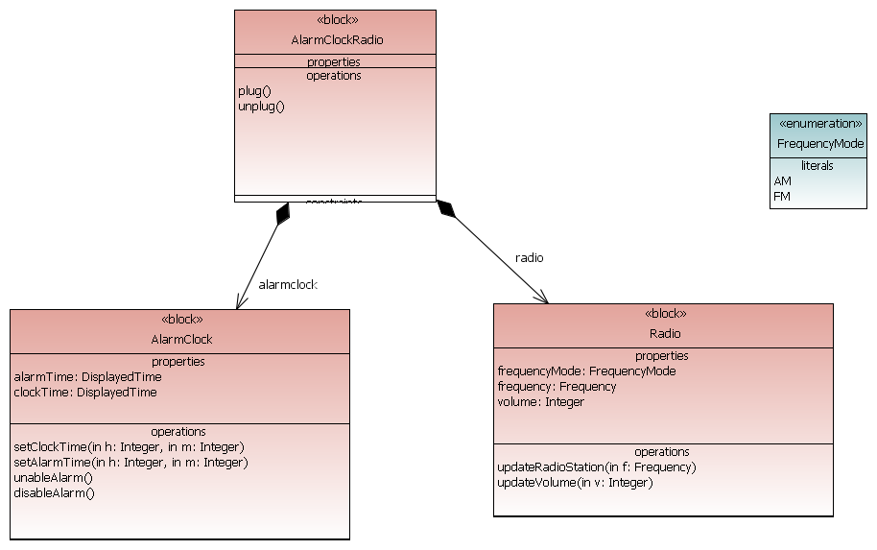

# Diagram : AlarmClock_internal

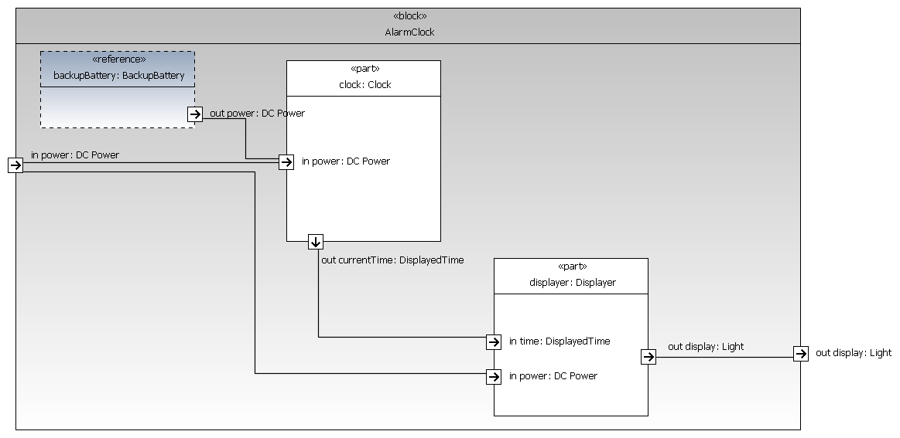

# Diagram : ReqTraceability



# Diagram : SetClockTime

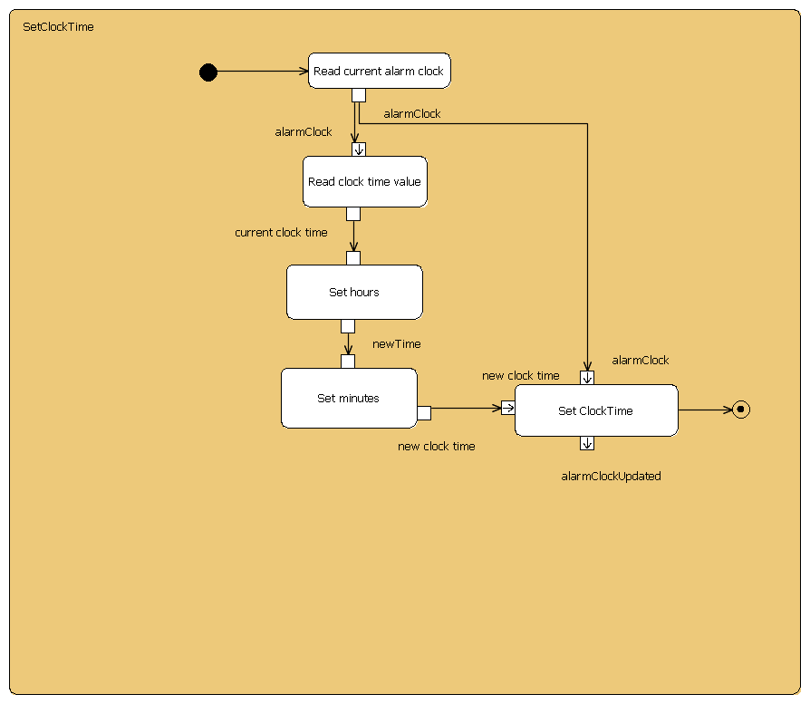

# Diagram : AlarmClockRadio_Internal

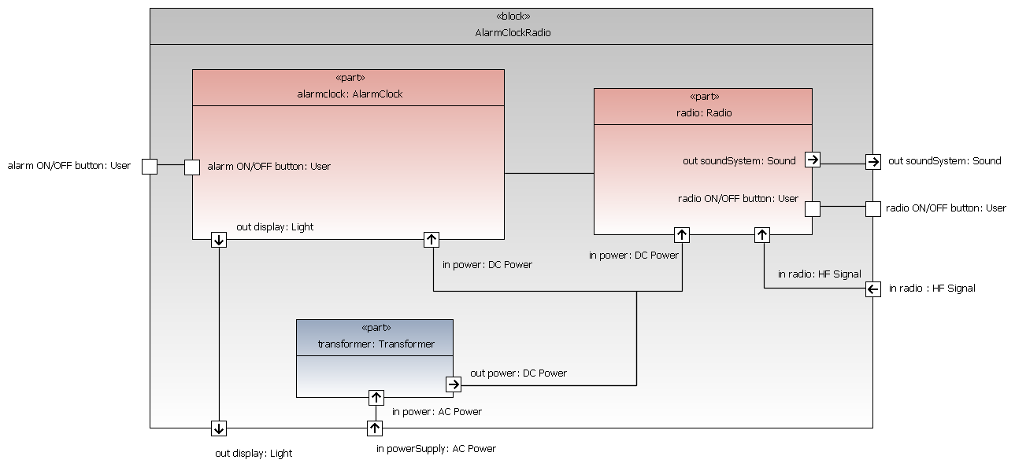

# Diagram : Radio_stateMachine

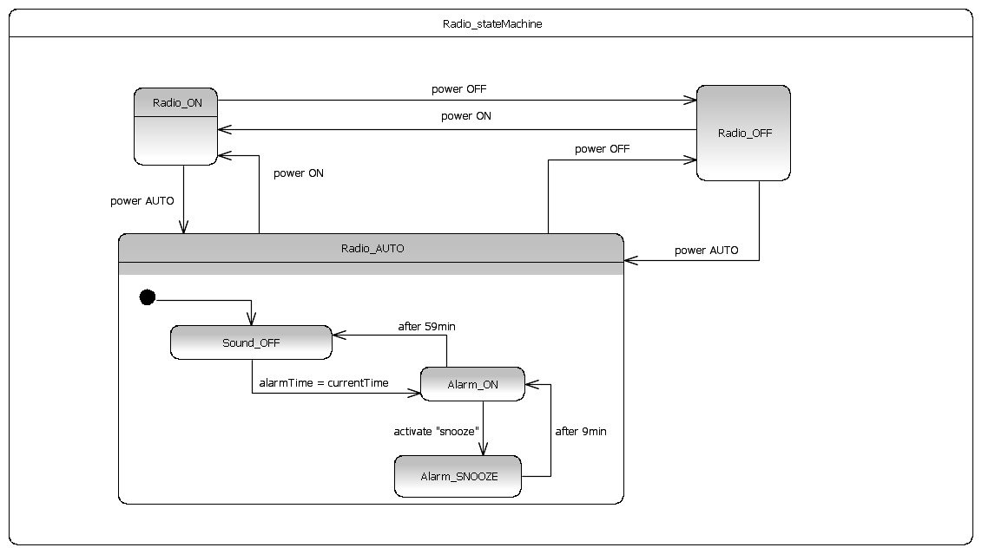

# Diagram : ValueTypes

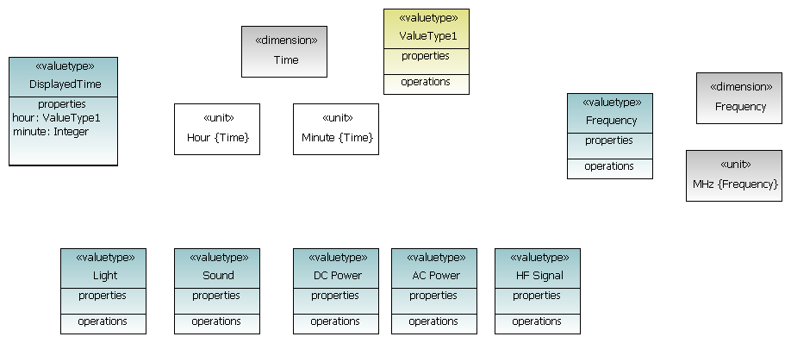

# Diagram : Overview

