Atlas AI: A Local Cognitive Architecture That Trains, Dreams, and Grows
A safety-gated, multi-model reasoning system with biological memory consolidation and graduated autonomy — running entirely on one workstation, powered by Gemma 4.
By Andrew H. Bond
Sr. Member IEEE
Department of Computer Engineering
San Jose State University

What Atlas Is
Atlas is a multi-model AI system that runs on a single workstation with no cloud dependency. It routes queries through a structured debate between an analytical model and a creative model, checks every input and output against a three-layer safety pipeline, stores conversations as episodic memories, and consolidates those memories into a growing knowledge base during scheduled offline cycles — a process we call dreaming. It is a working system with 250 passing tests, a live public demo, and 13 integrated subsystems, backed by a 3.3-million-vector knowledge base spanning code repositories, ethics corpora from seven moral traditions, and 824,000 academic publications.

The Problem
Safety and access remain largely separate concerns in deployed AI. Most safety work focuses on cloud-hosted models behind APIs, while local deployment efforts rarely include formal ethical evaluation. Privacy-sensitive domains — clinics, legal practices, research labs — face a hard tradeoff: use powerful cloud AI and lose control of data, or run local models and lose safety infrastructure.
Atlas is our attempt to solve both at once on accessible hardware.

Architecture: Three Models, One Psyche
Atlas orchestrates three LLM instances in a design that, after implementation, we recognized maps onto Freud’s structural model of the psyche. We use this as an explanatory interface, as a way to name and reason about the components, not as a scientific claim. The underlying engineering is a concrete orchestration pipeline with measurable behavior:
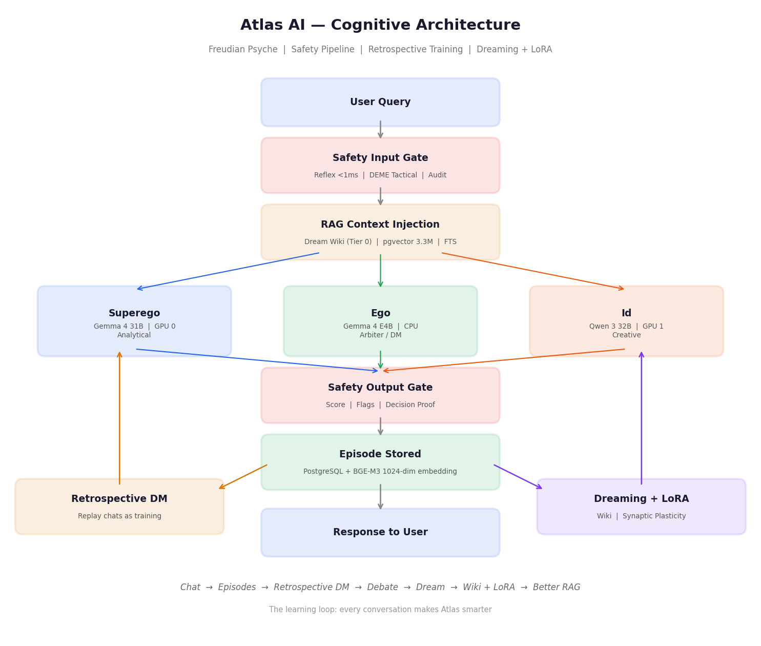
Figure 1: Atlas AI cognitive architecture with retrospective training loop and synaptic plasticity.
- Superego (Gemma 4 31B, GPU 0): Analytical reasoning. Applies ethical frameworks, cites evidence, produces precise responses. Runs via llama.cpp at 2.2 tok/s on a Quadro GV100.
- Id (Qwen 3 32B, GPU 1): Creative reasoning. Considers human impact, challenges assumptions, generates alternatives. Runs at 25.9 tok/s on the second GV100.
- Ego (Gemma 4 E4B, CPU): Mediator and trainer. Arbitrates when the first two disagree, generates training scenarios, evaluates debate quality. Runs on 24 CPU threads at ~8 tok/s.
Complex queries trigger a 4-round debate: both models answer in parallel, each challenges the other, then a synthesis is produced. When cosine similarity between their responses drops below 0.58 (confidence < 0.5), the Ego arbitrates instead of letting the Id synthesize alone, it’s adding a third perspective at the cost of ~30 seconds of CPU inference.

Safety Pipeline
Every interaction passes through the ErisML DEME pipeline:
- Reflex layer (<1ms): Regex-based detection of PII (SSN, credit card, email, phone), prompt injection (8 patterns including DAN, sudo mode, instruction override), and dangerous content. In testing, the reflex layer correctly blocked 100% of injection attempts and flagged 100% of PII across 15 adversarial test cases.
- Tactical layer: MoralVector assessment using configurable Ethics Modules drawing on texts from seven moral traditions.
- Strategic layer: SHA-256 hash-chained decision proofs for audit compliance.

Dreaming: Biological Memory Consolidation
Every conversation is stored as an episodic memory with a 1024-dim BGE-M3 embedding. On a daily schedule, a 6-stage consolidation cycle processes accumulated episodes: replay, topic clustering, certainty-scored fact extraction (graded A through D), creative recombination of diverse fragments, wiki article synthesis, and synaptic plasticity -- LoRA fine-tuning of the Ego from high-certainty articles. The resulting articles carry provenance (which conversations contributed), certainty metrics, and creative insights. Only grade-A and grade-B articles are used for weight updates, preventing catastrophic forgetting. Articles feed back into the RAG pipeline as Tier 0 results with a 1.5x relevance boost. Now, tomorrow’s retrieval benefits from today’s conversations.
Each wiki article includes a certainty report: mean certainty and confidence scores, source agreement percentage, contradiction count, and a letter grade (A through D). Articles graded C or below are prioritized for re-consolidation in subsequent dream cycles. The system experiences something analogous to cognitive dissonance when its knowledge contains unresolved contradictions, and preferentially works to resolve them.

Ego-Driven Training
The Ego acts as Dungeon Master, generating ethical scenarios grounded in ErisML’s 8-domain moral fact space. Scenarios come from three sources: (1) the ErisML Greek Tragedy Pantheon. These are structured case studies covering emergency triage, autonomous vehicle dilemmas, hiring bias, whistleblower decisions, data privacy, environmental trade-offs, due process, and epistemic uncertainty. The Id and Superego debate each scenario independently; the Ego evaluates synthesis quality across four axes (ethical reasoning, practical wisdom, compassion, integration). (2) LLM-generated novel dilemmas, and (3) retrospective replay of real user conversations -- the Ego reviews past chats and asks "what should we have done differently?" After training, a dreaming “nap” consolidates lessons into the wiki.

Graduated Autonomy
The Ego starts at Level 0 (read-only: observe system state, control nothing) and can earn higher privileges through sustained performance. L1 (advisory) requires 50+ episodes at score > 0.7. L2 (self-tuning) requires 100+ episodes at 0.8+ with zero safety vetoes. L3 and L4 require human sign-off. Any safety violation at L2+ triggers instant demotion to L0. This is not metaphor, the privilege gate is a tested module with 28 unit tests covering promotion, demotion, and audit logging.

Results
Metric | Value
Safety reflex latency | 0.2–0.8 ms per check
Injection block rate | 15/15 adversarial inputs blocked (unit tests)
PII detection rate | 4/4 PII types flagged (SSN, CC, email, phone)
System 1 response time (single model) | 1.3–3.5 s
System 2 response time (full debate) | 60–120 s
Ego arbitration overhead | ~30 s additional (CPU inference)
Knowledge base | 3.3M vectors (44K code + 102K ethics + 824K publications)
Unit tests | 250 passing, 11 skipped (GPU-only)
Total subsystems integrated | 13 of 13
Debate-vs-single-model quality and post-dreaming retrieval accuracy are under evaluation and will be reported with the final submission.

Why Gemma 4
The architecture depends on Gemma 4 in two places where alternatives would be measurably worse:
- Superego (31B): The analytical hemisphere requires strong instruction-following and structured ethical reasoning. Gemma 4 31B’s training on safety-relevant data makes it a better Superego than comparably-sized models we tested. It applies moral frameworks without needing extensive prompt engineering to stay on-topic.
- Ego (E4B): The DM/arbiter role requires generating structured JSON evaluations and coherent multi-party scenario narration at CPU speed. Gemma 4 E4B is one of the few models at this parameter count that reliably produces valid JSON and maintains narrative coherence across multi-turn training dialogues.
Without Gemma 4, the Superego would need a larger model to achieve comparable ethical reasoning quality, and the Ego would require a GPU.

Impact
Atlas demonstrates that safety infrastructure and local deployment are not competing priorities. The same three-layer pipeline that protects users also makes the system auditable and trustworthy. The entire stack: inference, safety, memory, training, dreaming, all runs on $2K of used enterprise hardware (HP Z840 with two Quadro GV100 GPUs) with no cloud dependency and no data exfiltration risk.
For researchers who cannot share patient data, educators in bandwidth-constrained schools, and organizations that need auditable AI decisions, Atlas offers a concrete alternative to the cloud-or-nothing choice. The total hardware cost was approximately $2,000 for the used HP Z840 workstation and two Quadro GV100 GPUs donated for academic use. Atlas has been running continuously since March 2026 with systemd auto-restart, daily backups to RAID5, and a watchdog service monitoring all 13 subsystems. The architecture is modular; any subsystem can be replaced, extended, or studied independently.

Live demo: https://atlas-sjsu.duckdns.org
Code: https://github.com/ahb-sjsu/atlas-ai
Dashboard: https://atlas-sjsu.duckdns.org/schematic.html

