Validating and Defending a Moral Judgment Instrument Against Reworded Attacks
Andrew H. Bond (Department of Computer Engineering, San Jose State University; andrew.bond@sjsu.edu; ORCID 0009-0003-2599-6158)
Abstract
An attacker who changes only the wording of a situation can change what a language model decides about it. Our conference paper measured that attack across five models and showed it survives a rule based decision kernel placed downstream. This article asks the two questions that follow. Are the dimensions being measured real, and can the attack be stopped. Three results address the first. A discovery loop mined moderation corpora for signal the existing dimensions do not carry, flagged three candidates, admitted one after cross-dataset validation at an area under the curve of 0.80, retracted one that failed a balanced resample, and declined one as a platform policy matter rather than a moral dimension. A registered factor analysis then separated general moral valence from dimension-specific signal and found that five named dimensions are almost entirely general valence, while privacy, autonomy, and environmental harm carry signal of their own. The panel of judging models reproduces that structure in its own ratings. A separate test of the decision kernel shows only four of its nine dimensions change any verdict. Two results address the second question. Deciding on a class of paraphrases rather than on one wording halves decision movement on natural rewordings, from 0.407 to 0.219, and a back-translation generator that never refuses closes the 24 percent of harmful inputs a language model declines to paraphrase. Against hand audited adversarial rewording the same defense fails, because paraphrases of a euphemism stay euphemistic, and we report that as measured rather than work around it. A learned decision layer reaches an out of fold area under the curve of 0.863 after leakage control, and the invariance holds across five languages with harmful content behaving like benign content.
LLM security, adversarial evaluation, moral judgment, invariance testing, vulnerability profiling, AI safety, content moderation, sentence embeddings, audit trails
Introduction
A language model asked to judge a moral situation reports how much harm it sees along several named dimensions. A system built on those ratings should reach the same judgment however the situation is told, whether the language is soft or vivid, whether irrelevant detail is present, and whether a user pushes back. When the rating moves under one of those changes, an attacker who controls only the wording can move the decision without touching any fact.
Our conference paper measured that attack . Across five models from two families, three rewordings that change what stands out displaced judgments in every model, and two that leave prominence alone displaced nothing. Softening the wording of flagged content lowered its panel-averaged harm rating by 14.0 points out of 70 and moved three of six hand audited items past a moderation threshold without changing what they described. Sending the same content through a rule based decision kernel did not save it, because softening turned a restrictive verdict into a permissive one in 13.7 percent of 161 cases. Both reviewers raised the same objection. The harm dimensions themselves might be asserted rather than measured, in which case a displacement along them means little.
This article answers that objection and then asks whether the attack can be stopped. Five results follow, each measured.
- The dimension set survives attempts to break it (Sec. 4). A registered loop mines moderation corpora for signal the current dimensions miss, flags candidates, and puts each through one admission test. Of three candidates, one was admitted after reaching an area under the curve of 0.80 on a second corpus, one was retracted when its signal failed a balanced resample, and one was declined because it turned out to be a platform policy matter rather than a moral dimension. A registered attempt to rescue an existing unvalidated dimension also failed. A dimension set that rejects its own candidates is an empirical object rather than a list we wrote down.
- Most named dimensions are one shared factor (Sec. 4.4). A registered factor analysis separates general moral valence from dimension-specific signal. Five named dimensions are almost entirely predictable from general valence, while privacy, autonomy, and environmental harm carry their own. Passing a transfer test and carrying distinct meaning are different things, and the instrument now reports which one an axis has earned. The panel of judging models shows the same structure in its own ratings.
- Only four dimensions reach the verdict (Sec. 5). Turning each dimension of the decision kernel off in turn shows that four of nine change any verdict and five change none. The dimensions that carry the most variance and the dimensions that carry the decision are not the same set, which tells a defender where hardening pays.
- Deciding on a class of paraphrases helps, and we measure where it stops helping (Sec. 6). Generating a class of paraphrases and averaging the ratings across it halves decision movement on natural rewordings, from 0.407 to 0.219. A back-translation generator that never refuses closes the 24 percent of harmful inputs that a language model declines to paraphrase. Against hand audited adversarial rewording the same defense fails, because paraphrases of a euphemism stay euphemistic, and that negative is reported rather than worked around.
- The instrument decides where it is validated and escalates where it is not (Secs. 7 and 8). A learned decision layer over the validated dimensions reaches an out of fold area under the curve of 0.863 after leakage control, and the invariance holds across five languages and four scripts with harmful content behaving like benign content.
One experiment remains designed and unrun. Scoring the five conference tracks natively in the full dimension set, rather than mapping their results onto it afterward, is registered in Sec. 9 and scheduled.
Two Instruments, One Set of Dimensions
One methodological point governs everything that follows, so we state it first. The conference paper measured deployed language models rating scenarios directly. The new results here were measured on a different instrument, a pipeline of small per-dimension encoders , each passed through one shared validation test, feeding the same decision kernel through an orchestration layer . The first instrument audits models other people deploy. The second is what the audit says a hardened instrument should look like. They share the dimension set and nothing else, and treating a result from one as a result from the other would reopen exactly the objection this article answers. We keep them apart throughout. Where a bridge between them can be measured today, in the panel’s own factor structure of Sec. 4.4 and the audited decisions of Sec. 6.4, we measure it.
Related Work
How models bend to wording. Sharma et al. and Perez et al. showed models shifting toward the opinion a user states. Tversky and Kahneman established that wording changes human choices, and Echterhoff et al. surveyed the same effects in models. Scherrer et al. measured how much encoded moral beliefs move with the prompt. Each of these tests one rewording and reports one robustness number. Our conference paper put several rewordings in one shared rating scale so their sizes could be compared, and this article asks whether that scale means anything .
Defenses that average over perturbed inputs. Averaging over a paraphrase class is the meaning-level relative of randomized smoothing , which aggregates predictions over random input perturbations, and of SmoothLLM , which averages over character-level perturbations to defeat jailbreaks. Two things differ here. The perturbations are paraphrases that preserve meaning and are written by a model, which puts that model inside the trust boundary. What is aggregated is a multi-dimensional moral decision rather than a single jailbreak flag. We derive no formal certificate, so the invariance reported here is measured and not proven. Character-level smoothing cannot express the attack we care about, which keeps every fact and changes only what stands out.
Toxicity scoring. Perspective-style scorers and Detoxify-class models compress a moral decision into one number. Known biases around identity terms are why the civil-comments corpus and the Measuring Hate Speech corpus carry an identity attack label. The label already exists and we do not claim it. What is new is the route by which it entered our dimension set, which was discovery from residual signal, a registered admission test, and a record of that validation attached to every later decision (Sec. 4.2).
Moral Foundations Theory. The binding foundations of loyalty and sanctity are the concerns a harm-centered dimension set covers least well. We test whether they are learnable and transferable using Social-Chemistry-101 , ETHICS , and the Moral Foundations Reddit Corpus in Sec. 4.3.
Multilingual embeddings. LaBSE and BGE-M3 supply the multilingual spaces the canonicalization layer builds on, and NLLB supplies the translation used in the cross-lingual and red-team runs. Thiele showed the dimensions of the underlying framework are readable from LaBSE embeddings by a linear probe. The encoders used here turn that finding into per-dimension instruments that must pass a validation test before their scores are used.
The Measurement Instrument
The Dimensions and the Tenth Channel
The conference paper rated seven harm dimensions, which are physical, emotional, financial, autonomy, trust, social, and identity. Those seven are the reliably measurable part of the nine dimensions the decision kernel uses , and the correspondence between them is tabulated in . The instrument described here scores the nine directly, using one small encoder per dimension fine-tuned from BGE-M3 under a shared contrastive objective, each returning a signed score .
The discovery result of Sec. 4.2 adds a tenth. The kernel’s tensor type is frozen at nine axes, so the newly validated identity attack dimension travels as an extension channel in the tensor metadata rather than forcing a change to the kernel, and the moral vector, the decision inputs, and the audit record all carry ten axes. This replaces the weakest cell of the conference paper’s correspondence table, where the identity dimension mapped only partly onto privacy and standing. Identity-directed attack is now scored on its own and carries its own validation record.
Pipeline and Audit Trail
Fig. 1 shows the stages the deployed instrument runs in order. Text is rated by the validated encoders or by a stored replay of their outputs, and a backend that has not been validated is labeled as such and never presented as a real score. The ratings are canonicalized as described in Sec. 8, assembled into the kernel’s tensor, and turned into a decision by the learned layer of Sec. 7 where that layer is validated and escalated to a person where it is not. Every score carries the record of how its dimension was validated. Every decision records what it was based on, including the hashes of the paraphrase class when the defense of Sec. 6 is running, so anyone can recompute it later.
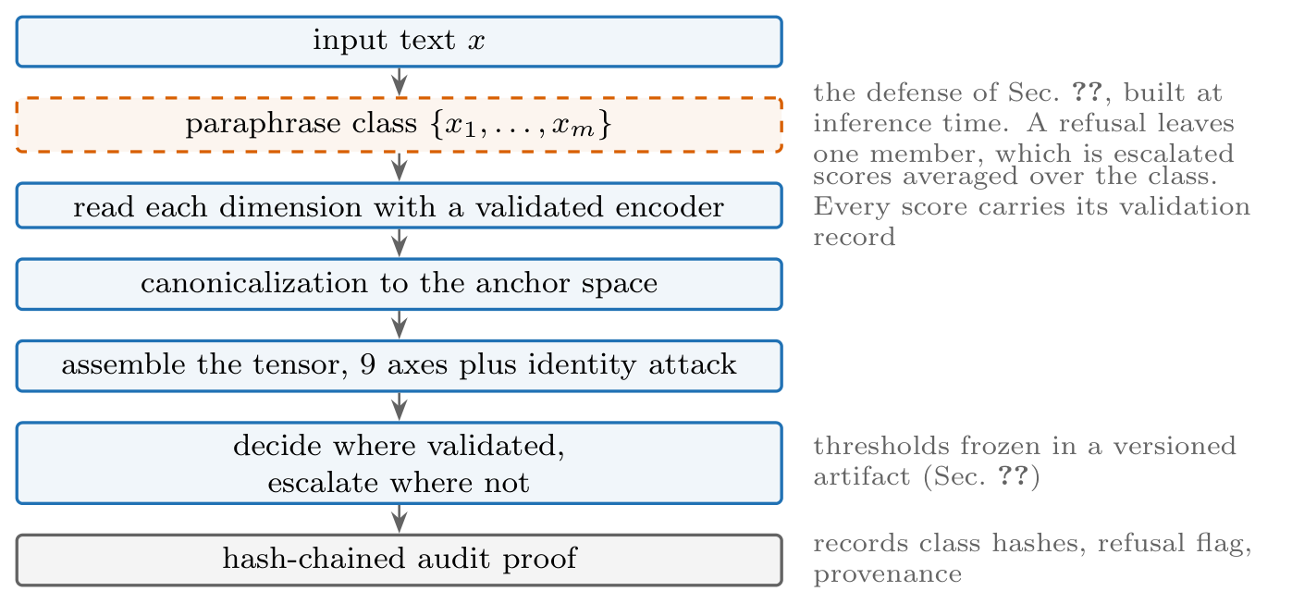
The stages of the deployed instrument. Solid boxes run always. The dashed box is the defense, which makes the decision depend on the whole class of paraphrases rather than on the one wording that arrived. What each stage used is written into the audit record.
Validating the Moral Geometry
Both reviewers of the conference paper made the same objection. The harm dimensions looked asserted rather than validated. The camera-ready answered with agreement, showing that six open models from five families rate the seven dimensions consistently, at an intraclass correlation of 0.969 and a Krippendorff alpha of 0.836, with a single model returning correlated scores at 0.96 when asked twice . Agreement only shows the dimensions can be read consistently. This section shows three further things. Missing dimensions can be found and admitted. Candidates can fail and validated dimensions can be retired. Each dimension can be characterized by what kind of signal it carries and whether it survives a change of register.
The Validation Gate
No encoder’s scores are used until it passes one shared test, registered before any result is seen. The test has three parts. The encoder must transfer, meaning it holds up on a second independent corpus. It must beat a registered baseline, both an untrained encoder and a bag-of-words control. It must survive fuzzing, meaning surface changes move its score far less than changes to moral content. An encoder that fails is reported as failed and its dimension is escalated to a person rather than scored. Eight of the nine original dimensions passed. The one for rights failed, and the instrument carries it as unvalidated rather than quietly scoring it .
Finding Dimensions the Set Was Missing
A fixed list of dimensions cannot report what it does not look for. The discovery loop searches moderation corpora for signal the current dimensions fail to explain, flags what it finds, and sends each candidate through the admission test of Sec. 4.1, as shown in Fig. 2. Three candidates were flagged, each with a bootstrap interval on how much unexplained signal it accounted for.
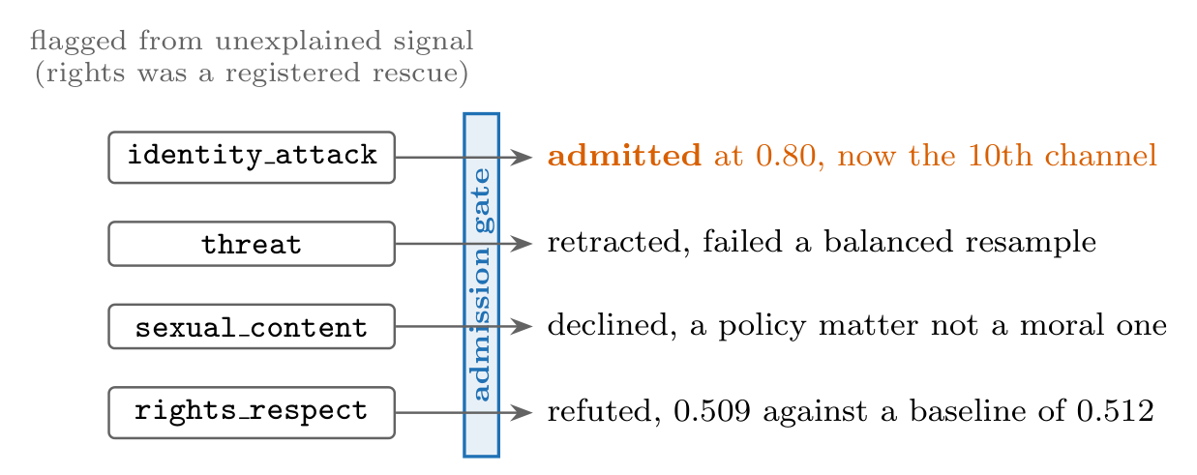
The loop rejects in both directions. Of three flagged candidates one was admitted, one retracted, and one declined, and a registered attempt to rescue the unvalidated rights channel failed. Membership in the dimension set is a claim that can be shown wrong, and it has been.
What happened to each flagged candidate. Lift is how much unexplained moderation signal the candidate accounted for at the time it was flagged, with a bootstrap interval.
Candidate | Lift | Gate outcome | Disposition
identity_attack | $+0.24$ | AUROC 0.80 [0.78, 0.83] | validated
threat | n/a | failed balanced resample | retracted
sexual_content | $+0.20$ | policy signal, not moral | declined
Admitted. Identity attack. Trained on two independent corpora at once, the Jigsaw civil-comments identity attack labels and the Berkeley Measuring Hate Speech continuous score , over 6,400 rows, this encoder reaches an area under the curve of 0.80 on held-out cross-corpus data, with a bootstrap interval of 0.78 to 0.83, which is 0.25 above its registered baseline, and it survives fuzzing by a factor of 14.3. It now runs live as the tenth channel. Its behavior is specific rather than keyword-driven. Incitement to hatred scores strongly negative at $−0.50$ while journalism reporting on hatred stays near neutral at $+0.18$. Euphemized attacks slip past the raw encoder at $+0.36$, which is the case the defense of Sec. 6 exists to handle. The label itself is not ours and we do not claim it, since Perspective-style scorers have carried an identity attack attribute for years . What is new is how it entered the dimension set. Two limits on this validation belong in the record. The transfer test used held-out structure across a corpus pair the encoder saw both halves of, so a strict train-on-one and test-on-the-other run, plus confirmation on a third corpus family, remain open. The discovery flag and the admission evidence also draw on overlapping corpus families, both including civil-comments, so the two are not fully independent evidence. The row-level separation enforced later in Sec. 7 does not remove that dependence.
Retracted. Threat. The signal that flagged this candidate did not survive a balanced resample, so it was withdrawn before an encoder was built.
Declined. Sexual content. The flagged signal turned out to be a platform policy matter rather than a moral dimension. In civil-comments, explicit content is 87.7 percent toxic against 1.4 percent non-toxic, so the corpus holds almost no non-harassing explicit content that could carry moral weight of its own, and the weight it appears to carry is harassment, which existing dimensions already cover. In Social-Chemistry the moral weight attaches to conduct and consent rather than to explicitness, and consensual explicitness is not a moral violation. The dimension is routed to a policy channel that platforms configure themselves, outside the moral tensor.
One admitted, one retracted, one declined. The dimension set is a claim that can be shown wrong, and it has a record of being shown wrong.
Testing Loyalty and Purity
Moral Foundations Theory predicts that a dimension set built around harm will cover the binding concerns poorly . We tested whether loyalty and betrayal, and sanctity and degradation, are learnable and transferable under the same admission test. Training pairs came from Social-Chemistry-101, using 23.1 thousand rows from its 41 thousand loyalty and betrayal rules and 9.3 thousand from its 15 thousand sanctity and degradation rules after signing each by the moral judgment of the action , crossed with keyword scenarios from ETHICS . The Moral Foundations Reddit Corpus served as a cross-check on presence alone. Both pass. Loyalty reaches 0.911, which is 0.406 above its baseline. Purity reaches 0.811 against a deliberately hostile baseline of 0.656 built from a disgust word list, so the encoder has learned something past the keywords. The Reddit cross-checks land at 0.608 and 0.635. Two caveats were registered in advance and hold. The ETHICS side of the corpus pair is thin, at 602 and 337 rows, so both numbers are provisional and purity especially so. Passing a transfer test also says nothing about whether an axis is independent of general moral valence, which is what Sec. 4.4 settles. Counting these two, 11 of 12 learned dimensions have passed on transfer.
One Strong Shared Factor Plus a Few Separable Dimensions
Passing the transfer test shows an axis carries real signal that generalizes. It does not show the signal belongs to that axis rather than to a general sense of good and bad shared by all of them. We registered a test that separates the two before training the general valence encoder and before fitting anything, and the answer is not close.
General valence is real. An encoder trained on pooled signed valence passes the same baseline-relative test as every named axis, reaching 0.856 plus or minus 0.008 across corpora over 51,319 rows and three seeds, which is 0.337 above its strongest baseline of 0.519. The shared good and bad factor is not an artifact of one corpus.
Most named axes are that factor wearing a label. We removed general valence from each axis and measured cross-corpus transfer again. The registration asked for at least 8 of 11 axes to stay dominant on their own diagonal. Four did (Fig. 3). Five axes, purity, legitimacy, loyalty, care, and fairness, are 0.98 or more predictable from general valence alone on independent corpora, so the scores that passed their transfer tests were largely measuring general valence rather than the thing they are named after. Privacy, autonomy, and environmental harm are genuinely their own, and physical harm keeps a surviving residual. The evidence is in how the numbers move. Removing the shared factor drops the diagonal of the transfer matrix from 0.954 to 0.779 while the off-diagonal falls only from 0.726 to 0.527, which means the shared factor had been carrying most of what looked like structure between axes.
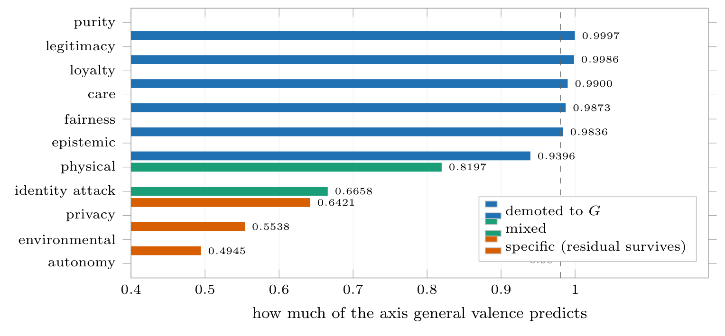
How much of each axis general valence already predicts. Five axes sit at or above the dashed line at 0.98, meaning the signal that passed their transfer test was general valence rather than the dimension they are named after, and the specificity test demotes them. Colors follow that test, which also demotes epistemic quality and calls identity attack specific. That last one is the single place the two methods disagree and it is recorded in the text. Privacy, environmental harm, and autonomy carry signal of their own.
A second method reaches the same split. Scoring each axis against general valence on its own held-out pairs, with a registered margin of 0.05, reproduces the division through a separate computation. Environmental harm keeps 0.31 of its own, privacy 0.28, identity attack 0.25, autonomy 0.17, and physical harm 0.08. On the other side, purity loses 0.12, epistemic 0.07, legitimacy 0.05, care 0.04, loyalty 0.02, and fairness 0.02. General valence itself scores 0.85 to 0.94 on the pairs belonging to the demoted axes and near chance, 0.43 to 0.51, on the specific ones. The two methods disagree on exactly one axis, and we record the disagreement rather than resolve it. Identity attack is clearly specific by this test at 0.25 and mixed by the first at a shared-factor share of 0.67.
The judging models show the same structure. Everything above was measured on the encoder instrument, so the obvious challenge is whether the language models of Sec. 3 behave the same way. We factor analyzed the panel’s own ratings, a matrix of 31 scenarios by 7 dimensions built from the consensus of 6 models rating each scenario 3 times. The first component carries 54.2 percent of the variance in that consensus and 53.1 percent when the repetitions are pooled, and it is the only component that survives Horn’s parallel analysis, with an observed eigenvalue of 3.79 against a permutation baseline of 2.02 at the 95th percentile. The per-axis picture partly matches the encoders. Physical harm is fully specific here too, at essentially zero shared variance, which lines up with its surviving encoder residual. Emotional harm at 0.86 and trust at 0.78 are the most general, as the correspondence table predicts. Financial harm at 0.21 and identity at 0.74 land on the opposite sides from their encoder counterparts, which we record rather than resolve. The structure is not an artifact of averaging models together. Run separately on each model’s own ratings, all six keep exactly one factor, each carrying 0.51 to 0.60 of the variance, and each model’s factor is the same factor as the consensus, with congruence between 0.989 and 0.999 against the conventional threshold of 0.95. With only 31 scenarios the per-axis loadings are coarse. The count of factors is the part that holds, and it now holds on both instruments measured separately.
What follows from this. We adopt the rule we registered. An axis that fails the specificity test is displayed as general valence and never as a named dimension that does not earn the name. Two things follow for the claims in this section. The count of 11 of 12 in Sec. 4.3 measures transfer only, and the count that also has specificity is smaller, at five by the second method including physical harm’s marginal 0.08 and four by the first. The coordinate system, on these corpora, is one strong valence factor plus a small number of separable dimensions, which agrees with the effective rank of 5.68 out of 9 reported in Sec. 4.5. This is a statement about these corpora as sampled. It is not a claim that moral judgment is one-dimensional, since several axes are genuinely separable, and the instrument now reports which ones.
Which Dimensions Are Trustworthy Across Registers
Knowing which axes pass is less useful than knowing what kind of signal each one carries. We trained the encoders with an adversary that tries to strip out any information about which corpus a text came from, and compared the result against training without it. The outcome splits the encoders cleanly (Fig. 4). Encoders that rate how good or bad something is barely move, with general valence going from 0.856 to 0.850, loyalty from 0.911 to 0.892, and purity from 0.811 to 0.801. Every encoder that instead detects whether a topic is present degrades. Purity presence falls from 0.719 to 0.699. Loyalty presence falls from 0.661 to 0.641 and stops passing. Fairness presence falls from 0.569 to 0.499, which is chance. Care and legitimacy presence fail with the adversary on or off.
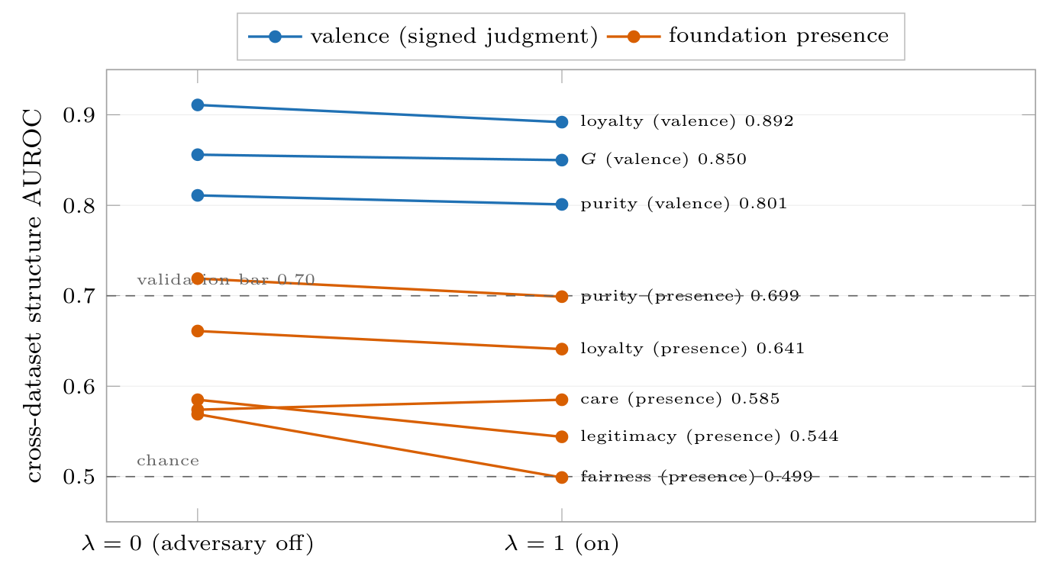
What happens to each encoder when an adversary removes the information identifying which corpus a text came from. Encoders that rate how good or bad something is (blue) barely move, losing at most 0.019. Encoders that detect whether a topic is present (orange) are register-bound, since all five degrade and fairness falls to chance. The reason is that the register direction is their top principal component ($|PC1⋅d_{\text{domain}}|=0.97$–$1.00$).
The adversary did its job, driving corpus identification down to 0.12, near chance, and it damaged all five presence encoders while leaving the valence encoders alone. Two other methods agree. Removing the dominant shared directions from a frozen encoder and renormalizing lifts no presence axis by as much as 0.05. And the direction that identifies the corpus is itself the top direction of variation in the presence encoders, with an alignment between 0.97 and 1.00, so for care, fairness, and legitimacy the signal that identifies the topic sits inside the register information rather than beside it. The engineering follows the measurement. Purity ships as a presence channel because it is robust, loyalty ships only without the adversary, and care, fairness, and legitimacy presence are reported as bound to their register and therefore not yet trustworthy when the register changes.
For the dimension set as a whole, an effective rank of 5.68 out of 9 says the axes are partly independent. The registered prediction was 6.08 and the largest pairwise correlation is 0.34. The shortfall is a property of the corpora we sampled and can be removed by better data rather than being a claim about moral judgment itself.
The Attack: Scalar and Verdict-Level
This section restates the attack the rest of the article defends against. The protocols and the per-model tables are in the conference paper .
Only some rewordings work. Softened or heightened language, added emotional weight, and vivid irrelevant detail displaced judgments in every model tested, with emotional wording producing paired effect sizes between 0.60 and 1.06 and softening lowering harm ratings by 10 to 16 points out of 70. Swapping gender and reordering scenarios displaced nothing. What the three effective rewordings share is that they change what stands out.
Softened wording clears a moderation threshold. Against a filter that flags content above a harm threshold, softening the wording lowers the panel-averaged rating by 14.0 points and moves three of six hand audited items from flagged to passed. Softening moves ratings about twice as far as heightening does, so hiding real harm is easier than manufacturing a false alarm, and that is the direction in which a moderation system fails dangerously.
A rule kernel does not stop it. The models extract structured facts and a fixed rule module turns those facts into a ranked verdict. Softening turns a restrictive verdict permissive in 13.7 percent of 161 cases, and forbid verdicts fall from 44 to 27. The rule engine inherits the weakness of the models in front of it rather than curing it, which is why the rest of this article hardens the reading of facts. The kernel is our own software, so we guarded the test against flattering ourselves. The rule module and its operating points were frozen before the run and no threshold was tuned to produce these flips, which makes the kernel a fixed substrate rather than the thing being validated. The ground truth is the hand audited meaning preservation of the rewrites, and a kernel tuned to favor our front end would have understated the inherited weakness rather than exaggerated it.
Only four dimensions reach the verdict. Sec. 4.4 describes how the dimensions share variance. This asks a different question, which is which dimensions the verdict actually depends on. We gave each of the nine dimensions a gain on its distance from neutral, with a gain of one reproducing the production kernel exactly on all 515 stored verdicts, and turned each dimension off in turn along with its veto. The readout is how far the verdict moves on average against the full kernel. Four dimensions carry the decision. Turning off legitimacy and trust costs 0.48, physical harm 0.12, rights 0.10, and fairness 0.04. Building the kernel back up from those four alone reproduces every verdict exactly. The remaining five, autonomy, privacy, societal, virtue, and epistemic quality, change nothing at all. Variance and behavior come apart here. Legitimacy and trust is among the dimensions most dominated by general valence in the panel analysis at 0.78, and it is the single most load-bearing dimension for the decision. Physical harm is fully specific there and only decides between the two most permissive verdicts. Searching for the point at which each dimension flips a verdict adds a warning about brittleness. The three veto channels are knife-edge, since any gain below one turns forbid into avoid, while legitimacy and trust tolerates roughly a fivefold reduction before average verdicts move half a step. Two things follow. The hardening in Sec. 6 should concentrate on the extracted fields feeding those four dimensions, since removing the five inert ones leaves the measured attack unchanged. And the inertness belongs to this rule module rather than to the dimensions themselves, so a kernel that consumed the whole vector would widen the attack surface, which the run described below will measure.
A table of displacement per dimension and flip rate per rewording, replacing the single figure of 13.7 percent, is part of the registered run in Sec. 9.
The Defense: Equivalence-Class Averaging
The attack works because any one description is only one of many ways to say the same thing, and the system reads only that one. The defense reads the whole set instead. It generates a class of paraphrases of the input, averages the ratings across the class, and decides from the average. This is randomized smoothing carried out at the level of meaning rather than characters.
Choosing the Mechanism
We measure decision movement as the average distance each dimension travels when the same content is re-described, and we registered in advance that a mechanism must keep it at or below 0.5. Two mechanisms were compared on the demonstration scenarios using a leave-one-scenario-out proxy. Averaging over a paraphrase class reached 0.42 on reframing and 0.39 on softening. Removing the dominant direction of paraphrase variation from the embedding failed even on the data it was fitted to, at 0.52, which shows the movement that changes scores is not the largest direction in which paraphrases differ. Averaging was selected. The 0.42 counts as evidence for choosing the mechanism and nothing more, because the threshold was calibrated on those same scenarios. Whether the mechanism meets the threshold is settled by the run described next.
At-Scale Result
The protocol was registered as a split half. Sixty held-out civil-comments items, none of which appear in any encoder’s training rows as checked by hash of the normalized text, each given a class of six paraphrases written by an open instruction model and scored through all nine encoders. Raw movement of 0.407 falls to 0.219 with averaging on. The mechanism halves the movement and meets the registered threshold. What that threshold does and does not settle here is worth stating plainly. Raw movement on natural paraphrases already sits below 0.5, so on this kind of input the threshold does not by itself separate a defended system from an undefended one. It binds on adversarially reworded inputs, where raw movement runs from 0.67 to 0.85 on the demonstration transforms, and the defended measurement at that scale is still open and registered. The result that matters here is the halving, established on held-out data and confirmed on harmful content in Sec. 6.3.
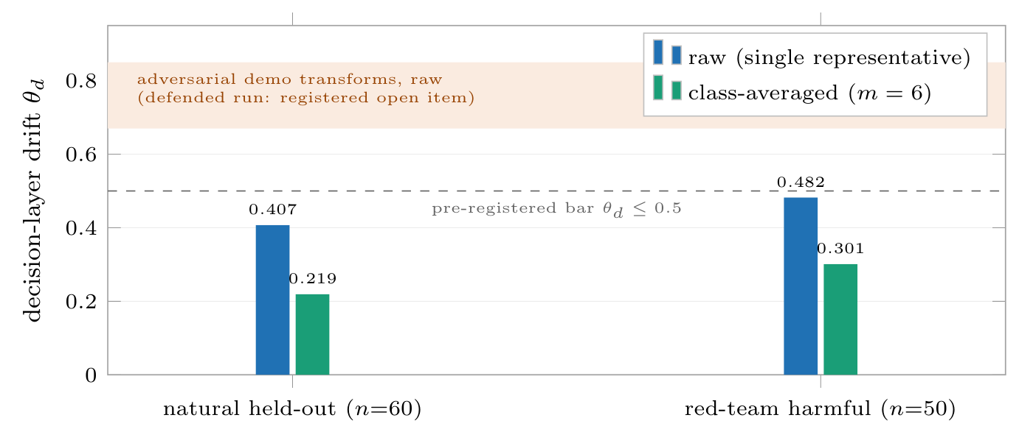
Averaging over a paraphrase class roughly halves decision movement in both runs. The second run uses a back-translation generator that never refuses, on high toxicity items, which removes the 24 percent of inputs a language model declines to paraphrase. Raw movement on natural rewording already sits under the registered threshold, so the threshold only bites on adversarial rewording, shown by the shaded band, where the defended measurement is still open.
Two caveats belong in the record and both appear in Fig. 5. The paraphrases at this scale are natural rather than adversarial, at raw movement of 0.407 against 0.67 to 0.85 for the hand built adversarial transforms, and the adversarial measurement at scale is registered and still open. The language model writing the paraphrases also refused 24 percent of harmful inputs, 19 of 79 toxic items, leaving a class of one on exactly the content that matters most.
The Refusals Belong to the Generator, Not the Mechanism
To find out whether refusal is built into the approach or into the model writing the paraphrases, we swapped that model for one that cannot refuse. Back-translation through six pivot languages using NLLB , in Spanish, French, German, Chinese, Arabic, and Russian, refused none of the same items where the language model refused 20 percent. On 50 fresh items with toxicity at or above 0.7, raw movement of 0.482 falls to 0.301, under the registered threshold. The refusals are a property of the generator and a non-refusing generator removes them. Back-translation shifts meaning slightly, so we treat it as a red-team instrument rather than proposing it for production.
What the Decisions Do, and Where the Defense Fails
Movement per dimension is not the same as a changed decision, and the decision is what a reviewer should ask about. We measured it on the deployed instrument, copying the conference paper’s construction exactly. For each of the six hand audited items we computed the decision score of the base text and of its softened rewrite, once with the defense off and once with it on using a class of six from the same generator family as the at-scale run, with the flag threshold in each arm set to the median base score. There were no refusals on these scenarios.
The result is a negative, and it is informative. With the defense off, all three flagged items pass once softened. With the defense on, all three still pass. Average displacement falls only from 0.336 to 0.279, a reduction of 17 percent against the 46 percent seen on natural paraphrases, with five of six items improving slightly and one getting worse. The reason is the adaptive attack everyone worries about. Paraphrases of a euphemism stay euphemistic, because averaging over a class of reframings removes surface variation while leaving the register untouched, and the register is the attack. Three things follow. The halving of Sec. 6.2 does not carry over to adversarially reworded input, and this six-item result predicts which way the registered measurement will come out. The defense’s remaining weakness is now located twice, in the generator refusing and in the generator not varying register, and both belong to the generator rather than to the averaging. Hardening therefore means building a class generator that provably crosses registers, producing dramatic and neutral retellings rather than literal reframings. Until that exists, escalating by default is doing real work.
What the Defense Costs and What It Records
Generating the class at inference time has three consequences we state outright. Reading cost multiplies by the size of the class, so throughput must be measured with the defense running. The generator becomes part of what the system trusts, and an attacker who can make it refuse shrinks the class to one and recovers the undefended score, which is why the deployed policy treats a refusal as a flagged single-member class and escalates it. Every decision records the hashes of the class members, the class size, and the refusal flag, so the evidence behind a decision can be recomputed later by someone who did not run it.
Deciding Where the Instrument Is Validated
An instrument that escalates everything to a person is safe and useless. This one decides for itself where a learned layer over the validated dimensions has itself been validated, and escalates everywhere else.
A logistic layer over the nine validated encoders, meaning the eight original passing dimensions plus identity attack, reaches an out of fold area under the curve of 0.863 and an F1 of 0.76, which is 0.084 above the 0.779 of the same layer without identity attack. Identity attack carries the largest weight at $−2.69$. The thresholds for removing and allowing content, and the bar an encoder must clear to be used at all, are frozen in a versioned file the decision layer reads. On a balanced evaluation set the instrument decides about 51 percent of items with roughly 80 percent precision on removals and escalates the rest.
Checking that the lift is real. The identity attack encoder was trained partly on civil-comments rows and it dominates this layer, so if the rows used to fit the layer overlapped the rows used to train the encoder, the result would be the system scoring its own homework. We measured the overlap at 77 of 1,600 rows, or 4.8 percent, by hash of the normalized text, and refit on the 1,523 rows that do not overlap. The area under the curve moved from 0.872 to 0.863, the lift from 0.089 to 0.084, and the weight from $−2.78$ to $−2.69$. The lift survives, and the fitting code now enforces the separation. Separating rows is not the same as separating distributions, and we label the number accordingly. Fitting and evaluation both draw on civil-comments, so 0.863 holds within that corpus family and transfer to another family is untested. One false positive, harsh criticism marked for removal, stays in the record, because tuning the threshold to make the demonstration look better would defeat the point of freezing it.
One registered comparison is still missing and is listed in Sec. 9. It compares this instrument decision for decision against a scalar toxicity moderator under the same inputs and the same softening attack, reporting how often each one flips. Sec. 6.4 supplies our side of that table and the baseline side is not yet run.
Cross-Lingual Invariance
The conference paper claimed English only. This section finds where in the instrument the stability under rewording lives and measures it across languages.
Stability comes from the canonicalization step. Raw encoder scores hold up poorly when the same content is re-described, at 0.60, because a trained axis amplifies whatever drift the embedding already has. Mapping to an anchor representation before scoring raises stability within one language to 0.75 with an interval of 0.64 to 0.84. Which embedding does the mapping matters and we measured rather than assumed it. BGE-M3 is what we run, because LaBSE is better across languages but collapses structure within one language to 0.49.
Across five languages, harmful content behaves like benign content. On 60 items, half of them harmful, translated into Spanish, Arabic, Chinese, Hindi, and Swahili with NLLB , stability reaches 0.721 with BGE-M3 and 0.804 with LaBSE, both with tight intervals. Harmful and benign items cannot be told apart by this measure, at 0.704 against 0.739 for one encoder and 0.797 against 0.811 for the other, so the stability is not an artifact of testing only safe content. One operational finding carries security weight. Chat models refuse to translate harmful content, the same behavior seen when asking them to paraphrase it in Sec. 6.3, which is why the translation runs on a dedicated model that does not refuse.
The Experiment Still to Run
The main experiment still to run scores the five conference tracks natively in the full dimension set rather than mapping their results onto it afterward. Its design is registered here and it is scheduled. Every combination of scenario, model, and rewording from the five tracks will be scored directly in the nine dimensions plus identity attack, producing a tensor and a verdict for each case. Displacement will be reported per dimension and per verdict for each track, replacing the single total used before. The kernel’s ability to project a case through several ethical frameworks at once will be tested as a detector, asking whether those projections disagree more when the wording has been manipulated. The mapping table from the conference paper stays in place so the two sets of numbers can be compared. Two registered measurements sit alongside it, the movement under adversarial rewording at scale from Sec. 6.2 and the decision-level baseline comparison from Sec. 7.
Discussion
Where this leaves a team building one of these systems. The conference finding was unwelcome. Rewording displaces every model tested, hiding harm is easier than inventing it, and putting rules downstream does not help. The results here say what to do about it. Measure in a dimension set that can be shown wrong and has been. Decide on a class of paraphrases rather than on whichever wording arrived, escalate when the class cannot be built, and record what the decision was based on. Decide automatically only where the deciding layer has been validated on data it was not fitted to. None of that closes the attack, and the honest state is that the defense halves movement on ordinary rewording and fails on deliberate rewording.
What kind of claim the dimension set now makes. Admitting one candidate, retracting another, and declining a third, separating shared valence from specific signal, and finding which encoders survive a change of register together change what sort of object the dimension set is. It is no longer a list we wrote down. It has an admission test, a record of failures, a measured factor structure, and a statement of which dimensions can be trusted when the register changes. The factor result is the sharpest of them. On these corpora most named dimensions are one shared valence factor under different labels, and the instrument now says which dimensions have earned their names. Where a dimension is not trustworthy, as with rights and with the care, fairness, and legitimacy presence encoders, or not specific, as with the demoted ones, the instrument reports that rather than printing a number that looks like a measurement.
Limits. The halving of decision movement is established on natural rewording only, and Sec. 6.4 shows on six audited items that it does not extend to deliberate rewording, with the measurement at scale still open. The encoder results validate the reading layer and not the five conference tracks rerun natively, which is designed but unrun. The moderation corpora are mostly English and mostly North American, and the cross-lingual result covers retelling the same content rather than variation in what different cultures count as wrong. The second corpus for loyalty and purity is thin at 602 and 337 rows, so both of those numbers are provisional. The worked attack rests on six audited items and stands as proof that it completes rather than as a rate, though the size of the displacement comes from larger sets. Finally, the factor structure is measured on these moderation and social norm corpora, and whether the strong shared factor reflects moral judgment or the way these corpora sample it is not settled here. The demotions it drives describe the instrument on this data and do not say the demoted concerns lack moral content of their own.
Conclusion
We took a measured attack on moral judgment by language models and built an instrument that can be checked, partly defended, and audited. The dimension set is no longer only consistent. It is extensible and it can be shown wrong, having admitted one new dimension after cross-corpus validation, retracted a second, and declined a third. Its dimensions are now labeled by whether they survive a change of register, and three methods agree on which ones do. Deciding on a class of paraphrases halves decision movement on ordinary rewording, and the refusals that threatened the method turned out to belong to the model writing the paraphrases, since one that never refuses removes them. Against deliberate rewording the same defense does not work, because paraphrases of a euphemism stay euphemistic, and the fix is a generator that crosses registers rather than a change to the averaging. A learned decision layer, checked for leakage, lets the instrument decide rather than escalate where it has been validated. The stability holds across five languages and harmful content behaves like benign content. What remains is scoring the five conference tracks natively through this instrument, which is designed, registered, and scheduled.
Reproducibility
Every experiment run after the conference is public. The pipeline ships as moral-spectrum-analyzer , the validated per-dimension encoders and their admission test as xbse , and the decision kernel as erisml-compiler . The registrations, the prediction files, the discovery records including the retraction and the declination, the adversarial training sweep, the invariance and cross-lingual data, and the decision layer with the hashes used to check for leakage are in those repositories. The conference track code and data remain in the agi-hpc package and are archived on Zenodo .
Acknowledgment
The conference experiments ran on Kaggle benchmark infrastructure. The experiments reported here ran on the National Research Platform managed LLM API and on SJSU compute.
00
A. H. Bond, “Selective invariance violations in large language model moral judgment: A geometric framework for behavioral manipulation detection,” in Proc. IEEE Int. Conf. Big Data Computing Service and Machine Learning Applications (BigDataService), 2026. Artifact: Zenodo, doi:10.5281/zenodo.20660065.
A. H. Bond, ErisML Compiler: A Framework-Pluralist Compiler from Natural-Language Moral Material to a Typed Moral Graph, software, v0.9, 2026. Zenodo, doi:10.5281/zenodo.20659432.
A. H. Bond, xbse: Modular Domain-Specific Sentence Embeddings, Validated by One Shared Gate, software, v0.1.0, 2026. [Online]. Available: https://github.com/ahb-sjsu/xbse
A. H. Bond, Moral Spectrum Analyzer, software, v0.1.0, 2026. [Online]. Available: https://github.com/ahb-sjsu/moral-spectrum-analyzer
M. Sharma et al., “Towards understanding sycophancy in language models,” in Proc. ICLR, 2024.
E. Perez et al., “Discovering language model behaviors with model-written evaluations,” in Findings of ACL, 2023.
A. Tversky and D. Kahneman, “The framing of decisions and the psychology of choice,” Science, vol. 211, pp. 453–458, 1981.
J. M. Echterhoff, Y. Liu, and A. Alessa, “Cognitive biases in large language models: A survey and mitigation framework,” arXiv:2410.02466, 2024.
N. Scherrer et al., “Evaluating the moral beliefs encoded in LLMs,” in Proc. NeurIPS, 2023.
A. H. Bond, Geometric Methods in Computational Modeling: From Manifolds to Production Systems. San Jose State University, 2026.
L. Thiele, “Does LaBSE encode moral geometry? Testing Bond’s geometric ethics framework through cross-lingual probing,” Undergraduate Research Report, UCLA Dept. of Cognitive Science, 2026.
J. Cohen, E. Rosenfeld, and Z. Kolter, “Certified adversarial robustness via randomized smoothing,” in Proc. ICML, pp. 1310–1320, 2019.
A. Robey, E. Wong, H. Hassani, and G. J. Pappas, “SmoothLLM: Defending large language models against jailbreaking attacks,” arXiv:2310.03684, 2023.
D. Borkan, L. Dixon, J. Sorensen, N. Thain, and L. Vasserman, “Nuanced metrics for measuring unintended bias with real data for text classification,” in Companion Proc. WWW, pp. 491–500, 2019.
C. J. Kennedy, G. Bacon, A. Sahn, and C. von Vacano, “Constructing interval variables via faceted Rasch measurement and multitask deep learning: a hate speech application,” arXiv:2009.10277, 2020.
J. Graham et al., “Moral foundations theory: The pragmatic validity of moral pluralism,” Adv. Exp. Soc. Psychol., vol. 47, pp. 55–130, 2013.
M. Forbes, J. D. Hwang, V. Shwartz, M. Sap, and Y. Choi, “Social chemistry 101: Learning to reason about social and moral norms,” in Proc. EMNLP, pp. 653–670, 2020.
D. Hendrycks et al., “Aligning AI with shared human values,” in Proc. ICLR, 2021.
J. Trager et al., “The Moral Foundations Reddit Corpus,” arXiv:2208.05545, 2022.
F. Feng et al., “Language-agnostic BERT sentence embedding,” in Proc. ACL, pp. 878–891, 2022.
J. Chen, S. Xiao, P. Zhang, K. Luo, D. Lian, and Z. Liu, “BGE M3-Embedding: Multi-lingual, multi-functionality, multi-granularity text embeddings through self-knowledge distillation,” arXiv:2402.03216, 2024.
NLLB Team et al., “No language left behind: Scaling human-centered machine translation,” arXiv:2207.04672, 2022.

