The Legal Bond Index:
A Matched-Neighbourhood Diagnostic of Algorithmic
Disparity, Applied to COMPAS
Andrew H. Bond
Department of Computer Engineering
San José State University, San José, CA 95192
andrew.bond@sjsu.eduORCID: 0009-0003-2599-6158
July 2026 (revised)
Abstract
The 2016–2017 controversy over the COMPAS pretrial-risk algorithm exposed a deep ambiguity in the concept of algorithmic fairness. ProPublica showed that COMPAS’s false-positive rate is substantially higher for Black defendants. Northpointe (the algorithm’s vendor) replied that COMPAS approximately satisfies predictive parity: among defendants it classifies high-risk, the observed recidivism rate is similar across races. Subsequent technical work proved that the two properties cannot both hold when race-specific recidivism base rates differ—a genuine impossibility theorem. The literature has since proliferated competing metrics (demographic parity, equalized odds, calibration, counterfactual fairness, individual fairness), each capturing one facet of the problem and none of them dispositive.
We introduce a complementary axis of measurement that the impossibility result does not constrain: the Legal Bond Index (LBI), a matched-neighbourhood diagnostic of algorithmic disparity. For each defendant, LBI compares the algorithm’s score divergence from the $k$ nearest opposite-group neighbours in a Mahalanobis metric on selected legitimate predictors (age, prior offences, juvenile record, charge degree) with its divergence from the $k$ nearest same-group neighbours; the index is the ratio of the two divergences averaged over defendants. $LBI=1$ means cross-group score divergence among legitimately-matched neighbours is no larger than within-group divergence; $LBI>1$ means it is larger. For COMPAS ($n=5,278$) the entire neighbourhood-scale curve lies above 1: $LBI(\text{race})$ ranges from $1.041$ to $1.069$ across $k∈[1,100]$, with pointwise 95 % CIs excluding 1 at every scale; at the illustrative scale $k=20$, $LBI(\text{race})=1.049$. We then interrogate that number the way a sceptical reader should. Cross-race neighbours are indeed somewhat farther away in feature space than same-race neighbours (mean distance ratio 1.28 at $k=20$), and under specifications that force matching parity—caliper exclusion, coarsened-exact matching, distance-matched comparators—the point estimate attenuates to $1.00$–$1.02$. A conditional randomization test that redraws race labels preserving $P(\text{race}∣x)$—which a semi-synthetic validation suite shows is correctly calibrated (4.5 % false-positive rate at the nominal 5 % level) exactly where the conventional permutation test false-fires on 56.5 % of race-blind datasets—still rejects conditional label independence decisively ($z=4.9$; global multiscale $p=0.001$). The same validation shows the index rises monotonically with an injected direct race coefficient, detects strong proxy discrimination, and can be inflated by omitting a legitimate predictor from the matching set. The honest summary is therefore two-sided: COMPAS scores carry a race-associated component beyond what these legitimate features explain—largest at ProPublica’s medium-or-high classification threshold ($LBI=1.092$; matched cross-race vs. same-race disagreement rates 37.3 % vs. 34.2 %)—but the unadjusted index overstates its magnitude, and we quantify both parts. LBI is a screening diagnostic conditional on the measured predictors, not a proof of legal unfairness: because the public dataset contains only a subset of the variables COMPAS uses, the analysis cannot confirm that the compared defendants were fully similarly situated, isolate a causal effect of race, or establish discrimination.
LBI is a matched-neighbourhood disparity diagnostic inspired by individual-fairness principles and by the Aristotelian “treat-like-cases-alike” criterion. It is computationally cheap; it requires only an audit dataset containing the algorithm’s inputs, its outputs, and the protected attribute (the algorithm itself need not take the protected attribute as an input); it does not require knowledge of the algorithm’s internals; and it produces a scale-indexed curve with confidence intervals. It is a research-stage screening signal that may contribute one input to an audit, not a validated regulatory audit standard. The reference implementation is openly archived on Zenodo (doi:10.5281/zenodo.21310251).
Keywords: algorithmic fairness, COMPAS, recidivism prediction, Mahalanobis distance, matched-pair analysis, criminal justice, audit, equal protection.

Introduction
In May 2016, ProPublica published an investigation arguing that the COMPAS recidivism-risk algorithm, in use across multiple U.S. jurisdictions for pretrial release and sentencing recommendations, was racially biased against Black defendants. The reporters’ principal evidence was an asymmetry in error rates: among defendants who did not in fact reoffend within two years, Black defendants were roughly twice as likely as White defendants to have been classified as high-risk by COMPAS. Northpointe (the algorithm’s vendor, now equivant) replied that COMPAS was in fact fair under a different criterion—predictive parity: among defendants it classified high-risk, the empirical recidivism rate was approximately the same across races . Both parties could substantiate their claims from the same data; the disagreement was about which fairness criterion applied.
The technical community resolved the empirical question within a year. and , working independently, proved that the two criteria ProPublica and Northpointe each invoked are mathematically incompatible when group-specific base rates differ: an algorithm that is calibrated within groups ($Pr(\text{recid}∣\text{score},\text{group})$ is invariant across groups) cannot simultaneously satisfy equalized error rates (false-positive and false-negative rates invariant across groups), except in the trivial cases of perfect prediction or equal base rates. The impossibility is a structural feature of the prediction problem, not a defect of any particular algorithm.
The decade since has produced a sprawl of competing fairness criteria. Demographic parity requires that the rate of positive predictions be equal across groups . Equalized odds requires equal true-positive and false-positive rates across groups conditional on the actual outcome. Predictive parity (Northpointe’s criterion) requires equal precision across groups. Counterfactual fairness requires that an individual’s prediction be invariant under a hypothetical intervention on their protected attribute. Individual fairness requires that similar individuals receive similar predictions, leaving the similarity metric to be specified. Each captures a real concern; none of them by itself adjudicates the COMPAS case; and the proliferation has rendered the debate which-metric-to-use rather than is-it-fair.
This paper introduces a diagnostic that is operationally distinct from all of those above. It is rooted in the oldest legal principle: like cases should be treated alike. We make this principle precise, measurable, and applicable to algorithmic systems through the Legal Bond Index (LBI), a matched-neighbourhood diagnostic that asks whether the algorithm assigns more divergent outputs to defendants who are similar on the selected legitimate predictors but differ on a protected attribute than to defendants who are similar on both. LBI is geometric: “similar” is operationalized via the Mahalanobis distance on a feature space of legitimate predictors. LBI is symmetric across protected attributes and does not depend on the base-rate structure that drives the calibration–equalized-odds impossibility.
On the ProPublica COMPAS dataset, the primary finding is a neighbourhood-scale curve: at every prespecified scale $k∈\{1,5,10,20,50,100\}$ (where $k$ is the number of nearest neighbours of each group against which a defendant’s score is compared), $LBI(\text{race})$ lies above 1, ranging from $1.041$ to $1.069$ with pointwise 95 % CIs excluding 1 at every scale. At the illustrative scale $k=20$, used throughout for detailed diagnostics, $LBI(\text{race})=1.049$: when two defendants are matched on age, prior offences, juvenile record, and charge degree, COMPAS scores diverge on average 5 % more across race than within race. A ratio of this kind can be inflated mechanically—cross-race neighbours might simply be farther away in feature space than same-race neighbours—and on these data that concern is partly borne out: we measure the matching gap directly, show that matching-parity specifications attenuate the point estimate to $1.00$–$1.02$ (§4.5), and build the mechanical component into the null of a conditional randomization test, which nonetheless rejects race-independence decisively ($z=4.9$, global multiscale $p=0.001$; §4.6). The entire pipeline—estimator and tests—is validated on semi-synthetic data with known ground truth (§4.9).
The remainder of this paper proceeds as follows. Section 2 reviews the COMPAS controversy and the existing fairness-metric landscape. Section 3 defines LBI formally, gives the matched-neighbourhood operational specification, and sets out the inference machinery. Section 4 reports the empirical analysis: filter, features, results, matching diagnostics, robustness, and the synthetic validation. Section 5 compares LBI to the existing criteria, identifies what it adds, and discusses limitations. Section 6 addresses regulatory and audit implications, including the doctrinal context. Section 7 concludes.

Background: the COMPAS Controversy and the Fairness Landscape

The 2016–2017 dispute
COMPAS (Correctional Offender Management Profiling for Alternative Sanctions), developed by Northpointe, scores individuals on a 1–10 decile scale of two-year recidivism risk. The algorithm is widely deployed in U.S. pretrial detention decisions. ProPublica’s 2016 analysis , working from public records in Broward County, Florida, reported two findings: (i) among defendants who did not reoffend, Black defendants were nearly twice as likely as White defendants to have been classified as high-risk by COMPAS (44.9 % vs. 23.5 %); and (ii) the algorithm’s predictive accuracy was approximately equal across races (about 62 % in both groups). The first finding is now referred to as the equalized-odds violation; ProPublica framed it as evidence of racial bias.
Northpointe’s response disputed several of ProPublica’s statistical choices, but the company rested its central defense on a different criterion: it argued that the relevant fairness criterion was predictive parity: among defendants classified high-risk, the empirical probability of recidivism should be the same across racial groups. By that criterion COMPAS was approximately fair: at the high-risk threshold, Black and White defendants had similar two-year recidivism rates—a precision claim, not a demonstration of per-score calibration. The dispute, as it played out in the popular and academic press, was less about the data than about which property a fair classifier should have.
The technical resolution came rapidly. proved that an instrument satisfying predictive parity cannot simultaneously satisfy equalized false-positive and false-negative rates, except in trivial cases. proved an analogous impossibility theorem for calibration and balance. The two findings together established that the COMPAS dispute was not resolvable by data alone: the choice between Northpointe’s criterion and ProPublica’s criterion is a normative choice about which kind of unfairness one prefers to permit.

The proliferation of fairness criteria
The decade since has produced a long list of competing fairness criteria. We summarize the principal ones to fix terminology.
Demographic parity (). $Pr(\hat{Y}=1∣A=a)=Pr(\hat{Y}=1∣A=b)$ for all protected groups $a,b$. Requires equal positive-prediction rates; this is generally in tension with using legitimate predictors that correlate with $A$, though such correlation can sometimes be offset by design rather than by excluding the predictor. Demographic parity is related to, but not identical with, the legal doctrine of disparate impact: the doctrine (under Title VII and its progeny) asks whether a facially neutral practice disproportionately burdens a protected group and whether the practice is justified by business necessity, a two-step inquiry that no single statistic settles . The EEOC’s “four-fifths rule” is an administrative enforcement heuristic from employment selection; it has no doctrinal standing in criminal justice, and we use it in this paper only as a descriptive yardstick familiar to readers.
Equalized odds (). $Pr(\hat{Y}=1∣Y=y,A=a)=Pr(\hat{Y}=1∣Y=y,A=b)$ for all $y$ and all $a,b$. Requires equal true-positive and false-positive rates conditional on the true outcome.
Predictive parity and calibration (). These are distinct properties. Calibration is score-level: $Pr(Y=1∣S=s,A=a)=Pr(Y=1∣S=s,A=b)$ for all scores $s$ and groups $a,b$ (at a given score the observed outcome rate is group-independent). Predictive parity is a threshold condition on precision: among those classified positive, $Pr(Y=1∣\hat{Y}=1,A=a)=Pr(Y=1∣\hat{Y}=1,A=b)$. Northpointe’s defence was predictive parity at the high-risk threshold, not full per-score calibration.
Counterfactual fairness (). The prediction $\hat{Y}(X,A)$ should equal the counterfactual prediction $\hat{Y}(X_{A:=a^{′}},a^{′})$ for any protected attribute $a^{′}$. Requires a causal model.
Individual fairness (). Similar individuals should receive similar predictions: a Lipschitz condition on the prediction map with respect to a task-appropriate metric. The similarity metric is left to be specified.
The first three criteria are population-level: they constrain aggregate statistics on a population. The fourth requires a causal model that may not be available. The fifth is general and philosophically attractive but undertheorized—which metric? The Legal Bond Index draws on the individual-fairness tradition without implementing it: it adopts a concrete matching metric (the Mahalanobis distance on legitimate predictors) and a concrete operational specification (matched-pair $k$-NN average), turning the like-cases-alike desideratum into a measurable quantity with a confidence interval—a diagnostic inspired by the framework, not a certification of its property (§5.2).

What population-level metrics miss
The Chouldechova–Kleinberg impossibility is a result about populations. With unequal base rates, no scoring rule can simultaneously equalize calibration and false-positive rates across groups. This is mathematics; one cannot escape it by being clever.
But the impossibility result is silent about case-level properties. Consider the following question: take two defendants who agree on legitimate predictors (age, priors, juvenile record, charge degree), differing only on race. Does the algorithm assign them similar scores? This is a question about matched pairs, not about populations. The Chouldechova–Kleinberg theorem does not constrain the answer; nothing in the impossibility result prevents an algorithm from being case-level fair. To the extent the matching features capture the legally relevant grounds of similarity, an algorithm that scores legitimately-matched defendants alike is case-level fair, and one that systematically scores them differently by race exhibits a case-level disparity that the population-level metrics do not reveal. That qualification is essential: because the match is on a selected, possibly incomplete set of observed features, a disparity among matched pairs is a diagnostic signal requiring further investigation, not by itself proof of legal unfairness (§5, §4.8).
The Legal Bond Index is a quantitative diagnostic aimed at this matched-comparison question. To be precise about what it delivers: LBI is computed from local, case-level comparisons and then aggregated, so the reported index is a population-level summary of matched-neighbourhood contrasts, not a per-case verdict; and because no defendant’s protected attribute is counterfactually altered—different people are compared—an elevated LBI establishes that cross-group score divergence exceeds within-group score divergence among neighbours selected on the specified observed features, not that the algorithm “uses race.” It does not adjudicate the Chouldechova–Kleinberg dispute; it provides a quantitative answer to a question the dispute does not address.

The Legal Bond Index

Definition
Let $V$ be the set of individuals (defendants, applicants, claimants) to whom an algorithm is applied. Each individual $i∈V$ has a legitimate-predictor vector $x_{i}∈R^{d}$ and a protected attribute $g_{i}∈\{0,1\}$ (we treat the binary case throughout and discuss the multi-class extension in Section 5). The algorithm assigns a score $f(i)∈R$. We equip $R^{d}$ with the Mahalanobis metric
$$d_{M}(x_{i},x_{j}) = \sqrt{(x_{i}−x_{j})^{⊤}Σ^{−1}(x_{i}−x_{j})},$$
where $Σ$ is the empirical covariance of $x$ over the population. The Mahalanobis metric is the natural choice when legitimate predictors are correlated (age and prior offences typically are) because it accounts for the joint distribution rather than treating each axis independently. Under standardized features, $d_{M}$ reduces to Euclidean distance on the de-correlated representation .
Definition 1 (Legal Bond Index, LBI). At neighbourhood scale $k≥1$, the Legal Bond Index of an algorithm $f$ with respect to protected attribute $g$ is $${LBI}_{k}(f,g) = \frac{E_{i}\left[ {\text{mean}}_{j∈N_{k}(i, ¬g_{i})} |f(i)−f(j)| \right]}{E_{i}\left[ {\text{mean}}_{j∈N_{k}(i, g_{i})} |f(i)−f(j)| \right]},$$ where $N_{k}(i,c)$ is the set of the $k$ nearest neighbours to individual $i$ in $(V,d_{M})$ satisfying condition $c$, and $E_{i}$ is the empirical mean over individuals.
The parameter $k$—the neighbourhood scale—is the number of nearest neighbours of each group against which each defendant’s score is compared: at $k=1$ each defendant is compared with their single closest same-group and closest opposite-group neighbour; at $k=100$ with their hundred closest of each. Small $k$ probes tight matches (with more sampling noise); large $k$ trades match tightness for stability. Because no single scale is privileged a priori, we treat the full curve $k↦{LBI}_{k}$ over prespecified scales as the primary object of inference, and use $k=20$ as an illustrative scale for detailed diagnostics.
Interpretation. The numerator is the average score difference between an individual and their $k$ nearest neighbours of the opposite protected group. The denominator is the average score difference between an individual and their $k$ nearest neighbours of the same protected group. The ratio measures cross-group score divergence relative to within-group score divergence among neighbours matched on the specified legitimate features:
- ${LBI}_{k}=1$: no excess divergence. Scores diverge no more across the protected attribute than within it, at the same neighbourhood scale on the same matching features.
- ${LBI}_{k}>1$: excess divergence. Defendants’ scores diverge more from legitimately-similar neighbours of the other group than from equally similar neighbours of their own group. This is a disparity among comparably-matched cases—a signal to be investigated. By itself it does not establish that the algorithm uses the protected attribute: no attribute is counterfactually flipped, and the excess can also arise from residual differences the matching features do not capture (§4.5, §4.9).
- ${LBI}_{k}<1$: deficit divergence. Scores diverge less across the protected attribute than within it. This is unusual; it would suggest score variation is compressed across groups relative to the within-group noise floor.

Why a ratio, why $k$-NN, and why Mahalanobis
Each of the three choices in Definition 1 is deliberate.
Ratio vs. raw difference. The denominator of [eq:lbi] provides a within-group baseline against which the cross-group score gap is normalized. Without this baseline, an algorithm operating on a population with naturally large legitimate variation would appear “unfair” simply because all neighbourhoods have large score gaps. The ratio quotients out the algorithm’s overall sensitivity to the selected legitimate predictors, contextualizing the cross-group gap against ordinary within-group variation. It does not by itself isolate the marginal causal contribution of the protected attribute: that reading holds only to the extent that the matching features are a sufficiently complete and legally defensible account of relevant similarity (§5, §4.8).
$k$-NN matched-pair vs. regression. A regression of $f$ on legitimate predictors and protected attributes can extract a coefficient on the protected attribute. But that coefficient depends on the functional form assumed (linear, polynomial, with interactions) and on the choice of regularization. The $k$-NN matched-pair approach is non-parametric: it makes no functional-form assumption about how $f$ depends on its inputs. It is not, however, assumption-free: the assumptions are shifted to the choice of matching features, the distance metric, the feature scaling, and $k$, which jointly determine which cases count as “similar.” It also produces a neighbourhood-scale curve ${LBI}_{k}$ for $k∈[1,100]$, which exposes whether the effect is local (small $k$) or global (large $k$). For COMPAS we find the effect is approximately scale-invariant. This is suggestive that the pattern is not a small-$k$ artefact, but we read it cautiously: persistent scale-invariance is equally consistent with a persistent omitted-variable imbalance as with a genuine case-level effect.
Mahalanobis vs. Euclidean. Legitimate predictors are correlated (older defendants have more priors, etc.). Euclidean distance overcounts the contribution of correlated axes; Mahalanobis de-correlates by construction . Equivalently, Mahalanobis distance is Euclidean distance on the whitened (principal-component, variance-equalized) representation: each principal direction is divided by its standard deviation, so high-variance leading directions—which dominate raw Euclidean distance—are downweighted to the common scale, and disagreement is priced equally per standard deviation along every de-correlated direction. Section 4.8 shows the results are not specific to this choice.

Inference: confidence intervals and randomization tests
Confidence intervals. LBI is a ratio of means of per-defendant quantities that are not independent across defendants: the same individual appears as a neighbour in many other individuals’ comparison sets, so a bootstrap that merely resamples the per-defendant gaps (holding the neighbourhoods fixed) understates the resampling variability of the whole construction. We therefore report percentile-bootstrap confidence intervals in which the neighbourhoods are re-formed inside every replicate: each of 1,000 replicates resamples $n$ defendants with replacement, recomputes every retained defendant’s $k$ nearest same-group and opposite-group neighbours within the resampled set, and recomputes the index. All confidence intervals reported across neighbourhood scales are pointwise (per-$k$), not simultaneous; the multiscale significance claim rests on the global randomization test below, not on reading six intervals at once.
Randomization tests. The natural null device is to permute the protected-attribute labels and recompute LBI; the permutation distribution supplies an empirical null and the one-sided $p$-value is the fraction of null draws at or above the observed value. Plain permutation, however, tests the null that the labels are independent of everything—scores and legitimate features alike. Permuting race destroys the actual dependence between race and the legitimate predictors, and it is precisely that dependence which could, in principle, let a race-blind score produce $LBI≠1$ through differential matching quality. We therefore report three progressively stricter null constructions, all computed on the full sample ($n=5,278$) for both the observed and the null statistics, with 1,000 draws each:
- Plain permutation of the race labels (the conventional test, reported for continuity);
- Stratified permutation within deciles of the estimated propensity score $\hat{P}(\text{race}∣x)$, which preserves the coarse race–feature dependence; and
- A conditional randomization test (CRT): race labels are redrawn independently from $\hat{P}(\text{race}∣x_{i})$ estimated by logistic regression, preserving the race–feature dependence that permutation destroys. Under this null, any mechanical contribution of race-correlated feature geometry to the index is present in the null draws as well.
For the multiscale claim we use a global max-$z$ statistic: each scale’s LBI is standardized against its own null mean and standard deviation, and the test statistic is the maximum standardized value over the prespecified scales $k∈\{1,5,10,20,50,100\}$; the global $p$-value compares the observed maximum with the null distribution of the same maximum. This controls for selection across scales rather than attaching the significance claim to any single $k$.
Randomization tests probe the label-independence null; they cannot by themselves rule out that cross-race neighbours are systematically worse-matched than same-race neighbours under the actual labels. The direct response to that concern is empirical, and we treat it as a first-class part of the method: §4.5 measures the matching-quality gap explicitly and re-estimates LBI under distance-matched, caliper-restricted, and exact-matched specifications, and §4.9 calibrates the entire pipeline—estimator plus tests—on semi-synthetic data with known ground truth, including race-blind scores on the real, race-correlated feature distributions.

Empirical Analysis: LBI on COMPAS
We compute LBI on the ProPublica COMPAS dataset and compare it against the standard fairness metrics that shaped the 2016–2017 debate.

Data and filter
We use ProPublica’s published file compas-scores-two-years.csv, retrieved on June 11 2026 from the public GitHub repository propublica/compas-analysis. The dataset contains 7,214 records of defendants screened by COMPAS in Broward County, Florida.
We apply ProPublica’s canonical analytical filter to obtain the 6,172-record analysis subset: screening date within 30 days of arrest, recidivism record present, charge degree not “Ordinary,” and COMPAS score text valid. Restricting further to African-American and Caucasian defendants (the two race categories that drove the public controversy and the subsequent technical literature) yields $n=5,278$ defendants, of whom 3,175 (60.2 %) are African-American and 2,103 (39.8 %) are Caucasian.
Two definitions used throughout. Score: the COMPAS general recidivism decile (decile_score, 1–10), not the separate violent-recidivism scale. COMPAS deciles map to three published risk categories: 1–4 “low,” 5–7 “medium,” 8–10 “high.” Recidivism: ProPublica’s two-year indicator (two_year_recid)—a new criminal offence resulting in a jail booking within two years of the COMPAS screening date, excluding traffic offences and municipal-ordinance violations; it is an arrest-based outcome, not a conviction-based one, a limitation of the source data that applies to every study built on this file. The six matching features contain no missing values in the filtered subset.

Legitimate-feature space
We adopt six legitimate predictors documented by Northpointe and engaged by courts as inputs to pretrial risk assessment (see State v. Loomis, 881 N.W.2d 749 (Wis. 2016), which upheld sentencing use of COMPAS—whose inputs include criminal-history and age factors—while cautioning on its use): age, priors_count, juv_fel_count, juv_misd_count, juv_other_count, and an indicator for whether the current charge is a felony ($c_charge_F$). We standardize each feature (mean-zero, unit-variance) before computing the Mahalanobis metric. Although these predictors all count prior conduct, they do not double-count it: the three juvenile counts are mutually exclusive charge classes (felony, misdemeanour, other), and priors_count records adult priors, so the four partition rather than duplicate a defendant’s record. The empirical covariance matrix accordingly has condition number $2.65$, confirming no severe multicollinearity; the Mahalanobis metric additionally de-correlates whatever residual dependence remains. The COMPAS score is the published decile risk ($1$–$10$).

Standard fairness metrics: confirming the prior literature
We first reproduce the 2016–2017 controversy by computing standard metrics on the filtered subset. Table 1 reports the headline numbers.
Standard fairness metrics on the COMPAS Black/White subset ($n=5,278$). Binary threshold: decile $≥5$, ProPublica’s “medium-or-high” class (see §4.7); “high-risk” in the row labels follows ProPublica’s usage.
Metric | African-American | Caucasian | Disparity
$n$ | 3,175 | 2,103 | —
Base recidivism rate | 0.523 | 0.391 | $+0.132$
$Pr(\text{high-risk})$ | 0.576 | 0.331 | $× 1.74$
False positive rate | 0.423 | 0.220 | $+0.203$
False negative rate | 0.285 | 0.496 | $−0.211$
$Pr(\text{recid}∣\text{high-risk})$ | 0.650 | 0.595 | $+0.055$
$Pr(\text{recid}∣\text{low-risk})$ | 0.351 | 0.290 | $+0.061$
The pattern matches the published literature exactly. ProPublica’s headline finding—the false-positive-rate disparity—is $+20.3$ percentage points, with a corresponding false-negative-rate disparity of $−21.1$ percentage points. (These are distinct rates on different denominators—the FPR is the complement of the true-negative rate and the FNR of the true-positive rate—so they are not two forms of a single quantity, though under this classifier they move in opposite directions.) Northpointe’s defence is predictive parity at the high-risk threshold: the empirical recidivism rate among defendants classified high-risk is approximately equal across races (a precision gap of $+0.055$), not a demonstration of per-decile calibration. The Chouldechova–Kleinberg impossibility holds because the recidivism base rates differ by $+13.2$ percentage points. (An earlier version of this table mixed values from differently filtered drafting runs; all cells are now produced by the same script and subset as every other number in the paper.)

LBI across neighbourhood scales
We compute LBI(race) and LBI(sex) at the six prespecified neighbourhood scales $k∈\{1,5,10,20,50,100\}$ using the matched-neighbourhood $k$-NN procedure of Definition 1. Confidence intervals come from the bootstrap of §3.3, which re-forms every neighbourhood inside each of 1,000 replicates; they are noticeably wider than the naive per-defendant bootstrap (at $k=20$: $[1.027,1.072]$ vs. $[1.039,1.058]$), which is what one expects once the reuse of neighbours across defendants (mean 40 reuses, max 198) is allowed to propagate into the interval. All CIs are pointwise per scale.
Legal Bond Index for COMPAS, by protected attribute and neighbourhood scale $k$. $n=5,278$ defendants. CIs are pointwise percentile bootstrap with neighbourhoods re-formed in every replicate.
$k$ | LBI(race) |  | LBI(sex)
2-3(lr)4-5 | value | 95 % CI | value | 95 % CI
1 | 1.045 | $[1.002,1.089]$ | 0.962 | $[0.935,1.032]$
5 | 1.043 | $[1.010,1.074]$ | 1.012 | $[0.974,1.043]$
10 | 1.041 | $[1.017,1.068]$ | 1.016 | $[0.987,1.043]$
20 | 1.049 | $[1.027,1.072]$ | 1.021 | $[0.998,1.044]$
50 | 1.060 | $[1.041,1.079]$ | 1.028 | $[1.008,1.048]$
100 | 1.069 | $[1.053,1.087]$ | 1.041 | $[1.023,1.060]$
Figure 1 plots the curves. LBI(race) lies above $1$ at every scale, with pointwise CIs excluding $1$ throughout (narrowly at $k=1$, where estimates are dominated by distance ties; see §4.10). The race curve, not any single point on it, is the primary finding; $k=20$ is used below as an illustrative scale for the detailed diagnostics.
The sex result. LBI(sex) is not distinguishable from $1$ at small and moderate scales: the point estimate is below $1$ at $k=1$ ($0.962$) and the pointwise CIs include $1$ for all $k≤20$. Only at $k=50$ and $100$—scales at which matches are loose—do the intervals exclude $1$, and the global multiscale randomization tests of §4.6 do not reject label independence for sex (plain permutation $p=0.39$, conditional test $p=0.90$). An earlier version of this paper described the sex effect as real but smaller than the race effect; the corrected inference does not support that claim, and we withdraw it. We note also that a nonzero LBI(sex) would not carry the same normative significance as LBI(race): courts have upheld express consideration of sex in risk assessment (§6.3), so LBI(sex) is reported as a methodological comparison, not an alleged violation.
Focal-group decomposition. Averaging over all defendants weights the larger group (African-American, 60.2 %) more heavily. Computing the index separately by focal group at $k=20$ gives ${LBI}_{\text{Black focal}}=1.027$ $[1.015,1.039]$ and ${LBI}_{\text{White focal}}=1.087$ $[1.071,1.102]$; the group-balanced index (equal-weight average of the two focal groups’ numerators and denominators) is $1.055$. The disparity is thus asymmetric: White defendants’ scores diverge from their matched Black neighbours substantially more than the reverse, consistent with matched Black neighbours receiving systematically different (higher) scores in the neighbourhoods of White focal defendants.
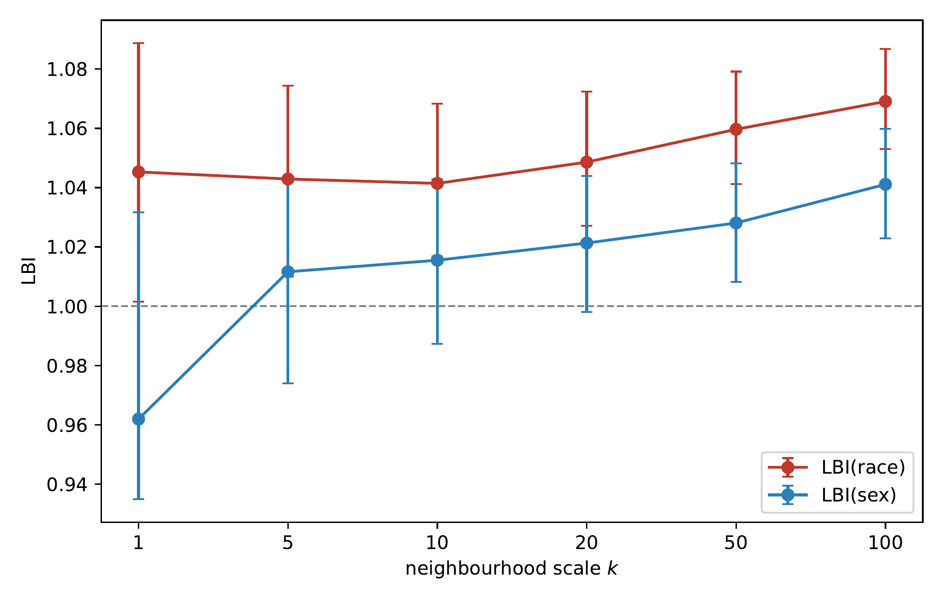
COMPAS Legal Bond Index by protected attribute, across neighbourhood scales $k$. Bars show pointwise 95 % bootstrap CIs with neighbourhoods re-formed in every replicate. The race curve is above $1$ at every scale; the sex curve is not distinguishable from $1$ at $k≤20$ and its global randomization test does not reject (§4.6). The horizontal dashed line marks LBI $=1$.

Are cross-race neighbours worse-matched?
Definition 1 compares each defendant with two different neighbour sets, and nothing in the definition forces those sets to be equally close. If opposite-race neighbours are systematically farther away in the legitimate-feature space, their scores may differ more even under a completely race-blind scoring function, mechanically producing $LBI>1$. This subsection measures that gap directly and re-estimates the index under specifications that force matching parity. The answer, in brief: the gap is real, it accounts for part—but not all—of the unadjusted index, and quantifying it changes the honest summary of the COMPAS result.
The matching gap. Cross-race neighbours are indeed farther (Table 3; Figure 2): at $k=20$ the mean Mahalanobis distance to cross-race neighbours is $0.458$ versus $0.357$ to same-race neighbours, a ratio of $1.28$, shrinking monotonically with $k$ (from $1.52$ at $k=1$ to $1.17$ at $k=100$); the medians tell the same story ($0.143$ cross vs. $0.120$ same at $k=20$), so the gap is not an artifact of a few extreme defendants. Per-feature balance shows the same picture: the mean absolute standardized difference between a defendant and their cross-race neighbours exceeds the same-race value on every feature, most markedly on prior counts ($0.187$ vs. $0.141$) and juvenile felony counts ($0.082$ vs. $0.046$). Common support, by contrast, is not a problem: on a logistic propensity score $\hat{P}(\text{race}∣x)$, 99.8 % of defendants lie in the common-support interval, and restricting to that region leaves the index unchanged ($1.048$).
Distance diagnostics: mean Mahalanobis distance from each defendant to their $k$ nearest same-race and cross-race neighbours.
$k$ | same-race | cross-race | ratio
1 | 0.104 | 0.158 | 1.52
5 | 0.194 | 0.262 | 1.35
10 | 0.265 | 0.349 | 1.32
20 | 0.357 | 0.458 | 1.28
50 | 0.523 | 0.639 | 1.22
100 | 0.684 | 0.801 | 1.17
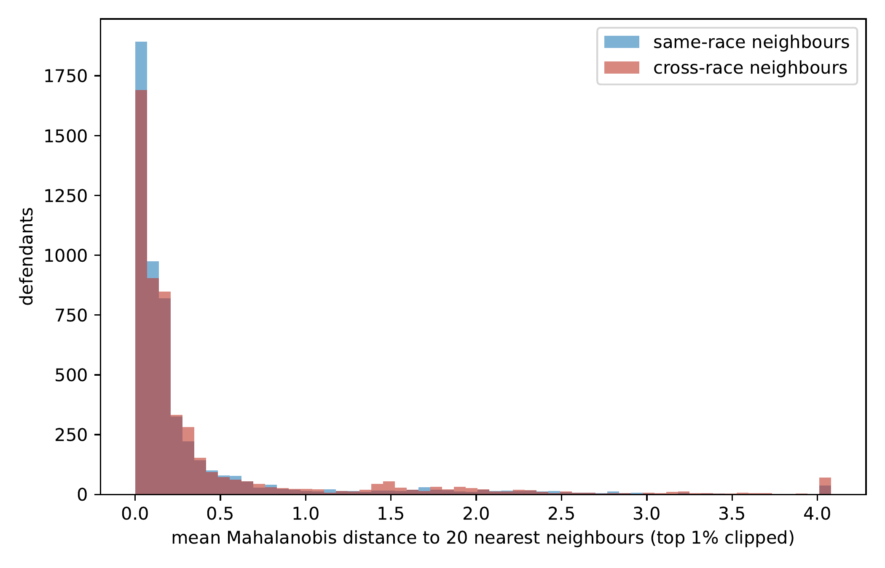
Distribution over defendants of the mean Mahalanobis distance to the 20 nearest same-race and cross-race neighbours. Cross-race neighbours are systematically farther (mean ratio 1.28), which by itself can inflate LBI under a race-blind score; the specifications of §4.5 quantify how much.
Matching-parity specifications. We re-estimate $LBI(\text{race})$ at $k=20$ under five specifications that tighten or equalize matching quality (Table 4):
$LBI(\text{race})$ at $k=20$ under matching-parity specifications. CIs for restricted specifications are naive percentile bootstrap over per-defendant quantities and are reported for orientation only.
Specification | LBI | $n$ used | Note
unrestricted (baseline) | 1.049 | 5,278
exact match on felony indicator | 1.050 | 5,278 | then Mahalanobis
caliper: cross-race NN within q90 of same-race NN | 1.022 | 4,656
caliper: within q75 | 1.012 | 3,826
fixed-radius neighbourhoods (median $k=20$ radius) | 1.022 | 4,171
coarsened-exact strata, then Mahalanobis | 1.009 | 3,159 | CI $[1.000,1.018]$
distance-matched same-race comparators | 1.003 | 5,278 | overcorrects; see text
Exact matching on the felony indicator before continuous matching changes nothing ($1.050$): the charge-degree indicator was already well matched. The caliper analyses—excluding focal defendants whose nearest cross-race comparator is farther than the 90th (75th) percentile of nearest same-race distances—attenuate the index to $1.022$ ($1.012$). Fixed-radius neighbourhoods, which force both comparison sets inside the same ball, give $1.022$. Coarsened-exact matching (age, priors, any-juvenile, felony bins; Mahalanobis within stratum) gives $1.009$ $[1.000,1.018]$ on the $3,159$ defendants with sufficient within-stratum comparators. The distance-matched specification selects, for each defendant, same-race comparators at the same distances as the cross-race set; because the greedy matching overshoots (mean same-race comparator distance $0.662$ vs. cross-race $0.458$), it overcorrects—the same-race baseline is drawn from strictly worse matches—and its value of $1.003$ is best read as a lower bound.
Where the signal lives. The reviewer-requested distribution of per-defendant contrasts (Figure 3) completes the picture: at $k=20$, 53.9 % of defendants have a positive cross-minus-same gap (mean $+0.108$ deciles, median $+0.100$), and excluding the top 5 % of gaps lowers the index from $1.049$ to $1.009$. The unadjusted index is thus materially driven by its upper tail—defendants, disproportionately in the sparse high-priors region where close cross-race comparators are scarce, whose cross-race score divergence is large.
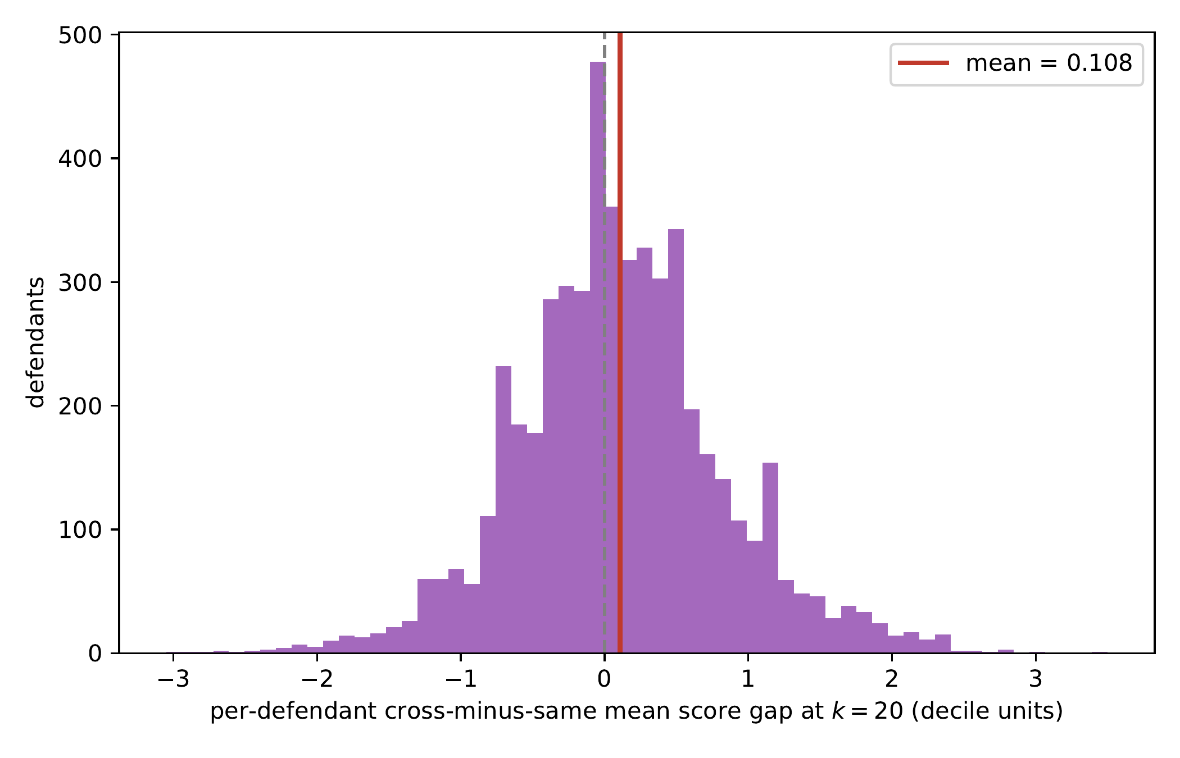
Distribution over defendants of the per-defendant cross-minus-same mean score gap at $k=20$ (decile units). The mass is centred just above zero (53.9 % positive) with a heavy right tail; excluding the top 5 % lowers the aggregate LBI from 1.049 to 1.009.
Taken together, the diagnostics support a two-component reading of the unadjusted $1.049$: a mechanical component attributable to the poorer average quality of cross-race matches (on the order of $+0.01$ to $+0.015$; compare the race-blind synthetic level of $1.009$ and the conditional null centre of $1.015$ in §4.9 and §4.6), and a residual race-associated component that is concentrated in the poorly-overlapped region of feature space and in the upper tail of the gap distribution. The inferential question—is the residual component distinguishable from zero once the mechanical component is built into the null?—is answered next.

Randomization inference at full sample size
Table 5 reports the three null constructions of §3.3, each with 1,000 draws, with observed and null statistics computed identically on the full $n=5,278$ (the earlier version of this paper computed the null on 500-defendant subsamples with 200 permutations; both departures are corrected here).
Null distributions for $LBI(\text{race})$, 1,000 draws each, full sample. $z$ is the observed value ($1.049$ at $k=20$) standardized against the null; the global $p$ uses the max-$z$ statistic across all six scales.
Null construction | null mean | null SD | $z$ ($k=20$) | global $p$
plain permutation | 1.0013 | 0.0049 | 9.7 | $0.001$
stratified permutation (propensity deciles) | 1.0124 | 0.0066 | 5.5 | $0.001$
conditional randomization (CRT) | 1.0150 | 0.0068 | 4.9 | $0.001$
Two features deserve emphasis. First, the stricter nulls are not centred at $1$: preserving the race–feature dependence shifts the null centre to $1.012$–$1.015$, which is precisely the mechanical matching component the reviewer anticipated—a race-blind score on these feature distributions is expected to produce an LBI of about $1.015$, not $1.000$. The plain permutation test, whose null is centred at $1.001$, therefore tests the wrong hypothesis, and §4.9 shows it false-fires on more than half of race-blind synthetic datasets. Second, even against the correctly centred conditional null, the observed index rejects decisively: $z=4.9$, pointwise and global $p=0.001$ (no null draw’s max-$z$ reached the observed), with the stratified permutation—a nonparametric check on the CRT’s logistic propensity model—agreeing ($z=5.5$). Figure 4 shows both nulls against the observed value.
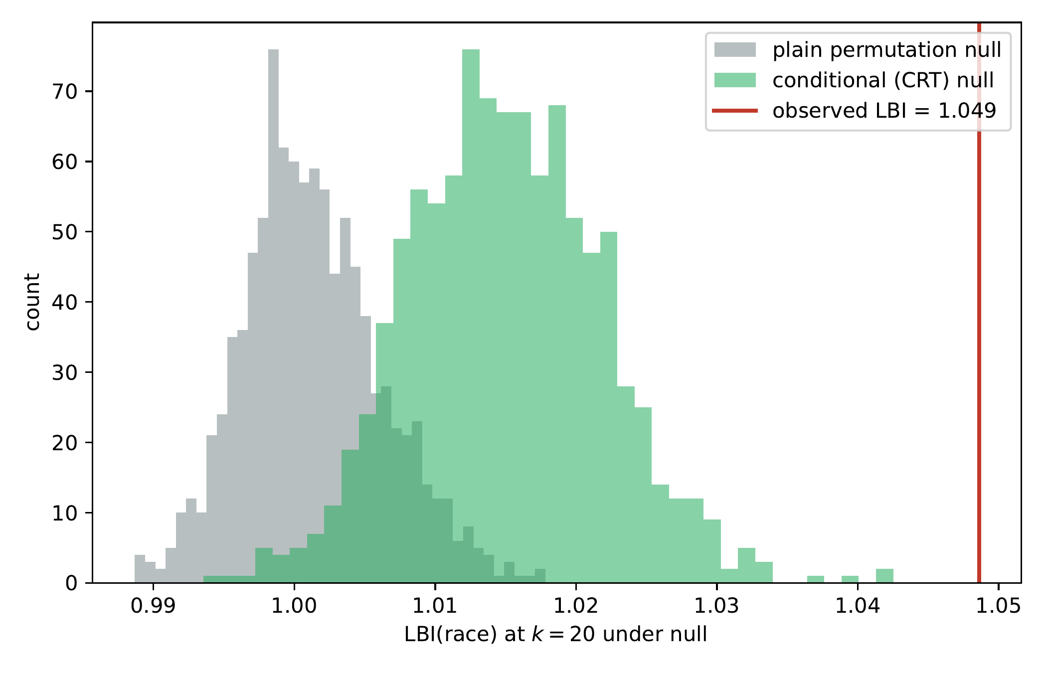
Null distributions of LBI(race) at $k=20$ from 1,000 draws at full sample size: plain permutation (grey) and the conditional randomization test preserving $\hat{P}(\text{race}∣x)$ (green). The conditional null is centred at $1.015$, not $1.000$—the mechanical component of the index under race-blind scoring. The observed value (red line) lies $z=4.9$ above the conditional null; no draw exceeded it under either construction.

Scores, categories, and classifications
COMPAS deciles map to three published categories: 1–4 “low,” 5–7 “medium,” 8–10 “high.” ProPublica’s binary analysis treated “medium or high” (decile $≥5$) as its “higher risk” class; we report that threshold under its proper name, add the $≥8$ (“high” only) threshold, and caution that neither is universally decision-relevant—operational cutoffs vary by jurisdiction and decision point. Because a ratio alone cannot convey practical magnitude, Table 6 reports the raw numerator and denominator: the mean cross-race and same-race classification-disagreement rates among matched neighbours.
$LBI(\text{race})$ at $k=20$ by score representation, with the underlying matched-neighbour disagreement rates (for the decile row, mean absolute score gaps in decile units). Naive bootstrap CIs.
Representation | LBI | cross rate | same rate | 95 % CI
raw decile (1–10) | 1.049 | 2.323 | 2.215 | $[1.039,1.058]$
three-category (low/med/high) | 1.065 | 0.619 | 0.582 | $[1.052,1.077]$
binary medium-or-high ($≥5$; ProPublica) | 1.092 | 0.373 | 0.342 | $[1.077,1.106]$
binary high ($≥8$) | 1.026 | 0.246 | 0.240 | $[1.007,1.045]$
At ProPublica’s medium-or-high threshold, matched cross-race neighbour pairs disagree on the classification 37.3 % of the time against a same-race rate of 34.2 %: a 3.1-percentage-point absolute, 9.2 % relative excess. At the “high” threshold the excess is smaller (1.026; 24.6 % vs. 24.0 %). The disparity is therefore largest exactly at the cutoff that drove the public controversy, and an LBI of 1.092 should be read as a 9.2 % relative increase in disagreement, not a nine-point one.

Robustness: feature sets and matching methods
The standing objection to any matched-comparison diagnostic is that the signal is an artefact of the analyst’s choices: the feature list, or the matching machinery itself. Table 7 tests both. (All rows use the rebuilt pipeline with deterministic tie-breaking; naive bootstrap CIs.)
Robustness of $LBI(\text{race})$ at $k=20$. Top: legitimate-feature set (Mahalanobis, decile score). Bottom: matching method (six features, decile score).
Specification | LBI | 95 % CI
Feature set
minimal (age, priors) | 1.034 | $[1.025,1.042]$
paper (6 features) | 1.049 | $[1.039,1.058]$
drop contested juvenile counts | 1.034 | $[1.025,1.042]$
paper $+$ sex control$†$ | 1.060 | $[1.050,1.071]$
Matching method
Euclidean on standardized features | 1.048 | $[1.038,1.057]$
robust Mahalanobis (MinCovDet) | 1.048 | $[1.039,1.057]$
$log(1+x)$ on count features, Mahalanobis | 1.048 | $[1.038,1.057]$
rank transform, Euclidean | 1.044 | $[1.035,1.053]$
Gower distance (mixed-type) | 1.049 | $[1.040,1.059]$
$†$Adding sex as a matching control raises the race index (1.049 $→$ 1.060) because within-sex matching removes cross-sex dilution: without the control, some matched neighbours differ in sex as well as race, and averaging over those pairs attenuates the race-specific gap.
The unrestricted index is insensitive to both choices: every feature set yields $LBI≥1.034$ with CIs excluding 1—including the specification that drops the racially patterned juvenile counts—and the five alternative distance constructions agree to within $0.005$. (The matching-parity restrictions of §4.5 are the specifications that move the estimate; robustness to the metric family is not the same as robustness to match quality, and the two should not be conflated.) The deeper omitted-variable concern—COMPAS inputs absent from the public file (substance use, education, employment) cannot be matched on—remains, and is exactly the failure mode quantified as condition 4 of the synthetic validation below.

Validation under known ground truth
A new diagnostic should demonstrate what it detects. We build semi-synthetic scores on the real feature matrix and race labels—preserving the actual race–feature dependence—and run the full pipeline (estimator plus tests) under four known conditions. The base score is ${\hat{f}}_{0}(x)$, a linear fit of the observed decile on the six standardized features ($R^{2}=0.42$, residual SD $σ=2.16$ deciles), plus Gaussian noise of the same residual scale. Conditions: (1) race-blind: $S={\hat{f}}_{0}(x)+ε$; (2) direct: add $β⋅1[\text{Black}]$ for $β∈\{0.25,0.5,1.0\}$ deciles; (3) proxy: add $γZ$ where $Z$ has correlation $0.8$ with race and $γ∈\{0.5,1.0\}$; (4) omitted legitimate predictor: race-blind score built on all six features, matching on only five (priors count withheld). Each condition runs $60$–$200$ Monte Carlo replicates; each replicate is tested at the 5 % level by plain permutation and by CRT (200 draws each), with an OLS race-coefficient $t$-test as a parametric baseline.
Semi-synthetic validation at $k=20$. “Reject %” is the fraction of replicates in which each test rejects at the nominal 5 % level: under condition 1 this is the false-positive rate; under conditions 2–3, power. The Dwork-style nearest-neighbour consistency of the last column is flat across the race-structure conditions (1–3) and responds only to the omitted-predictor condition, illustrating that it measures smoothness of the score in the matching space, not protected-attribute structure.
Condition | mean LBI | Reject % (5 % level) |  |  | consistency
3-5 |  | perm | CRT | OLS
1. race-blind | $1.009±0.006$ | 56.5 | 4.5 | 6.0 | 0.37
2. direct, $β=0.25$ | $1.015±0.006$ | 88.3 | 21.7 | 100 | 0.37
2. direct, $β=0.5$ | $1.027±0.007$ | 100 | 85.0 | 100 | 0.37
2. direct, $β=1.0$ | $1.071±0.010$ | 100 | 100 | 100 | 0.38
3. proxy, $γ=0.5$ | $1.052±0.008$ | 100 | 100 | 100 | 0.38
3. proxy, $γ=1.0$ | $1.153±0.013$ | 100 | 100 | 100 | 0.37
4. omitted predictor | $1.015±0.006$ | 88.3 | 5.0 | 1.7 | 0.31
Table 8 and Figure 5 deliver five conclusions.
- Under a race-blind score the index sits near—but not at—1 ($1.009±0.006$): the mechanical matching component of §4.5 is real but small on these data.
- The plain permutation test is badly anticonservative (false-positive rate 56.5 % at the nominal 5 % level), confirming quantitatively the concern raised in review; it should not be used with LBI, and we retain it only as a cautionary row. The CRT is correctly calibrated (4.5 %).
- The index rises monotonically with direct discrimination ($1.009→1.015→1.027→1.071$ as $β$ runs $0→1$ decile) and responds strongly to proxy discrimination ($1.153$ at $γ=1$), which a race-blind-inputs audit would miss entirely.
- Matching failure inflates the point estimate but not the calibrated test: withholding a legitimate predictor from the matching set (condition 4) raises mean LBI to $1.015$, yet the CRT still rejects at only 5 %—because the CRT conditions on the full covariate set, its validity survives an impoverished matching space, provided the audit records the covariate even when it cannot match well on it. When a legitimate determinant is unrecorded, both LBI and every other observational diagnostic inherit the bias; that is the irreducible limitation of §5.
- Comparators: the OLS race coefficient is more powerful than LBI against purely linear direct effects (100 % vs. 21.7 % at $β=0.25$)—parametric tests win on their home turf—while a Dwork-style nearest-neighbour consistency score is flat across the race-structure conditions (0.37–0.38 as the injected effect grows from zero to its largest value) and moves only when a legitimate predictor is withheld from the matching space (0.31 under condition 4), confirming that it measures smoothness of the score in the matched coordinates, not protected-attribute structure. LBI’s role is the model-free middle ground: no functional-form assumption, black-box outputs (including purely categorical ones), and a null-calibrated test.
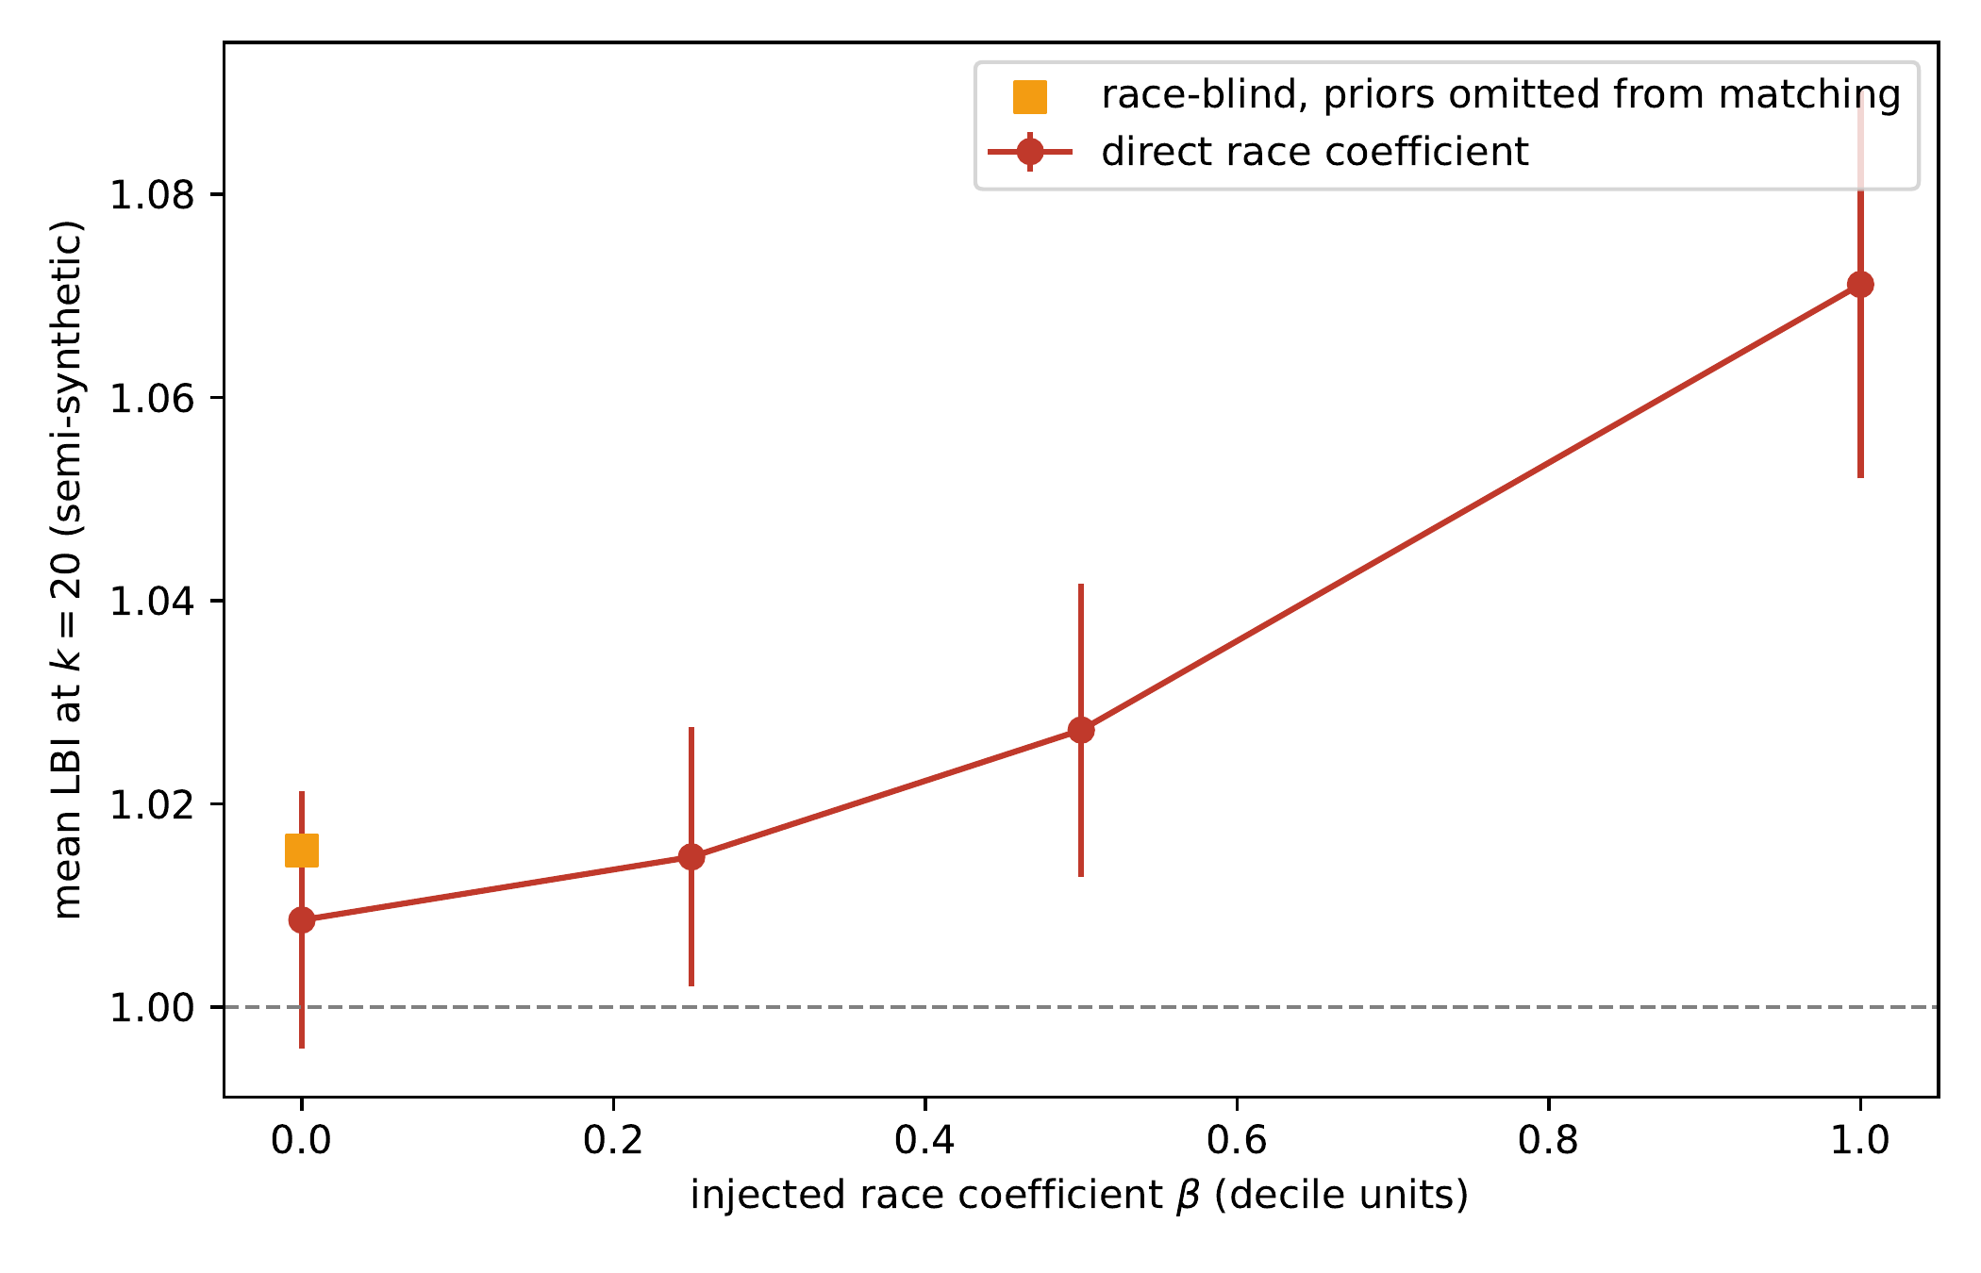
Semi-synthetic validation: mean LBI at $k=20$ (error bars $±2$ SD over replicates) as a function of an injected direct race coefficient $β$, on the real COMPAS feature distributions. The race-blind level is $1.009$, not $1.000$ (the mechanical matching component); the response is monotone in $β$. The orange square marks condition 4 (race-blind score, priors count omitted from the matching set), whose inflation to $1.015$ quantifies the matching-failure failure mode.

Implementation details
For audit reproducibility we record the implementation choices that the review process surfaced as material. Ties and duplicates: the six-feature space is heavily duplicated—3,673 of 5,278 defendants share their exact feature vector with at least one other—so distance ties are pervasive (79 % of defendants have a tie straddling the $k=20$ neighbourhood boundary). Neighbour selection uses a stable sort, so tie-breaking is deterministic (by dataset row order); estimates at $k=1$ are the most tie-sensitive, which is why small-$k$ values should be read with their (wide) CIs. Score ties raise no issue: score gaps enter as absolute differences. Neighbour reuse: each defendant appears in a mean of 40 (max 198) other defendants’ comparison sets; the re-formed-neighbourhood bootstrap propagates this dependence into the CIs. Missing values: none among the six features in the filtered subset. Covariance inversion: the correlation matrix has condition number 2.65; inversion uses a ridge of ${10}^{−6}$. Insufficient comparators: in unrestricted analyses every defendant has at least $k=100$ comparators of each group; under exact-stratum and coarsened-exact restrictions, defendants lacking $k$ within-stratum comparators of either group are excluded and the retained $n$ is reported alongside the estimate.

Summary
Table 9 summarizes the empirical findings.
Headline fairness measurements on the COMPAS Black/White subset, $n=5,278$.
Metric | Value | Interpretation
Disparate impact (Black/White, medium-or-high) | $1.741$ | Fails the four-fifths screen if translated from employment law (illustrative only; §6.3)
FPR disparity (Black $−$ White) | $+0.203$ | ProPublica’s headline finding; large
FNR disparity (Black $−$ White) | $−0.211$ | Complementary rate (distinct denominator); large
Predictive-parity gap, $Pr(\text{recid}∣\text{high})$ (Black $−$ White) | $+0.055$ | Northpointe’s defence; small
LBI(race) at $k=20$ | $1.049$ | CI $[1.027,1.072]$; CRT $z=4.9$, global $p=0.001$
under matching-parity restrictions | $1.00$–$1.02$ | mechanical component removed (§4.5)
at the medium-or-high threshold | $1.092$ | disagreement rates 37.3 % vs. 34.2 %
The honest summary is two-sided. The unadjusted index overstates the race-associated component: roughly $+0.01$ to $+0.015$ of the excess is mechanical, attributable to cross-race neighbours being worse-matched on these feature distributions, and specifications that force matching parity land at $1.01$–$1.02$. What remains is nonetheless statistically unambiguous under the correctly calibrated conditional test ($z=4.9$, global $p=0.001$ across all scales), is concentrated among defendants with scarce cross-race comparators and in the upper tail of the gap distribution, is asymmetric across focal groups ($1.087$ White-focal vs. $1.027$ Black-focal), and is largest at the classification threshold that drove the public controversy ($1.092$; 37.3 % vs. 34.2 % disagreement).

Discussion

What LBI adds to the fairness literature
LBI complements rather than replaces the existing fairness metrics. Three properties distinguish it:
(i) It is matched-neighbourhood, not marginal. The Chouldechova–Kleinberg impossibility is a constraint on marginal, group-level statistics (error rates and calibration conditioned only on group and outcome). LBI is built from local comparisons between defendants matched on legitimate predictors and then aggregated, so it is best described as a population-level summary of case-level contrasts; what distinguishes it from the marginal metrics is the conditioning—every comparison is between similarly-situated defendants—not the level of aggregation. The impossibility theorem does not constrain it: an algorithm can have $LBI=1$ without satisfying either calibration or equalized odds, and conversely.
(ii) It is a compact, reportable object. Population-level metrics typically come in matched pairs (FPR and FNR; precision at high and low; positive-prediction rate by group). LBI is a scale-indexed curve with pointwise confidence intervals and a single global test, a compact form that could slot into audit-style reporting if the metric matures beyond its current research stage. Compactness is a reporting convenience, not an epistemic virtue: case-level disparity may itself vary by offence type, decision point, or assessment window—and on COMPAS it demonstrably varies by focal group and by region of feature space (§4.4, §4.5)—so the index is best read as a screening signal to be disaggregated when it fires, not a substitute for the fuller metric panel.
(iii) It depends on a metric on legitimate predictors, not on the algorithm’s internals. LBI can be computed by an auditor who has access to the inputs and outputs of the algorithm but not to its parameters. This is the typical audit setting: a regulator or oversight body can observe predictions but not the model.

Relationship to individual fairness
introduced individual fairness as the requirement that “similar individuals are treated similarly,” formalized as a Lipschitz constraint with respect to a task-appropriate metric. They acknowledged the difficulty of specifying the metric and treated it as an open problem.
LBI is not an implementation of individual fairness; it is a matched-neighbourhood disparity diagnostic inspired by individual-fairness principles, with two specific choices: the metric is the Mahalanobis distance on the available legitimate predictors, and the quantity reported is the matched-pair $k$-NN ratio rather than a uniform Lipschitz bound. The distinction matters, and it is a weakness of the approach relative to the ideal: because the matching metric is defined only on the measured predictors—a subset of what COMPAS uses—matched neighbours are similar in the measured coordinates, not certifiably similar simpliciter, so LBI can neither verify nor refute the Dwork-style property itself. What the matched-pair formulation buys is operational tractability—to verify a uniform Lipschitz bound, one must evaluate the algorithm on all pairs in the domain, which is infeasible for any non-trivial population—at the price of this weaker, conditional guarantee.

Relationship to counterfactual fairness
require that the algorithm’s output be invariant under a counterfactual change of the protected attribute, holding the legitimate features fixed at their observed values. This is a strict version of case-level fairness; LBI is a soft version. The strict version requires a causal model of how the legitimate features depend on the protected attribute; the soft version (LBI) does not. The relationship between the two is heuristic, not exact, because LBI compares different individuals while counterfactual fairness compares counterfactual versions of the same individual: if the matching features capture all legitimate determinants of the score and matched neighbours are close, a counterfactually fair algorithm will exhibit $LBI≈1$; and an elevated LBI is what counterfactual unfairness would produce, but it can also be produced by omitted legitimate determinants (§4.9, condition 4), so the implication runs cleanly only in the presence of a causal model.

Limitations
Choice of legitimate features, and contested proxies. The LBI signal depends on what we declare “legitimate,” and that choice is normative, not merely practical—data availability cannot substitute for legal justification. Two failure modes cut in opposite directions. If relevant legitimate predictors are omitted, matched pairs are not truly similarly situated and LBI can overstate unfairness; the public ProPublica file omits COMPAS inputs such as substance-use, education, and employment items, so our matching is necessarily on a subset. Conversely, some included features are themselves racially patterned proxies—prior counts and juvenile counts reflect policing, surveillance, and charging practices as much as underlying conduct—so controlling on them can understate unfairness by normalizing part of the very disparity we seek to measure. These features are therefore not “uncontroversial”; a careful audit distinguishes predictors that are legitimate-and-available, legitimate-but-unavailable, and available-but-contested. The robustness analysis (§4.8) shows the case-level signal survives every available-feature choice we can test—including dropping the contested juvenile counts—but the unmeasured COMPAS inputs remain a genuine limit on any claim of complete case-level similarity. To state the weakness plainly: because the public dataset contains only a subset of the variables COMPAS uses, this analysis cannot establish full individual fairness or its violation—it cannot confirm that the compared defendants were fully similarly situated, cannot isolate a causal effect of race, and cannot prove discrimination. Every finding in this paper is conditional on the measured predictors.
External validity of the semi-synthetic validation. The validation suite of §4.9 is built on the COMPAS feature matrix, its race–feature dependence, and one linear score family. It establishes calibration and power in this setting; it does not establish that the metric or its inference machinery will perform consistently across other algorithms, jurisdictions, or decision settings. This is a weakness of the present evidence: transportability of the diagnostic is untested, and each new setting requires its own ground-truth validation before the index is relied upon there.
Binary protected attributes. Definition 1 treats the protected attribute as binary. Multi-class extension is straightforward in either of two ways: compute pairwise LBI between all pairs of classes (giving a matrix of values), or take a one-vs-rest formulation. The COMPAS analysis uses the African-American vs. Caucasian binary because that is the contrast that drove the public controversy; the extension to multiple race categories is mechanical.
The 5 % magnitude. The COMPAS LBI of $1.049$ is statistically robust but quantitatively modest, and because it is a relative measure, its practical import depends on the underlying rates: at the binary medium-or-high threshold, the matched cross-race classification-disagreement rate is 37.3 % against a same-race rate of 34.2 %—a 9.2 % relative excess, or 3.1 percentage points (§4.7). The legal and regulatory significance of an excess of this size is a policy question, not a statistical one; and the matching-parity analyses of §4.5 imply the adjusted excess on the decile score is smaller still ($1.00$–$1.02$).
Mahalanobis on $R^{d}$. For continuous and binary features the Mahalanobis metric is well-defined; for genuinely categorical features (e.g., charge type with twenty levels), a modified metric (Gower distance, learned similarity, propensity score) may be more appropriate. The COMPAS feature space is predominantly continuous so this issue does not arise here. In settings where cases are unstructured documents rather than feature vectors, a learned case-similarity embedding could in principle supply the metric, but it should not be assumed adequate: general-purpose text embeddings conflate legal structure with generic textual similarity, so any learned metric should be validated against external structure (citation networks, expert similarity judgments) before it anchors a fairness audit. The metric is a substantive, validated input to the audit, not a commodity.
Causal disentanglement. LBI measures a statistical association between the protected attribute and the algorithm’s output, controlling for legitimate features via the Mahalanobis neighbourhood. It does not by itself establish a causal mechanism for that association. The causal story may be that the algorithm encodes race indirectly through correlated features that are not in our legitimate-feature set (residential zip code, employment history). Distinguishing these causal pathways is beyond what LBI alone can do; LBI is an audit signal that flags the issue and quantifies its magnitude, not a complete causal account.

Policy and Regulatory Implications

A research-stage screening signal for legal-AI audits
The LBI is a research-stage screening signal that may contribute one input to an audit of a scored or classified decision process; it is not a validated regulatory audit standard, and nothing in this paper should be read as certifying it for that role. Its validation to date consists of one dataset and one semi-synthetic suite (§4.9), which—as noted in §5—does not establish consistent performance across other algorithms, jurisdictions, or decision settings. With that standing caveat, the ingredients an LBI screen requires are modest: a dataset containing the algorithm’s legitimate inputs, its outputs, and the protected attribute; the algorithm itself need not take the protected attribute as an input—COMPAS, whose questionnaire does not ask race, is the case in point. The candidate procedure is:
- Obtain a sample of the algorithm’s inputs and outputs, joined to the protected attribute from administrative records ($n$ in the thousands; the COMPAS analysis used $n=5,278$).
- Specify the legitimate-feature set (this is the normative input that the audit cannot supply; it must come from statute, regulation, or expert designation).
- Compute LBI(protected attribute) across prespecified neighbourhood scales $k$, with the matching-quality diagnostics of §4.5.
- Report the $k$-curve, pointwise confidence intervals, the global multiscale randomization $p$-value, and the underlying cross- and same-group rates at the operational decision threshold.
The procedure does not require access to the algorithm’s parameters, training data, or vendor documentation. It treats the algorithm as a black box and audits its outputs directly. This makes it well-suited to settings where the algorithm is proprietary, as COMPAS is. The COMPAS analysis of this paper also illustrates the procedure’s standing weakness: whatever the screen reports is conditional on the predictors the audit dataset actually contains. Where those are a subset of the instrument’s true inputs—as here—an elevated index does not establish that fully similarly situated individuals were treated differently, and a null result does not certify that they were not. Nothing in the construction is specific to criminal justice: the same audit applies wherever a scored or classified decision process can be joined to legitimate features and a protected attribute—consistency of content-moderation decisions across the identity groups mentioned in the content, lending decisions across applicant demographics, triage scores across patient groups—with the legitimate-feature designation supplied, in each domain, by the governing normative framework.

Threshold setting
A regulatory threshold for LBI must come from policy, not statistics, and we propose none here. Earlier drafts of this paper offered descriptive ranges (“probably acceptable,” “probably warrants mitigation”); we have removed them, because no empirical benchmark, power analysis, or regulatory consensus yet exists that would ground such judgments. What can be said now is narrower and better supported: the synthetic validation of §4.9 shows how the index behaves under known race-blind, direct-coefficient, and proxy-coefficient conditions on realistic feature distributions, and audits of this kind—accumulated across instruments and jurisdictions—are the raw material from which defensible reference ranges could eventually be built. Until then, an elevated LBI should be read as a trigger for the disaggregated follow-up analyses described above, weighed alongside the standard metric panel, not against a numeric cutoff.

Doctrinal context
LBI is not a substitute for the constitutional and statutory analysis that determines whether an algorithm’s deployment is lawful, and the doctrinal landscape it feeds into is more demanding than a statistical disparity. Four points situate the tool.
Equal protection. Under Washington v. Davis, 426 U.S. 229 (1976), a facially neutral practice violates the Equal Protection Clause only on a showing of discriminatory purpose; disparate impact alone is insufficient. McCleskey v. Kemp, 481 U.S. 279 (1987), rejected an equal-protection challenge to capital sentencing built on rigorous statistical evidence of race-correlated outcomes, requiring proof of discriminatory purpose in the individual case. An elevated LBI is therefore evidence of a race-associated disparity among similarly-situated defendants—probative, perhaps, of how an instrument operates, but nowhere near sufficient for a constitutional claim .
Due process and contestability. In State v. Loomis, 881 N.W.2d 749 (Wis. 2016), cert. denied, 137 S. Ct. 2290 (2017), the Wisconsin Supreme Court upheld the sentencing use of COMPAS against a due-process challenge grounded in the instrument’s proprietary, non-inspectable methodology, while requiring written warnings about, inter alia, undisclosed methodology and studies questioning accuracy across racial groups. The black-box audit posture of LBI is designed for exactly this setting: it gives courts, defendants, and oversight bodies a quantitative handle on a proprietary instrument’s behaviour without access to its internals, addressing part of the contestability deficit identified in the technological due-process literature .
Statutory frameworks. Title VII’s disparate-impact framework (with the EEOC four-fifths heuristic) governs employment selection, not pretrial or sentencing risk assessment; no analogous federal statutory regime currently governs criminal-justice risk instruments. Analyses that import the four-fifths rule into this setting (including, descriptively, our Table 9) should be read as illustrative translation, not doctrine.
The use of protected attributes in risk assessment. Whether a protected attribute is “legally irrelevant” is attribute- and context-specific. Express use of race in sentencing risk assessment is constitutionally foreclosed; sex is different—Loomis itself upheld COMPAS’s use of sex as statistically necessary, and some jurisdictions use sex-specific instruments—which is why we report LBI(sex) as a comparison, not as a violation. The broader scholarly debate on whether risk assessment can be race-neutral at all, given racially patterned inputs like criminal history, is developed in , , and ; our treatment of prior and juvenile counts as “available-but-contested” matching features (§5) follows that literature.
A high LBI does not, by itself, establish a violation of any specific legal rule; a low LBI does not, by itself, license deployment. LBI provides a quantitative input to legal analysis; the legal analysis itself proceeds under the doctrinal categories appropriate to the deployment context.

Conclusion
The COMPAS controversy crystallized a structural ambiguity in algorithmic fairness: when group base rates differ, no scoring rule can simultaneously satisfy calibration and equalized error rates. The literature has responded by proliferating fairness criteria, each capturing a different facet, none of them dispositive.
We have introduced the Legal Bond Index, a measure that sits on a distinct axis: it summarizes matched-neighbourhood behaviour rather than constraining marginal group statistics. On the ProPublica COMPAS dataset the index curve lies above 1 at every prespecified neighbourhood scale ($1.041$–$1.069$; $1.049$ at $k=20$, 95 % CI $[1.027,1.072]$), and the finding survives the strictest inference we could construct—a conditional randomization test whose null absorbs the mechanical effect of cross-race neighbours being worse-matched, validated for calibration on semi-synthetic ground truth ($z=4.9$, global multiscale $p=0.001$). The same diagnostics that certify the signal also bound it: matching-parity specifications put the adjusted decile-score excess at $1.00$–$1.02$, the disparity concentrates where close cross-race comparators are scarce, and it is largest at ProPublica’s medium-or-high classification threshold ($1.092$; disagreement rates 37.3 % vs. 34.2 %). The result is small in magnitude, statistically unambiguous, orthogonal to the calibration–equalized-odds debate, and reported with the diagnostics a reader needs to weigh it.
Two weaknesses bound what these findings can support, and we restate them here so no reader overlooks them. First, the public dataset contains only a subset of the variables COMPAS uses, so the findings are conditional on the measured predictors: they do not establish that fully similarly situated defendants were treated differently, do not isolate a causal effect of race, and do not prove discrimination. Second, the semi-synthetic validation is specific to this dataset and score family; it does not establish that the metric will perform consistently across other algorithms, jurisdictions, or decision settings.
Within those limits, LBI is a matched-neighbourhood disparity diagnostic inspired by individual-fairness principles and by Aristotle’s like-cases-alike criterion; it is cheap to compute; it requires only an audit dataset of inputs, outputs, and the protected attribute; and it produces a scale-indexed curve with confidence intervals. It is offered as a research-stage screening signal that may contribute one input to an audit, not as a validated regulatory audit standard.
The reference implementation is openly archived on Zenodo at doi:10.5281/zenodo.21310251 (concept DOI, resolving to the latest version; source in the ahb-sjsu/erisml-lib repository under docs/papers/foundations/submission/jscilaw/). The data, the filter, the metric, and the figures are all reproducible from the public ProPublica file.
Author note. LBI was originally motivated by a geometric framework for legal analysis (the “Judicial Complex,” in which legal states form a weighted simplicial complex and legal judgments are required to be invariant under legally irrelevant transformations of the case description), developed in companion theoretical work . The present paper is self-contained and makes no use of that machinery; readers interested only in LBI as an audit tool may ignore it entirely.
Data availability. The COMPAS data are public at https://github.com/propublica/compas-analysis. A single script (revision2_analysis.py, fixed seed) reproduces every number, table, and figure in this paper from the public file; the script and its outputs are bundled with the manuscript submission.
Competing interests. The author declares no competing interests.
Funding. No external funding supported this work.
99
Angwin, J., Larson, J., Mattu, S., & Kirchner, L. (2016). Machine bias. ProPublica, May 23, 2016.
Barocas, S., & Selbst, A. D. (2016). Big data’s disparate impact. California Law Review, 104(3), 671–732.
Bond, A. H. (2026a). Geometric Economics: Heuristic Bounded Rationality, the Bond Geodesic, and the Death of Homo Economicus. Monograph.
Bond, A. H. (2026b). The computational origin of bounded rationality: a tractability theorem for behavioral equilibria on the economic decision manifold. Working paper.
Chouldechova, A. (2017). Fair prediction with disparate impact: A study of bias in recidivism prediction instruments. Big Data, 5(2), 153–163.
Citron, D. K. (2008). Technological due process. Washington University Law Review, 85(6), 1249–1313.
Dieterich, W., Mendoza, C., & Brennan, T. (2016). COMPAS risk scales: Demonstrating accuracy equity and predictive parity. Northpointe Inc. Research Department.
Dwork, C., Hardt, M., Pitassi, T., Reingold, O., & Zemel, R. (2012). Fairness through awareness. In Proceedings of the 3rd Innovations in Theoretical Computer Science Conference, 214–226.
Feldman, M., Friedler, S. A., Moeller, J., Scheidegger, C., & Venkatasubramanian, S. (2015). Certifying and removing disparate impact. In Proceedings of the 21st ACM SIGKDD International Conference on Knowledge Discovery and Data Mining, 259–268.
Hardt, M., Price, E., & Srebro, N. (2016). Equality of opportunity in supervised learning. In Advances in Neural Information Processing Systems 29, 3315–3323.
Huq, A. Z. (2019). Racial equity in algorithmic criminal justice. Duke Law Journal, 68(6), 1043–1134.
Kleinberg, J., Mullainathan, S., & Raghavan, M. (2017). Inherent trade-offs in the fair determination of risk scores. In Proceedings of the 8th Innovations in Theoretical Computer Science Conference (ITCS), 43:1–43:23.
Kusner, M. J., Loftus, J. R., Russell, C., & Silva, R. (2017). Counterfactual fairness. In Advances in Neural Information Processing Systems 30, 4066–4076.
Mahalanobis, P. C. (1936). On the generalised distance in statistics. Proceedings of the National Institute of Sciences of India, 2(1), 49–55.
Mayson, S. G. (2019). Bias in, bias out. Yale Law Journal, 128(8), 2218–2300.
Starr, S. B. (2014). Evidence-based sentencing and the scientific rationalization of discrimination. Stanford Law Review, 66(4), 803–872.

