How Stale Can an Optical Digital Twin Be?
A Measured Freshness Budget for QoT Decisions
Andrew H. Bond
Department of Computer Engineering, San José State University, San José, CA 95192, USA
andrew.bond@sjsu.edu

Introduction
Digital twins of the optical physical layer are moving from research to practice . A twin holds a QoT model of the deployed network, and operators use it to answer provisioning questions: which format will this lightpath sustain, how much margin does it need. The twin’s answer is only as good as its view of the network, and the view goes stale. Between telemetry syncs, channels are added, nonlinear interference grows, and the GSNR the twin believes is no longer the GSNR the receiver sees. The question every deployment must answer is how often the twin needs to sync. Today that answer is set by engineering judgment. This paper gives it a measured number.
We treat each twin decision as a certificate. The twin clears a format for a lightpath, and the certificate fails when the deployed channel cannot support that format. We call this failure a false-clear, and we measure its rate on the GN-model physical layer of GNPy over the CORONET-CONUS reference network, with fill statistics drawn from a public demand matrix. Three results follow. The false-clear rate of a stale twin is zero until a few channels have been added to the band a service shares along its path, then climbs steeply, crossing a $5\%$ risk target at about eight such adds: the twin’s freshness budget. Which services are exposed when the twin is stale is set by spectral position and reach, so a per-lightpath view recovers real capacity over a uniform margin. And when the twin’s QoT model is a learned surrogate, training it on average error leaves it blind exactly at the FEC threshold where its decisions are made.

Method
Substrate. Lightpaths are transparent shortest-path routes of the CORONET-CONUS reference topology; per-channel GSNR comes from the GN model in GNPy . Table 1 lists the parameters. The twin’s view is the band as last synced. The staleness variable $N$ is the number of channels present in the C-band that co-propagates with the service along its own path (its interference neighbourhood), and $ΔN$ counts the channels added to that band since the sync. $N$ runs from a lightly filled provisioning band of 6 to a full grid of 76. The filling protocol is fixed and disclosed: the band fills as a contiguous comb of 32 GBd channels on the 50 GHz grid, from the low-frequency edge of the C-band ($191.35$ THz) upward, so an add always lands at the top of the comb. Each sweep point evaluates the certificate over 40 spectral positions per fill level, across the route pool’s span-count classes weighted by route multiplicity. A certificate selects the highest of five declared formats whose required GSNR the twin’s estimate clears: QPSK, 8QAM, 16QAM, 32QAM and 64QAM at $6.5$, $9.0$, $12.5$, $16.0$ and $19.0$ dB respectively ($32$ GBd, roughly $20\%$-overhead soft-decision FEC; declared values, no probabilistic shaping). The capacity result of §3.2 uses a rate-flexible transceiver instead: spectral efficiency $min(6,\log_{2}(1+SNR/Γ))$ per polarisation with a $Γ=1$ dB gap for FEC and implementation.
Substrate parameters
Topology | CORONET-CONUS (75 nodes; routes $≤2500$ km, 2–31 spans)
Fibre | SSMF, 0.2 dB/km, $D=17$ ps/nm/km, 80 km spans
Amplifiers | EDFA, NF 6 dB
Launch power | $+2$ dBm per channel, flat (not re-optimised per fill)
Grid | 32 GBd on 50 GHz, C-band of 76 channels
QoT engine | GNPy GN model (analytic NLI)
Deployed fill | sampled from SNDlib janos-us-ca per-link distribution
Estimator noise | 0.3 dB monitoring; 0.5 dB RMSE in §3.2
Certificate, consumer, witness. A certificate selects the highest format whose required GSNR the twin’s estimate clears. The consumer is that decision. The witness is the true deployed GSNR, in practice the receiver’s pre-FEC BER. For the surrogate study the features are the synced GSNR plus spectral position, reach and fill, the label carries an irreducible term for unmeasured network state, and two gradient-boosted objectives compete: average-error (squared loss) and decision-aware (a conservative quantile loss). Bars and manipulation checks are pre-registered. The sealed record is content-hashed and graded on seeds disjoint from those used during design .

Results

The freshness budget
The risk of a stale twin is driven by the fill added since its last sync. Sweeping the deployed band from 6 to 76 channels while the twin’s view stays at the sync point gives the failure curve directly, and we report the curve rather than a fit. The false-clear rate is zero through the first four added channels, crosses a $5\%$ risk target at $8.1$ adds (interpolated between measured points), reaches about $0.21$ by eighteen adds, and saturates near $0.5$ as the band fills. An earlier draft summarised this as a linear law; the curve’s flat onset and its saturation make that the wrong summary, and review caught it. The measurement stands as a curve, and the budget is its crossing: about eight added channels at a $5\%$ risk target. The rule is concrete. Re-sync the twin, or re-certify the affected services, before the band around them grows by about eight channels, rather than on a fixed calendar. Given an arrival rate the budget converts to time. A band taking one add per week can hold a sync for about two months. A busy one taking one add per day must sync roughly weekly.

Who is exposed when the twin is stale
Staleness does not spread its damage evenly. A lightpath’s GSNR drops as neighbours arrive, and whether it crosses a format threshold depends on where it sits: false-clears concentrate on services whose spectral position and reach leave their GSNR near a boundary, and are absent elsewhere (Fig. 1). So a single blanket margin cannot protect the fleet efficiently. We price this against today’s practice of one uniform system margin, with fill statistics grounded on public demand data. Routing the 1482 demands of the SNDlib janos-us-ca reference matrix (39 nodes, 61 undirected links) gives a per-link channel-fill distribution with median 10 and 90th percentile 35 of 76; each CORONET lightpath’s deployed fill is then sampled independently from that marginal distribution. The demand data grounds the fill statistics, not a routed traffic snapshot: correlations between links along a route are not carried over. What matters for the comparison is the heavy tail, which is exactly what a marginal preserves: a uniform margin sized for the few near-full links over-provisions the lightly filled majority. Giving both policies the same estimator uncertainty of $0.5$ dB RMSE, a twin that sizes each margin to the lightpath’s own fill recovers about $8\%$ of spectral efficiency, near $0.33$ b/sym or $21$ Gb/s per channel, at matched safety (false-clear at most $0.01$) on a rate-flexible transceiver model. The gain is capacity the uniform margin strands on links that never fill.
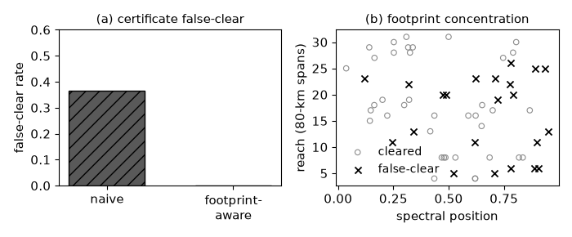
Where a stale twin fails (GNPy over CORONET-CONUS). Per-service false-clear over spectral position and reach concentrates on threshold-adjacent services. A per-lightpath view removes it. Marker shape distinguishes classes.

The learned surrogate fails at the threshold
Many twins replace the physics model with a learned surrogate for speed. How that surrogate is trained matters more than how accurate it is on average. Uncertainty-aware and quantile QoT models are established ; what has not been measured is the price of ignoring them at the decision boundary. Under irreducible prediction uncertainty the average-error surrogate wins the metric it was trained on and loses the one the twin exists for. Its MAE is $0.65$ dB against $0.95$ dB for the quantile objective, yet its false-clear rate is about $0.041$ against $0.008$, five times higher, at comparable delivered spectral efficiency near $3.9$ bits/symbol (Fig. 2a). The failures sit where the true GSNR lies within about a decibel below the next format’s threshold (Fig. 2b): there a small upward prediction error clears one format too high, and nowhere else can it. That is the cliff, and a symmetric error metric is blind there. A uniform backoff is the fair baseline and we report it: on the sealed per-prediction records, backing the average-error surrogate off by a further $0.85$ dB matches the quantile model’s false-clear at the same delivered bits. But that $0.85$ dB is found by tuning against witnessed outcomes after the fact; the quantile objective reaches the same operating point from its training loss alone, with no post-hoc knob, and the machinery to do so already exists .
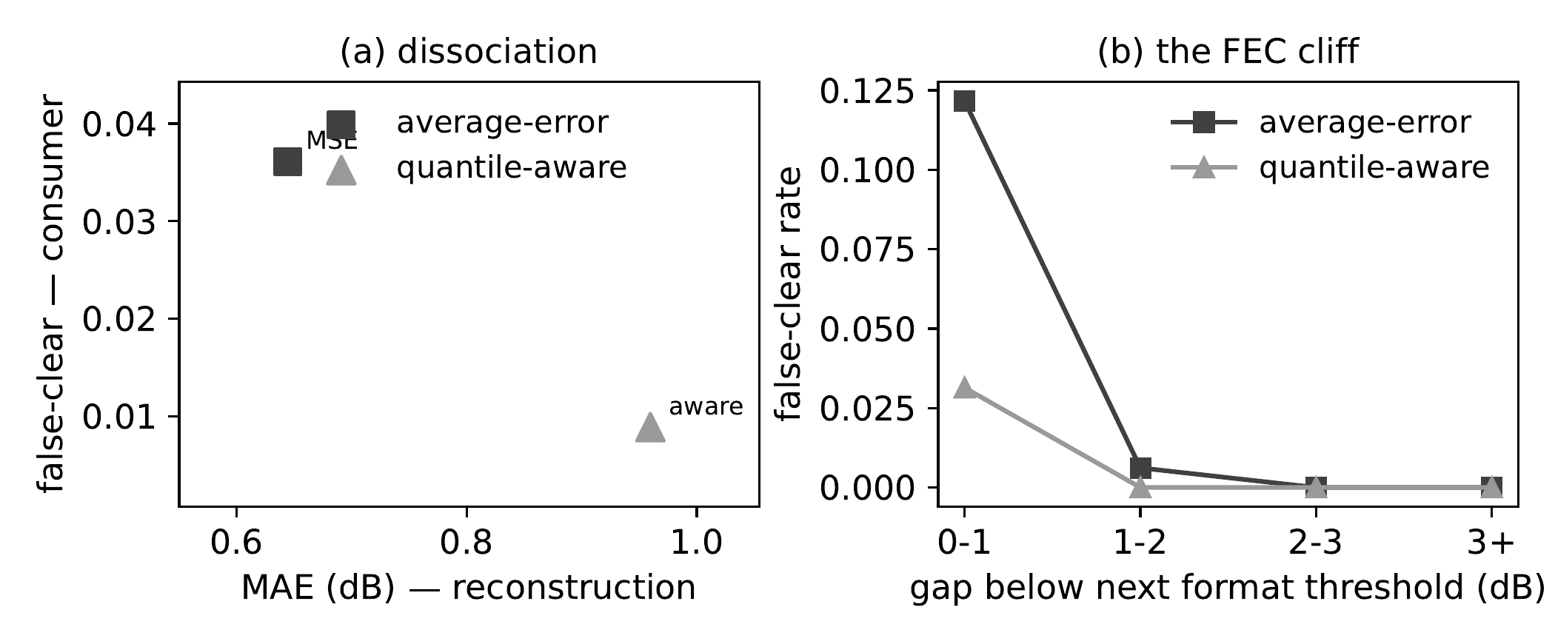
Two surrogate objectives, two metrics (GNPy, gradient-boosted regressors). (a) The average-error objective has lower MAE and higher false-clear than the quantile objective. (b) Its false-clears concentrate where the true GSNR sits within a decibel below the next format threshold; services already clearing the top format cannot false-clear and are excluded. Marker shape distinguishes objectives.

Related work
Optical digital twins are an active area, from GNPy-based twins fed by network telemetry to calibration against field data; that work builds and tunes the twin, and does not quantify how stale it can afford to be. Margin erosion under channel add is known qualitatively, and impairment-aware provisioning accounts for it at setup time ; our contribution is the measured staleness law and the budget it implies for the twin that persists after setup. Uncertainty-aware ML-QoT, including quantile models, is established ; we credit it as the correction for the surrogate result and add the measured cliff dissociation that motivates it. We do not offer a better twin, estimator or allocator. We offer the freshness budget, the exposure map, and the price of the wrong training objective.

Discussion
A digital twin is a certificate factory, and certificates age. The freshness budget turns twin synchronization from a judgment call into a provisioned quantity: re-sync within eight adds to a service’s band at a $5\%$ risk target, protect the threshold-adjacent services first, and train surrogates on the decision rather than the average. The evidence stands on the GN model with public demand data, and its limits are worth stating. Launch power is flat at $+2$ dBm and not re-optimised as the band fills, ROADM filtering penalties are not modelled, and the witness is the GN-model GSNR rather than a receiver’s pre-FEC BER. These effects do not all push the budget the same way: re-optimising launch power as the band fills would offset part of the drop the twin misses, while filtering penalties would add to it. The budget should be re-measured, not extrapolated, and a coherent-receiver witness on a testbed twin is the natural next step. In companion sealed experiments, two margin policies with equal fleet budgets received opposite verdicts from two service classes whose failures ride different axes of the network state (cells XPROTO-QOT-FLIP and XPROTO-CSI-FLIP in the sealed repository ); a full treatment of that inversion is beyond this paper’s scope and is reported separately. The same consumer-relative failure appears in radio link adaptation and in database replication . The results here stand on the optical QoT certificate alone.
9 A. Ferrari et al., “GNPy: an open source application for physical layer aware open optical networks,” J. Opt. Commun. Netw. 12, C31–C40 (2020). S. Shen et al., “End-to-end QoT predictions enhanced by GNPy-based digital twin with network telemetry,” in Proc. OFC, Th2A.16 (2024). H. Maryam, T. Panayiotou, and G. Ellinas, “Learning quantile QoT models to address uncertainty over unseen lightpaths,” Comput. Netw. 212, art. 108992 (2022). C. Rottondi et al., “Machine-learning method for quality of transmission prediction of unestablished lightpaths,” J. Opt. Commun. Netw. 10, A286–A297 (2018). Y. Pointurier, “Design of low-margin optical networks,” J. Opt. Commun. Netw. 9, A9–A17 (2017). S. Orlowski, R. Wessäly, M. Pióro, and A. Tomaszewski, “SNDlib 1.0—Survivable Network Design Library,” Networks 55, 276–286 (2010). A. H. Bond, “Observation Theory: consumer-relative witnessed certificates,” sealed pre-registrations and code, https://github.com/ahb-sjsu/observation-theory-campaigns (2026).

