One Report Cannot Serve Every Budget
Overrun and Age Horizons in Five 5G NR Adaptation Certificates

Abstract
A channel state report drives one rate decision, and different consumers hold that decision to different error budgets. We measure what that costs on an NR LDPC-based link-to-system simulation, in three ways. First, overrun. A selection policy whose achieved block error rate sits near a broadband budget of one block in ten overruns a low-latency budget of one in a thousand by a factor of 112 on the same channel, and the overrun holds at every mean SNR from cell edge to cell centre. A budget-aware policy removes it at a stated cost in margin and diversity. Second, age. With the link calibrated so that a fresh report actually meets the broadband budget, we ask how long a report may be held before the budget is lost. The answer is four transmission intervals at walking pace and a single interval at moderate mobility and above. Periodic reporting alone then meets the budget only at the frame minimum, and correction driven by acknowledgements becomes necessary rather than optional. Third, reach. Four further NR reports fail the same way against their own witnesses, the millimetre wave beam index, the precoder, the rank, and the uplink timing advance. A held periodic report fails at roughly three to four times the target on all four. The deployed re-reporting loops bring three of them to the target and leave the precoder above it. The results come from sealed, pre-registered experiments, and a superseded relaxed-threshold pilot is kept and disclosed.
CSI feedback, link adaptation, URLLC, outer-loop link adaptation, reliability, 5G NR.

Introduction
Adaptive modulation and coding turns a channel state report into a rate decision. The transmitter selects the highest modulation and coding scheme whose required signal-to-interference-and-noise ratio the report clears, and the selection is tuned to an error budget. The trouble is that the traffic behind one report does not share one budget. A broadband flow tolerates one block error in ten. A low-latency flow tolerates one in a thousand or less. The same decision, from the same report, on the same channel, is judged against both.
This paper measures that mismatch with two quantities. The first is the achieved block error rate of a selection policy. The second is the budget overrun, which is the achieved rate divided by the consumer’s budget. The overrun is where consumer relativity lives. The achieved rate is a property of the policy and the channel, while the overrun depends on who is asking. Certificates that do not set a rate need one more quantity, introduced with them in §5.
Three results follow. The first (§3) is partly mechanical and we say so. A policy run near one error in ten must overrun a budget of one in a thousand by about a hundredfold. The measured content is the exact overrun of 112, the fact that it holds across the whole SNR range including the cell edge, and the stated cost of the budget-aware policy that removes it. The second (§4) is the paper’s core. With the link calibrated so that a fresh report actually meets the broadband budget, the age horizon, meaning the longest a report can be held before the budget is lost, collapses to four transmission intervals at walking pace and to a single interval above a bicycle’s speed. An earlier exploration at a relaxed threshold suggested that this horizon scales with the coherence time. The calibrated recomputation shows that at the budget itself there is almost no horizon left to scale. The third (§5) tests whether any of this is particular to rate selection. It is not. Four further NR reports, the beam index at millimetre wave, the precoder, the rank, and the uplink timing advance, each fail against their own witness at roughly three to four times the target when held over one report period. The corrections are old, outer loop link adaptation and beam failure recovery above all, and our measurement says when they have stopped being optional.

Method
Substrate. We use an NR LDPC-based link-to-system simulation. For each MCS of the NR table (TS 38.214 Table 5.1.3.1-1, QPSK to 64-QAM, code rates $≥1/5$) we measure a block-error curve $e_{m}(γ)$ with the Sionna 5G LDPC decoder over AWGN, 400 decoded blocks per point on a $−8$ to $28$ dB grid at $2$ dB spacing, linearly interpolated between points. The time-domain link draws a per-TTI SNR trace from a 3GPP TR38.901 TDL-A channel ($3.5$ GHz, $30$ ns delay spread) and resolves each transmission as $NACK(t)∼Bernoulli(e_{m}(γ(t)))$. Two accuracy limits follow and bound our claims. At 400 blocks per point, a measured zero errors still leaves a binomial $95\%$ upper bound near $7.5×{10}^{−3}$, so the curves are trustworthy at the ${10}^{−2}$ level and above, and any smaller value is an interpolation rather than a count. The linear interpolation is a disclosed simplification that is coarse on steep tails. And the SNR-to-error mapping ignores fading within a TTI. Table 1 lists the parameters.
System model. Let $γ(t)$ be the true SNR in dB at TTI $t$ and $\hat{g}(t)$ the estimate the transmitter holds. Fresh CSI reads $\hat{g}(t)=γ(t)+n(t)$ with $n∼N(0,σ^{2})$, $σ=1$ dB. A report held with period $P$ reads $\hat{g}(t)=γ(t_{k})+n(t_{k})$ with $t_{k}=P⌊t/P⌋$, so the estimate carries the report noise of its issue time and then ages. The certificate selects, at reference target $β_{0}={10}^{−1}$ with backoff $Δ$,
$$m^{⋆}(\hat{g})=max\{m:ρ_{m}(β_{0})+Δ≤\hat{g}\},$$
where $ρ_{m}(β)=min\{γ:e_{m}(γ)≤β\}$. The achieved BLER is estimated two ways. The age study uses the empirical NACK rate
$$\hat{B}=1/T\sum_{t=1}^{T}{1}[NACK(t)]$$
and the budget study uses the expected rate B=1Tt​em⋆(γ(t)), because a scale of one error in a thousand cannot be resolved by counting at $T=6000$. The consumer-relative observable is the budget overrun $Ω(β)=\hat{B}/β$. $\hat{B}$ itself does not depend on $β$, which is why the eMBB and URLLC-naive columns of Table [tab:results](a) coincide by construction. The two consumers differ in $Ω$, where the same $\hat{B}≈0.112$ reads $Ω≈1.1$ for eMBB and $Ω≈112$ for URLLC.
Budget-aware policy. It raises the backoff to $Δ=4$ dB and combines $K=3$ diversity branches, independent TDL-A realizations from distinct seeds standing in for frequency or spatial replicas, and a block fails only if all branches fail. A backoff alone cannot reach ${10}^{−3}$, because a single Rayleigh branch spends about $6\%$ of its time in fades where even the lowest MCS misses the ${10}^{−3}$ budget. Independence makes the diversity a best case, and the claim rests on a product rather than a directly counted deep tail. The per-branch failure rates sit at the percent level, where the curves are reliable, and their independence product lies below the ${10}^{−3}$ budget by a factor of about fifty. The absolute product value ($≈{10}^{−5}$) inherits the interpolation’s error and should be read as an order of magnitude.
OLLA. The correction of §4 selects $m^{⋆}(\hat{g}(t)+o(t))$ and updates the offset on HARQ feedback,
$$o(t+1)=o(t)+δ_{up} 1[\text{ACK}(t)]−δ_{dn} 1[\text{NACK}(t)],$$
with $δ_{up}=0.1$ dB and $δ_{dn}=δ_{up}(1−β)/β$, so ACKs push the selection up and the loop settles where the NACK rate equals $β$. This recurrence matches the verified implementation line for line.
The age horizon. Because the naive fresh policy lands near but above the budget ($\hat{B}≈0.11$), the age study first calibrates. A fixed backoff $Δ_{cal}$, chosen in $0.25$ dB steps on a disclosed calibration seed, brings the fresh policy to $\hat{B}≤0.09$ at every Doppler. All policies then carry $Δ_{cal}$. The age horizon is $P^{⋆}(f_{D})=max\{P:\hat{B}(P)≤0.10\}$. A Doppler at which no period qualifies is recorded as censored and never clamped.
Four more certificates. Sections 3 and 4 study one report, the channel quality estimate that sets a rate. Four further NR reports carry the same structure, and each has an independent witness of whether the served transmission worked. The beam index reported at millimetre wave is witnessed by HARQ. The precoder and the rank are witnessed by the decode of the layers they select. The uplink timing advance is witnessed by the uplink decode, which fails once the residual delay exceeds the cyclic prefix. For these the observable is the rate $F$ at which a held report is paired with a failed transmission, against a target of $0.10$ throughout. Three policies run over one aging track per cell. The naive policy holds the periodic report. The witnessed policy re-reports after two consecutive failures, the deployed loop in each case, which is beam failure recovery for the beam, re-selection for the precoder, reduction for the rank, and the timing advance command. The fresh policy re-reports every slot and carries no aging. The beam cell uses an exact sixteen-element half-wavelength array factor over a twenty-four-beam codebook spanning $±60$ degrees, with the dominant direction drifting at $300$ degrees per second and a one-degree measurement error. The precoder, rank and timing cells age parametrically, with an angular drift of $1200$ degrees per second at $0.3$ dB of gain loss per degree, a rank changing $270$ times per second over four ranks, and a delay drifting $20 μ$s per second against a $4.7 μ$s cyclic prefix. All four decode on the measured Sionna LDPC curves at a fixed modulation and coding scheme, set two decibels below the aligned operating point so that the certificate under test and not rate selection drives the failures. Only the decode is measured in these four cells, a weaker substrate than §4 uses, and §5 states what that limits.
Discipline. Each experiment is pre-registered with numerical bars fixed before the graded run. Records are content-hashed and graded on seeds disjoint from design, and failed, voided and superseded outcomes stay in the record. Review of an earlier draft found that the age sweep had used a relaxed $0.15$ threshold while the text claimed $0.10$. That exploration is kept, and §4 reports the calibrated recomputation.
Link-level parameters
Carrier / TTI | $3.5$ GHz / $1$ ms
Channel model | 3GPP TR38.901 TDL-A, DS $=30$ ns
Mean SNR | $12$ dB
Decoder curves | Sionna 5G NR LDPC, 400 blk/pt, $−8$–$28$ dB @ $2$ dB
MCS set | NR TS 38.214 Tbl 5.1.3.1-1 (QPSK–64QAM)
CQI report noise $σ$ | $1$ dB
Trace length | $6000$ TTI (budget), $12 000$ TTI (age)
eMBB / URLLC budget | ${10}^{−1}$ / ${10}^{−3}$
Budget-aware policy | $Δ=4$ dB $+$ $K=3$ independent branches
OLLA steps | $δ_{up}=0.1$ dB, $δ_{dn}=0.9$ dB
Age sweep | $f_{D}=10$–$400$ Hz, $P=1$–$32$ TTI, calib. $Δ_{cal}$
Four further certificates (§5)
Beam cell | 16-element ULA, 24 beams over $±{60}^{∘}$, ${300}^{∘}$/s
Precoder / rank | ${1200}^{∘}$/s at $0.3$ dB/deg, 270 rank flips/s
Timing advance | $20 μ$s/s drift against a $4.7 μ$s cyclic prefix
Cadence / length | 20 slots (200 for TA), 6000 slots, target $0.10$

The Reliability Budget
A base station serving mixed traffic derives one CSI estimate per user and picks an MCS from it. Consider the same estimate judged under two budgets, ${10}^{−1}$ for eMBB and ${10}^{−3}$ for URLLC. Figure 1 shows the sealed result, three graded seeds of $6000$ TTI each with fresh CSI. The naive policy achieves $\hat{B}≈0.112$, near its eMBB budget. The URLLC consumer reads the same $0.112$ as an overrun of $112×$. Part of this is arithmetic, and we do not claim otherwise. A policy run near one budget must overrun a budget a hundred times stricter by about that factor. What the measurement adds is the exact figure, the fact that nothing in the scheduler’s view flags it, and a feasible policy that removes it. The budget-aware policy of §2 meets the ${10}^{−3}$ budget with margin. Its protection is stated, a $4$ dB backoff and threefold diversity, though we do not quantify the resulting spectral-efficiency loss here.
The overrun is not an artifact of the operating point. A separately sealed cell sweeps the mean SNR from $3$ to $21$ dB (Fig. 2). The certificate rides the eMBB budget, so the URLLC overrun stays between $77×$ and $142×$ at every in-range SNR and is still $54×$ where the MCS table saturates. At $6$ dB and below even the eMBB consumer loses its budget, since the lowest MCS is already too fast for the channel ($\hat{B}≈0.20$ at $6$ dB and $0.33$ at $3$ dB). No margin repairs a certificate whose weakest format is too aggressive.
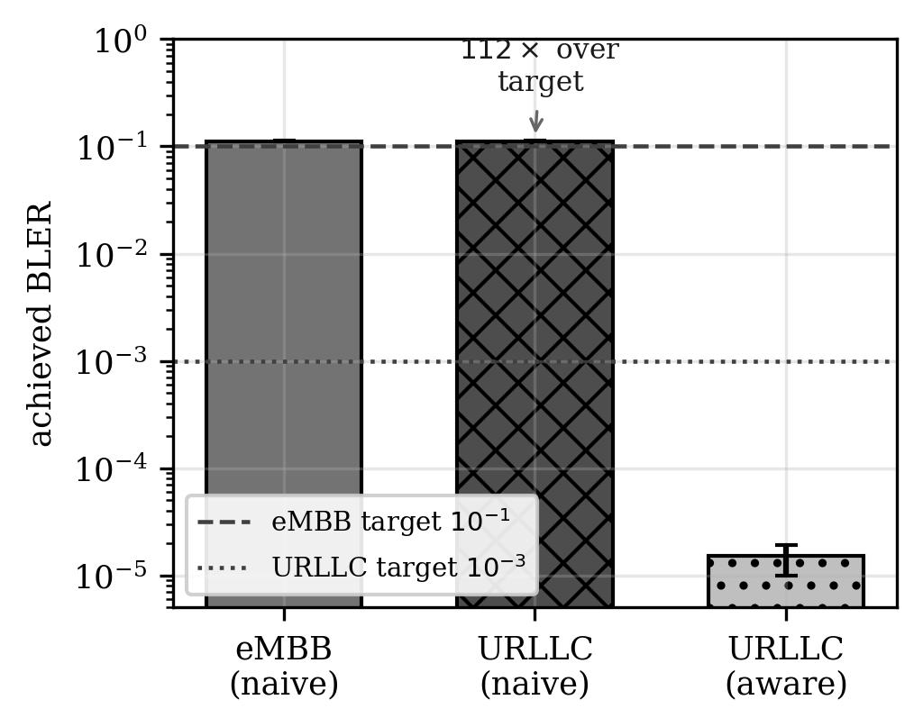
One report, two budgets (NR LDPC link-to-system, 3 sealed seeds, bars are means, whiskers min–max). Lower is better. The same selection sits near the eMBB budget and overruns the URLLC budget by $112×$. The budget-aware policy meets it.
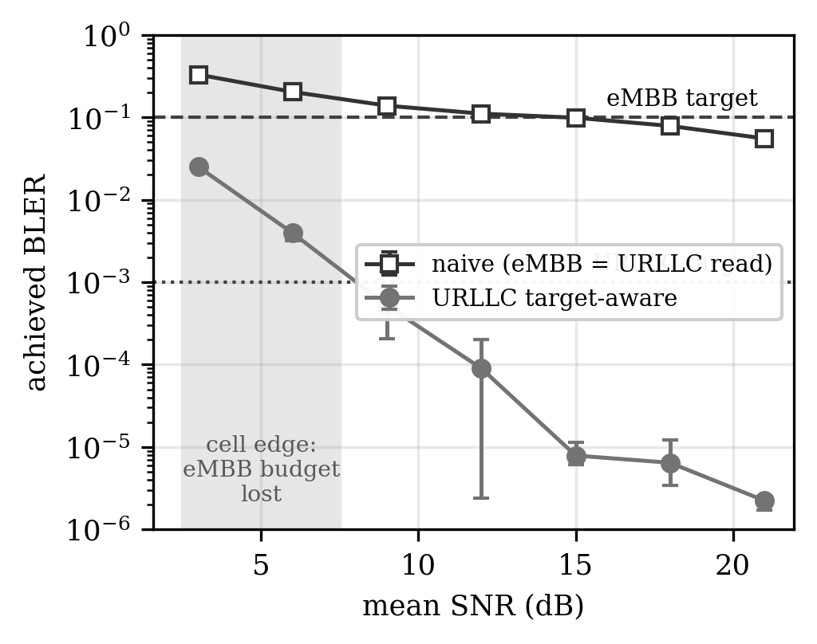
The overrun across mean SNR (sealed sweep, 3 seeds, whiskers min–max). The URLLC overrun is roughly a hundredfold at every in-range SNR. At $6$ dB and below (shaded) even the eMBB budget is lost.

The Age Horizon
The second axis is time, and it is where the budget question bites hardest. A report is fresh when issued and ages as the channel decorrelates. At $200$ Hz Doppler with a $20$-TTI report period, the held estimate is off by $5.7$ dB on average (mean absolute error, of which aging dominates and report noise contributes about $1$ dB), and the naive certificate runs at $\hat{B}≈0.36$ against the $0.10$ budget, an overrun of $3.6×$ from age alone. OLLA, Eq. [eq:olla], corrects the same held report and holds $0.10$ over three sealed seeds, $0.34$ to $0.37$ naive against $0.101$ to $0.102$ corrected, with the per-seed record in the public ledger .
How long may a report be held before the budget is lost? An exploratory sweep at a relaxed $0.15$ threshold suggested a coherence-proportional law, $P^{⋆}≈0.18 T_{coh}$. It was superseded by the calibrated $0.10$ experiment reported here, and both records are kept. The calibrated recomputation at the true $0.10$ budget gives a starker answer (Fig. 3, Table [tab:results](b)). With the fresh baseline calibrated to $\hat{B}≤0.09$ at every Doppler (a $0.5$ dB backoff suffices), the horizon over the three graded seeds is $P^{⋆}=4$ TTI at $10$ Hz ($6$ on one seed), $2$ at $25$ Hz ($3$ on one seed), and $1$ TTI, the frame minimum, at $50$ Hz and above, with no censored points. There is no room for a proportionality law. Once the budget is tight, the first few milliseconds of aging consume it, and almost no horizon is left to scale. At $3.5$ GHz these Dopplers are modest speeds. Ten hertz is about $3$ km/h, a walk, and $50$ Hz about $15$ km/h, a bicycle. The operational statement follows. Below walking pace a report survives a few TTIs. At moderate mobility and above, periodic reporting meets the budget only at the frame-minimum interval, so HARQ-driven correction is necessary for any less aggressive reporting cadence. The coherence-proportional behaviour is real but belongs to relaxed thresholds, where degradation has room to accumulate before the budget is lost.
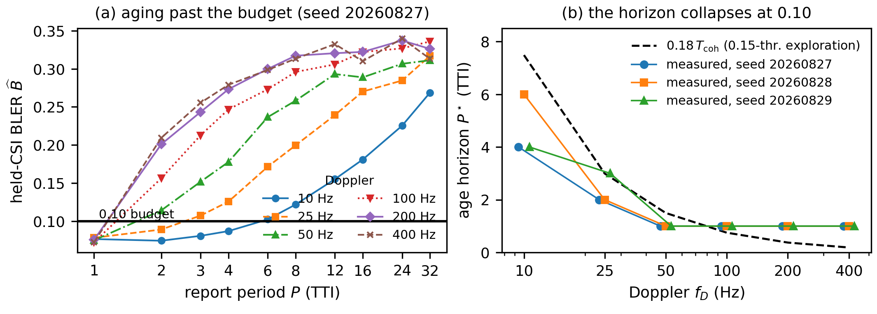
The age horizon at the true $0.10$ budget (calibrated baseline, three sealed graded seeds). (a) Held-CSI BLER against report period, where lower is better. (b) The horizon collapses to a few TTI at low mobility and to the frame minimum above $50$ Hz.
lllll
seed & eMBB & URLLC-naive & URLLC-aware &
& $0.1119$ & $0.1119$ & $1.7×{10}^{−5}$ &
20260825 & $0.1103$ & $0.1103$ & $1.9×{10}^{−5}$ &
20260826 & $0.1125$ & $0.1125$ & $<{10}^{−5}$ &
seed & $P^{⋆}(10)$ & $P^{⋆}(25)$ & $P^{⋆}(≥50)$ & fresh worst
& $4$ & $2$ & $1$ & $0.080$
20260828 & $6$ & $2$ & $1$ & $0.078$
20260829 & $4$ & $3$ & $1$ & $0.080$

Four More Certificates Fail the Same Way
The results so far concern one report. If the budget question belonged only to rate selection it would be a narrow finding. It does not. Figure 4 and Table [tab:fam] give four further certificates, three graded seeds each, every bar fixed before the graded run.
Held over one report period, each fails against its own witness well above the $0.10$ target. The beam index reaches $0.310$ to $0.329$, the precoder $0.299$ to $0.311$, the rank $0.268$ to $0.299$, and the uplink timing advance $0.419$ to $0.425$. Averaged over seeds the four rates span $2.8$ to $4.2$ times the target. The drift behind them is large in each case. Mean beamforming loss runs $4.67$ to $4.79$ dB for the beam and $3.09$ to $3.11$ dB of precoding gain for the precoder, and the timing advance leaves a mean residual of $0.42$ cyclic prefixes. For the rank the drift measure and the failure rate coincide by construction, because a stale high rank fails exactly when the current channel cannot carry the layer, so that row reports one number rather than two.
The deployed re-reporting loops repair three of the four. Rank reduction reaches $0.079$ to $0.085$ and the timing advance command reaches $0.055$ to $0.056$, both under the target. Beam failure recovery lands on it at $0.098$ to $0.104$. Precoder re-selection does not, holding $0.124$ to $0.130$, which is $24$ to $30$ percent above the budget it exists to protect. Waiting for two consecutive failures is a slow trigger against a precoder that drifts continuously, and the cell re-reports 549 to 558 times in 6000 slots without catching up. This is the one place in this paper where a deployed correction, run as specified, does not reach the target.
With the report refreshed every slot the beam cell runs at $0.021$ to $0.027$, and the other three record no failure at all in 6000 slots. Three seeds of 6000 slots with zero events bound the fresh rate below $5×{10}^{−4}$ at $95\%$ confidence rather than establishing zero. Aging causes these failures and the model is not broken.
One of the four is an uplink certificate. The timing advance sets when the UE transmits, and a stale value is paid for by the base station’s decoder rather than the UE’s. The same holding failure appears on both links, so it is not a property of downlink rate adaptation.
The scope is narrower here than in §4. These four cells age parametrically and measure only the decode, so they establish that the failure structure carries across certificates. They do not fix the rates a deployed network would see.
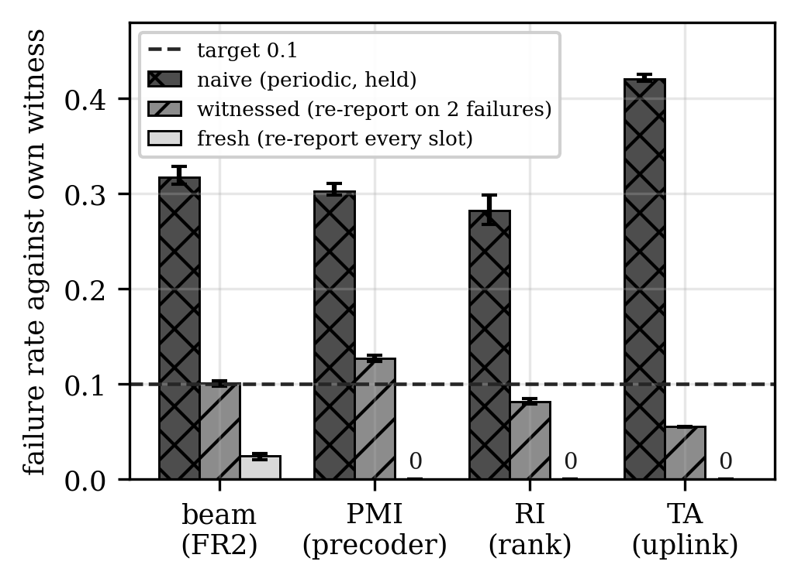
Four more NR certificates under aging (sealed, 3 graded seeds each, whiskers min–max). Lower is better. A held periodic report fails several times over target on all four. The deployed loop recovers the rank, the timing advance and the beam, and leaves the precoder above target.
lllll certificate & drift & naive $F$ & witnessed $F$ & fresh $F$
beam, FR2 & $4.67$–$4.79$ dB & $0.310$–$0.329$ & $0.098$–$0.104$ & $0.021$–$0.027$
precoder & $3.09$–$3.11$ dB & $0.299$–$0.311$ & $0.124$–$0.130$ & $0$
rank & (see text) & $0.268$–$0.299$ & $0.079$–$0.085$ & $0$
timing adv. & $0.420$–$0.427$ & $0.419$–$0.425$ & $0.055$–$0.056$ & $0$

Related Work
Link adaptation, CSI aging and outer-loop correction are old subjects. OLLA holds an error target under imperfect or stale CSI by adjusting an SINR offset on HARQ feedback, and it is exactly the correction our age result makes mandatory. Short-packet analysis establishes the reliability setting in which these budgets are written. NR configures CSI reporting as periodic, semi-persistent, or DCI-triggered aperiodic . None of these adapt the cadence to the consumer’s budget, and our horizon result says how little cadence alone can do at a tight one. Event-based sampling such as send-on-delta is a natural extension we tested only in exploratory form (a sealed confirmation attempt was voided by a control check and we claim nothing). Learned CSI feedback trained on reconstruction error is active. In our controlled tests the difference in objective it might suggest did not appear at practical operating points. The four certificates of §5 all have standardised correction loops of their own. Beam management at millimetre wave, including beam failure detection and recovery, is surveyed in and specified in , which also carries the uplink timing advance command. Precoder and rank reporting and their adaptation are specified alongside CSI reporting in . We credit all of these as the deployed repairs and measure how far each one gets. We offer no new estimator, scheduler or offset rule. We offer the measurement, which is achieved error against the consumer’s budget, the age horizon at the budget itself, and the same failure in four more certificates.

Discussion and Conclusion
The unit of correctness in link adaptation is not the report. It is the pair of report and budget. Sized to the consumer’s budget, margins and reporting cadence hold the certificate to its target. Sized to a nominal channel they do not, and the costs are now numbers, a $112×$ overrun for a mismatched budget, an age horizon of a few milliseconds at a tight one, and three to four times the target on four further certificates whenever a periodic report is held. The evidence has limits worth stating. It is an NR LDPC-based link-to-system simulation, one TDL-A profile, and one MCS table topping at 64-QAM, and values below one error in a thousand are limited by the resolution of the decoder curves. The four certificates of §5 age parametrically and measure only the decode. Over-the-air HARQ traces are the natural next step for all of it. In companion sealed experiments, two margin policies with equal fleet budgets received opposite verdicts from two user fleets whose failures ride different axes of the channel (cells XPROTO-CSI-FLIP and XPROTO-QOT-FLIP in the sealed repository ). A full treatment of that inversion, with scheduler interpretations and goodput, is reported separately. The same budget-relative failure appears in optical quality-of-transmission and in database replication , so the method is not specific to radio. The results here stand on the 5G NR certificates alone.

Acknowledgment
The author used Anthropic’s Claude, a large language model, to help write the simulation, analysis and plotting code, to draft and edit text in all sections, to check the reported numbers and references against the sealed records, and to write the Lean proofs and the claim-checking script. The author directed the work, reviewed all content, and is responsible for it.
1 A. Sampath, P. Sarath Kumar, and J. M. Holtzman, “On setting reverse link target SIR in a CDMA system,” in Proc. IEEE 47th Veh. Technol. Conf. (VTC), vol. 2, 1997, pp. 929–933. J. Hoydis et al., “Sionna: An open-source library for next-generation physical layer research,” arXiv:2203.11854, 2022. G. Durisi, T. Koch, and P. Popovski, “Toward massive, ultrareliable, and low-latency wireless communication with short packets,” Proc. IEEE, vol. 104, no. 9, pp. 1711–1726, 2016. 3GPP TS 38.214, “NR; Physical layer procedures for data,” v17, clause 5.2 (CSI reporting: periodic, semi-persistent, aperiodic), 2022. M. Miskowicz, “Send-on-delta concept: An event-based data reporting strategy,” Sensors, vol. 6, no. 1, pp. 49–63, 2006. C.-K. Wen, W.-T. Shih, and S. Jin, “Deep learning for massive MIMO CSI feedback,” IEEE Wireless Commun. Lett., vol. 7, no. 5, pp. 748–751, 2018. M. Giordani, M. Polese, A. Roy, D. Castor, and M. Zorzi, “A tutorial on beam management for 3GPP NR at mmWave frequencies,” IEEE Commun. Surveys Tuts., vol. 21, no. 1, pp. 173–196, 2019. 3GPP TS 38.213, “NR; Physical layer procedures for control,” v16.2.0, clause 6 (link recovery procedures) and clause 4.2 (transmission timing adjustments), 2020. A. H. Bond, “Observation Theory: consumer-relative witnessed certificates,” sealed pre-registrations and code, https://github.com/ahb-sjsu/observation-theory-campaigns, 2026.

