Consumer-Aligned Learning for Quality-of-Transmission:
The False-Clear Rate at the FEC Cliff
Andrew H. Bond
Department of Computer Engineering, San José State University, San José, CA 95192, USA
andrew.bond@sjsu.edu

Introduction
Machine-learning Quality-of-Transmission (ML-QoT) estimation is a leading route to reducing the system margin—the deliberately stranded capacity—that optical operators carry against uncertain reach performance . ML-QoT models are almost always trained to minimise a prediction error (mean-squared or mean-absolute GSNR/OSNR error). We argue, and measure, that this objective is misaligned with the consumer it serves. The consumer of a QoT estimate is the format-selection decision, and ultimately the forward-error-correction (FEC) decoder, which reads a threshold: a lightpath either meets its format’s required GSNR or it does not. An estimator can be excellent on average yet, near a format boundary, over-predict just enough to select a rate the link cannot support— a false-clear (an in-service outage), even though its mean error is small.
We make the false-clear rate a first-class, measured KPI and show three things on the GN-model physical layer of GNPy over the CORONET-CONUS reference network: (i) an average-error ML-QoT objective false-clears at the FEC cliff, while a consumer-aware objective does not, at equal capacity; (ii) the underlying QoT margin is consumer-relative—which lightpaths are at risk is a footprint property (spectral position and reach), so no blanket margin fits all; and (iii) a fill-driven refresh floor sets when a certificate must be re-validated.

Method
Substrate. Lightpaths are transparent shortest-path routes of the CORONET-CONUS reference topology (75 nodes; $≤2500$ km, 2–31$×$ 80 km spans). Per-channel GSNR is computed with the GN model in GNPy on standard single-mode fibre (0.2 dB/km, $D=17$ ps/nm/km), EDFAs (NF 6 dB), +2 dBm/ch, 32 GBd, 50 GHz grid, from a lightly filled “provisioning” band (6 channels) to a full C-band (76 channels).
Certificate, consumer, witness. A certificate selects the highest format whose required GSNR the estimate clears. The consumer is that decision; the witness is the true deployed GSNR (the receiver’s pre-FEC BER). For the ML study, features are provisioning-time GSNR and (spectral position, reach, fill), the label carries an irreducible unmeasured-state term, and two gradient-boosted objectives are compared: average-error (squared loss) and consumer-aware (a conservative lower-quantile loss that protects the decision, not the mean). Bars and manipulation checks are pre-registered; the sealed record is content-hashed with disjoint graded seeds .

Results

ML-QoT trained on the wrong metric
Under irreducible prediction uncertainty, the average-error estimator attains lower mean error yet false-clears far more at the FEC cliff than the consumer-aware objective: MAE $0.65$ vs $0.95$ dB (it wins reconstruction) but false-clear $≈0.041$ vs $≈0.008$ ($∼$5$×$) at comparable delivered spectral efficiency ($≈3.9$ bits/symbol). Figure 1(a) shows the reconstruction-vs-consumer dissociation; (b) shows that the average-error false-clears concentrate where the GSNR headroom above the nearest format threshold is small—the cliff—exactly where a symmetric error metric is blind. The prescription is to train ML-QoT on the consumer’s threshold decision, not on volume-averaged fidelity.
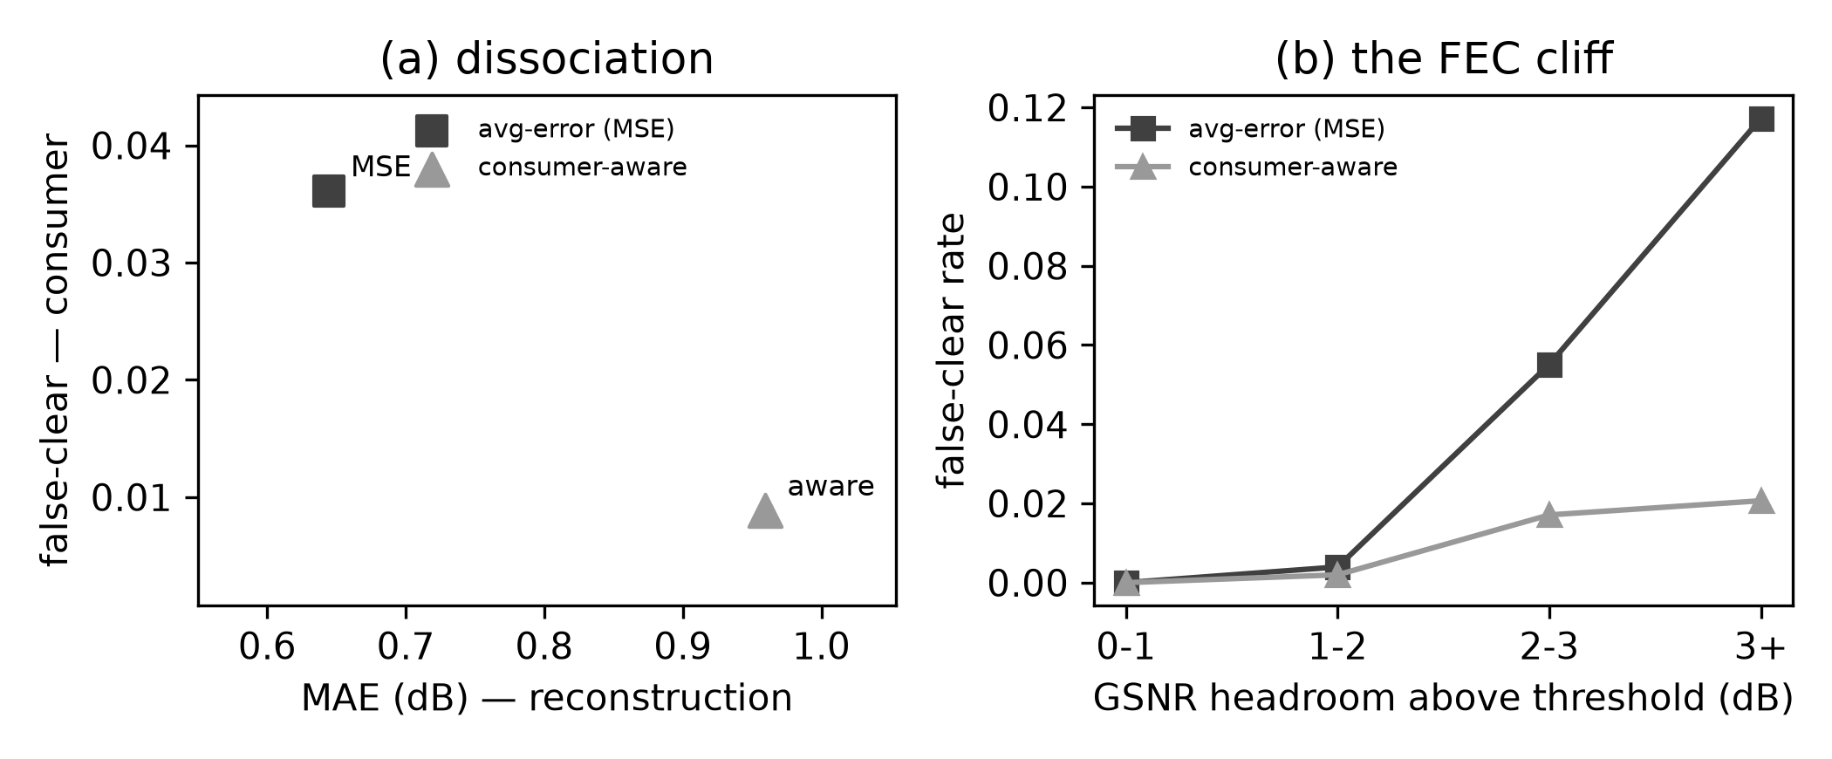
ML-QoT reconstruction-vs-consumer dissociation (GNPy + gradient-boosted regressors): (a) the average-error objective attains lower MAE yet higher false-clear than the consumer-aware objective; (b) it false-clears at the FEC cliff (small GSNR headroom), where the consumer-aware objective does not. Marker shape distinguishes objectives.

The margin is consumer-relative
The same threshold-blindness afflicts the margin itself under incremental fill. As a lightpath’s band fills toward its deployed load, its GSNR drops, and whether it crosses a format threshold depends on its footprint: false-clears concentrate on the services whose spectral position and reach place their GSNR nearest a boundary, and are absent elsewhere (Fig. 2). Consequently a single blanket margin cannot be right for all. We quantify the cost against today’s practice—one uniform system margin sized so the fleet stays safe—using real deployed fill: each lightpath’s channel load is drawn from the per-link fill distribution of the SNDlib janos-us-ca demand matrix (61 links; median 10, 90th-percentile 35 of 76 channels ). Real traffic is heavy-tailed, so a uniform margin sized for the few near-full links over-provisions the lightly-filled majority. Giving both policies the same QoT-estimator uncertainty (0.5 dB RMSE, so the footprint-aware certificate is not assumed perfect), a certificate that sizes each margin to the lightpath’s own fill recovers $≈8\%$ of spectral efficiency ($≈0.33$ b/sym, $∼$21 Gb/s per channel) at matched safety (false-clear $≤0.01$), on a rate-flexible transceiver model. The gain is modest but free: it is capacity the uniform margin strands on the majority of links that never fill.
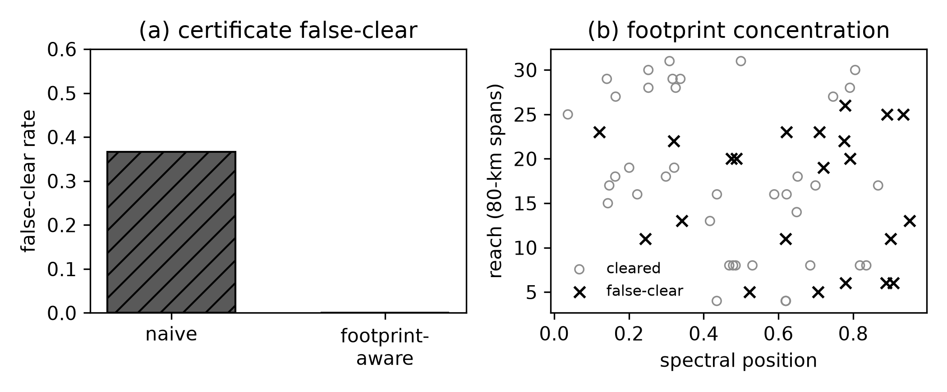
Consumer-relativity of the QoT margin on GNPy over CORONET-CONUS: per-service false-clear over (spectral position, reach) concentrates on threshold-adjacent services; a footprint-aware certificate removes it. Marker shape distinguishes classes.

The refresh floor
Because the risk is driven by the fill increment between provisioning and use, a certificate has a refresh horizon. Sweeping the deployed fill from 6 to 76 channels, the naive false-clear rises approximately linearly with the number of added channels ($FC≈0.008 ΔN$, $R^{2}=0.95$); at a 0.05 target the refresh floor is $≈8$ added channels. The rule is concrete: re-certify a service before the band around it grows by $∼$8 channels, not on a fixed calendar.

Related work
QoT estimation and physical-layer-aware routing/spectrum assignment are mature ; ML-QoT is active, with estimators trained predominantly on prediction error . Our contribution is orthogonal: not a better estimator or allocator, but a measurement—the false-clear rate as a first-class, consumer-relative KPI—and the finding that the ML-QoT training objective, and the margin allocation, should target the consumer’s threshold.

Discussion
Train QoT models, and size QoT margin, for the decision the FEC decoder makes, not for average fidelity. The GN model is the evidence rung; a coherent-receiver pre-FEC-BER witness on a fibre testbed, and the EGN/split-step model, are the external-validity graduations. (The consumer-relative, false-clear methodology is not optics-specific , but the results here stand on the optical QoT certificate alone.)
9 A. Ferrari et al., “GNPy: an open source application for physical layer aware open optical networks,” J. Opt. Commun. Netw. 12, C31–C40 (2020). C. Rottondi et al., “Machine-learning method for quality of transmission prediction of unestablished lightpaths,” J. Opt. Commun. Netw. 10, A286–A297 (2018). Y. Pointurier, “Design of low-margin optical networks,” J. Opt. Commun. Netw. 9, A9–A17 (2017). S. Orlowski, R. Wessäly, M. Pióro, and A. Tomaszewski, “SNDlib 1.0—Survivable Network Design Library,” Networks 55, 276–286 (2010). A. H. Bond, “Observation Theory: consumer-relative witnessed certificates,” sealed pre-registrations and code, https://github.com/ahb-sjsu/observation-theory-campaigns (2026).

