HOW MUCH DO ENVIRONMENTAL MATTERS AFFECT HONG KONG'S LOCAL FOOD PRODUCTION?

TOPIC

This study investigates the impact of climate variability on Hong Kong's local food production from 2007 to 2024. The objective is to examine relationships between three key climate factors—atmospheric pressure, relative humidity, and rainfall—and the annual yield of different food categories, including vegetables, livestock, seafood, and poultry. By analyzing these relationships, the study aims to identify which food sectors are most sensitive to weather patterns and provide data-driven insights for local food security planning. Understanding climate sensitivity is increasingly important as Hong Kong seeks to enhance its food resilience amid global climate change and supply chain uncertainties. The analysis combines daily climate records from the Hong Kong Observatory with annual food production statistics.

DATA DESCRIPTION

Please refer to Appendix A for the data description table. The food data will go through a transformation where it is converted from a wide format to a tall format so that analysis can be done easily. All three of the climate data will be cleaned, combined, and aggregated to annual averages (pressure, humidity) and totals (rainfall). Relationships will be explored through scatter plots, correlation analysis, and matrix/heatmap to identify climate sensitivity across food categories.

TABLE DESCRIPTION

Before transformation, each CSV (Table 990-92071_en.xlsx, daily_HKO_RH_ALL.csv, daily_HKO_RF_ALL.csv, and daily_HKO_MSLP_ALL.csv) file is loaded individually into Power Query as a separate query. Initially, I had loaded all of the files as they were, but later on, I faced a limitation or error with Power Query where it was unable to load all the rows of the CSV files. After facing this, I converted all files into .xlsx.

Table 990-92071_en.xlsx is a complex cross-tabulated statistical table on local foodstuff production. Rows 3–6 define a multi-layered header structure with categories, units, and subcategories, while row 7 labels the first data column "Year". Data begins in row 8, with the first column listing years.

daily_HKO_MSLP_ALL.csv, daily_HKO_RH_ALL.csv, and daily_HKO_RF_ALL.csv are daily time-series datasets from the Hong Kong Observatory, containing mean atmospheric pressure (hPa), humidity (%), and rainfall (mm), respectively. Each CSV uses mixed delimiters, includes comments (e.g., *** for missing data, # for notes), and features a completeness flag (C for complete data).

TRANSFORMATION DESCRIPTION

The data transformation process involved cleaning and restructuring four distinct raw datasets into analysis-ready formats using Power Query. For the foodstuff production table (Table 990-92071_en.xlsx, later renamed to FoodProduction), the complex multi-layered header structure was systematically removed by skipping rows, promoting headers twice, and unpivoting the cross-tabulated format into a tidy long format with Year, Category, and Quantity columns. For the three Hong Kong Observatory climate datasets (daily_HKO_MSLP_ALL.xlsx, daily_HKO_RH_ALL.xlsx, daily_HKO_RF_ALL.xlsx), transformations included filtering out comment rows marked with null values or special characters, retaining only complete data records where indicated by the completeness flag, converting data types, imputing missing or erroneous values with variable-specific averages (e.g., 1012.79 hPa for pressure, 77.72% for humidity, 8.05 mm for rainfall), and adding a Metric column to distinguish pressure, humidity, and rainfall readings. These three climate tables were then combined into a unified DailyClimate table, aggregated into yearly summaries (YearlyPressure, YearlyHumidity, YearlyRainfall), and merged into a single YearDim table linking annual climate averages with total rainfall. Finally, a FoodCategory lookup table was created to map food items to their respective categories, completing the transformation pipeline and enabling integrated analysis between agricultural production and climatic conditions.

DATA DESCRIPTION

The data model follows a star schema design for efficient analysis:

- Fact Table: FoodProduction (contains measures: Quantity)

- Dimension Tables:

- YearDim (contains climate aggregates: AvgPressure, AvgHumidity, TotalRainfall)

- FoodCategory (contains category classifications: Category, FoodType)

Relationships:

- FoodProduction[Year] → YearDim[Year] (many-to-one, single direction)

- FoodProduction[Category] → FoodCategory[Category] (many-to-one, single direction)

This structure allows slicing food production by year, climate conditions, and food type simultaneously. The YearDim table serves as the bridge connecting climate data to production data, enabling correlation analysis between weather patterns and agricultural output. Intermediate tables (YearlyPressure, YearlyHumidity, YearlyRainfall, DailyClimate) are hidden from the report view to maintain a clean field list.

MEASURES

Measure 1: Total Production (Please refer to Appendix B for the formula)

This base measure is essential for all production-related calculations. It sums the quantity across all food categories for any selected context (year, category, food type), providing the foundation for percentage calculations, rankings, and comparisons throughout the analysis.

The SUM function aggregates the Quantity column from the FoodProduction fact table. When used in visuals with filters from dimension tables (Year, Category), it automatically recalculates to show the total for the selected subset of data.

Measure 2: Year-over-Year Growth % (Please refer to Appendix B for the formula)

This measure identifies years of significant production increase or decline. Understanding year-to-year changes helps isolate periods where external factors (including climate) may have influenced food output, guiding deeper investigation into those specific years.

The formula calculates the percentage change from the previous year. It uses CALCULATE with FILTER to retrieve the previous year's total regardless of current filters, then divides the difference by the previous year's value. The DIVIDE function handles division by zero gracefully.

Measure 3: Production Volatility (Please refer to Appendix B for the formula)

This measure quantifies how unstable a food category's production is from year to year. Categories with high volatility may be more vulnerable to external factors like climate, disease, or market conditions, making them priority targets for food security planning.

This is the coefficient of variation—standard deviation divided by mean. STDEVX.P calculates the population standard deviation of production across years for each category, while AVERAGEX calculates the mean. Higher values indicate greater relative variability and instability.

Measure 4: High Humidity Year Flag (Please refer to Appendix B for the formula)

This flag identifies years with abnormally high humidity (more than 10% above the long-term average). It allows quick visual filtering to compare production in unusually humid years versus normal years, testing the hypothesis that humidity affects food output.

The measure calculates the overall average humidity across all years using CALCULATE with ALL to remove filters. It then compares the current selected year's humidity to 110% of that average. Years exceeding the threshold are flagged as "Very Humid" for easy identification in visuals.

Measure 5: Total Rainfall (Year) (Please refer to Appendix B for the formula)

Need: This measure provides quick access to annual rainfall totals for use in visuals alongside production data. Having rainfall as a reusable measure simplifies chart creation and ensures consistency when comparing rainfall patterns to production trends across multiple visualizations.

Explanation: This simple measure sums the TotalRainfall column from the YearDim dimension table. When used in a visual with Year on the axis, it displays the correct annual total, making it easy to create dual-axis charts comparing rainfall and production.

CUSTOM COLUMN 1,2 AND 3

All three of these columns are named Metric, and they have been used in the tables named: daily_HKO_MSLP_ALL, daily_HKO_RH_ALL, and daily_HKO_RF_ALL.

This custom column was needed to categorize the rows of each of the columns of the aforementioned tables. The aim is to make aggregation easier when making the DailyClimate table.

The three formulas (please refer to APPENDIX C) each attempt to add a new column called "Metric" to a table or respective tables. The first line fills every row in the new column with the text "Pressure," the second with "Humidity," and the third with "Rainfall."

CUSTOM COLUMN 4 AND 5

The columns are named AvgPressure and AvgHumidity, and they have been used in the tables named YearlyPressure and YearlyHumidity, respectively.

This custom column was needed to find the yearly average reading of the two tables. The aim is to make aggregation easier and analysis more easier when making the YearDim table.

These two formulas (please refer to APPENDIX C) group data by the "Year" column, but they produce different aggregation results. The first formula creates a summary table showing the average pressure for each year by calculating the list.Average([Reading]) and naming the result column "AvgPressure." The second formula does the same grouping operation but produces an "AvgHumidity" column instead, averaging humidity readings per year.

CUSTOM COLUMN 6

The column is named TotalRainfall, and it has been used in the table named YearlyRainfall.

This custom column was needed to find the total rainfall for each year. The aim is to make aggregation easier and analysis easier when making the YearDim table.

This formula (please refer to APPENDIX C) groups data by the "Year" column and calculates the total rainfall for each year by summing the values in the [Reading] column using List.Sum. The result is a summary table with two columns: "Year" and "TotalRainfall," where each row represents a single year and the aggregated sum of rainfall readings for that period.

VISUALIZATION 1

Line Chart – Total Food Production vs. Total Rainfall Over Time (Please refer to Appendix D)

This dual-axis line chart displays total food production (primary axis) and total annual rainfall (secondary axis) from 2007 to 2024. The visualization allows visual comparison of trends—whether high-rainfall years correspond to production increases or decreases and extreme years can be identified for further investigation.

It is used to identify potential correlations between rainfall patterns and overall food production levels, and to visualize the dramatic production drop after 2007.

VISUALIZATION 2

Multi-Line Chart – Climate Trends Over Time (Please refer to Appendix D)

This chart displays all three climate variables—average pressure, average humidity, and total rainfall—on a single timeline from 2007 to 2024. Using consistent scaling where possible (or dual axes if needed), it reveals how Hong Kong's climate has evolved over the study period and identifies years with extreme values in any metric.

It is used to establish the climate context for the entire period and identify specific years where one or more climate factors deviated significantly from normal.

VISUALIZATION 3

Bar Chart – Top 5 Food Categories by Total Production (Please refer to Appendix D)

This horizontal or vertical bar chart shows the five food categories with the highest cumulative production across all years. The length of each bar represents the total production quantity, with exact values displayed. This visualization immediately reveals which categories dominate Hong Kong's local food system and which are minor contributors.

It is used to identify the most significant food categories for subsequent climate sensitivity analysis, focusing attention on categories that matter most to local food security.

VISUALIZATION 4

Scatter Plot Matrix – Climate Variables vs. Production (Please refer to Appendix D)

Three separate scatter plots arranged side-by-side, each plotting a climate variable (pressure, humidity, rainfall) on the X-axis against total production on the Y-axis. Each point represents a year, and trend lines are added to show correlation direction and strength. Years can be identified as points to spot outliers, like 2007.

They are used to test for statistical relationships between each climate factor and food production, identifying which variables show the strongest correlation and whether relationships are positive or negative.

VISUALIZATION 5

Matrix/Heatmap – Production by Category and Year (Please refer to Appendix D)

This matrix visual uses color intensity to show production levels—rows are food categories, columns are years. Conditional formatting applies a color scale (green = high production, red = low production). This compact visualization reveals patterns across both dimensions simultaneously: which categories consistently perform well, which years were good for multiple categories, and where declines occurred.

It is used to identify category-specific climate sensitivity by visually comparing good years (green) and bad years (red) across the timeline and noting whether they align with climate extremes.

VISUALIZATION 6

Ribbon Chart – Ranking Changes Over Time (Please refer to Appendix D)

This ribbon chart displays how the ranking of food categories changes from year to year. Categories are represented by colored ribbons that flow across the timeline, showing upward or downward movement in rank. The width of each ribbon corresponds to production quantity, allowing viewers to see not only rank changes but also relative magnitude.

To reveal shifts in Hong Kong's food production landscape over time, and whether certain categories are gaining or losing importance relative to others. This complements the heatmap by showing competitive dynamics between categories, such as the rivalry between pigs and salt-water fish for the top position.

LIMITATIONS

Several limitations should be considered when interpreting these results. First, a data granularity mismatch exists: food production is reported annually, while climate data are daily. Aggregating to yearly averages may obscure short‑term weather events (e.g., typhoons, heatwaves) that could critically affect production. Second, rainfall errors were imputed using the mean; although this preserves the overall distribution, it may mask extreme events if errors occurred disproportionately on high‑rainfall days. Third, limited production diversity—pigs and salt‑water fish together account for over 80% of total output—means climate sensitivity for vegetables, field crops, and freshwater fish cannot be meaningfully assessed because their baseline production is consistently near zero. Fourth, confounding variables such as policy changes (e.g., agricultural land use regulations), global and local crises (e.g., COVID‑19 lockdowns), urbanization, and economic shifts are not controlled for and likely explain much of the observed variation. Fifth, the analysis is correlational, not causal, and relies on a single weather station, which may not capture microclimatic differences across farming areas. Sixth is that each of the metrics used has different symbols (hpa, mm, and %), and so they are not directly comparable by themselves. Finally, original data quality in the climate files could contain undetected errors beyond those imputed.

INSIGHTS

Analysis shows that climate factors such as atmospheric pressure, relative humidity, and rainfall show either weak or negligible correlation to Hong Kong’s local food production from 2007 to 2024. For atmospheric pressure and humidity, the scatter plots display points clustered and with no clear trend. For rainfall, it too is clustered, but it shows a slight downward trend. The only statistical outlier, 2007, achieved an exceptional production of 455,207 units, which is nearly double that of typical years. It happened under unremarkable climate conditions of 76.75% humidity, 2,310 mm rainfall, and 1,012.8 hPa pressure. It can be assumed that my findings strongly suggest that non-climate drivers, such as policy changes, economic shifts, urbanization, or data reporting modifications, are primarily responsible for the enormous post-2007 decline of production.

While there are many food categories locally produced, only pigs and salt-water fish contain sufficient volume of production for a meaningful analysis to be done. Together, they make up 81% of total production. Data suggests that neither of them shows clear sensitivity to climate-related conditions (pressure, humidity, and rainfall). Additionally, the analysis provided two other observations:

- Pigs perform best in 2007 (moderate humidity), but have since declined despite stable humidity averaging 77.72%

- Salt-water fish briefly overtook pigs as the top category in 2008-2009—coinciding with the highest rainfall year (2008 at 3,855 mm)—but 2008 production was actually lower than 2007, weakening this correlation

All other categories except for the ones mentioned above (vegetables, field crops, freshwater fish, poultry) had production levels that were consistently low (shown in red in the matrix/heat-map), and so climate impact could not be assessed properly. The near-zero baseline for these suggests that there may be structural barriers in Hong Kong, such as land scarcity, import competition, and policy priorities. All of these outweigh the environmental factors in this case.

Observations have shown that production has decreased steadily from 2022 to 2024, with 2024 having the lowest production level (in the given time period between 2007 to 2024) at 196,263 units, which is a 10.5% drop from 2023. This acceleration occurs during moderate rainfall (2,897 mm), further confirming that the climate is not the primary driver.

In terms of food security planning, the findings show that structural factors need greater attention than climate variability. Some recommendations can be made, for example: Investigating the post-2007 structural break in production, diversifying beyond the pig/fish duopoly to build climate resilience, addressing the accelerating 2022-2024 decline, and maintaining climate monitoring while focusing policy on economic and infrastructure factors affecting local food production.

REFERENCE

DATA.GOV.HK. (2023). Local production of foodstuffs - table 990-92071 : Estimated local production of foodstuffs. https://data.gov.hk/en-data/dataset/hk-censtatd-tablechart-990-92071
Hong Kong Observatory. (2026a). Daily mean pressure - daily mean pressure all year - hong kong observatory. Daily mean pressure - Daily Mean Pressure All Year - Hong Kong Observatory | DATA.GOV.HK. https://data.gov.hk/en-data/dataset/hk-hko-rss-daily-mean-pressure/resource/862813a4-2dea-4acb-8f23-284419d9d2d5
Hong Kong Observatory. (2026b). Daily mean relative humidity - daily mean relative humidity all year - hong kong observatory. Daily mean relative humidity - Daily Mean Relative Humidity All Year - Hong Kong Observatory | DATA.GOV.HK. https://data.gov.hk/en-data/dataset/hk-hko-rss-daily-mean-relative-humidity/resource/c1f699d6-66d1-4723-9f7f-c0bb0685a76d
Hong Kong Observatory. (2026c). Daily total rainfall - daily total rainfall all year - hong kong observatory. Daily total rainfall - Daily Total Rainfall All Year - Hong Kong Observatory | DATA.GOV.HK. https://data.gov.hk/en-data/dataset/hk-hko-rss-daily-total-rainfall/resource/fe463867-cfe1-4566-aa3e-a7e60b5e3473

APPENDIX

APPENDIX A

Category | Source | Description
Food | Table 990-92071.csv | Annual production quantities (in metric units) of locally produced food in Hong Kong, 2007–2024. Categories include vegetables, fruit, field crops, salt-water fish, fresh-water fish, crustacean and molluscs, fresh milk, pigs, cattle, chickens, pigeons, and hen eggs.
Climate | daily_HKO_MSLP_ALL.csv | Daily mean sea level pressure (hPa) readings from Hong Kong Observatory.
Climate | daily_HKO_RH_ALL.csv | Daily relative humidity (%) readings from Hong Kong Observatory.
Climate | daily_HKO_RF_ALL.csv | Daily rainfall (mm) readings from Hong Kong Observatory; contains some "Error" values requiring cleaning.

APPENDIX B

Measure 1: Total Production

Total Production = SUM('FoodProduction'[Quantity])

Measure 2: Year-over-Year Growth %

YoY Growth % =
VAR CurrentYearTotal = [Total Production]
VAR PreviousYearTotal =
CALCULATE(
[Total Production],
FILTER(ALL('YearDim'), 'YearDim'[Year] = MAX('YearDim'[Year]) - 1)
)
RETURN
DIVIDE(CurrentYearTotal - PreviousYearTotal, PreviousYearTotal, 0)

Measure 3: Production Volatility

Production Volatility =
DIVIDE(
STDEVX.P(VALUES('FoodCategory'[Category]), [Total Production]),
AVERAGEX(VALUES('FoodCategory'[Category]), [Total Production]),
0
)

Measure 4: High Humidity Year Flag

High Humidity Year =
VAR OverallAvg = CALCULATE(AVERAGE('YearDim'[AvgHumidity]), ALL('YearDim'))
VAR CurrentYearAvg = SELECTEDVALUE('YearDim'[AvgHumidity])
RETURN
IF(CurrentYearAvg > OverallAvg * 1.1, "Very Humid", "Normal")

Measure 5: Total Rainfall (Year)

Total Rainfall (Year) = SUM('YearDim'[TotalRainfall])

APPENDIX C

Adding Pressure Metric Column:

= Table.AddColumn(#"Replaced Value", "Metric", each "Pressure")

Adding Humidity Metric Column

= Table.AddColumn(#"Replaced Value", "Metric", each "Humidity")

Adding Rainfall Metric Column

= Table.AddColumn(#"Replaced Value", "Metric", each "Rainfall")

Grouping by Year to Calculate Average Pressure

= Table.Group(#"Filtered Rows", {"Year"}, {{"AvgPressure", each List.Average([Reading]), type nullable number}})

Grouping by Year to Calculate Average Humidity

= Table.Group(#"Filtered Rows", {"Year"}, {{"AvgHumidity", each List.Average([Reading]), type nullable number}})

Grouping by Year to Calculate Total Rainfall

= Table.Group(#"Filtered Rows", {"Year"}, {{"TotalRainfall", each List.Sum([Reading]), type nullable number}})

APPENDIX D

Line Chart – Total Food Production vs. Total Rainfall Over Time

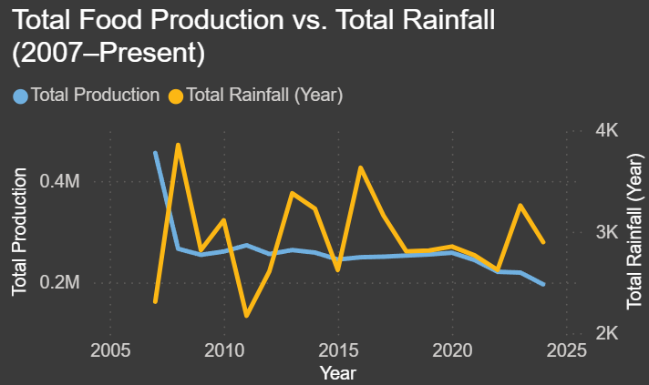

Multi-Line Chart – Climate Trends Over Time

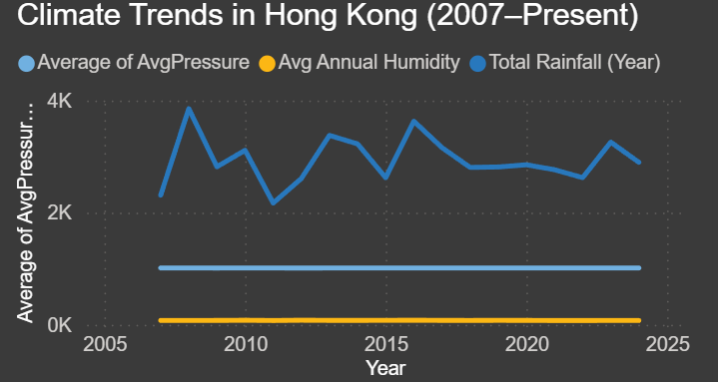

Bar Chart – Top 5 Food Categories by Total Production

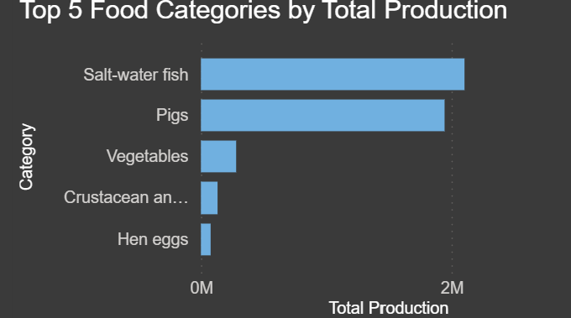

Scatter Plot Matrix – Climate Variables vs. Production

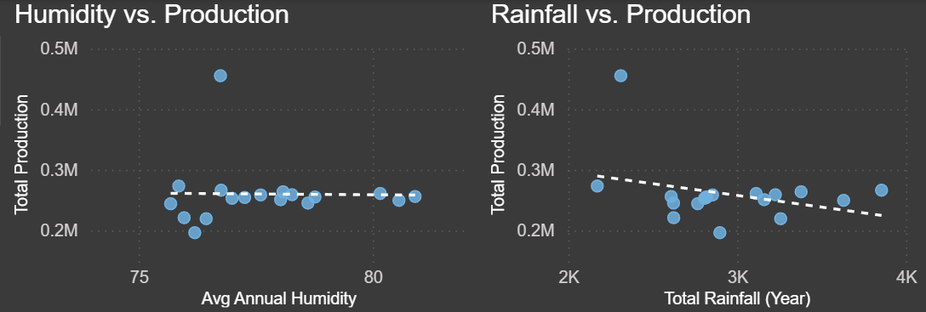

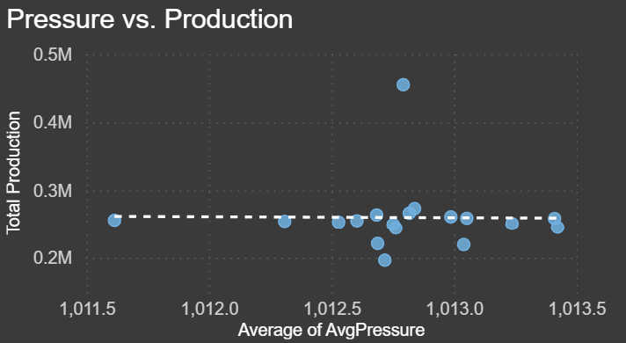

Matrix/Heatmap – Production by Category and Year

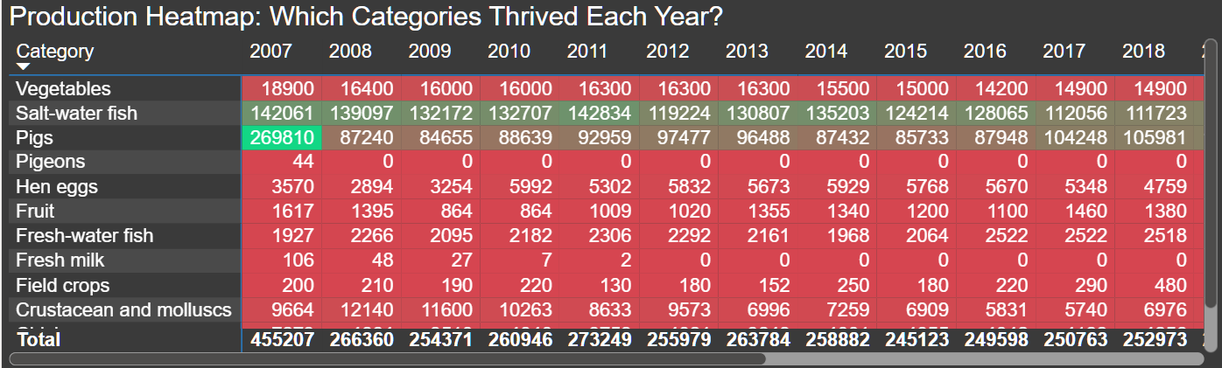

Ribbon Chart – Ranking Changes Over Time

