BurnDown Chart:

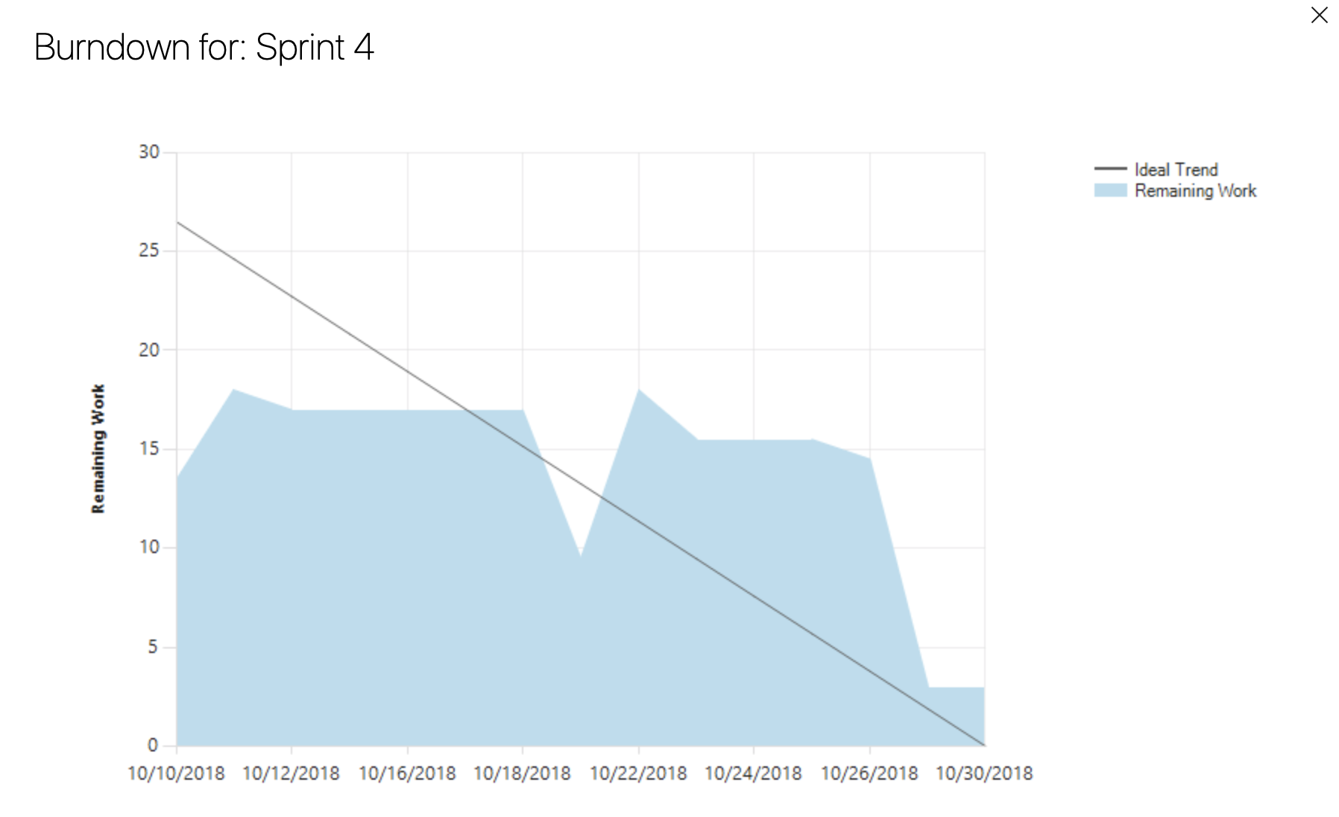

For the Sprint 4, we have much more work than Sprint3 and previous work, so the number of remain work become larger than before. At the first, since we have some problem with how to start, so neither of us start of our work. It keeps several days to make the work load be flat. Then we know how to start. So, we start our work and make a sharp decrease of the remaining work.

Then after the initial implementation. We make more tasks on refractory, like rewrite the physics and jump for Mario. That takes us some time to handle that problem. Also, while we are doing the refractory work, we also come across some problem. Since we leave some problem with Mario big and small jump, some collision issues. That takes us sometime to handle that problem to finish our work. That cause another flat line on the remaining work. At last few days, we know how to handle the situation and fix that problem, we try our best to fix that problems.

Overall, although the burn down looks weird and quite different than other’s work, however, we tried our best to fix these problem in order to have a good Mario game.