Burndown chart report: Oirma

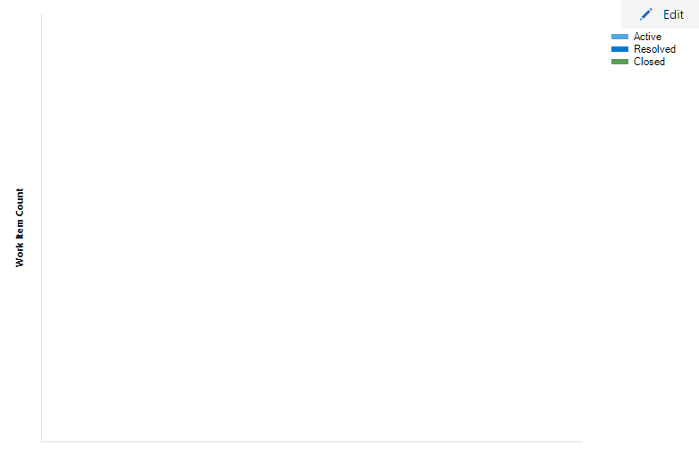

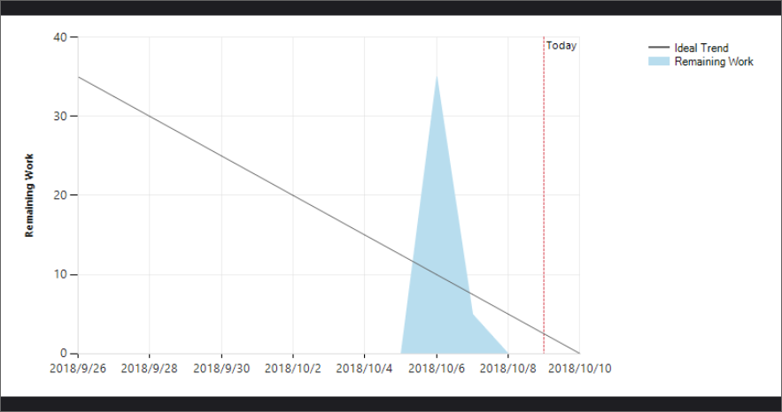

In our burndown chart, since there is a person dropped from our group, we must rebuild our VSTS and make a new project for sprint 3 and our future works. Therefore, our burndown chart looks not so normal: all our task seems to be built at one day and being done by one or two days near the due date. But our true schedule is not like that. We arrange a meeting right after the sprint 3 assigned date and we work together to make all the task.

Then, after picking our own task, we uploaded and talked about our work during days every day and went to office for help. Our time for implementation is well-scheduled and we are even able to get ahead and make the first implementation done one day earlier than due day and start changing codes based on the code quality.

On the refectory, we spend most of the time fixing warnings and making our class cleaner, we all get us own work and we can merge our work before the due date. I really think this is a great start. If we keep following the schedule like this, we will be able to meet every due date and have spare time for improving our code.