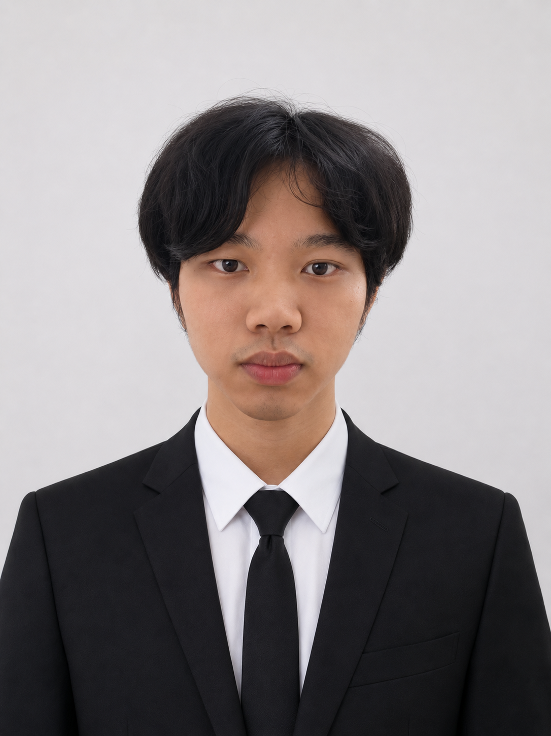  CONTACT  Phone number: 010-2713 519  Email: ahchai0212@gmail.com  Address: Bahau, Jempol, Negeri Sembilan  Itch.io link: ahchai0212.itch.io  Linkedin: www.linkedin.com/in/wen-kiat-chai-626160408  EDUCATION  Bachelor of Game Development  Universiti Teknikal Malaysia Melaka (UTeM)  Expected: April 2027 | CGPA: 3.68 / 4.00  TECHNICAL SKILLS  Languages: C++, C#, Java, HTML, CSS, JavaScript, MySQL  Game Engines: Unreal Engine 5, Unity, GDevelop, Raylib  3D / Design: Blender, Adobe Illustrator  Video & Audio: Premiere Pro, After Effects, CapCut, Audacity  Dev Tools: Visual Studio 2022, VS Code, XAMPP  Web / Scripting: Three.js, HTML/CSS/JS, MySQL  SOFT SKILLS  Communication  Teamwork  Problem-Solving  Fast Learner  LANGUAGES  Malay  English  Mandarin  Cantonese  Japanese  CO-CURRICULAR  Game Jam Participant  Developed functional game prototypes under strict time limits, demonstrating rapid prototyping and creativity under pressure. | CHAI WEN KIAT  Game Development Graduate  ABOUT ME  Final-year Game Development student at UTeM with a strong CGPA of 3.68, passionate about creating engaging interactive experiences. Proficient across multiple game engines and programming languages, with hands-on experience in solo and team projects spanning mobile, PC, and browser platforms. Actively seeking an internship in Game Development, Programming, QA Testing, Backend Development, or AI Prompt Engineering.  PROJECTS & PORTFOLIO  Shadow House — Individual · Final Year Project · Sole Developer  Unity | C#  - Designed and built a horror educational puzzle game from scratch — responsible for gameplay programming, real-time hunter AI, level design, and UX flow.  Turn-Based RPG — Group Project · Game Programmer  Unreal Engine 5 | Blueprints  - Engineered core combat systems using Blueprints, including action queuing, turn management, and win/loss logic, then collaborated on system integration and playtesting.  Light's Gone — Mobile Game — Individual · Mobile Developer  Unreal Engine 5 | Android SDK & NDK  - Developed and deployed a complete Android game solo — configured the full SDK/NDK toolchain and optimised assets for mobile hardware.  Train Ticket Booking System — Individual · Full-Stack Developer  C++ | XAMPP | MySQL  - Built a full-stack ticket booking app in C++ with a MySQL backend, implementing input validation and persistent data storage via XAMPP.  Zombie Shooting Game — Group Project · Programmer & 3D Artist  Unity | C# | Blender  - Modelled and rigged original 3D characters in Blender, then authored C# scripts for character behaviour, shooting mechanics, and enemy wave management.  Local Multiplayer Car Game — Group Project · UI/UX & Blueprint Developer  Unreal Engine 5  - Designed all menus, HUD elements, and scene transitions, and implemented Blueprint logic to manage multiple local players in a single game instance.  Farm Simulator — Group Project · Frontend Developer  Three.js | HTML / CSS / JavaScript  - Built the resource management system in JavaScript, handling game-state logic for planting, harvesting, and inventory tracking in a 3D browser environment.  Ninja Legend — 2D Platformer — Individual · Sole Developer  GDevelop  - Independently designed and built a complete 2D side-scrolling platformer with character movement, slash combat, and level progression.  Game Trailers & Advertisements — Individual & Group · Video Editor & On-Screen Talent  Adobe Premiere Pro | Adobe After Effects  - Planned, filmed, and edited a Hitman-inspired game trailer for YouTube; also acted as on-screen talent and editor for a Sifu-themed action sequence and a 100Plus brand ad.  Open to internship opportunities in Game Development, Programming, Video/Audio Editing, QA Testing, Backend Development & AI Prompt Engineering

