Readme

This program mainly uses VGG16 to extract the feature of the image and then implements Kmeans for clustering.

1. Data Preprocessing

Since the input of VGG16 is 224\*224, the size of the picture is unified into the size of 224\*224, and the pictures are normalized, that is, each channel is normalized separately.

2.Feature Extraction

Use VGG16 to extract features, the main use is the flattening feature of VGG16 after the last pooling.

3.Dimensionality Reduction

The features extracted by VGG16 have a 25088-dimension, which is extremely inefficient if directly utilized by Kmeans. Therefore, I consider using PCA for dimensionality reduction, which retains 99% of the information and the resulting dimension is 4390. It can be seen that PCA dimensionality reduction can eliminate most of the redundant information.

4.Clustering

The above obtained features are clustered using the Kmeans algorithm. The K value is mainly obtained by experiment, K=10 (optimal).

5.Results

Below are some examples of each category, as shown below. From the following results, it can be seen that with the features extracted by the pre-trained VGG16, after clustering, the same semantic pictures can be grouped together according to certain semantic information, and so the expected outcome is achieved!

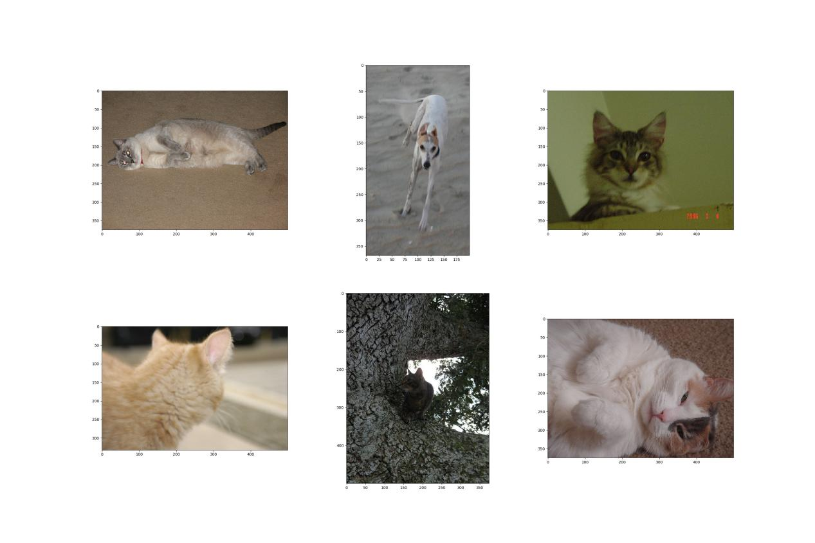

1

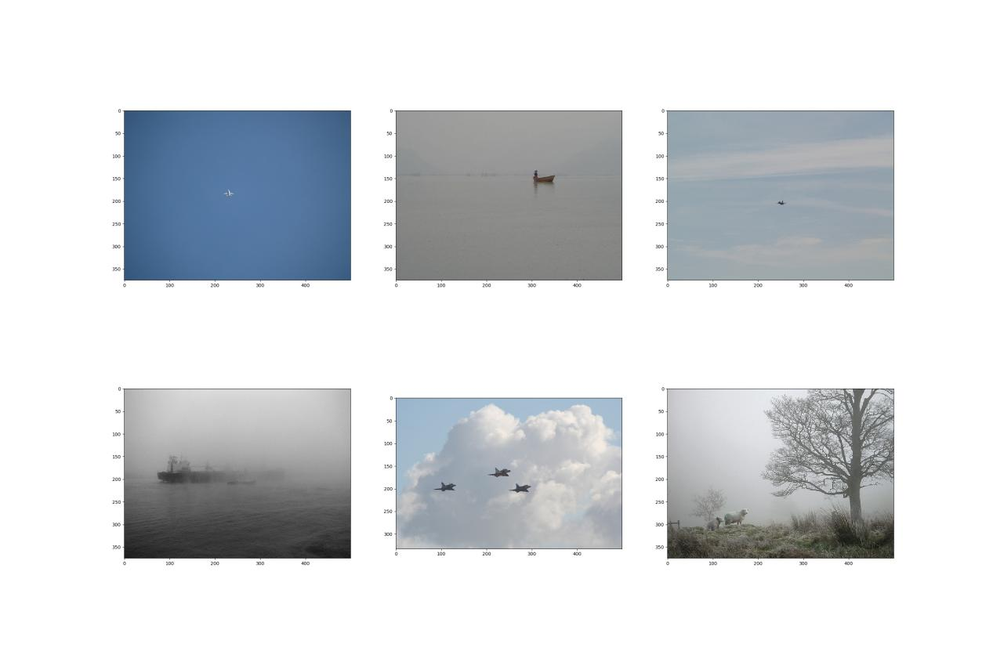

2

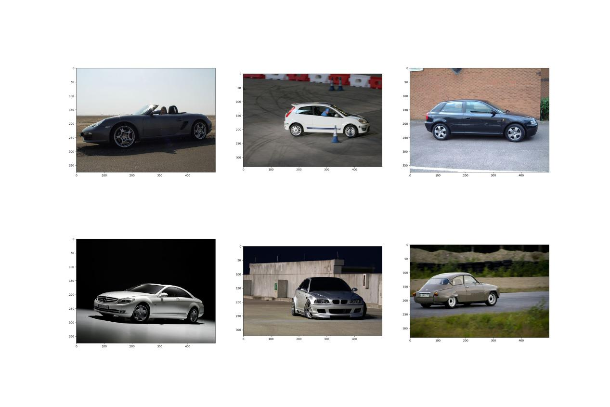

3

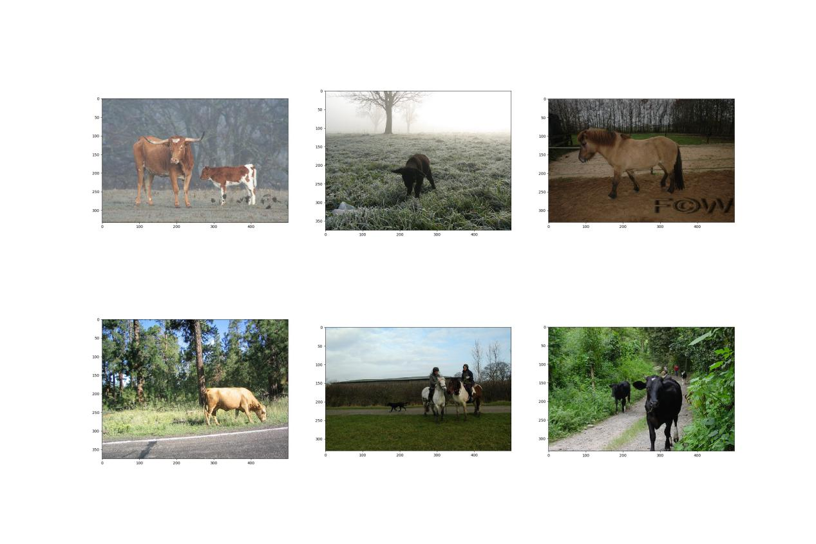

4

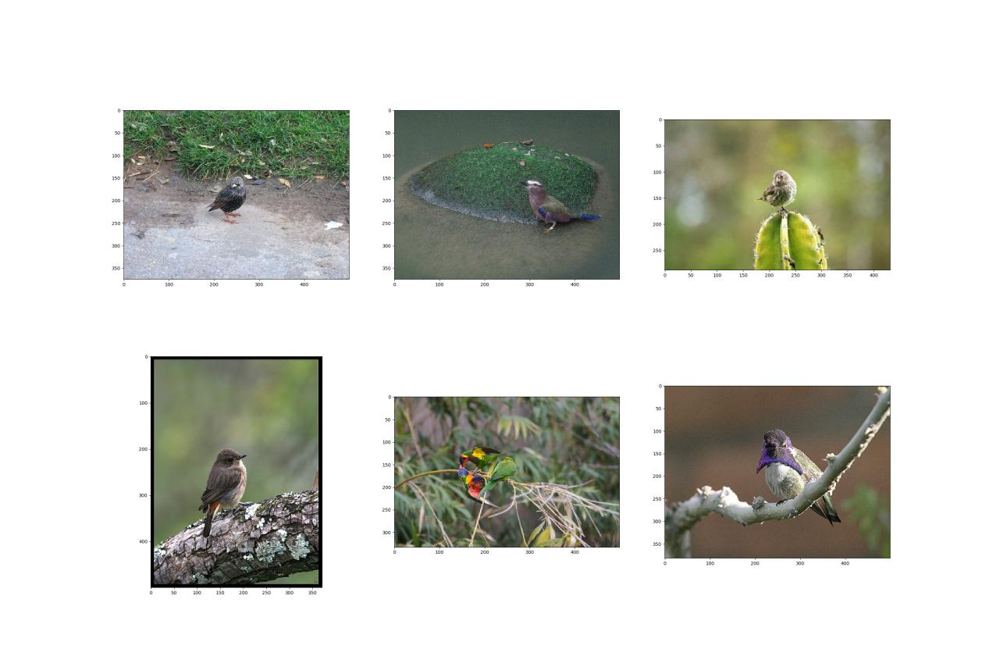

5

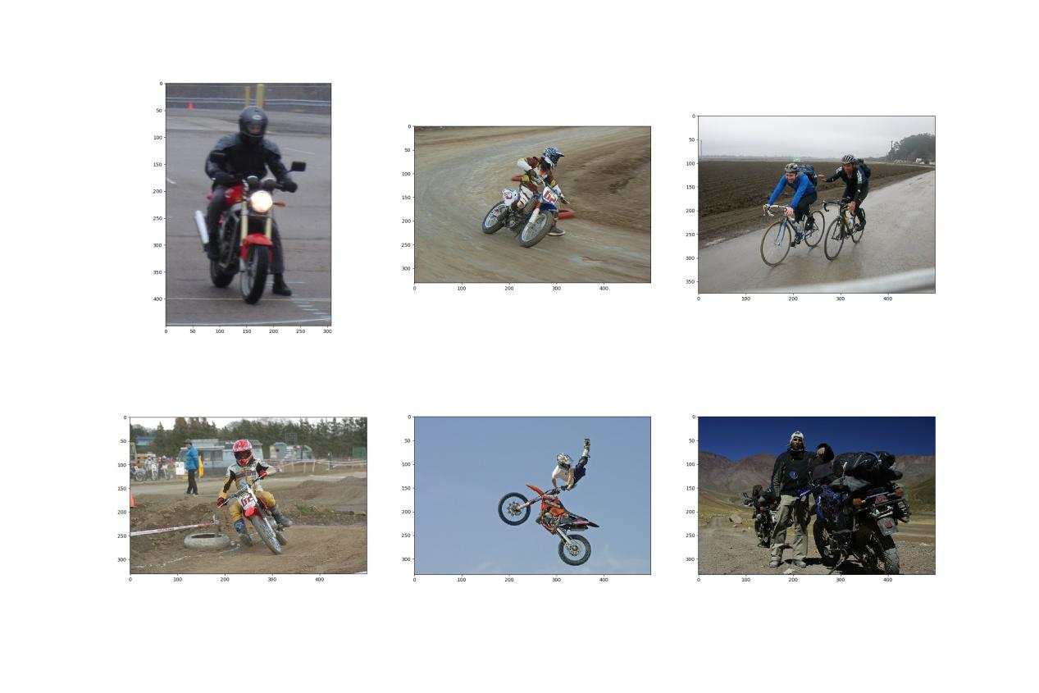

6

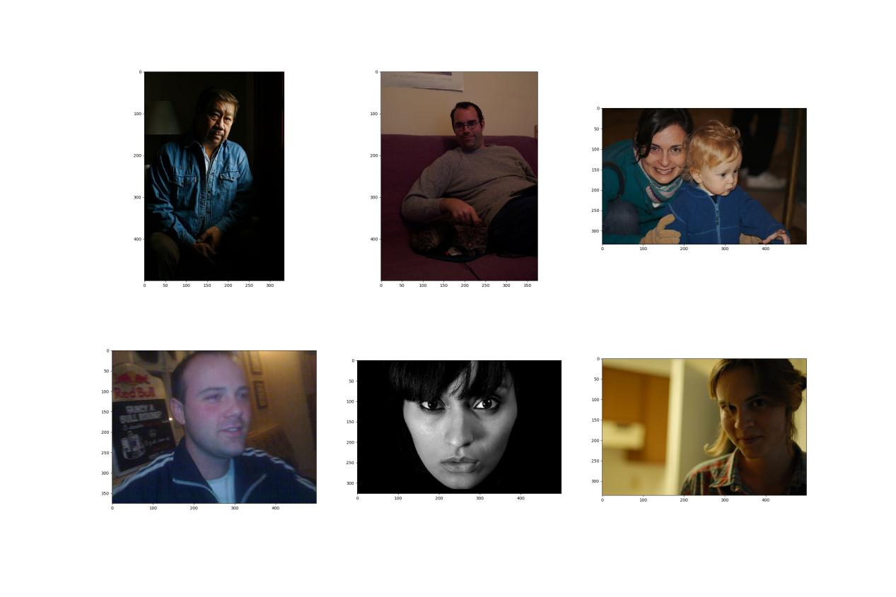

7

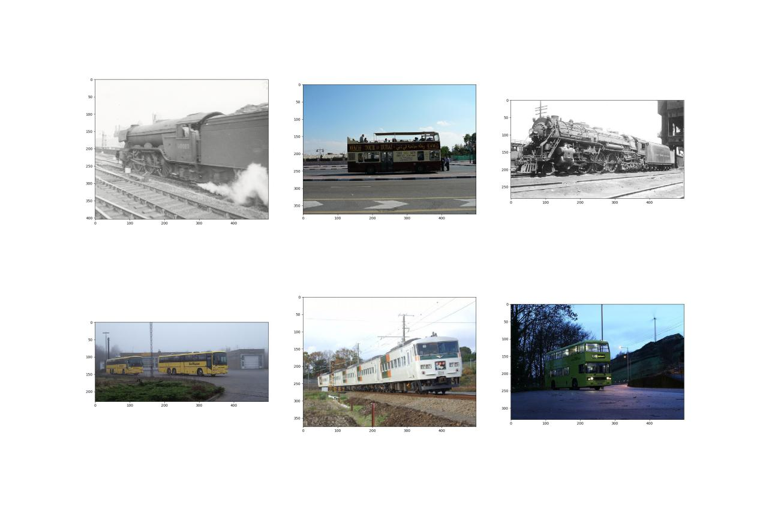

8

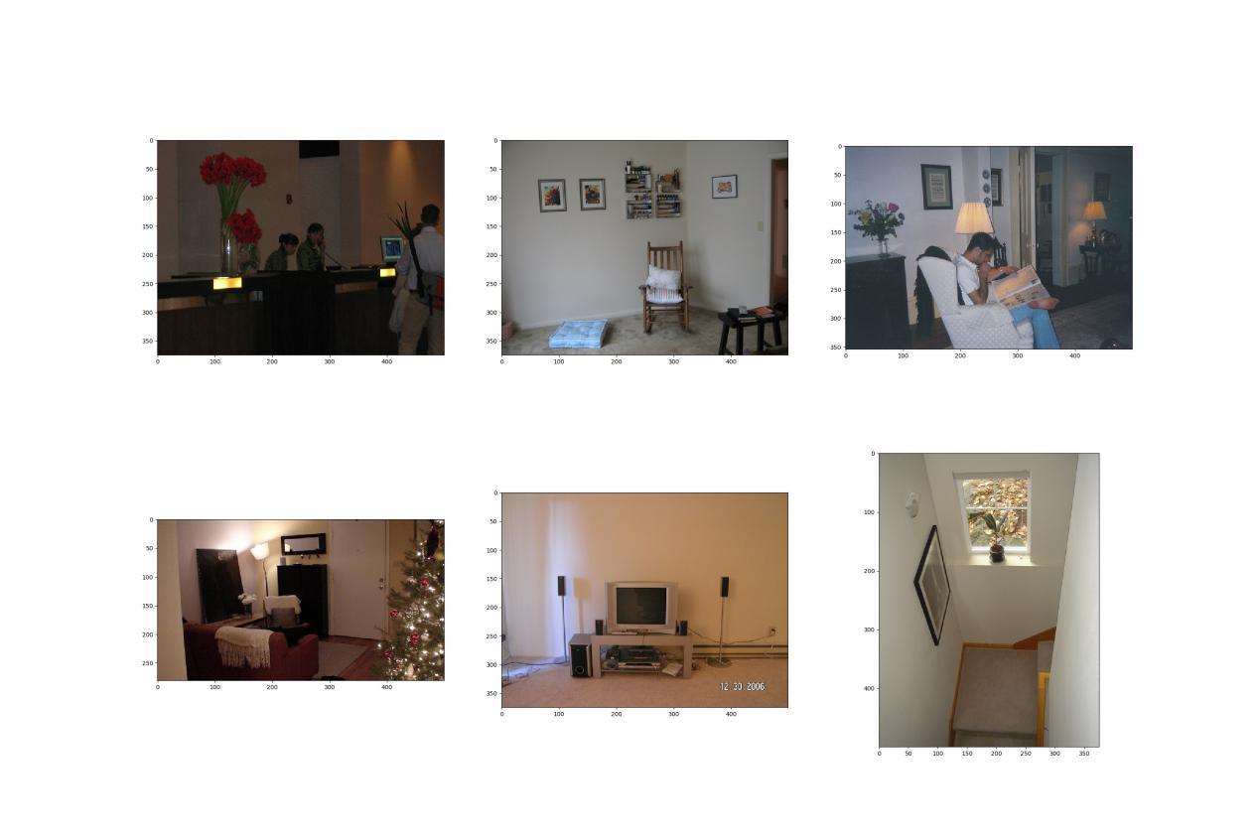

9

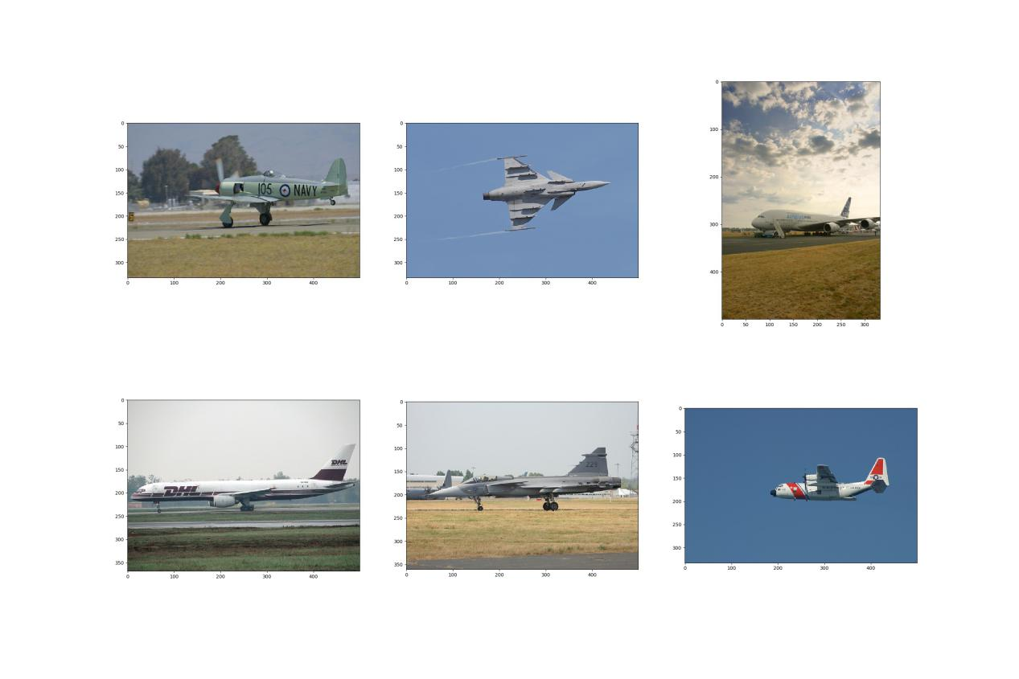

10