Fill in the cover sheet carefully
Course/ Programme | : | Diploma in Software Engineering
Module/ Code OR Subject /Code | : | Software Design / SED2413
Title of Assignment | : | Group Assignment
Lecturer Name | : | Celine Haren Anak Paschal
Session | : | August 2025
Submission Date | : | 28th November 2025
Due Date | : | 28th November 2025
*Please refer to the student handbook on late submission rules.

No. | Name(s)  [Use BLOCK LETTERS according to I.C/ Passport] | Student ID Number | Student(s) Declaration:  I hereby declare that I am aware of the college policy on plagiarism in coursework as detailed in the handbook. The assignment submitted herewith does not have any plagiarised content.
1 | Chong Kuok Fui | EW5728 | Chong
2 | Lim Jia Hong | EW5757 | Lim
3
4
5
*For group work, all group members must enter their names, student ID numbers and sign the Student Declaration.

CHECKLIST:
If the following are not met, the assignment will be penalised with a 10% reduction of the marks awarded.

Have you understood all the question(s)?
If there is more than one question in the assignment brief, have you answered them all?
Have you check for presentation, formatting and appropriate use of the English language?
Have you submitted the assignment to TurnItIn and is within the allowable similarity percentage?

Have you submitted the hard copy of the assignment?

Revised by Academic Department @ 29 September 2023

Table of Contents
1.0 Part A – System Overview 3
1.1 Introduction to CodeConnect 3
1.2 The Problem Statement 4
1.3 Purpose and Core Objectives 4
1.4 Intended Users 5
2.0 Part B – Modeling and Diagrams 5
2.1 Use Case Diagram 5
2.1.1 Detailed Explanation 6
2.2 Activity Diagram 6
2.2.1 Detailed Explanation 6
2.3 Class Diagram 7
2.3.1 Detailed Explanation 7
3.0 Part C – Design Patterns 8
3.1 Model-View-Controller (MVC) Pattern 8
3.1.1 Implementation in CodeConnect 8
3.1.2 Justification and Benefits 9
3.2 Factory Method Pattern 10
3.2.1 Implementation in CodeConnect 10
3.2.2 Justification and Benefits 11
4.0 Part D – GitHub Collaboration 12
4.1 Our Collaborative GitHub Workflow 12
4.2 Documentation and Project Management 13
4.3 Contribution Summary 13
4.4 Repository Contents 14
5.0 References 15

1.0 Part A – System Overview

1.1 Introduction to CodeConnect
CodeConnect is a proposed software platform that is aimed at improving and structure the collaborative experience of teams developing based upon GitHub. It is something like a smart layer in combination with GitHub that aims to address everyday problem areas in repository maintenance, interaction between teams, and the review of the code. It is not about the replacement of GitHub but rather the extension of it with additional functionality to facilitate improved communication, faster feedback loops, and efficient project management without having to leave it

1.2 The Problem Statement
Collaborative software development is the natural result of modern software development, and the tools represent a potent, yet frequently fragmenting, workflow. A number of challenges are associated with teams:
- Poor Code Reviews: Code review by hand may prove to be a bottleneck, particularly with large teams. Switching between contexts and waiting on a colleague to review can be an extremely slow way to develop.
- Scattered Communication: Codes are discussed in pull requests, general team communication may occur on different platforms such as Slack or Microsoft Teams, and result in the loss of context and information silos.
- Problematic Project Onboarding: Other team members find it difficult to know the structure of the project, the standards of coding and the branches of active development, which adds time to their productivity.
- Minimal Automated Intelligence: GitHub is only partially automated with respect to suggesting proactive intelligent recommendations to developers on code quality and code best practices during development, and not after the fact.
CodeConnect will help tackle these particular concerns by designing a smarter and more unified cooperation centre.

1.3 Purpose and Core Objectives
CodeConnect is mainly aimed at enhancing the productivity of the software teams and the quality of its code through decelerating the acuity of the daily process of the software team. Its core objectives are:
- To expedite the process of code review by using AI-based suggestion systems.
- In order to make communication within the team central, we need to attach conversations to code commits and pull requests.
- To offer user friendly tools in managing the repository and branch, to simplify the process of locating projects to all.
- To provide practical recommendations regarding project health and team action to the leads and managers.

1.4 Intended Users
The system has three key user personalities:
- Developers: They will manage their daily activities with the help of CodeConnect to push code, which will get instant automated feedback, reviewing of their code, and interact with their respective teams without stepping out of their development environment. They have access to quicker feedback and better context of the tasks.
- Team Leads/ Project Managers: This group is using the system to monitor the progress of a project and individual and team contributions, access repositories and monitor that coding standards are being upheld. They are advantageous in the fact that they have a premium dashboard and smoothed out oversight.
- New Team Members; CodeConnect will include onboarding checklists, and project wikis, which will be incorporated with the codebase. They enable new developers to get a quick insight into the architecture of the project, the conventions of the code and the workstreams that have been underway to develop and thus enable their ramp-up time to be shorter.
In summary, CodeConnect seeks to become the brain of a software team, such that the complicated team effort of collaborative coding is made more structured, accessible and effective.

2.0 Part B – Modeling and Diagrams

2.1 Use Case Diagram

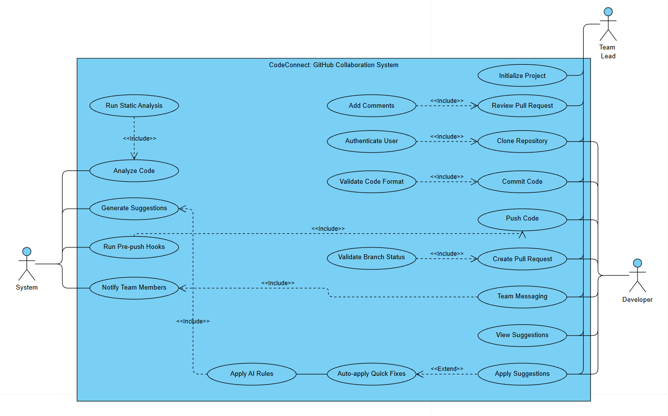

2.1.1 Detailed Explanation
Our Use Case Diagram will give an overview of how the system's functionality from the perspective of the main users, or of its actors. The first actors which we have identified are the System, the Team Lead and the Developer.
The diagram has been laid down into major areas of operations. In the case of Repository Management, Developers and Team Leads are capable of executing fulfilling Git functions that include clone repository, commit code as well as pushing its modification. Nonetheless, there is the Increase use case of initialize New Project which is extended solely to the Team Lead considering that there is a greater degree of responsibility and control on project creation.
The Collaboration module is at the point of value proposition of CodeConnect. It also has features such as Creating Pull request, review Pull request and a specialized Team message feature. The system is a messaging platform that aims to minimise context-switching because developers can discuss any specified feature or bug in the platform itself. Developers and Team Leads engage in these cases of collaboration.
Two important innovations in CodeConnect are the Automated Code Review system and the Automated Code Review system. In this case, the System actor is in the act. Upon the code being pushed by a developer (an extension of the "Push Code" use case), system will invoke the "Analyze Code" use case. It can consist of a code inspection of the code being static and not necessarily artificial intelligence checks on style and complexity, as well as typical vulnerabilities. The results are then bundled in as the package generate review suggestions that is offered to the Developer. The Developer can then view suggestions and implement these Suggestions to establish a very strong feedback loop, which does not necessarily depend on the human factor. This diagram was essential in making sure that we identified the entire user interactions and bordered the user roles and the automated system functionality.

2.2 Activity Diagram
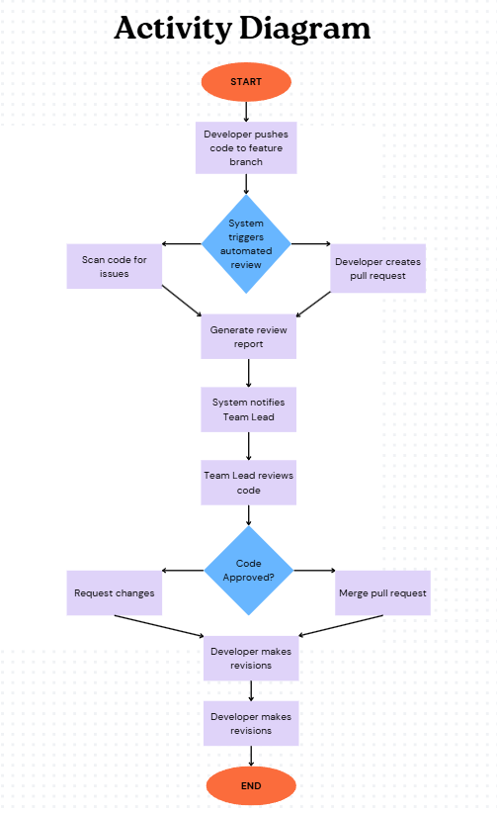

2.2.1 Detailed Explanation
The workflow we chose to model using our Activity Diagram is the End-to-End Code Review Workflow since it is a fundamental, multi-actor process in the CodeConnect. The diagram illustrates the overall process of completion of the code to successful integration with an emphasis on the decisions and the concurrent activities.
The first node in the workflow is an indication that a Developer is ready to complete working on a new feature or a bug fix. The initial step is Pushing of code to Feature Branch. This gesture is a signal, which induces two parallel flows. The original flow is connected to the System itself that triggers Automated Code Review. This subsystem in turn Scans the Issues (e.g. syntax errors, security smells, style violation) and then it Generates a Report.
At the same time, in the second parallel, the Developer has to Make a Pull Request, in which they request formally that their changes are to be incorporated into the main codebase. When the pull request is made and automated report is prepared the flows sync. The system informs Team Lead of the new pull request and it adds the automated review report.
The Team Lead is then expected to conduct the Manual Review of Code in which he or she reviews the code that has been written by the human as well as the code generated by the system. This causes a decision node [Code Approved?] to appear critical. When the answer is "No," the Team Lead Requests Changes and the process reminds of the Developers whose job is to Make Revisions and push the code back to the automation and the process restarts. This loop can repeat itself several times.
In the case of the response in the decision node is yes, the workflow undergoes the Merge Pull Request action and successfully incorporates the code. The last operation, which is carried out by the system, is to Close Feature Branch cleaning up the repository. This diagram was also used in visualizing the intricate chain of events and finding possible bottlenecks which in this case included the reliance on the Team Lead to review the records manually which facilitated us to develop notifications and prioritization part of the feature to limit the delays.

2.3 Class Diagram

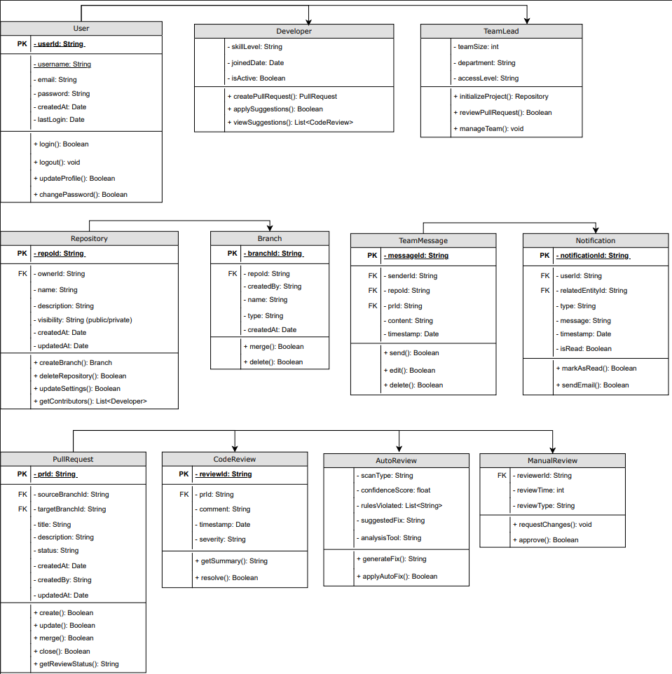

2.3.1 Detailed Explanation
The Class Diagram of our system is the detailed plan of the CodeConnect system, this plan delineates the structure of the system in static terms by displaying the classes, attributes, methods, and the relationships between the classes. It converts the operation requirements of the use cases into a technical design.
There are some fundamental classes on which the diagram is constructed. The User class is an abstract base class that has some common attributes such as user Id, Username, email address and password. There is the generalization of this class via inheritance in that we have the subclass of Developer and TeamLead. This structure enables specification of role particular characteristics and techniques in future without making any changes to the fundamental user structure.
The Repository class is the core of the model and it has the attributes like repository id or repoId, name and description. It is at the one to many composition relationship with the Branch class (a repository has one or more branches), that is, the lifecycle of a Repository is linked to that of a Branch. The Repository is linked to a TeamLead (the owner), though it may have many Developer contributors in its association which is of a many-to-many nature.
Another main object is the PullRequest class. It contains such properties as prId, title, description, and status. Importantly, it has two associations with the Branch class the sourceBranch (changes in) and targetBranch (changes out). ). This accurately reflects the real-world relationship.
CodeReview class highlights application of inheritance and an application of Factory pattern that we used. It limits common attributes such as comment and reviewId. CodeReview has specializations, AutoReview and ManualReview. AutoReview has such attributes as scanType and confidenceScore and ManualReview has a reviewerId which relates to a User. Each PullRequest may host many CodeReview objects (including automatic and manual) and it is a gorgeous representation of the polymorphism achieved by us through design.
This systematic approach will make certain that our system will be designed on the basis that is flexible toward scaling, maintenance, and understandability since each of the classes has one, unproblematic duty.

3.0 Part C – Design Patterns
Design patterns in software engineering refer to solutions to the general problems that have been proved. Use of them is important in creating systems that are simple to comprehend, change, and expand. In the case of CodeConnect, we have used two basic patterns, Model-View-Controller (MVC) and the Factory Method.

3.1 Model-View-Controller (MVC) Pattern

3.1.1 Implementation in CodeConnect
The MVC pattern divides an application into three interconnected components to separate internal representations of information from the ways that information is presented to and accepted from the user.
- Model: The Model has a representation of the primary data and business logic of CodeConnect. It includes the objects which are places in our Class Diagram like User, Repository, PullRequest, and CodeReview. The Model is in charge of handling the data, applying business constraints, for example “only a TeamLead has the authority to delete a repository”, and communicating with the database. It is totally ignorant of the user interface.
- View: The view is what the user sees and interacts with on his or her web browser, which is called the presentation layer. The View of the CodeConnect includes all web pages: the dashboard with repositories and the pull request diff view, the interface with the review of the original code, and the team chat. This is its only task, which is to show the information provided by the Controller and provide user requests (clicks and submitting the form) to the Controller.
- Controller: This is the Controller who serves as an intermediary. It takes user inputs and View, communicates with the corresponding Models to do this or fetch information and decides on which View to be displayed next. To give an example, in case a user postulates a new pull request (View), the Controller authenticates the request and invokes the PullRequest Model create() method and redirects the user to the newly created pull request page (View).

3.1.2 Justification and Benefits
We chose MVC as the architectural pattern for CodeConnect because it is the industry standard for building scalable and maintainable web applications.
- Better Modularity: The recognition of concerns makes developers be able to work on the different aspects of the application at the same time. The View can be developed by a UI/UX designer as HTML/CSS without any regard to the logic on the back-end and the Model can be developed by a back-end developer without understanding how the data will be presented.
- Greater Maintainability: In case we should change the business logic such as how the code review is being scored, we would just need to change the CodeReview Model. The View and the Controller are not manipulated. Likewise, we would be able to make any update on the user interface altogether without doing any modification to the data structures.
- Greater Reusability: The same Model that can be used to support various types of Views is a Model that contains all the business logic. As a case in point, the same Repository Model can be used to deliver data to our web View and a future native mobile app View and each of them has its own Controller to control the specific flow of user interaction.

3.2 Factory Method Pattern

3.2.1 Implementation in CodeConnect
The Factory Method pattern establishes an interface that must be used in the construction of an object, but allows the subclasses to vary the type of objects that should be constructed. This pattern was used in order to manage the generation of various kinds of CodeReview objects.
- To an abstract interface, like CodeReviewFactory, we added a method signature such as createReview(reviewData).
- Then we carried out two concrete factory.
- classes included like AutoReviewFactory and ManualReviewFactory.
- Upon completion of the scan of the automated analysis engine, the system creates an AutoReview object with the help of the AutoReviewFactory and populates it with scan results.
- A comment posted by a user (Developer or Team Lead) on a pull request results in the system creating a ManualReview object through the ManualReviewFactory, and associated with the ID of the user.
The central application code will not need to be aware that it is creating an AutoReview or a ManualReview: it just invokes the createReview method on whoever is factory on the case at hand.

3.2.2 Justification and Benefits
This pattern was ideal to the issue of generating the related yet different types of review objects.
- Facilitates the ability to expand and be versatile: This is the most valuable advantage. Suppose that we would wish to incorporate a third category of review in the future, say an AISecurityReview, an AI-based model that will identify security vulnerabilities. Under the Factory Method we only need to make a new AISecurityReviewFactory class and define the createReview method. The code which is currently in place, requesting a review creation, does not require to be changed. Making the system very versatile to new requirements is a result of this open for extension, closed for modification principle.
- Hides Object Creation Logic: Objects are created by the Factory Method which gathers all the complicated instantiating logic. It is the AutoReviewFactory which is informed of what information and parameters it requires when creating a valid AutoReview object. This makes the client code (e.g., the service that accepts the webHooks with the webHooks posted by GitHub) simple and clear since it does not get complicated with the specifics of object construction.
- Improves the Readability of the Code: The code is made more self-documenting, due to descriptive factory names such as AutoReview factory.createReview. One can instantly tell the type of object under construction, and this enhances the general maintainability and readability of the codebase.

4.0 Part D – GitHub Collaboration
In this project, we did not simply design a Git-Hub collaboration system, we experienced it through using GitHub as the main collaboration system. This enabled us to get a feel of the working processes and difficulties.

4.1 Our Collaborative GitHub Workflow
We used a feature-branch workflow, a common solution to software development by multiple people.
- Repository Init: Chong has established the central GitHub repository called Codeconnect-SED2413 and established the procedural permissions including the invitations of all the rest of members as collaborators with write permissions.
- Branching Strategy: The source of truth was safeguarded. Each new task (e.g., creation of the use case diagram, the MVC section) would result in a new descriptively named feature branch off of main (e.g. feature/use-case-diagram, feature/activity-diagram, feature/mvc-pattern).
- Development and Committing: Every member in his or her branch worked independently on his or her assigned work in the feature branches. We used commuted files a lot with their specific and description messages like, "feat: add provisional class diagram containing User and Repository objects' classes" or documents: widen MVC definition with practical instances. This gave a distinct and comprehensible history of our development.
- Pull Requests and Code review: A member would open a Pull request (PR) after the completion of one of the features went to main in a feature branch. This was a critical step. One of our fixtures was that the PR had to be examined by one more team member before it could be combined. Accuracy, completeness and compliance would be checked by reviewers and the agreed standards (e.g. labeling diagrams, formatting reports etc.) would be checked. On the PR itself, comments and discussions occurred in a manner similar to a direct copy of the code review process we were designing with CodeConnect.
- Merge and Deployment: Once a PR has been passed the original author would merge the same into the main branch. To maintain the history of the main branch, we selected an option called squash and merge in GitHub. The main branch was always the foundation of our final report and documentation and this gave it the advantage of being the latest team integrated work.

4.2 Documentation and Project Management
- README.md: README.md is a well-documented file that is used as the home page and is the name of our repository. It contains the purpose of the project, a guide to a quick start as well as a detailed walkthrough of the repository structure (e.g. /docs for reports, /diagrams for source files) and a complete list of contributors with links to their GitHub profiles.
- GitHub Projects: This Kanban board is a simple tool that we used to monitor our tasks by using GitHub Projects. It included columns to do, in progress, under review and done. Every task was developed as a problem and included in the project, which provided us with a visual picture of our stage and the distribution of workload.

4.3 Contribution Summary
The members of our group were all active and contributing members. This is evident through the transparent record of the GitHub repository; the Insights tab and the commit/PR history. Distribution of contributions was good:
- Chong: In charge of the System Overview, Use Case Diagram, and the overall report integration.
- Lim: In charge of the Activity Diagram and the description of the MVC pattern in details.
- Lim: In charge of the Class Diagram and the detailed explanation of the pattern of the Factory Method.
- Chong: was in charge of GitHub repository configuration, collaboration documentation (Part D), and the development of presentation slides.

4.4 Repository Contents
Our GitHub repository is completely filled and has:
- README.md: Brief our project overview and documentation.
- SED2413CodeConnectReport.pdf: This is the entire report.
- docs: Folder with the report in (.docx) format.
- diagrams: Folder with the source of all the diagrams (e.g. in .drawio, .puml or in XML format).
- presentation: Folder with complete presentation slide (no more than 8 slides).
Repository Name: codeconnec-SED:2413
Repository Link: https://github.com/ahchong14/codeconnect-SED2413

5.0 References
Gamma, E., Helm, R., Johnson, R., & Vlissides, J. (1994). Design Patterns: Elements of Reusable Object-Oriented Software. Addison-Wesley Professional.
Martin, R. C. (2008). Clean Code: A Handbook of Agile Software Craftsmanship. Prentice Hall.
Wikipedia contributors (2025a) Factory method pattern. https://en.wikipedia.org/wiki/Factory_method_pattern (Accessed: November 12, 2025).
Wikipedia contributors (2025a) Model–View–Controller. https://en.wikipedia.org/wiki/Model%E2%80%93view%E2%80%93controller (Accessed: November 12, 2025).
Wikipedia contributors (2025e) Unified modeling language. https://en.wikipedia.org/wiki/Unified_Modeling_Language (Accessed: November 12, 2025).

