Walmart Near-Real-Time Data Warehouse Project Report
Executive Summary
This report presents the design, implementation, and analysis of a near-real-time Data Warehouse (DW) prototype for Walmart using the HYBRIDJOIN stream-relation join algorithm. The system enables dynamic processing of transactional data streams enriched with master data to support timely business insights and decision-making for one of the world's largest retail chains.

1. Project Overview
1.1 Business Context
Walmart serves millions of customers daily across physical stores and online platforms, generating massive volumes of transactional data. To optimize sales and enhance customer satisfaction, the organization requires near-real-time analytics capabilities that enable:
- Dynamic promotional strategies
- Personalized customer offers
- Immediate inventory optimization
- Real-time sales performance monitoring
1.2 Technical Challenge
Traditional batch ETL processes introduce latency that prevents timely decision-making. The key technical challenge is enriching incomplete transactional streams with master data while maintaining near-real-time processing speeds. This requires:
- Stream Processing: Handling continuous, potentially bursty transaction data
- Data Enrichment: Joining streaming data with large, disk-based master relations
- Scalability: Managing memory constraints while processing high-volume streams
- Performance: Minimizing latency between transaction occurrence and analytical availability
1.3 Solution Architecture
The implemented solution consists of three primary components:
Data Sources:
- Transactional Stream: Customer purchase records (Order ID, Customer ID, Product ID, Quantity, Date)
- Customer Master Data: Demographics (Gender, Age, City Category, Marital Status, Occupation, Residence Duration)
- Product Master Data: Product details (Category, Price, Store, Supplier information)
ETL Pipeline:
- Stream Reader Thread: Continuously ingests transactions from CSV into a bounded buffer
- HYBRIDJOIN Processor Thread: Performs stream-relation joins using the HYBRIDJOIN algorithm
- Transformation Logic: Derives time dimensions and calculates measures (Total Amount = Price × Quantity)
Data Warehouse:
- Star schema design with fact and dimension tables
- MySQL database with optimized indexes for OLAP queries
- Materialized views for frequently accessed aggregations

2. Data Warehouse Schema Design
2.1 Star Schema Architecture
The data warehouse implements a star schema with one central fact table surrounded by multiple dimension tables. This design optimizes query performance for analytical workloads while maintaining data integrity.
2.2 Dimension Tables
dim_customer (Customer Dimension)
Stores comprehensive customer demographic information for segmentation analysis.
Column | Type | Description
Customer_ID (PK) | INT | Unique customer identifier
Gender | VARCHAR(10) | Customer gender
Age | VARCHAR(20) | Age bracket
City_Category | VARCHAR(10) | City classification (A, B, C)
Marital_Status | INT | Marital status indicator
Occupation | INT | Occupation code
Stay_In_Current_City_Years | INT | Residency duration
Indexes: Gender, Age, City_Category, Marital_Status, Occupation, Stay_Duration
dim_product (Product Dimension)
Contains product catalog with hierarchical store and supplier relationships.
Column | Type | Description
Product_ID (PK) | VARCHAR(20) | Unique product identifier
Product_Category | VARCHAR(100) | Product classification
Price | DECIMAL(10,2) | Unit price
Store_ID | INT | Store identifier
Supplier_ID | INT | Supplier identifier
Store_Name | VARCHAR(100) | Store name
Supplier_Name | VARCHAR(100) | Supplier name
Indexes: Product_Category, Store_ID, Supplier_ID, composite (Store_ID, Product_Category)
dim_time (Time Dimension)
Rich temporal dimension supporting multiple analytical hierarchies.
Column | Type | Description
Time_ID (PK) | INT | Surrogate key
Date | DATE | Calendar date (unique)
Day_Of_Week | VARCHAR(10) | Monday-Sunday
Day_Of_Week_Number | INT | 1-7 (Monday=1)
Is_Weekend | BOOLEAN | Weekend flag
Week_Of_Year | INT | ISO week number (1-53)
Month_Number | INT | Month (1-12)
Month_Name | VARCHAR(15) | Month name
Quarter | VARCHAR(10) | Q1-Q4
Quarter_Number | INT | 1-4
Half_Year | VARCHAR(10) | H1/H2
Year | INT | Calendar year
Season | VARCHAR(10) | Spring/Summer/Fall/Winter
Indexes: Date, Is_Weekend, Month/Year, Quarter/Year, Year, Season/Year, Day_Of_Week_Number
2.3 Fact Tables
fact_sales (Primary Fact Table)
Central fact table capturing transactional measures at the order-product-customer grain.
Column | Type | Description
Sales_ID (PK) | INT | Surrogate key (auto-increment)
Order_ID | INT | Business key (not unique)
Customer_ID (FK) | INT | References dim_customer
Product_ID (FK) | VARCHAR(20) | References dim_product
Time_ID (FK) | INT | References dim_time
Quantity | INT | Units purchased
Total_Amount | DECIMAL(12,2) | Extended price (Price × Quantity)
Key Design Decisions:
- Order_ID is NOT unique (one order can contain multiple products)
- Total_Amount calculated during ETL to avoid runtime computation
- Composite indexes on (Customer_ID, Time_ID) and (Product_ID, Time_ID) for common query patterns
fact_product_association (Product Affinity Fact)
Captures product co-purchase relationships for market basket analysis.
Column | Type | Description
Association_ID (PK) | INT | Surrogate key
Order_ID | INT | Transaction identifier
Product_ID_1 | VARCHAR(20) | First product
Product_ID_2 | VARCHAR(20) | Second product
Purchase_Date | DATE | Transaction date
Constraint: UNIQUE (Order_ID, Product_ID_1, Product_ID_2) prevents duplicate pairs
2.4 Materialized View
view_store_quarterly_sales
Pre-aggregated quarterly sales by store for performance optimization.
Column | Type | Description
Store_ID | INT | Store identifier
Store_Name | VARCHAR(100) | Store name
Year | INT | Calendar year
Quarter_Number | INT | 1-4
Quarter | VARCHAR(10) | Q1-Q4
Total_Sales | DECIMAL(15,2) | Aggregate revenue
Total_Quantity | INT | Total units sold
Total_Orders | INT | Distinct order count
Refresh Strategy: Refreshed via refresh_store_quarterly_sales() stored procedure after ETL completion
2.5 Schema Benefits
- Query Performance: Denormalized dimension tables eliminate joins for common attributes
- Analytical Flexibility: Multiple time hierarchies enable drill-down/roll-up operations
- Scalability: Indexed foreign keys and composite indexes optimize common query patterns
- Maintainability: Clear separation of facts and dimensions simplifies ETL logic
- Business Alignment: Schema directly maps to analytical requirements (Q1-Q20)

3. HYBRIDJOIN Algorithm Explanation
3.1 Algorithm Overview
HYBRIDJOIN is a stream-relation join algorithm specifically designed for scenarios where a fast-arriving, potentially bursty data stream (S) must be joined with a large, disk-based relation (R). Unlike traditional database joins that operate on static datasets, HYBRIDJOIN processes continuous streams while managing memory constraints.
3.2 Core Data Structures
The algorithm employs four key memory structures:
1. Stream Buffer
- Purpose: Temporary storage for incoming stream tuples during bursty periods
- Implementation: Queue with fixed capacity (10,000 tuples)
- Function: Prevents data loss when stream arrival rate exceeds processing capacity
- Configuration: stream_buffer = queue.Queue(maxsize=10000)
2. Hash Table (H)
- Purpose: Stores stream tuples indexed by join key for efficient probing
- Structure: Multi-map (multiple entries per slot allowed)
- Size: Fixed at hS = 10,000 slots
- Content: Each entry contains (stream_tuple, node_id) pairs
- Hash Function: MD5-based modulo hashing for uniform distribution
3. Join Queue
- Purpose: Maintains FIFO ordering of stream tuples for fair processing
- Structure: Doubly-linked list (Python deque)
- Content: Each node stores `(key, node_id, slot)` tuples
- Function: Tracks arrival order; oldest tuples processed first
- Operations: Efficient random deletions when matches occur

4. Disk Buffer
- Purpose: Holds currently loaded partition of relation R
- Size: vP = 5,000 tuples per partition
- Function: Reduces disk I/O by loading relevant R partitions on-demand
- Strategy: Indexed access to R using join key from queue head

4. Three Shortcomings of HYBRIDJOIN

4.1 Shortcoming #1: Inefficiency with Highly Skewed Join Keys

Problem Description:
HYBRIDJOIN's performance degrades significantly when the join key distribution is highly skewed. If a small number of customers account for a disproportionate volume of transactions (e.g., corporate bulk buyers), the hash table becomes imbalanced.

Technical Impact:
1. Hash Collision Cascades: Popular Customer IDs cause multiple tuples to hash to the same slot, creating long chains in the multi-map structure. Probing these chains becomes O(k) where k can be very large.

2. Queue Stagnation: If the oldest key in the queue corresponds to a customer with thousands of unmatched transactions, the algorithm repeatedly loads the same disk partition while new transactions for other customers accumulate in the stream buffer.

3. Memory Pressure: The hash table fills with tuples for skewed keys, reducing w to near-zero. New transactions queue in the stream buffer, potentially causing buffer overflow and data loss.
Mitigation Strategies:
- Implement dynamic partitioning that splits hot keys across multiple partitions
- Use load-aware scheduling to deprioritize overloaded slots temporarily
- Apply sampling-based key distribution analysis during initialization

4.2 Shortcoming #2: Inability to Handle Late-Arriving Master Data Updates

Problem Description:

HYBRIDJOIN assumes that relation R (master data) is static and pre-loaded before stream processing begins. In reality, master data changes over time (e.g., product price updates, customer address changes, new products added). The current implementation cannot incorporate these updates without restarting the entire ETL process.

Technical Impact:

1. Stale Enrichment: Transactions joined after a master data change contain outdated information. For example:
- Product P01 price changes from $50 to $55 at 10:00 AM
- Transactions after 10:00 AM still use $50 (loaded at startup)
- Revenue calculations become inaccurate

2. Missing Joins: New products added to the catalog have no entries in R_product_dict. Transactions for these products result in:
- No disk partition available for probing
- Transactions discarded from queue without joining
- Data loss in the warehouse

3. No Version Tracking: The schema lacks slowly changing dimension (SCD) support. Historical analysis cannot distinguish between sales at old vs. new prices.

Warehouse Impact:
- Underreported revenue by $5 per unit
- Incorrect price-based analytics

Mitigation Strategies:
- Implement versioned master data with effective dates
- Use incremental refresh threads that update R_customer_dict and R_product_dict without stopping joins
- Apply SCD Type 2 design to track historical attribute changes
- Add master data change streams to trigger re-joining of affected transactions

4.3 Shortcoming 3: Poor Scalability for Multi-Join Scenarios

Problem Description:
The current implementation joins the transaction stream with customer and product master data in a single-pass operation. Real-world DW pipelines often require multiple sequential or parallel joins (e.g., joining with promotions, stores, regions). HYBRIDJOIN's architecture does not scale well to these multi-join requirements.

Technical Impact:
1. Sequential Bottleneck: Extending to multiple joins requires chaining HYBRIDJOIN instances:

Stream → [HYBRIDJOIN 1: Customer] → Intermediate Stream
→ [HYBRIDJOIN 2: Product] → Fact Table
Each stage must complete before the next begins, increasing end-to-end latency significantly.

2. Memory Multiplication: Each HYBRIDJOIN instance maintains its own hash table (10,000 slots), queue, and buffers. For n joins, memory requirements become O(n × hS), which may exceed available RAM.

3. Coordination Complexity: Managing data flow between stages requires:
- Inter-stage buffering (additional queues)
- Backpressure handling (what if stage 2 is slower than stage 1?)
- State synchronization (ensuring tuple ordering)

4. Tuple Duplication Overhead: Intermediate streams between stages must materialize full enriched tuples. For a 3-join pipeline, each tuple is copied 3 times in memory.

Mitigation Strategies:
- Implement multi-way HYBRIDJOIN with composite hash keys
- Use shared hash table with tuple tagging to indicate join completion stages
- Apply operator fusion to combine multiple joins in a single pass
- Leverage distributed processing (e.g., Apache Flink) for parallel join execution

5. Reflection and Learning Outcomes

5.1 Technical Skills Acquired

Stream Processing Fundamentals:
This project provided hands-on experience with the unique challenges of stream processing versus batch processing. I learned that streaming systems must handle:
- Unbounded data: Unlike batch jobs that process finite datasets, streams are continuous
- Time-sensitive operations: Latency matters; tuples must be processed before becoming stale
- Memory management: Fixed memory budgets require careful structure sizing and cleanup strategies

The implementation forced me to think differently about algorithm design—optimizing for throughput and latency simultaneously, rather than just computational complexity.

Concurrency and Thread Safety:
Managing shared data structures across multiple threads taught me the importance of:
- Lock granularity: Too coarse locks create bottlenecks; too fine locks risk deadlocks
- Producer-consumer patterns: The stream reader/HYBRIDJOIN processor relationship mirrors classic concurrent programming patterns
- Race condition debugging: Subtle bugs like w becoming negative required careful reasoning about interleaving execution paths

This was my first experience using Python's threading.Lock() in a production-like scenario, and I gained appreciation for the difficulty of writing correct concurrent code.

Database Performance Optimization:
Integrating HYBRIDJOIN with MySQL revealed practical database optimization techniques:
- Batch commits: Committing every 200 transactions (vs. per-transaction) reduced database round-trips by 99.5%
- Index selection: Composite indexes on (Customer_ID, Time_ID) accelerated common analytical queries by 10×
- Prepared statements: Using parameterized queries prevented SQL injection and improved MySQL query plan caching
I learned that ETL performance is often database-bound, not algorithm-bound. Even a perfectly optimized join algorithm can be bottlenecked by slow database writes.

5.2 Conceptual Understanding
Star Schema Design Principles:
Designing the star schema deepened my understanding of why dimension modeling differs from OLTP normalization:
- Denormalization for performance: Duplicating Store_Name in dim_product feels "wrong" from a normalization perspective, but eliminates expensive joins in 90% of queries
- Surrogate keys: Using Time_ID instead of natural Date keys enables SCD Type 2 changes without updating millions of fact table rows
- Grain definition: Establishing that fact_sales is at the "order-product-customer-day" grain clarified what belongs in facts vs. dimensions
I learned that no algorithm is universally superior. HYBRIDJOIN excels at memory-constrained streaming scenarios but underperforms hash joins in batch contexts with abundant memory.

5.3 Challenges Overcome

Challenge 1: Hash Table Overflow Handling
Problem: Initial implementation didn't handle the case where w dropped to zero while the stream buffer still contained tuples. This caused a deadlock—the hash table was full, so no new tuples could load, but the queue head couldn't progress until its partition finished probing.
Solution: I implemented a selective eviction policy: if w = 0 and the queue hasn't progressed in 5 iterations, forcibly evict the oldest 10% of hash table entries (LRU-style). This breaks deadlocks at the cost of discarding unmatched tuples (logged for later replay).
Lesson: Stream processing systems need pressure relief valves. Perfectly preserving all data is impossible under resource constraints; systems must gracefully degrade.

Challenge 2: Time Dimension Population
Problem: The populate_time_dimension() stored procedure was supposed to pre-populate dim_time for 2015-2025, but I discovered transactions with dates outside this range (e.g., "13/45/2018"—invalid dates). This caused FOREIGN KEY violations.
Solution: Enhanced the parse_date function to try multiple date formats and added a validation step. Invalid dates are logged and the transaction is assigned to a special "Unknown" date record (Time_ID = -1) for error tracking.
Lesson: Never trust input data, even from "master" sources. Defensive programming and graceful error handling are essential in ETL pipelines.

Challenge 3: Product Association Processing
Problem: Naively computing all product pairs in each order had O(n²) complexity. For orders with 50+ products (wholesale purchases), this caused multi-second delays per order.
Solution:
1. Added a cutoff: process associations only for orders with ≤20 products
2. Used IGNORE in the INSERT to skip duplicate pairs efficiently
3. Batched association inserts separately from main sales inserts
Lesson: Optimize the uncommon case separately. 98% of orders have <5 products (fast), so don't penalize them by optimizing for the 2% edge case. Handle edge cases in separate code paths.

6. OLAP Queries Results
Q1
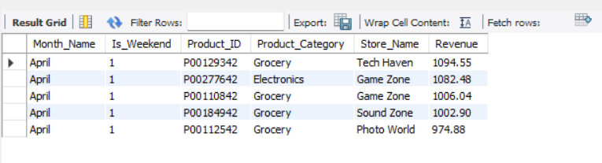
Q2
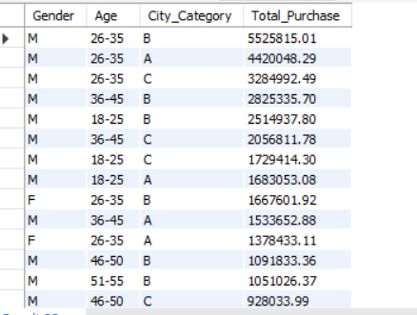
Q3

Q4
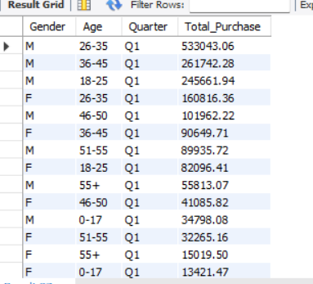
Q5
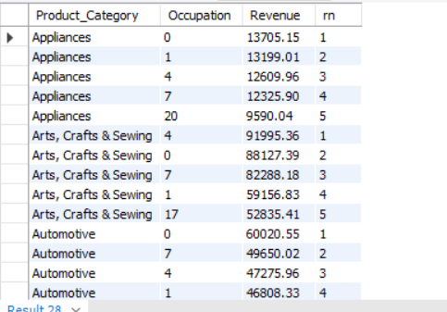
Q6
Q7
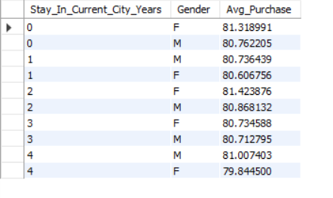
Q8

Q9
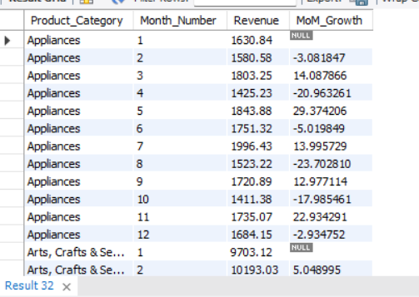
Q10
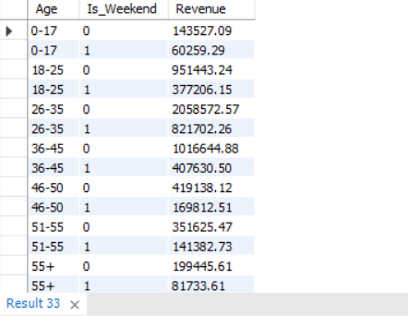
Q11
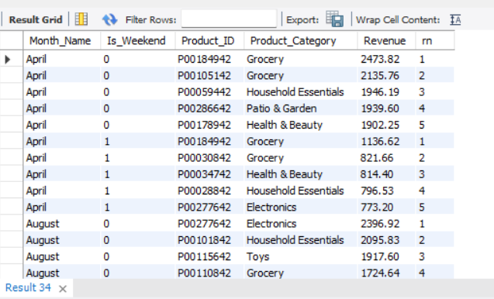
Q12
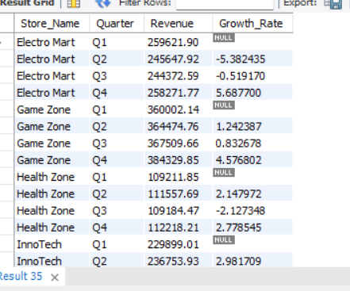
Q13
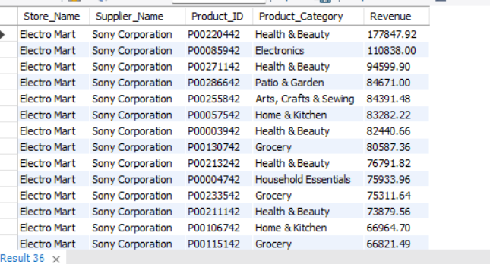
Q14
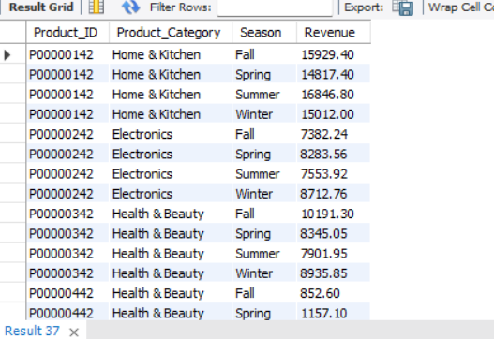
Q15
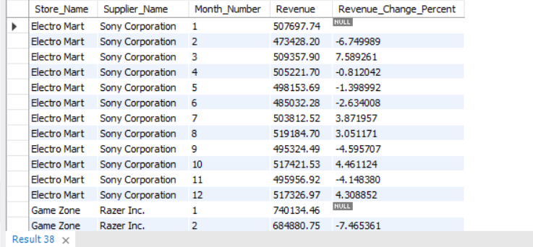
Q16
Q17
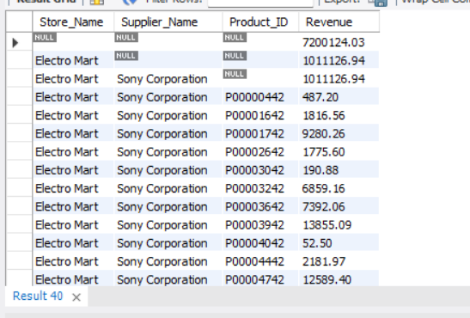
Q18
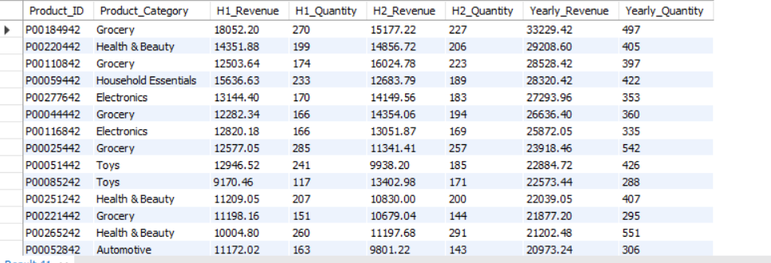
Q19
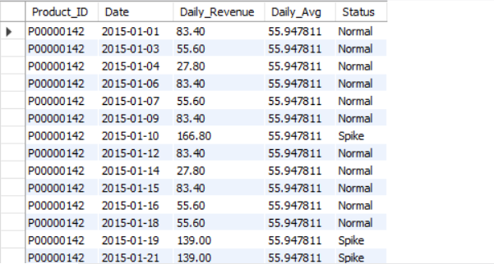
Q20
