State Differences in Light-Duty Vehicle Net Survival Rates
David L. Greene¹, Benjamin P. Leard¹, Arthur Yip^{2*}, Ruixiao Sun³
1 The University of Tennessee Baker School for Public Policy and Public Affairs
2 National Laboratory of the Rockies (formerly NREL), Center for Integrated Mobility Sciences
3 Oak Ridge National Laboratory, National Transportation Research Center
* Corresponding author for this submission. Email: arthur.yip@nlr.gov

1. Motivation and Research Questions
Transitioning to electric vehicles (EVs) is a complex and multidecadal process of systemic change. Hardman et al. (2024) outline how mass market EV adoption in the fleet lags EV sales shares in both theory and practice. Underpinning the EV transition is stock turnover, modeled by vehicle survival and replacements via new sales. However, vehicle survival is typically modeled at the national level, due to data and modeling limitations, but also a lack of understanding of varying vehicle survival and migration at the subnational level. Another relevant phenomenon is the large differences in EV sales across the United States. These factors drive our desire to understand subnational survival and migration of used vehicles.
The specific research questions addressed in this work are: How do light-duty vehicles survive differently and migrate across states over time? What economic, demographic, and geographic factors drive the migration and survival rates of these vehicles? Finally, how can we successfully separate true vehicle scrappage from state-to-state migration in the absence of detailed Vehicle Identification Number (VIN) tracking?
We hypothesize that one mechanism of vehicle migration across states is the trade of used vehicles across households and states driven by the heterogeneity of preferences. Higher-income households may demand more new vehicles and produce a net supply of used vehicles, which may be demanded by lower-income households. Another mechanism is the migration of households themselves across state lines, with their vehicles in tow.

2. Background and Contribution
National scrappage and survival rates have been well studied (Greene and Leard, 2024; Jacobsen and van Benthem, 2015), as have their implications for energy transition and greenhouse gas mitigation (e.g., Leard and Greene, 2023; Woody et al., 2024). The economic and environmental effects of international trade in used vehicles in North America (Olguín et al., 2023; Chen et al., 2018; Davis and Kahn, 2010) and worldwide have also received significant academic attention. Furthermore, foundational theory of vehicle scrappage dates back to Cramer (1958) and Walker (1968).
Despite this robust literature, migrations of used vehicles among U.S. states and differences in state-level vehicle survival rates have received almost no attention from researchers. The primary contribution of this work is empirical. This study provides the first geographic mapping and statistical modeling of domestic used-vehicle trade flows and state-level net survival rates across the U.S.
Furthermore, this work provides conceptual and methodological contributions by distinguishing and decomposing subnational vehicle net survival into state-specific factors, patterns, and net migration. The estimation of net imports/exports from vehicle registration data circumvents the lack of affordable proprietary VIN-level data by mathematically isolating migration from scrappage using age-specific survival assumptions. Finally, it serves as a robust data resource contribution, providing state-level net survival functions that can be utilized by researchers in building vehicle adoption and turnover models.

3. Data and Methods
The core analysis utilizes state-level annual net survival rates calculated for U.S. light-duty vehicles from 2014 to 2025, provided by the National Laboratory of the Rockies (NLR), formerly National Renewable Energy Laboratory (NREL). These rates were derived from a total census of vehicles in operation from Experian Automotive Solutions, measured as of December 31 of each year. Vehicles were segmented into three specific classes: passenger cars, SUVs and vans, and pickup trucks. We then compute state-level vehicle net survival, which incorporates the combined effects of vehicle migration and survival.
The observed state survival rate, or “net survival rate”, is defined as the number of vehicles of body style j and age a in state s in year t, divided by the number of vehicles of the same type and one year younger (a-1) in the previous year (t-1). Because this single metric combines true scrappage alongside vehicle migrations into and out of state s, we developed an exploratory analysis using Stata’s lasso software for variable selection. Potential determinants tested included economic factors (disposable income growth, job growth, GDP), demographics (driving age population, population density), and wear-and-tear indicators (annual road salt usage, traffic fatalities, Interstate congestion).
To model used vehicle migration specifically, we constructed an indicator of state used vehicle net imports and net exports. This indicator relies on assumptions that for vehicles under 10 years old, true scrappage rates are exceedingly low (below 5%) and driven only by rare catastrophic events, meaning they do not differ substantially from the national average. Thus, the estimated fraction of a-year-old vehicles in state s imported or exported is simply the difference between the state net survival rate and the national survival rate. We then weighted these estimates by their respective cumulative survival rates to calculate a cumulative indicator of net vehicle migrations for vehicles aged 2 to 8.
For predictive modeling, we estimated net survival functions using Ordinary Least Squares (OLS) regressions for vehicles aged 1 to 40 years. Our formulated model regresses the net survival rate on the natural logarithm of vehicle age, state annual growth rate of population over 16, state employment growth, and population density. The models include fixed effects for age, state, and year, along with an interaction between the state fixed effect and the log of vehicle age. We excluded state-year pairs of data due to erratic outliers and data quality issues, removed data for vehicles over 40 years old due to high variance, and introduced fixed effects for several data years to account for vehicle registration data affected by the COVID-19 pandemic.

4. Results
First, we show computed state net survival rates in gray dots and national survival rates in black dots. We also show implied cumulative net survival curves for each state and data year.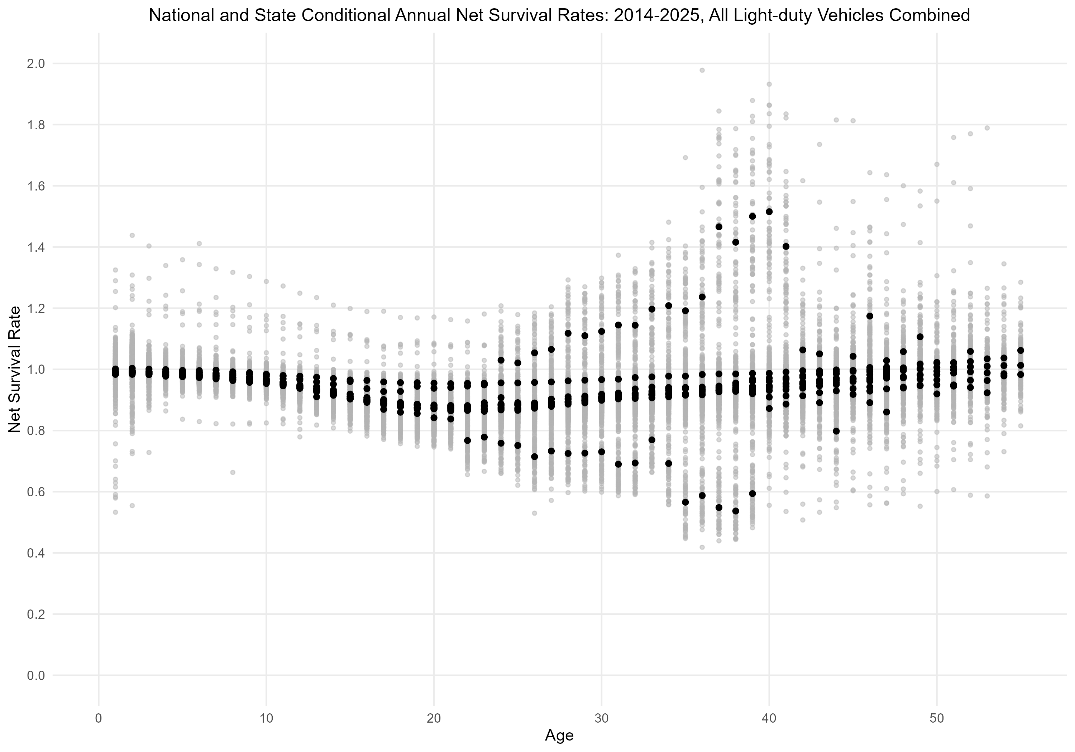
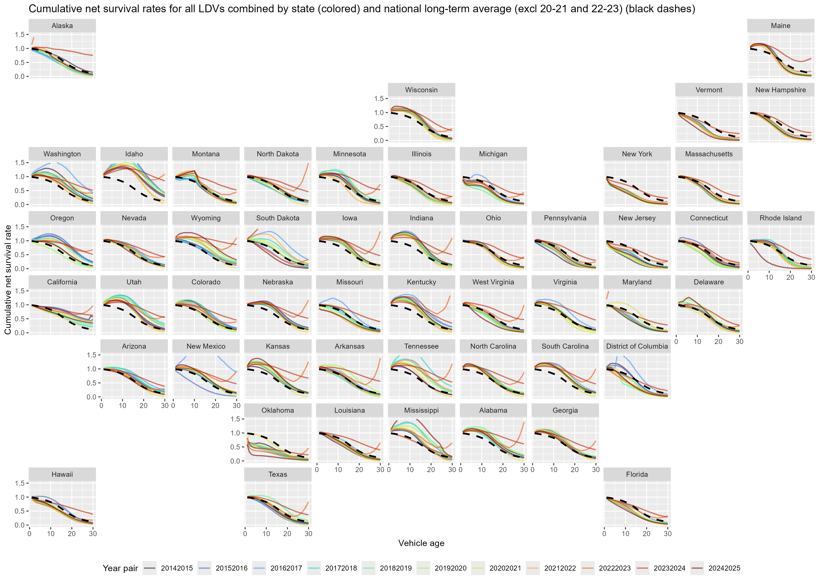
Net survival rates decline for the first 20-25 years but then increase. State net survival rates are more variable than national survival rates because state-to-state differences in survival rates tend to offset each other at the national level. The variance of the state net survival rates increases with vehicle age, particularly after 30 years, while the numbers of vehicles in operation decreases. Many data outliers and anomalies exist, particularly related to COVID-19 pandemic related effects on vehicle survival and registrations. In particular, we attribute the sharp drops in vehicle survival especially in older vehicles (20+ years) to the unprecedented drop in vehicle miles traveled, severe economic downturn, deceased owners, owners electing not to register or insure older, non-essential vehicles during the crisis, and waivers on vehicle registrations. In addition, data for vehicles of age 25+ are much more sparse, thereby inherently suffering from poor data quality. Certain states such as Delaware and Oklahoma show substantial early-age vehicle survival drops, which are attributable to the registration and migration patterns of large numbers of organization or fleet-owned vehicles in these states relative to their household populations.

Econometric Investigation and Predicted Net Survival Rates
OLS regressions successfully explained the vast majority of the variance in the net survival data, yielding robust adjusted R-squared values of 0.82 for passenger cars, 0.76 for SUVs and vans, and 0.92 for pickup trucks. All economic and demographic factors included (employment growth, population growth, GDP growth, and population density) were statistically significant and positively associated with increased net survival rates. Specifically, higher economic and employment growth rates directly drew a higher migration of used vehicles into a state, increasing local net survival.
Our lasso variable exploratory selection further identified that a higher fraction of the population holding a bachelor’s degree or higher was associated with reduced net survival rates for older vehicles, pointing to a correlation between higher education and preferences for younger vehicles. Higher lease rates also strongly predicted lower net survival rates for used vehicles, proving that states with heavy leasing footprints act as major supply hubs (exporters) for newer used vehicles to the rest of the country.
Based on these factors, our modeling successfully produced detailed state net survival functions for the three vehicle classes. For most states, annual survival rates begin between 0.95 and 1.00 for 2-year-old vehicles and decline relatively slowly until about 10 years of age. After this threshold, survival rates decrease more rapidly. The decline slows approaching 20 years and subsequently reverses, increasing slightly after about 22 years. While national year-to-year survival remains generally stable, state rates showcase wide and systematic variance indicating that some states act as permanent importers while others act as exporters.

Estimated Net Vehicle Flows
We estimate consistent interstate flows of vehicles. An analysis of variance (ANOVA) of the annual state net migration indicators demonstrated that state fixed effects accounted for more than ten times the variance of either year or vehicle-type effects, proving that geographic migration patterns are highly persistent over time.
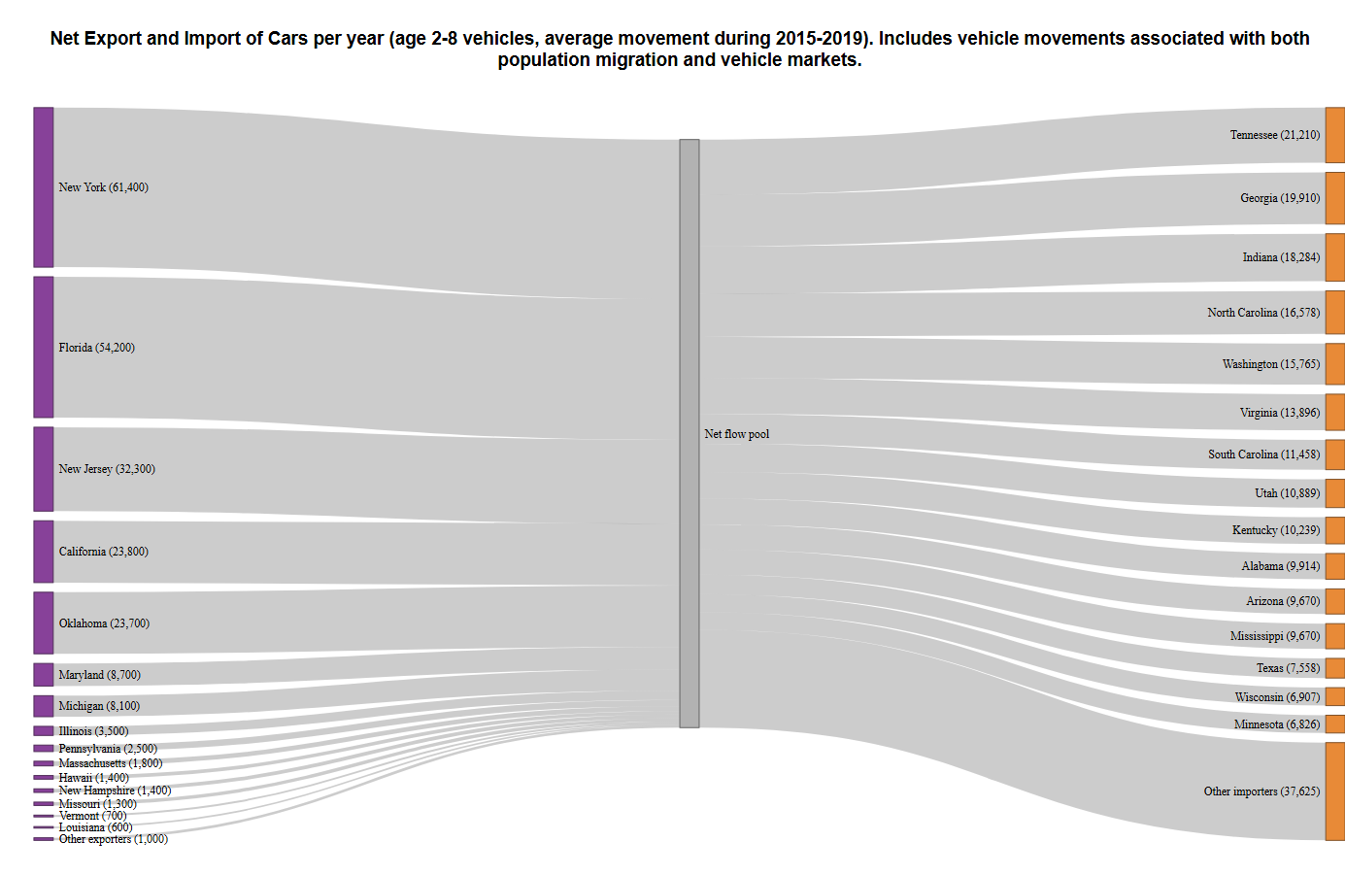
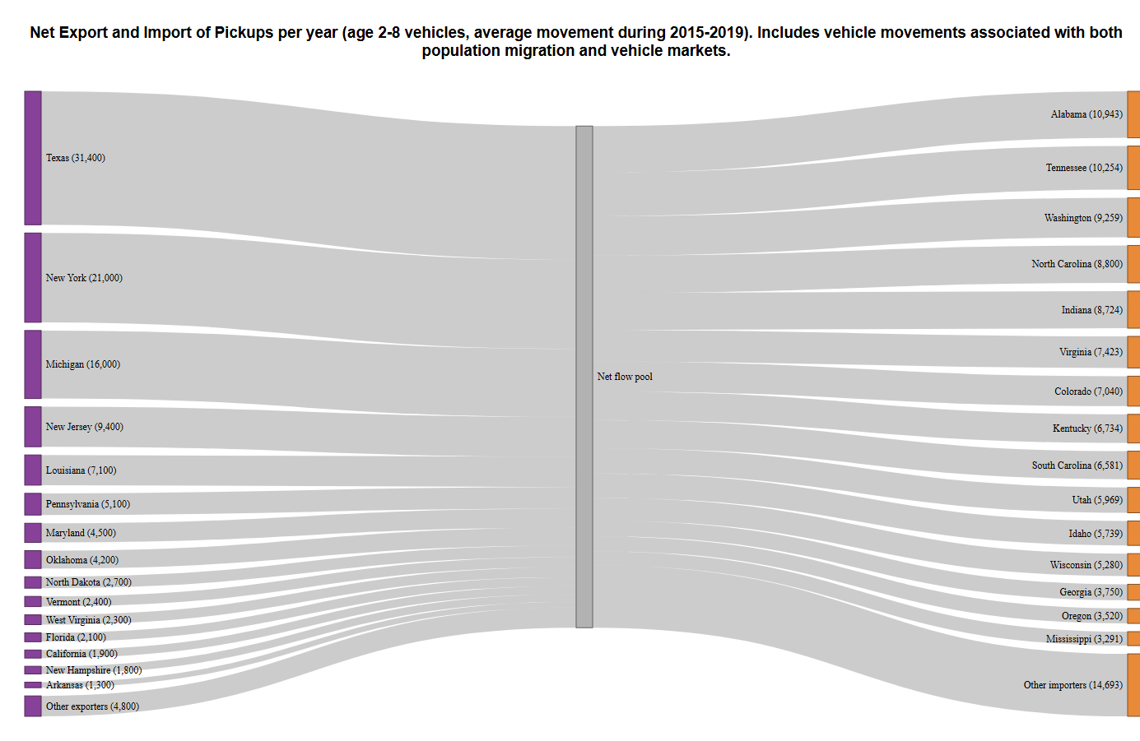
The geography of these flows show that states in the Northeast and Midwest generally act as “donor” states (net exporters), while a variety of states, with disproportionately large ones in the South, act as “receiver” states (net importers). Donor states are more concentrated, while receiver states are more widespread. These results intuitively align with broader population migrations observed over the last decade, as many households will take their vehicles with them in a move.

5. Implications
The systematic movement of younger used vehicles from donor to receiver states provides vital insight into how new vehicle innovations, such as EVs, will diffuse geographically. States like California and New York—which have adopted stringent Advanced Clean Cars/ZEV regulations—are prominent net exporters of used vehicles. As new vehicle sales in these donor states become increasingly electrified, the secondary market pipeline will inherently push used EVs into receiver states such as those in the Southeast and Mountain West, even if those receiver states completely lack their own ZEV mandates.
This dynamic implies that non-ZEV states may experience a faster-than-anticipated influx of EVs via the used market. Consequently, utility planners and policymakers in these receiver states must integrate these used vehicle migration patterns into their grid decarbonization and charging infrastructure expansion plans to prevent infrastructure bottlenecks. Furthermore, this dynamic introduces strong equity considerations: as high-income states and households supply the used market, lower-income households in receiving states will gain primary access to sustainable transportation technologies. Tracking, understanding, and modeling these specific migrations will be essential to ensure an equitable distribution of charging access across demographics.

6. Conclusion
This research represents the first empirical modeling of light-duty vehicle net survival and state-to-state migration in the United States.
Our core findings establish baseline predicted net survival rates for each state, demonstrating interesting and significant differences across states. Utilizing econometric modeling, we showed that variables like employment, GDP, and population growth are strong and significant predictors of state-level vehicle net survival. Finally, our novel Import/Export estimation successfully circumvented the lack of VIN data to expose a highly structured interstate trade network where the Northeast and Midwest consistently export younger used vehicles dispersed to a variety of states.
The main contribution of this work is the empirical differences in net survival rates between states and the methodological framework developed to understand them. Future steps in this ongoing research should include applying this methodology to explicitly differentiate between internal combustion engine vehicles and EVs, and integrating more detailed data to cleanly separate true scrappage rates from migration.

References
Chen, L., B. Garcia-Medina, and R. Wan, 2019. “Trade liberalization, consumption shifting and pollution: Evidence from Mexico’s used vehicle imports”. Review of International Economics, 27:1591-1608.
Cramer, J., 1958. “The Depreciation and Mortality of Motor-Cars,” Royal Statistical Society. Journal. Series A: General, 121(1): 18-46.
Davis, L. and M. Kahn, 2010. “International Trade in Used Vehicles: The Environmental Consequences of NAFTA”, American Economic Journal: Economic Policy, 2(4):58-82.
Greene, D.L. and B.P. Leard, 2024. “Trends in scrappage and survival of U.S. light-duty vehicles,” Transportation Research A: Policy and Practice, 180.
Hardman, S., Shafaeen, M., and G. Tal. 2024. Identifying mass market adoption in the transition to electric vehicles. Environ. Res. Lett. 19 111005. 10.1088/1748-9326/ad7bd1
Jacobsen, M.R. and A.A. van Benthem, 2015. “Vehicle Scrappage and Gasoline Policy,” American Economic Review, 105(3): 1312-1338.
Leard, B. and D. Greene, 2023. “Coordinating the Electric Vehicle Transition and Electricity Grid Decarbonization in the U.S. is Not Essential to Achieving Substantial Long-Term Carbon Dioxide Emissions Reductions,” Environmental Research Letters, 18(7), 074035.
Olguín, F., G. Iskakov and A. Kendall, 2023. “US-Mexico second-hand electric vehicle trade: Battery circularity and end-of-life policy implications”, Transportation Research D: Transport and Environment, 125.
Walker, F., 1968. “Determinants of Auto Scrappage,” Review of Economics and Statistics, 50(4): 503- 506.
Woody, M., Stolper, S., Vaishnav, P. and G. A. Keoleian. et al., 2024. Vehicle scrappage policies for transportation decarbonization. Environ. Res.: Energy 1 033002. https://iopscience.iop.org/article/10.1088/2753-3751/ad63aa/meta

Data Availability Statement
The primary data source for this work was Experian Automotive Solutions Vehicles In Operation (VIO) data licensed to NLR. While the raw data is not available for public release, derived survival data is available by request.

Disclosure of Funding Sources, Attribution Statement, Legal Disclaimer, and Government Rights Notice
This work was authored in part by the National Laboratory of the Rockies (NLR) for the U.S. Department of Energy (DOE), operated under Contract No. DE-AC36-08GO28308, and Oak Ridge National Laboratory (ORNL) for the U.S. Department of Energy, operated under contract No. DE-AC05-00OR22725. Funding provided by the U.S. Department of Energy Office of Critical Minerals and Energy Innovation Transportation Technologies Office. The views expressed in this work do not necessarily represent the views of the University of Tennessee, NLR, ORNL, DOE, or the U.S. Government. The U.S. Government retains and the publisher, by accepting the article for publication, acknowledges that the U.S. Government retains a nonexclusive, paid-up, irrevocable, worldwide license to publish or reproduce the published form of this work, or allow others to do so, for U.S. Government purposes.

