Expanded Section Estimating State Imports and Exports of Younger Used Vehicles

Differences in state net vehicle survival rates may provide insights into movements of used vehicles among states. Understanding migrations of used vehicles could be useful in anticipating the diffusion of new vehicle innovations like vehicle electrification and automation. Ideally, we would have data including unique vehicle identification numbers (VIN) to track vehicle movements from state to state. Such data exist but are considered private information, are held as protected and proprietary information, and even if available to purchase, would be unaffordable given our resources.
Variations in net survival rates of younger used vehicles (<10 years old) across states show that net survival rates well above and below 1.0 are common, suggesting that substantial numbers of used vehicles migrate into states from other states. The distributions of net survival rates of 3-year-old used vehicles for all states and all years from 2014 to 2021 illustrate this fact and differ noticeably by vehicle type (Figures 3a3c). The frequency histogram for passenger cars is skewed to the left, and most net survival rates are below 1.0. The SUV distribution is closer to symmetrical around 1.0, while the greater mass of pickup truck net survival rates exceeds 1.0, a plausible result given the large variation in the sizes of state vehicle populations. However, net survival rates include both scrappage and migrations, and the geography of state imports and exports of used vehicles is also of interest. To estimate the magnitudes and spatial distribution a method of separating scrappage from imports and exports is required.
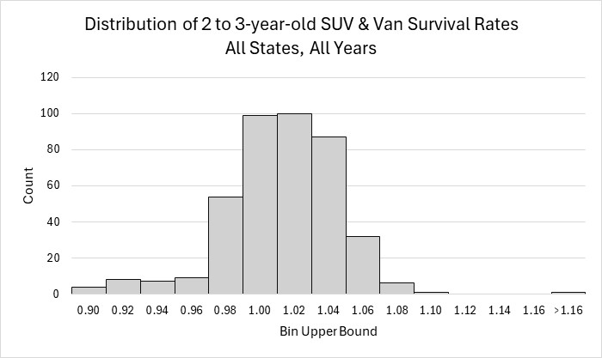
Figure 3a.
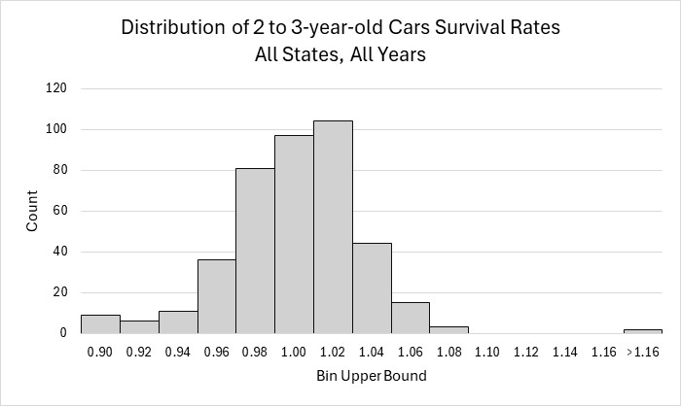
Figure 3b
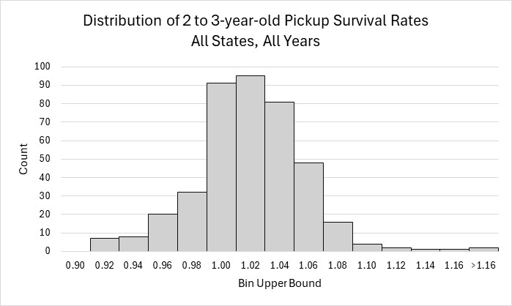
Figure 3c.
Lacking detailed data on individual vehicles, we constructed an indicator of state used vehicle net imports (+) and net exports (-) that relies on two key assumptions: 1) that survival rates of younger used vehicles are close to 1.0 and similar across all states and, 2) that national survival rates are a reasonable approximation to state survival rates for younger vehicles. Theories of vehicle scrappage postulate that vehicles are scrapped when they experience a collision or mechanical failure, and the cost of restoring the vehicle plus its value as scrap exceeds its restored market value (e.g., Parks, 1977). For younger used vehicles, this would require a major collision or catastrophic mechanical failure. Consequently, annual survival rates for vehicles less than ten years old generally exceed 95% (scrappage rates below 5%). U.S. vehicle scrappage (1-survival) rates shown in Figure 4 also suggest an inflection point for Cars and SUVs after 10 years beyond which scrappage rates increase rapidly.
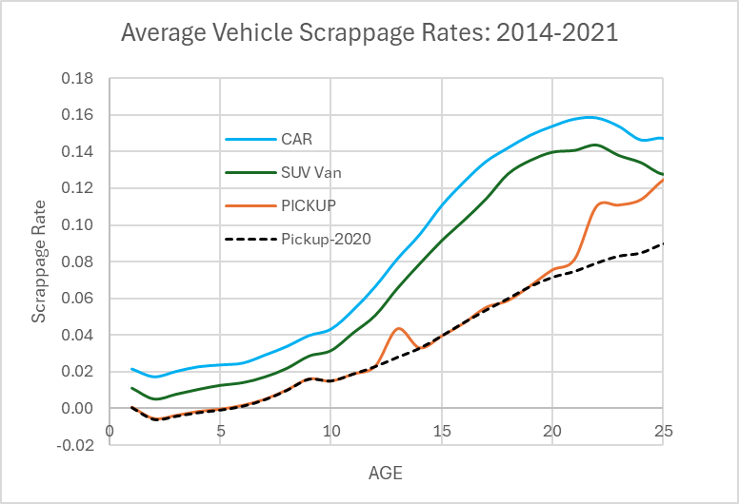
Figure 4. Average Light-Duty Vehicle Scrappage Rates by Vehicle Type: 2014-2021.
Our method assumes that for vehicles less than nine years old, state scrappage rates due to extreme collisions and mechanical failures will not differ much from the national rates but if they do, the differences will be on the order of 1%. We estimate state net imports or exports by vehicle type and calendar year by the difference between state and national net survival rates. National net survival rates do not include migrations among states but do include net national exports (discussed above) as do the state survival rates.
We denote and compute the national net survival rate as $r_{jat}=n_{jat}/n_{j\left(a-1\right)(t-1)}$. The estimated fraction of a-year-old vehicles in state s imported or exported in a given year is assumed to be the difference between the state net survival rate and the national survival rate: $f_{jast}=r_{jast }-r_{jat}$. Positive values for $f_{jast}$ represent net imports and negative values for $f_{jast}$ represent net exports. We use the estimated $f_{jast}$ to compute an indicator, $F_{jst}$, of cumulative net imports/exports as fraction of vehicles of ages 2 to 8 in operation in each state at the beginning of t. The range 2 to 8 excludes year 1 in which unsold new vehicle inventory of the previous model year inflates survival rates and ends before scrappage rates turn upward around age 10. If we had data on the numbers of vehicles in operation by state, vehicle type, and age for each year, we could weight the estimated net imports ($f_{jast}$) by the respective number of vehicles in operation ($n_{jsat}$) and divide by the sum of vehicles in operation aged 2 to 8 in that year to obtain an indicator of net vehicle migrations as a fraction of vehicles aged 2 to 8. In the absence of numbers of vehicles in operation, we weight by the product of the state net survival rates from t-a to t and divide by the sum of the weights (equation 2).
$$\begin{aligned}F_{jsy}= {\left(\sum_{a=2}^{8}{f_{jsat}}\prod_{i=2}^{a}{r_{jsi(t-i)}}\right)}/{\sum_{a=2}^{9}{\prod_{i=2}^{a}{r_{jsi(t-i)}}}}\#\left(2\right)\end{aligned}$$
If the number of 2-year-old vehicles were the same in each year, equation 2 would give the same result as weighting the $f_{jast}$ by the number of vehicles in operation, $n_{jsa(t-a)}$.
Equation 2 requires state and vehicle-specific survival rates going back seven years, e.g., from 2015 to 2021. Since our survival data includes calendar years from 2014 to 2021, we can calculate $F_{jsy}$ only for 2021 and 2022 using equation 2. As an alternative that could be used for all years, we tried using weights for the $f_{jsat}$ based on national survival rates for the current year, $r_{jat}$. Because the $F_{jsy}$ depend primarily on the values of the $f_{jsat}$ and because national survival rates for year t are similar in magnitude to state values for historical years, the national approximation yields an accurate linear approximation to the $F_{jsy}$ values produced using historical state survival rates (as required by equation 2). Regressing the 2022 $F_{jsy}$ values calculated using equation 2 on 2022 estimates produced using 2022 national survival rates produced R² values in excess of 0.997 and slope coefficients ranging from 0.99 to 1.02 (Figure 5).

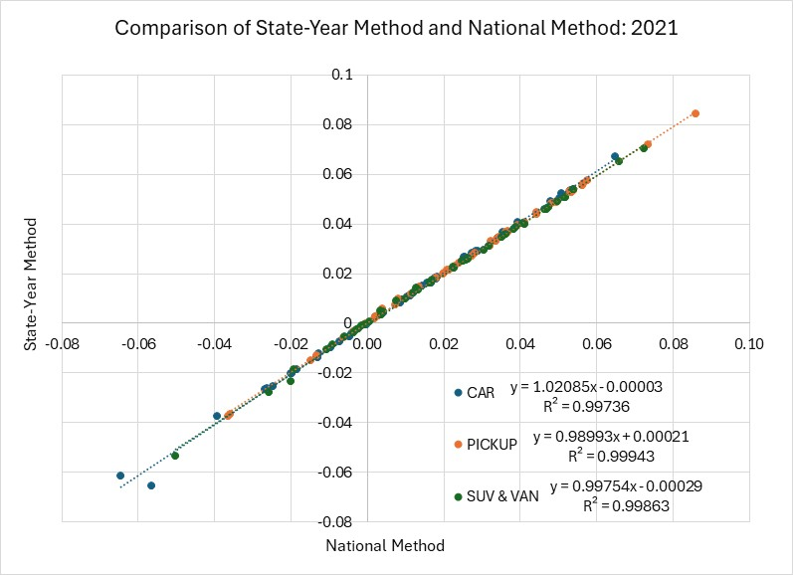
Figure 5. Comparison of Vehicle Migration Indicators Using State-Year-Specific and National Survival Rates as Weights
The average of the $F_{jst}$ values calculated using the national method for each year from 2014 to 2021 are shown in the maps (Figures 6a-c). The values indicate typical net imports (+) or exports (-) of 2 to 8-year-old vehicles as a fraction of all vehicles of that age in operation in the state from January 1, 2015, to January 1, 2022 (Figure 4). Certain states stand out as exporters of 2-8-year-old used passenger cars, including New York and New Jersey. Other car-exporting states include California, Florida, Michigan, Pennsylvania and Oklahoma. Idaho and Western Mountain states, Tennessee and Southeastern states tend to be importers of used cars. The general pattern of importers and exporters is very similar across vehicle types, but there are noticeable differences in the skewness of the distributions, especially for pickup trucks. Nearly all states have survival rates above the national average for light trucks, especially pickups.
An analysis of variance of the annual state net migration indicators, $F_{jsy}$, found that state, vehicle type and year effects were all statistically significant, but that state effects accounted for more than ten times the variance of the other two variables (Table X). We also included an effect for anomalous data for the state of Tennessee in 2014 which alone accounted for four times the variance of year or vehicle type.
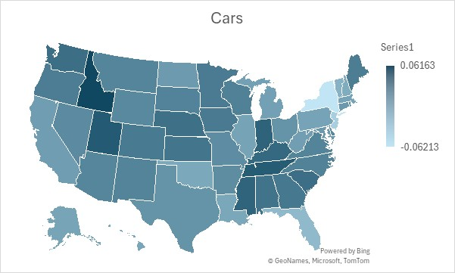
Figure 6a.
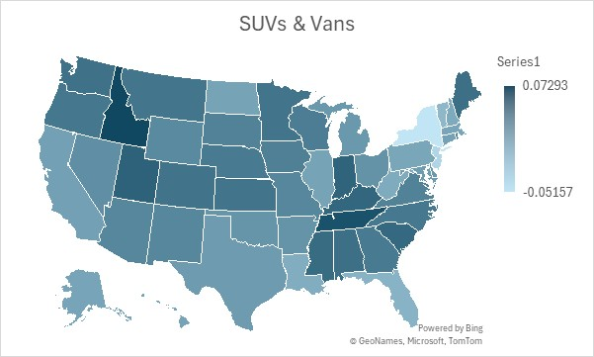
Figure 6b.
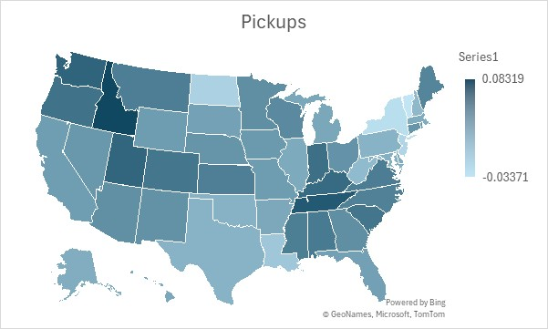
Figure 6c.
Table X. Analysis of Variance of State Used Vehicle Import(+)/Export(-) Indicators
Number of observations = 1,224 |  |  |  | R-squared = |  | 0.7894
Root MSE = | 0.015984 |  |  | Adj. R-squared = |  | 0.7785
Source | Partial SS |  | df | MS | F | Prob>F
Model | 1.11372 |  | 60 | 0.01856 | 72.65 | 0.0000
State | 0.64836 |  | 50 | 0.01297 | 50.75 | 0.0000
Year | 0.05915 |  | 7 | 0.00845 | 33.07 | 0.0000
Vehicle Type | 0.05626 |  | 2 | 0.02813 | 110.10 | 0.0000
TN2014 | 0.25535 |  | 1 | 0.25535 | 999.45 | 0.0000
Residual | 0.29713 |  | 1,163 | 0.00026
Total | 1.41085 |  | 1,223 | 0.00115

An OLS regression of the state indicators, $F_{jsy}$, including state GDP, income and population growth rates as explanatory variables in addition to state and year fixed effects, indicated that all factors, including state fixed effects as a group were statistically significant at the 0.0001 level. The growth rates of GDP, income and population all increased migration of used vehicles into states, but the growth rate of state population had a much larger impact, an intuitive result suggesting that used vehicle migration mainly reflects population growth. We tested Census estimates of annual population migration as a percentage of state population (USDOC, 2024), but we found that including population growth rendered our migration variable insignificant. The Ramsey F-test rejected the hypothesis of omitted variables, the variance inflation factor (VIF) test for overfitting calculated an average VIF of 2.0 with no variable including the state fixed effects having a VIF greater than 2.65, except for the population growth rate at 5.63, indicating that multicollinearity was also not a problem (Table X+1).
Table X+1. Regression of State Used Vehicle Import(+)/Export(-) Indicators on Growth Rates
Number of obs = 1,224 |  |  | R-squared = 0.7746
F(57, 1166) = 91.27 |  |  | Root MSE = 0.01651
Prob > F = 0.0000
 |  | Robust
Variable | Coefficient | Std. Eff. | t | P>|t| | [95% conf. interval]
Pickup | 0.01614 | 0.00121 | 13.32 | 0.000 | 0.0138 | 0.0185
SUV Van | 0.01146 | 0.00108 | 10.62 | 0.000 | 0.0093 | 0.0136
GDP | 0.07077 | 0.01680 | 4.21 | 0.000 | 0.0378 | 0.1037
Income | 0.05018 | 0.01251 | 4.01 | 0.000 | 0.0256 | 0.0747
Population | 1.08111 | 0.17940 | 6.03 | 0.000 | 0.7291 | 1.4331
Year | 0.00237 | 0.00023 | 10.13 | 0.000 | 0.0019 | 0.0028
TN2014 | 0.30573 | 0.02575 | 11.87 | 0.000 | 0.2552 | 0.3563
Constant | 0.01260 | 0.00219 | 5.74 | 0.000 | 0.0083 | 0.0169

We have been unable to find a vendor who will sell us such data, let alone at a price we could afford. In response to the query, “Can I buy a complete census of all used vehicles in the us by vin number?” Google AI responded: “No, you cannot buy a complete census of all used vehicles in the U.S. by VIN, but you can access comprehensive data through services like NMVTIS (National Motor Vehicle Title Information System) and third-party providers (Carfax, AutoCheck) for specific vehicle histories, pulling title, salvage, theft, and odometer data for individual VINs, not a bulk list of every car.” (12,8/2025) Reasons offered included data privacy and that firms considered the data proprietary.
There are anomalies in all three scrappage curves due to calendar year 2020 when the COVID pandemic struck the U.S. The anomalies are especially strong for pickup trucks, whose scrappage curve minus 2020 data is shown in the dashed line in Figure 3. All curves show reduced scrappage from 1 to 2 years of age due to unsold inventory from the previous model year.

