**Program 29 : Write a program to find Fibonacci series.**

#include<stdio.h>

int main(){

int first=0,second=1,next,c;

for(c=0;c<21;c++){

if(c<=1)

next=c;

else{

next=first+second;

first=second;

second=next;

}

printf("%d\n",next);

}

return 0;

}

**OUTPUT**

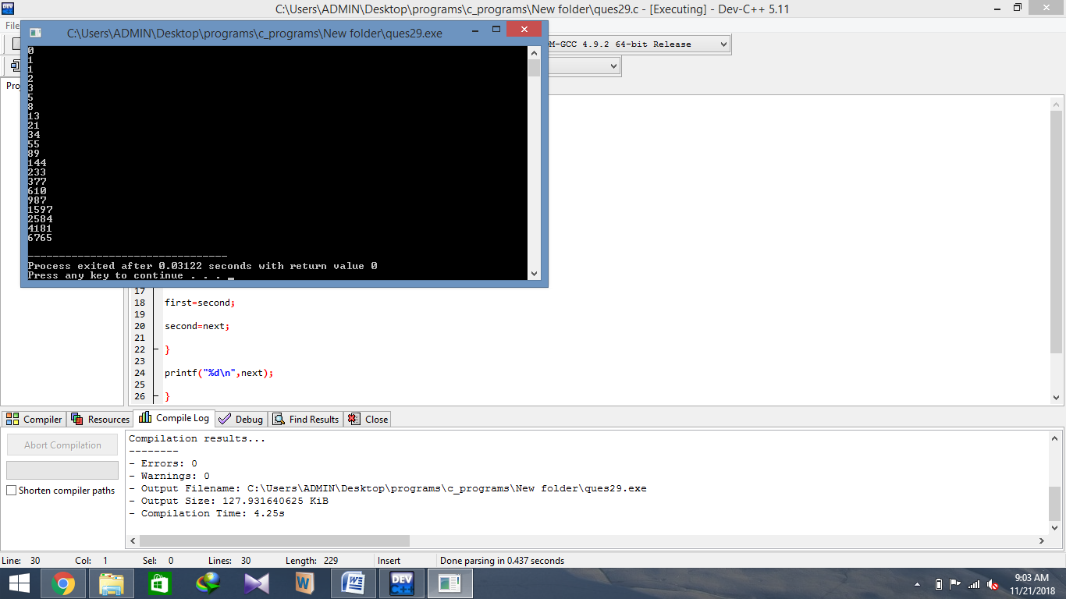

**Program 30 : Word size of the computer refers to the number of bytes that can be stored in a single memory location. Write a program to find word size of the computer**

#include <stdio.h>

#include <limits.h>

int main(void){

printf("%d\n", sizeof(void *) * CHAR_BIT);

return 0;

}

**OUTPUT**

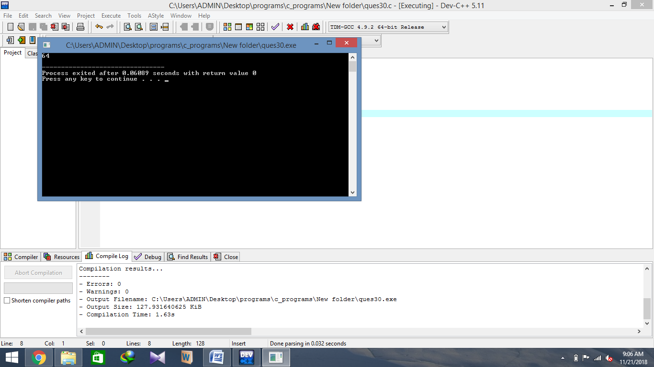

**Program 31 . Write a program to illustrate the working of pointer to pointer.**

#include<stdio.h>

int main(){

int a=8,*p,*p1;

p=&a;

p1=p;

printf("\n Value of variable=%d",a);

printf("\n Value of pointer=%d",*p);

printf("\n Vlaue of pointer to pointer=%d",*p1);

return 0;

}

**OUTPUT**

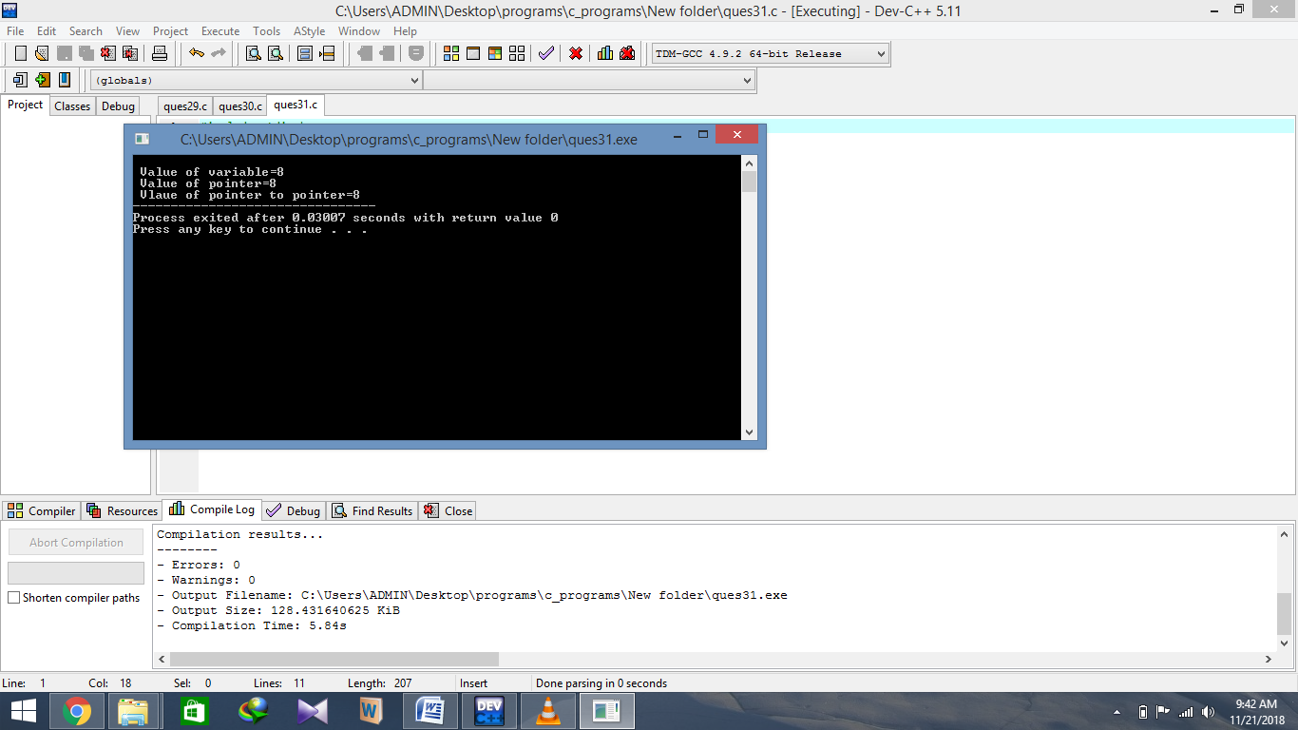

**Program 32 : Write programs to illustrate pointer arithmetic for different types of pointers.**

#include<stdio.h>

int main(){

int i=12, *ip=&i;

double d = 2.3, *dp = &d;

char ch = 'a', *cp = &ch;

printf("Value of ip = %d\n",ip);

printf("Value of dp = %d\n",dp);

printf("Value of cp = %d\n",cp);

printf("Value of ip = %d\n",ip + 1);

printf("Value of dp = %d\n",dp + 1);

printf("Value of cp = %d\n",cp + 1);

printf("Value of ip = %d\n",ip + 2);

printf("Value of dp = %d\n",dp + 2);

printf("Value of cp = %d\n",cp + 2);

return 0;

}

**OUTPUT**

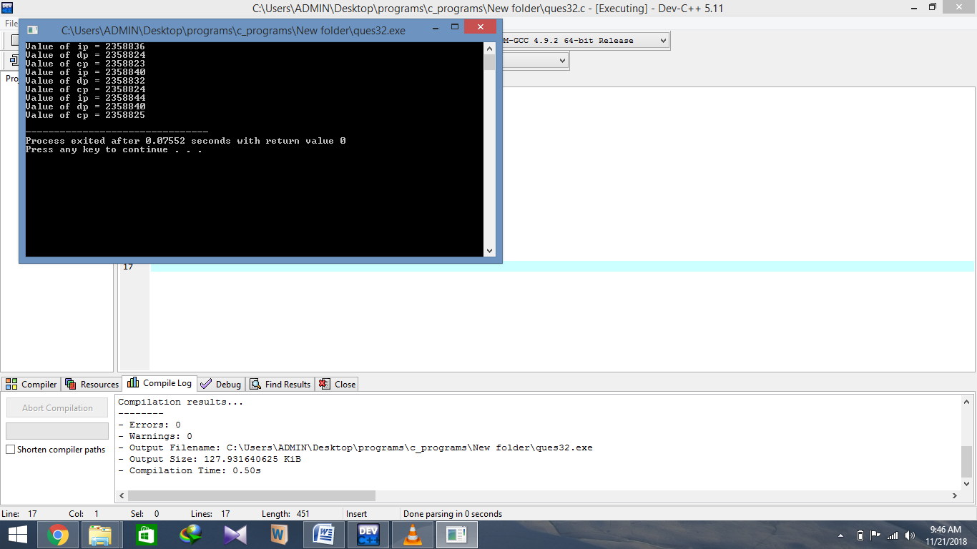

**Program 33 : Write a program to find size of various types of pointers (int, float, char)? What are the factors on which size depends?**

#include <stdio.h>

int main(){

    printf("\nsize of char pointer: %d"     ,sizeof(char*));

    printf("\nsize of int pointer: %d"      ,sizeof(int*));

    printf("\nsize of float pointer: %d"    ,sizeof(float*));

    printf("\nsize of long int pointer: %d" ,sizeof(long int*));

    printf("\nsize of double pointer: %d\n" ,sizeof(double*));

    return 0;

}

**OUTPUT**

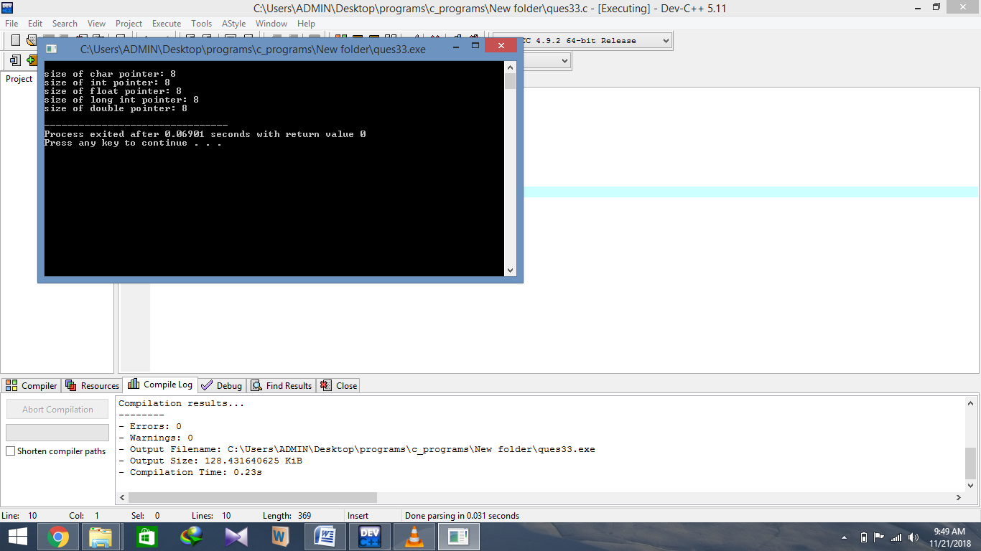

**Program 34 : Write a program to input a string and display the same as output.**

#include <stdio.h>

int main(){

    char name[30];

    printf("Enter name: ");

    gets(name);     // read string

    printf("Name: ");

    puts(name);    // display string

    return 0;

}

**OUTPUT**

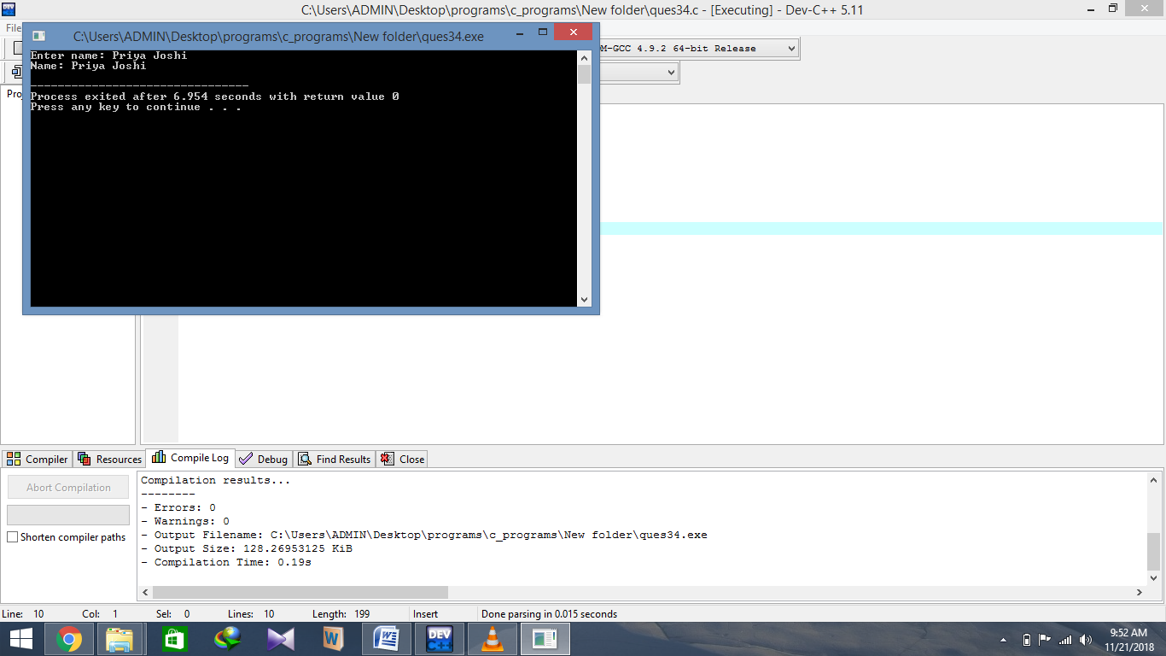

**Program 35 : Write a program to find the length of string without using library functions.**

#include<stdio.h>

int main(){

char s[50];

inti=0;

printf("\n enter the string");

scanf("%s",s);

for(i=0;s[i]!='\0';i++);

printf("\n Length of string=%d",i);

return 0;

}

**OUTPUT**

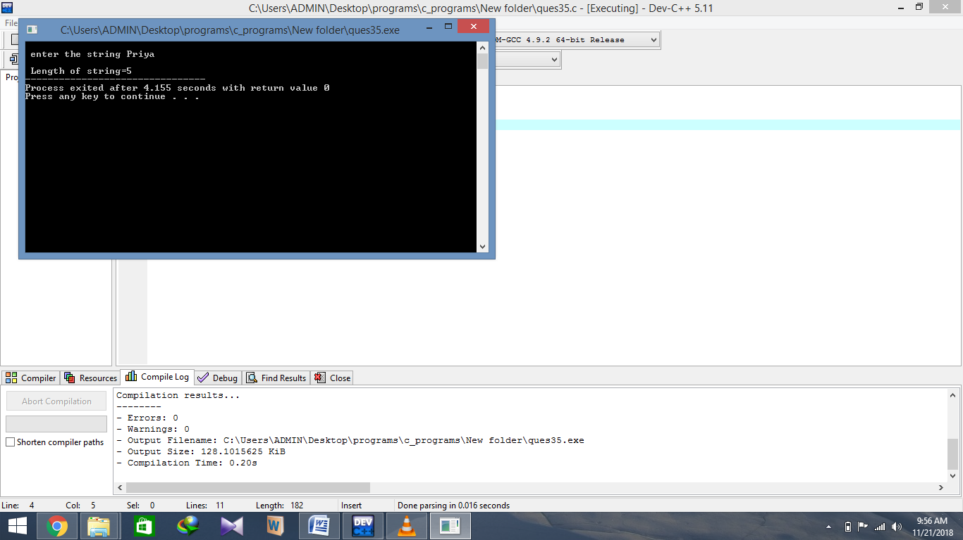

**Program 36 Write a program to compare two strings without using library functions.**

#include<stdio.h>

int main(){

char s1[10],s2[10];

int i,flag=0;

printf("\n enter the string");

scanf("%s",s1);

printf("\n enter the second string");

scanf("%s",s2);

for(i=0;s1[i]!='\0';i++){

if(s1[i]==s2[i])

flag=flag+1;

}

if(flag==i)

printf("\n Strings are equal");

else

printf("\n Strings are not equal");

return 0;

}

**OUTPUT**

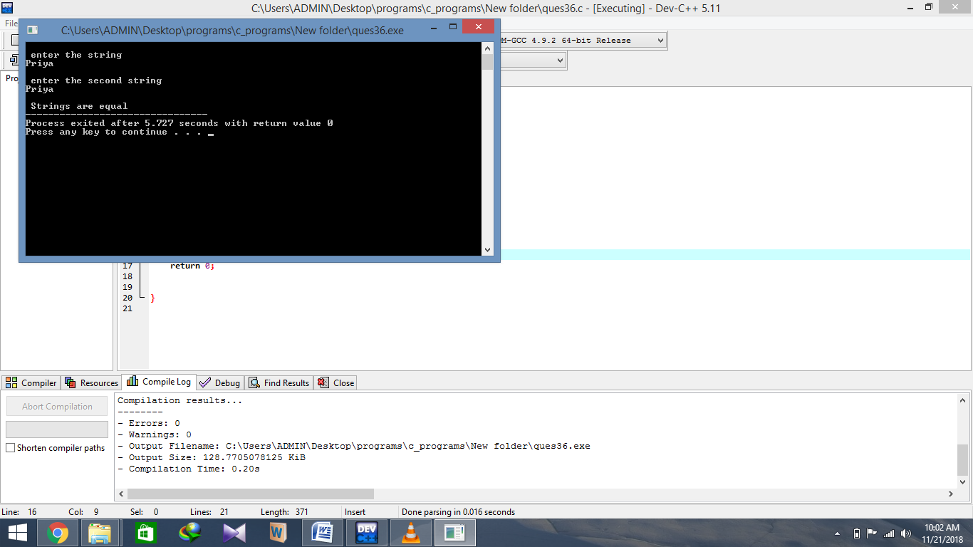

**Program 37 : Write a program to copy a string without using library functions.**

#include<stdio.h>

int main(){

char s1[10],s2[10];

int i;

printf("\n enter the string\n");

scanf("%s",s1);

for(i=0;s1[i]!='\0';i++){

s2[i]=s1[i];

}

s2[i]='\0';

printf("\n Copied String = %s",s2);

return 0;

}

**OUTPUT**

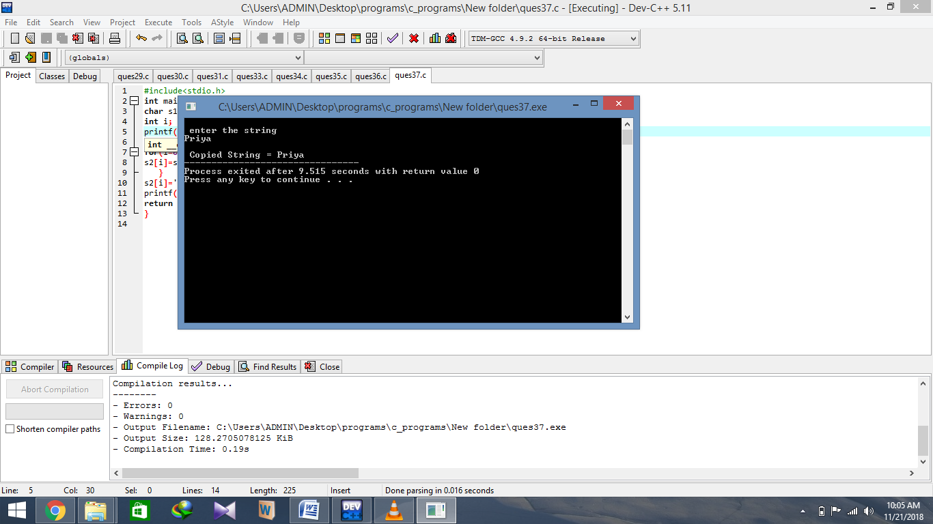

**Program 38 : Write a program to reverse a string without using library functions.**

#include<stdio.h>

int main(){

char s1[10],s2[10];

int i,l,j;

printf("\n enter the string");

scanf("%s",s1);

for(i=0;s1[i]!='\0';i++);

j=0;

for(l=i-1;l>=0;l--)

{

s2[j]=s1[l];

j++;

}

s2[j]='\0';

printf("\n Reversed string = %s",s2);

return 0;

}

**OUTPUT**

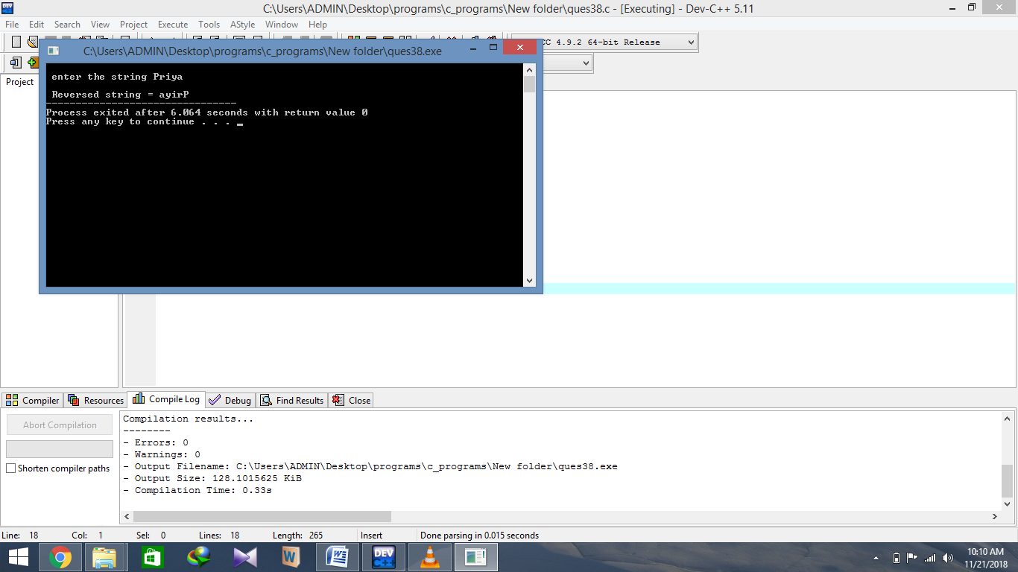

**Program 39 . Write a program to concatenate two strings without using library functions.**

#include<stdio.h>

int main(){

char s1[10],s2[10],s3[20];

int i,j,l;

printf("\n enter the string1");

scanf("%s",s1);

printf("\n enter the string2");

scanf("%s",s2);

for(i=0;s1[i]!='\0';i++){

s3[i]=s1[i];

}

l=i;

for(i=0;s2[i]!='\0';i++){

s3[l]=s2[i];

l++;

}

s3[l]='\0';

printf("\n Concatenate String = %s",s3);

return 0;

}

**OUTPUT**

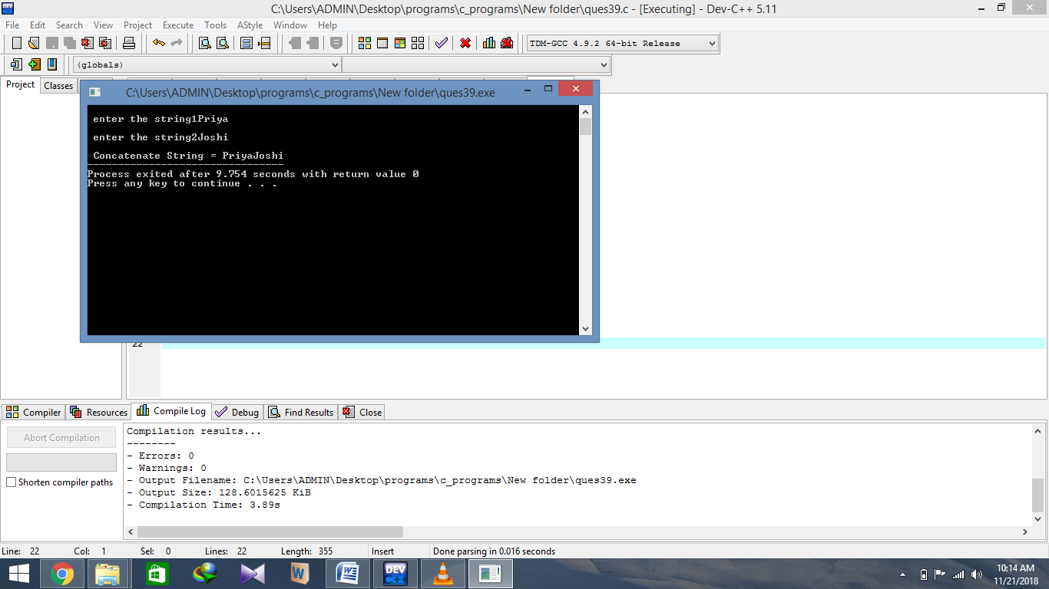

**Program 40 : Write a program to illustrate scope,visibility and lifetime of various storage classes.**

**a.)Auto Class**

#include<stdio.h>

void f1(){

auto int i=2;

printf("\n Value in f1=%d",i);

}

void f2(){

auto int i=3;

printf("\n Value in f2=%d",i);

}

int main(){

auto int i=1;

f1();

f2();

printf("\n Value in main=%d",i);

return 0;

}

**OUTPUT**

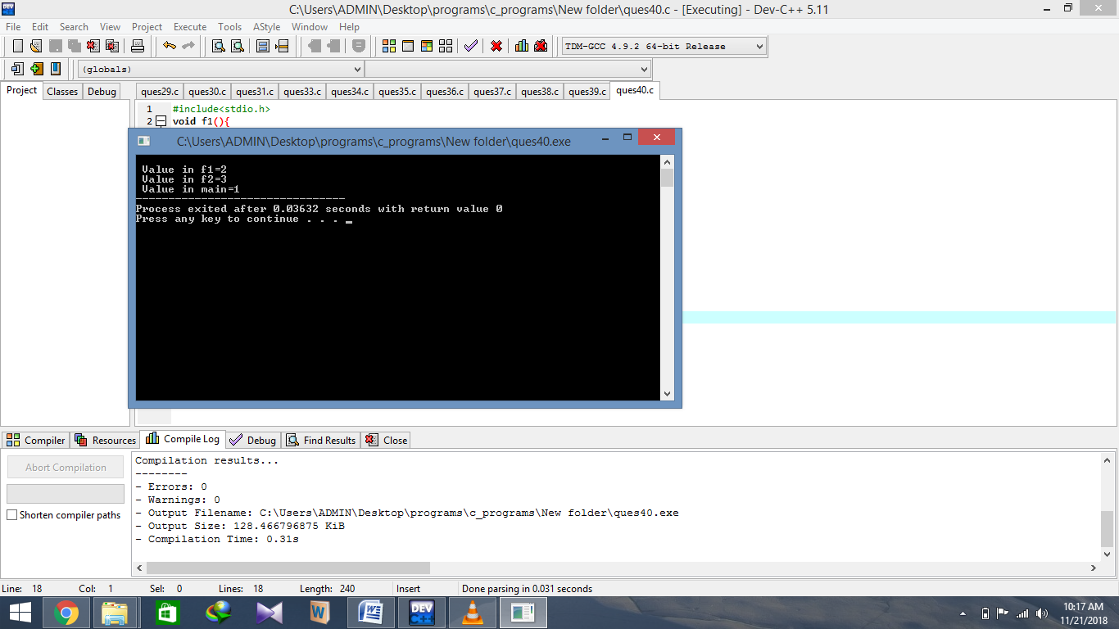

**Program 41 : Write a program to find the area of circle using PI as a macro.**

#include<stdio.h>

#define pi 3.1416

int main(){

float area, radius;

printf("Enter the radius\n");

scanf("%f",&radius); area=pi*radius*radius;

printf("\n the area of the circle is = %f" , area);

return 0;

}

**OUTPUT**

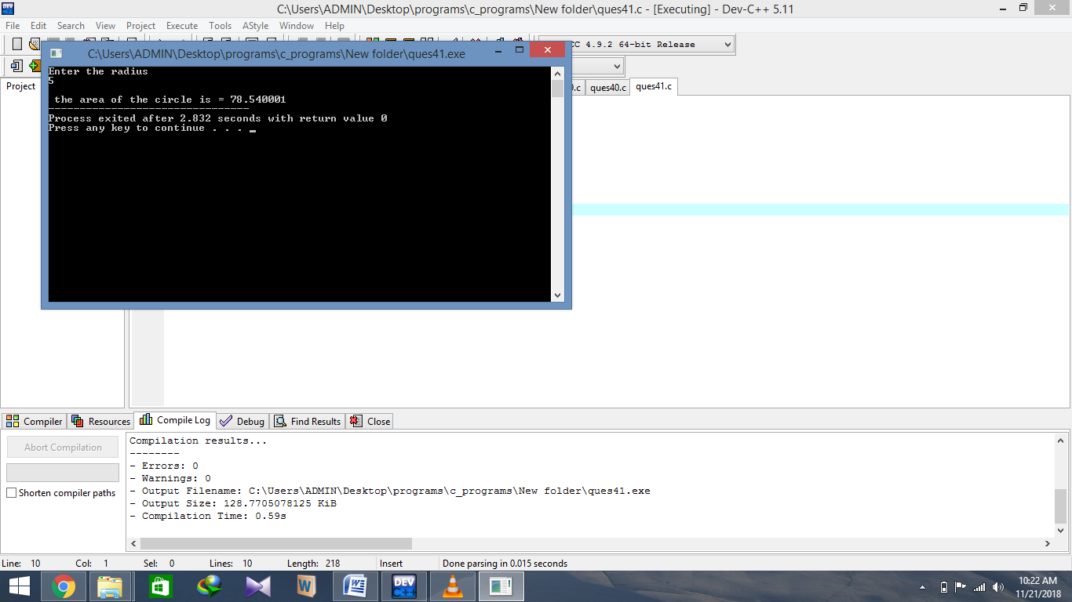

**Program 42 : Illustrate pointer to structure.**

#include<stdio.h>

struct book{

char title[50];

int page;

float cost;

};

int main(){

int i,j;

struct book b,*p;

p=&b;

printf("\n enter the book title");

fgets((p+i)->title,50,stdin);

fflush(stdin);

printf("\n enter the page");

scanf("%d",&(p+i)->page);

fflush(stdin);

printf("\n enter the cost");

scanf("%f",&(p+i)->cost);

fflush(stdin);

printf("\n enter the book title = %s",(p+i)->title);

fflush(stdin);

printf("\n enter the page = %d",(p+i)->page); fflush(stdin);

printf("\n enter the cost = %.2f",(p+i)->cost);

return 0;

}

**OUTPUT**

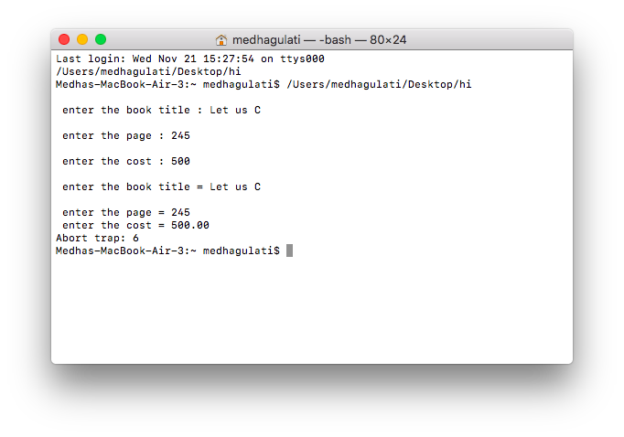

**Program 43 : Write a function that takes two end points of line segment as input and returns its slope and mid point.**

#include<stdio.h>

#include<conio.h>

int main(){

    float x1,x2,y1,y2,slope,midX,midY;

    printf(" Enter the X Coordinate of Endpoint 1: ");

    scanf("%f",&x1);

    printf(" Enter the Y Coordinate of Endpoint 1: ");

    scanf("%f",&y1);

    printf(" Enter the X Coordinate of Endpoint 2: ");

    scanf("%f",&x2);

    printf(" Enter the Y Coordinate of Endpoint 2: ");

    scanf("%f",&y2);

    printf(" The Endpoints of a Line are : (%.2f,%.2f) and (%.2f,%.2f)",x1,y1,x2,y2);

    slope=(y2-y1)/(x2-x1);

    midX=(x1+x2)/2;

    midY=(y1+y2)/2;

    printf(" Slope : %.2f",slope);

    printf(" Midpoint : (%.2f,%.2f)",midX,midY);

    return 0;

}

**OUTPUT**

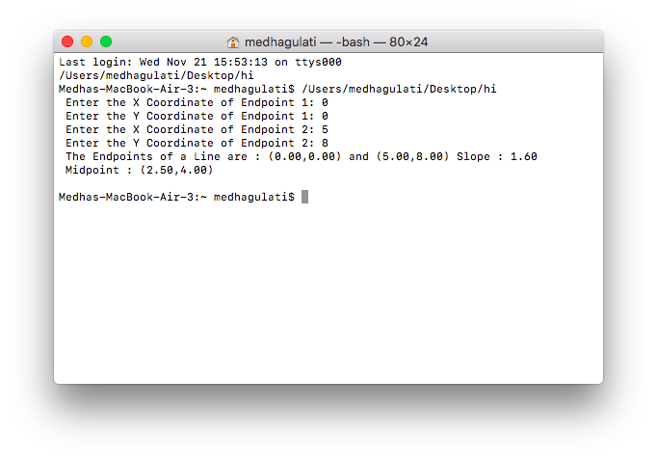

**Program 44 : Write a program to read a file as input and count the number of characters, words and lines.**

#include<stdio.h>

int main(){

FILE *fp;

int l=0,w=0,c=0;

char str,fname[50];

fp=fopen("test.txt","r");

while((str=fgetc(fp))!=EOF){

if(str=='\n'){

l++;

w++;

}

else if(str==' ')

w++;

else

c++;

}

fclose(fp);

printf("\n Lines=%d\nWords=%d\nCharacters=%d",l+1,w+1,c+1);

return 0;

}

**OUTPUT**

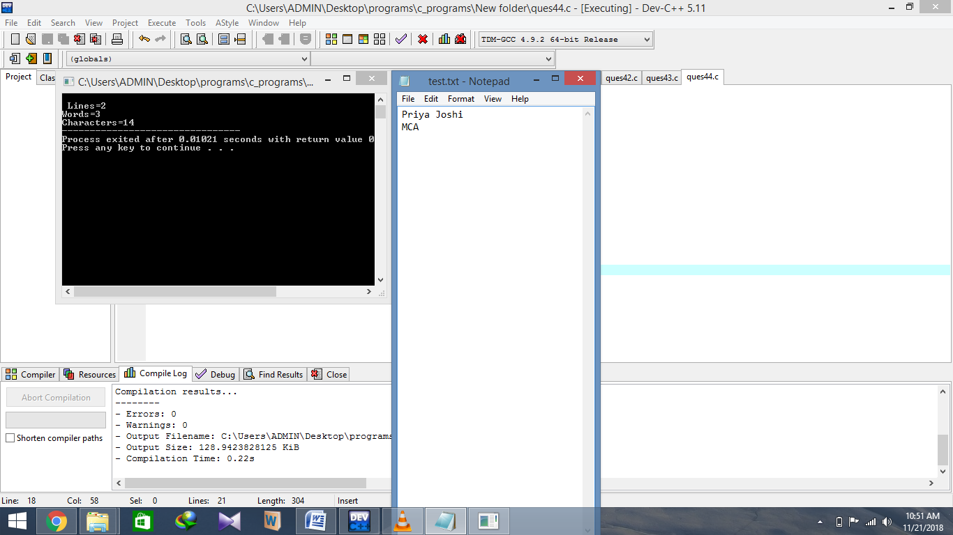

**Program 45 : Write a program to copy a source text file into a target text file.**

#include <stdio.h>

#include <stdlib.h>

int main(){

   char ch, source_file[20], target_file[20];

   FILE *source, *target;

   printf("Enter name of file to copy\n");

   gets(source_file);

   source = fopen(source_file, "r");

   if( source == NULL ){

      printf("Press any key to exit...\n");

      exit(EXIT_FAILURE);

   }

   printf("Enter name of target file\n");

   gets(target_file);

   target = fopen(target_file, "w");

   if( target == NULL ){

      fclose(source);

      printf("Press any key to exit...\n");

      exit(EXIT_FAILURE);

   }

   while( ( ch = fgetc(source) ) != EOF )

      fputc(ch, target);

   printf("File copied successfully.\n");

   fclose(source);

   fclose(target);

   return 0;

}

**OUTPUT**

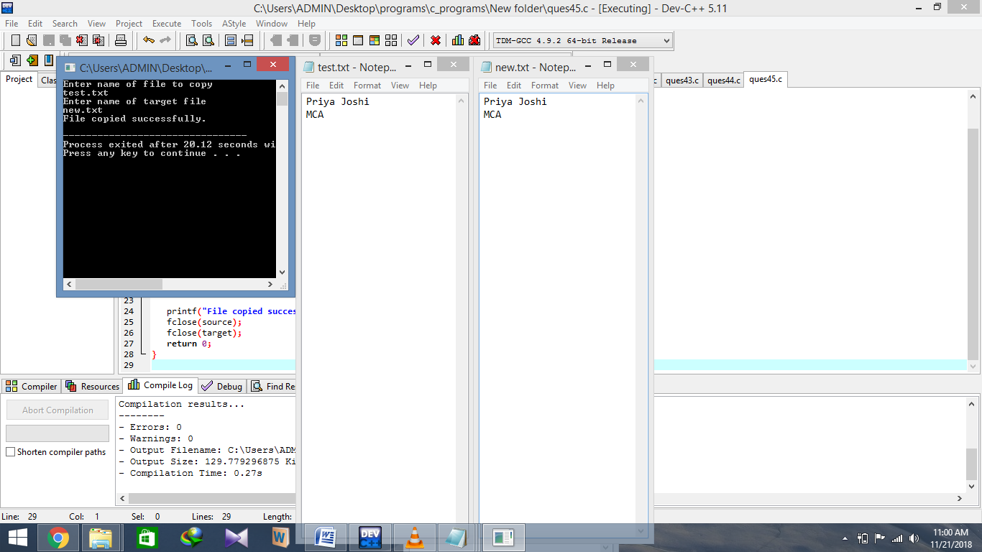

**Program 46 : Write a program to read and write the file using following commands**

**a.)fgetc() and fputc()**

#include <stdio.h>

#include<process.h>

int main(){

FILE *fs, *ft ;

char ch ;

fs = fopen ( "test.txt", "r" ) ;

if ( fs == NULL ){

puts ( "Cannot open source file" ) ;

return 0 ;

}

ft = fopen ( "new.txt", "w" ) ;

if ( ft == NULL ){

puts ( "Cannot open target file" ) ;

fclose ( fs ) ;

return 0;

}

while ( 1 ){

ch = fgetc ( fs ) ;

if ( ch == EOF )

break ;

else

fputc ( ch, ft ) ;

}

fclose ( fs ) ;

fclose ( ft ) ;

return 0;

}

**OUTPUT**



**b.)fprintf() and fscanf()**

#include <stdio.h>

#include <stdlib.h>

int main(){

FILE *fp;

char str[80], str1[80];

fp = fopen("new.txt","w");

if(fp == NULL)

{

printf("Cannot open file.\n");

exit(1);

}

printf("Enter string to be written in a file: ");

fscanf(stdin, "%s", str);

fprintf(fp, "%s", str);

fclose(fp);

fp = fopen("test.txt","r");

if(fp == NULL) {

printf("Cannot open file.\n");

exit(1);

}

fscanf(fp, "%s", str1);

fprintf(stdout, "%s", str1);

return 0;

}

**OUTPUT**

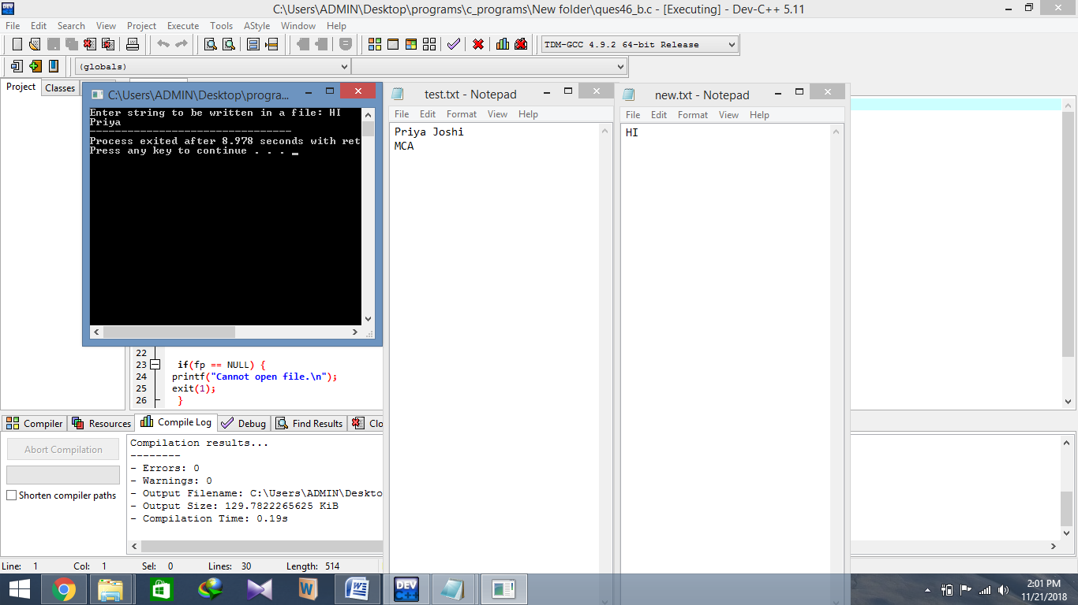

**c.)fgets() and fputs()**

#include <stdio.h>

int main(){

FILE *fptr = fopen("new.txt","w");

fputs("C Programming\n",fptr);

fputs("Java Programming",fptr);

fclose(fptr);

fptr = fopen("test.txt","r");

char ch[20];

while(fgets(ch,20,fptr)!=NULL){

printf("%s",ch);

}

fclose(fptr);

return 0;

}

**OUTPUT**

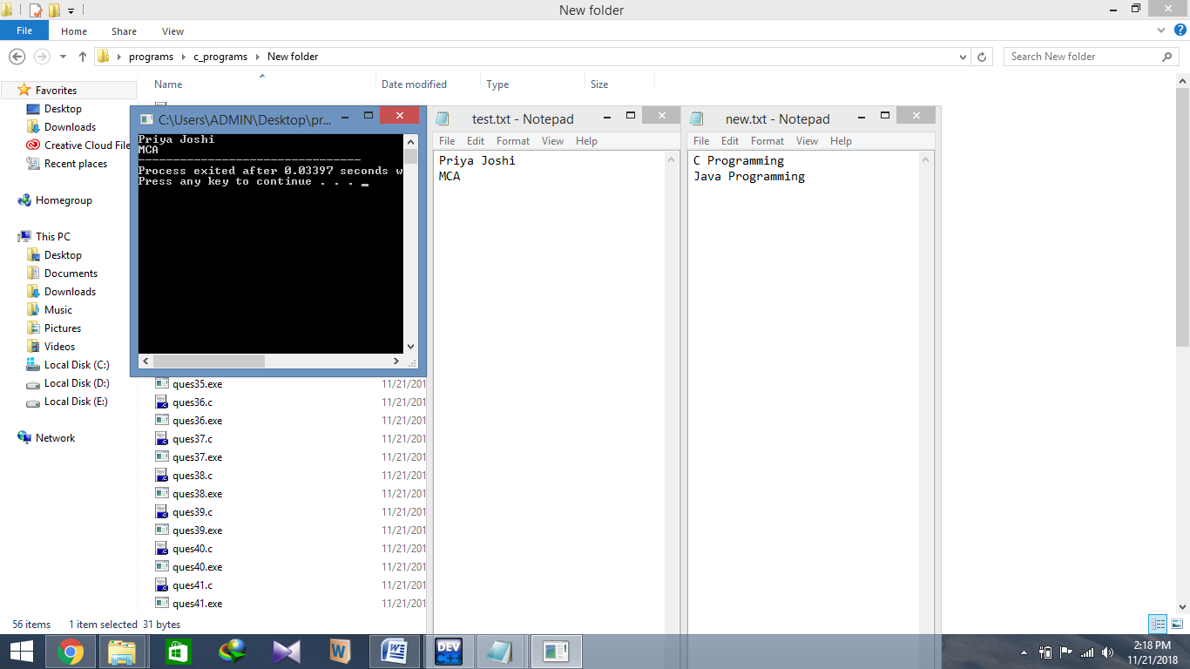

**d.)fread() and fwrite()**

#include <stdio.h>

#include <string.h>

int main(){

char Name[]="ABCDEF";

char Name2[7];

FILE *ptr=fopen("new.txt","w");

fwrite(Name,sizeof(char),strlen(Name)+1,ptr);

fclose(ptr);

ptr=fopen("test.txt","r");

fread(Name2,sizeof(char),strlen(Name)+1,ptr);

printf("Name2 = %s",Name2);

fclose(ptr);

return 0;

}

**OUTPUT**

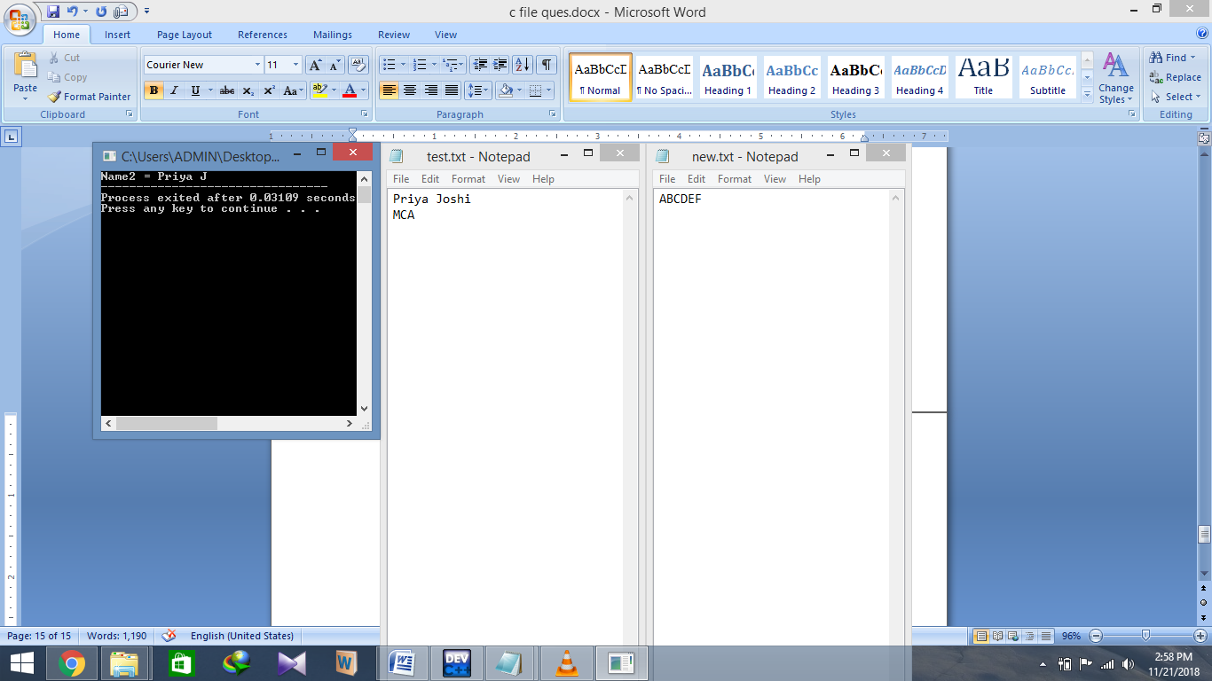

**Program 47 : Given it was Monday on 1st Jan 1990 . Write a program to find what is the day on 1st Jan of the given year.**

#include <stdio.h>

int main(void){

int yr,diff,lpyrdays,normaldays,res;

printf("Enter a year whose day of 1st Jan you want to know\n");

scanf("%d",&yr);

yr = (yr - 1) ;

lpyrdays = (yr/4) + (yr / 400) - (yr / 100 );

normaldays = (yr* 365 )+ 1 + lpyrdays ;

res = normaldays % 7;

if(res==0)

printf("\nSunday");

if(res==1)

printf("Monday");

if(res==2)

printf("Tuesday");

if(res==3)

printf("Wednesday");

if(res==4)

printf("Thursday");

if(res==5)

printf("Friday");

if(res==6)

printf("Saturday");

return 0;

}

**OUTPUT**

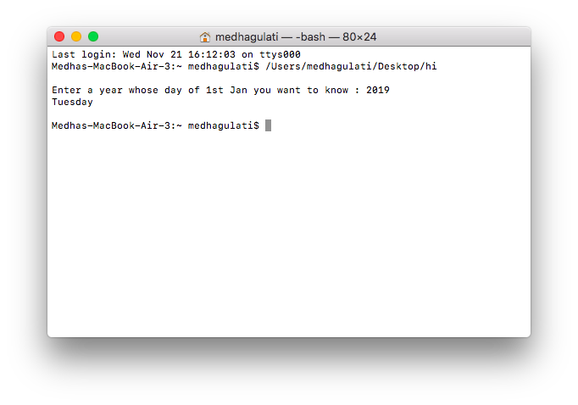

**Program 48 : Write a program to input a number and print its digit in words.**

#include <stdio.h>

int main(){

    int n, num = 0;

printf("Enter any number to print in words: ");

    scanf("%d", &n);

    while(n != 0){

        num = (num * 10) + (n % 10);

        n /= 10;

    }

    while(num != 0){

        switch(num % 10){

            case 0:

                printf("Zero ");

                break;

            case 1:

                printf("One ");

                break;

            case 2:

                printf("Two ");

                break;

            case 3:

                printf("Three ");

                break;

            case 4:

                printf("Four ");

                break;

            case 5:

                printf("Five ");

                break;

            case 6:

                printf("Six ");

                break;

            case 7:

                printf("Seven ");

                break;

            case 8:

                printf("Eight ");

                break;

            case 9:

                printf("Nine ");

                break;

        }

        num = num / 10;

    }

    return 0;

}

**OUTPUT**

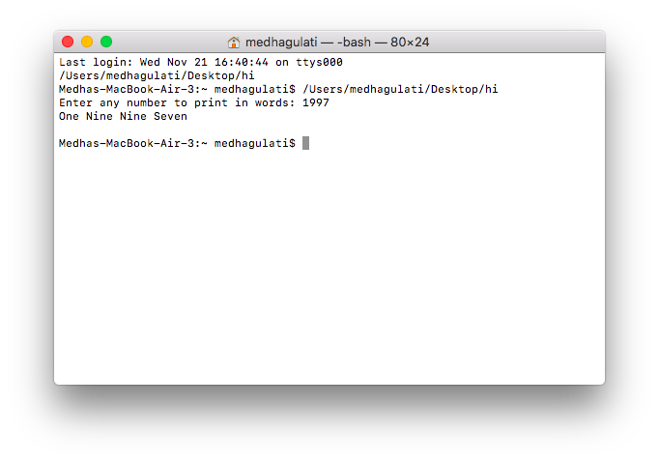

**Program 49 : Generate the divisors of a given number.**

#include<stdio.h>

int main()

{

int i,n;

printf("Enter any number:");

scanf("%d",&n);

printf("\nDivisors of %d are",n);

for(i=1;i<=n/2;++i)

if(n%i==0)

printf(" %d ",i);

printf("\n\n");

return 0;

}

**OUTPUT**

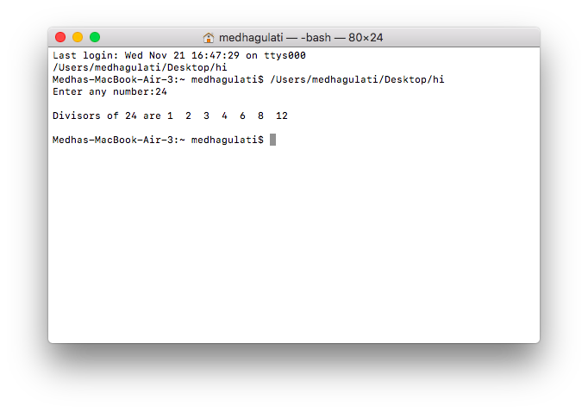

**Program 50 : Find LCM and GCD of a given number.**

#include <stdio.h>

int main() {

  int a, b, x, y, t, gcd, lcm;

  printf("Enter two integers\n");

  scanf("%d%d", &x, &y);

  a = x;

  b = y;

  while (b != 0) {

    t = b;

    b = a % b;

    a = t;

  }

  gcd = a;

  lcm = (x*y)/gcd;

  printf("Greatest common divisor of %d and %d = %d\n", x, y, gcd);

  printf("Least common multiple of %d and %d = %d\n", x, y, lcm);

  return 0;

}

**OUTPUT**

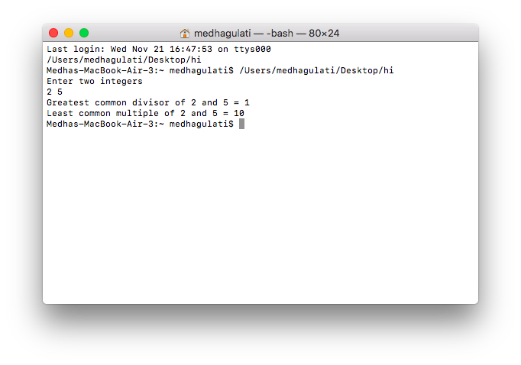

**Program 51 : Check whether square root of a given number is prime or not.**

#include <stdio.h>

#include<math.h>

int main(){

    int n, i, flag = 0,sq;

    printf("Enter a positive integer : ");

    scanf("%d", &n);

    sq = sqrt(n);

    printf("\nSquare root of the no is : %d\n",sq);

    for(i = 2; i <= sq/2; ++i){

        if(sq%i == 0){

            flag = 1;

            break;

        }

    }

    if (sq == 1){

      printf("1 is neither a prime nor a composite number.\n");

    }

    else{

        if (flag == 0)

          printf("%d is a prime number.\n", sq);

        else

          printf("%d is not a prime number.\n", sq);

    }

    return 0;

}

**OUTPUT**

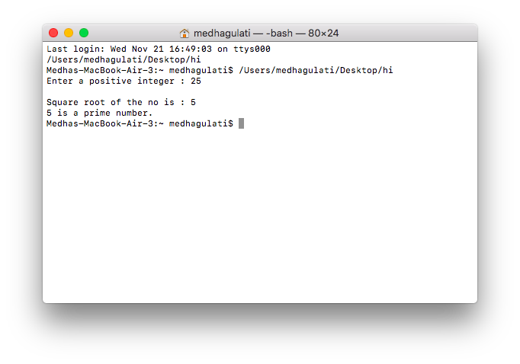

**Program 52 : Find out the difference between two dates in terms of number of days.**

#include<stdio.h>

#include<math.h>

#include<conio.h>

int main(){

int day1,mon1,year1,day2,mon2,year2;

int ref,dd1,dd2,i;

printf("Enter first date day, month, yearn");

scanf("%d%d%d",&day1,&mon1,&year1);

printf("Enter second date day, month, yearn");

scanf("%d%d%d",&day2,&mon2,&year2);

ref = year1;

if(year2<year1)

ref = year2;

dd1=0;

dd1=dater(mon1);

for(i=ref;i<year1;i++){

if(i%4==0)

dd1+=1;

}

dd1=dd1+day1+(year1-ref)*365;

dd2=0;

for(i=ref;i<year2;i++){

if(i%4==0)

dd2+=1;

}

dd2=dater(mon2)+dd2+day2+((year2-ref)*365);

printf("nn Difference between the two dates is %d days",abs(dd2-dd1));

return 0;

}

int dater(x){

int y=0;

switch(x){

case 1: y=0; break;

case 2: y=31; break;

case 3: y=59; break;

case 4: y=90; break;

case 5: y=120;break;

case 6: y=151; break;

case 7: y=181; break;

case 8: y=212; break;

case 9: y=243; break;

case 10:y=273; break;

case 11:y=304; break;

case 12:y=334; break;

default: printf("Invalid Input"); exit(1);

}

return y;

}

**OUTPUT**

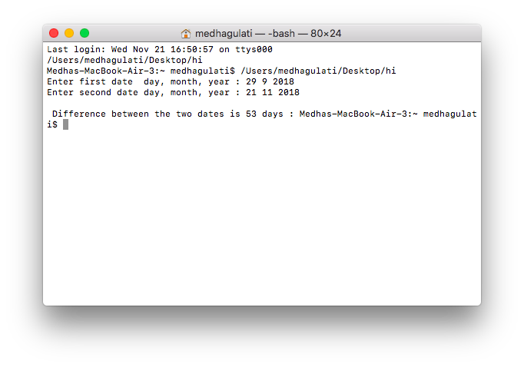

**Program 53 : Determine all pythagorian triplets in a given range.**

#include<stdio.h>

int main(){

int initial,final,a,b,c;

printf("Enter the range in which you want to search for Pythagorean Triplets:\nInitial: ");

scanf("%d",&initial);

printf("\nFinal: ");

scanf("%d",&final);

printf("The Pythogorean Triplets in the given range are as follows:\n____________________________________________________________\n");

for(a=initial;a<=final;a++){

for(b=a;b<=final;b++){

for(c=b;c<=final;c++){

if(c*c==a*a+b*b){

printf("%d , %d , %d\n",a,b,c);

}

}

}

}

return 0;

}

**OUTPUT**

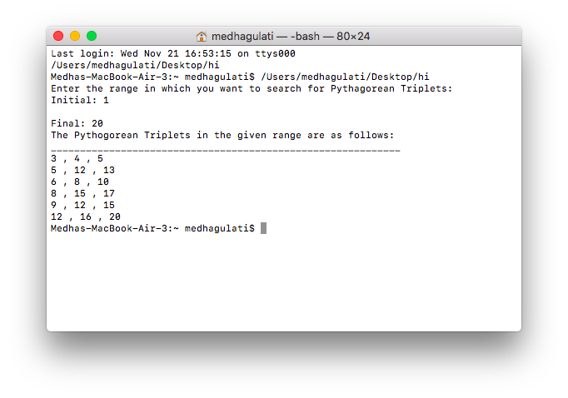

**Program 54 : 145 => 1!+4!+5!=145**

**Find all such numbers within a given range.**

#include <stdio.h>

int main(){

int i, j, cur, lastDigit, end;

long long fact, sum;

printf("Enter upper limit: ");

scanf("%d", &end);

for(i=1; i<=end; i++){

cur = i;

sum = 0;

while(cur > 0){

fact = 1ll;

lastDigit = cur % 10;

for( j=1; j<=lastDigit; j++){

fact = fact * j;

}

sum += fact;

cur /= 10;

}

if(sum == i){

printf("%d, ", i);

}

}

return 0;

}

**OUTPUT**

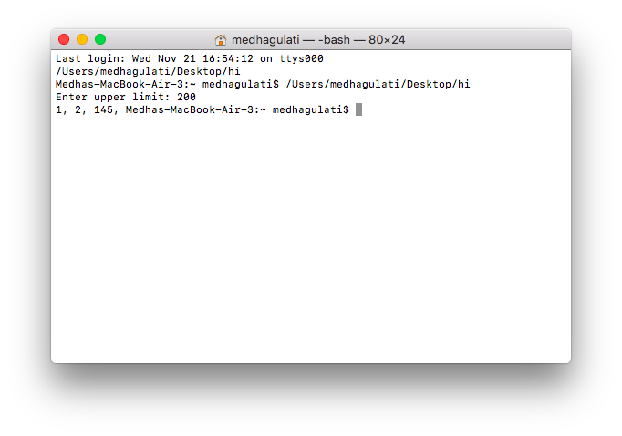

**Program 55 : 122 =144 and 212=441**

**Find out such numbers in a given range.**

#include <stdio.h>

int reverse (int num) {

int rev = 0, mod;

while (num > 0) {

mod = num % 10;

rev = (rev * 10) + mod;

num = num / 10;

}

return rev;

}

int main() {

int n, i, num, rev, num_sq, rev_sq,limit;

printf("Enter upper limit: ");

scanf("%d",&limit);

for (i = 0; i < limit; i++) {

num = i;

rev = reverse(num);

num_sq = num * num;

rev_sq = rev * rev;

if (num_sq == reverse(rev_sq)) {

printf("square of %d is %d\n", num, num_sq);

printf("square of %d is %d\n", rev, rev_sq);

}

}

return 0;

}

**OUTPUT**

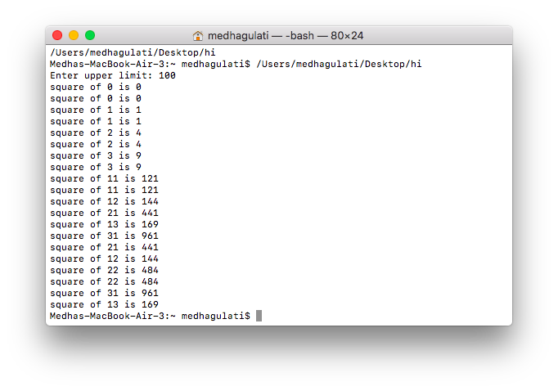

**Program 56 : Print the truth table for xy+z**

#include<stdio.h>

int main(){

int x,y,z,res;

printf("x y z xy+z\n");

for(x=0;x<=1;x++){

for(y=0;y<=1;y++){

for(z=0;z<=1;z++){

res=(x&y)|z;

printf("%d %2d %2d %3d\n",x,y,z,res);

}

}

}

return 0;

}

**OUTPUT**

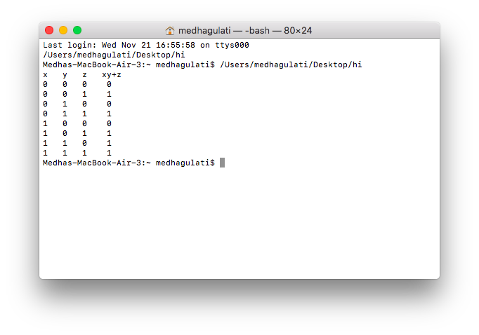

**Program 57 : Count number of occurrences of a given number in a given integer array**

#include<stdio.h>

int first(int arr[], int low, int high, int x, int n){

  if(high >= low){

    int mid = (low + high)/2;  /*low + (high - low)/2;*/

    if( ( mid == 0 || x > arr[mid-1]) && arr[mid] == x)

      return mid;

    else if(x > arr[mid])

      return first(arr, (mid + 1), high, x, n);

    else

      return first(arr, low, (mid -1), x, n);

  }

  return -1;

}

int last(int arr[], int low, int high, int x, int n){

  if (high >= low){

    int mid = (low + high)/2;  /*low + (high - low)/2;*/

    if( ( mid == n-1 || x < arr[mid+1]) && arr[mid] == x )

      return mid;

    else if(x < arr[mid])

      return last(arr, low, (mid -1), x, n);

    else

      return last(arr, (mid + 1), high, x, n);

  }

  return -1;

}

int count(int arr[], int x, int n){

  int i;

  int j;

  i = first(arr, 0, n-1, x, n);

  if(i == -1)

    return i;

  j = last(arr, i, n-1, x, n);

  return j-i+1;

}

int main(){

  int arr[] = {1, 2, 2, 3, 3, 3, 3};

  int x =  3;

int i;

printf("The array is\n");

for(i=0;i<7;i++)

printf("%d ",arr[i]);

  int n = sizeof(arr)/sizeof(arr[0]);

  int c = count(arr, x, n);

  printf(" %d occurs %d times ", x, c);

  return 0;

}

**OUTPUT**

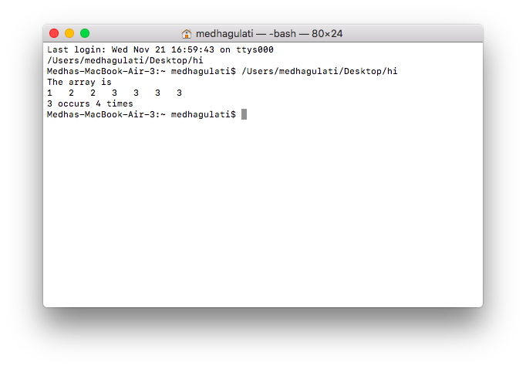

**Program 58 : Find the age of a person by given date of birth.**

#include <stdio.h>

#include <stdlib.h>

void findAge(int current_date, int current_month,

             int current_year, int birth_date,

             int birth_month, int birth_year){

    int month[] = { 31, 28, 31, 30, 31, 30, 31,

                          31, 30, 31, 30, 31 };

    if (birth_date > current_date) {

        current_date = current_date + month[birth_month - 1];

        current_month = current_month - 1;

    }

    if (birth_month > current_month) {

        current_year = current_year - 1;

        current_month = current_month + 12;

    }

    int calculated_date = current_date - birth_date;

    int calculated_month = current_month - birth_month;

    int calculated_year = current_year - birth_year;

    printf("Present Age\nYears: %d  Months: %d  Days:"

           " %d\n", calculated_year, calculated_month,

                                      calculated_date);

}

int main(){

    int current_date = 21;

int current_month = 11;

int current_year = 2018;

int birth_date = 29;

int birth_month = 9;

int birth_year = 1997;

    findAge(current_date, current_month, current_year,

            birth_date, birth_month, birth_year);

    return 0;

}

**OUTPUT**

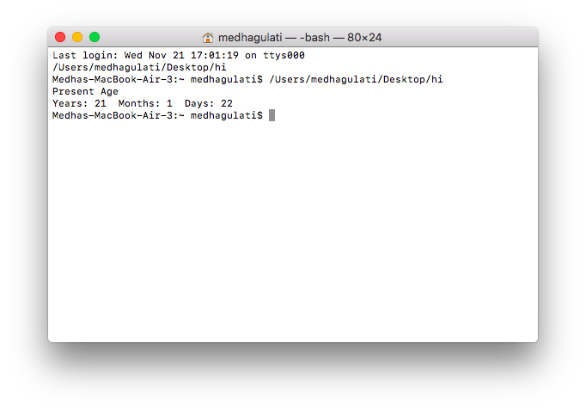

**Program 59 : Sum of the series ,when x is given.**

**1 + x^2/1! + x^4/2! + … + x^2n/n!**

#include<stdio.h>

#include<math.h>

int fact(int n){

    if(n==0||n==1)

        return 1;

    else

        return n*fact(n-1);

}

int main(){

    int sum=1,x,n,num,deno,term;

    printf("\nEnter no of terms in the series : ");

    scanf("%d",&n);

    printf("\nEnter x : ");

    scanf("%d",&x);

    for(int i=1;i<=n;i++){

        num = pow(x,i);

        deno = fact(i);

        term = num/deno;

        sum = sum + term;

    }

    printf("\nSum of the series : %d",sum);

    return 0;

}

**OUTPUT**

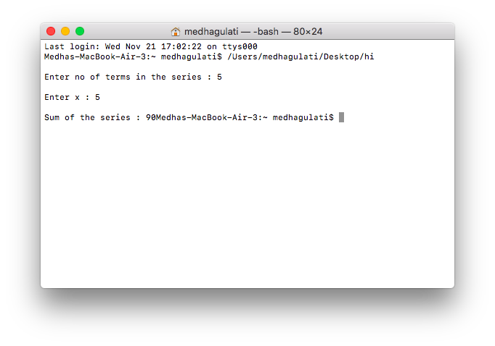

**Program 60 : Add the number of days to a given date.**

#include<stdio.h>

int isLeap(int y) {

if (y%100 != 0 && y%4 == 0 || y %400 == 0)

return 1;

return 0;

}

int offsetDays(int d, int m, int y) {

int offset = d;

switch (m - 1) {

case 11: offset += 30;

case 10: offset += 31;

case 9: offset += 30;

case 8: offset += 31;

case 7: offset += 31;

case 6: offset += 30;

case 5: offset += 31;

case 4: offset += 30;

case 3: offset += 31;

case 2: offset += 28;

case 1: offset += 31;

}

if (isLeap(y) && m > 2)

offset += 1;

return offset;

}

void revoffsetDays(int offset, int y, int *d, int *m) {

int month[13] = { 0, 31, 28, 31, 30, 31, 30,

31, 31, 30, 31, 30, 31 };

if (isLeap(y))

month[2] = 29;

int i;

for (i = 1; i <= 12; i++) {

if (offset <= month[i])

break;

offset = offset - month[i];

}

*d = offset;

*m = i;

}

void addDays(int d1, int m1, int y1, int x) {

int offset1 = offsetDays(d1, m1, y1);

int remDays = isLeap(y1)?(366-offset1):(365-offset1);

int y2, offset2;

if (x <= remDays){

y2 = y1;

offset2 += x;

}

else{

x -= remDays;

y2 = y1 + 1;

int y2days = isLeap(y2)?366:365;

while (x >= y2days){

x -= y2days;

y2++;

y2days = isLeap(y2)?366:365;

}

offset2 = x;

}

int m2, d2;

revoffsetDays(offset2, y2, &d2, &m2);

printf("d2 = %d m2 = %d y2 = %d \n",d2,m2 ,y2);

}

int main() {

int d = 11, m = 21, y = 2018;

int x = 366;

addDays(d, m, y, x);

return 0;

}

**OUTPUT**

