Rapport Final - Projet 2

Nom : Ahmed Nasr
Numéro d'étudiant : 300279868
Titre du rapport : Développement d'un site web pour un magasin de pièces informatiques et assemblage PC sur mesure

2. Expérience en développement JavaScript
I have intermediate experience with JavaScript from previous coursework and personal projects. I'm comfortable with DOM manipulation, event handling, and working with browser APIs like localStorage and sessionStorage. For this project, I deepened my understanding of multi-step form logic, form validation patterns, and progressive enhancement.

Resources used:
- MDN Web Docs - JavaScript Guide (https://developer.mozilla.org/en-US/docs/Web/JavaScript/Guide) - Used as primary reference for DOM APIs, event listeners, and form validation.
- W3Schools JavaScript Tutorial (https://www.w3schools.com/js/) - Quick reference for sessionStorage API and CSS class manipulation.
- CSS-Tricks (https://css-tricks.com/) - Referenced for CSS animation techniques (typing cursor, transitions) and responsive design patterns.
- Stack Overflow - Consulted for specific implementation questions around multi-step form state management and beforeinstallprompt events.

3. Type de service
I chose a local PC parts and custom build shop ("ByteBox Ottawa") because it presents rich UX design challenges. The target audience spans a wide spectrum: from enthusiast gamers who understand technical specifications and want to quickly book a build consultation, to non-technical users like parents or small business owners who need diagnostics but don't know what's wrong with their computer. Designing for this dual audience required careful attention to progressive disclosure of technical information, clear service descriptions that avoid jargon, and a booking flow that accommodates both the "I know exactly what I need" and the "I need help figuring out what I need" user paths. This directly relates to UCD principles covered in class -- understanding diverse user needs and designing interfaces that serve all of them effectively.

4. Sites d'inspiration

1. Canada Computers (https://www.canadacomputers.com)
Canada's largest PC parts retailer. Inspired the service categorization approach and the balance between technical detail and accessibility. I adapted their clear pricing display style but simplified the layout to avoid the information overload that characterizes large e-commerce sites.
2. Framework Laptop (https://frame.work)
Inspired the minimal, dark aesthetic and clean typography. Framework's site demonstrates how technical products can be presented in an approachable way through generous whitespace, clear hierarchy, and restrained use of color. I adopted their approach of using a single accent color against a dark background.
3. Micro Center (https://www.microcenter.com)
Inspired the service booking concept. Micro Center offers in-store services with online booking, which validated the idea of a multi-step booking form for a PC shop. I simplified their complex booking flow into a 4-step process that maintains context through a progress indicator.

5. Maquettes originales
The initial mockups were created to establish the page structure, navigation flow, and content hierarchy before implementation. Each mockup focused on the user's primary goal for that page.

Maquette - Page d'accueil
The home page mockup established the hero section with a split layout: promotional text and call-to-action on the left, decorative ASCII art on the right. Below: a 3-card service overview, testimonials section, and business hours. The goal was to give users an immediate understanding of what ByteBox offers and a clear path to booking.
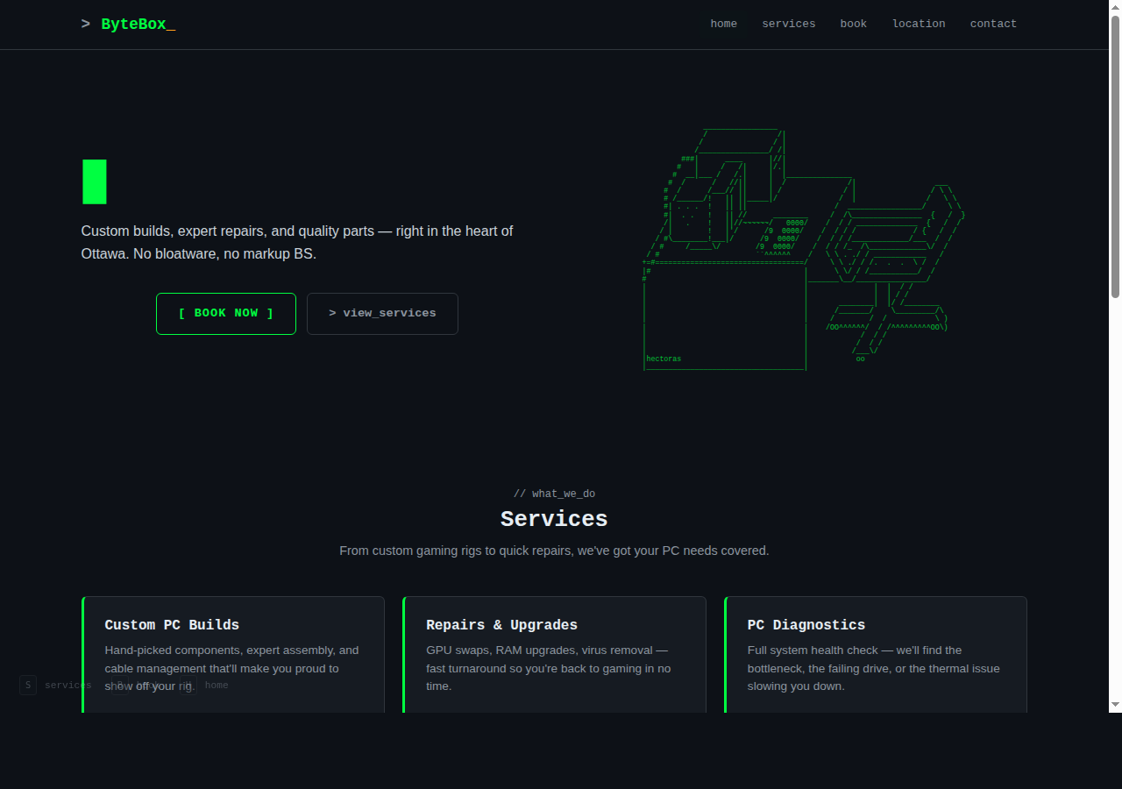

Maquette - Page des services
The services page mockup organized 6 service offerings in a responsive grid. Each card includes the service name, description, price, and a direct link to the booking page with the service pre-selected. This design supports both browsing users (who explore all options) and directed users (who know what they need).
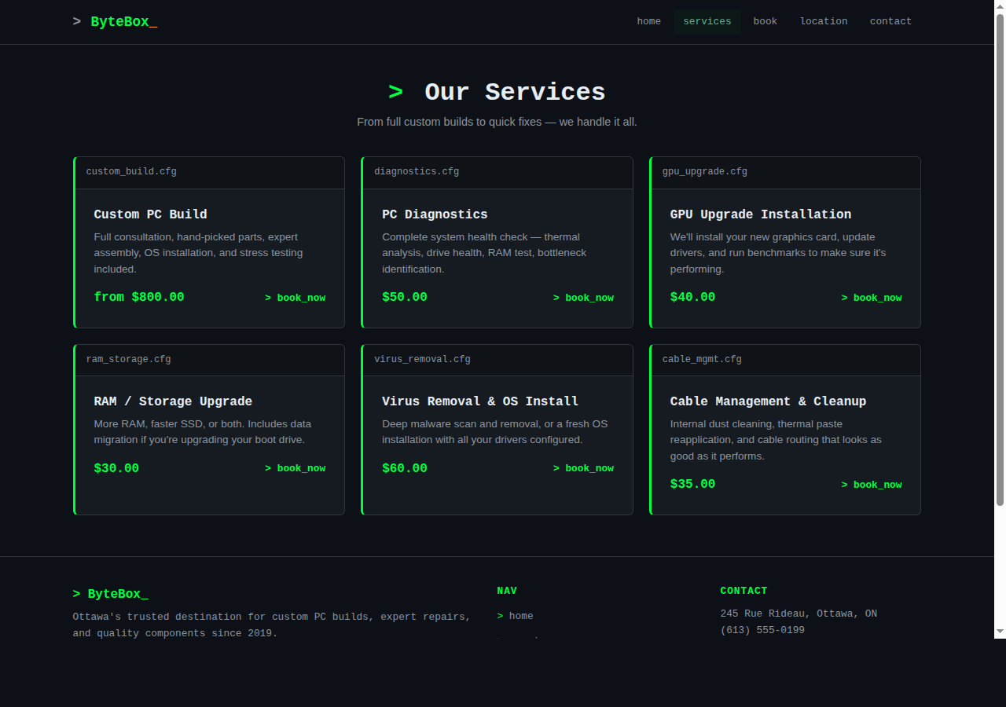

Maquette - Page de réservation
The booking form mockup used a 4-step progressive flow: service selection, date/time picker, client information, and review/confirmation. A progress bar at the top provides visibility of system status (Nielsen heuristic #1). This reduces cognitive load by breaking a complex form into manageable chunks.
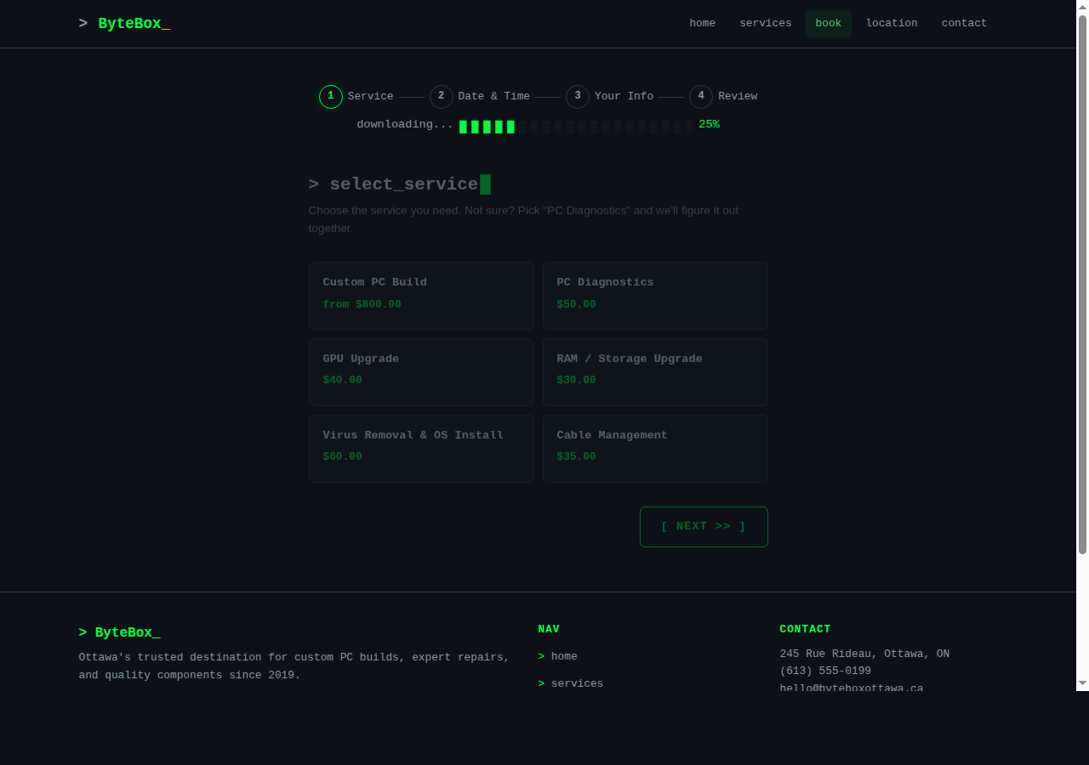

Maquette - Page de contact
The contact page mockup combined a contact form with direct contact information and an FAQ accordion. The two-column layout serves both users who prefer self-service (FAQ) and those who want direct communication (form/phone).
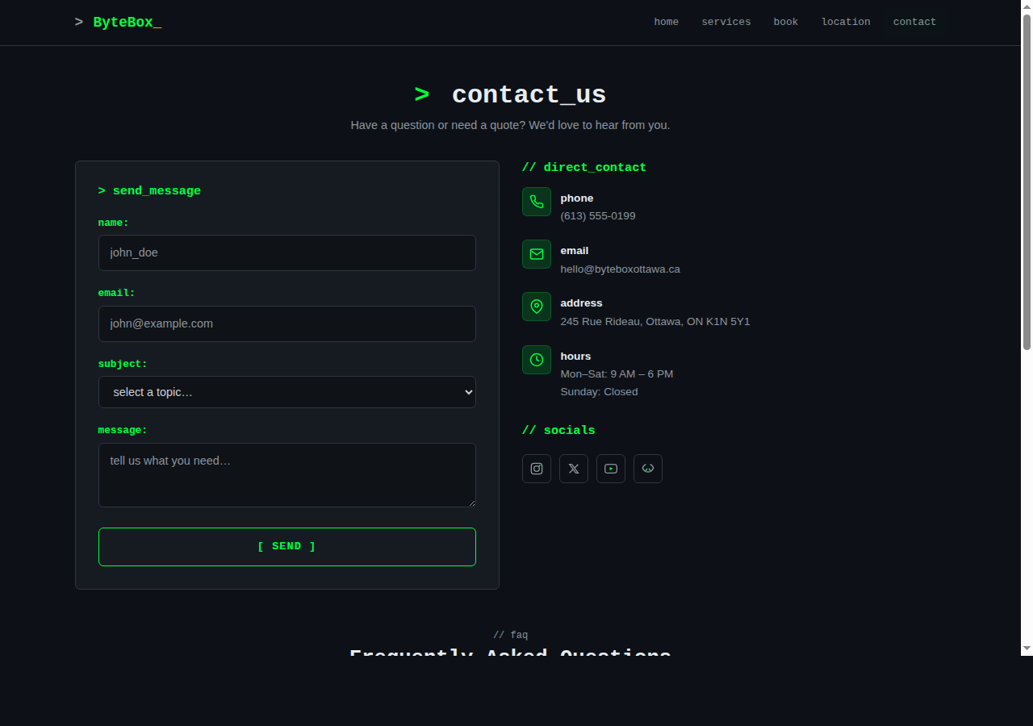

Maquette - Page de confirmation
The confirmation page mockup provides clear feedback after booking: a success indicator, reference number, booking summary, and next steps. This satisfies the "visibility of system status" heuristic.
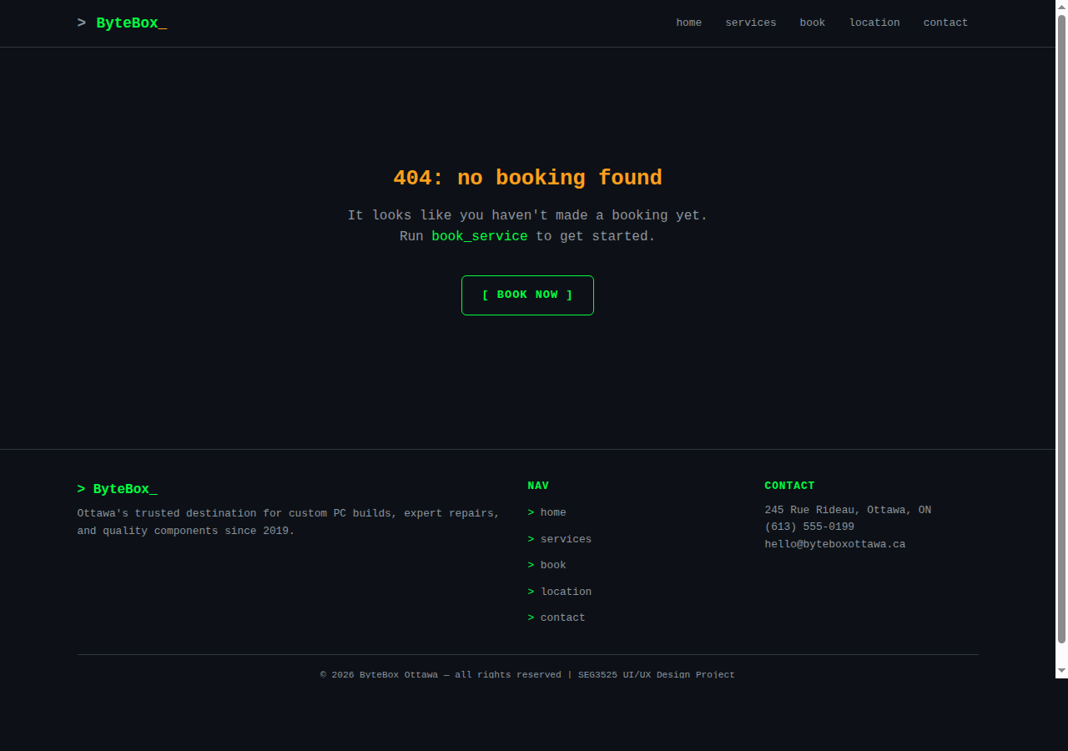

Maquette - Page de localisation
The location page mockup features an embedded Google Maps view, full address and contact details, business hours table, and directions from major landmarks. This addresses the fundamental user need of "how do I get there?"
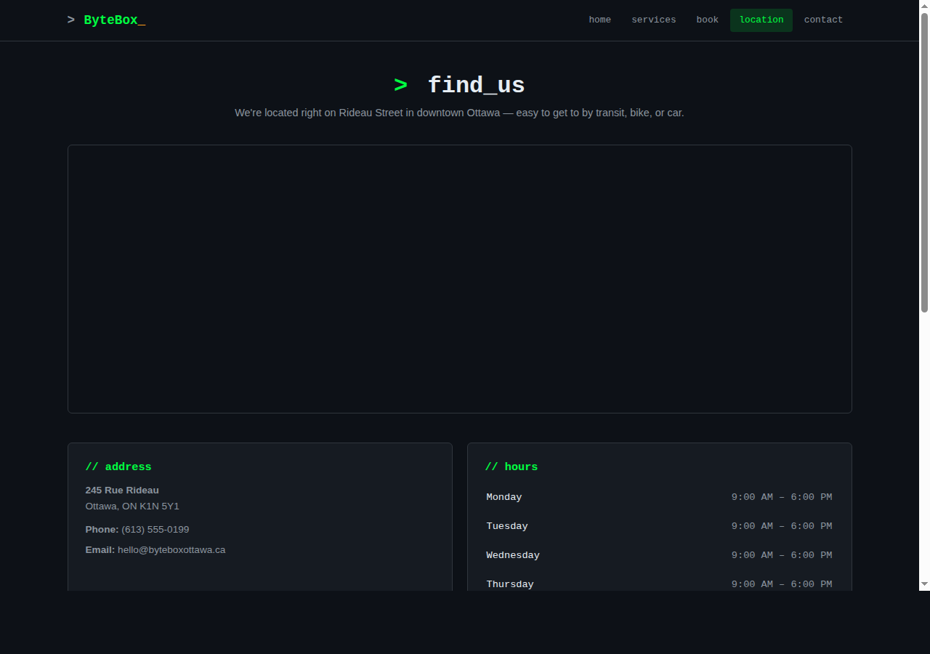

6. Modifications apportées en fonction du feedback

Éléments conservés :
- Dark theme with terminal-inspired aesthetic -- reviewers found it distinctive and appropriate for a PC shop targeting tech enthusiasts.
- Multi-step booking form with progress indicator -- praised for reducing form complexity.
- Responsive navigation with hamburger menu on mobile -- worked well across devices.
- Testimonial section styled as code comments (/* */) -- reviewers appreciated the creative touch that reinforced the brand identity.

Éléments modifiés :
- Removed overly complex ASCII art from the hero section that was rendering incorrectly on some screens. Replaced with a cleaner, properly aligned design (hectoras PC desk art) that scales better across viewport sizes.
- Toned down the terminal theme from "100% terminal" to "90% clean, 10% personality" -- the initial version had CRT scanlines, macOS-style window dots on cards, and full green monospace text that sacrificed readability for aesthetic. The final version uses terminal accents sparingly.
- Changed card design from terminal windows with colored dots to clean cards with a subtle green left-border accent -- more professional while retaining personality.
- Made form inputs use standard sans-serif font with green focus borders instead of full monospace green text -- significantly improved readability and usability.
- Added FAQ section to the contact page based on the insight that users often have common questions that don't require a form submission.

7. Personas et objectifs

Persona 1: Marcus (22, uOttawa CS student, PC gamer)
Objectif: Book a custom PC build consultation for Saturday afternoon, with a budget of $1,500 for a gaming rig.
Marcus knows the components he wants (RTX 4070, Ryzen 7) but needs expert advice on case airflow, PSU sizing, and compatibility. He wants to browse services and prices beforehand, book online rather than calling, and find the shop location easily since he'll take the bus from campus.
Raison de la sélection: Represents the tech-savvy user who values efficiency, self-service booking, and detailed technical information. Tests the booking flow's ability to handle a user who knows what they want.

Persona 2: Sophie (45, small business owner)
Objectif: Get her office desktop diagnosed -- it's running slow and crashing during video calls.
Sophie doesn't know if her computer needs a repair, upgrade, or replacement. She wants to understand what each service costs before committing, book a diagnostic appointment at a convenient time, and be able to ask questions before visiting. She values clear, jargon-free descriptions.
Raison de la sélection: Represents the non-technical user who needs guidance and reassurance. Tests whether the service descriptions are accessible and the booking flow accommodates uncertainty.

8. Lien vers l'UI finale
Live site: https://ahdernasr.github.io/seg3525-project2/
The site is fully responsive and functional. All pages are accessible, the booking form persists data across steps using sessionStorage, and the site works on both desktop and mobile browsers.

9. Lien vers le code
GitHub Repository: https://github.com/ahdernasr/seg3525-project2
The repository contains all source files: 6 HTML pages, shared CSS stylesheet, shared JavaScript file. Note: This project uses pure HTML, CSS, and JavaScript without Bootstrap, as the custom design required full control over styling to achieve the terminal-inspired aesthetic.

10. Justification du design

1. Color Scheme (Visual Communication - Chapter 7)
The interface uses a dark background (#0d1117) with terminal green (#00ff41) as the primary accent and amber (#ff9f1c) for secondary highlights. This color choice is intentional: green has strong associations with technology, terminals, and PC culture, immediately communicating the shop's identity to its target audience. The dark theme reduces eye strain for the tech-savvy demographic who likely use dark themes in their development environments. The limited color palette (2 accent colors) maintains visual consistency and reduces cognitive load, as discussed in the visual communication chapter.

2. Multi-Step Booking Form (Task Analysis - Chapter 4)
The booking process is broken into 4 sequential steps (service, date/time, client info, review), directly applying task analysis principles from Chapter 4. Each step represents a sub-task with a clear goal, reducing the cognitive burden of a long form. The progress bar provides visibility of system status (Nielsen heuristic #1), and the review step allows error correction before submission (heuristic #5: error prevention). Pre-selection from the services page supports recognition over recall (heuristic #6).

3. Typography and Information Hierarchy (System Image - Chapter 6)
Headings use a monospace font (Courier New) while body text uses the system sans-serif stack. This dual-font approach creates a clear visual hierarchy: monospace signals "this is a label/title" while sans-serif signals "this is content to read." This aligns with Chapter 6's system image concepts -- the user's mental model should distinguish navigation elements from content, and the typography system makes this distinction automatic. Section prefixes like "// what_we_do" use developer syntax as wayfinding cues for the target audience.

4. Responsive Layout and F-Pattern (Human Cognition - Chapter 5)
The layout follows the F-pattern reading model discussed in Chapter 5: the most important information (hero heading, call-to-action) is positioned in the top-left where users' eyes naturally begin. Service cards use a grid layout that leverages Gestalt proximity -- related information is grouped within cards, and cards are evenly spaced to signal they are peers. On mobile, the layout collapses to a single column, respecting the reduced screen real estate while maintaining the content hierarchy. The ASCII art is hidden on mobile to prioritize functional content over decoration, demonstrating progressive enhancement principles.

11. Contributions à l'évaluation par les pairs
a) Feedback donné par moi:

Feedback-1: Reviewed a hair salon website. Suggested improving the color contrast on the booking form (light grey text on white background was hard to read), adding a confirmation page after form submission, and making the navigation sticky so it remains accessible when scrolling long pages.
Feedback-2: Reviewed a dental clinic website. Recommended adding prices to the services page (users want to know costs upfront), reducing the number of navigation items by combining similar pages, and adding hover states to clickable elements to improve affordance.

b) Feedback que j'ai reçu:

Feedback-1: "The terminal theme is very creative and fits the PC shop concept well. The ASCII art in the hero was hard to read on smaller screens -- consider hiding it on mobile. The booking form progress bar is helpful but the green monospace text in the input fields is hard to read -- use a normal font for form inputs."
Feedback-2: "Good use of dark theme and consistent design language. Suggestion: add a FAQ section to the contact page for common questions. The service cards could benefit from icons to make them scannable faster. Overall navigation is intuitive and the site feels professional."

12. Conclusion
This project was a valuable exercise in applying user-centered design principles to a real web development task. The iterative process -- from initial mockups through peer review to final implementation -- demonstrated how feedback fundamentally improves design quality. My initial terminal-themed design prioritized aesthetic novelty over usability, and it was through iteration that I found the right balance between creative identity and functional clarity.
Key learnings:
1. Aesthetic choices must serve usability, not compete with it. The CRT scanlines and full monospace text looked "cool" but hurt readability. Toning them down improved the user experience without losing the brand personality.
2. Multi-step forms significantly reduce perceived complexity. Breaking the booking flow into 4 steps made it feel approachable even though it collects the same amount of information as a single long form.
3. Designing for dual audiences (technical and non-technical) requires progressive disclosure -- show the essential information to everyone, and let users who want more detail find it without overwhelming those who don't.
4. ASCII art in web design presents unique challenges -- it requires monospace fonts, exact character alignment, and responsive handling (hiding on mobile) that I hadn't considered before.
I gained practical experience with JavaScript (form validation, sessionStorage, DOM manipulation), CSS (custom properties, responsive design, animations), and the iterative UCD process. This project reinforced that good design is not about the first idea -- it's about refining through feedback and testing.

13. Clause de non-responsabilité
J'ai utilisé Claude (Anthropic), https://claude.ai, pour assister avec la génération du code HTML, CSS et JavaScript, ainsi que pour itérer sur le design visuel du site. Le concept créatif (thème terminal/PC enthusiast), les décisions de design UX, les personas, l'architecture de l'information, et l'analyse des principes de conception centrée sur l'utilisateur ont été développés par moi. L'outil a été utilisé comme un assistant de développement, pas comme un remplacement du processus de conception.

14. Références
1. Canada Computers - https://www.canadacomputers.com (site inspirant)
2. Framework Laptop - https://frame.work (inspiration design)
3. Micro Center - https://www.microcenter.com (inspiration booking flow)
4. ASCII Art Archive - https://www.asciiart.eu/computers/computers (ASCII art par hectoras)
5. MDN Web Docs - https://developer.mozilla.org/en-US/docs/Web/JavaScript/Guide (JavaScript reference)
6. W3Schools - https://www.w3schools.com/js/ (JavaScript tutorial)
7. CSS-Tricks - https://css-tricks.com/ (CSS techniques)
8. Nielsen Norman Group - https://www.nngroup.com/articles/ten-usability-heuristics/ (usability heuristics)
9. W3C WCAG - https://www.w3.org/WAI/WCAG21/quickref/ (accessibility guidelines)

