ByteBox Ottawa - PC Parts & Custom Builds

Nom de l'étudiant : Ahmed Nasr
Numéro d'étudiant : 300279868

Site d'entreprise inspirant
Site de référence : Canada Computers - https://www.canadacomputers.com
Canada Computers is a well-established Canadian PC parts retailer with both physical stores and an online presence. Their website inspired me because of its clear service categorization, straightforward navigation for both parts browsing and service booking, and how it balances technical information with accessibility for non-expert users. I wanted to capture a similar balance of expertise and approachability, but with a more modern, minimal design aesthetic and a personality that reflects the enthusiast PC culture.

Type d'entreprise choisi
I chose a local PC parts and custom build shop because it presents interesting UX challenges: the target audience ranges from enthusiast gamers who know exactly what they want, to parents buying their kid's first computer who need guidance. Designing for this dual audience requires careful attention to information architecture, progressive disclosure of technical details, and a booking flow that accommodates both "I know what I need" and "I need a consultation" user paths. This also allowed me to explore creative visual design (the terminal/retro aesthetic) while maintaining usability -- a core tension studied in SEG3525.

Deux personas
Persona 1 - Marcus (22, uOttawa CS student, gamer): Marcus wants to build a custom gaming PC for under $1,500. He has a rough idea of the components he wants (RTX 4070, Ryzen 7) but wants expert advice on case airflow and PSU sizing. He wants to book a build consultation for Saturday afternoon, browse the service options and prices beforehand, and know exactly where the shop is since he'll be taking the bus from campus.
Persona 2 - Sophie (45, small business owner): Sophie's office desktop is running slow and crashing during video calls. She doesn't know if it needs a repair, an upgrade, or a full replacement. She wants to book a diagnostic appointment, understand what each service costs before committing, and be able to contact the shop with questions. She values clear, jargon-free descriptions and a straightforward booking process.

Captures d'écran des maquettes

Page d'accueil
Home page with hero section, typing animation, ASCII art, service overview, testimonials, and business hours.
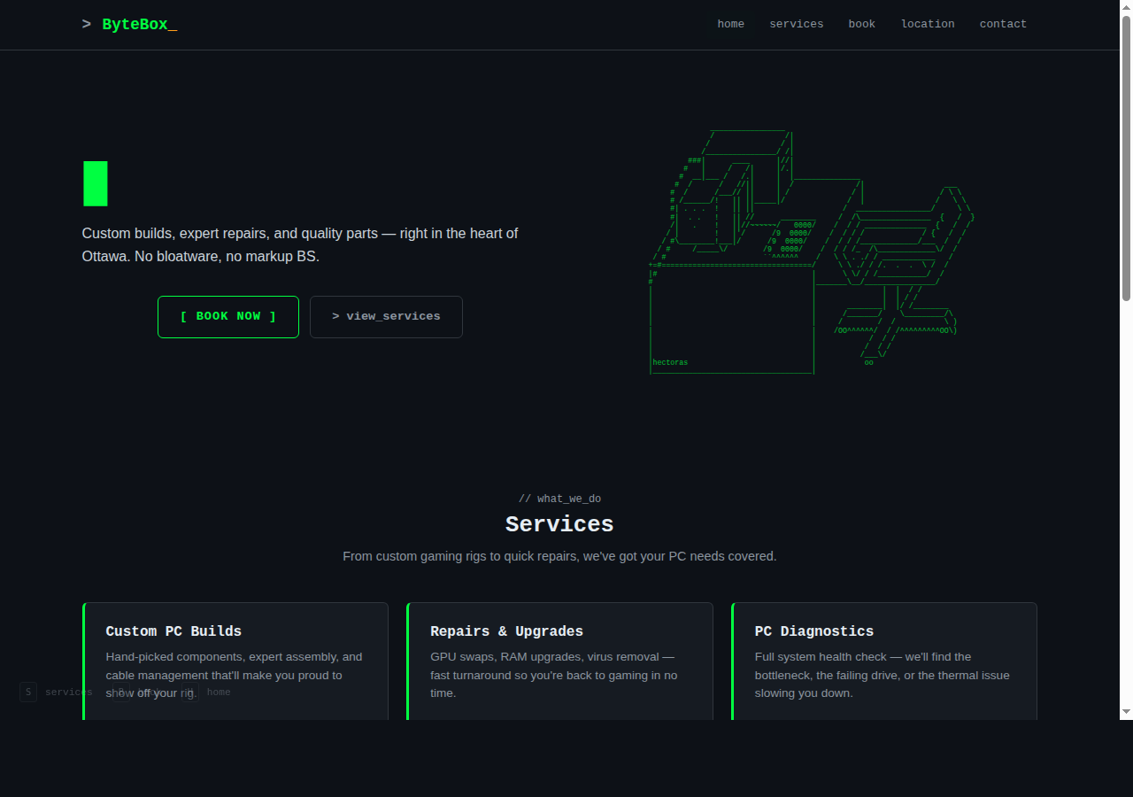

Page des services
Six service cards with descriptions, prices, and direct booking links. Clean grid layout with hover effects.
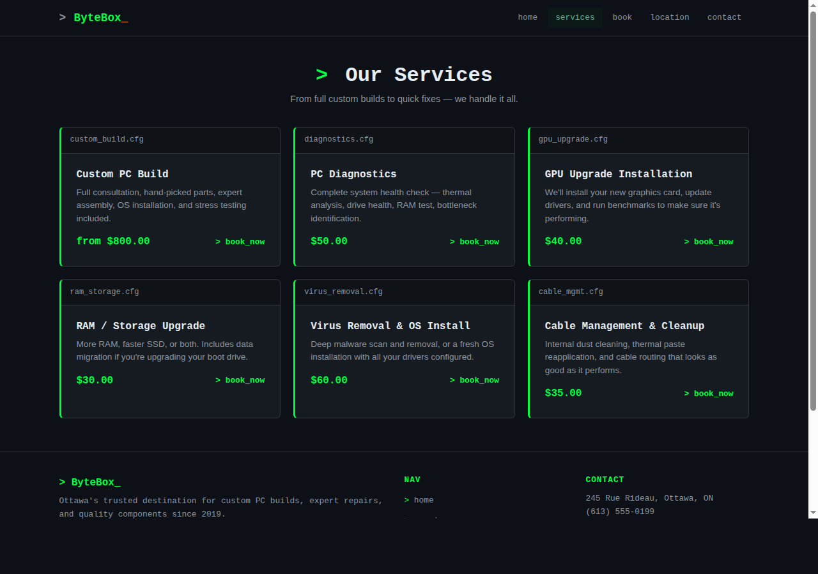

Page de réservation
Multi-step booking form (4 steps): service selection, date/time, client information, and review. Terminal-style progress bar.
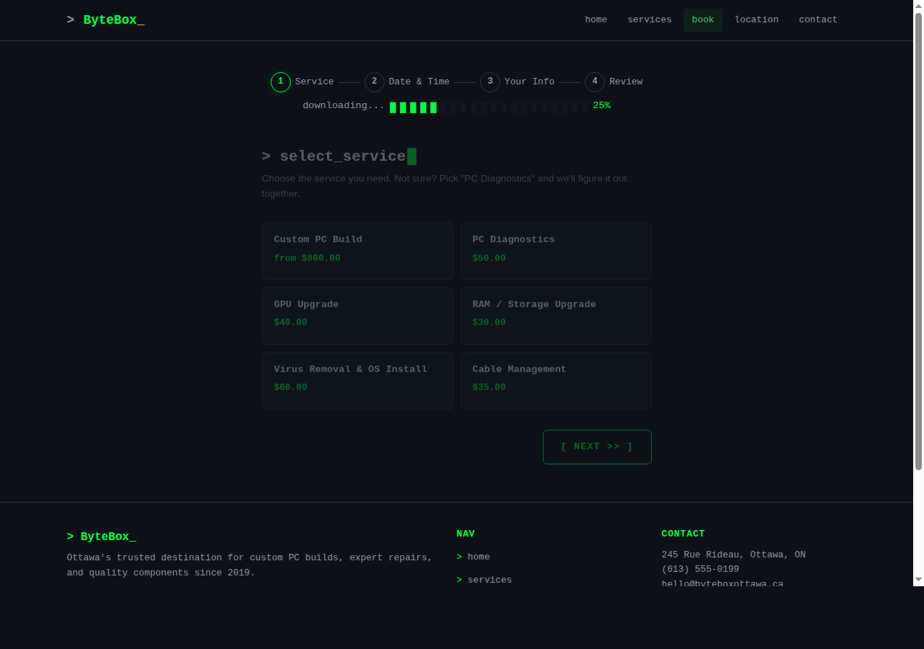

Page de contact
Contact form, direct contact info with icons, social media links, and FAQ accordion section.
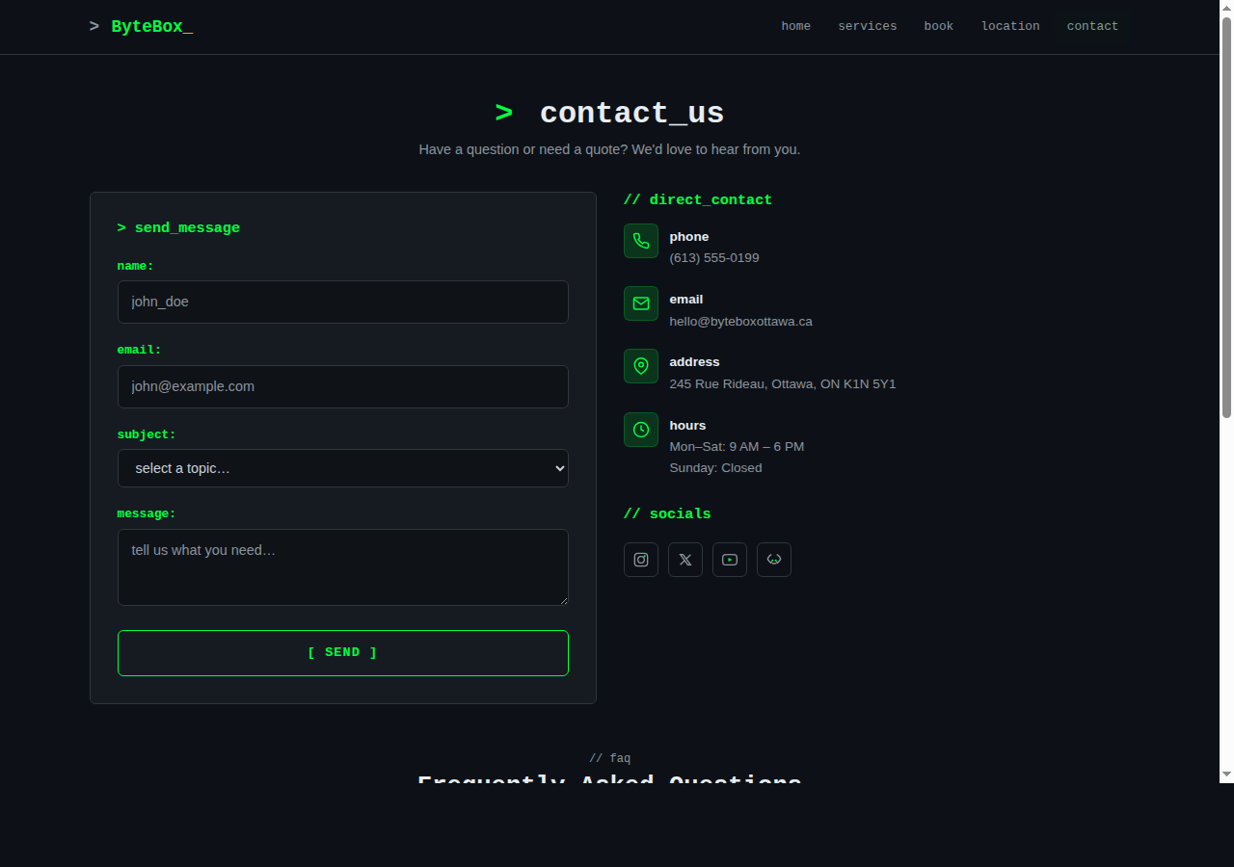

Page de confirmation
Booking confirmation with reference number, appointment summary, and calendar link.
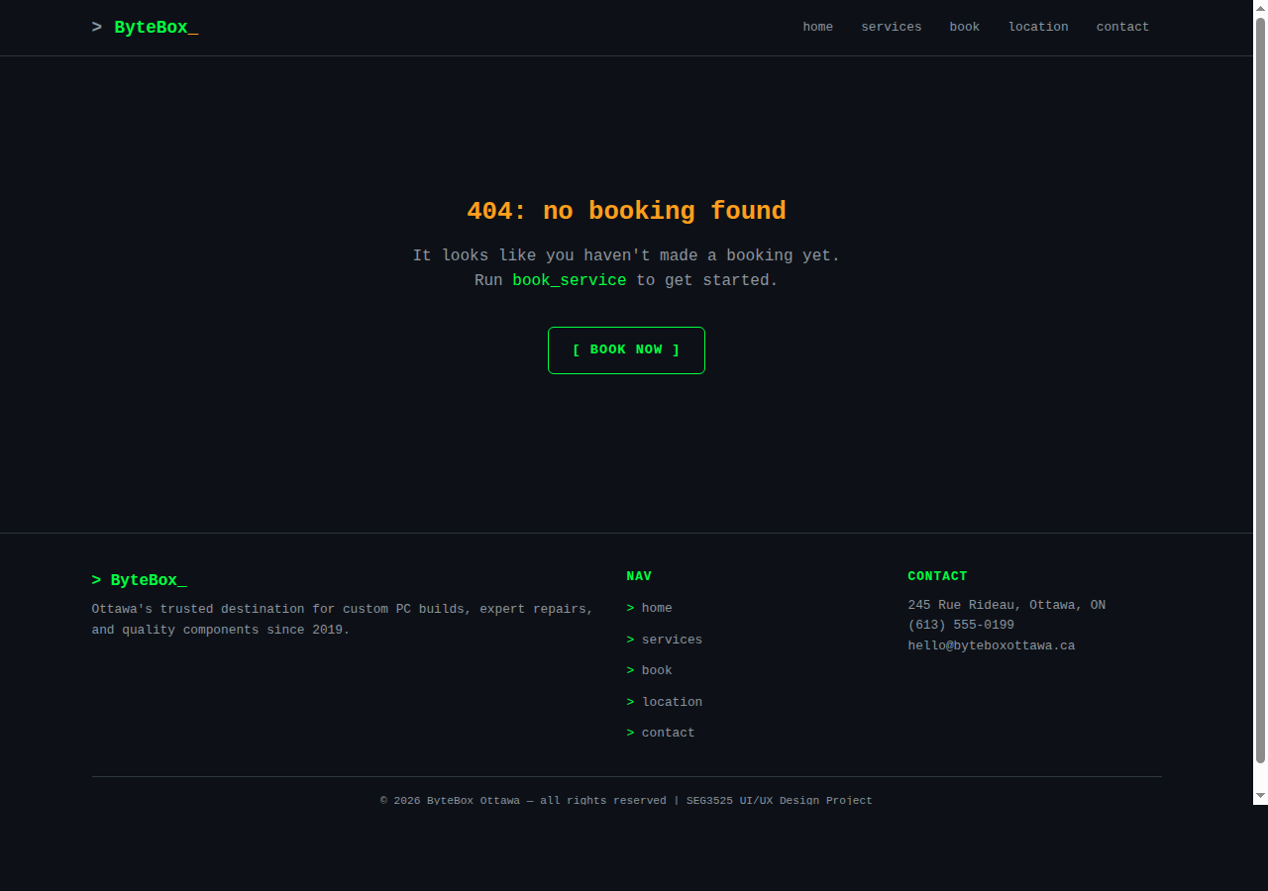

Page de localisation
Google Maps embed, address and contact details, business hours table, directions, and parking info.
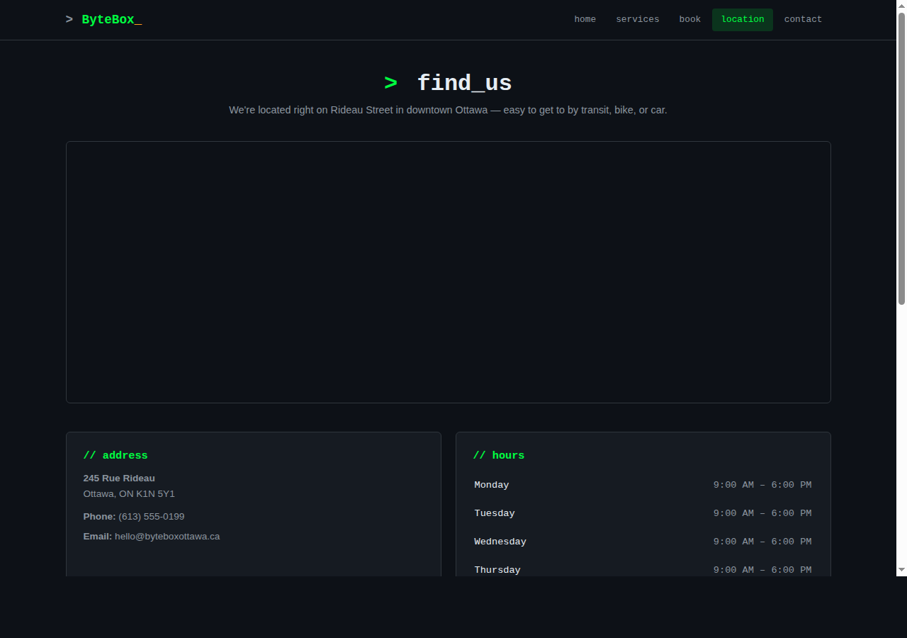

Clause de non-responsabilité
J'ai utilisé Claude (Anthropic), https://claude.ai, pour assister avec la génération du code HTML/CSS/JavaScript et pour le design visuel du site web. Le concept créatif, les décisions de design UX, les personas, et l'architecture de l'information ont été développés par moi.

Références
1. Canada Computers - https://www.canadacomputers.com (site inspirant)
2. ASCII Art Archive - https://www.asciiart.eu/computers/computers (ASCII art by hectoras and Kevin Lam)
3. Nielsen Norman Group - https://www.nngroup.com/articles/ten-usability-heuristics/ (heuristics reference)
4. MDN Web Docs - https://developer.mozilla.org/en-US/docs/Web/Progressive_web_apps (PWA and responsive design)
5. W3C Web Content Accessibility Guidelines - https://www.w3.org/WAI/WCAG21/quickref/ (accessibility)

