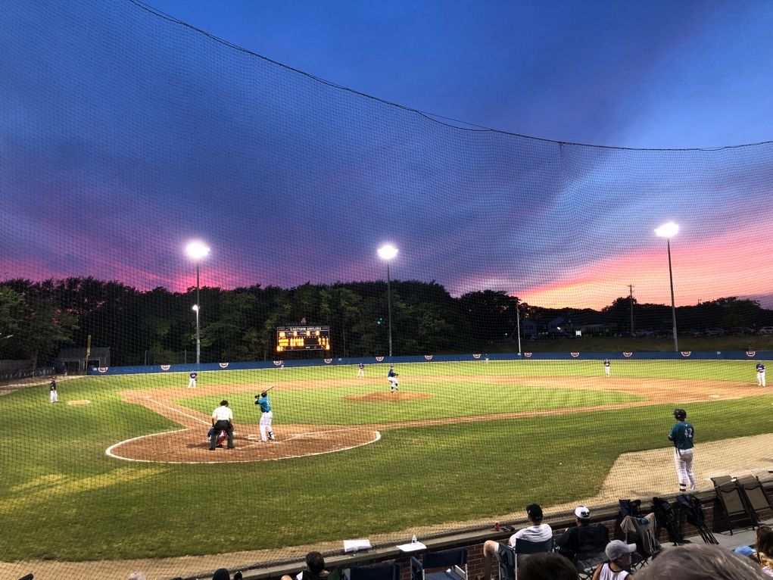

Source: me (personal photo)

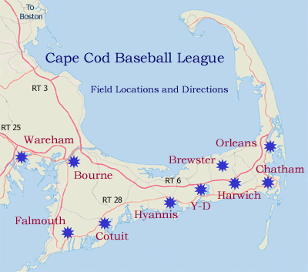

<http://www.capecodbaseball.org/teams/field-directions/>

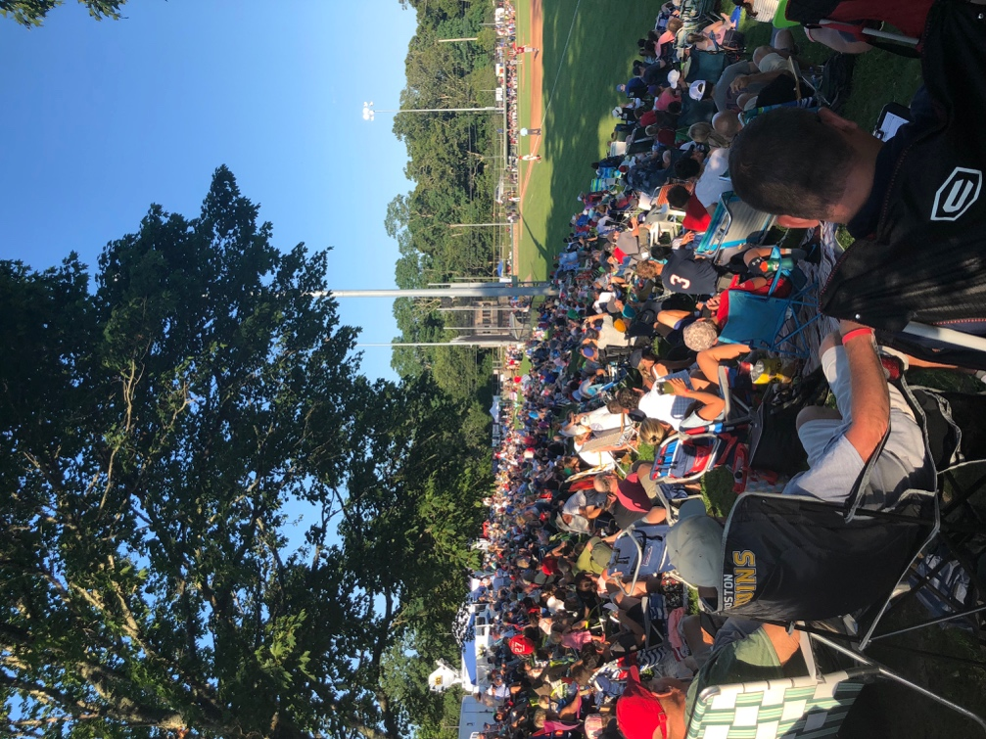

Source: me

videos:

<https://vimeo.com/74356495>

<https://www.youtube.com/watch?v=FY65TPNQq-A>

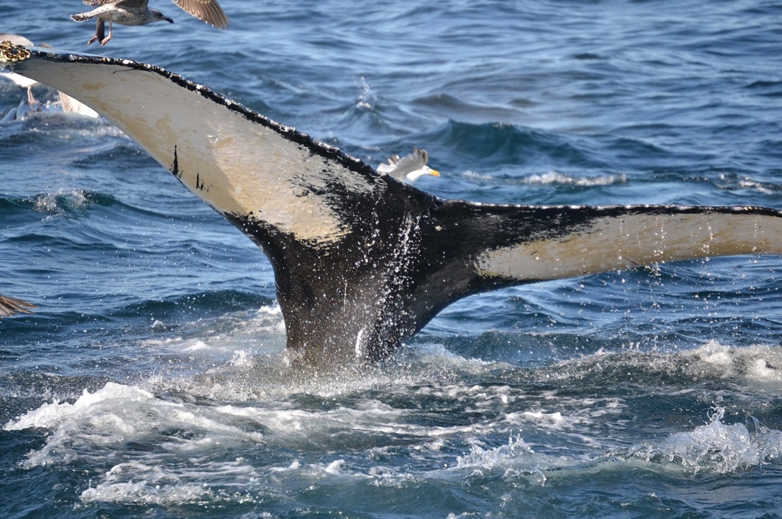

<https://pixabay.com/photos/humpback-whale-whale-cape-cod-2819470/>

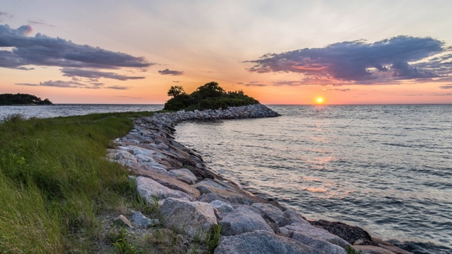

<https://www.goodfreephotos.com/united-states/massachusetts/cape-cod/sunset-and-dusk-landscape-over-cape-cod-massachusetts.jpg.php>

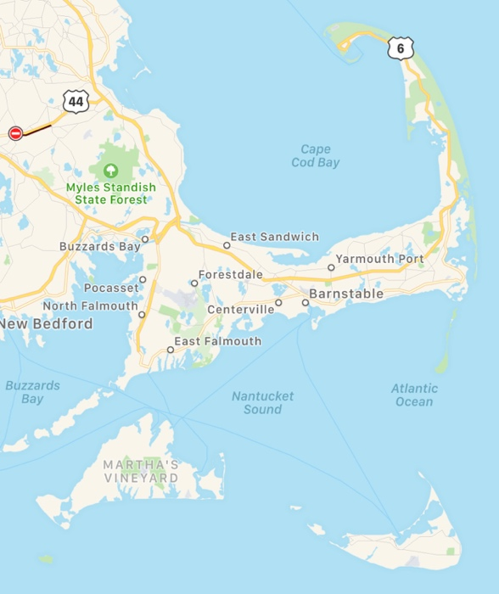

Source: me

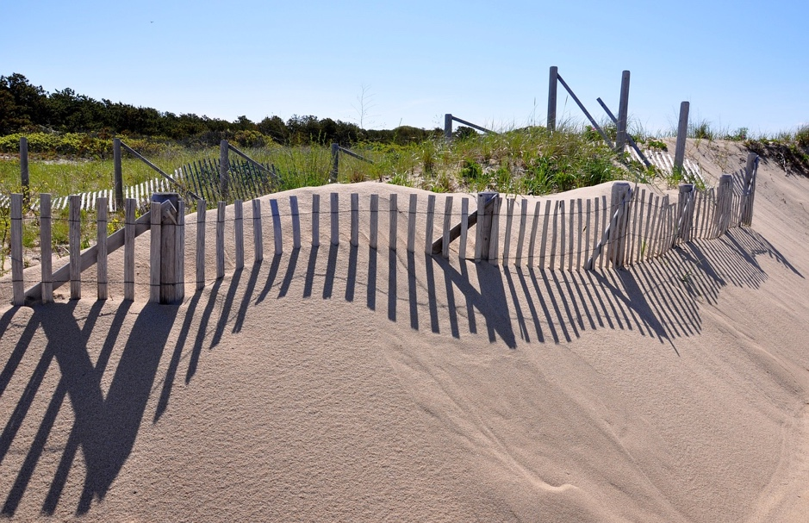

<https://pixabay.com/photos/cape-cod-provincetown-dune-grass-2232972/>

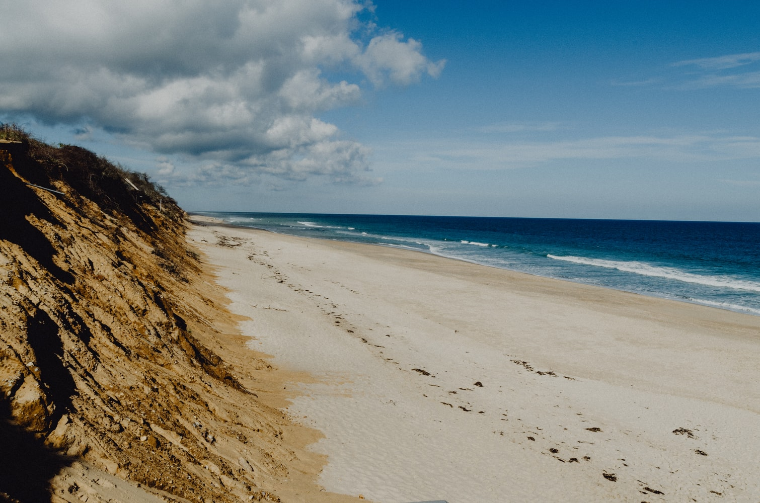

<https://unsplash.com/photos/mSoM8rDzhfE>

surfer:

<https://unsplash.com/photos/scIXeTCipZA>

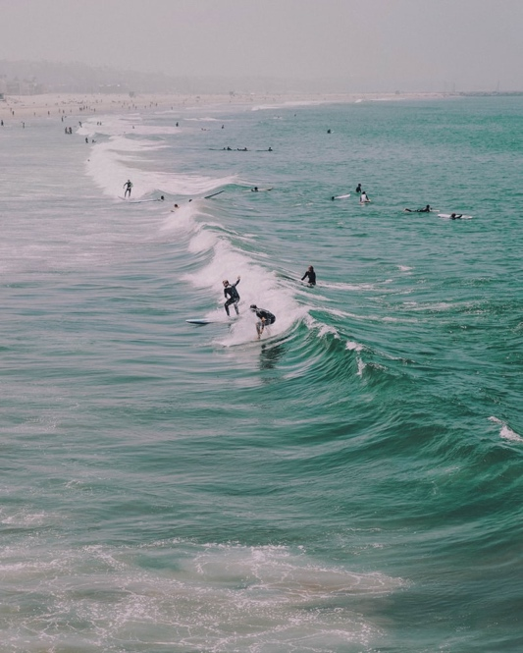

chatham

<https://www.pinterest.com/pin/204632376792511186/?lp=true>

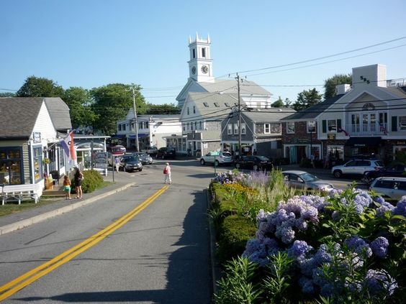

ferry

<https://pixabay.com/photos/boat-switzerland-bergsee-tourism-1513948/>

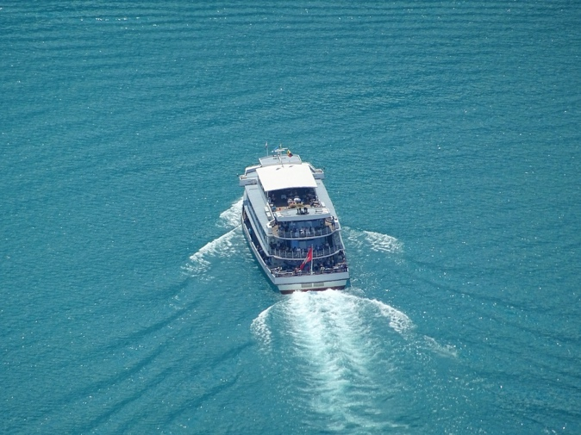

Race point

<https://cdn.pixabay.com/photo/2015/03/20/21/22/race-point-beach-682934_1280.jpg>

