**Sprint Review Meeting**

**Sprint 1:**

**When to held:**

* End of each sprint.

**Participant Involved:**

* Scrum Master (Christopher Foh Wei Chung)
* Team member (Hiew Chin Ching, Chu Yung Onn, Ho Kin Hoe, Chua Jien Xian, Kelvin)
* Product owner & Stakeholder

**Purpose:**

* This meeting is held to allow Scrum Master and his team to demonstrate part of the system developed or the part accomplished to the stakeholder to allow full transparency on the system.
* This meeting also allow Scrum Master and his team to gather feedback from the stakeholder regarding the system developed or part of the system developed.
* Another purpose is to gather approval from the customer whether the developed system or the increment product acceptable or not.
* This meeting is also used to allow the Scrum Master to report the status of the sprint and the status of the user stories complete / incomplete so the Product owner can have the full context regarding the whole situation.

**Module Involved:**

* Login Module
* Bus Management Module
* Route Management Module
* Bus Schedule Management Module
* Staff Management Module

**Review User Stories Session**

**Login Module**

|  |  |  |
| --- | --- | --- |
| **User Stories** | **Status** | **Satisfied/Dissatisfied** |
| Allow staff to login | Started | Satisfied |
| Allow manager to login | Started | Satisfied |
| Allow customer to login | Started | Satisfied |
| Allow customer to register | Started | Satisfied |

**Bus Management Module**

|  |  |  |
| --- | --- | --- |
| **User Stories** | **Status** | **Satisfied/Dissatisfied** |
| Allow staff to add new bus | Started | Satisfied |
| Allow staff to edit existing bus | Started | Satisfied |
| Allow staff to search a bus to view | Started | Satisfied |
| Allow staff to delete a bus | Started | Satisfied |

**Route Management Module**

|  |  |  |
| --- | --- | --- |
| **User Stories** | **Status** | **Satisfied/Dissatisfied** |
| Allow staff to add new route | Started | Satisfied |
| Allow staff to edit existing route | Started | Satisfied |
| Allow staff to search or route to view | Started | Satisfied |
| Allow staff to delete a route | Started | Satisfied |

**Bus Schedule Management Module**

|  |  |  |
| --- | --- | --- |
| **User Stories** | **Status** | **Satisfied/Dissatisfied** |
| Allow staff to add new schedule | Started | Satisfied |
| Allow staff to edit existing schedule | Started | Satisfied |
| Allow staff to search schedule to view | Started | Satisfied |
| Allow staff to delete a schedule | Started | Dissatisfied |

**Staff Management Module**

|  |  |  |
| --- | --- | --- |
| **User Stories** | **Status** | **Satisfied/Dissatisfied** |
| Allow manager to add new staff | Started | Dissatisfied |
| Allow manager to edit existing staff | Started | Satisfied |
| Allow manager to search staff to view | Started | Satisfied |
| Allow manger to delete a staff | Started | Satisfied |

**Customer Feedback 1**

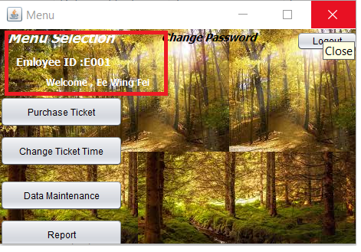

The title text in the homepage is rather small and the color is white which make the text itself even harder to see or read. The customer suggested to change the size of the text and the color so it that do not melt into the background so the word will be able to read and easier to recognize. The customer is satisfied with the theme of background because it enables the customer to feel relax whenever they are working in front the computer for whole day. However, the customer wants the background to become a full picture instead of mix of a few repeating picture.

**Customer Feedback 2**

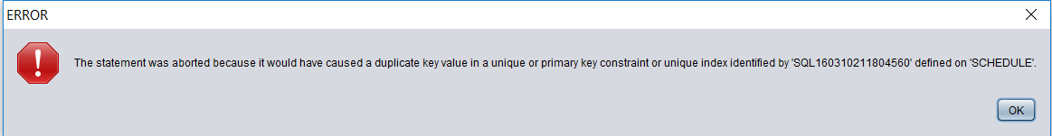

The error message itself is a system message which only understand by professional which it is not helpful to customer to correct their mistake. The customer does not understand the technical term, therefore it is confusing to the customer about what to do. So, the customer suggested that the error message should be simple and human-readable. The error message should be helpful to the customer or user to guide them through.

**Customer Feedback 3**

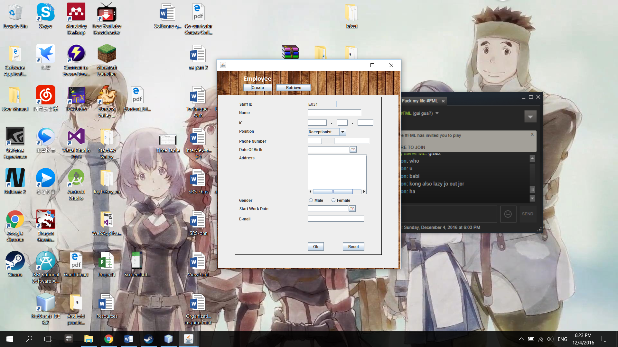

This window does not provide a home button or a back button for the user to the navigate back to the home menu. The customer thinks that it is not convenient because the window have to be close every time after they accomplished their task. The customer may need to use other functions after perform certain task. Thus, customer suggested to provide a button to navigate back to homepage to allow flexibility.