NetOsis Hybrid Cyber Deception System
Complete Proxmox SDN, OPNsense & Kea DHCP Setup Guide
Comprehensive Step-by-Step Setup, In/Out Traffic Flows & Empirical Screenshot Evidence
Date: September 2026 | NetOsis FYP Architecture

1. Executive Summary & Core Concept
This document serves as the master setup and deployment guide for the NetOsis Cyber Deception Platform. It outlines the complete network architecture, Proxmox Software-Defined Networking (SDN) configuration, OPNsense interface assignments, Kea DHCPv4 service setup, in-and-out traffic flows, and empirical screenshot evidence recorded during lab configuration.
2. Proxmox VE SDN & Network Bridges Architecture
Proxmox VE Software-Defined Networking (SDN) abstracts physical and virtual network layer 2/3 topologies into manageable objects: Zones, VNets, and Subnets.
• Zone: fypzone is a VLAN-type Zone (IPAM: pve) defined across node vhos. It enforces 802.1Q VLAN encapsulation over the internal bridge vmbr1.
• VNets: Virtual networks FIN (VLAN Tag 10), OPS (VLAN Tag 20), ENT (VLAN Tag 30), and SOC (VLAN Tag 40).
• Bridges: vmbr0 (Management & External WAN: 172.30.226.0/24, Non-VLAN-aware) and vmbr1 (Internal 802.1Q Trunk Bridge, VLAN-aware: Yes).
Figure 1: Proxmox Datacenter SDN Zone (fypzone)
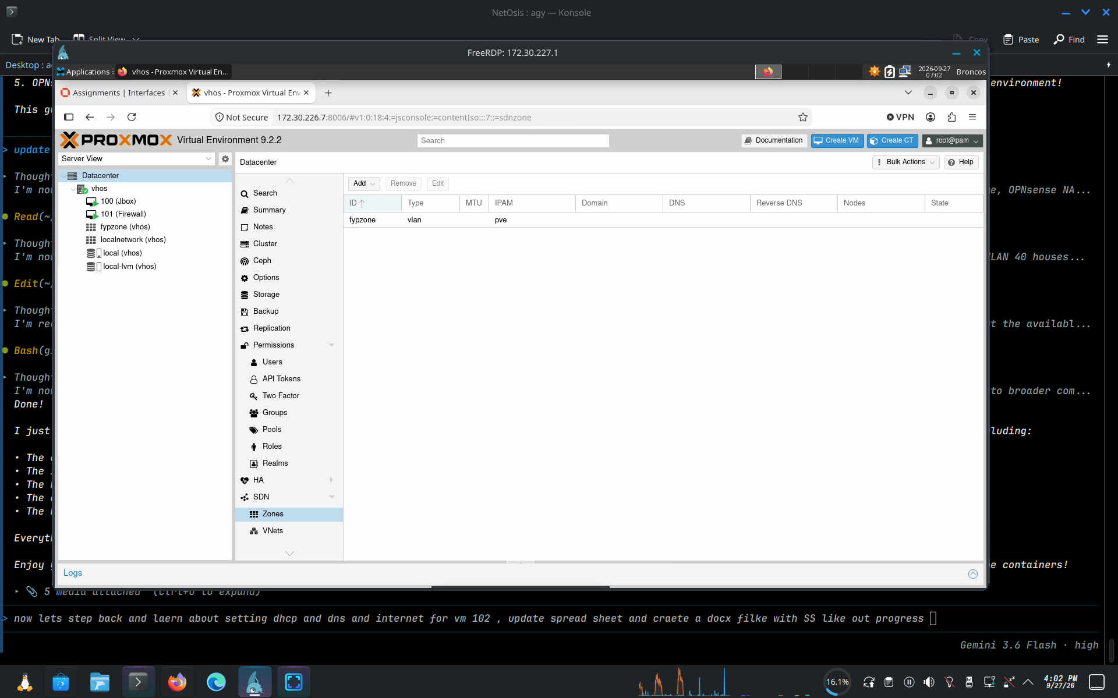
Displays Datacenter > SDN > Zones in Proxmox VE, illustrating fypzone configured as a VLAN-type Zone (IPAM: pve) attached to node vhos.

Figure 2: Proxmox Datacenter SDN VNets (ENT, FIN, OPS, SOC)
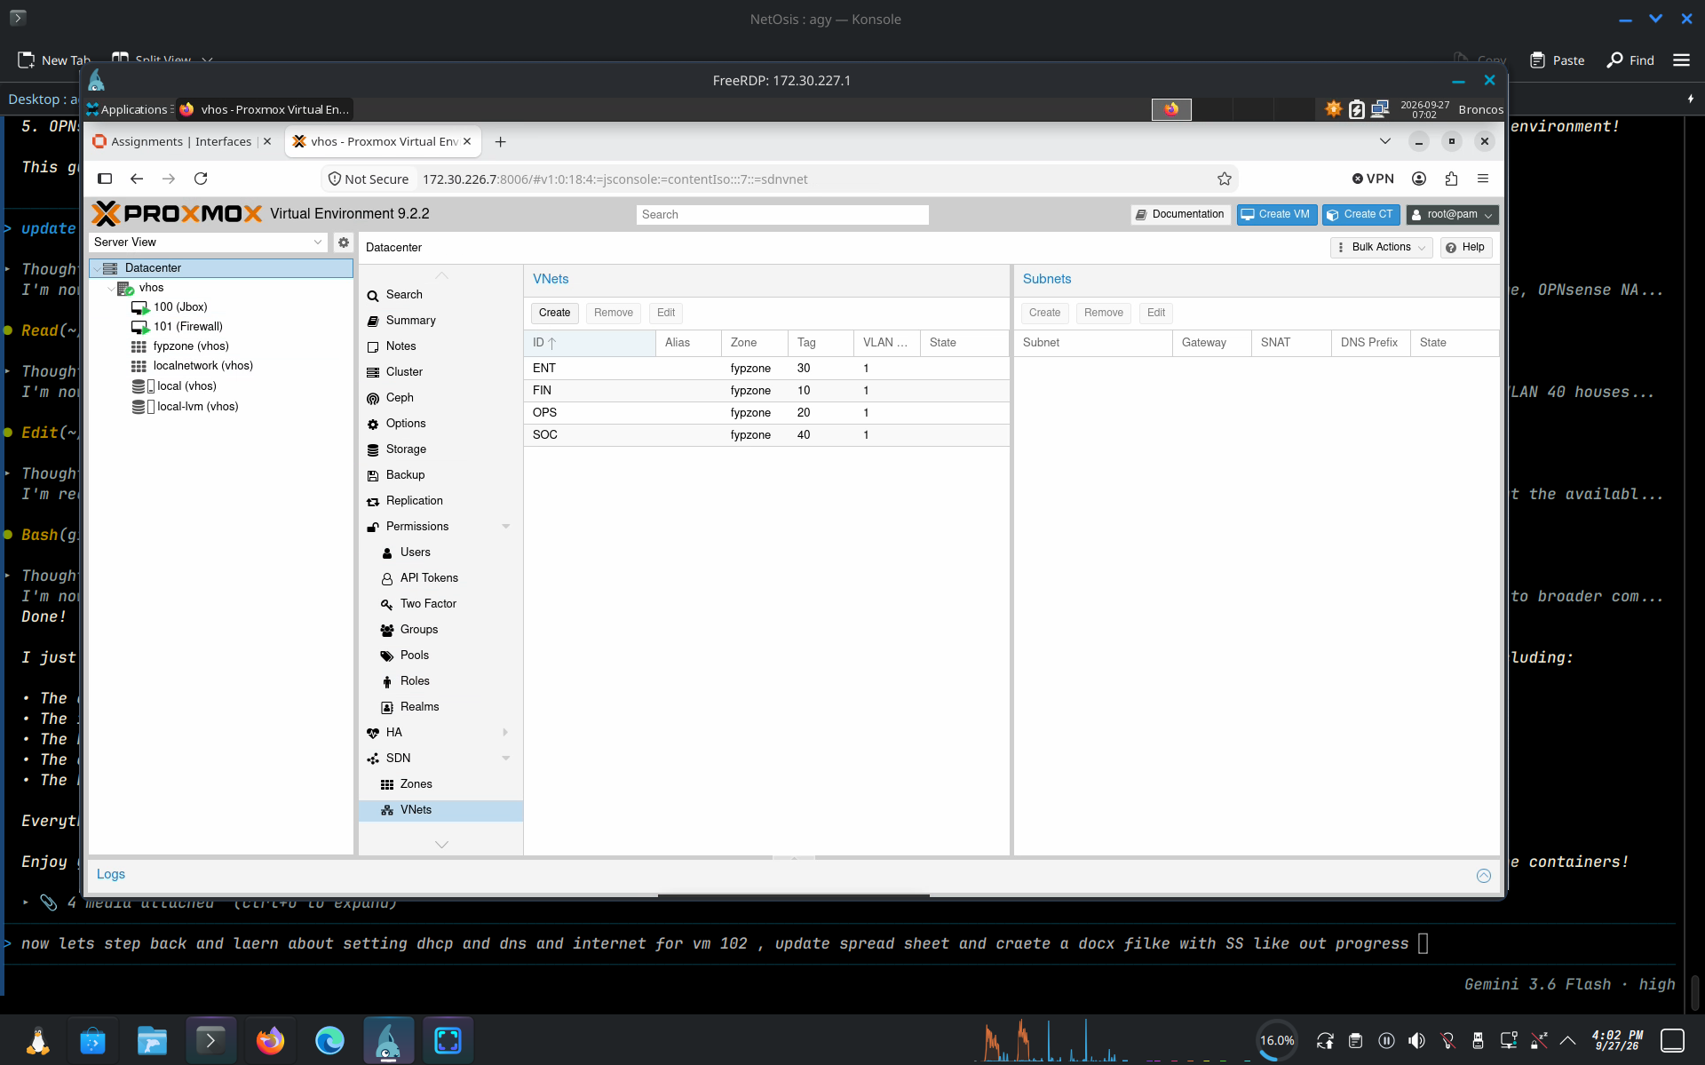
Displays Datacenter > SDN > VNets in Proxmox VE, showing Virtual Networks ENT (Tag 30), FIN (Tag 10), OPS (Tag 20), and SOC (Tag 40) bound under fypzone.

Figure 3: Proxmox Node fypzone Virtual Bridges
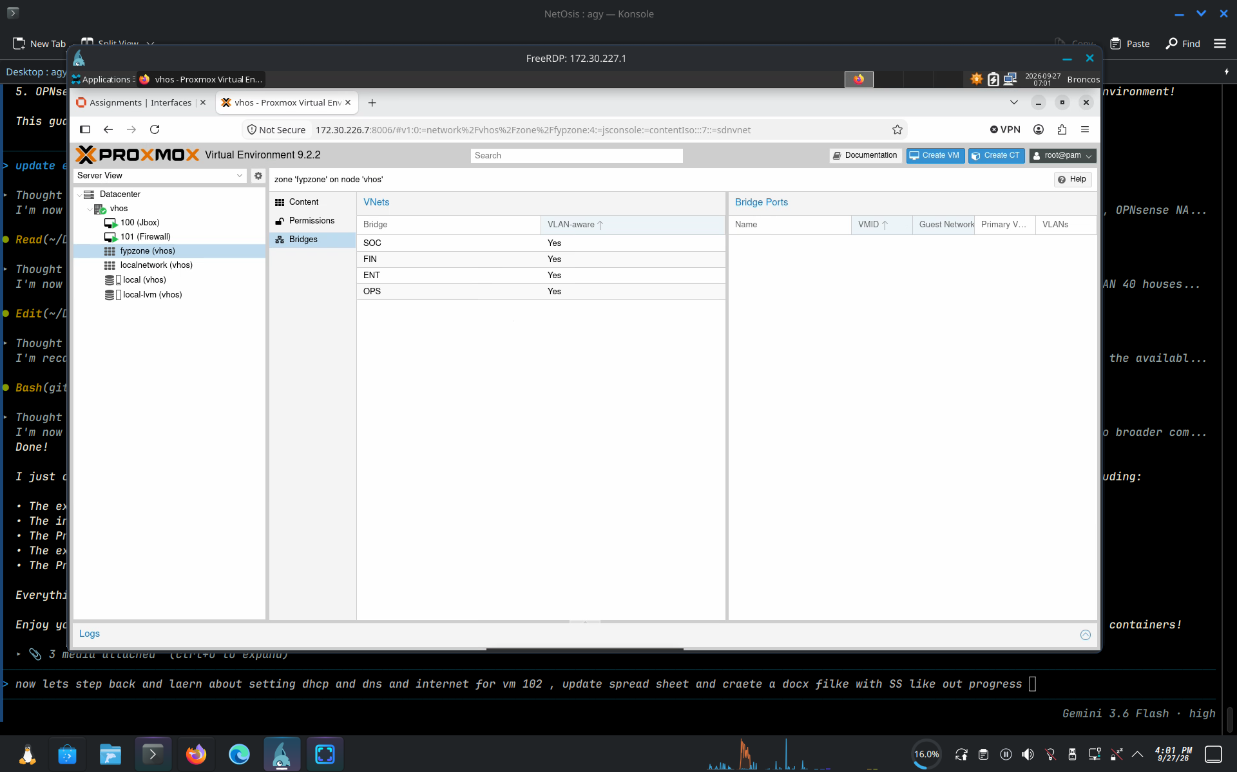
Shows node vhos under SDN zone fypzone, depicting virtual bridge endpoints SOC, FIN, ENT, and OPS with VLAN-aware status enabled.

Figure 4: Proxmox Node localnetwork Linux Bridges (vmbr0, vmbr1)
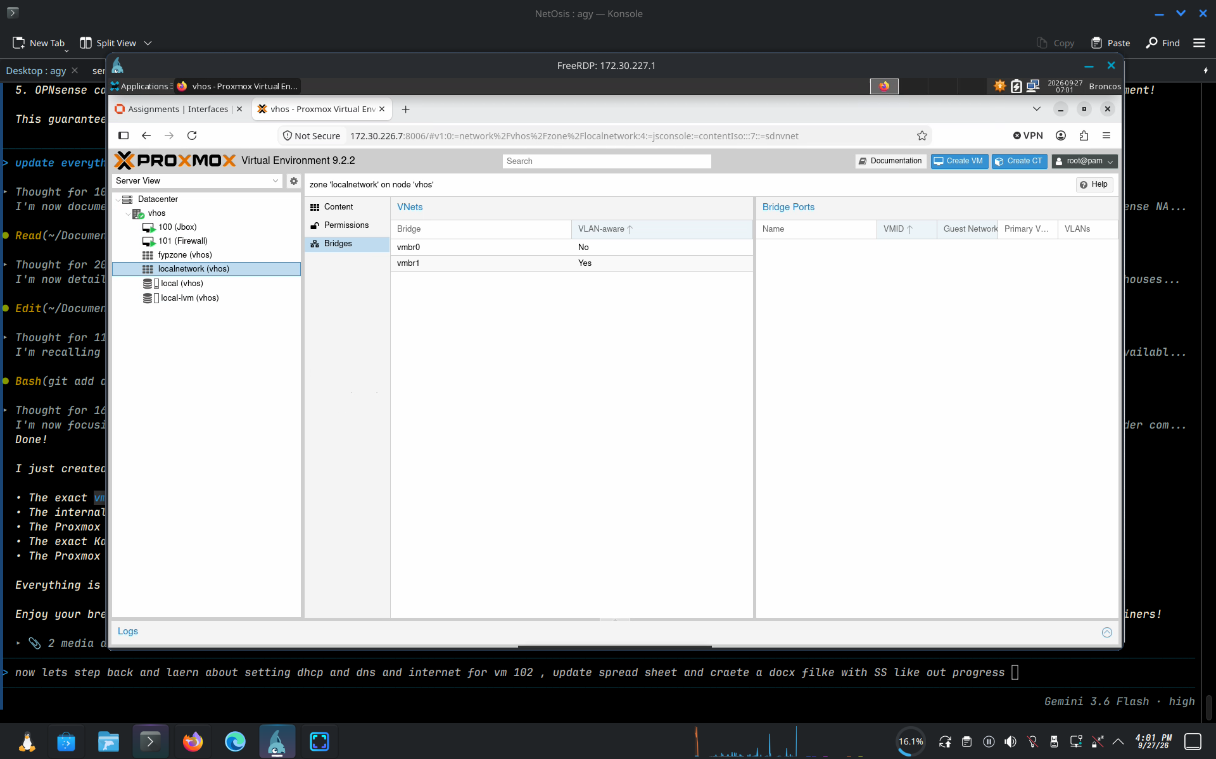
Shows node vhos Linux bridges under zone localnetwork: vmbr0 (Management/WAN, non-VLAN-aware) and vmbr1 (Internal trunk bridge, VLAN-aware: Yes).

Figure 5: VM 102 Hardware Network Device Configuration
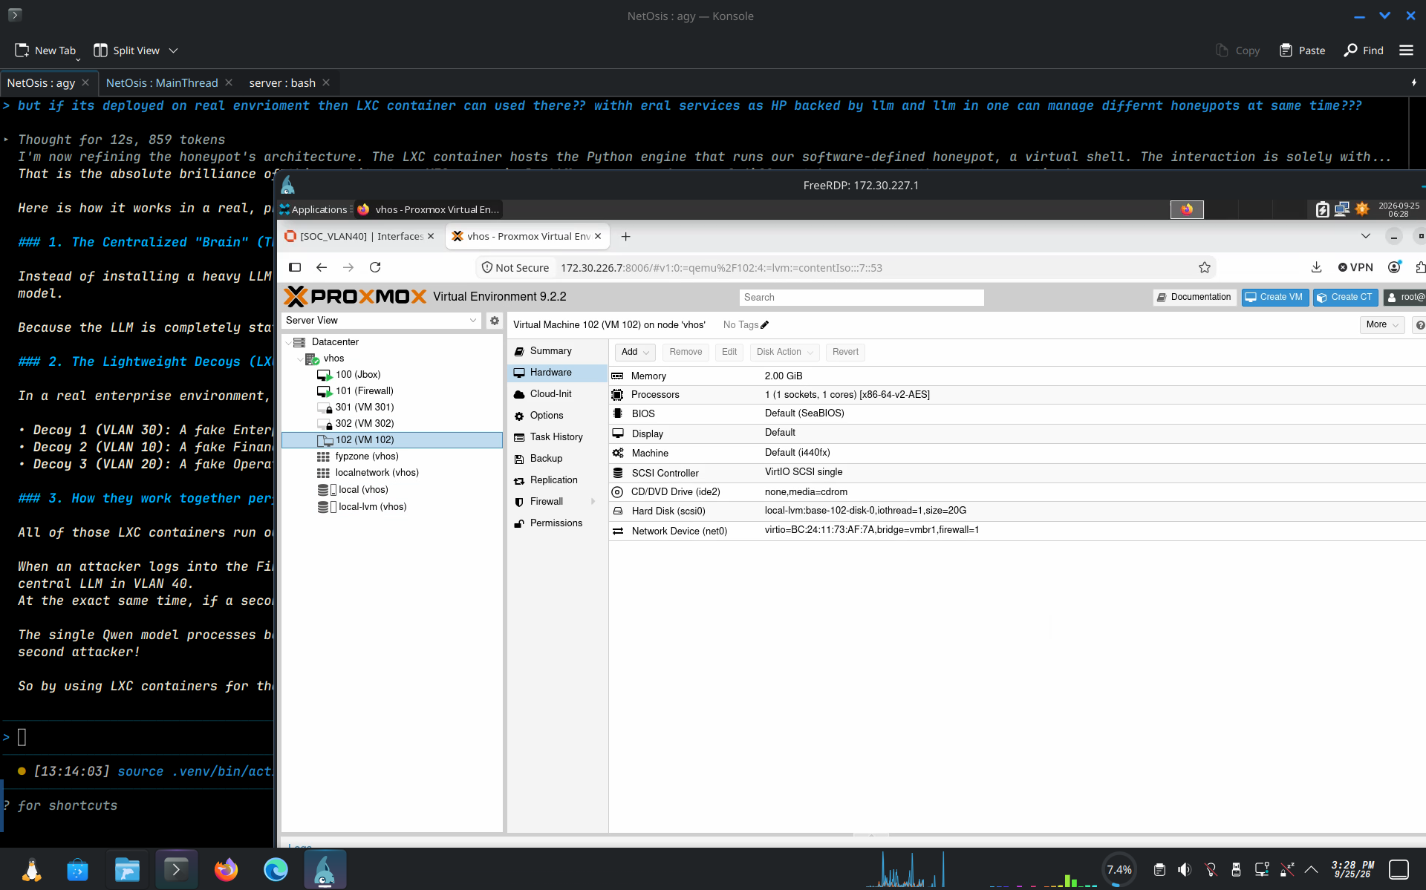
Displays VM 102 hardware configuration attached to bridge vmbr1 with firewall enabled (firewall=1).

Figure 6: Proxmox VE GUI Status Daemon Connection View
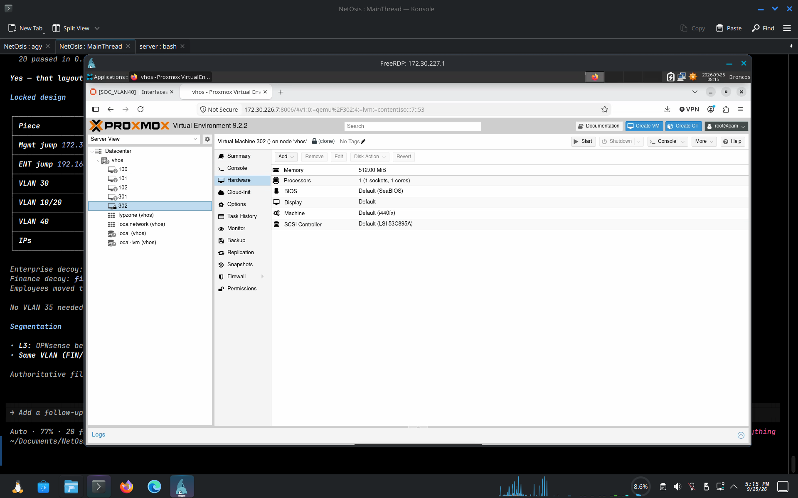
Illustrates Proxmox VE GUI displaying status daemon state across VMs and storage pools.

3. OPNsense Firewall Interface Assignments & Gateways
OPNsense acts as the core Layer 3 router, firewall, and NAT gateway between internal VLANs and the external network.
Figure 7: OPNsense Interface Assignments
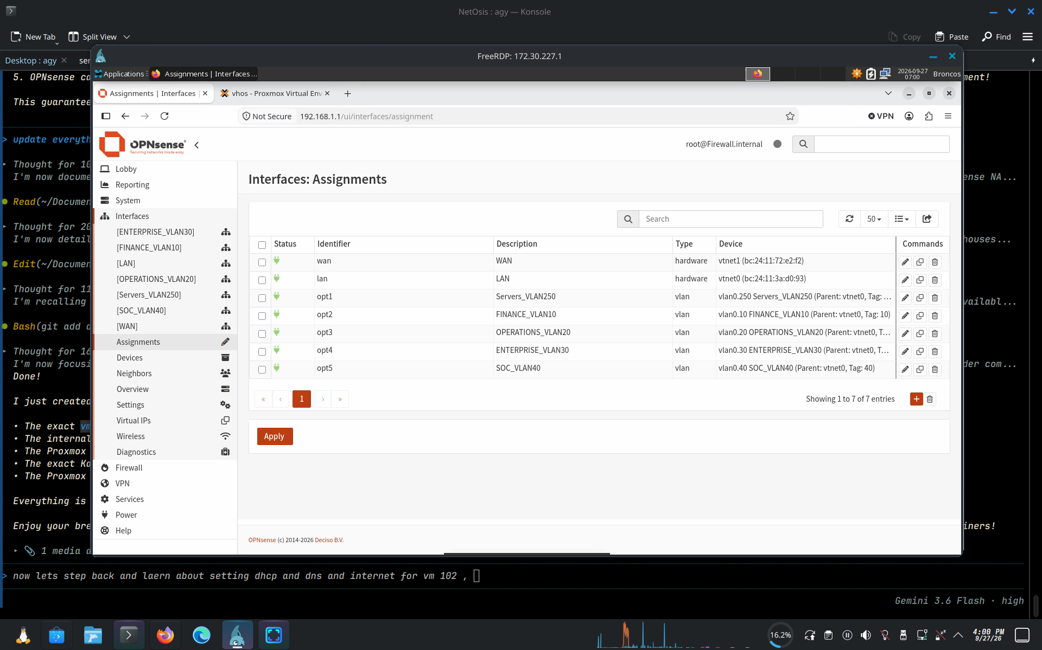
Shows OPNsense hardware interfaces vtnet1 (WAN) and vtnet0 (LAN parent), along with assigned 802.1Q VLAN subinterfaces: vlan0.10 (FINANCE_VLAN10), vlan0.20 (OPERATIONS_VLAN20), vlan0.30 (ENTERPRISE_VLAN30), vlan0.40 (SOC_VLAN40), and vlan0.250 (Servers_VLAN250).

Figure 8: OPNsense System Gateways Configuration
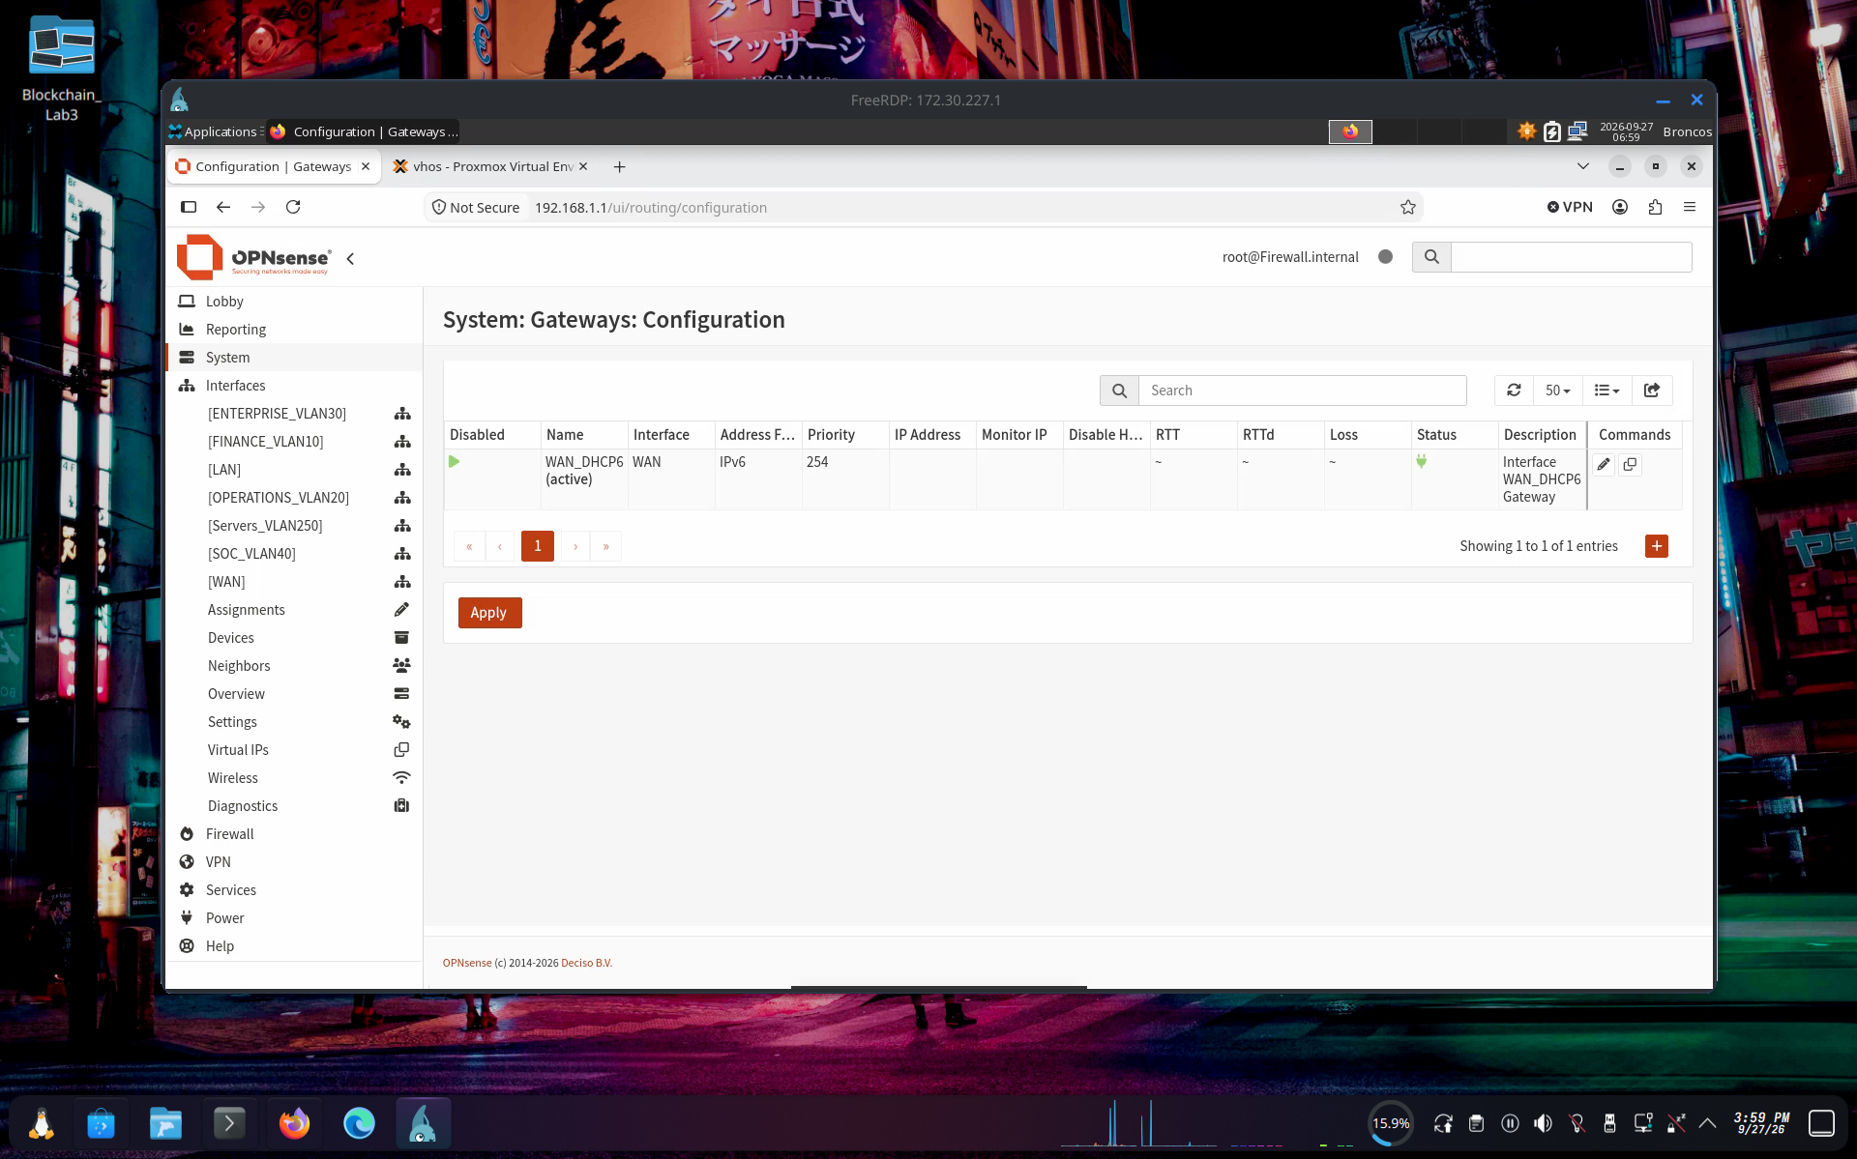
Displays the System > Gateways > Configuration page in OPNsense, confirming the active WAN IPv6/IPv4 default gateway route for upstream internet connectivity.

4. Modern Kea DHCPv4 Configuration & Subnet Setup
In OPNsense 24.x, the legacy DHCPv4 server is replaced by modern Kea DHCP. Kea DHCP is accessed via Services > Kea DHCP > Kea DHCPv4.
Figure 9: OPNsense Services Menu Showing Kea DHCP
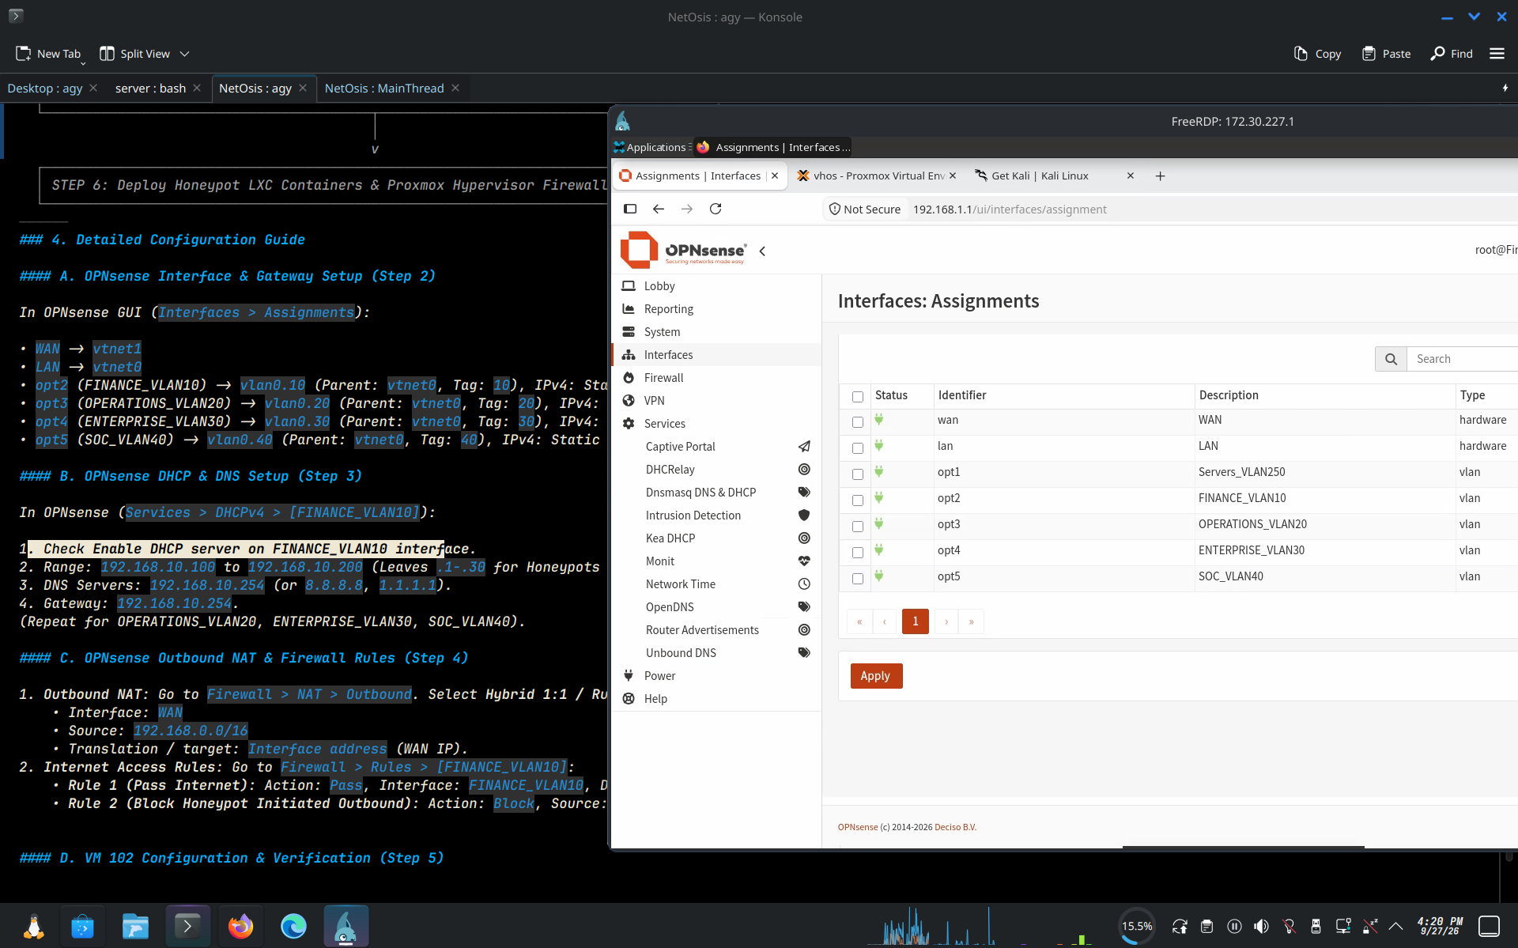
Demonstrates the location of Kea DHCP under Services > Kea DHCP in OPNsense 24.x left navigation sidebar.

Figure 10: Kea DHCPv4 Subnets Initial View
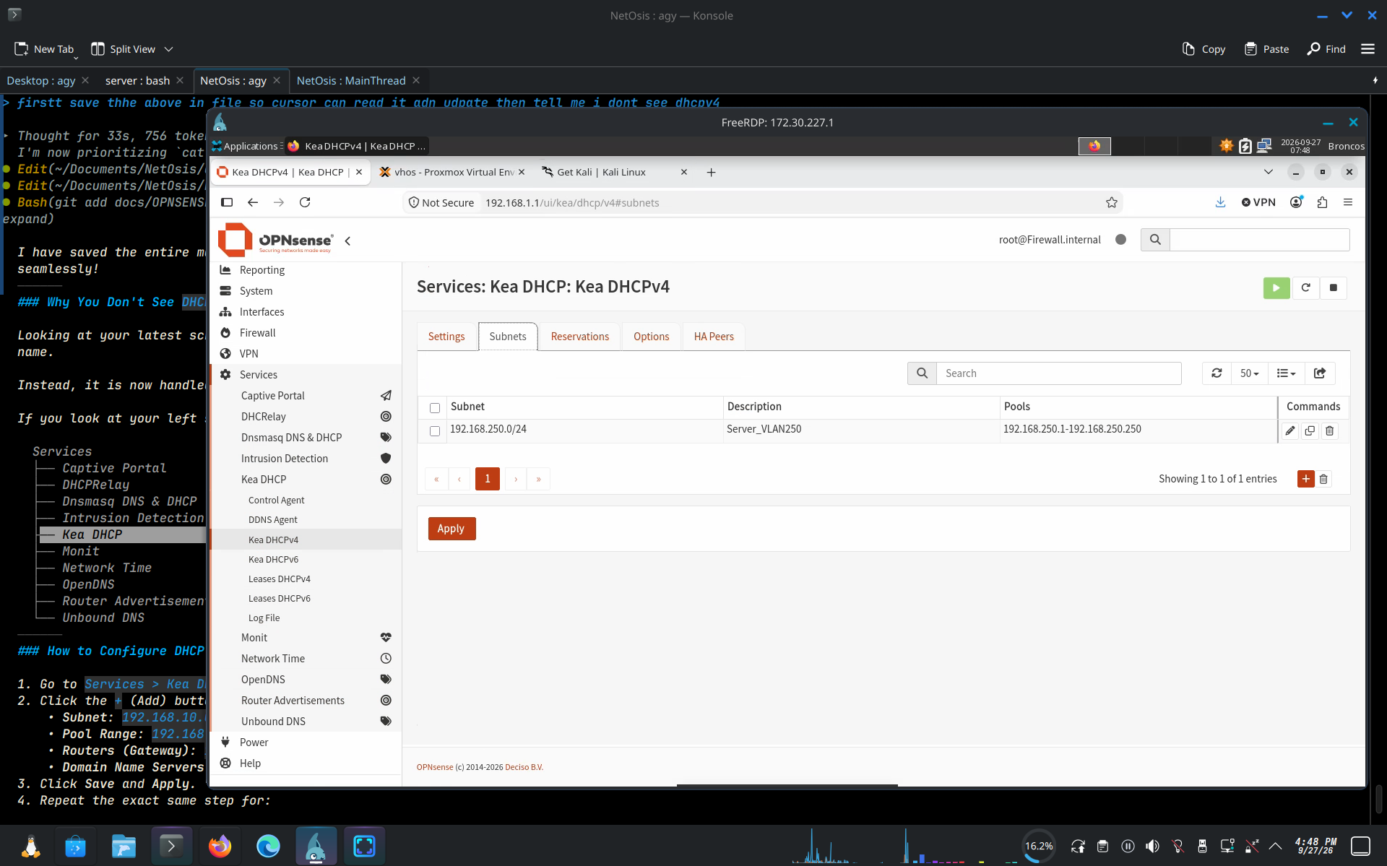
Shows the Kea DHCPv4 Subnets tab prior to configuring FYP VLAN subnets.

Figure 11: Kea DHCP Edit Subnet Modal (FINANCE_VLAN10)
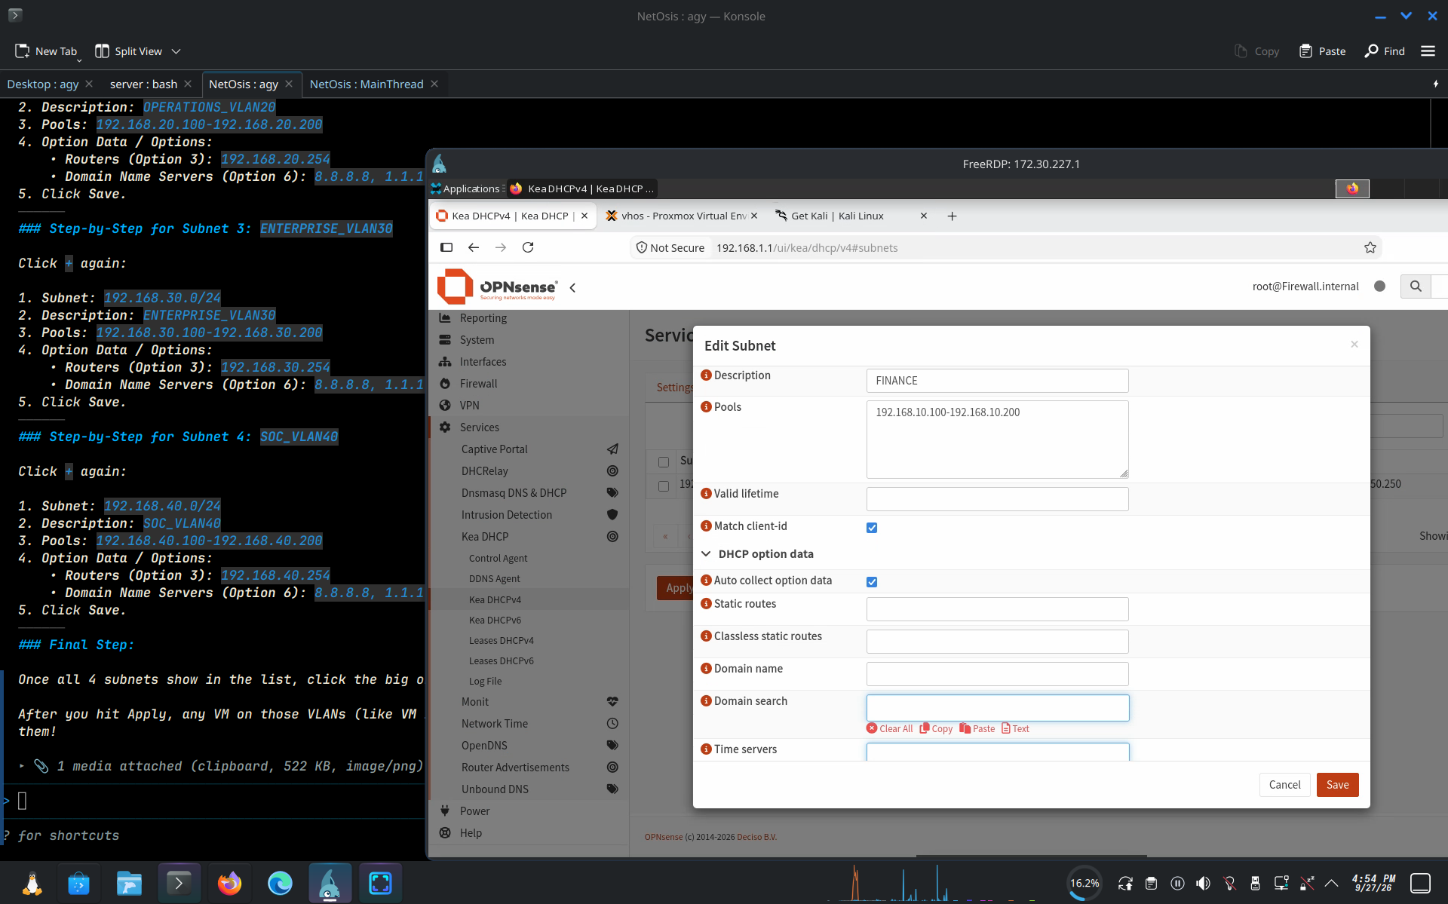
Displays the Edit Subnet modal dialog for FINANCE_VLAN10 (Subnet: 192.168.10.0/24, Pool: 192.168.10.100-192.168.10.200, Auto collect option data: checked).

Figure 12: Kea DHCP Options Configuration View
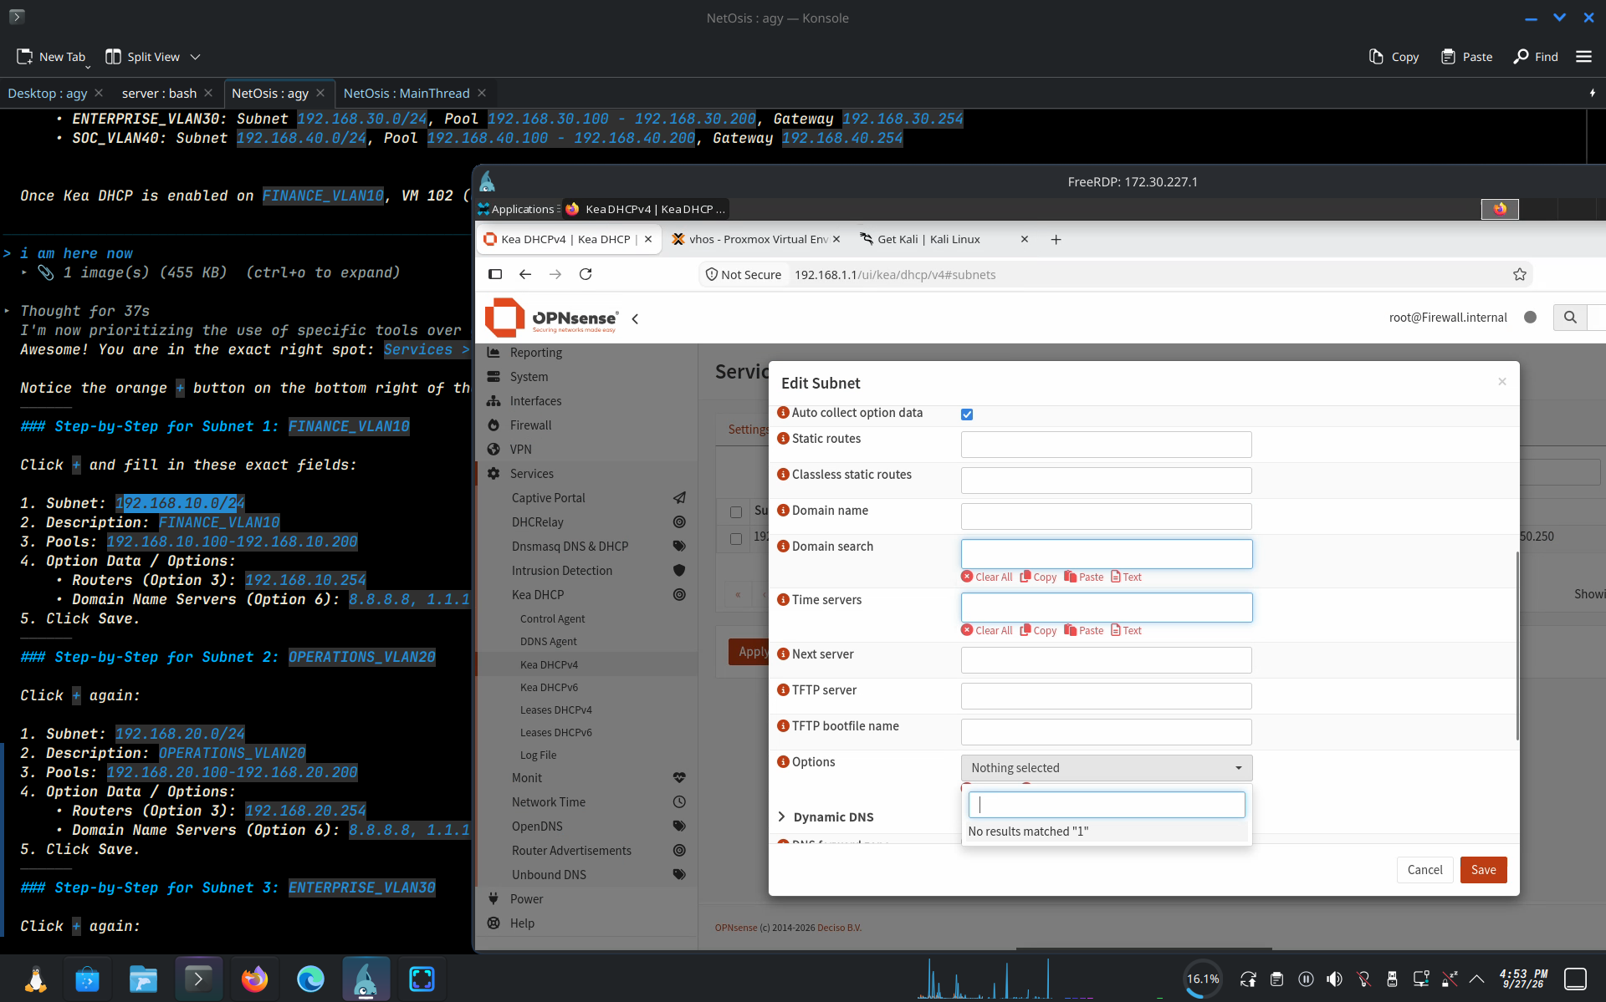
Shows the bottom options section of the Kea DHCP Subnet editor.

Figure 13: Kea DHCPv4 Completed Subnets Table
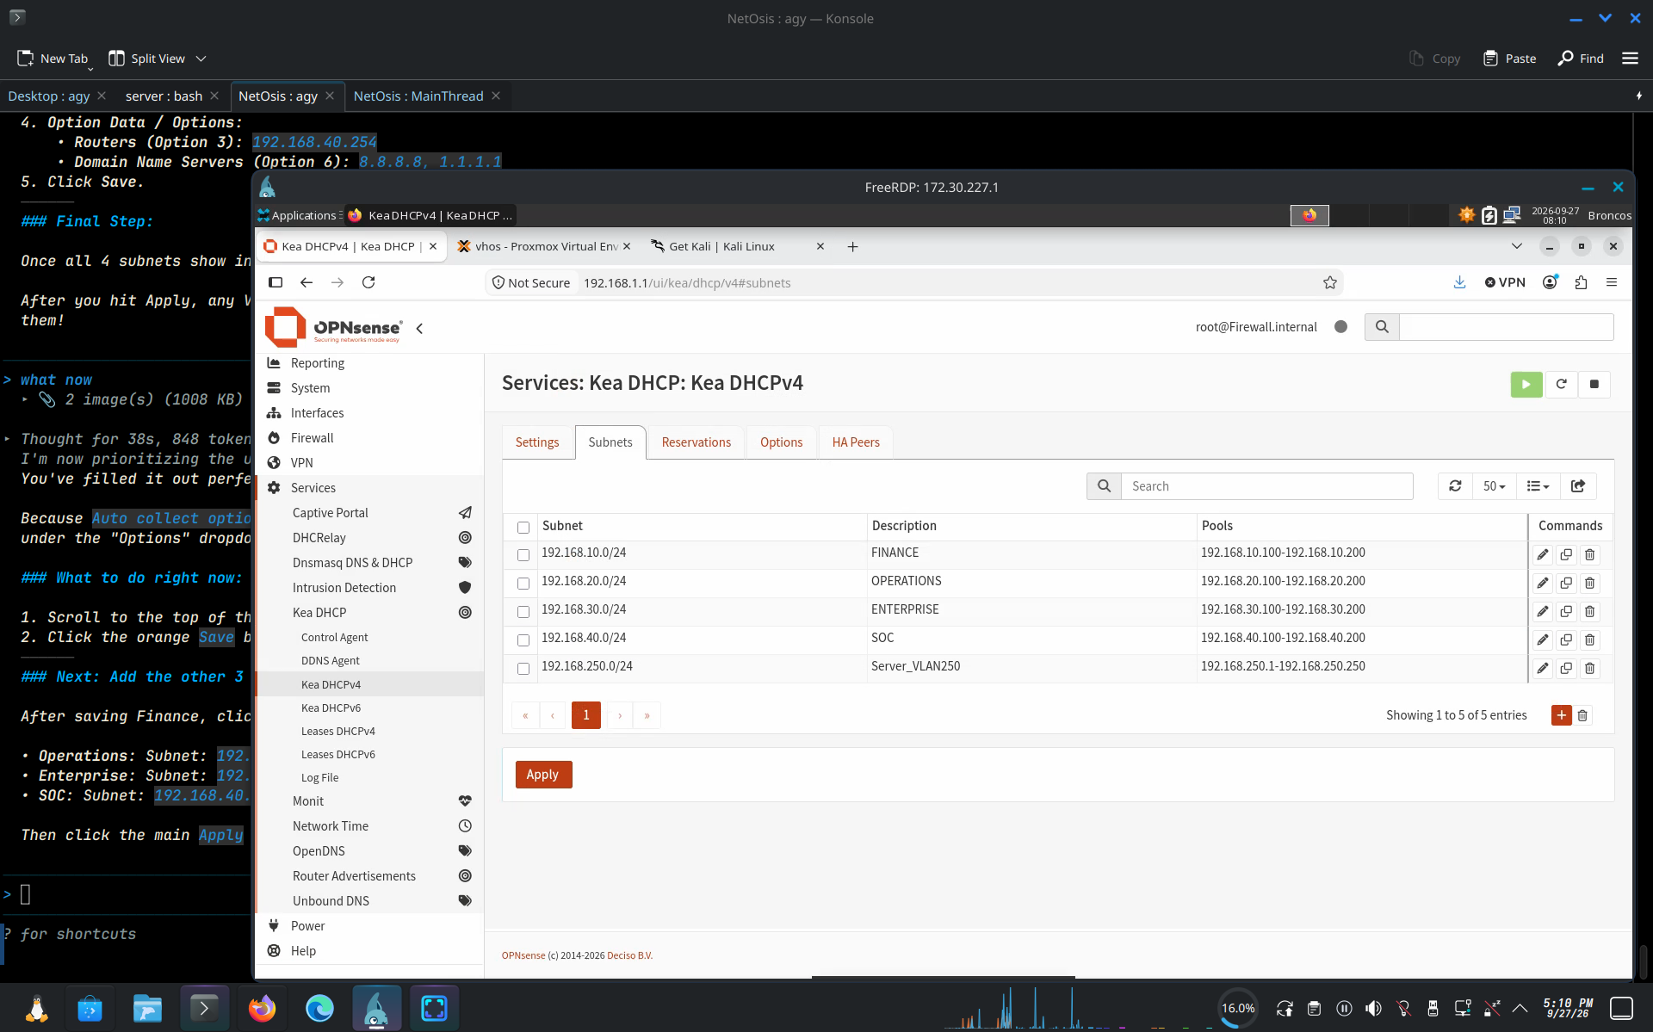
Displays the finalized Kea DHCPv4 Subnets table showing all 5 active subnets: FINANCE (192.168.10.0/24), OPERATIONS (192.168.20.0/24), ENTERPRISE (192.168.30.0/24), SOC (192.168.40.0/24), and Server_VLAN250 (192.168.250.0/24).

5. In-and-Out Traffic Flows & Microsegmentation
1. Outbound Internet Access (VM 102 / Employees -> Internet):
VM 102 (192.168.10.102) sends packet -> VNet FIN / vmbr1 (Tag 10) -> OPNsense vtnet0 / vlan0.10 -> Firewall Pass Rule -> Outbound NAT to WAN IP -> vtnet1 / vmbr0 -> Upstream Gateway (172.30.226.254) -> Internet.
2. Inbound Recon & Attack (Kali -> Honeypot):
Kali on vmbr0 (172.30.226.50) targets OPNsense WAN IP -> NAT Port Forwarding rule -> Rewrites destination to Honeypot IP 192.168.30.10 (VLAN 30) -> Routed out vlan0.30 over vmbr1 (Tag 30) -> Honeypot LXC container.
3. IP Allocation & Microsegmentation:
IPs .1-.30 are reserved for Honeypots (HHPs); IPs .31-.253 are reserved for Real VMs. OPNsense rules and Proxmox Hypervisor Firewall (firewall=1) drop any outbound traffic initiated from Honeypots toward real employee subnets.
6. Master Sequence of Setup Steps
Step 1: Verify Proxmox SDN & Bridges (vmbr0, vmbr1 VLAN-aware, fypzone, VNets FIN, OPS, ENT, SOC).
Step 2: Assign OPNsense Interfaces (vtnet1 WAN, vtnet0 LAN parent, subinterfaces vlan0.10 to vlan0.40) and set static gateway IPs .254/24.
Step 3: Enable Kea DHCP on OPNsense under Services > Kea DHCP > Kea DHCPv4 > Subnets for subnets 10, 20, 30, and 40 (Pools: .100-.200).
Step 4: Enable Hybrid Outbound NAT on WAN for 192.168.0.0/16 and create firewall Pass rules per VLAN interface.
Step 5: Attach VM 102 to VNet FIN (Tag 10), verify DHCP IP assignment or set static IP, and test ping to gateway 192.168.10.254, 8.8.8.8, and google.com.

