HW(1)

Alex Hege

1/31/2022

#Run this code first

### If you don’t know the answer, leave it blank. If you are caught cheating, you will be given minus 50 points.

Q1. Replace the author name with your name in YAML part above.

Q2. Store five values 82.0, 31.2, 98.2, 19.4, 72.6 into the scores variable.

scores <- c(82.0, 31.2, 98.2, 19.4, 72.6)

Q3. Write a code that finds the minimun value of scores that you have created in Q2.

min(scores)

## [1] 19.4

Q4. Assign the value of 4 raised to 2 to a variable generation. Then, print out the value of generation.

generation <- 4^2  
generation

## [1] 16

Q5. Assign the value of square root 81 to a variable nine, and print out nine.

nine <- sqrt(81)  
nine

## [1] 9

Q6. Store a text mozart into the variable piano.

pinao <- "mozart"

Q7. What are three components for a single plot of ggplot2 package?

#ggplot(data,mapping,geom)  
#three components are: data, mapping, geom

Q8. A line of code that shows presidential data as a table

View(presidential)

Q9. Create a matrix with 4 rows that contain the numbers 1 up to 12

data1 = c(1,2,3,4,5,6,7,8,9,10,11,12)  
matrix(data1, 4, 3)

## [,1] [,2] [,3]  
## [1,] 1 5 9  
## [2,] 2 6 10  
## [3,] 3 7 11  
## [4,] 4 8 12

Q10. A line of code that assigns displ column as x-axis and hwy column as y-axis of mpg data to a variable mpg_plot using ggplot2 package

mpg_plot <- ggplot(data=mpg, aes(x=displ, y=hwy))  
mpg_plot

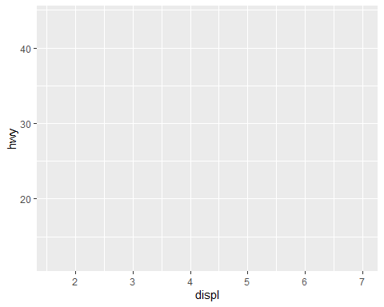

Q11. Two lines of code that create a scatter plot of a variable mpg_plot that you have made in Q10

mpg_plot +   
 geom_point()

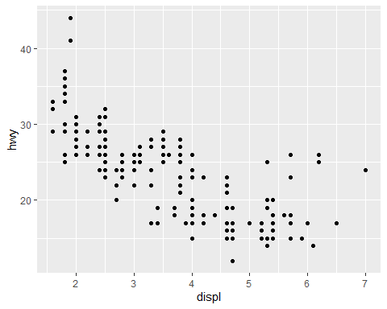

Q12. Three lines of code that create subplots (four rows) by class column, using two lines of code for Q10.

mpg_plot +  
 geom_point()+  
 facet_wrap(~class, nrow=4)

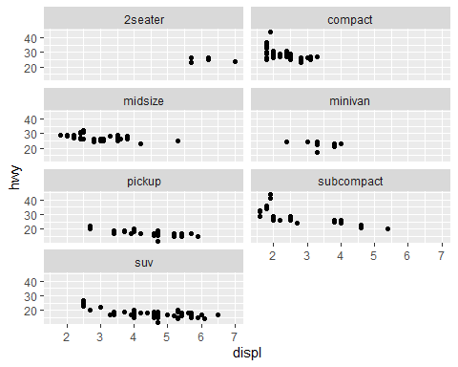

Q13. A line of code that returns dimension information of presidential data

dim(presidential)

## [1] 11 4

Q14. What are the unique values of party column of presidential data?

unique(presidential$party)

## [1] "Republican" "Democratic"

Q15. Two lines of code that will directly create a simple stacked bar plot that shows the count by class column of mpg data with filling color by trans column

bardata <- table(mpg$class, mpg$trans)  
barplot(bardata, col=c("red","orange","yellow","green","blue","purple","hotpink"))

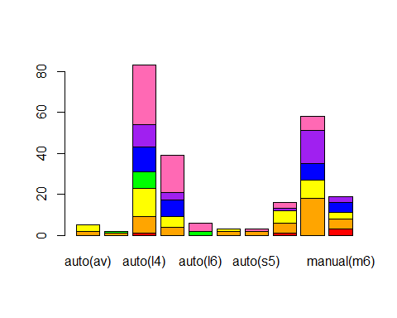

Q16. A line of code that assigns state column as x position of midwest data to a variable midwest_plot using ggplot2 package

midwest_plot <- ggplot(midwest, aes(state))  
midwest_plot

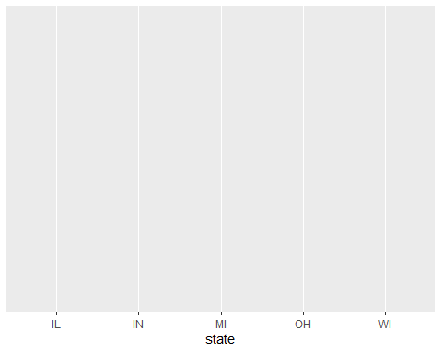

Q17. Five lines of code that will return a bar plot of the midwest_plot variable with a title Plot of count by state. X-axis is labeled as state and y-axis as count.

midwest_plot +  
 geom_bar()

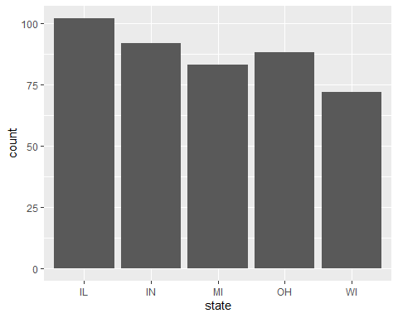

xlab("state")

## $x  
## [1] "state"  
##   
## attr(,"class")  
## [1] "labels"

ylab("count")

## $y  
## [1] "count"  
##   
## attr(,"class")  
## [1] "labels"

ggtitle("Plot of count by state")

## $title  
## [1] "Plot of count by state"  
##   
## attr(,"class")  
## [1] "labels"

Q18. What is the name of 7th column of diamonds dataset?

diamonds[, c(7)]

## # A tibble: 53,940 x 1  
## price  
## <int>  
## 1 326  
## 2 326  
## 3 327  
## 4 334  
## 5 335  
## 6 336  
## 7 336  
## 8 337  
## 9 337  
## 10 338  
## # ... with 53,930 more rows

Q19. How many columns and rows does midwest data have?

nrow(midwest)

## [1] 437

ncol(midwest)

## [1] 28

dim(midwest)

## [1] 437 28

#midwest data has 437 rows and 28 columns

Q20. Two different commands for a quick overview of mpg data that we have learned in our class

View(mpg)  
summary(mpg)

## manufacturer model displ year   
## Length:234 Length:234 Min. :1.600 Min. :1999   
## Class :character Class :character 1st Qu.:2.400 1st Qu.:1999   
## Mode :character Mode :character Median :3.300 Median :2004   
## Mean :3.472 Mean :2004   
## 3rd Qu.:4.600 3rd Qu.:2008   
## Max. :7.000 Max. :2008   
## cyl trans drv cty   
## Min. :4.000 Length:234 Length:234 Min. : 9.00   
## 1st Qu.:4.000 Class :character Class :character 1st Qu.:14.00   
## Median :6.000 Mode :character Mode :character Median :17.00   
## Mean :5.889 Mean :16.86   
## 3rd Qu.:8.000 3rd Qu.:19.00   
## Max. :8.000 Max. :35.00   
## hwy fl class   
## Min. :12.00 Length:234 Length:234   
## 1st Qu.:18.00 Class :character Class :character   
## Median :24.00 Mode :character Mode :character   
## Mean :23.44   
## 3rd Qu.:27.00   
## Max. :44.00

dim(mpg)

## [1] 234 11

colnames(mpg)

## [1] "manufacturer" "model" "displ" "year" "cyl"   
## [6] "trans" "drv" "cty" "hwy" "fl"   
## [11] "class"

unique(mpg)

## # A tibble: 225 x 11  
## manufacturer model displ year cyl trans drv cty hwy fl class  
## <chr> <chr> <dbl> <int> <int> <chr> <chr> <int> <int> <chr> <chr>  
## 1 audi a4 1.8 1999 4 auto~ f 18 29 p comp~  
## 2 audi a4 1.8 1999 4 manu~ f 21 29 p comp~  
## 3 audi a4 2 2008 4 manu~ f 20 31 p comp~  
## 4 audi a4 2 2008 4 auto~ f 21 30 p comp~  
## 5 audi a4 2.8 1999 6 auto~ f 16 26 p comp~  
## 6 audi a4 2.8 1999 6 manu~ f 18 26 p comp~  
## 7 audi a4 3.1 2008 6 auto~ f 18 27 p comp~  
## 8 audi a4 quattro 1.8 1999 4 manu~ 4 18 26 p comp~  
## 9 audi a4 quattro 1.8 1999 4 auto~ 4 16 25 p comp~  
## 10 audi a4 quattro 2 2008 4 manu~ 4 20 28 p comp~  
## # ... with 215 more rows

### *End of document*