ME 587 Lab 1 Report

# 1 Introduction to ROS and Clearpath Platform

In order to begin working with the target robotic platform, a reasonable understanding of the system was needed. The overall system comprised of:

1. Robotic Operating System (ROS) a real time operating system designed specifically for use on robotic platforms.
2. The Clearpath robotic framework comprising of all motor actuators and sensors.
3. The Internal Positioning System (IPS) an IR framework which facilitating th

Sensor information was collected from the ClearPath platform by ROS where it would pass through the control system. The controllers would be written for ROS in either C or Python and loaded into ROS before a use case would be run.

## 1.2 Sensors and Actuators

For the purposes of this lab, the ClearPath platform was comprised of the following sensors and actuators.

**Sensors:**

Motor encoders –Determined the rotational speed of the motor in ticks.

**Actuators:**

Drive Motor

Steering Servo Motor

**External Inputs:**

IPS – global coordinate frame

# 2 System Modeling and Theory

To implement velocity control for the system, the system response of the driving motor had to first be identified.

Since the velocity response for the brushless DC motor was necessary, the plant could be represented by a first order system of the form.

$$\frac{K}{τs+1}$$

To determine the system parameters, the system was subjected to a step input and the response was collected and analyzed.

The time constant (τ) was determined from the time it took the system to reach 63% of its final value (rise time) while the plant gain was determined from the steady state value of the system.

The values which were determined for the plant were as follows:

$$K=0.0032684 τ=0.1474926$$

This plant model was then discretized to obtain a discrete transfer function of:

$$\frac{0.0004736*z+0.0004736}{z^{5}-0.7101*z^{4}}$$

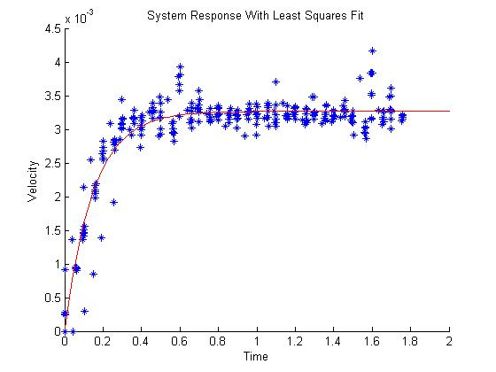

Figure : System response to step input with least squares fit.

# 3 Controller Implementation and Theory