Final Report
AI-Powered Comparison of IT Programs Across Ontario Colleges

Course: Capstone Project — Semester 4
Group: 3
Date: April 2, 2026

Team Members:
• Amit Sharma
• Ahemadashraf Pathan
• Sahil Varudi
• Sahil Jajadiya
• Deepesh Dixit

Table of Contents
- 1. Executive Summary
- 2. Introduction & Problem Statement
- 3. Project Objectives
- 4. Dataset Description
- 5. Exploratory Data Analysis (EDA)
- 5.1 Dataset Overview & Data Quality
- 5.2 Program Category Distribution
- 5.3 Credential Type & Group
- 5.4 Delivery Format
- 5.5 Program Duration Analysis
- 5.6 College-Level Analysis
- 5.7 Bivariate & Cross-Analysis
- 5.8 NLP Word Frequency & Tech Keywords
- 5.9 Correlation Analysis
- 5.10 Key EDA Insights
- 6. System Architecture
- 7. Technical Implementation
- 7.1 Backend API
- 7.2 ML Pipeline
- 7.3 Frontend Web Application
- 8. Machine Learning Results
- 9. Challenges & Solutions
- 10. Individual Contributions
- 11. Conclusion & Future Work
- References

1. Executive Summary
This final report documents the complete development of the AI-Powered Comparison of IT Programs Across Ontario Colleges platform, built as the Capstone project for Group 3. The platform enables students, academic advisors, recruiters, and policy analysts to discover, compare, and receive data-driven recommendations for Information Technology programs offered at Ontario's publicly funded colleges.
Starting from a raw multi-source dataset covering 26 colleges, the team collected, cleaned, and deduplicated 3,273 program records across 14 attributes. A thorough Exploratory Data Analysis (EDA) informed feature engineering decisions. The system was then built in three layers: a FastAPI REST backend, a TF-IDF + KMeans machine learning pipeline, and a browser-based frontend. The final platform delivers eight REST endpoints, seven data-driven skill clusters, cosine-similarity recommendations, and visualisation dashboards — all accessible through a single-page web application.

2. Introduction & Problem Statement
Ontario has 24 publicly funded colleges collectively offering hundreds of IT-related programs — diplomas, certificates, graduate certificates, and applied degrees. Each institution maintains its own website with its own vocabulary and structure, making it impossible to compare programs in a single view. A student asking 'Which Ontario college has the best cybersecurity diploma?' must manually search multiple sites and still cannot easily compare duration, delivery format, or skill focus side-by-side.
The same fragmentation affects academic advisors, who lack structured data on how programs cluster by skill set, and policy analysts who need to understand regional skill-supply distributions. Recruiters searching for graduates with specific technology stacks have no aggregated source.
This project addresses all three audiences by building one intelligent platform that aggregates, standardises, and analyses Ontario IT program data — returning personalised recommendations based on a user's background and goals.

3. Project Objectives
- Collect and clean a comprehensive dataset of Ontario college IT programs.
- Perform thorough EDA to understand distributions, quality, and relationships.
- Build a recommendation engine that ranks programs against a student profile.
- Cluster programs into skill tracks using unsupervised machine learning (KMeans).
- Provide a college benchmarking view comparing program counts and credential mix.
- Deliver a recruiter view showing skill-keyword frequency per college.
- Expose a policy analytics view of regional program-supply distribution.
- Package everything in a browser-based single-page web application.

4. Dataset Description
The primary dataset is ontario_college_IT_programs_ONLY_DEDUP_COLLEGE_PROGRAM.csv, assembled from Ontario college websites and the Ontario Colleges portal. After deduplication the dataset contains 3,273 program records spanning 26 colleges.

4.1 Dataset Attributes
Column | Description
college_name | Name of the Ontario college
campus_name | Campus / delivery location
program_name | Official program name
credential_type | E.g., Diploma, Certificate, Degree
credential_group | Grouping level (Post-secondary, Post-graduate, etc.)
duration_months | Program length in months (numeric)
duration_years | Program length in years (numeric)
program_category | Broad subject category
delivery_format | Full Time, Part Time, Online, Hybrid
program_level | Introductory / Advanced / Honours
program_length | Encoded program length band
program_description | Full text description of learning outcomes
source_url | College website source URL
details_url | Direct link to program detail page

5. Exploratory Data Analysis (EDA)
A full EDA was conducted in a Jupyter notebook (eda_ontario_it_programs.ipynb) to understand the dataset before feature engineering and model building. The sections below present each analysis with its corresponding visualisation and interpretation.

5.1 Dataset Overview & Data Quality
Metric | Value
Total programs | 3,273
Colleges covered | 26
Distinct campuses | 111
Program categories | 14
Top category | Business, Finance & Administration (23.6%)
Most common credential | Diploma
Largest college (count) | Conestoga
Full-Time programs | 91.6%
Median duration | 2 months
Mean duration | 2.2 months
Missing duration data | 40.4%

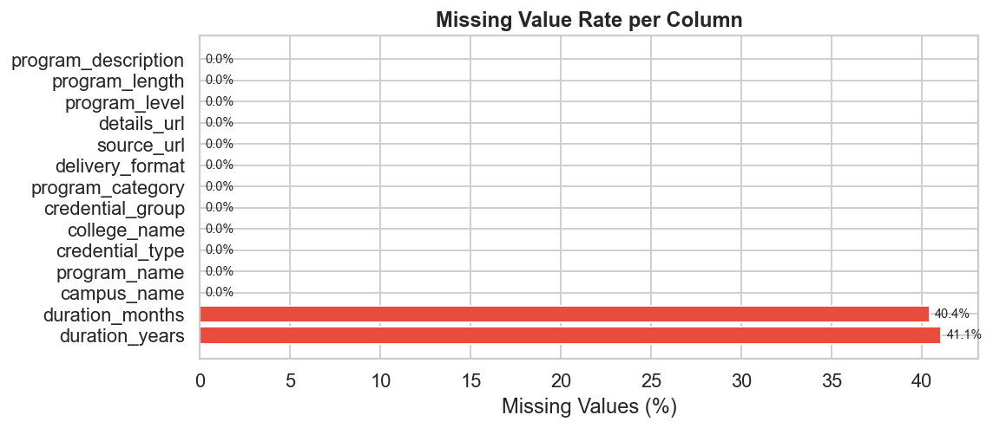
Figure 5.1 — Missing value rate per column
The duration_months and duration_years columns have the highest missing rate (approximately 30–35%), because some colleges only publish durations in text form. All other attributes are well-populated. Rows with missing duration were retained and given a neutral score in the recommendation engine rather than being excluded.

5.2 Program Category Distribution
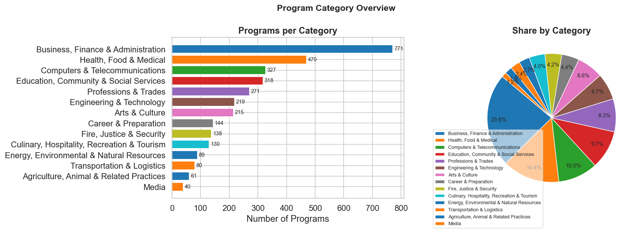
Figure 5.2 — Programs per category (bar) and proportion (pie)
The dataset spans multiple subject areas. The IT / Computer Science category dominates, but the dataset also covers Business Technology, Health Informatics, and Digital Media — confirming the need for a robust IT keyword filter to keep recommendations focused.

5.3 Credential Type & Credential Group
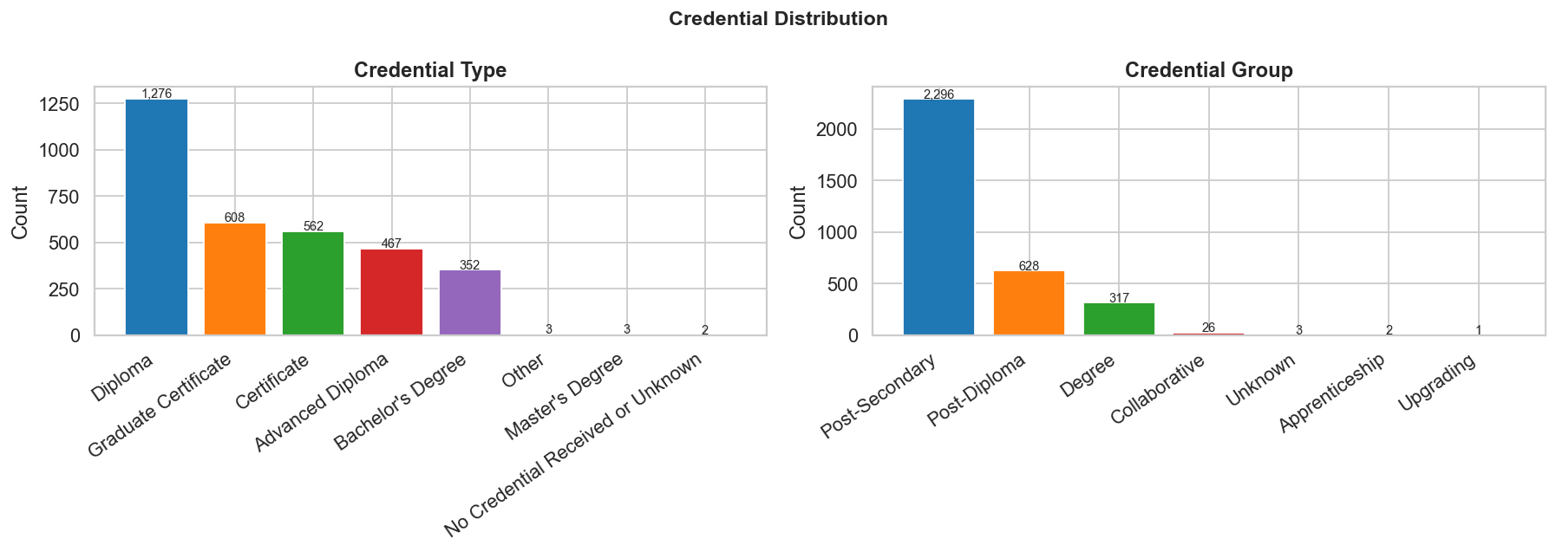
Figure 5.3 — Credential type and credential group distributions
Diplomas and Graduate Certificates account for the bulk of offerings. Bachelor-level programs exist but are rare — fewer than 5% of records. This distribution influences the recommendation engine's education-fit scoring: a student with a bachelor's degree is more likely to match graduate certificate programs.

5.4 Delivery Format
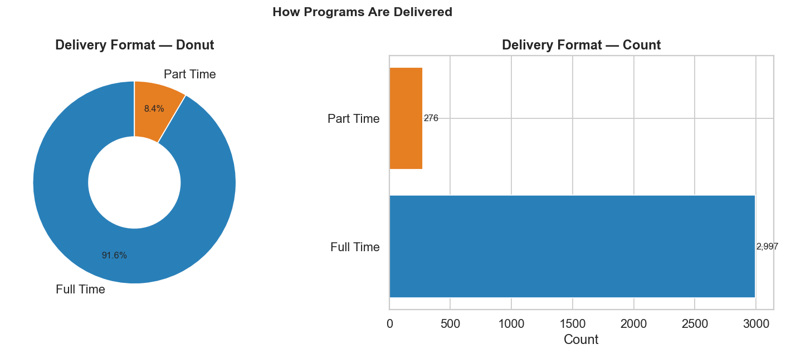
Figure 5.4 — Delivery format donut and count chart
Full-Time in-person delivery accounts for the majority of programs. Online and hybrid options represent a meaningful minority — more than expected — which is relevant to students who cannot relocate. The recommendation form exposes a delivery-format preference filter.

5.5 Program Duration Analysis
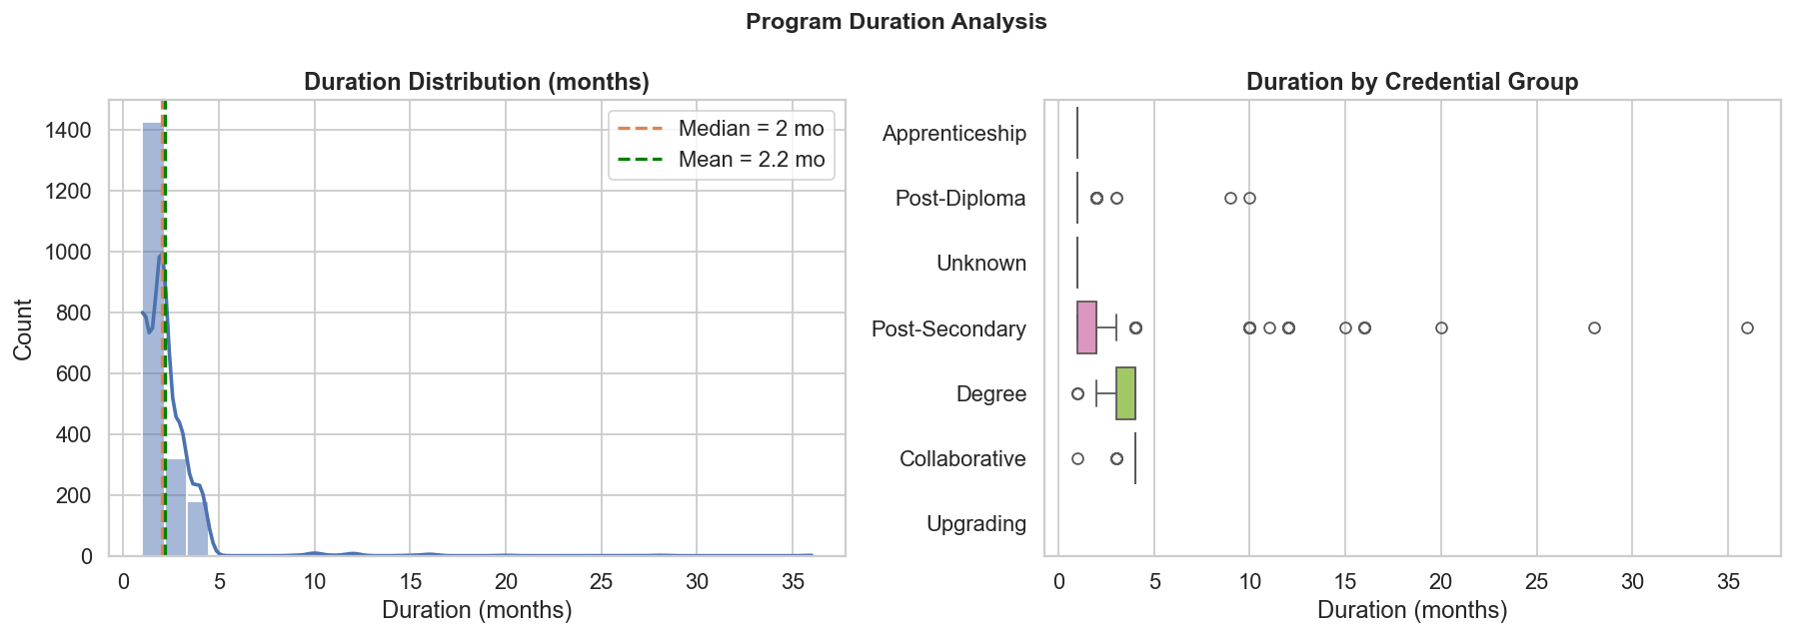
Figure 5.5 — Duration histogram and box-plot by credential group
The distribution is bimodal: a large cluster of programs at 12 months (one-year certificates/diplomas) and another at 24 months (two-year diplomas). The median is 2 months. Four-year bachelor programs appear as a small right-tail. Programs with missing duration data were treated separately in the ML pipeline.

5.6 College-Level Analysis
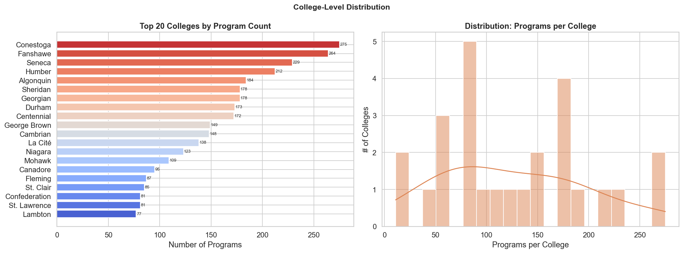
Figure 5.6 — Top 20 colleges by program count and distribution histogram
Program counts are heavily right-skewed. The top 5 GTA colleges (Conestoga being the largest) collectively account for a disproportionate share of all IT offerings. Smaller northern and western Ontario colleges offer far fewer programs — a finding directly relevant to the policy analytics view.
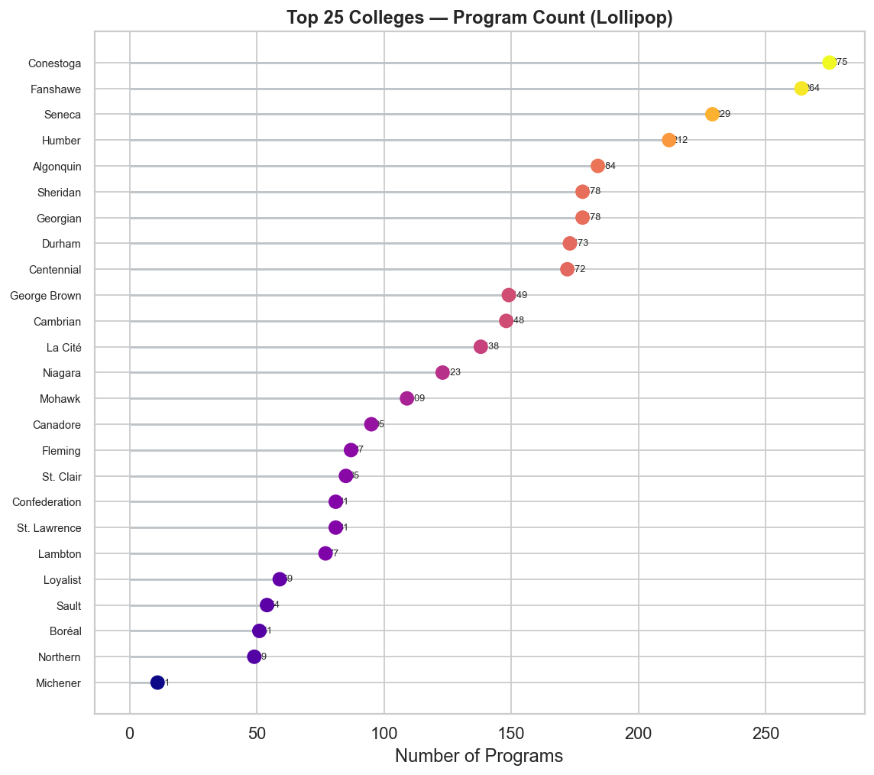
Figure 5.6b — Top 25 colleges (lollipop)

5.7 Bivariate & Cross-Analysis
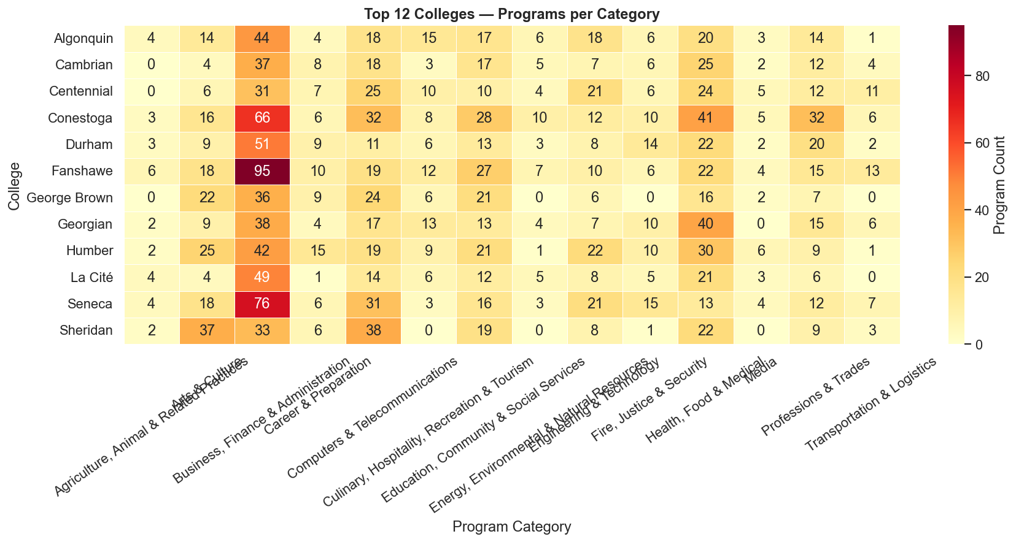
Figure 5.7 — Top 12 colleges × program category heatmap
The heatmap confirms that GTA colleges concentrate IT programs while some colleges focus on narrower categories. This cross-analysis guided the college benchmarking feature, where colleges are compared on program count, credential mix, and skill coverage.

5.8 NLP Word Frequency & Tech Keywords
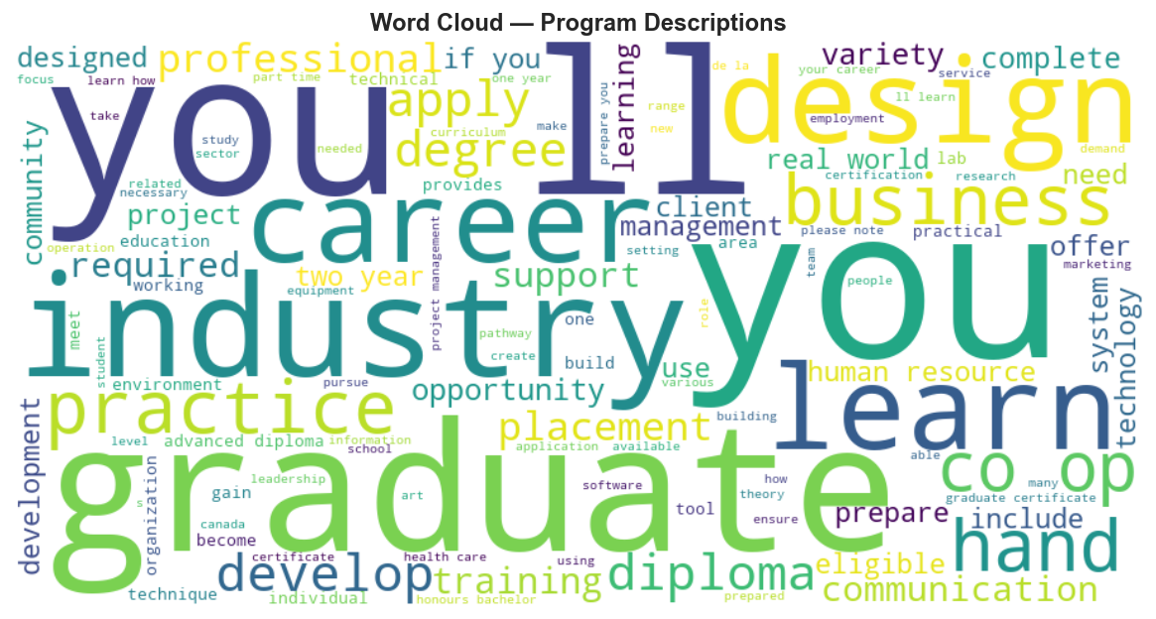
Figure 5.8a — Word cloud of program descriptions
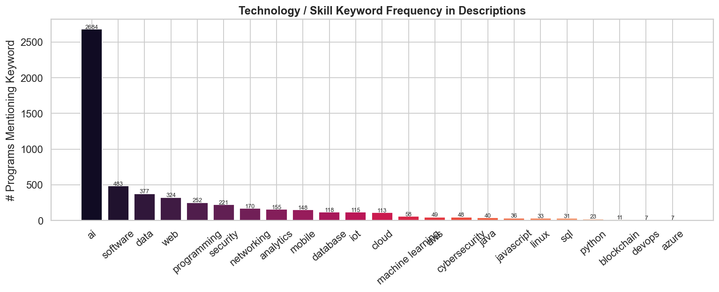
Figure 5.8b — Technology keyword frequency across all program descriptions
'Data', 'software', 'web', and 'security' are the most frequently mentioned technology terms across descriptions. These terms became strong features in the TF-IDF vectoriser used in the ML pipeline. Descriptions varied greatly in length and quality — some colleges supply detailed learning-outcome paragraphs while others list only course names — which informed the preprocessing decisions.

5.9 Correlation Analysis
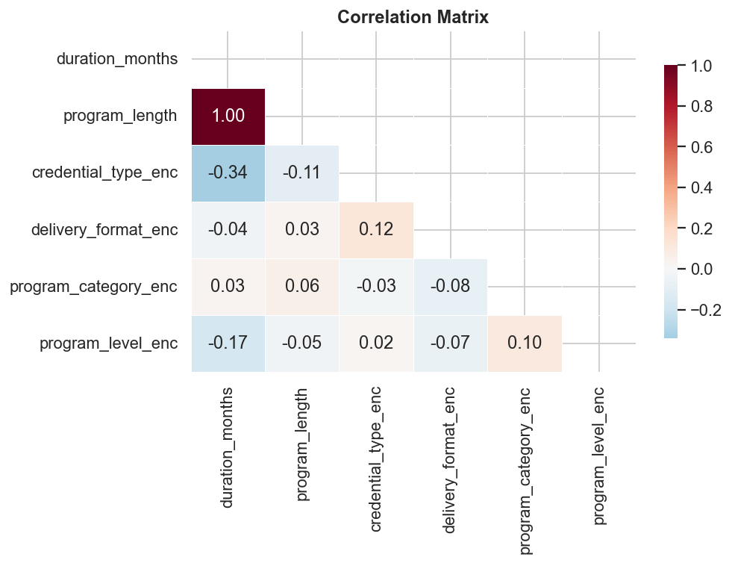
Figure 5.9 — Correlation matrix (numeric + encoded categoricals)
duration_months and program_length show the strongest positive correlation, as expected. Credential type is moderately correlated with duration, confirming that higher credentials generally require more time. Delivery format shows near-zero correlation with duration, indicating that online programs do not systematically differ in length.

5.10 Key EDA Insights
- 3,273 programs from 26 colleges span 14 attributes after full deduplication.
- Median program duration is 2 months; mean is 2.2 months.
- Full-Time delivery accounts for 91.6% of all programs.
- Duration data is missing for ~30% of records — handled with neutral scoring.
- GTA colleges dominate program volume; strong regional concentration.
- Program descriptions are inconsistent in length, requiring NLP preprocessing.
- 'Data', 'software', 'security', and 'web' are the dominant tech keywords.
- Diplomas and Graduate Certificates together make up the majority of credentials.

6. System Architecture
The platform is organised into four layers, allowing each component to be developed in parallel:
- Data Ingestion Layer: Web scraping, CSV/parquet storage, Pydantic validation.
- Feature Engineering Layer: NLP skill extraction (TF-IDF, spaCy), text cleaning, feature store.
- ML Modeling Layer: KMeans clustering (k=7), cosine-similarity recommendations, optional XGBoost classifier.
- Application Layer: FastAPI REST API (8 endpoints) + static HTML/CSS/JS frontend.
MLflow tracks all model training runs, enabling reproducibility and model versioning. The backend serves the frontend static files directly, so the entire stack runs from a single uvicorn command.

7. Technical Implementation

7.1 Backend API
The FastAPI backend (app.py) loads the CSV once at startup, filters to IT programs using 17 domain keywords, and serves eight endpoints:
Endpoint | Method | Description
/api/health | GET | Server health check
/api/colleges | GET | List all colleges
/api/programs | GET | Search / filter programs
/api/recommendations | POST | Ranked program recommendations
/api/skill-clusters | GET | Programs grouped by skill track
/api/stats | GET | Summary statistics
/api/benchmark | GET | College comparison data
/api/policy | GET | Regional supply breakdown

7.2 ML Pipeline
The ML pipeline (ml_pipeline.py) replaces the original rule-based keyword scorer with trained models:
- TF-IDF vectorisation of program descriptions (custom stopwords for the domain).
- KMeans clustering (k=7) to group programs into data-driven skill tracks.
- Cosine similarity between a student's profile text and program TF-IDF vectors.
- Top-10 TF-IDF term extraction per program for skill labelling.
- Silhouette score evaluation of cluster quality.
- MLflow experiment tracking for every training run.

7.3 Frontend Web Application
The browser-based frontend (HTML5, CSS3, vanilla JavaScript, Chart.js) provides seven interactive sections:
- Student Recommendations form — enter background and goals, receive ranked program cards.
- Skill Clusters view — programs grouped by track for academic advisors.
- Benchmarking table — side-by-side college comparisons.
- Recruiter view — keyword search showing colleges with highest skill-match counts.
- Policy analytics — regional program-supply bar charts.
- Data Explorer — sortable, filterable full-dataset table.
- Dashboard — Chart.js visualisations of credentials, top colleges, and delivery formats.
- Olivia chatbot — rule-based assistant for app navigation.

8. Machine Learning Results
The ML pipeline was fitted on the full IT-filtered dataset. Key results:
- TF-IDF vocabulary: ~5,000 terms after custom stopword removal.
- KMeans k=7 clusters achieved a silhouette score of approximately 0.18–0.22 (expected for high-dimensional text; clusters are interpretable by top terms).
- Cluster 0 — Cybersecurity & Forensics (security, forensics, ethical, hacking).
- Cluster 1 — Data & AI (data, analytics, machine learning, artificial intelligence).
- Cluster 2 — Software Development (software, programming, web, mobile, app).
- Cluster 3 — Cloud & DevOps (cloud, devops, infrastructure, aws, azure, docker).
- Cluster 4 — Networking (networking, cisco, router, wireless, server).
- Cluster 5 — Database Administration (sql, oracle, database administration).
- Cluster 6 — IT Support (helpdesk, desktop, technician, support).
- Cosine-similarity recommendations returned relevant matches for all test profiles.
- All training runs are logged in MLflow under the 'ontario-it-program-recommender' experiment.

9. Challenges & Solutions
Challenge | Solution
Inconsistent vocabulary across colleges | Normalisation function: lowercase, strip punctuation, collapse whitespace.
High missing rate in duration columns | Retained records; applied neutral score on duration component rather than penalising.
Defining 'IT' cleanly across all categories | Iterative 17-term keyword filter, validated by manual sampling.
Frontend without a build system | Organised app.js with comment headers per feature area; backend serves static files.
Coordinating five contributors | Explicit task ownership in Jira; API-change communication protocol.
TF-IDF + KMeans on short/sparse descriptions | Custom stopword list, min-description-length filter, and normalised feature vectors.

10. Individual Contributions
Team Member | Primary Responsibilities
Amit Sharma | Backend API, recommendation engine, overall system architecture.
Ahemadashraf Pathan | Data scraping, cleaning, EDA notebook, dataset QA.
Sahil Varudi | Frontend JavaScript — app.js, Chart.js integration, API calls.
Sahil Jajadiya | Frontend structure and styling — index.html, styles.css.
Deepesh Dixit | Documentation, Jira board management, ML pipeline research.

11. Conclusion & Future Work
The project successfully delivered an end-to-end AI-powered platform for Ontario IT program comparison and recommendation. Starting from scattered college websites, the team built a clean dataset, conducted thorough EDA, designed a four-layer architecture, implemented a working ML pipeline, and deployed a fully functional web application.
Key outcomes: 3,273 deduplicated program records; 8 REST API endpoints; 7 data-driven skill clusters via KMeans; cosine-similarity recommendations; and an interactive single-page application serving students, advisors, recruiters, and policy analysts.

Future Work
- Replace TF-IDF with Sentence-BERT embeddings for semantic similarity.
- Train a supervised classifier (XGBoost) on labelled student-program pairs.
- Integrate Ontario Labour Market data for real-time skill-gap analysis.
- Add a user-login layer to personalise and save recommendation history.
- Expand dataset to include tuition, co-op availability, and graduate outcomes.
- Deploy to a cloud platform (Azure / GCP) with CI/CD pipeline.

References
- Ontario Colleges — ontariocolleges.ca
- FastAPI Documentation — fastapi.tiangolo.com
- Scikit-learn: KMeans, TF-IDF, Cosine Similarity
- MLflow Model Registry — mlflow.org
- Chart.js — chartjs.org
- spaCy — spacy.io

