FIELD PROJECT REPORT
(Course Code: CA-310 | Field Project | FP-2)
on
SpareGo
Spare Parts Order and Delivery Management System for Local Auto-Spare-Parts Shops
Submitted by
[Student name(s) and roll number(s)]
Under the guidance of
[Guide name]
[Class, Department, College, University, Academic year]

CERTIFICATE (College / Mentor)
This is to certify that the Field Project "SpareGo – Spare Parts Order and Delivery Management System" was carried out by [names] during the academic year [year] under my guidance.
Guide: ____________ HOD: ____________ Principal: ____________

ORGANIZATION CERTIFICATE
[Paste the signed certificate from the spare parts shop where the field study was done: shop name, address, owner signature and stamp.]

ACKNOWLEDGEMENT
We thank our guide [name], the owner of [shop name] for allowing the study and sharing honest feedback, our HOD, faculty and family.

CONTENTS
Chapter 1: Introduction
Chapter 2: Problem Identification and Feasibility Study
Chapter 3: Requirement Analysis
Chapter 4: System Design
Chapter 5: Implementation
Chapter 6: Conclusion and Future Scope
Appendix A: Questionnaire | Appendix B: Test Cases | References

Chapter 1: Introduction

1.1 Background of the Project
Local auto-spare-parts shops serve mechanics, garages and vehicle owners. Customers usually phone or visit the shop, ask for a part by vehicle model, and the shop sends it by a delivery boy. Orders are noted on paper or WhatsApp, availability is checked by searching shelves, and customers repeatedly call to ask "where is my part?". Wrong parts, lost orders and wasted time are common, and a mechanic waiting for a part loses working hours.
SpareGo is a web application that digitises this workflow: parts catalogue searchable by vehicle model, stock tracking with low-stock alerts, order placement with automatic invoice, packing and rider assignment, a public tracking page for customers, and OTP-verified delivery.

1.2 Objectives of the Project
- To study the existing manual order and delivery process of a spare parts shop through field visit, interviews, observation and questionnaires.
- To identify the problems and define functional and non-functional requirements.
- To design the system using DFD, ERD, use case, flowchart and database schema.
- To develop a working application using Python, Flask and SQLite.
- To add smart features: search by vehicle model, low-stock alerts, order tracking link on WhatsApp, delivery OTP and rider performance report.
- To test the system manually and compare the existing and proposed systems.

1.3 Scope
Single shop, one owner/staff login, in-house riders. Online payment, GPS tracking and multi-shop support are future scope.

Chapter 2: Problem Identification and Feasibility Study

2.1 Description of the Current System
The field study was done at [shop name, address] on [dates]. Owner: [name]; years in business: [years]; number of delivery boys: [n]; approximate orders per day: [n]. The current process is:
- Customer phones or visits and asks for a part by vehicle and part name.
- Owner or helper searches shelves/memory; availability is told verbally.
- Order is written in a notebook or WhatsApp chat; bill is hand-written.
- A delivery boy is told verbally; the customer calls to ask about delivery status.
- Payment collection and delivery proof are not recorded.
[Write 1–2 paragraphs in your own words about what you actually observed.]

2.2 Limitations of the Existing System
No. | Problem | Impact
1 | No searchable catalogue by vehicle model | Slow response, wrong part given
2 | Stock checked by memory | Out-of-stock found late; lost sales
3 | Orders on paper / WhatsApp | Lost or forgotten orders
4 | No order status for customer | Repeated calls to shop
5 | No delivery proof | Disputes about delivery and payment
6 | No rider or sales reports | Owner cannot measure performance

[Confirm/replace this table with your real survey findings.]

2.3 Feasibility Study
Type | Assessment
Technical | Free tools (Python, Flask, SQLite); runs on any PC; customer needs only a phone browser. Feasible.
Economic | No licence cost. Feasible.
Operational | Few screens, simple steps; owner confirmed he can use it [[confirm in interview]]. Feasible.
Schedule | Completed within the 60-hour project period. Feasible.

Chapter 3: Requirement Analysis

3.1 Method of Data Collection
Primary data was collected through field visit, interview, questionnaire and observation. The questionnaire is in Appendix A.

3.2 Field Visit Details
Visit | Date | Place | Purpose
1 | [[date]] | [[shop]] | Introduce project, observe order and delivery process
2 | [[date]] | [[shop]] | Interview owner, collect questionnaires
3 | [[date]] | [[shop]] | Demonstrate prototype and take feedback

3.3 Interview Details
Interviewee: [owner name]. Duration: [minutes]. Main points: [real answers about order volume, delivery delays, wrong-part returns, how customers ask for status].

3.4 Questionnaire / Survey Method
A 10-question questionnaire was given to [N] respondents ([shop owners, mechanics, customers]).

3.5 Observation Details
We observed the shop for [hours] on [days] and noted how orders were taken, how long search took and how delivery was handled. [Write real observations.]

3.6 Summary of Collected Data
Question | Result (fill from your survey)
Customers who call to ask delivery status | [[x of N]]
Orders delivered late / wrong part sent | [[x of N]]
Orders recorded on paper/WhatsApp only | [[x of N]]
Would like order tracking link | [[x of N]]
Willing to use an app for orders | [[x of N]]

NOTE: Numbers must come from the real survey; do not invent them.

3.7 Functional Requirements
- FR1: Secure shop login.
- FR2: Add parts with vehicle model, price, stock; search by part/brand/vehicle; restock.
- FR3: Add customers (individual/mechanic/garage) and riders.
- FR4: Place order with stock check; stock reduces automatically; delivery fee rule (free above Rs 1000).
- FR5: Order life cycle: Placed → Packed → Out for Delivery → Delivered.
- FR6: Rider must be assigned before dispatch.
- FR7: Delivery completes only with correct customer OTP.
- FR8: Public tracking page (order number + phone) and WhatsApp tracking link.
- FR9: Printable invoice.
- FR10: Dashboard, low-stock alerts, most-ordered parts, rider performance and 7-day order value.

3.8 Non-Functional Requirements
- Usability: simple pages; tracking page is mobile friendly.
- Performance: page loads in under 1 second for small data.
- Reliability: foreign keys and CHECK constraints; invalid input rejected.
- Security: hashed passwords, login protection, OTP for delivery, tracking needs phone match.
- Portability: runs on any OS with Python.

Chapter 4: System Design

4.1 Use Case Diagram
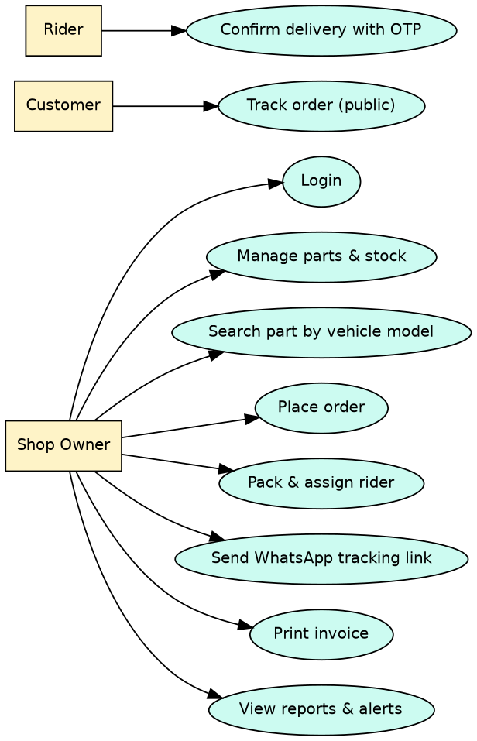
Figure 4.1: Use case diagram

4.2 Flowchart
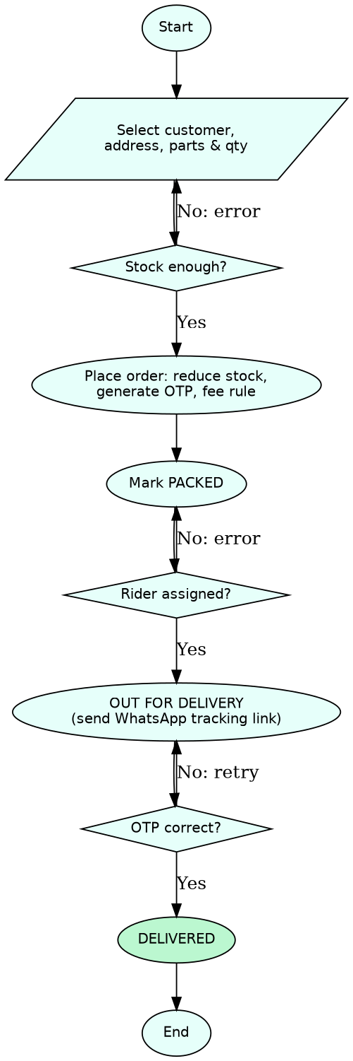
Figure 4.2: Order and delivery flowchart

4.3 Data Flow Diagrams
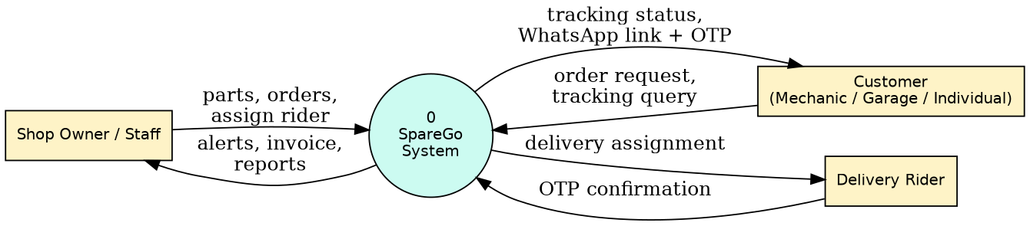
Figure 4.3: DFD Level 0
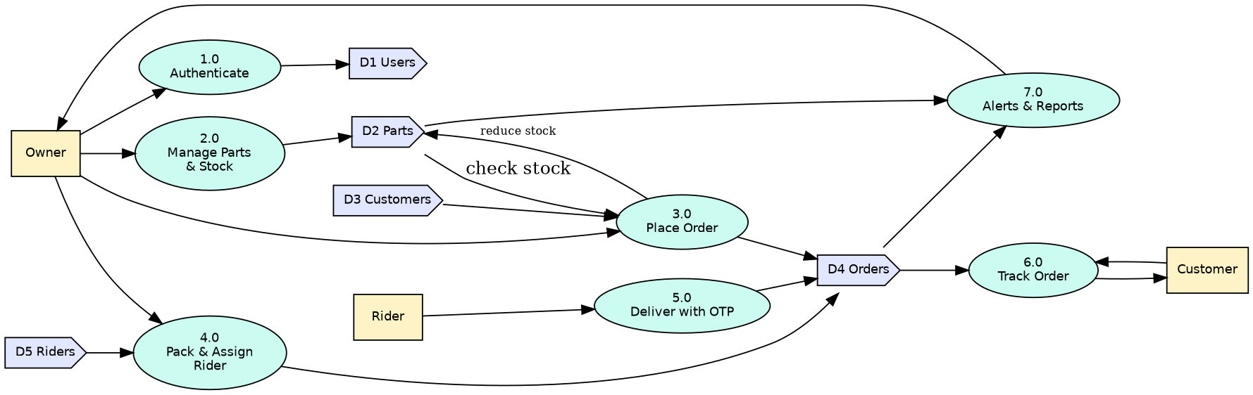
Figure 4.4: DFD Level 1

4.4 Entity Relationship Diagram
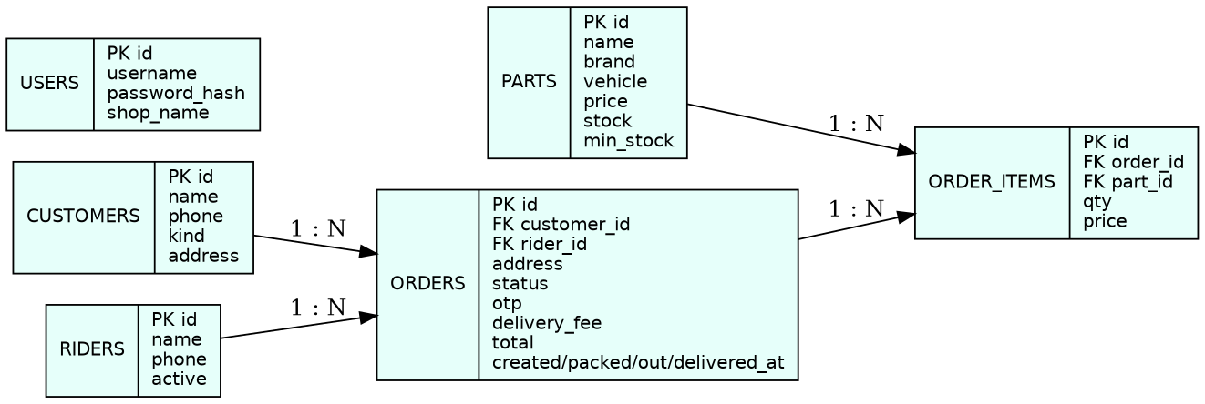
Figure 4.5: ER diagram

4.5 Database Design
Table | Columns | Keys / constraints
users | id, username, password_hash, shop_name | PK id; username UNIQUE
parts | id, name, brand, vehicle, price, stock, min_stock | PK id; price>=0, stock>=0
customers | id, name, phone, kind, address | PK id
riders | id, name, phone, active | PK id
orders | id, customer_id, rider_id, address, status, otp, delivery_fee, total, created/packed/out/delivered_at | PK id; FK customer_id, rider_id
order_items | id, order_id, part_id, qty, price | PK id; FK order_id, part_id

Tables are in third normal form. The unit price is copied into order_items so old invoices do not change when part prices change.

4.6 Business Rules
- Delivery fee Rs 40; free if subtotal is Rs 1000 or more.
- Order cannot be placed if quantity exceeds stock.
- Status can only move forward one step at a time.
- Rider is mandatory before Out for Delivery; correct OTP is mandatory for Delivered.
- Low-stock alert when stock is less than or equal to minimum stock.

Chapter 5: Implementation

5.1 Technologies Used
Component | Technology
Language | Python 3
Framework | Flask with Jinja2
Database | SQLite
Front end | HTML5, CSS3 (offline)
Security | Werkzeug hashing, Flask sessions
Tools | VS Code, Git/GitHub, Playwright, Graphviz

5.2 Description of Modules
Module | Description
Authentication | Login/logout, session protection
Parts & Stock | Catalogue, search by vehicle, restock, low-stock
Customers & Riders | Master data, rider workload and history
Orders | Order creation, stock deduction, fee, invoice
Delivery & OTP | Pack, assign rider, dispatch, OTP-confirmed delivery
Tracking | Public tracking page and WhatsApp link
Reports | Dashboard, top parts, rider performance, 7-day value

5.3 Application Screenshots
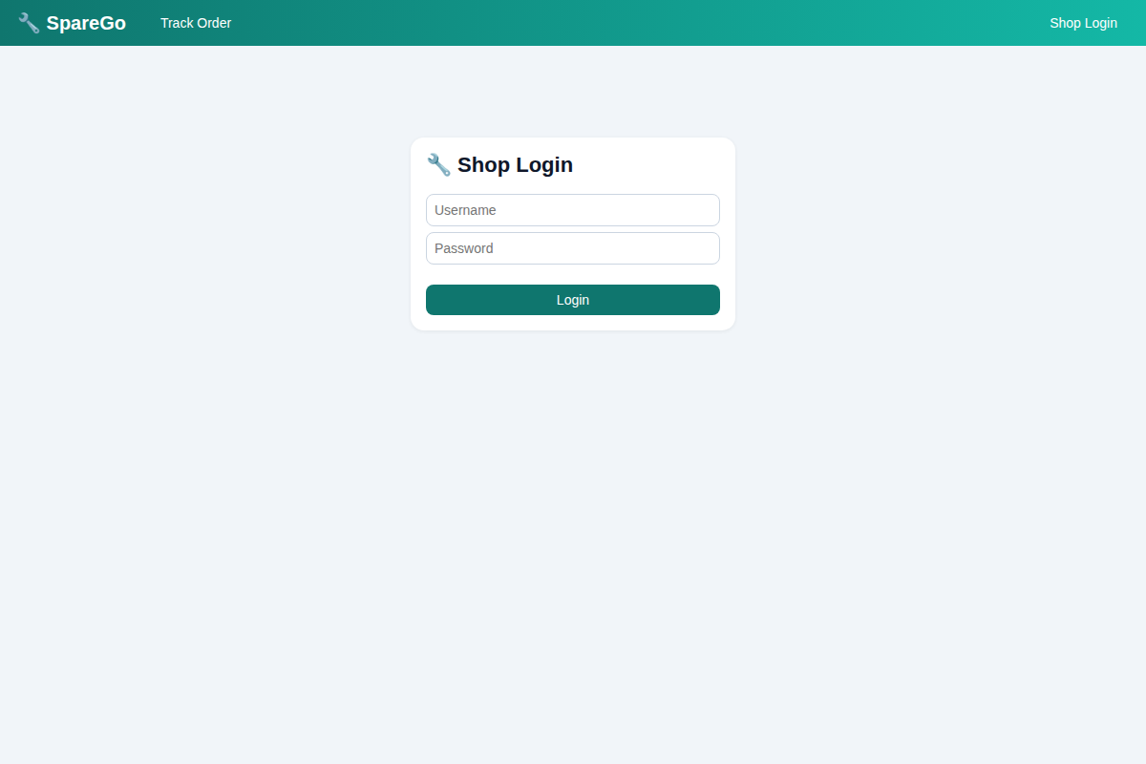
Figure: Login
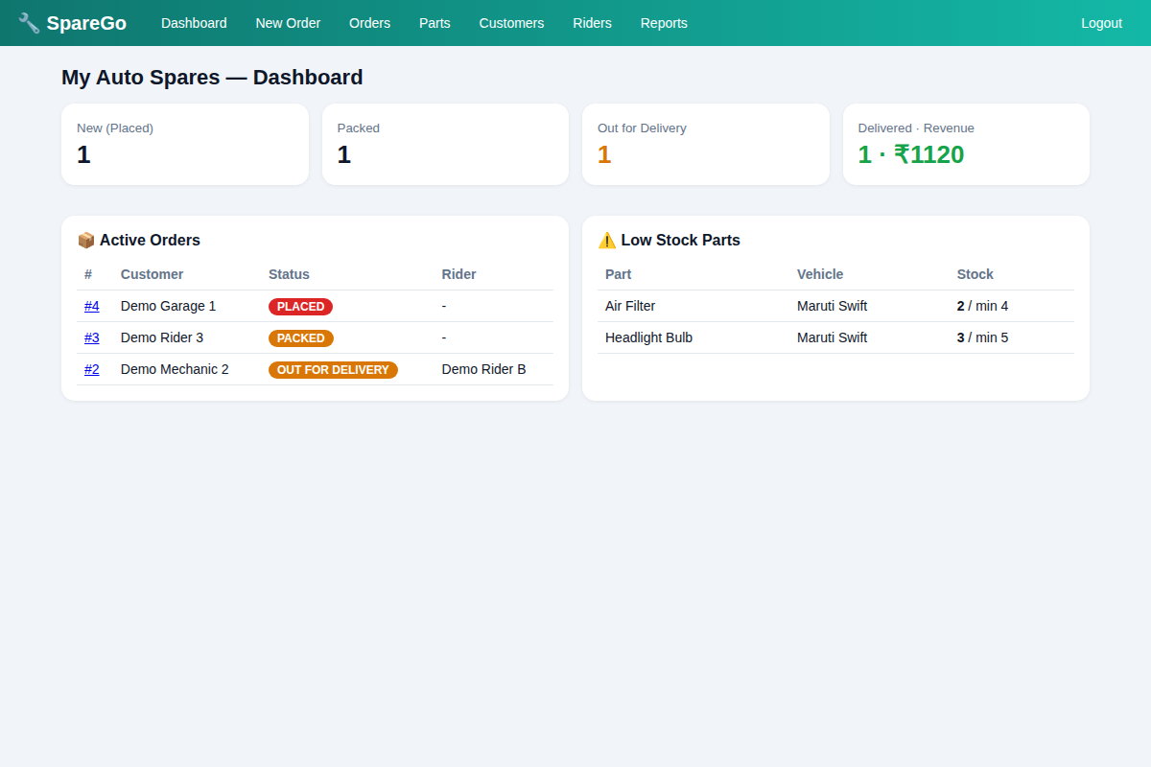
Figure: Dashboard
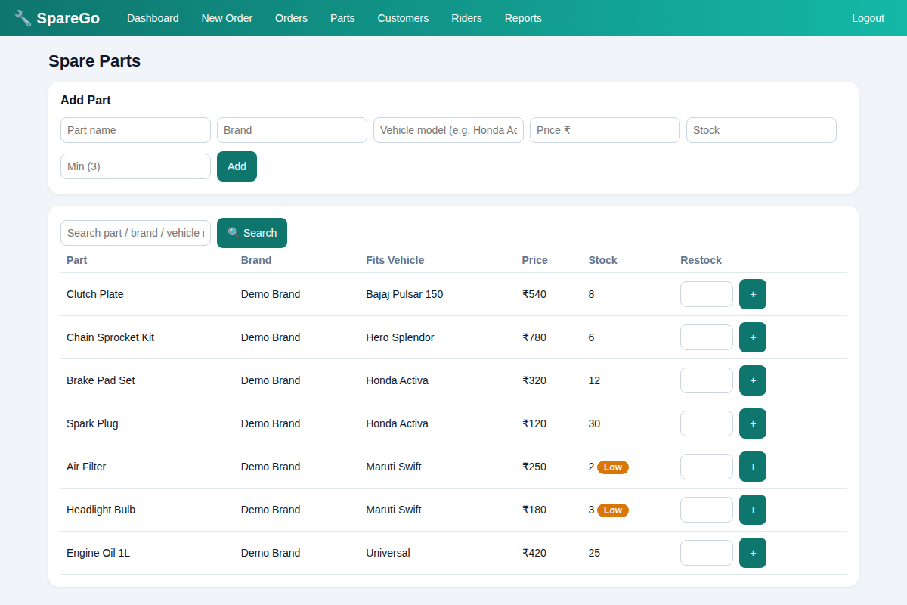
Figure: Parts catalogue and search
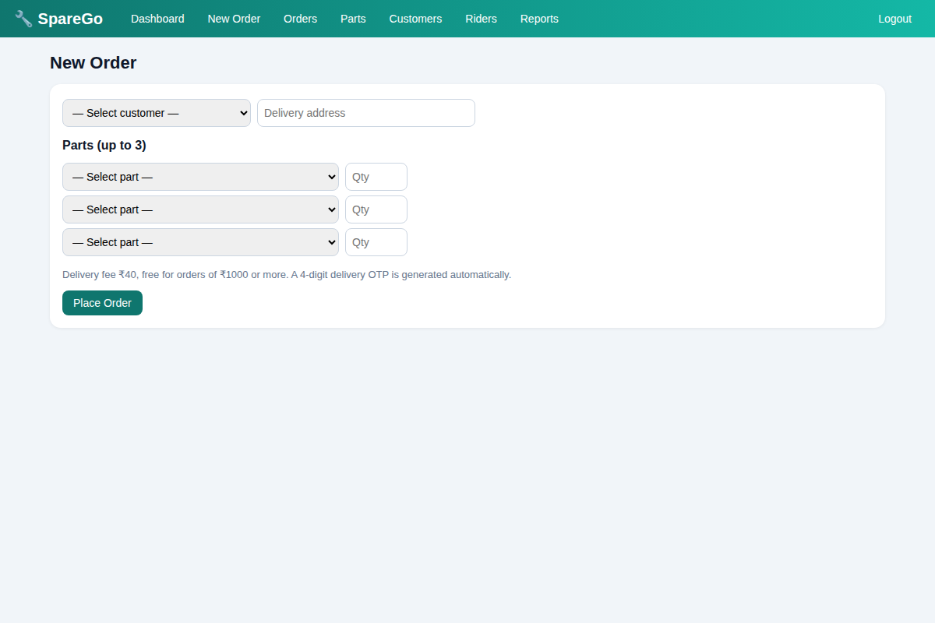
Figure: New order
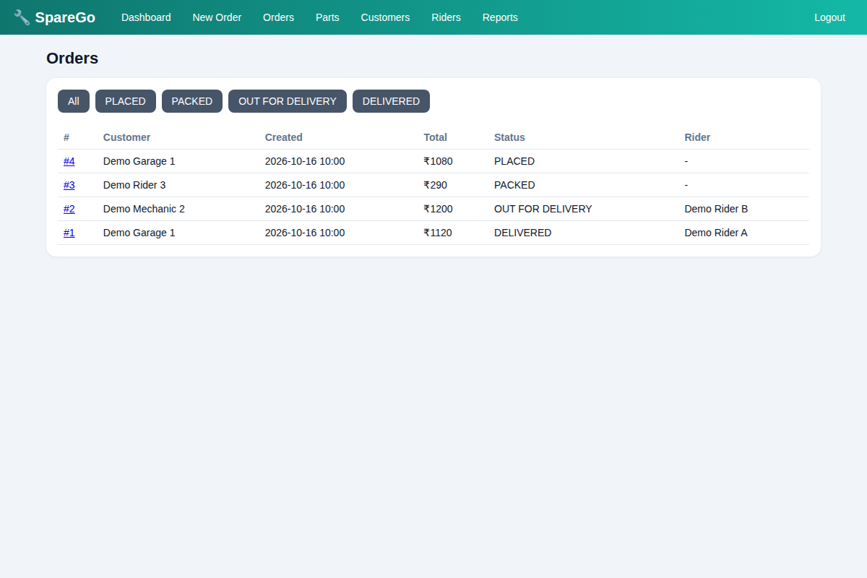
Figure: Order list
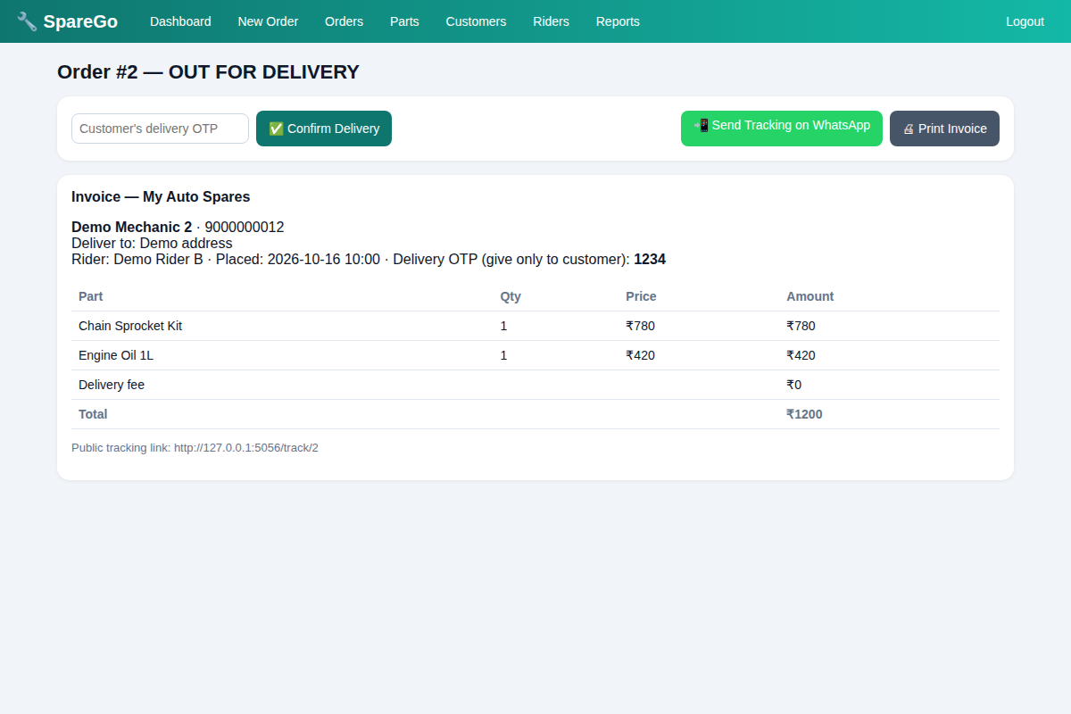
Figure: Order detail, invoice and WhatsApp link
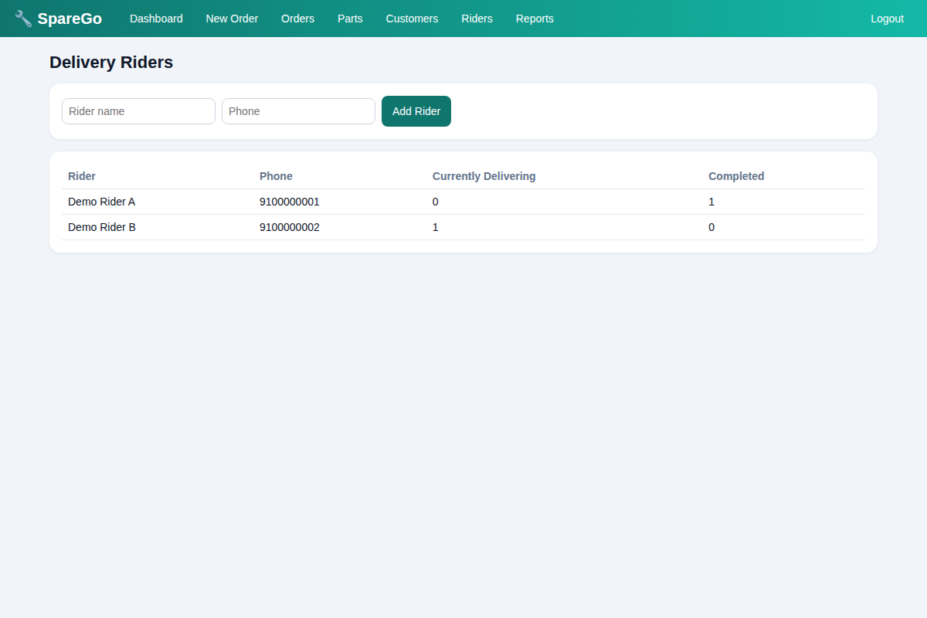
Figure: Riders
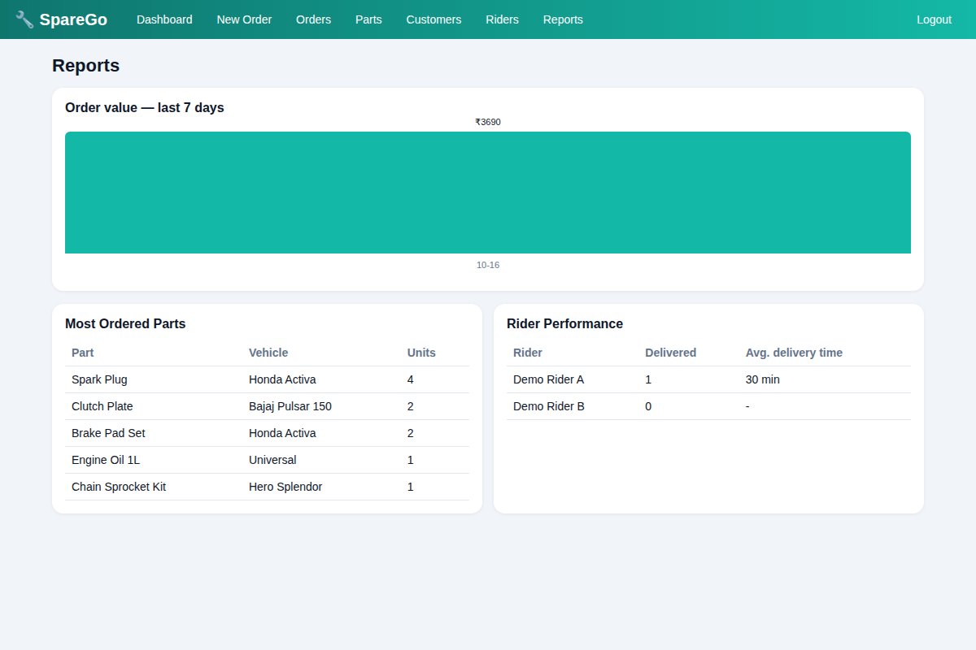
Figure: Reports
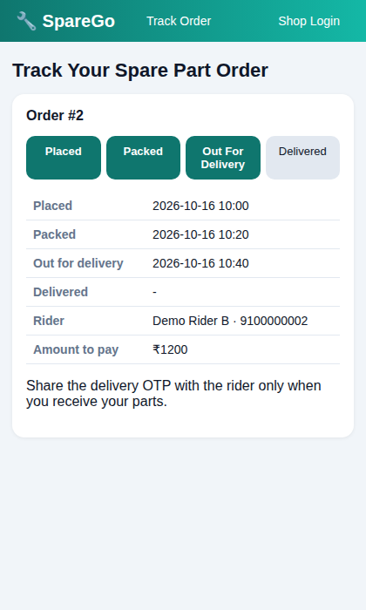
Figure: Customer tracking page (mobile view)
NOTE: Screenshots use demo data. Replace them with real-data screenshots before submission.

Chapter 6: Conclusion and Future Scope

6.1 Conclusion
SpareGo replaces paper and WhatsApp-based ordering with a structured system that finds parts by vehicle model, prevents over-selling, tracks every order and proves delivery with an OTP. All 16 test cases passed. [Add the owner's real feedback after the demo.]

6.2 Existing vs Proposed System
Feature | Existing | SpareGo
Part search | Memory / shelves | Search by part, brand, vehicle
Order record | Notebook / chat | Database with invoice
Status for customer | Phone calls | Tracking link / page
Delivery proof | None | OTP verification
Stock alert | None | Low-stock alerts
Reports | None | Auto reports and rider performance

6.3 Future Scope
- Live GPS tracking of riders and ETA.
- Rider mobile app.
- Online payment / UPI link and COD reconciliation.
- Barcode scanning, supplier purchase orders.
- Multi-shop and staff roles, Hindi/Marathi interface.
- Demand prediction from order history.

Appendix A: Questionnaire
Q1. What type of customer are you? Mechanic / Garage / Individual
Q2. How do you order spare parts now? Visit / Phone / WhatsApp
Q3. How long does it take to know if a part is available?
Q4. Have you received a wrong or incompatible part? Yes / No
Q5. How long does delivery usually take?
Q6. Do you have to call to ask where your order is? Yes / No
Q7. Is delivery ever late enough to affect your work? Yes / No
Q8. Would you like a tracking link on WhatsApp? Yes / No
Q9. Would you prefer to confirm delivery using an OTP? Yes / No
Q10. Would you use a simple app for ordering parts? Yes / No

Appendix B: Manual Test Cases
ID | Test case | Expected | Result
TC01 | Wrong password | Error shown | Pass
TC02 | Valid login | Dashboard opens | Pass
TC03 | Add part | Part listed | Pass
TC04 | Invalid phone | Rejected; valid saved | Pass
TC05 | Add rider | Rider listed | Pass
TC06 | Order qty above stock | Rejected | Pass
TC07 | Order 2 x Rs 300 | Total 640 (incl. fee 40); stock 10→8 | Pass
TC08 | Fee rule | Free at 1000+, else 40 | Pass
TC09 | Mark packed | Status PACKED | Pass
TC10 | Dispatch without rider | Blocked | Pass
TC11 | Assign rider, dispatch | OUT FOR DELIVERY | Pass
TC12 | Wrong OTP | Not delivered | Pass
TC13 | Correct OTP | DELIVERED | Pass
TC14 | Public tracking | Status visible without login | Pass
TC15 | Tracking wrong phone | Not found | Pass
TC16 | Admin page without login | Redirect to login | Pass

References
- Flask documentation – https://flask.palletsprojects.com
- SQLite documentation – https://www.sqlite.org/docs.html
- Pressman R., Software Engineering: A Practitioner's Approach.
- Kendall & Kendall, Systems Analysis and Design.

