ImageJ Colocalisation Plugins

Alex Herbert
MRC Genome Damage and Stability Centre
School of Life Sciences
University of Sussex
Science Road
Falmer
BN1 9RQ
a.herbert@sussex.ac.uk
Table of Contents
1 Introduction 3
2 Stack Threshold Plugin 4
2.1 Image Thresholding 4
2.2 Plugin Interface 5
2.2.1 Input Parameters 5
3 Colocalisation Threshold Plugin 6
3.1.1 Example Input 6
3.1.2 Example Output 7
3.2 Features 8
3.3 Method 8
3.3.1 Step 1: Regression Analysis 8
3.3.2 Step 2: Define limits 8
3.3.3 Step 3: Iterative search 8
3.4 Plugin Interface 9
3.4.1 Input Parameters 10
3.4.2 Search Parameters 10
3.4.3 Results Parameters 11
3.5 Results Table 13
4 Confined Displacement Algorithm (CDA) Plugin 17
4.1.1 Example Input 18
4.1.2 Example Output 19
4.2 Features 20
4.3 Method 20
4.3.1 Stage 1: Identify Channel Signal 20
4.3.1.1 Using the ImageJ minimum display value 20
4.3.1.2 Using the ImageJ ROI 22
4.3.1.3 Using an image mask 23
4.3.2 Stage 2: Analysis 24
4.3.2.1 Manders Coefficient 24
4.3.2.2 Pearson Correlation Coefficient 25
4.3.2.3 Displacements 25
4.3.2.4 Speed Increases 27
4.4 Plugin Interface 27
4.4.1 Input Parameters 27
4.4.2 Displacement Parameters 28
4.4.3 Options Parameters 29
4.5 Results Table 30
5 CDA (macro) Plugin 32
6 Stack Correlation Analyser Plugin 33
6.1 Plugin Interface 33
6.1.1 Input Parameters 33
6.2 Results 34
6.2.1 Header Record 34
6.2.2 Threshold Record 35
6.2.3 Correlation Record 35
7 Stack Colocalisation Analyser Plugin 36
7.1 Plugin Interface 37
7.1.1 Input Parameters 37
7.2 Results Table 38
8 References 40
9 Appendix 1: Batch Processing 41
9.1 Step 1: Record the macro 41
9.2 Step 2: Prepare input files 41
9.3 Step 3: Process Batch command 41

Introduction
Digital images can be recorded using different light filters. Each filter records an image containing only the information from the wavelengths of light that pass through the filter. This produces an image with multiple channels each representing different light. Colocalisation analysis is used to determine the amount of an image channel's signal that occurs in the same location as another channel. If the channels represent specific objects such as fluorescence tagged proteins, colocalisation analysis will quantify whether the different objects are found in the same location.
The GDSC Colocalisation plugins provide various tools to perform colocalisation analysis. The following tools are available:
Stack Threshold | Processes an image stack and applies thresholding to create a mask for each channel+frame combination. This defines the signal region of each channel.
Colocalisation Threshold | Compares two images for correlated pixel intensities. If the two images are correlated a search is performed to identify the threshold below which the two images are not correlated.
CDA | Uses the Confined Displacement Algorithm (CDA) to compute the significance of colocalisation metrics (Manders' coefficient and correlation coefficient).
Stack Correlation Analyser | Processes a stack image with multiple channels. Extracts all the channels and frames and performs:  - Thresholding to create a mask for each channel+frame  - All-vs-all channel correlation within the union/intersect of the channel masks
Stack Colocalisation Analyser | Processes a stack image with multiple channels. Requires three channels. Each frame is processed separately. Extracts all the channels (collating z-stacks) and performs:  - Thresholding to create a mask for each channel  - CDA analysis of channel 1-vs-channel 2 within the region defined by channel 3
The stack analyser plugins can be incorporated into ImageJ macros to allow rapid analysis of hundreds of images for correlations.

Stack Threshold Plugin

Image Thresholding
An initial stage of image analysis is to determine which pixels contain the important image data. All the other pixels can then be ignored resulting in faster processing of the image. A simple way to separate the important pixels is to assign a threshold level to the image. All pixels below this level are ignored as the background, pixels above the level are the foreground.
It is possible to automatically set a threshold level. This is done by analysing the image distribution of pixel intensities (image histogram) and setting a threshold value that separates a background cluster from the foreground pixels. The following image outlines the two peaks that are characteristic of a well defined background and foreground.
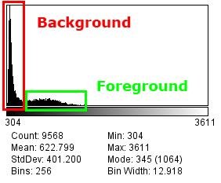
There are many different thresholding methods. ImageJ also has a built-in threshold method available using the command Image > Adjust > Threhold... The Auto Threshold plugin of Gabrial Landini contains several different methods that you can try (see http://pacific.mpi-cbg.de/wiki/index.php/Auto_Threshold).
However the threshold methods require the analysis of the image histogram for the channel that you are thresholding. ImageJ can perform thresholding on a single image or a 3d image stack. It has no method for processing a multi-channel image.
The Stack Threshold plugin can analyse a multi-dimensional image and apply thresholding to each channel and time frame in the image. The result is presented as a new image mask. Foreground pixels are white, background pixels are black. An example of an input and output image are shown below:
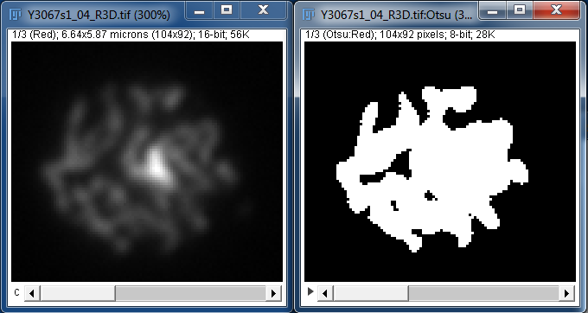

Plugin Interface
The Stack Threshold plugin uses the standard ImageJ plugin dialogue. Select the image to process and then run the plugin. This will present the following window:
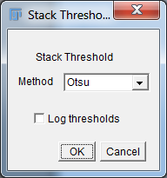

Input Parameters
Parameter | Description
Method | Specify the thresholding method
Log thresholds | Record the thresholds to the ImageJ log window. A threshold will be calculated for each combination of timeframe and channel, e.g:  t1c1 threshold = 778  t1c2 threshold = 617  t1c3 threshold = 2441

Colocalisation Threshold Plugin
The positive correlation between two images indicates that the signal in one channel is observed at the same time as the signal in the other channel. This may have biological significance.
This correlation is expected to be high when the strength of the signal is both channels is high. However as the strength of the signal reduces towards background noise it would be expected that the strength of the correlation also reduces. Under this assumption it is possible to measure the amount of signal that is correlated.
A method for determining the threshold level for each channel was proposed by Costes, et al. (2004). Each image is thresholded at its maximum intensity and the correlation below this threshold is measured (i.e. the correlation for the entire signal). This will be positive if the two channels are colocated. The threshold is then reduced and the colocalisation remeasured. By iterating this process a search is performed for the intensity threshold below which there is no correlation. The fraction of signal above this threshold is a measure of the colocalisation of the signal in the two image channels.
An exhaustive search for the thresholds is computationally expensive due to the large number of combinations. The Colocalisation Thresholds plugin computes a regression between the two channels. This regression is used to approximate the threshold level required in the second image for a set threshold in the first image. The plugin performs a converging search for the image thresholds and reports various metrics on the resulting thresholded images.

Example Input
The following figure shows the input required for the plugin. The input consists of 2 channels of a microscopy image where the channels are stained for different proteins.
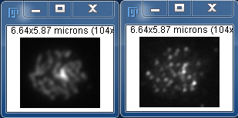

Example Output
The results of colocalisation threshold analysis. (A) Combined RGB image showing only pixels above the threshold levels. The image shows the original channels in red and green; the blue channel shows colocalised pixels. (B) A plot of channel 1 verses channel 2. The regression line is plotted along with the threshold level for channel 1 (vertical line) and channel 2 (horizontal line). (C) Plot of the correlation above (blue) and below (red points) the threshold level for channel 1 verses the threshold level.
A. 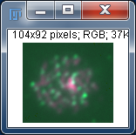
B. 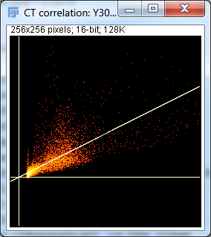
C. 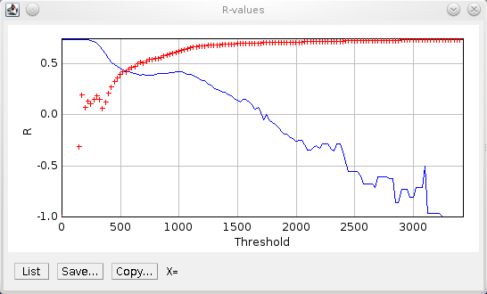

Features
- Processes 8-bit and 16-bit greyscale images
- Processes 2D and 3D images (i.e. image stacks)
- Selection of channel regions using the ImageJ ROI
- Calculates threshold value for each image below which there is no correlation
- Outputs threshold mask images
- Generates a full results table
- Efficient convergence algorithm is fast
Note
The plugin presented here is a modification of the original [ColocThreshold] plugin available from:
http://www.uhnres.utoronto.ca/facilities/wcif/imagej/colour_analysis.htm#6.3 Colocalisation Threshold
The plugin has been altered to add additional features such as support for 16-bit and 3D images, region selection options, more results output and the new implementation of the threshold search code.

Method
The colocalisation threshold plugin uses a heuristic search for the threshold limits for each channel below which there is no correlation. The search is only performed if there is a positive correlation between all the pixels in both channels. The method is outlined below.

Step 1: Regression Analysis
A regression is computed between the two channels. This assumes a linear relationship between the two channels. The value of channel 2 can then be expression as:
ch2 = ch1 * m + c

Step 2: Define limits
The limits for the threshold search are set using the maximum and minimum value of channel 1. These are named T_{max} and T_{min}.
Using the linear regression the limits for channel 2 are then defined using:
ch2min = T_{min} * m + c
ch2max = T_{max} * m + c

Step 3: Iterative search
The search is performed by continuously updating the current threshold for channel 1, calculating the threshold for channel 2 and the subsequent regression value for all pixels below the thresholds. The search is convergent in that it only operates between the current maximum and minimum limit for channel 1. The limits are adjusted based on the results of each iteration and the current threshold is updated to half way between the two limits.
- At any point in the algorithm it is known that there is a positive correlation when T = T_{max}. T is then set as T_{min} + (T_{max} – T_{min}) / 2, i.e. halfway between the two limits
- Calculate the new regression value
- If the correlation is positive then it is known the threshold must be lowered. T_{max} is updated to T
- If the correlation is negative then it is known the threshold must be raised. T_{min} is updated to T
- Repeat
The iteration stops when either:
- The correlation is within the Search tolerance of the Correlation limit
- The distance between T_{max} and T_{min} is 1, i.e. convergence
- The Maximum iterations value is reached
In certain cases the final threshold limit may not have the desired correlation. This is because convergence or Maximum iterations occurs during a search where the Correlation limit is not reached. In this case the results are sorted in descending order by the threshold. The final limit is set as the threshold value which resulted in:
- The correlation above the threshold being more than the Correlation limit
- The correlation below the threshold is the closest to the target Correlation limit
In the event that no results satisfy the criteria then the threshold is set using the lowest intensity level sampled from channel 1.
The following chart shows how the threshold is updated during a typical search. Initially the threshold is reduced until the correlation goes below the Correlation limit. The threshold is then raised and subsequently raised/lowered as the correlation alternates around the Correlation limit. In this instance the Correlation limit was not obtained and the threshold converged at 166.
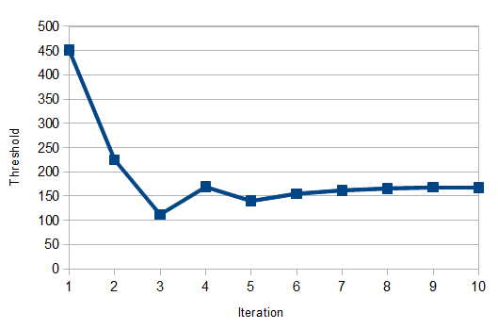

Plugin Interface
The Colocalisation Threshold plugin interface uses a frame within the ImageJ application. The plugin has many options but these can be divided into sections controlling parts of the algorithm. The different sections are shown in the following image and are described below.
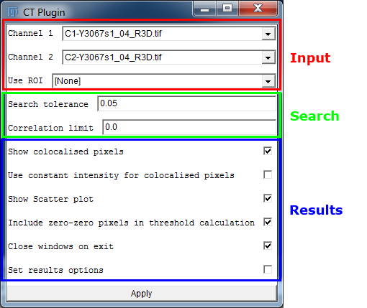

Input Parameters
The input parameters specify the images to use for the analysis. The user can select the two input channels and specify the region to use for the analysis.
Parameter | Description
Channel 1/2 | Specify the channel 1 or 2 image.  If the user selects an image stack then the channel and frame will be requested during run-time. This is to eliminate optional fields from the main dialogue
Use ROI | Specify the region to use for analysis. This uses an Region-of-Interest (ROI) that has been drawn on the input image using the ImageJ ROI tools. The options are:  - None  - Image 1 ROI  - Image 2 ROI

Search Parameters
The search parameters control the algorithm used to find the colocalisation thresholds.
Parameter | Description
Search tolerance | Specify the tolerance for convergence on the desired correlation for the pixels below the thresholds.  The search will stop if the correlation is the Correlation limit +/- Search Tolerance. E.g. using a Search tolerance of 0.05 and Correlation limit of 0 the search will stop if the correlation in within -0.05 to 0.05.
Correlation limit | Define the desired correlation for the pixels below the image thresholds. This can be increased from the default of 0 in an attempt to obtain thresholds that specifiy more strongly correlated channel pixels

Results Parameters
The other parameters provide results for the plugin.
Parameter | Description
Show colocalised pixels | Specify the tolerance for convergence on the desired correlation for the pixels below the thresholds.  The search will stop if the correlation is the Correlation limit +/- Search Tolerance. E.g. using a Search tolerance of 0.05 and Correlation limit of 0 the search will stop if the correlation in within -0.05 to 0.05.
Use constant intensity for colocalised pixels | Show the blue channel (colocalised pixels) of the output RGB image using a constant intensity (255)
Show scatter plot | Show a scatter plot of the channel 1 intensity verses the channel 2 intensity
Include zero-zero pixels in the threshold calculation | Include pixels with zero value in both channels in the correlation calculations. Ignoring these pixels is useful for images that have been masked so that certain regions have no value
Close windows on exit | If checked then all the windows that have been opened by the plugin are closed when the plugin window is closed. This includes the result table and output images and charts.
Set results options | Shows a pop-up dialogue with additional options (see below)
Clicking the Set result options checkbox shows the following pop-up dialogue:
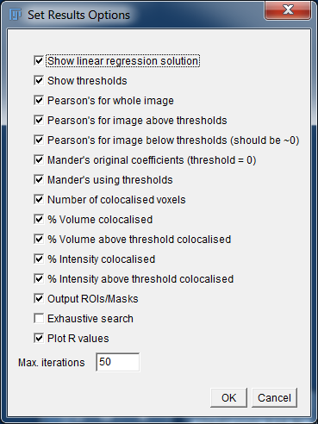
The dialogue contains settings for configuring the columns included in the result table. Further details can be found in the Results Table section. This can be useful if you have limited screen resolution and would like to disable some columns.
The dialogue also contains the following options:
Parameter | Description
Output ROIs/Masks | If an ROI was selected from an input image then this option will output a cropped duplicate of the input images with all the pixels outside the ROI (if non rectangular) set to zero, e.g.  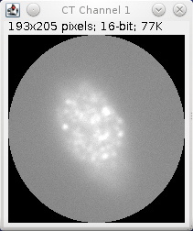  In all cases this option will also show a mask image for each channel where all the pixels above the colocalisation threshold are white, other pixels are black, e.g.  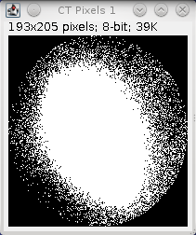
Exhaustive search | If selected the convergence algorithm is not used. Instead all threshold values between the maximum and minimum for channel 1 are analysed using Max iterations to define the step increments. The final threshold is set as the highest threshold with a positive correlation for pixels above the threshold and the closest correlation to the Correlation limit for the pixels below the threshold
Plot R values | Produce a plot of (a) the correlation (R) values above (solid line) and (b) below (cross points) the threshold verses the threshold, e.g.  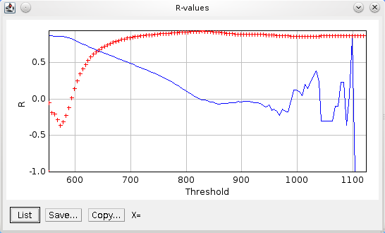
Max iterations | Specify the maximum iterations to use within the algorithm

Results Table
The results table contains details about the threshold analysis. The analysis is performed on pixels that have been classified using different criteria:
- pixel is greater than a set level for one channel
- pixel is greater than the set levels for both channels
In each case the level can be set using the a threshold of 0 (i.e. count any pixel), 1 (i.e. the pixel has a value) or the threshold set during the analysis phase.
This allows the following values to be computed:
Result Value | Description
nCh1 | The number of pixels in channel 1
nCh1gt0 | The number of pixels in channel 1 greater than zero
nCh1gtT | The number of pixels in channel 1 greater than the channel 1 threshold
nColoc | The number of pixels where both channels are above the threshold
sumCh1 | The sum of pixel values in channel 1
sumCh1gtT | The sum of pixel values in channel 1 greater than the channel 1 threshold
sumCh1_Ch2gt0 | The sum of pixel values in channel 1 where channel 2 is greater than zero
sumCh1_Ch2gtT | The sum of pixel values in channel 1 where channel 2 is greater than the channel 2 threshold
sumCh1_Coloc | The sum of pixel values in channel 1 where both channels are above the threshold
Note: With the exception of nColoc all of these values have corresponding equivalents for Channel 2.
The initial result values are used to compute result metrics that are displayed in the result table. The following table describes the results and the option used to enable/disable the result column(s):
Result | Option | Description
Images | - | Contains the titles of the input images used for the analysis
ROI | - | Contains the ROI that was used to select the region for the analysis
ZeroZero | - | Shows whether Include zero-zero pixels in the threshold calculation was selected
Rtotal | Pearson's for whole image | The Pearson's correlation for the entire image
m/b | Show linear regression solution | The linear regression coefficients:  ch2 = ch1 * m + b
Ch1 / Ch2 thresh | Show thresholds | The channel thresholds
Rcoloc | Pearson's for image above threshold | The Pearson's correlation coefficient for the pixels above both the channel thresholds
R<threshold | Pearson's for image below threshold | The Pearson's correlation coefficient for the pixels below both the channel thresholds. This should be close to the Correlation limit
M1 / M2 | Manders original coefficient | The Manders coefficient for the image  M1 = sumCh1_ch2gt0 / sumCh1  (How much of channel 1 intensity occurs where channel 2 has signal)
tM1 / tM2 | Manders using threshold | The Manders coefficient for the pixels above the channel thresholds  tM1 = sumCh1_ch2gtT / sumCh1  (How much of channel 1 intensity occurs where channel 2 is correlated)
N | Number of colocalised voxels | The number of pixels in the analysis region (optionally excludes the zero-zero pixels)
nZero | Number of colocalised voxels | The number of pixels that are zero for both channel 1 and 2
nCh1gtT / nCh2gtT | Number of colocalised voxels | The number of pixels that are above the threshold for channel 1/2
nColoc | Number of colocalised voxels | The number of pixels that are above the threshold for both channel 1 and channel 2
% Vol Coloc | % Volume colocalised | The percentage of pixels that are above the thresholds for both channels:  % Vol Coloc = nColoc / TotalPixels  Note that TotalPixels is the total number of pixels in the analysis region including zero-zero pixels.
%Ch1gtT Vol Coloc / %Ch2gtT Vol Coloc | % Volume above threshold colocalised | The percentage of pixels above the channel threshold that are also above the threshold for the other channel:  %Ch1gtT Vol Colocn = Coloc / nCh1gtT
%Ch1 Int Coloc / %Ch2 Int Coloc | % Intensity colocalised | The percentage of channel intensity that is colocalised:  %Ch1 Int Colocsum = Ch1_Coloc / sumCh1
%Ch1gtT Int Coloc / %Ch2gtT Int Coloc | % Intensity above threshold colocalised | The percentage of channel intensity that is above the channel threshold that is colocalised:  %Ch1gtT Int Coloc = sumCh1_Coloc / sumCh1gtT

Confined Displacement Algorithm (CDA) Plugin
The Confined Displacement Algorithm (CDA) ImageJ plugin allows the identification of significant areas of colocalisation within 2D and 3D images.
The quantification of colocalisation is performed in two stages. Stage 1 identifies locations where the two channels both occur. Stage 2 calculates a measure to quantify the cooccurrence of the two channels, for example using the percentage of colocated signal or the correlation between the colocated channels.
However the quantification of colocalisation has no context. This results in subjective interpretation as to the significance of the value. For example a given colocalisation result may be very good or very bad depending on the underlying distribution of signal intensity within the image. In this case the results of many different images can be compared to provide a context for the result under investigation. However this analysis is also subjective and it is possible that alternative images are either not available or not representative.
To solve this issue representative images for comparison can be produced from the original image. This ensures the total channel intensity is the same. Randomly shuffling the pixels provides new images but does not maintain a realistic grouping of pixel intensities characteristic of structural content. Rotating the image in 90 degree intervals or translating the image with wrapping does maintain the structural content but introduces bias depending on the nature of the transform, e.g. the centre of the rotation or the angle of the translation.
A solution to this situation is to perform translations in all directions and at all possible distances. If the colocalisation measure is calculated for each translation then a probability density function can be computed that shows how the measure varies with distance. If the two channels are significantly colocated it would be expected that the original colocalisation measure would be very different from the colocalisation measure of a highly shifted image. If there is no true colocalisation then shifting the image will produce colocalisation scores higher (and lower) than the actual measure.
An additional factor to consider is that the information in the two channels may be located in only parts of the overall image, for example the nucleus of a cell. Consequently the translation shifts may move the signal of the channel into an area of the image where it would never naturally occur. This could result in a false conclusion that the two channels are colocated in the original image. The solution is to define an area within which the pixels can be translated. Pixels moving beyond the region are wrapped to re-enter from the other side. This method thus maintains the underlying image structure. This method is the principle behind the Confined Displacement Algorithm (CDA) [Ramirez et al].

Example Input
The following figure shows the input required for the CDA plugin. The input consists of 3 channels of a microscopy image where the red and green channels are stained for different proteins and the blue is stained for DNA. The mask images have been produced by performing thresholding using the ImageJ default threshold method. Colocalisation analysis can be performed between any of the channels.

Example Output
The results of colocalisation analysis between the red and green channels. The CDA algorithm was run using all displacements up to 25 pixels. The scores from displacements above 15 pixels used as the background; significance was assessed using a p-value of 0.01. (A) The mask regions of the red and green channel were used to define the presence of each channel. The mask region of the blue channel was used to confine the analysis region. The output image and mask shows the original pixels in red and green. Any overlap is visible as yellow. Regions outside the analysis area are white. (B) The individual correlation coefficients scores. The line shows the sample average using a bin width of 1. (C) The probability density of the correlation coefficient scores. The measured correlation (R=0.31) is significant given the estimated probability density function.
A.
B. 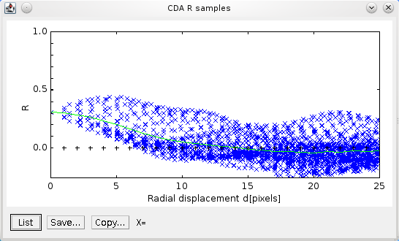
C. 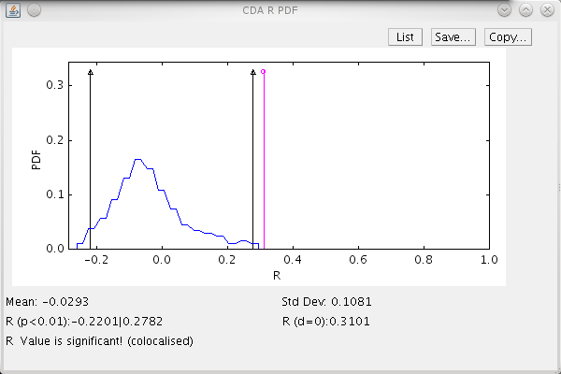

Features
- Processes 8-bit and 16-bit greyscale images
- Processes 2D and 3D images (i.e. image stacks)
- Selection of channel regions and confined region using: a mask image; an image minimum display value; or the ImageJ ROI
- Optional expansion of confined region to include channel regions
- Performs CDA shifts within a configurable radius
- Calculates Manders' coefficients and correlation coefficient
- Outputs the analysed regions as a new image
- Generates a full results table
- Saves results text table and images to a directory
- Efficient combined-image displacement algorithm is fast
- Multi-threading support for extra speed
Note
The plugin presented here is a modification of the original CDA plugin available from the ImageJ wiki:
http://imagejdocu.tudor.lu/doku.php?id=plugin:analysis:confined_displacement_algorithm_determines_true_and_random_colocalization_:start
The plugin has been altered to add additional features such as support for 16-bit and 3D images, additional region selection options, correlation analysis, saving the results to file and the reimplementation of the core CDA code.

Method
The CDA plugin provides colocalisation analysis for 2D and 3D images. The process for using the plugin has two stages: identification of the regions containing the signal in each channel; and running the CDA analysis.

Stage 1: Identify Channel Signal
To determine if the signal in two channels is colocated the first step is to assign the region that contains the signal in each channel. Additionally it is possible to define a region of the image where the signal is expected to occur. This is the Confined region which will be used within the Confined Displacement Algorithm.
This region assignment process is not performed by the CDA plugin. However the plugin provides flexibility in that it recognises different methods for defining the signal regions:
- Using the ImageJ minimum display value
- Using an ImageJ ROI
- Using an image mask
Each of these options are described in further detail below:

Using the ImageJ minimum display value
ImageJ provides the ability to change the range of pixel values that are displayed on screen. Any pixel above the maximum display value will be fully saturated, pixels below the minimum display value will be black.
To change the display range use Image > Adjust > Brightness/Contrast. This will display a small dialogue that has sliders to control the display range. Use the Minimum slider to set a different minimum display value. This should be adjusted so that any areas that do not contain a strong signal (i.e. background pixels) are black. To assist in viewing the channel signal you can adjust the Maximum slider to set the major signal regions to fully saturated.
This process is outlined using an example. The following image shows the default representation of an image using the full range of pixel intensity:
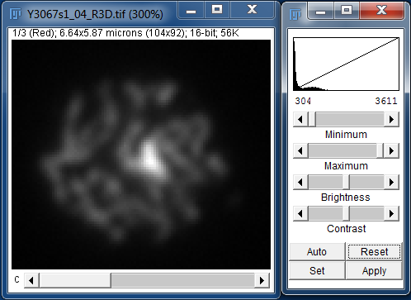
Step 1: Adjust the Maximum slider to view the region of strong signal:
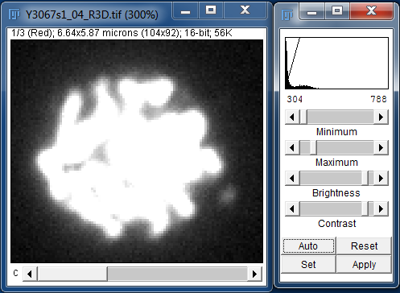
Step 2: Adjust the Minimum slider to exclude the background leaving only the channel signal:
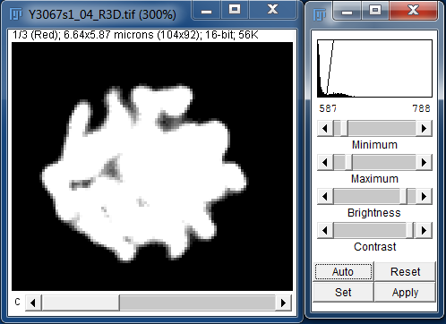
All the pixels that are still visible will define the pixels that will be included in the analysis.
Note: Adjusting the image display range will not alter the underlying channel intensity data that will be used to perform the analysis.

Using the ImageJ ROI
ImageJ contains tools for drawing regions of interest (ROIs). These can be based on shapes - Rectangle, Oval or Polygon - or Freehand. Each tool can be selected from the ImageJ toolbar using one of the first 4 toolbar buttons:
The Rectangle and Oval tools are used by simply dragging on the image to define the shape. This can be moved by dragging inside the shape and resized by dragging the small white markers at the shape edge.
The Polygon tool is used by clicking on points in the image that you want to be a polygon apex. The polygon is completed by clicking in the small square that defined the start point. The polygon can be moved and resized as above.
The Freehand tool is used by clicking to define a start point and then dragging the mouse to trace a shape. Releasing the mouse results in ImageJ completing the shape. The shape can be moved but not resized.
The following example shows an image where the Freehand ROI tool has been used to define a region:
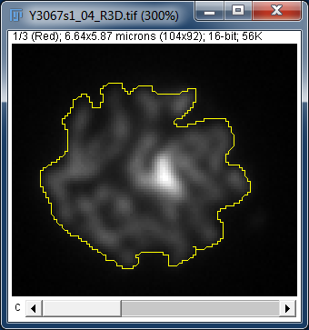
Note that since the ROI must be contiguous using this method is not recommended for defining regions with two or more distinct segments of channel intensity.

Using an image mask
A mask is an image of the same dimensions as the original image but with pixel values set as either foreground or background. This is usually done using a black and white image. Only the pixels that are not black will be used.
ImageJ provides tools to produce a mask from your original image. This is done by analysing the image and setting a threshold value for pixels to be included in the foreground:
- Image > Duplicate...
- Image > Adjust > Threhold...
There are many different thresholding methods. The Auto Threshold plugin of Gabrial Landini contains several that you can try (see http://pacific.mpi-cbg.de/wiki/index.php/Auto_Threshold). You can apply all the methods to see which is best for your image. However in most cases the default ImageJ method or the Otsu method both provide robust and efficient partitioning of the data.
The following image shows the result of applying the Otsu method:
To assist in the thresholding of multi-dimensional images you can use the GDSC > Stack Threshold plugin. This plugin can process a 5D hyperstack. Each combination of channel+frame are extracted for separate processing. The threshold method is then applied to the individual channel Z-stack for each time frame in the sequence. The methods are the same as those available in the Auto Threshold plugin. The results are displayed as a new hyperstack.
Note: In practice it is possible to use any image as a mask. All non-zero pixels will define the region to include in the analysis.

Stage 2: Analysis
The Confined Displacement Algorithm (CDA) computes measures of colocalisation for the selected pixels in two channels (CH1 and CH2). The regions that define the channels are known as ROI1 and ROI2 respectively. This analysis is performed within a defined area (the confined compartment). The colocalisation measures are the Manders coefficient and the Pearson correlation coefficient.
The metrics are computed for all possible translations (displacements) of one of the images within a set radius. The distribution of the scores can be used to determine if the score of the original image is significant.

Manders Coefficient
The Manders coefficient provides a measure of how much of the signal intensity of a channel occurs in the same location as the other channel. The overlap between ROI1 and ROI2 defines the region used to calculate the Manders coefficient (Manders et al, 1993). The coefficient is calculated for each channel as follows:
M1 = Sum of CH1 intensity in overlap region / Sum of CH1 intensity in ROI1
M2 = Sum of CH2 intensity in overlap region / Sum of CH2 intensity in ROI2
The values range from 0 to 1. The Manders coefficient can be interpreted as the fraction of signal that is colocated. It does not provide a measure of whether there is a dependency between the strength of the two channel signals.

Pearson Correlation Coefficient
The Pearson correlation coefficient (R) provides a measure of dependence between two quantities, in this case the two image channels. It is calculated as:
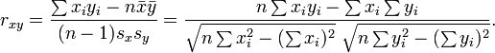
The value ranges from +1 in the case of a perfect positive (increasing) linear relationship (correlation) to −1 in the case of a perfect decreasing (negative) linear relationship (anticorrelation). As it approaches zero there is less of a relationship (closer to uncorrelated). The closer the coefficient is to either −1 or 1, the stronger the correlation between the variables.
In the CDA plugin the Pearson correlation coefficient is calculated using all the pixels within the confined region and not just those pixels within the overlap of the ROIs. This allows it to be used when no ROIs have been defined.
Note that since the denominator of the calculation is independent of matched pairs of x and y this value can be pre-calculated. This allows the CDA plugin to rapidly calculate R for each shift of the image channels.

Displacements
The CDA method involves shifting one image relative to the other and computing the colocalisation metrics. All possible displacements within a radius are computed. The user must select the maximum radius to use for the displacements. The plugin provides charts to help in this process.
Once all the displacements have been performed the resulting distribution of metrics can then be plotted verses the distance. In the case where the two channels contain colocated signal the distribution will show a fall off with increasing distance as the metrics approach a random background. This can be seen in the following chart of the R samples of a weakly correlated image:
The fall off will eventually plateau at a level that corresponds to random images with the same underlying structure. The plateau should be defined where the mean of the samples is approximately constant. To assist in setting this level the plot shows the mean of the samples as a continuous line. The mean is calculated by rounding the displacement distance to the nearest whole number and averaging all the samples for each distance.
The point at which the random plateau begins should be used to define the distribution for calculating the significance. This level will vary between images and so requires the user to configure the displacement radius.
For example the same image is shown below with the region from 15 to 25 pixels used to define the random or background distribution:
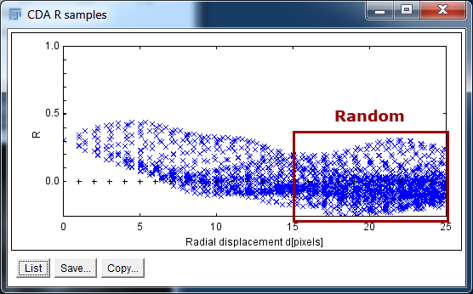
The following plot shows the probability distribution of the samples taken from the 15 to 25 pixel displacement distance. The 95% confidence interval is shown as the black lines marked by triangles. It can be clearly seen that the original metric score lies outside the range expected for a random pair of images. In this case the correlation of 0.31 is significant.
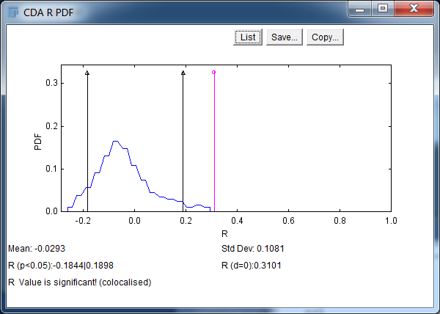

Speed Increases
When using a large radius there may be many thousands of possible displacements. It is possible to compute a random subset of these displacements to increase speed. The number of samples can be configured in the plugin options (using the Permutations parameter). However enough samples must be computed to produce an estimate of the distribution.
The plugin uses multi-threaded code to compute the permutations. The number of threads can be configured using the ImageJ options (selected from the menu item Edit > Options > Memory & Threads). By default this will be the number of processor cores available on your computer.

Plugin Interface
The CDA interface uses a frame within the ImageJ application. The plugin has many options but these can be divided into sections controlling parts of the algorithm. The different sections are shown in the following image and are described below.
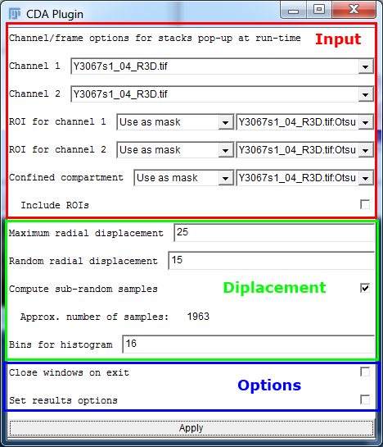

Input Parameters
The input parameters specify the images to use for the analysis. The user can select the two input channels and specify the regions to use for the analysis.
Parameter | Description
Channel 1/2 | Specify the channel 1 or 2 image.  If the user selects an image stack then the channel and frame will be requested during run-time. This is to eliminate optional fields from the main dialogue.
ROI for channel 1/2 | Specify the region that contains the image signal for channel 1 or 2.  The methods are described in above in the section titled Stage 1: Identify Channel Signal.  If [None] is selected then only the correlation analysis will be relevant (since the Manders coefficient will always be 1).
Confined compartment | Specify the region used to confine the displacements. Only pixels within this region will be analysed.  The methods are described in above in the section titled Stage 1: Identify Channel Signal.
Include ROIs | If this option is selected the confined compartment will be expanded to contain all the pixels in ROI 1 and 2. Otherwise the two ROIs will be cropped to the confined compartment. This allows the user to separately define the confined region but ensure that all the channels' signal is included in the analysis.

Displacement Parameters
The displacement parameters control the maximum shift applied to one image relative to the other. Increasing the maximum displacement will increase the number of calculations required.
Parameter | Description
Maximum radial displacement | The maximum displacement distance
Random radial displacement | The distance that defines the random sample distribution. The probability distribution will be calculated using all sample above this level.
Compute sub-random samples | All the samples below the Random radial displacement are not required for the analysis. However they are useful for determining the displacement radius since they are plotted in the samples window.  Use this option if you have configured the Random radial displacement and are re-running the analysis to produce different result outputs. This will decrease calculation time.
Approx number of samples | The label shows an estimate of the number of displacements that are required for the analysis. It is possible to reduce the number of samples by using the Permutations parameter in the Set Results Options dialog (see below).
Bins for histogram | The probability distribution is calculated by binning data to produce a histogram. This parameter sets the number of bins to use to cover the range. If there are a large number of samples this value can be increased.

Options Parameters
The other parameters provide options for the CDA plugin.
If Close windows on exit is checked then all the windows that have been opened by the plugin are closed when the plugin window is closed. This includes the result table and output images and charts.
Clicking the Set result options checkbox shows the following pop-up dialogue:
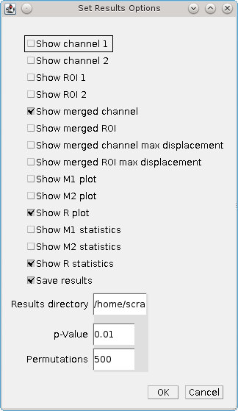
The dialogue contains the following settings:
Parameter | Description
Show channel 1/2 | Show an image of the signal of channel 1 or 2. This represents the input data used in the analysis
Show ROI 1/2 | Show an image of the signal region of channel 1 or 2. This represents the region used in the analysis
Show merged channel | Show a combined RGB image that contains both channels
Show merged ROI | Show a combined RGB image that contains both channel regions
Show merged channel max displacement | Show a combined RGB image that contains both channels but with one channel shifted at the maximum displacement (i.e. representative of a random pair of channels)
Show merged ROI max displacement | Show a combined RGB image that contains both channel regions but with one channel shifted at the maximum displacement
Show M1/M2/R plot | Specify whether to show a plot of the samples for the M1/M2/R metrics
Show M1/M2/R statistics | Specify whether to show a probability distribution for the M1/M2/R metrics
Save results | If selected this will cause the results to be saved to a folder in the Results directory. The folder will be named cdaYYYYMMDD_HHmmss where the date section will be set using the current time.  The plugin will save the Merged channel and Merged ROI as ImageJ TIFF images and the results that are recorded in the result table in a text file called results.txt. These items allow a user to quickly see the channel data used in the analysis and the results. This is useful for quickly scanning a history of CDA analysis. All the other results can be recomputed using the plugin if necessary
Result directory | Specify the root directory for the results. If it does not exist then the plugin will not save any results.  If an invalid directory is entered the plugin will alert the user with a warning
p-Value | Set the p-value used to define the limits for the assessment of significance. If the score from the unshifted image lies outside of the probability values defined using this p-value then the result is labelled as significant
Permutations | The number of displacements to compute. If set lower than the total number possible then a subset will be randomly chosen. Use this option to speed up the CDA algorithm.  Setting this value to zero causes all permutations to be computed

Results Table
The results table contains details about the CDA analysis. The table contains the following information:
Result | Description
Exp. Id | Contains the experiment ID. It has the format cdaYYYYMMDD_HHmmss where the date section will be set using the current time.  Note: This is used to name the folder within the Results directory if results are being auto-saved
Channel 1/2 | The name of the image used for channel 1 or 2
ROI 1/2 | The method used to define ROI 1 or 2. If an image is used (e.g. Min display value or Use as mask) then the image name will be included
Confined | The method used to define the confined compartment. If an image is used (e.g. Min display value or Use as mask) then the image name will be included
Include ROIs | If true then the ROI regions were used to expand the confined region
D-max | The maximum displacement distance
D-random | The distance used to define the random background used to buld the probability distribution
Sample | The number of displacement samples in the probability distribution
Bins | The number of bins used to calculate the probability distribution
p-Value | The p-value used for the significance assessment
M1 | The Manders coefficient for channel 1
M1 av | The sample average for M1
M1 sd | The sample standard deviation for M1
M1 limits | The upper and lower limits for the significance assessment
M1 result | Contains the significance results. Can be one of three values: Not significant; Significant (colocated); and Significant (not colocated)
The same results are shown for the Manders coefficient for channel 2 (M2) and for the Pearson correlation coefficient (R).

CDA (macro) Plugin
Test for significant colocalisation within images using the Confined Displacement Algorithm (CDA). The CDA (macro) plugin performs the same analysis as the CDA plugin. However it uses the standard ImageJ plugin dialog to get the parameters. This allows it to be recorded by the ImageJ Macro Recorder and supported in ImageJ macros.
The plugin interface is shown below:
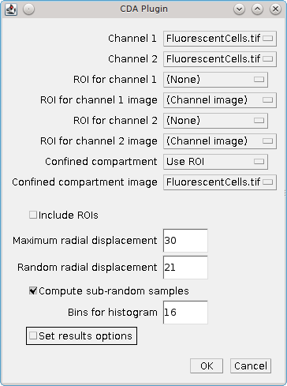
The options and results are identical to the CDA plugin. For further details see section 4: Confined Displacement Algorithm (CDA) Plugin.

Stack Correlation Analyser Plugin
The analysis of a single image for correlated channels requires definition of the channel signal region, definition of the region overlap and then analysis of the signal intensity. This can be a labour intensive task if performed manually. However it is possible to perform all the steps automatically for a fast initial analysis of multiple channel images.
The Stack Correlation Analyser automates the search for correlated channels within a multi-channel image. The plugin extracts all the channels and frames and performs:
- Thresholding to create a mask for each channel+frame (optionally aggregating the z-stack)
- All-vs-all channel correlation (see 4.3.2.2) within the union/intersect of the channel masks
- All-vs-all Manders overlap coefficients (see 4.3.2.1) if using the intersect of the channel masks
For example a 3 channel image will have a correlation analysis performed for 1-vs-2, 1-vs-3 and 2-vs-3 for each frame in the image sequence. For images with a z-stack this can be performed using the entire stack or for each z-slice individually.
The plugin can be used within the ImageJ scripting tools to rapidly test a large number of images for correlated channels (see Appendix 1: Batch Processing). This allows the user to identify the best candidate images for further analysis.

Plugin Interface
The Stack Correlation Analyser plugin uses the standard ImageJ plugin dialogue. Select the image to process and then run the plugin. This will present the following window:
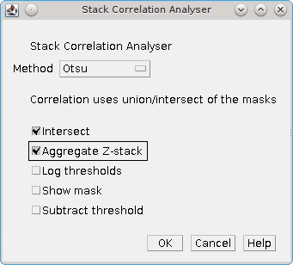

Input Parameters
Parameter | Description
Method | Specify the thresholding method to use to identify the channel signal (foreground) from the background. Details of the thresholding methods can be found in section 2.1: Image Thresholding
Intersect | If checked then the intersect of the two channel masks will be used to define the pixels used in the analysis. Otherwise the union will be used.  If the intersect is used then a Manders overlap coefficient is calculated for each channel
Aggregate Z-stacks | Combine the z-stack of each channel-frame combination into a single stack for analysis, i.e. this will perform all-vs-all analysis between channels using the entire z-stack.  If unchecked then all-vs-all analysis between channels is performed for each slice of the z-stack
Log thresholds | Record the thresholds to the ImageJ log window. A threshold will be calculated for each combination of timeframe and channel (and optionally z-slice), e.g:  t1c1z1 threshold = 778  t1c2z1 threshold = 617  t1c3z1 threshold = 2441
Show mask | If selected then the mask image calculated using the thresholds will be shown, e.g.  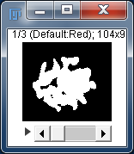  This allows the user to check that the mask is selecting the correct regions for analysis
Subtract threshold | Subtract the threshold value from each pixel before calculating the Manders coefficient. The coefficient then represents the fraction of intensity above the background that overlaps with the other region

Results
The Stack Correlation Analyser writes the results directly to the ImageJ log window.

Header Record
The first line records the threshold method used for the analysis and the name of the input image, e.g.
Stack correlation (Default) : Y3067s1_04_R3D.tif

Threshold Record
If the Log thresholds is selected the plugin records the thresholds for each extracted channel, e.g.
t1c1z1 threshold = 777
t1c2z1 threshold = 616
t1c3z1 threshold = 2441

Correlation Record
A single line is written for each channel correlation that is calculated. Each line uses a comma-separated format, e.g.
t1,c1z1,c2z1,1182,12.35%,0.3120,0.9190,0.7818
t1,c1z1,c3z1,2692,28.14%,0.2281,0.9164,0.7854
t1,c2z1,c3z1,1305,13.64%,-0.0233,0.1018,0.9006
The fields of the result entry are described in the following table:
Field | Description
1 | The timeframe of the image used for the analysis
2 | The first channel and z-slice of the image used for the analysis.  If Aggregate Z-stacks was selected then this will contain only the channel
3 | The second channel and z-slice of the image used for the analysis
4 | The number of pixels used for the analysis. This is either the union or intersect of the two channel masks depending on the Intersect parameters
5 | The percentage area used in the analysis, i.e. the number of pixels used in the analysis divided by the total number of pixels in the channel
6 | The Pearson correlation coefficient for the two channels
7 | The Manders overlap coefficient for the first channel. This is only shown if the intersect of the masks is used
8 | The Manders overlap coefficient for the second channel. This is only shown if the intersect of the masks is used

Stack Colocalisation Analyser Plugin
The Confined Displacement Algorithm (CDA) can be used to determine the significance of the colocalisation measures between two channels. The CDA plugin for ImageJ (see section 4: Confined Displacement Algorithm (CDA) Plugin) provides a feature rich interface for configurable analysis of images using the CDA algorithm. This can be a time consuming task when processing many images.
The Stack Colocalisation Analyser provides a simple implementation of the CDA algorithm for fast automated analysis of multi-channel images. The plugin requires an image with at least 2 channels. The plugin performs the following steps:
- Selection of the 2 analysis channels
- Thresholding to create a mask region for each channel+frame (aggregating the z-stack)
- Optional thresholding of a third channel to define the analysis region
- CDA analysis of channel 1 verses channel 2 using the mask regions
- Analysis using different thresholding methods can be performed in a batch operation
During the CDA analysis the total number of displacements is limited to increase speed. This is performed by computing a random subset of all possible displacements. The subset size can be configured but should be large enough that the sample is representative of the entire set (e.g. 20%).
The plugin can be used within the ImageJ scripting tools to rapidly test a large number of images for colocated channels (see Appendix 1: Batch Processing). This allows the user to identify the best candidate images for further analysis.

Plugin Interface
The Stack Correlation Analyser plugin uses the standard ImageJ plugin dialogue. Select the image to process and then run the plugin. This will present the following window:
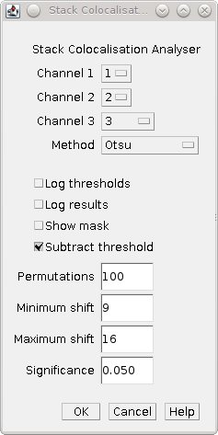

Input Parameters
Parameter | Description
Channel 1/2 | Select the two channels for CDA analysis
Channel 3 | Optionally select the channel used to define the confinement region for CDA analysis
Method | Specify the thresholding method to use to identify the channel signal (foreground) from the background. Details of the thresholding methods can be found in section 2.1: Image Thresholding.  Thresholding can be disabled by selecting [None]
Log thresholds | Record the thresholds to the ImageJ log window. A threshold will be calculated for each combination of timeframe and channel, e.g:  t1c1 threshold = 778  t1c2 threshold = 617  t1c3 threshold = 2441
Show mask | If selected then the mask image calculated using the thresholds will be shown, e.g.  This allows the user to check that the mask is selecting the correct regions for analysis
Subtract threshold | Subtract the threshold value from each pixel before calculating the Manders coefficient. The coefficient then represents the fraction of intensity above the background that overlaps with the other region
Permutations | Specify the number of displacements to use for CDA analysis. This will be a random subset of the entire set of possible displacements (unless the Permutations is greater than the entire set)
Maximum shift | Set the maximum displacement distance
Minimum shift | Set the maximum displacement distance
Significance | Set the p-value used to calculate significance

Results Table
The results table contains details about the CDA analysis. The table contains the following information:
Result | Description
Image | The title of the input image
p | The p-value used to assign significance
Method | The threshold method used to generate the mask image
Frame | The image frame used in the analysis
Ch1/2 | The two channels used for CDA analysis
Ch3 | The channel used to define the confined region. If no region was selected this is set to [None]
n | The number of pixels in the overlap between the channel 1 and 2 mask regions
Area | The percentage of pixels within the confined region used for analysis that are inside the overlap between the channel 1 and 2 mask regions
M1/2 | The thresholded Manders coefficient for channel 1/2. The Manders coefficient is calculated as the fraction of intensity in the channel where the other channel is above the threshold, e.g.  M1 = sumCh1_Ch2gtT / sumCh1  (How much of channel 1 foreground intensity occurs where channel 2 is foreground)
sig | The significance of the Manders coefficient (true/false)
R | The Pearson correlation coefficient calculated using only the pixels from the overlap between the channel 1 and 2 mask regions
sig | The significance of the Pearson correlation coefficient (true/false)

References
Costes et al. (2004). Automatic and quantitative measurement of protein-protein colocalization in live cells. Biophysical Journal, 86, 3993-4003.
Ramirez et al. (2010). Confined Displacement Algorithm Determines True and Random Colocalization. Journal of Microscopy, 239, 173-183.
E.M.M. Manders, F.J. Verbeek and J.A. Aten. (1993) Measurement of co-localization of object in dual-colour confocal images. Journal of Microscopy, 169, 375-382.

Appendix 1: Batch Processing
ImageJ can automate processing large numbers of image files with a macro in a single batch process. This can be used to run a plugin on multiple input files.

Step 1: Record the macro
Open a representative image to be used for the analysis. Test the plugin (or series of commands) using different parameters and ensure the result is as desired.
Open the ImageJ macro recorder: Plugins > Macro > Record...
Run the chosen commands on the image configuring the parameters as required. ImageJ will record the commands to the Recorder window. For example running the Stack Correlation Analyser plugin on an image will produce the following macro command:
run("Stack Correlation Analyser", "method=Default intersect aggregate");
Pressing the Create button to generate a new macro and save it for use later. You can test the macro on a fresh image by using the Macros > Run Macro command from the Macro window.

Step 2: Prepare input files
Place all the image files in a single directory. The directory should not contain images that you do not want to process.
If the macro command modifies the images then you can also create an output directory that will be used to store the modified images.

Step 3: Process Batch command
Open the ImageJ Process Batch window: Process > Batch > Macro...
The Process Batch window allows you to select an input directory containing all your images. You can then specify an optional output directory and the format for the output images.
The dialogue provides the ability to select from common commands which are then inserted into the text area. You can also open your own macros or paste the code from the ImageJ macro recorder. The Process button starts the batch processing.
For each image in the input folder ImageJ will open the image, apply the commands, save the image to the output folder (if present) and then close the image. Any results windows generated by the plugin commands will remain open.
Note that if you do not specify an output directory then the images will not be saved after running the command. This is useful if your macro command does not alter the input images.
The following image shows the Process Batch window configured to run the Stack Correlation Analyser on all the images in the F:\Temp directory.
