ImageJ FindFoci Plugins
Alex Herbert
MRC Genome Damage and Stability Centre
School of Life Sciences
University of Sussex
Science Road
Falmer
BN1 9RQ
a.herbert@sussex.ac.uk
Table of Contents
Introduction 4
Further information 5
FindFoci 6
Example Input 6
Example Output 6
Features 7
Overview 7
Stage 1: Assign Background 8
Stage 2: Assign Maxima 8
Stage 3: Expand Peaks 8
Stage 4: Merge Peaks 9
Plugin Interface 10
Mask 10
Background Parameters 10
Search Parameters 11
Peak Merging Parameters 12
Results Parameters 13
Advanced Parameters 16
Results Table 17
FindFoci GUI 19
Features 19
Plugin Interface 19
Preview 21
Java Requirements 21
FindFoci Batch 22
Features 22
Overview 22
Create the FindFoci parameters 22
Record the options using the ImageJ Macro Recorder 22
Save the options to file using FindFoci 22
Save the options to file using the FindFoci Optimiser 23
Note on the parameters 23
Plugin Interface 24
Parameters 24
Output 25
FindFoci Optimiser 27
Example Input 27
Example Output 28
Features 29
Overview 29
Stage 1: Create Reference Foci 29
Mark Foci on the Image 29
Specify Foci in a Text File 30
Loading the Foci 30
Stage 2: Run the Optimiser 30
Result Assessment 31
Plugin Interface 32
Settings Presets 32
Initialisation Parameters 33
Search Parameters 33
Peak Merging Parameters 34
Results Parameters 34
Extra Parameters 34
Optimisation Parameters 35
Additional Parameters 35
Range Limit Fields 36
Output 36
Result Table 36
Showing a result 38
FindFoci Images 38
Score Images 38
FindFoci Optimiser GUI 39
Features 39
Plugin Interface 39
Java Requirements 39
FindFoci Optimiser Multi-Image 40
Features 40
Input 40
Method for Combined Ranking 40
Score Conversion 40
Plugin Interface 42
Parameters 43
Results 44
Result Table 44
Invalid Results 46
FindFoci Helper 47
Features 47
Overview 47
Plugin Interface 47
Parameters 48
Workflow 48
Multi-point ROI Mode 48
Initialisation 48
Marking Peaks 49
Moving Peaks 50
Deleting Peaks 50
Point Overlay 50
Saving Results 51
Stopping Point Alignment 52
Alignment Log 52
Java Requirements 52
Match Calculator 53
Example Input 53
Example Output 53
Features 54
Overview 54
Match Algorithm 54
Height Analysis 54
Plugin Interface 56
Parameters 56
Extra Parameters 57
Results Table 58
Unmatched Results Table 59
Matched Results Table 59
Overlay 60
Point Aligner 61
Example Input 61
Example Output 61
Features 62
Overview 62
Alignment Algorithm 62
Minimum Peak Height Limit 63
Alignment Results 63
Plugin Interface 64
Parameters 64
Results Table 65
Alignment Log 66
OK / Moved 66
Conflict 66
NoAlign 66
Unaligned Images 67
Overlay 68
Point Extractor 69
Features 69
Overview 69
Parameters 70
Creating a 3D coordinate file 71
References 72
Appendix 1: BeansBinding Java framework 73
Appendix 2: Binary Scoring Statistics 74
Jaccard 74
Recall 74
Precision 74
F-score 75
Defining the Actual or Predicted Points 75

Introduction
The FindFoci ImageJ plugins allow the identification of peak intensity regions within 2D and 3D images. The algorithm is highly configurable and parameters can be optimised using reference images and then applied to multiple images using the batch mode.
There are six different plugins that can be run from the ImageJ plugins menu:
- FindFoci
- FindFoci GUI
- FindFoci Batch
- FindFoci Optimiser
- FindFoci Optimiser GUI
- FindFoci Optimiser Multi-Image
The main algorithm is contained within the FindFoci plugin. This is a standard ImageJ plugin filter that operates on an opened image. It shows a dialogue box to request parameters and then performs the image processing. Results are presented as a mask image, shown in tabular format and/or saved to file.
The FindFoci GUI opens a permanent window frame within ImageJ. It has the same parameters as the FindFoci plugin. It runs the FindFoci plugin to perform the processing work. A preview option allows the parameters to be interactively updated.
The FindFoci Batch plugin allows a set of parameters for the FindFoci algorithm to be applied to all the images in a directory. The algorithm is run on each image in turn and the results are saved to an output directory.
The FindFoci Optimiser finds the best parameters for the FindFoci algorithm using the maxima marked on a representative image. It iterates through thousands of combinations and identifies the best parameters to find the desired peak regions. These parameters can then be easily applied to other images of the same type using the ImageJ scripting tools or the FindFoci Batch plugin.
The FindFoci Optimiser GUI opens a permanent window within ImageJ. It allows the user to select an image and run the FindFoci Optimiser. This is a convenience plugin to allow the optimiser to be run repeatedly on one or many images.
The FindFoci Optimiser Multi-Image plugin allows the optimiser to be run on a directory of reference images to find the best parameters across the dataset. The results for each image are saved to an output directory and can be reloaded allowing the parameters to be ranked using different scoring methods.
In addition to the plugins that run the FindFoci algorithms there are several plugins that provide useful functionality for peak analysis:
- FindFoci Helper
- Match Calculator
- Point Aligner
The FindFoci Helper provides semi-automated assistance to aid identification of peaks in an image. The plugin uses the FindFoci algorithm to identify all possible peaks in an image. Then when a user clicks on the image to label a peak using the ImageJ ROI tools the plugin updates the point, moving it to the nearest peak position if one is available. The plugin selects peaks within a search radius using either the nearest-neighbour or the highest peak. The plugin supports dragging points and removing false assignments. Results can be saved to a table.
The Match Calculator compares the ROI points marked on two images and calculates the number of points that match. Points are aligned using a nearest-neighbour ranking within a specified distance threshold and the results are displayed as a statistics table. Using the image intensity for each point allows further analysis of the data including a scatter plot of intensity for matched points and analysis of matches within each quartile of the data. The matched and unmatched points can be shown as a colour-coded overlay on the input image.
The Point Aligner can move the current ROI points to align with the true image peaks found using the FindFoci algorithm. Points are aligned using a nearest-neighbour ranking. Alignment results are output to a result table and can be used to update the ROI positions or shown as a colour-coded overlay on the image.

Further information
The FindFoci algorithm and the advantages of training software on multiple reference images for focus detection is described in the paper:
Herbert AD, Carr AM, Hoffmann E (2014) FindFoci: A Focus Detection Algorithm with Automated Parameter Training That Closely Matches Human Assignments, Reduces Human Inconsistencies and Increases Speed of Analysis. PLoS ONE 9(12): e114749. doi: 10.1371/journal.pone.0114749.

FindFoci
ImageJ plugin that finds areas of maximum intensity in 2D and 3D images.

Example Input
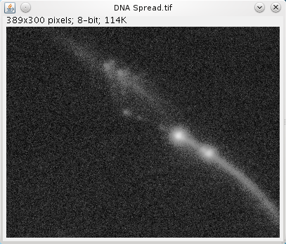
Input image with regions of high intensity for peak analysis.

Example Output
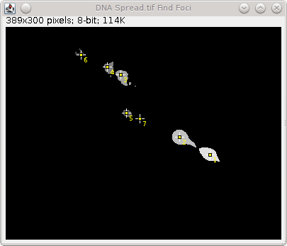
Output image showing the identified peak regions. Each peak centre is labelled with a point ROI marker.

Features
- Processes 8-bit and 16-bit greyscale images
- Processes 2D and 3D images (i.e. image stacks)
- Allows hyperstacks but only processes the current channel and time frame
- Finds peak regions above a configurable background
- Searches within the region of interest (ROI) if available
- Merges sub-peaks into their parent using merging criteria
- Ranks peaks using configurable criteria and outputs the top N
- Outputs the peaks regions as a new image
- Generates a results table
- Marks peak centres using ImageJ point ROIs
- Allows processing within a mask, labelling maxima within each identified mask object
- Saves results text table and images to a directory
- All functionality is scriptable
- Efficient two-stage algorithm is fast

Overview
The FindFoci plugin finds all the points of maximum intensity and expands them into regions. The initial regions are processed using merging criteria to produce a cleaner final result.
The following diagram shows an intensity profile to which the peak finding algorithm will be applied.


Stage 1: Assign Background
Assign the background level (all pixels below this level are ignored).


Stage 2: Assign Maxima
Find the points with an intensity higher than all the surrounding points. These local maxima are potential peaks.
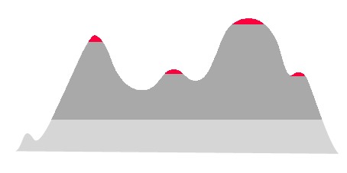

Stage 3: Expand Peaks
Expansion is then performed by progressively assigning points of lower intensity to the peak area above it. This allows all points to be processed in a single pass from the highest to the lowest. The result is an initial assignment of all the points above the background to a peak.
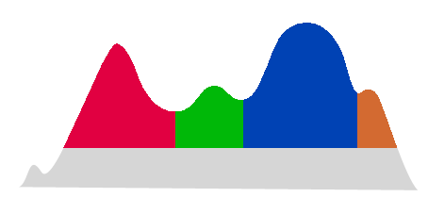

Stage 4: Merge Peaks
The final stage is to merge insignificant peaks into their parent peak. This can be done if the sub-peak is not high enough or covers insufficient area. This stage is optional but can improve results on noisy images.
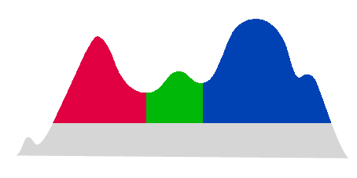

Plugin Interface
The FindFoci interface uses the standard ImageJ Generic Dialog. The plugin has many options but these can be divided into sections controlling parts of the algorithm. The different sections are shown in the following image and are described below.
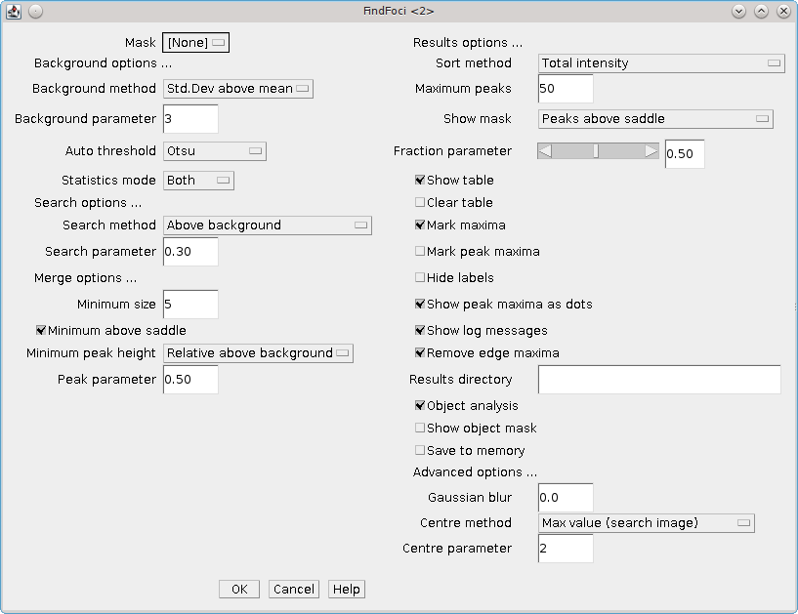

Mask
The Mask parameter allows the user to select a mask specifying which pixels to process. Any non-zero pixel will be included in the analysis. The selection box is populated with images that have the same width and height dimensions as the image to be processed. The mask can either have 1 slice or can be a stack with the same number of z-slices as the image to be processed.
Note that the mask can have objects defined using unique pixel values. The plugin provides the option to identify objects within the mask and then label any maxima as belonging to an object (see the Object analysis option). This allows the results to be used to count maxima in pre-labelled objects such as cell nuclei.

Background Parameters
The background parameters set the lowest intensity level used in the search for peak areas. Pixels that are below this level will not be included in the peak areas.
A simple approach would set the background to 0 (zero). However this means that all pixels in the image must be processed resulting in a slower runtime and the identification of many false peaks with insignificant heights. The plugin therefore provides different options for setting a background above zero.
The background parameters section contains four input fields: the main field (Background method) allows the selection of the background method and the other fields pass parameters to the selected method if applicable.
Background Method | Description
Absolute | The background intensity is set using the input value in the Background parameter text field
Mean | The background intensity is set using the mean of the image
Std.Dev above mean | The background intensity is set using the mean of the image plus the Background parameter field multiplied by the standard deviation of the image
Auto threshold | The background intensity is set using the Auto-threshold method.  The Auto threshold option uses the Auto Threshold plugin developed by Gabriel Landini (see http://pacific.mpi-cbg.de/wiki/index.php/Auto_Threshold). The plugin uses various methods to partition an image into foreground and background. Only the foreground pixels are then used in the peak finding algorithm. In most cases the Otsu method provides a fast and robust partitioning.
None | The background intensity is set as 0. Equivalent to using Absolute with a value of zero
The Statistics mode option is only relevant when using a selected region of interest (area ROI) on the image. In this case the algorithm will only search within the ROI for maxima. However the automatic background methods can use the pixel values from inside, outside or both inside and outside the ROI to set the background level. This is controlled using the Statistics mode option.

Search Parameters
The search parameters control how far the algorithm expands local maxima into peak regions. This can be used to reduce the area of peaks on an image to only part of the peak above the background. In an image that has hundreds of peaks this can make the peaks easier to view distinctly in the output image.
The section contains two input fields: the main field (Search method) allows the selection of the search method and the other field (Search parameter) passes a parameter to the selected method if applicable.
Search Method | Description
Above background | A region is grown until the intensity drops below the background (default method)
Half peak value | A region is grown until the intensity drops to halfway between the value at the peak (the seed for the region) and the background level. This is equivalent to using the Fraction of peak - background option with the threshold value set to 0.5
Fraction of peak - background | A region is grown until the intensity drops to:  background + (parameter value) * (peak height)  E.g. a Search parameter of 0.2 would grow the peak to 80% of its height above the background.

Peak Merging Parameters
The peak merging parameters are applied after the initial pass of the algorithm has identified all the peak regions. The parameters are used to control removal of insignificant peaks from the results.
Insignificant peaks are only removed if they have no neighbour peaks. If they have a neighbour then the peak's pixels are added to the highest neighbour peak (the parent peak). This is effectively merging a sub-peak into the larger peak.
The following diagram shows the merging process:
Initial peak regions | 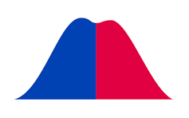
Peaks above saddle | 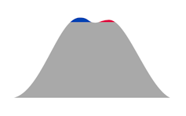
After merge into parent | 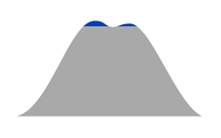
Final result | 
Peaks can be merged using two criteria: the peak size and the peak height.
Peak size
The Minimum size parameter sets the minimum size of a peak. If the peak is below this size then the peak is merged/removed. Set to zero to show all peaks including isolated local maxima.
The Minimum size above saddle optional restricts the peak size criteria to the pixels above its contact with a neighbour peak (the saddle point). This can be useful for eliminating sub-peaks which may only have a few pixels above the saddle to the parent peak but have been allocated a large number of pixels below the saddle height.
Peak Height
The peak height sets a minimum height that the peak must be above the highest saddle point, i.e. how far the peak stand out from any neighbours.
The peak height contains two input fields: the main field (Minimum peak height) allows the selection of the method and the other field (Peak parameter) passes a parameter to the selected method if applicable.
Minimum Peak Height | Description
Absolute Height | The peak must be an absolute height above the highest saddle point. The height is specified by the Peak parameter
Relative Height | The peak must be a relative height above the highest saddle point.  The height is calculated as peak intensity * parameter value.  E.g. a value of 0.2 indicates that the peak must contains at least 20% of its total height above the saddle point
Relative above background | The peak must be a relative height above the highest saddle point.  The height is calculated as (peak intensity – background) * parameter value.  E.g. a value of 0.2 indicates that the peak must contains at least 20% of its height over the background above the saddle point
Note that the if the peak has no neighbours, i.e. they have no saddle points, then the peak height limit is applied relative to the background.

Results Parameters
The results parameters control how the results will be displayed within ImageJ.
The Sort method options correspond to different columns of the results table (see the results table section). This allows the peaks to be sorted by any column in the table.
Maximum peaks specifies a limit (N) on the number of peaks that will be reported. Peaks are ranked using the specified sort method and then the top N are selected.
The Show mask parameter sets the type of output image to display. The image will be displayed in a image window with the original image title plus 'FindFoci'. If this window exists (i.e. the plugin has already been run on the input image) then the plugin will update the existing window. Therefore you should save your result mask image if you do not wish it to be overwritten.
The mask is shown as a greyscale image with value 0 corresponding to no peak region. ImageJ's max display settings are adjusted so that the highest value is white. In all output mask images the peak maxima (X,Y,Z coordinates) are shown as white pixels.
The mask options are shown below:
Result | Description
None | No mask image is shown
Peaks | The mask image contains all the pixels in the peak regions. Peak regions are assigned a value that corresponds to their ranking. The highest ranked peaks are shown as the lightest colours. The mask value for each peak is shown in the results table  
Threshold | The mask image contains all the pixels in the peak regions. Each peak region is thresholded using the auto-threshold method. This shows the high parts of the peak in a light shade and the low parts in a dark shade. The saddle pixels between peaks are shown in a dark grey  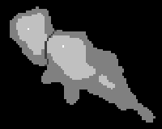
Peaks above saddle | The mask image contains all the pixels in the peak region above the highest saddle point. Peaks are coloured as the Peaks output above  
Threshold above saddle | The mask image contains all the pixels in the peak region above the highest saddle point. Peaks are coloured as the Threshold output above  
There are several flags for the results parameters as shown below:
Show table | Show the results table. This contains all of the information on the peak regions including height, centre, area and intensity. Note that if a results table is already present the results will be appended
Clear table | Select this option to remove any results already in the results table
Mark maxima | Label the maxima on the input image using ImageJ point ROIs. Existing ROIs will be deleted
Mark peak maxima | Label the maxima on the result mask image using ImageJ point ROIs
Hide labels | Remove the number labels from the ImageJ point ROIs that are added by Mark maxima and Mark peak maxima. This is useful when the labels overlap other closely spaced foci.
Show peak maxima as dots | If this option is selected then the pixel location at the centre of the maxima will be given the maximum value displayed in the mask (this can be used instead of Mark peak maxima). Disable this if the mask will be used for region labelling based on pixel value
Show log messages | Allow the plugin to write messages to the ImageJ log window. This provides additional information on the peak finding algorithm
Remove edge maxima | Removes any maxima from the results that contain pixels at the image border. This leave only peaks that are entirely within the image
Results directory | Specify a valid directory to save the results
Object analysis | If a mask was used then this option will search for objects within the mask. All non-zero pixels are potential objects. Objects are formed by joining touching pixels with the same value. Each distinct collection is assigned an object ID. The original mask value for the object is stored. The results table will contain the parent containing object and the original mask value for each identified maximum
Show object mask | Select this option to display an image of the mask objects calculated by the Object analysis. Pixels will have the object ID as their pixel value
Save to memory | Save the results to memory. Results are named using the image title and the channel and frame used for the analysis.  This option allows other ImageJ plugins to use the results
The Results directory parameter allows the user to specify a directory to use to save the results. The directory must exist otherwise the plugin ignores the parameter. If the directory exists then the plugin will create 3 files named with the prefix FindFoci-[Image Short Title]-YYYYMMDD_HHmmss (the datestamp ensures that files will not be over-written). The 3 files are:
- .xls: A tab-delimited text file containing the results as written to the result table (the Show table option is not required)
- .roi: An ImageJ ROI file. This uses ImageJ's ROI format. It can be loaded into ImageJ using the ROI manager
- .params: A text file containing all the parameters used to run the plugin including the original input image filename. This can be used as input for the FindFoci Batch plugin

Advanced Parameters
The Gaussian blur parameter is used to apply a Gaussian blur to the input image before running the peak finding algorithm. This is very useful for noisy images since it can eliminate peaks that are single pixel local maxima by smoothing the image content. This dramatically improves the algorithm speed due to the smaller number of merging steps required to eliminate all the sub-peak regions. Note that if a Gaussian blur is applied the final results are still calculated using the original image (e.g. the total intensity values).
The Centre method contains two input fields: the main field allows the selection of the method used to calculate the centre of the peak and the other field passes a parameter to the centre method if applicable.
Centre Method | Description
Max value (search image) | Define the peak centre using the highest pixel value of the search image (default). In the case of multiple highest value pixels, the closest pixel to the geometric mean of their coordinates is used
Max value (original image) | Re-map peak centre using the highest pixel value of the original image. If no blur is applied then this matches the result using the search image
Centre of mass | Re-map peak centre using the peak centre of mass (COM). The COM is computed within a given volume of the highest pixel value. Only pixels above the saddle height are used to compute the fit. The volume dimensions are specified using 2xN+1 where N is the Centre parameter
Gaussian | Re-map peak centre using a Gaussian fit. Only pixels above the saddle height are used to compute the fit. The fit is performed in 2D using a projection along the z-axis. If the centre parameter is 1 a maximum intensity projection is used; else an average intensity project is used. The z-coordinate is computed using the centre of mass along the projection axis located at the xy centre.  Note: Gaussian fitting functionality is experimental. This method rarely produces better results than the simpler methods above since a large peak is required for a fit. In addition the current method does not fit the correlation between axes and so poorly models elliptical peaks.  If no fit is possible then the peak is not remapped from the 'Max value (search image)' result

Results Table
The results table contains details about each peak region. The table contains the following information:
Result | Description
Peak # | The number of peak
Mask Value | The value used for the peak in the mask image (applies to the mask Peaks option)
X, Y, Z | The peak maxima location in X, Y and Z coordinates
Size | The number of pixels in the peak
Max | The maximum intensity value of the peak
Total | The total intensity of pixels in the peak
Saddle value | The intensity value of the highest saddle point
Saddle Id | The Id of the neighbour peak sharing the saddle
Abs.Height | The height of the peak above the highest saddle
Rel.Height (>Bg) | The relative height above the background:  (absolute height) / (max value – background)  i.e. The amount of the peak height that is above the saddle point
Size > saddle | The number of pixels above the highest saddle
Total > saddle | The total intensity above the highest saddle
Av | The average intensity of the peak
Total (>Bg) | The total intensity in the peak above the background level
Av (>Bg) | The average intensity in the peak above the background level
% Signal | The total intensity divided by the total image intensity
% Signal (>Bg) | The total intensity above background divided by the total image intensity above the background
Signal / Noise | The peak maximum value divided by the background
Object | The parent containing object identified by the mask object analysis. If Object analysis was not selected this will be zero
State | The original mask value of the parent containing object identified by the mask object analysis. If Object analysis was not selected this will be zero
Note: Although not all the columns are listed in the Sort method parameter, some values are derived from others and it should be possible to order the results using any column describing the maximum properties.
It is not possible to sort using the Object or State columns since the object analysis is performed after selection of the top maxima.

FindFoci GUI
ImageJ plugin that finds areas of maximum intensity in 2D and 3D images. The Graphical User Interface (GUI) passes the selected parameters to the FindFoci plugin for processing.

Features
- Permanent GUI within ImageJ
- Allows different images to be selected
- Runs the FindFoci algorithm to identify peak regions
- Supports the ImageJ macro recorder
Note that the the plugin supports the ImageJ macro recorder for the FindFoci command. This means that a user can record their actions with the FindFoci GUI within a macro and it will successfully record the execution of the FindFoci plugin.

Plugin Interface
The FindFoci GUI uses a Java frame within the ImageJ application. The plugin supports all the options of the FindFoci plugin. Full details of the parameters can be found in the FindFoci Plugin Interface section.
Since the interface is not limited by the layout of the standard ImageJ dialogue the design has been altered. The window is smaller and several less used options are accessed by clicking the 'Advanced options …' button. The smaller size makes the plugin a better option to use on monitors with a low resolution.
The interface has a drop-down menu that is used to select the image. This allows the user to quickly try the same parameters on different images that are open. The image list is populated with the currently open 8-bit and 16-bit greyscale images. Any images with the title ending in 'FindFoci' (i.e. previous results) are also ignored.
The interface has been designed to only allow the user to set the options that are relevant. For example it is only possible to set the Threshold method when the Background method is set to Auto threshold. This makes it easier for a user to set the parameters for the algorithm.

The following image shows the interface for the FindFoci GUI:
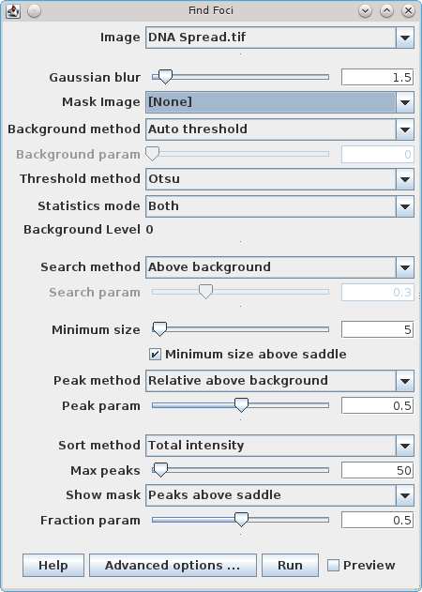
The interface has sliders to adjust the numeric parameters. The parameter can also be entered using the input text box. The range for the sliders are set to a default scale depending on the parameter. For example the background parameter is limited to the minimum and maximum values found in the image. The range for the slider can be updated by double-clicking the slider. This will display a dialog where the range can be updated:
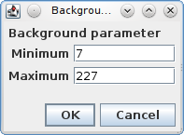
Note: To save space within the GUI not all the options from FindFoci are directly available. Clicking on the Advanced options … button will open a second window where more parameters are available as shown below.
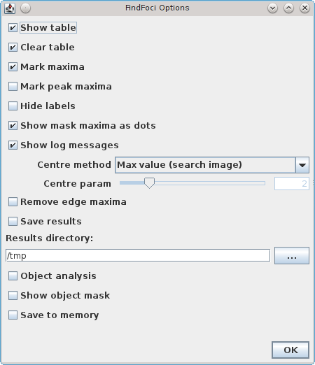

Preview
The FindFoci GUI interface has a preview option. If this option is checked then the plugin will automatically update the results based on any changes to the parameters. The plugin stores intermediate results in memory. When a parameter changes the plugin identifies the stages of the calculation that must be re-run and updates the results.
The preview provides the ability to change the parameters and quickly see the effects on the output mask and results table. However since the full FindFoci plugin is not run there is no output to the ImageJ log window and the command is not recorded to the ImageJ macro recorder. Only the Run button supports these options.
The preview option requires a large amount of memory to store the intermediate results. It may not be suitable for large stack images depending on the configuration of your system. The memory used by the preview is released when the preview option is unchecked. This method can also be used to reinitialise the preview in the event that it has stopped responding to parameter changes.

Java Requirements
The FindFoci GUI uses the BeansBinding Java framework. More details can be found in Appendix 1: BeansBinding Java framework.

FindFoci Batch
ImageJ plugin that runs the FindFoci algorithm on all the images in a chosen directory. Results are saved to an output directory.

Features
- Batch processing of images using FindFoci
- Auto-detection of mask images
- Parameters are specified using an input file
- Saves the results to an output directory

Overview
The FindFoci Batch plugin can be used to speed up the analysis of large numbers of images. All the images in a single directory can be processed with the same parameters and the results recorded to an output directory.
The input images can be any format that is read by ImageJ. The output images (if selected as an output option) will use the TIFF format.

Create the FindFoci parameters
The batch plugin requires all the parameters for FindFoci to be specified in a file. This can be done using three methods:

Record the options using the ImageJ Macro Recorder
- Start the ImageJ macro recorder using 'Plugins > Macros > Record...'
- Run the FindFoci plugin on an example image with the desired parameters
- The ImageJ Recorder will save the plugin name and options in the recorder using the following entry:
run(“FindFoci”, “[options ...]”);
- Copy the options string from the Recorder window and save it to a text file. The options should be saved to a single line in the file
The saved macro options can be used as the FindFoci parameters file.

Save the options to file using FindFoci
- Start the FindFoci plugin on an example image with the desired parameters
- Ensure that you provide a valid path to a results directory
- Run the plugin
OR
- Start the FindFoci GUI plugin
- Select an example image and set the desired parameters
- Click the 'Advanced options...' button
- Ensure the 'Save results' checkbox is selected and provide a valid path to a results directory
- Click the 'Run' button to run the FindFoci plugin
The FindFoci plugin will save a file to the results directory containing all the parameters needed for the plugin. The file will be named FindFoci-[ImageTitle]-YYYYMMDD_Hhmmss.params. The params file can be used as the FindFoci Batch parameters file. The file and file extension can be renamed if desired.

Save the options to file using the FindFoci Optimiser
- Run the FindFoci Optimiser plugin on an example image
- Ensure that you provide a valid path to a results file
- The optimiser will save the top scoring parameters to file with the suffix '.params'
Note that if the FindFoci Optimiser is run in multi-image mode then the parameters file will be placed in the output directory and named 'all.params'.

Note on the parameters
The FindFoci Batch plugin will auto-detect the type of parameters file that is selected. Any line in the file with an equals ('=') character will be read. If the file contains only one line then it is assumed the file contains the macro options from the ImageJ Recorder. Otherwise the file should be a valid params file with key=value pairs for all the parameters, one pair on each line.
The FindFoci Batch plugin will ignore the entries for:
- results_directory: This is specified in the FindFoci Batch dialog
- image: The image is auto-detected from the input directory
- mask: The mask is auto-detected using filenames
- show_table: The plugin will not produce a table of results as the results are always saved to a .xls file in the results directory

Plugin Interface
The FindFoci Batch interface uses the standard ImageJ Generic Dialog.
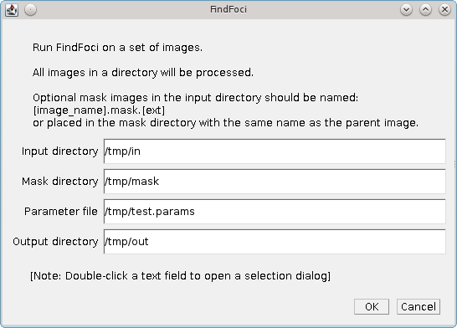
The input fields must specify the full path to the directories and the parameters file. If you double-click in the text field the plugin will open a selection dialog, for example:
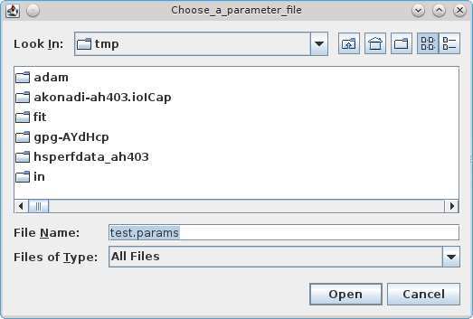

Parameters
Option | Description
Input directory | The directory containing the images to process.  All valid images supported by ImageJ will be opened. Note that the FindFoci plugin will only work on 8 and 16 bit images so do not put 32-bit or RGB color images in the directory.  Any file with the text 'mask.' will be ignored as these are assumed to be mask images. Optional mask images should be named using the image title with the text 'mask.' placed before the image extension:  [image_name].mask.[ext]
Mask directory | The directory containing mask images.  This parameter is optional.  Mask images must be named with the same name as the parent image in the input directory. Or the images can be named using the image title with the text 'mask.' placed before the image extension:  [image_name].mask.[ext]
Parameter file | The name of the FindFoci parameters file
Output directory | The output directory.  Note that the plugin will overwrite files that already exist

The Mask directory parameter is optional. This allows the user to place the mask images in a separate directory or the same directory as the input image. The mask will be found using the following search order:
- [Mask directory] + [Image filename]
- [Input directory] + [image_name].mask.[ext]
- [Mask directory] + [image_name].mask.[ext]
It should be noted that the FindFoci plugin will process the current channel and time-frame of a hyperstack image. The FindFoci Batch plugin does not support selecting channels and time-frames. When opening the images the channel and time-frame will be set to 1. To process a specific channel and time-frame the user will have to extract those frames into a single z-stack image and place it in the input directory.

Output
The FindFoci Batch plugin will not produce any results within ImageJ. The standard table of results or mask image will not be displayed. It is possible to see the algorithm running in the ImageJ status bar and in the ImageJ log (if Show log messages is enabled).
All the results for each image are saved to the output directory. The results will be prefixed with the image title. The following files are produced:
File | Description
.xls | The results of the FindFoci algorithm including foci sizes and coordinates
.roi | An ImageJ ROI file that allows the foci to be loaded onto an image within ImageJ
.params | The parameters used for the analysis
.tiff | The input image saved with the marked ROI.  This is only produced if the option to Mark maxima is selected
.mask.tiff | The output mask image.  This is only produced if the option to Show mask is selected
.objects.tiff | The input mask image reprocessed to display the identified objects.  This is only produced if the options Object analysis and Show object mask are selected

Note that the plugin will overwrite files that already exist in the output directory. Therefore care must be taken when selecting the output directory to be the same as the input directory. In the case that the output includes a mask or that the input image has the suffix '.tiff' the output results can conflict with the input.
The option to have the same input and output directory is allowed since certain settings will not conflict with the input images and the user may wish to keep all their results in the same directory.

FindFoci Optimiser
ImageJ plugin that iterates through combinations of parameters for the FindFoci plugin. Results are compared to an optimal reference image and the best parameters to match the reference result are identified.

Example Input
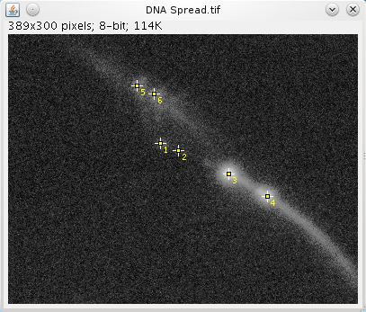
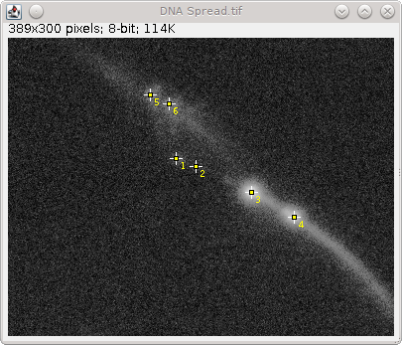
Input image with manually identified peaks. These are used a reference points for optimisation of the FindFoci algorithm.

Example Output
Output image showing the peaks identified with the best match to the input image.

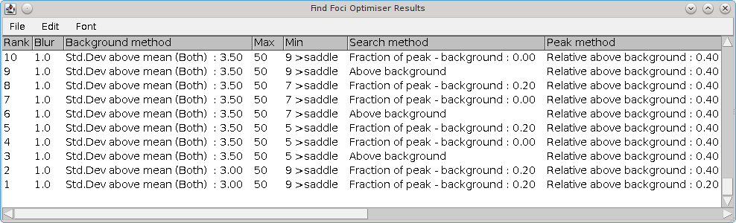
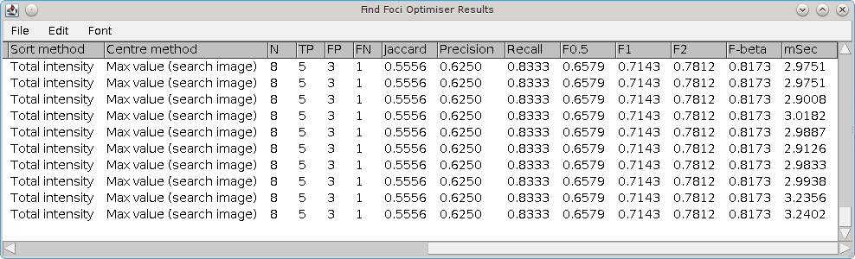
Result table showing the match scoring statistics comparing the identified peaks to the reference image for each set of parameters.

Features
- Enumerates combinations of parameters for the FindFoci plugin
- Compares the results to a reference image
- Reports the best parameters to identify the reference peaks
- Save the results table to file
- Staged processing allows fast enumeration of parameters
- Supports 2D/3D foci

Overview
The FindFoci Optimiser provides the ability set multiple options for each parameter of the FindFoci plugin. All the combinations are run and the results compared to a reference image to identify the best combination.
The options for each parameter are specified by the user. In the case of selection inputs and flags it is possible to specify more than one option for each parameter. In the case of numeric inputs it is possible to select a lower limit, upper limit and increment to use, e.g. 0 to 10 in 2 step intervals. The optimiser then runs the FindFoci plugin for all the combinations of parameters.
Since the FindFoci algorithm can be broken down into stages (background thresholding, maxima identification, peak growing and peak merging) it is possible to runs only the parts of the algorithm that differ when changing a subset of the parameters. This allows the optimiser to efficiently run thousands of combinations of parameters.
Each run of the FindFoci plugin is compared to a reference image with marked maxima and scored using various metrics. The final results are ranked and the best parameters identified.
Note that the optimiser runs on a single image. It is possible to run the optimiser on multiple images and combine all the results using the Find Foci Optimiser Multi-Image plugin. This plugin is described in a later section.

Stage 1: Create Reference Foci
The optimiser requires a reference set of foci to set a benchmark for the algorithm. The aim is to match the reference foci as closely as possible. Reference foci can be created using two methods: (a) Using the ImageJ ROI tool to mark the image; or (b) Using a text file. 3D coordinates are only supported using the text file method.

Mark Foci on the Image
Select the Multi-point tool by right-clicking on the Point Tool option in the toolbar and selecting the Multi-point Tool option.
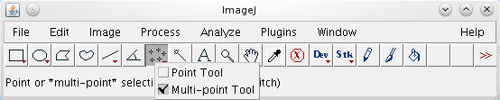
Open a reference image. Click the image to mark a maxima. Points can be moved by hovering over an existing point and dragging them. Points can be deleted by holding down the Alt key and clicking them.
Once the image maxima have been labelled you can save the image as a TIFF. ImageJ will save the ROI points to the image and they will be shown when the image is next opened.
Note: The ImageJ ROI tool only supports 2D coordinates. To label foci on a 3D image with multiple slices will require using a text file. The Point Extractor plugin can be used to assist in this task (see section Point Extractor).

Specify Foci in a Text File
The reference foci can be loaded from a text file. This supports both 2D and 3D coordinates.
The file must contain records with X, Y and optionally Z coordinates, i.e.
x y [z]
If no Z-coordinate is present for any record then the points will be loaded as 2D. Each field can be delimited by either a comma, space or tab character. This file can be created manually or the Point Extractor plugin can be used to create the file from points on an image or within the ImageJ ROI Manager.
File Location
The text file for the image must be placed in the same directory as the image that will be analysed by the FindFoci Optimiser. The file should be named using the same filename as the image but using the suffix '.csv'; '.xyz'; or '.txt'. E.g.
/myFiles/image1.tiff
/myFiles/image1.csv

Loading the Foci
When the FindFoci Optimiser is run it identifies the original source file for the image. It then searches the same directory for a coordinate text file and attempts to load the foci. If it cannot load the foci from file then the foci are loaded directly from the image using the marked point ROI. This means that any foci marked on an image are ignored if a coordinate file exists for that image. Also note that the z-component of 3D foci loaded from file is ignored if the test image is not a 3D stack.

Stage 2: Run the Optimiser
Select the different parameters for the optimiser to enumerate.
Click OK and the optimiser will show a dialogue containing the number of combinations. You can then select to continue or cancel to stop the optimiser and change the parameters.
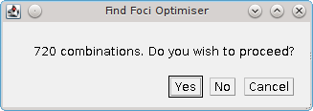
If you run the optimiser a progress bar will show in the ImageJ window that tracks the number of combinations currently completed. When the optimiser is finished a results window will appear showing the top N results. The number of results can be configured in the optimiser dialogue.
If the best result is obtained using a numeric parameter that lies on an extreme of the test range then the plugin will show a warning message:
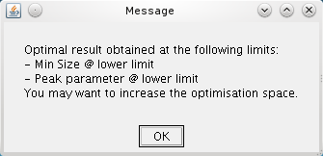
This allows the user to increase the range to ensure that the optimal parameters are identified.

Result Assessment
The optimiser scores the results of the FindFoci plugin by comparing the locations of the identified maxima to the reference image. Maxima are deemed to be correct if they are within a set distance of a reference point. The cut-off distance is configured in the plugin options. The default is 5% of the image width/height, whichever is smaller. Note that the distance will be computed in 3D if reference foci have been loaded from a 3D coordinate file.
The maxima assignment process is iterative. The maxima closest to any reference point is assigned as a match and the pair removed from the search. This is iterated until no more reference points exist, or all maxima are too far from a reference point to be a match. The results are then scored using the metrics detailed in Appendix 2: Binary Scoring Statistics.

Plugin Interface
The FindFoci Optimiser interface uses the standard ImageJ Generic Dialog. The plugin has many options as shown in the following image.
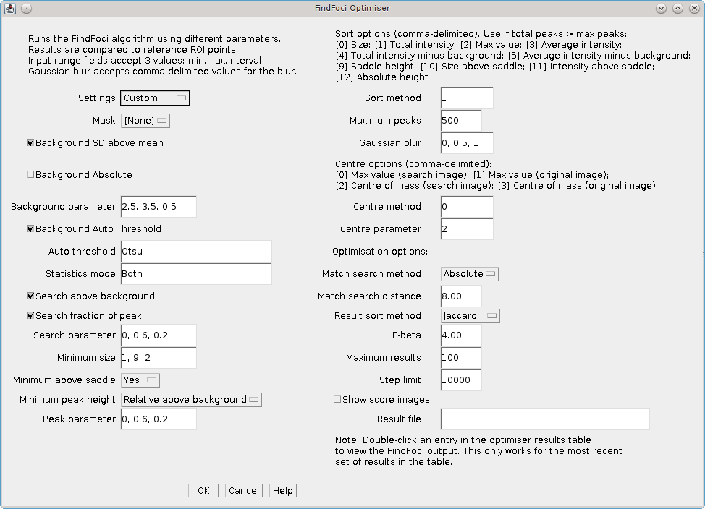

Settings Presets
To simplify configuration of the optimiser there is a Settings drop-down item that allows the user to choose from various presets. The following presets are available:
Preset | Combinations | Description
Custom | Variable | This preset is selected when the user modifies any of the fields.
Testing | 12 | A small number of combinations for testing
Default | 720 | The default combinations to try a range of parameters that are applicable to many images
Benchmark | 19,800 | A set of combinations that can be used as an initial search of the entire range of the algorithm parameters

It is possible to select any of the presets as a starting point for parameter configuration. When any setting is changed (except the results filename) the Settings option will change to Custom. It is possible to revert back to the preset by selecting it again from the Settings drop-down. In this event the current custom settings will be saved so that the user can switch back to their customised settings using the drop-down. However if any changes are made to the preset values then the saved custom settings will be discarded (since a new custom settings will be started).
Using custom settings is the best way to search for the optimum FindFoci parameters since each image analysis is unique. The following sections explain how to configure the optimiser parameters.

Initialisation Parameters
The FindFoci algorithm must be initialised with an image and optionally a mask identifying which pixels that are to be processed. The pixels are used to calculate image statistics and a background level for the peak finding algorithm. The optimiser will run the FindFoci plugin for each background option that is enabled. There are addition fields that allow parameters to be passed to the background method and control the pixels used for the statistics.
Initialisation Option | Description
Mask | Optionally select a mask to define the pixels to process. Only images with the same dimensions as the input image are listed. Any non-zero pixel is included in the analysis
Background SD above mean | Use the SD above Mean background method.  It is not allowed to use this at the same time as the Absolute method
Background Absolute | Use the Absolute background method.  It is not allowed to use this at the same time as the SD above Mean method
Background parameter | Set the lower limit, upper limit and increment for enumerating the background parameter passed to the background method. This applies to either SD above mean or Absolute
Background Auto Threshold | Use the Auto Threshold background method
Auto threshold | The method for performing the Auto Threshold calculation. The text field supports a comma-delimited list for multiple options
Statistics mode | When a mask image is used it is possible to set the region used to calculate the image statistics:  Inside – Use the pixels inside the image mask  Outside – Use the pixels outside the image mask  Both – Use all the pixels in the image  When no mask image is used this option is ignored

Search Parameters
The optimiser will run the FindFoci plugin for each search option that is enabled. There is an addition field that allows a parameter to be passed to the search method.
Search Option | Description
Search above background | Use the Search above background method
Search fraction of peak | Use the Fraction of peak – background method
Search parameter | Set the lower limit, upper limit and increment for enumerating the search parameter passed to the fraction of peak method

Peak Merging Parameters
The optimiser will run the FindFoci plugin for each combination of the following peak merging options.
Peak Merge Option | Description
Minimum size | Set the lower limit, upper limit and increment for enumerating the minimum size parameter passed to the peak merge method
Minimum above saddle | Set the option for limiting the peak size to above the saddle. Select Yes; No; or Both
Minimum peak height | Set the method for setting the minimum peak height
Peak parameter | Set the lower limit, upper limit and increment for enumerating the parameter passed to the minimum peak height method

Results Parameters
Option | Description
Sort Method | Set the method used to sort the peaks before extracting the top N.  Multiple options can be specified using a comma-delimited list
Maximum peaks | Set the maximum number of peak results

Extra Parameters
Control other options available within the FindFoci plugin.
Option | Description
Gaussian blur | Set the size of the blur to apply before running the Find Peak algorithm.  Multiple options can be specified using a comma-delimited list
Centre method | Set the method used to determine the centre of the peak.  Multiple options can be specified using a comma-delimited list
Centre parameter | Set the lower limit, upper limit and increment for enumerating the parameter passed to the centre method

Optimisation Parameters
The FindFoci Optimiser plugin has several options for controlling how the FindFoci results are calculated and ranked.
Option | Description
Match search method | Choose the method for specifying the distance for two peaks to be a match:  Relative – Use a distance relative to the shortest edge (width or height) in the image  Absolute – Use an absolute distance in pixels
match search distance | Set the distance limit used to determine if a peak maxima and a reference point are a match.  This value is specified as a fraction of the image short edge, e.g. 0.05 for a 600x400 pixel image would be 20 pixels (400 x 0.05), or an absolute value in pixels (see Match search method)
Result sort method | Specify the metric used to sort the results
F-beta | Specify the beta parameter used to calculate the custom F-score
Maximum results | Specify the maximum number of results to include in the result table
Step limit | The optimiser will not run if the total number of combinations (steps) is above the Step limit. This parameter can be used to increase the potential optimisation space

Additional Parameters
The FindFoci Optimiser plugin has several options for controlling how the FindFoci results are calculated and ranked.
Option | Description
Show score images | If enabled the optimiser will show three duplicates of the input image with overlay points marking the True Positives, False Positives and the False Negatives. The points are shown using an overlay as this can label points to a specific slice of a 3D stack. (Point ROI would be visible through the entire stack.)
Result file | Provide the prefix for the results files. The prefix should be a full path to a valid directory and include a filename prefix, e.g. /tmp/FindPeaks  Results files will have a suffix added corresponding to the result:  .results.txt – Contains the optimiser results  .points.csv – Contains the peak coordinates from the best  .params – Contains the FindFoci parameters for the best result (this can be input to the FindFoci Batch plugin)

Range Limit Fields
The plugin has several text fields that accept a lower limit, upper limit and interval. The numbers must be comma-delimited. If three numbers are present then the plugin will assume that they are lower, upper and interval. Otherwise only the upper limit is set using the first number in the text field. This is equivalent to using a single value and not a range of values.
The following fields allow range limits:
- Background parameter
- Search parameter
- Minimum size
- Peak Parameter
- Centre parameter
The plugin has several text fields that accept multiple values in a comma-delimited list. The following fields allow a comma-delimited list:
- Auto-threshold
- Statistics mode
- Sort method
- Centre method
- Gaussian blur*
* The use of a list for Gaussian blur is due to the fact that changes in the blur radius are most noticeable at increasing increments, e.g. 1, 2, 4, 8, 16. In this case a range field with a linear increment is unwanted.

Output
The FindFoci Optimiser records the parameters and results of each run of the FindFoci algorithm. The best results are shown in a result table and the complete results can be saved to file. The plugin also runs the FindFoci plugin using the optimal parameters on the input image to show the result peaks. Further details are outlined below.

Result Table
The result table shows the top scoring results from all the parameter combinations. The results are sorted using the Result sort method parameter and limited to the number specified by the Maximum results parameter. Results are presented in descending order so that the best result from the most recent analysis is shown at the bottom of the table.
In the event that two sets of parameters have an equal score then the results are ranked using a second metric. By default this is the RMSD (a measure of how close the true positives are to the answer) or if RMSD is chosen as the primary rank metric, the Jaccard.
In the event of a tie the parameters that have the most conservative settings are ranked first. The following logic is used:
- Lowest blur
- Background method: None < Auto-threshold < Std.Dev above mean < Mean < Absolute
- Lowest minimum size
- Search method: Above background < Fraction of peak - background < Half peak value
- Lowest search parameter
- Peak method: Relative above background < Relative height < Absolute height
- Lowest peak parameter
- Lowest run time
The result table shows the result rank and then columns containing the parameters. The table then shows the following scoring metrics:
Metric | Description
N | The number of maxima in the result
TP (True Positives) | The number of maxima in the result that match a reference point
FP (False Positives) | The number of maxima in the result that do not match a reference point
FN (False Negatives) | The number of reference points that were not identified as maxima
Jaccard | Measure of the overlap similarity between the reference and the maxima
Precision | Measure of how many identified maxima are correct
Recall | Measure of how many reference points were identified
F-score | Combined score that provides a weighted measure of the prediction accuracy:  β is a weighting factor between the Precision and Recall.  The F-score is calculated using β of 0.5, 1, 2 and the provided input F-beta parameter.
Score | The score used for ranking
RMSD | The Root Mean Square Deviation (RMSD) of the true positive results from the actual.  Where d is the distance between the predicted and actual coordinates and tp is the count of true positives.
mSec | The number of milliseconds taken to perform the calculation
Note that the metrics Jaccard, Precision, Recall and F-score all range from 0 to 1. Further details of the metrics can be found in Appendix 2: Binary Scoring Statistics.
A blank line is inserted at the end of the result table to allow easy visual separation of the results from multiple runs of the plugin.

Showing a result
By default the FindFoci Optimiser shows the result of running the FindFoci algorithm with the best result. However it is possible to show any result by double-clicking a row in the result table. The FindFoci algorithm will then be re-run with the parameters from that row.
Note that it is only possible to view the results for the latest run of the optimiser. Parameters for prior runs are discarded from this review functionality.

FindFoci Images
Upon completion the optimiser runs the FindFoci algorithm on the input image to display the peaks. To preserve the input image ROI points a copy is made of the original. This is named with the suffix ' clone'. FindFoci is then run on the clone image to mark the peak ROI points. A mask image showing the peaks above the saddle points is also created with the suffix ' clone FindFoci'.

Score Images
If the Show score images parameter is enabled then the input image is duplicated three times. These images are then marked with the points for either the True Positives (TP), False Positives (FP) or False Negatives (FN). The points are marked using an overlay, not a point ROI. This allows marking the points using the specific slice of a 3D image. Scroll up and down through a 3D stack to view the location of the each result.
If the optimiser is re-run on the same input image then the output result images will be detected (using the image title) and updated. This feature allows the images to be updated with the results of using the specified parameters when double-clicking on the result table (see section Showing a result).

FindFoci Optimiser GUI
The plugin provides an ImageJ Graphical User Interface (GUI) that runs the FindFoci Optimiser on the selected image.

Features
- Permanent GUI within ImageJ
- Allows different images to be selected
- Runs the FindFoci Optimiser algorithm to identify peak regions
- Supports the ImageJ macro recorder
Note that the the plugin supports the ImageJ macro recorder for the FindFoci Optimiser command. This means that a user can record their actions with the FindFoci Optimiser GUI within a macro and it will successfully record the execution of the FindFoci Optimiser plugin.

Plugin Interface
The FindFoci Optimiser GUI uses a Java frame within the ImageJ application. The plugin provides a selection box of the currently open images that can be processed by the optimiser.
The following image shows the interface for the FindFoci Optimiser GUI:
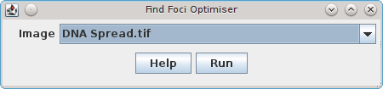
Clicking the Run button launches the FindFoci Optimiser on the selected image. Full details of the parameters can be found in the FindFoci Optimiser Plugin Interface section.
The interface has a drop-down menu that is used to select the image. This allows the user to quickly try the same parameters on different images that are open. The image list is populated with the currently open 8-bit and 16-bit single channel images that have an ImageJ Point ROI. Any images with the title ending in 'FindFoci' (i.e. previous results) are also ignored.

Java Requirements
The FindFoci Optimiser GUI uses the BeansBinding Java framework. More details can be found in Appendix 1: BeansBinding Java framework.

FindFoci Optimiser Multi-Image
ImageJ plugin that iterates through combinations of parameters for the FindFoci plugin. Processes all the reference images in a directory and identifies the best parameters to match the reference results.

Features
- Processes multiple reference images
- Enumerates combinations of parameters for the FindFoci plugin
- Compares the results to a reference image
- Saves the results for each reference image
- Combines the results from multiple images into a single ranking of parameters
- Reloads pre-computed results to allow re-ranking using different scoring metrics
- Supports 2D/3D foci

Input
The plugins requires a set of images in a single directory. Each image must have the foci marked on the image using the ImageJ ROI tool, or recorded in a text file in the same directory. See Stage 1: Create Reference Foci in the FindFoci Optimiser section for details on how to do this.

Method for Combined Ranking
When run on a single image the FindFoci Optimiser computes a score for each parameter set that specifies the match between the reference results and the FindFoci algorithm. The score can be chosen using the parameter Result sort method, for example the Jaccard score.
When using multiple images the overall rank for a set of parameters must combine the score from each image. The scores for each image can be converted to allow fair combination. The converted scores are then averaged across all images for the same set of parameters. The parameters are ranked using their averaged score and the results displayed.

Score Conversion
The scores on each image can be converted using the following methods:
Option | Description
Raw score metric | No conversion is made.  The raw score, e.g. the Jaccard, will be averaged across all the images.
Relative | The score is converted to a relative score using the percentage drop from the top score:
Z-score | The z-score is computed using the average and standard deviation (SD) of all the scores on the image:
Rank | The score is used to rank the results on the image and the rank is combined across images

Note that if the RMSD metric is used to score the results then only the Raw and Rank options are valid. If Relative or z-score is specified then Raw will be used. It is not recommended to use RMSD to score results since this will be zero if no true-positives are found, i.e. perfect which is not the case as the result has failed to find any foci. The metric is useful to discriminate results with the same number of true-positives as a secondary comparison.

Plugin Interface
The FindFoci Optimiser Multi-Image plugin is an extension of the FindFoci Optimiser. It uses the same processing engine to enumerate combinations of parameters for the FindFoci algorithm. The plugin shares the same main parameters as the FindFoci Optimiser. Additional parameters for processing multiple images are collected using the following dialog:
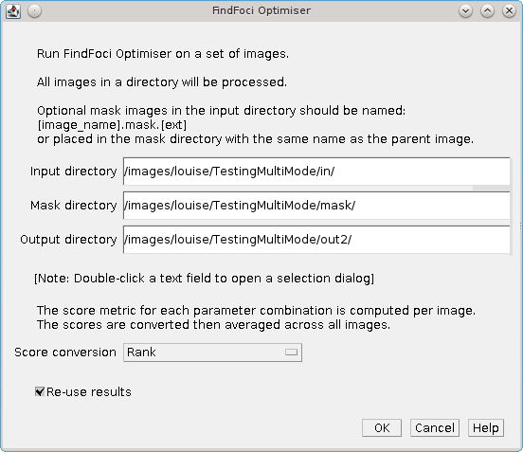
The input fields must specify the full path to the directories that exist. The plugin will not create the output directory automatically. To aid in selecting valid directories a double-click in the text field will open a directory selection dialog.

Parameters
Option | Description
Input directory | The directory containing the images to process.  Any file with the text 'mask.' will be ignored as these are assumed to be mask images. Optional mask images should be named using the image title with the text 'mask.' placed before the image extension:  [image_name].mask.[ext]  Optional coordinate files should be named:  [image_name].[csv|xyz|txt]  If no coordinate file exists for an image then the reference foci will be loaded from point ROI within the image.
Mask directory | The directory containing mask images.  This parameter is optional.  Mask images must be named with the same name as the parent image in the input directory. Or the images can be named using the image title with the text 'mask.' placed before the image extension:  [image_name].mask.[ext]
Output directory | The output directory.  Note that the plugin will overwrite files that already exist. The results for each image will be saved to a file named '[image_name].results.xls'.  The combined results across all images will be saved to a file named 'all.results.xls'  The parameters for the best result across all images will be saved to a file named 'all.params'. This can be input to the FindFoci Batch plugin.
Score conversion | Set the score conversion method (see the Score Conversion section above)
Re-use results | Select this option to re-use results that are in the results directory. Only files with the correct number of parameter combinations will be re-used, otherwise the results will be recomputed.  This option can be used to try different 'Score conversion' and 'Result sort method' parameters on the same set of results

The Mask directory parameter is optional. This allows the user to place the mask images in a separate directory or the same directory as the input image. The mask will be found using the following search order:
- [Mask directory] + [Image filename]
- [Input directory] + [image_name].mask.[ext]
- [Mask directory] + [image_name].mask.[ext]
Once the parameters for processing multiple images have been collected the plugin displays the same dialog as the FindFoci Optimiser. However the plugin does not allow specification of a mask image or a results file. The mask file for each image will be detected automatically in the input directory using the filename '[image_name].mask.[ext]'. All results will be saved to the output directory.

Results
When started the plugin will run the FindFoci Optimiser on each input image. Progress can be monitored using the ImageJ progress bar in the ImageJ window. As with the FindFoci Optimiser if the best result for an image is obtained using a numeric parameter that lies on an extreme of the test range then the plugin will log a warning message to the ImageJ log window. This allows the user to increase the range to ensure that the optimal parameters are identified.
Processing is performed using multiple threads to increase speed. The number of threads can be specified using the ImageJ preferences: Edit > Options > Memory & Threads...
The final combined ranking of the top N parameters is displayed in a table in ImageJ. All the combined results are saved to the output directory.
Once the results have been computed it is possible to re-rank the parameter sets using a different scoring method without re-calculating the results. The results will be loaded from the output directory if the 'Re-use results' option is selected and the results files contain the correct number of combinations.

Result Table
The result table shows the top scoring results from all the parameter combinations. The results are sorted using the average score across all the images and limited to the number specified by the Maximum results parameter. Note that RMSD scores cannot be averaged. The combined RMSD is re-computed using the RMSD and number of true positives in each image result.
Results are presented in descending order so that the best result from the most recent analysis is shown at the bottom of the table.
In the event that two sets of parameters have an equal score then the results are ranked using a second metric. By default this is the RMSD (a measure of how close the true positives are to the answer) or if RMSD is chosen as the primary rank metric, the Jaccard.
In the event of a tie the most conservative settings are ranked first. The following logic is used:
- Lowest blur
- Background method: None < Auto-threshold < Std.Dev above mean < Mean < Absolute
- Lowest minimum size
- Search method: Above background < Fraction of peak - background < Half peak value
- Lowest search parameter
- Peak method: Relative above background < Relative height < Absolute height
- Lowest peak parameter
- Lowest run time
The result table shows the result rank and then columns containing the parameters. The table then shows the same scoring metrics as the FindFoci Optimiser. However the counts display the total across all images and the scoring metrics show the average across all images. It is important to note that the scoring metrics, e.g. Jaccard and F-scores, are not recomputed using the total counts across all images. The following results are displayed:
Metric | Description
N | The total number of maxima in the results
TP (True Positives) | The total number of maxima in the results that match a reference point
FP (False Positives) | The total number of maxima in the results that do not match a reference point
FN (False Negatives) | The total number of reference points that were not identified as maxima
Jaccard | Average Jaccard score across all the images.  (Overlap similarity between the reference and the maxima)
Precision | Average Precision score across all the images.  (How many identified maxima are correct)
Recall | Average Recall score across all the images.  (How many reference points were identified)
F-score | Average F-score across all the images.  (Provides a weighted measure of the prediction accuracy where β is a weighting factor between the Precision and Recall.)  The F-score is calculated using β of 0.5, 1, 2 and the provided input F-beta parameter.
Score | The average score used for ranking across all the images.  This is the score set using Result sort method parameter in the main optimiser dialog and converted per image using the method defined by the Score conversion parameter from the multi-image dialog
RMSD | The Root Mean Square Deviation (RMSD) of the true positive results from the actual.  Where d is the distance between the predicted and actual coordinates and tp is the count of true positives. This is computed over all the images.
mSec | The total number of milliseconds across all the image
Note that the metrics Jaccard, Precision, Recall and F-score all range from 0 to 1. Further details of the metrics can be found in Appendix 2: Binary Scoring Statistics.

Invalid Results
Note that the results do not store the distance at which the scoring metrics were computed. Therefore is it left to the user to remember that if the match search distance is changed then results should be recomputed as they will not be valid. The option to Re-use results should be disabled.
However if the user wishes to change the Result sort method or the Score conversion parameters then the results can be re-used to produce the final combined ranking.

FindFoci Helper
An ImageJ plugin that aligns the manually added point Regions of Interest (ROIs) with the peaks found by the FindFoci algorithm.

Features
- Processes 8- or 16-bit images
- Extracts a single channel and time frame for processing N-dimensional images
- Computes the image peaks using the FindFoci algorithm
- Intercepts user clicks with the multi-point ROI tool and assigns the marked points to the true peaks
- Supports dragging points
- Outputs assignments to the ImageJ log window
- Optional output of a results table of point positions with intensity

Overview
The FindFoci Helper provides a semi-automated tool to assist in manually counting the peaks in an image. The tool is designed to work in conjunction with the ImageJ multi-point ROI tool.
The plugin must be attached to an image and initialised. During initialisation all the potential peaks in an image are calculated using the FindFoci algorithm.
The plugin then listens for mouse-click events from the ImageJ multi-point ROI tool. If a new ROI point is added then the plugin attempts to align the point to an available peak within a set distance. The alignment is performed using the highest or the closest peak. If an existing point is moved then the plugin will detect the drag and attempt to align the point when it is dropped.

Plugin Interface
The FindFoci Helper uses a Java frame within the ImageJ application. The following image shows the plugin window.
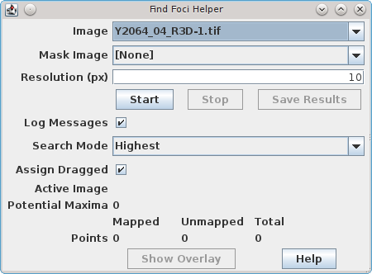

Parameters
Parameters | Description
Image | The target image
Mask Image | Optional mask image defining the region where points will be aligned
Resolution (px) | Defines the search radius for aligning a point (in pixels)
Log Messages | If selected record details of the point alignments to the ImageJ log window
Search Mode | Define the search mode for aligning points to the available maxima: Highest or Closest
Assign Dragged | If selected the plugin will re-align dragged points when they are dropped

Workflow

Multi-point ROI Mode
The ImageJ multi-point ROI tool must be activated. This can be found on the ImageJ toolbar as shown below:
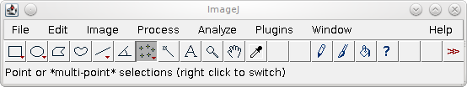
If the single-point ROI mode button is shown then the multi-point mode can be enabled by right-clicking the button and toggling the mode.
The multi-point ROI mode allows the user to manually mark multiple points on an image. Each point is represented by a cross and shows a numbered label (if more than 1 point is selected).

Initialisation
The FindFoci Helper shows a list of the available images that can be processed. This will be all the 8- and 16-bit images. Select the image and the list of possible masks images will be updated. Any non-zero pixel in the mask defines the region of the image where potential maxima will be detected. The mask image is optional.
Next configure the resolution for point assignment. The resolution defines the search distance around the point that can be used to locate a maxima. The resolution is fixed once the helper is initialised.
Click Start to initialise the helper. The plugin supports images with multiple channels or time frames but will only calculate the peaks on a single channel and time point. If a multi-dimensional image is selected then the plugin will show a dialogue requesting the user to select the channel and/or frame to be processed.
The plugin will calculate all the potential maxima above the mean of the image using the FindFoci algorithm. The mean is used as a reasonable threshold to avoid identifying false peaks.
If the image contains an existing multi-point ROI then the plugin will attempt to assign each point. If the Highest Search mode is enabled the plugin will process the points in descending height order. If the Closest Search mode is enabled the points will be processed using the closest pairing of point and maxima, iterating until no more assignments can be made.
The number of potential maxima along with the count of mapped and unmapped points will be displayed in the plugin window as shown below:
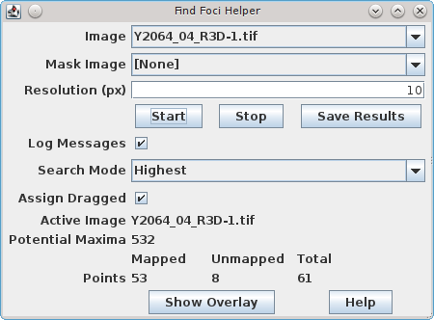

Marking Peaks
Mark a new peak by clicking on the image. The plugin will search for the closest or highest unassigned maxima within the search resolution.
If a maxima is found the point will be moved to the maxima. The mapped count on the plugin interface will increment.
If no maxima is found then the point will be unchanged. The unmapped count on the plugin interface will increment.
Note that if the Search mode is set to highest then a check is made for the highest peak within the search radius. If present then the search resolution is updated to the distance to the highest assigned peak. This means that the plugin requires the user to click closer to a second unassigned peak than to an existing assigned high peak in close proximity. This prevents the plugin moving the clicked point past an already assigned peak to reach an unassigned peak. If the plugin does not assign the peak as expected it can be moved by dragging as described below.

Moving Peaks
If the mouse cursor is hovered over an existing point it will change to a finger. The point can then be moved by holding down the mouse button and moving the mouse to drag the point.
The plugin will identify the point that has been dragged. If it is an aligned point the mapped count on the interface will decrement, otherwise the unmapped count will decrement.
When the mouse button is released the plugin will detect the point has been dropped. If the Assign Dragged option is enabled the plugin will attempt to align the point. Otherwise the point will be unchanged and the unmapped count will increment.
Note that is is possible to disable and re-enable the Assign Dragged option during the course of marking an image. This allows points to be moved without alignment or using alignment.
It is possible that the plugin fails to correctly detect that the peak was assigned before dragging. This will cause the mapped and unmapped counts to show errors. This can be solved by deleting a point which forces all existing points to be remapped without movement. The point can then be added back.

Deleting Peaks
If a the mouse cursor is hovered over an existing point it will change to a finger. It is possible to delete the point by clicking on it whilst holding down the Alt key on the keyboard.
The plugin will identify a point has been deleted. To maintain the ordering of points by ImageJ and the log message window the plugin will process all the remaining points and output the assignments using the new ImageJ point numbers.

Point Overlay
The current mapped and unmapped points can be displayed as an image overlay by clicking the Show Overlay button. This action saves the current ROI points and removes them from the image display. The points are then added back to the image as an overlay using green for the mapped points and yellow for the unmapped points. An example is show below:
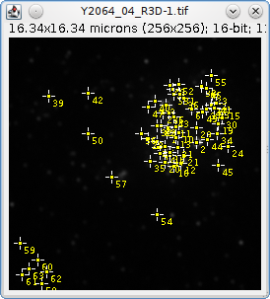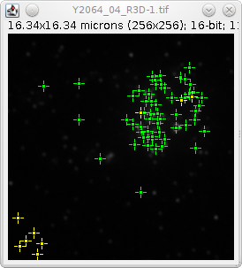
The Show Overlay button is a toggle button. It will return to the off state under the following conditions:
Condition | Result
Show Overlay clicked | Removes the overlay and restores the ROI points
Image clicked | Removes the overlay and:  - If using the multi-point ROI tool then the new point will be added to the ROI points  - If a different ROI tool is used, for example the Rectangle tool, then the ROI points will be lost  - If any other tool is used, for example to move or zoom the image, then the previous ROI is restored
Stop button clicked | Removes the overlay and restores the ROI points

Saving Results
The current point coordinates can be saved by clicking the Save Results button. The table contains the following information:
Result | Description
Id | The point identifier. This matches the ImageJ point ROI label
X | The point X coordinate
Y | The point Y coordinate
Height | The image intensity. Since only XY coordinates are used this is for the first plane of a multi-plane Z-stack
Assigned | True if the point is located on a FindFoci maxima. False entries indicate points that could not be aligned

Stopping Point Alignment
Clicking the Stop button will halt the FindFoci Helper. It will no longer intercept any mouse interactions with the image. All the working data used by the plugin is discarded and consequently the Save Results option will be disabled.
Note that clicking the Start button will reinitialise the FindFoci Helper. This will set a new resolution if it has been changed and as part of the initialisation will perform alignment of the existing points to maxima. This can potentially move any points that have been dragged with the Assign Dragged option disabled, i.e. points that were previously unmapped.

Alignment Log
If the Log messages option is enabled then the alignment result of each point will be recorded to the ImageJ log.
Each entry is preceded by the point ID. The numbering matches the Ids assigned by ImageJ on the image. Following the ID is the keyword Mapped or Unmapped, depending on the alignment status, and then the XY coordinates of the point that was clicked. If a mapped point was moved to align to the true peak then the new coordinates will be shown along with the distance moved in pixels. Examples are shown below:
45: Mapped (166,80) => (167,80) (1.0px)
46: Mapped (201,51)
46: Unmapped (196,75)

Java Requirements
The FindFoci Optimiser GUI uses the BeansBinding Java framework. More details can be found in Appendix 1: BeansBinding Java framework.

Match Calculator
ImageJ plugin that compares the multi-point Regions of Interest (ROIs) between two images.

Example Input
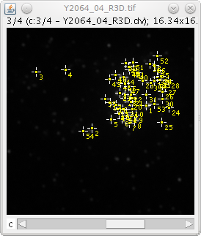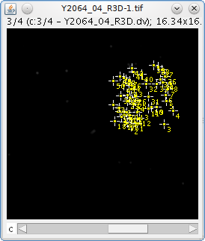
Input images 1 and 2 containing multi-point ROI

Example Output
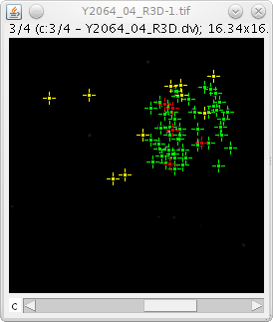
Output image overlay showing matched points in green, unmatched points from image 1 in yellow and unmatched points from image 2 in red.

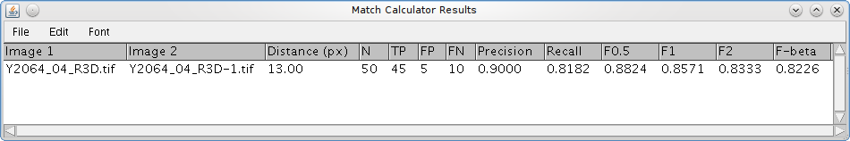
Results table showing the match statistics

Features
- Processes any images with point ROI
- Compares the ROI points and assigns matches using a nearest-neighbour method within a configurable distance threshold
- Generates a results table of match statistics
- Optional overlay of the match results onto the image
- Allows selection of channel and frame for multi-dimensional images when extracting heights
- Optional match statistics for each quartile of the data points when ranked by height
- Optional scatter plot of the height of matched and unmatched points
- Optional height analysis of the unmatched points

Overview
The Match Calculator plugin compares the ROI points on two images and computes the number of points that match. The matches can be used to generate match statistics as detailed in Appendix 2: Binary Scoring Statistics.
The plugin was developed to provide comparisons between the manual peak identification performed by different experimenters on the same image. The plugin can rapidly show differences between the peak labelling techniques used by two people.

Match Algorithm
Matches are calculated using a nearest-neighbour algorithm:
- The coordinates of the ROI points from each image are used to build two sets, A and B
- An all-vs-all distance matrix is computed for the two sets of points, i.e. the distance for any point in set A to any point in set B
- The closest pair of points is identified
- If the closest pair is below a distance threshold they are marked as a pair and removed from the sets. Step 3 is repeated
- If the closest pair is above the distance threshold the search ends
The distance threshold can be set using an absolute number of pixels or can be set relative to the image size, e.g. 5% of the longest edge.

Height Analysis
The plugin can produce an analysis of the points using their heights (image intensity values). Since ImageJ point ROIs do not readily support z-stacks the plugin uses a maximum intensity projection for height analysis. It does allow selection of the channel/frame that is used for the heights for multi-dimensional images.
The heights for all the points can be used to divide the data into quartiles. All the heights from both sets are combined into a single dataset and used to set quartile boundaries. Each set of points is compared to the other using only the points that fall within each quartile boundary. This analysis will show if the higher points (greater intensity) have an increased number of matches. Due to subdivision of the data the analysis is less relevant when the number of points is small (e.g. less than 50).
In addition the heights for the paired points can be used to divide the data. In this case the height is taken as the average height of the pair. The height distribution is used to set quartile boundaries. The unmatched points in a set can be counted for each of the height classifications defined using the boundary limits. This analysis shows where the unmatched points occur relative to points that have been matched.
A visual display of the heights for the matched and unmatched points uses a scatter plot of the point heights. The X-axis is the height of the point from set A and the Y-axis uses set B. If the points have been matched they will have both X and Y values. Otherwise they will be plotted on the axis. An example is shown below where matched points are shown in blue and unmatched points in red:
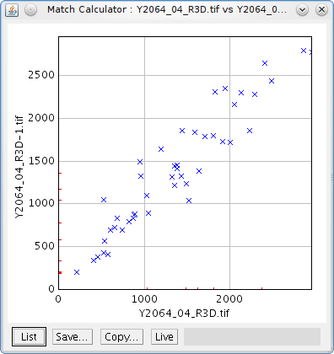

Plugin Interface
The FindFoci interface uses the standard ImageJ Generic Dialog. The input parameters are shown in the following image and are described below.
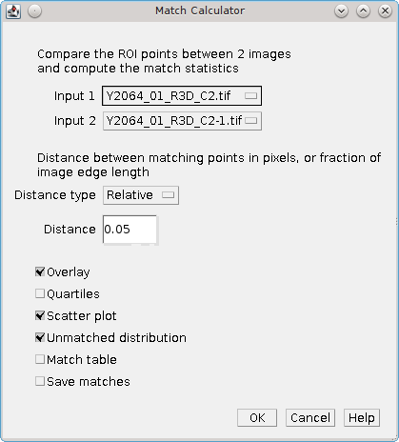

Parameters
Parameter | Description
Input 1 & Input 2 | The first and second input images.  Note: The selection options only show images labelled with ROI points
Distance type | Define the type for the distance parameter:  Relative – A fraction of the longest image edge  Absolute – A number of pixels
Distance | Specify the maximum distance allowed for a matched pair of points
Beta | The beta parameter for the F_{ß}-score. This allows a customised weighting between the Precision and Recall scores.
Overlay | Show the matched and unmatched points using a coloured overlay on image 2 (see Example Output)
Quartiles | Compute the match statistics for the points divided into 4 sets using their heights to define quartiles
Scatter plot | Output a scatter plot of the heights of set A verses set B, matched points a plotted as height pairs
Unmatched distribution | Output a result table of the counts of unmatched points within the limits defined by the quartile boundaries of the matched points
Match table | Show a table with the the coordinates and values of the points, paired into matches and then the unmatched points from one image and then the other
Save matches | Save the matches to a tab delimited file. A file selection dialogue will be shown to allow the filename to be chosen.  The file contains the coordinates and values of the points and a summary header containing the match statistics

Extra Parameters
If the FindFoci plugin has been run on an image the results are stored in memory. The Match Calculator can add values from these results to the match table if they correspond to one of the input images. The plugin dialogue presents extra parameters that allow the user to specify which image (if any) is marked with the current FindFoci results. If the selected image has the same number of ROI points as the FindFoci results then the a value from the FindFoci results can be added to the match table.
In the example below the second image contains the ROI points identified by the FindFoci plugin. The output match table will contain an extra column showing the peak intensity from the FindFoci results for each point from image 2. Addition of the data from the FindFoci results allows a comparison of the a manually marked image to the points identified by the algorithm with data that may explain why points have been matched (e.g. the intensity above background or pixel count is higher in matched points).
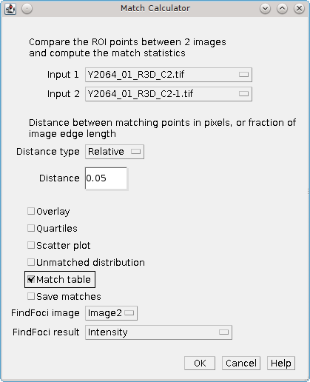
Note that if the selected image for the FindFoci image parameter is [None] or the image has the wrong number of marked ROI points then no extra data will be output (since it is impossible to assign the points to the FindFoci results).

Results Table
The results table contains details about the match statistics. The table contains the following information:
Result | Description
Image 1 | The first input image
Image 2 | The second input image
Distance (px) | The distance limit for matched pairs. Note this is always specified in pixels even when using a relative distance type
N 1 | The number of points in the first image
N 2 | The number of points in the second image
Match | The number of points that match
Unmatch 1 | The number of points in Image 1 that do not match Image 2
Unmatch 2 | The number of points in Image 2 that do not match Image 1
Jaccard | The Jaccard score
Recall 1 | The proportion of points in Image 1 that appear in Image 2
Recall 2 | The proportion of points in Image 2 that appear in Image 1
F1 | The F1-score, a balanced weighting of Recall 1 and Recall 2
If the Quartiles parameter is selected then an additional set of columns will be appended for each quartile Q1 through to Q4. There will be a column for N 1, N 2, Matches (M), Unmatched 1 (U1), Unmatched 2 (U2), Jaccard, Recall 1, Recall 2 and F1 for each quartile.

Unmatched Results Table
If the Unmatched distribution parameter is selected then a result table will be generated containing the height distribution of the unmatched points from each image relative to the matched points.
Result | Description
Image 1/2 | The first/second input image title
N | The number of unmatched points
% <Q1 | The percentage of points below the height of the lowest matched point
% Q1 | The percentage of points within the first quartile of matched points
% Q2 | The percentage of points within the second quartile of matched points
% Q3 | The percentage of points within the third quartile of matched points
% Q4 | The percentage of points within the forth quartile of matched points
% >Q4 | The percentage of points above the height of the highest matched point

Matched Results Table
If the Matched table parameter is selected then a result table will be generated containing the matched and unmatched points.
Result | Description
Image 1/2 | The first/second input image title
Id | The ROI point ID
X | The X coordinate
Y | The Y coordinate
Distance | The distance between the matched points in pixels
Extra | If the FindFoci results stored in memory have been assigned to one of the images an extra column will be added containing the selected value from the FindFoci results

Overlay
The results of the match can be shown as an overlay on the original image 2 using the Overlay parameter. The following key is used for the overlay:
Classification | Colour
Matched | Green
Unmatched image 1 | Yellow
Unmatched image 2 | Blue
Note: The colours have been chosen so that the different points should be visible to those with colour vision deficiency.
The following image shows an example of an overlay applied to the image:
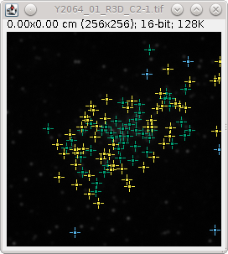
The overlay can be removed using Image > Overlay > Remove Overlay.
Note that the point ROI has been removed from the image. This can be restored using the ImageJ menu option Edit > Selection > Restore Selection (Ctrl+Shift+E). The point ROI are not removed if the overlay option is disabled.

Point Aligner
ImageJ plugin that aligns the marked multi-point Regions of Interest (ROIs) of an image with the peaks found by the FindFoci algorithm.

Example Input
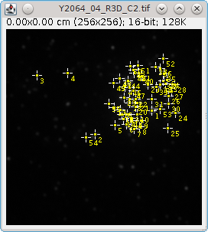
Input image containing multi-point ROI

Example Output
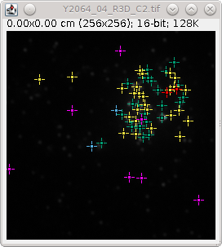
Output overlay showing aligned points in green, aligned but moved points in yellow, conflict points in red, unaligned points in blue and missed points in magenta
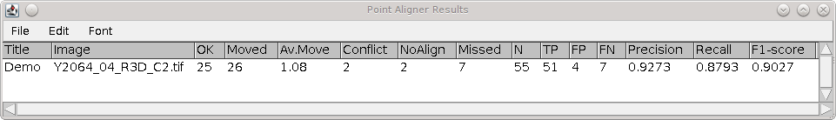
Results table showing the match statistics

Features
- Processes any single channel image with point ROI
- Computes the image peaks using the FindFoci algorithm
- Assigns the marked points to the true peaks
- Generates a results table of alignment statistics
- Identifies any peaks that have been missed by the marked points
- Optional overlay of the alignment results onto the image
- Optional output of marked points that cannot by aligned (conflict regions) as images

Overview
The Point Aligner plugin aligns the ROI points on an image to the peaks found using the FindFoci algorithm. Comparison of the original points and the aligned points can be used to generate match statistics as detailed in Appendix 2: Binary Scoring Statistics.
The plugin was developed to re-align the manual peak identification performed by an experimenter to the correct peak maxima location.

Alignment Algorithm
Alignments are calculated using the following algorithm:
- The image ROI points are extracted into an XY coordinate set
- The height of each point is calculated using a maximum intensity projection of the image (the projection is used due to the lack of a Z-coordinate for each point)
- A background level is set using the lowest point height minus the standard deviation of the maximum intensity projection
- The FindFoci algorithm is used to find maxima above the background level. No merging is performed thus the output peak map contains all potential maxima
- Points are processed in height order, highest first. Each point is aligned using the peak map (the pixels allocated to each maxima) effectively aligning the point by only proceeding up an intensity gradient to a peak. The maxima is then excluded from future alignments
- If the point aligns to a previously assigned maxima a search is conducted within the distance to the excluded maxima for an alternative. The highest maxima within the radius is selected
- Following alignment the heights of all the assigned maxima are analysed. The heights are used to set a limit for the minimum peak height that can be used for an alignment. Any point that aligns to a peak below the minimum peak height is reset to unaligned

Minimum Peak Height Limit
The minimum peak height is used to avoid points aligning to insignificant peaks. Note that the FindFoci algorithm will identify any pixel higher than its neighbours and extend the peak using a downhill gradient. This can produce false peaks at a low intensity that are not above the image background. These are available to the alignment algorithm and so should be filtered at the end of the process.
The height limit is set using the distribution of the assigned peak heights. The purpose is to identify any outlier low peaks that do not fit the distribution, similar to plotting outlier points on a box plot. The following methods are available, each method requires an input parameter f:
Method | Description
None | No height limit
Q1 - f * IQR | The limit is set using a factor of the Q1-Q2 interquartile range (IQR) subtracted from the Q1-Q2 boundary. A typical factor is 1.5
Mean - f * SD | The limit is set using a factor of the standard deviation subtracted from the mean. A factor of 3 will cover 99% of all the data assuming a standard normal distribution
nth Percentile | The limit is set using the f-th percentile of the heights. Using zero will not exclude any peaks. 100 will exclude all peaks.  Note: This method is poor since it will not target outliers but penalises any low points
% Missed < f | The number of unassigned (missed) and assigned peaks above the lowest assigned peak are counted. The percentage missed peaks is calculated:  Percentage missed = missed / (missed + assigned)  If the percentage missed is above the specified factor then the lowest assigned peak is removed and the process repeated. Finally the limit is set using the lowest assigned peak height.  Note: This method assumes that the purpose of the initial ROI point marking was to label the highest intensity values. If there are a large number of missed peaks above the highest assigned peak the method will fail. This can be the case if points were only labelled in a certain region of the image. This can be overcome using a mask image parameter

Alignment Results
Each point in the original image is given an alignment result. In addition it is possible to analyse maxima found by the FindFoci algorithm. The following alignment results are provided:
Result | Description
OK | The point aligns with a maxima and is in the correct location
Moved | The point aligns with a maxima but must be moved
Conflict | The point aligns with a maxima that has been assigned to a higher point, i.e. it conflicts with another aligned point
NoAlign | The point does not align with a maxima
Missed | The unassigned maxima is higher than the lowest maxima that has been assigned, i.e. it was missed in the original input points

Plugin Interface
The Point Aligner interface uses the standard ImageJ Generic Dialog. The input parameters are shown in the following image and are described below.
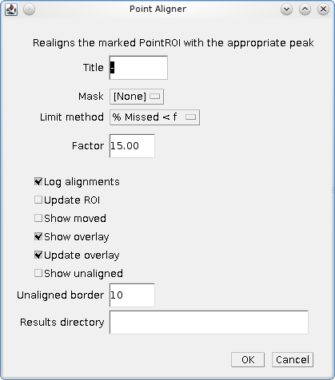

Parameters
Parameters | Description
Title | A text title to be inserted into the results table. For example this can be used within automated scripts to identify the experimenter who scored the image
Mask | Allows selection of an image mask. Only images with the same dimensions are listed. The mask can be used to restrict the region of peaks provided by the FindFoci algorithm; any peak located in a zero-value pixel will be excluded
Limit Method | The method used to set the minimum height for assigned peaks
Factor | The factor parameter used by the Limit method
Log alignments | Output the alignments to the ImageJ log window
Update ROI | If selected the point ROI on the image will be moved to the position of their assigned peaks
Show moved | Show the number of points that have been moved separately in the result table. The default is to show the OK and Moved counts together
Show overlay | Produce a coloured overlay on the image showing the points that were OK, moved, conflicting, missed or unaligned
Update overlay | If selected the overlay will show the moved points relocated to the correct positions. The default is to use the original location
Show unaligned | Extract an image containing each unaligned point. A sub-image is created containing the unaligned point plus a border of extra pixels. This allows examination of any points that cannot be aligned.  If the point is unaligned due to a conflict then the previously assigned maxima is included in the image. An overlay is added showing the point location (and the maxima if available)
Unaligned border | The number of border pixels to use for an unaligned point image
Results directory | If provided the unaligned images will be recorded to this directory. The directory path must exist.  Note: The Show unaligned option does not have to be enabled

Results Table
The results table contains details about the alignment results. The success of the alignment is assessed using binary scoring statistics. The original ROI points are compared against the potential maxima found by the FindFoci algorithm. Only maxima above the lowest assigned maxima are included. Further details of the statistics can be found in Appendix 2: Binary Scoring Statistics.
The table contains the following information:
Result | Description
Title | The Title parameter
Image | The input image
OK | The number of points that were aligned without no move
Moved | The number of points that were aligned with a move. This is only shown if Show moved is enabled
Av.Move | The average distance that an aligned point is moved in pixels. If Show moved is disabled the average includes the points that are not moved and will be lower
Conflict | The number of points that conflict with another aligned point
NoAlign | The number of points that cannot be aligned
Missed | The number of maxima that are above the lowest assigned maxima
N | The number ROI points in the image
TP | The True Positives, i.e. OK + Moved
FP | The False Positives, i.e. Conflict + NoAlign
FN | The False Negatives, i.e. Missed
Precision | The proportion of points in the image that are aligned
Recall | The proportion of identified peaks in the image that have been assigned
F1 | The F1-score, a balanced weighting of Precision and Recall. This provides an overall measure of the alignment success

Alignment Log
If the Log alignments option is enabled then the alignment result of each point will be recorded to the ImageJ log. The following text shows examples of each situation:

OK / Moved
If the peak can be aligned then the new coordinates and the pixel distance for the move are provided. The records are of the format:
Point [ID] <height> @ X,Y => <height> @ Xnew,Ynew (distance)
E.g.
Point [49] 793 @ 140,70 => 831 @ 141,70 (1.00)
Point [50] 784 @ 173,57 => 784 @ 173,57 (0.00)

Conflict
If the peak is in conflict then the ID of the other peak is provided. The coordinates of both peaks should be in close proximity. E.g.
Point [24] 1350 @ 205,67 => 1367 @ 205,68 (1.00)
Point [52] 717 @ 208,71 conflicts for assigned point [24]

NoAlign
If the peak is below the height threshold or cannot be aligned this is recorded.
Point [55] 479 @ 104,141 ~> 479 @ 104,141 (0.00) below height threshold (< 666)
Point [56] 186 @ 11,208 cannot be aligned

Unaligned Images
If a point cannot be aligned then the pixels surrounding the point can be extracted into a sub-image. A point can be unaligned for 3 reasons:
- There is no suitable maxima [noalign]
- It is below the height limit threshold [below_threshold]
- It conflicts with another aligned point [conflict]
The sub-image is named using the Input image name, the classification and the point ID:
<Input image>_<classification>_<ID>
If the image shows a conflict point or a below_threshold point then the potential maxima is included in the image. An overlay is added to mark the unaligned point and the potential maxima (if available). The images can be displayed using the Show unaligned option and/or saved to the Results directory.
The following is an example of unaligned point sub-image.
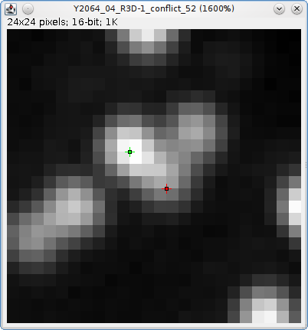
Note that in this case the conflict point (red) has been manually placed where there appears to be intensity from a second spot. However the FindFoci algorithm does not identify this as a point since it uses a downhill gradient to define peaks from local maxima. This example demonstrates how the conflict images can be used to review where the FindFoci algorithm differs from a manual peak assignment. Knowledge of the FindFoci behaviour will allow better use of the semi-automated peak labelling tool provided by the FindFoci Helper plugin (see section FindFoci Helper).

Overlay
The results of the alignment can be shown as an overlay on the original image using the Show overlay parameter. The following key is used for the overlay:
Classification | Colour
OK | Green
Moved | Yellow
Conflict | Red
NoAlign | Cyan
Missed | Magenta
The following image shows an example of an overlay applied to the image:
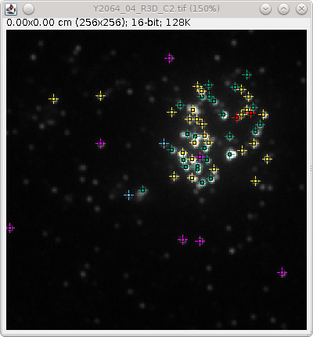
The overlay can be removed using Image > Overlay > Remove Overlay.
Note that the point ROI has been removed from the image. This is done before the overlay is added. The point ROI can be restored using the ImageJ menu option Edit > Selection > Restore Selection (Ctrl+Shift+E). The point ROI are not removed if the overlay option is disabled.

Point Extractor
ImageJ plugin that saves the XYZ coordinates from marked multi-point Regions of Interest (ROIs) in an image or the ImageJ ROI Manager to file.

Features
- Save points from a point ROI on an image (2D coordinates)
- Save points from the ROI Manager (3D coordinates)
- Optionally extract a pixel value for the coordinates from the current image
- Optionally filters the points to those within a 2D/3D mask

Overview
The Point Extractor plugin saves the coordinates from point ROIs to a coordinate file. The point ROI may be marked on an image. In this case the coordinates will be saved as 2D XY coordinates. The Z coordinate will be set to zero. Alternatively the point ROI may be read from the ImageJ ROI Manager. Each ROI in the manager is associated with a slice. The plugin saves the coordinates from all the point ROI in the ROI Manager as 3D XYZ coordinates. The Z coordinate is set using the associated slice of each ROI. The coordinate file can be used as input to train the FindFoci Optimiser.
The Point Extractor has options to save the pixel value of each coordinate from the current image to the output file. It can also restrict the coordinates to a specific subset using a mask.
When the plugin is run it counts the number of point ROI in the ImageJ ROI Manager. If no point ROI are present then the current image must have point ROI otherwise an error is shown.
If the image has point ROI then the following dialog is shown:
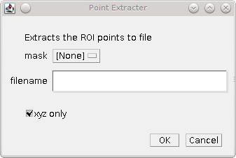
If the ROI Manager has point ROI then the following dialog is shown:
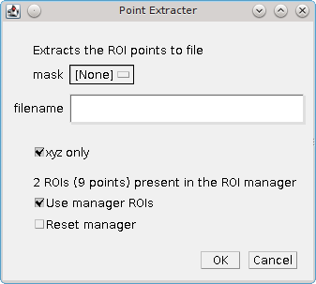

Parameters
Parameters | Description
Mask | Allows selection of an image mask. The mask can be used to restrict the coordinates. Any point located in a zero-value pixel will be excluded
Filename | The name of the file used to save the coordinates
xyz only | This option is only available if there is a current image.  If selected only the XYZ coordinates are saved to file. If not selected then the value of the XYZ coordinate in the current image is obtained and the output file will contain records of:  ID,T,X,Y,Z,Value  ID will be ascending from 1. T will be the current frame.  If the current image has multiple channels or frames then the current channel and frame will be used.
Use manager ROIs | This option is available if there are point ROIs in the ImageJ ROI Manager.  Select this option to obtain the XYZ coordinates from all the point ROIs in the ROI Manager.
Reset manager | This option is available if there are point ROIs in the ImageJ ROI Manager.  Select this option to remove all the ROIs from the ROI Manager. This can be used as part of a workflow to label an image, save the ROIs then reset the manager.

Creating a 3D coordinate file
ImageJ point ROIs only store the XY coordinates. However the FindFoci Optimiser can use 3D coordinates if they are loaded from file. The ROI can be associated with a slice in an image. Thus it is possible to generate 3D coordinates by creating multiple 2D ROIs, each associated with a particular z-slice.
The following is a suggested workflow for creating 3D coordinate files.
- Remove all ROIs from the current image: Edit> Selection > Select None (Ctrl+Shift+A)
- Clear the ROI Manager: Analyze > Tools > ROI Manager...
Select all the ROIs (if present) and click 'Delete'
- Select the ImageJ point ROI tool. Switch to single-point mode by right-clicking the tool and selecting 'Point Tool'
- Scroll up and down through the image z-stack until you have decided the correct z-slice for a point. Click the point to label it.
- Add the point to the ROI Manager: Edit > Select > Add To Manager (Ctrl+T)
- Continue labelling XY points (step 4-5).
Note if multiple foci are in the same slice then you can create a multi-point ROI by holding the Shift key. This will be replaced by a single-point if you let go of the Shift key for the next click.
- When all foci have been labelled and added to the ROI manager you can review them by clicking on each named ROI in the ROI Manager window. This will show the point ROI on the corresponding image slice.
- If all foci are correct run the Point Extractor plugin to save the foci to file. The ROI Manager can be cleared in preparation for the next image to be labelled using the Reset Manager option.

References
Herbert AD, Carr AM, Hoffmann E (2014) FindFoci: A Focus Detection Algorithm with Automated Parameter Training That Closely Matches Human Assignments, Reduces Human Inconsistencies and Increases Speed of Analysis. PLoS ONE 9(12): e114749. doi: 10.1371/journal.pone.0114749

Appendix 1: BeansBinding Java framework
The GDSC plugins require the BeansBinding framework. If you have installed the plugins using the ImageJ2 update site then all the required files will be included. However if you have installed the plugins manually then in addition to the GDSC plugins jar file you must install the BeansBinding jar. The file can be obtained from:
http://www.sussex.ac.uk/gdsc/intranet/files/beansbinding-1.2.1.jar
This file can be placed in the ImageJ plugins directory.
If the BeansBinding jar cannot be found any dependant plugin will show an error message in the ImageJ log window when initialising. The error message should provide useful information for fixing the problem.
The following plugins use the BeansBinding framework:
- FindFoci GUI
- FindFoci Optimiser GUI
- FindFoci Helper

Appendix 2: Binary Scoring Statistics
Several plugins within the GDSC package compute matches between points. When comparing the points the following combinations are possible:
Set 1 | Set 2 | Classification | Label
Present | Present | Match; True Positive | tp
Present | Absent | Unmatch 1; False Negative | fn
Absent | Present | Unmatch 2; False Positive | fp
The match/unmatch nomenclature is used when it is not clear which set is the real answer. When one set is the actual result and the other is the prediction then it is more conventional to use the tp/fn/fp nomenclature.
The classification counts can be used to compute binary scoring statistics as described below.

Jaccard
The Jaccard measures the similarity between two sets and is defined as the size of the intersection divided by the size of the union:

A score of 1 indicates that the overlap is perfect. Zero indicates no overlap.

Recall
Recall measures the number of actual points that are correctly predicted. It is also known as the True Positive Rate or sensitivity.

A score of 1 indicates that all the points were predicted, lower scores indicate that some points were missed.
Recall can be interpreted probabilistically as the chance that a randomly selected actual point will be predicted.

Precision
Precision measures the confidence of the predicted points. It is also known as the Positive Predicted Value.

A score of 1 indicates that all the predicted points were correct, lower scores indicate that some points are not correct.
Precision can be interpreted probabilistically as the chance that a randomly selected prediction is correct.

F-score
The precision and recall can be combined in a weighted score, the F_{ß}-measure or F-score.

A weight of 1 produces the balanced F-score where precision and recall are weighted equally. F_{0.5} puts more emphasis on precision and F₂ puts more emphasis on recall. However the weight ß can be any non-negative real value. The score was derived so that it measures the effectiveness of retrieval with respect to a user who attaches ß times as much importance to recall as precision.

Defining the Actual or Predicted Points
Note that the categorisation of the actual and predicted points can be arbitrary. If the categorisation is reversed then the precision and recall scores will be reversed. However the F₁-score will remain identical because it is the harmonic mean of the two scores. The F₁-score is consequently a good measure of the similarity of two sets of points that have been aligned for matches. If it is inappropriate to label either set as the actual result then the scores can be labelled as Recall 1 and Recall 2.

