17/04/2021

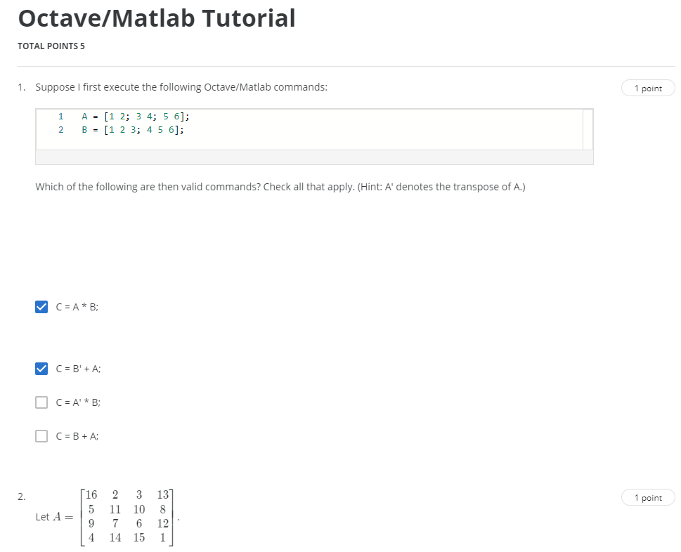

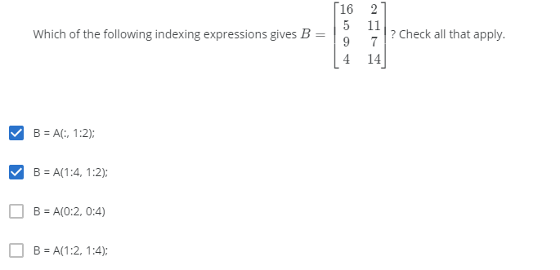

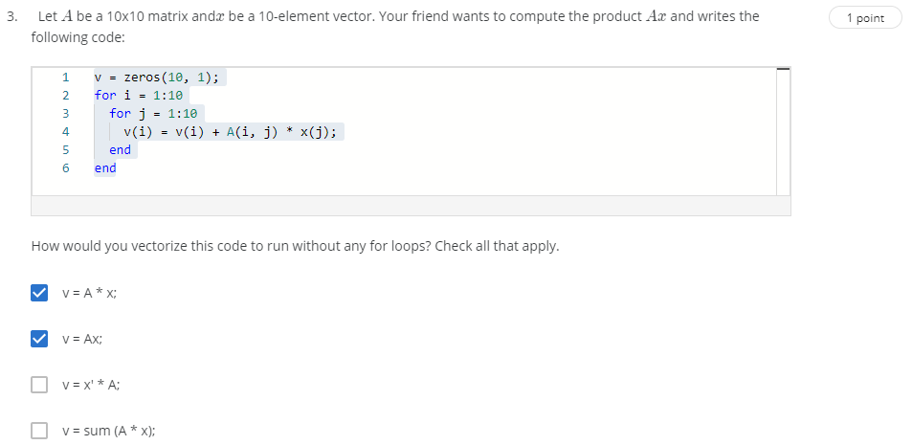

Incorrect

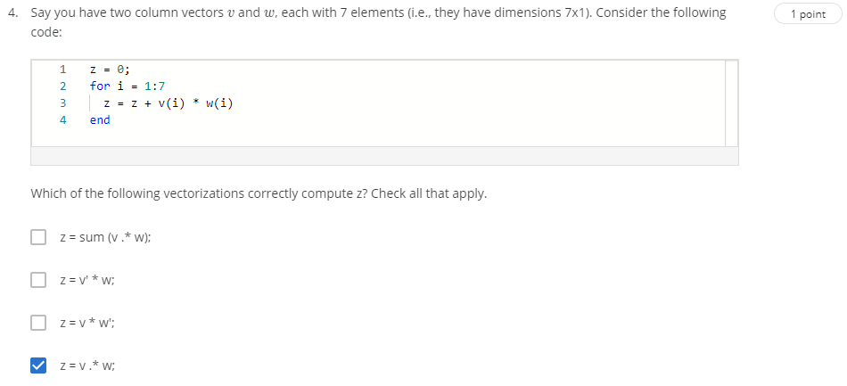

Incorrect

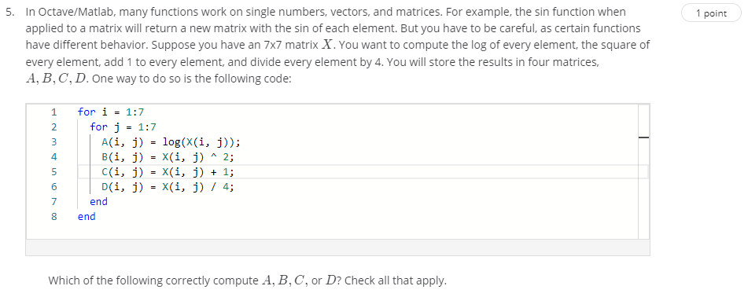

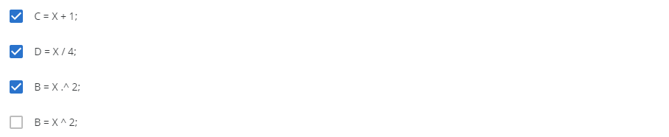

Second attempt 17/04/2021

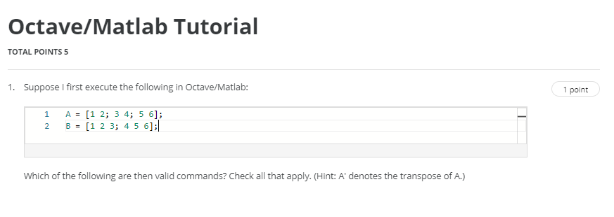



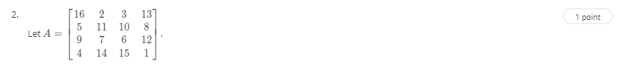



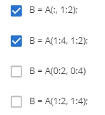

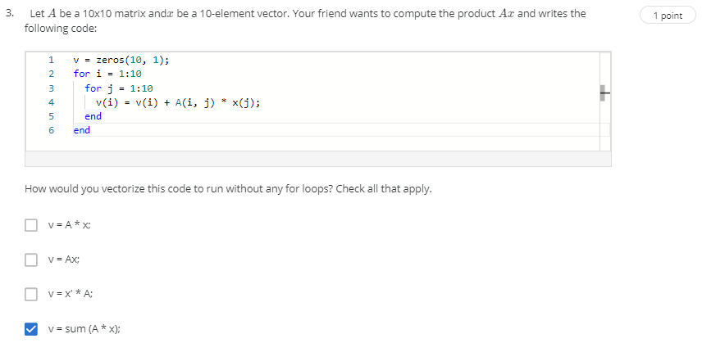

3 is incorrect… weird.

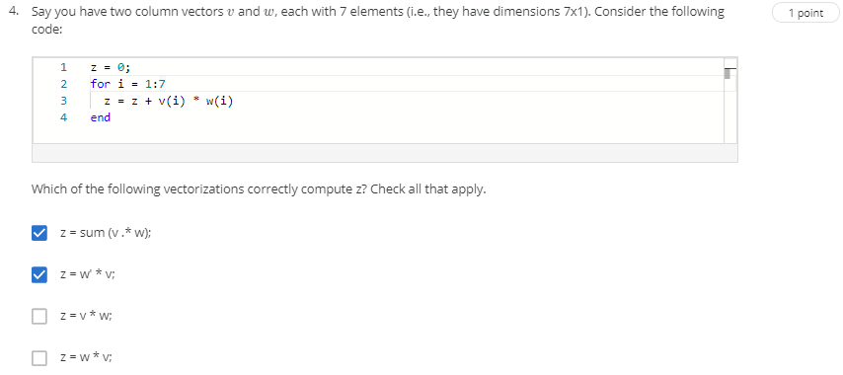

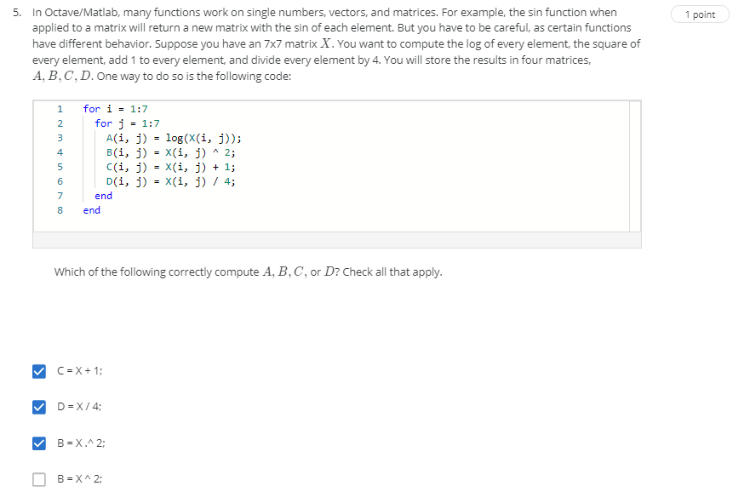

>> clear

>> A = [16 2 3 13;5 11 10 8;9 7 6 12;4 14 15 1]

A =

16 2 3 13

5 11 10 8

9 7 6 12

4 14 15 1

>> B = A(:,1:2)

B =

16 2

5 11

9 7

4 14

>> A(1:4)

ans =

16 5 9 4

>> A(1:4, 1:2)

ans =

16 2

5 11

9 7

4 14

>> A(0:2, 0:4)

error: A(0,_): subscripts must be either integers 1 to (2^63)-1 or logicals

>> A(1:2, 1:4)

ans =

16 2 3 13

5 11 10 8

>> magic(10)

ans =

92 99 1 8 15 67 74 51 58 40

98 80 7 14 16 73 55 57 64 41

4 81 88 20 22 54 56 63 70 47

85 87 19 21 3 60 62 69 71 28

86 93 25 2 9 61 68 75 52 34

17 24 76 83 90 42 49 26 33 65

23 5 82 89 91 48 30 32 39 66

79 6 13 95 97 29 31 38 45 72

10 12 94 96 78 35 37 44 46 53

11 18 100 77 84 36 43 50 27 59

>> v = zeros(10, 1);

>> for i = 1:10

for j = 1:10

v(i) = v(i) + A(i, j) * x(j);

end

end;

error: 'x' undefined near line 3, column 3

>> A = magic(10)

A =

92 99 1 8 15 67 74 51 58 40

98 80 7 14 16 73 55 57 64 41

4 81 88 20 22 54 56 63 70 47

85 87 19 21 3 60 62 69 71 28

86 93 25 2 9 61 68 75 52 34

17 24 76 83 90 42 49 26 33 65

23 5 82 89 91 48 30 32 39 66

79 6 13 95 97 29 31 38 45 72

10 12 94 96 78 35 37 44 46 53

11 18 100 77 84 36 43 50 27 59

>> v=A*x

error: 'x' undefined near line 1, column 1

>> v = A*x;

error: 'x' undefined near line 1, column 1

>> x=2

x = 2

>> v = A*x;

>> v

v =

184 198 2 16 30 134 148 102 116 80

196 160 14 28 32 146 110 114 128 82

8 162 176 40 44 108 112 126 140 94

170 174 38 42 6 120 124 138 142 56

172 186 50 4 18 122 136 150 104 68

34 48 152 166 180 84 98 52 66 130

46 10 164 178 182 96 60 64 78 132

158 12 26 190 194 58 62 76 90 144

20 24 188 192 156 70 74 88 92 106

22 36 200 154 168 72 86 100 54 118

>> Ax

error: 'Ax' undefined near line 1, column 1

>> v = Ax;

error: 'Ax' undefined near line 1, column 1

>> x'

ans = 2

>> x'*A

ans =

184 198 2 16 30 134 148 102 116 80

196 160 14 28 32 146 110 114 128 82

8 162 176 40 44 108 112 126 140 94

170 174 38 42 6 120 124 138 142 56

172 186 50 4 18 122 136 150 104 68

34 48 152 166 180 84 98 52 66 130

46 10 164 178 182 96 60 64 78 132

158 12 26 190 194 58 62 76 90 144

20 24 188 192 156 70 74 88 92 106

22 36 200 154 168 72 86 100 54 118

>> sum(A * x)

ans =

1010 1010 1010 1010 1010 1010 1010 1010 1010 1010

>> v = [1 2 3 4 5 6 7]

v =

1 2 3 4 5 6 7

>> w = [9 8 7 6 5 4 3]

w =

9 8 7 6 5 4 3

>> size(w)

ans =

1 7

>> size(v)

ans =

1 7

>> z = 0;

>> for i = 1:7

z = z + v(i) * w(i)

end

z = 9

z = 25

z = 46

z = 70

z = 95

z = 119

z = 140

>> sum(v.*w)

ans = 140

>> v

v =

1 2 3 4 5 6 7

>> v@

error: parse error:

syntax error

>>> v@

^

>> v'

ans =

1

2

3

4

5

6

7

>> v' * w

ans =

9 8 7 6 5 4 3

18 16 14 12 10 8 6

27 24 21 18 15 12 9

36 32 28 24 20 16 12

45 40 35 30 25 20 15

54 48 42 36 30 24 18

63 56 49 42 35 28 21

>> v * w'

ans = 140

>> v.*w

ans =

9 16 21 24 25 24 21

>> z=v.*w

z =

9 16 21 24 25 24 21

>> X = magic(7)

X =

30 39 48 1 10 19 28

38 47 7 9 18 27 29

46 6 8 17 26 35 37

5 14 16 25 34 36 45

13 15 24 33 42 44 4

21 23 32 41 43 3 12

22 31 40 49 2 11 20

>> A = log(X)

A =

3.4012 3.6636 3.8712 0 2.3026 2.9444 3.3322

3.6376 3.8501 1.9459 2.1972 2.8904 3.2958 3.3673

3.8286 1.7918 2.0794 2.8332 3.2581 3.5553 3.6109

1.6094 2.6391 2.7726 3.2189 3.5264 3.5835 3.8067

2.5649 2.7081 3.1781 3.4965 3.7377 3.7842 1.3863

3.0445 3.1355 3.4657 3.7136 3.7612 1.0986 2.4849

3.0910 3.4340 3.6889 3.8918 0.6931 2.3979 2.9957

>> C = X + 1

C =

31 40 49 2 11 20 29

39 48 8 10 19 28 30

47 7 9 18 27 36 38

6 15 17 26 35 37 46

14 16 25 34 43 45 5

22 24 33 42 44 4 13

23 32 41 50 3 12 21

>> D = X / 4

D =

7.5000 9.7500 12.0000 0.2500 2.5000 4.7500 7.0000

9.5000 11.7500 1.7500 2.2500 4.5000 6.7500 7.2500

11.5000 1.5000 2.0000 4.2500 6.5000 8.7500 9.2500

1.2500 3.5000 4.0000 6.2500 8.5000 9.0000 11.2500

3.2500 3.7500 6.0000 8.2500 10.5000 11.0000 1.0000

5.2500 5.7500 8.0000 10.2500 10.7500 0.7500 3.0000

5.5000 7.7500 10.0000 12.2500 0.5000 2.7500 5.0000

>> B = X.^2

B =

900 1521 2304 1 100 361 784

1444 2209 49 81 324 729 841

2116 36 64 289 676 1225 1369

25 196 256 625 1156 1296 2025

169 225 576 1089 1764 1936 16

441 529 1024 1681 1849 9 144

484 961 1600 2401 4 121 400

>> B = X ^ 2

B =

5740 4760 4081 3703 3577 4144 4620

4732 5649 4809 3927 3689 3752 4067

3948 4704 5810 4767 4025 3584 3787

3731 4032 4634 5831 4634 4032 3731

3787 3584 4025 4767 5810 4704 3948

4067 3752 3689 3927 4809 5649 4732

4620 4144 3577 3703 4081 4760 5740

>> % second attempt at quiz

>> A = [1 2; 3 4; 5 6];

>> B = [1 2 3; 4 5 6];

>> A' + B

ans =

2 5 8

6 9 12

>> B * A

ans =

22 28

49 64

>> A'

ans =

1 3 5

2 4 6

>> B

B =

1 2 3

4 5 6

>> A + B

error: operator +: nonconformant arguments (op1 is 3x2, op2 is 2x3)

>> B'

ans =

1 4

2 5

3 6

>> A

A =

1 2

3 4

5 6

>> B' * A

error: operator *: nonconformant arguments (op1 is 3x2, op2 is 3x2)

>> A * B'

error: operator *: nonconformant arguments (op1 is 3x2, op2 is 3x2)

>> A

A =

1 2

3 4

5 6

>> B

B =

1 2 3

4 5 6

>> B'

ans =

1 4

2 5

3 6

>> B'(1)

ans = 1

>> B'(:,1)

ans =

1

2

3

>> B'(:,1) * A

error: operator *: nonconformant arguments (op1 is 3x1, op2 is 3x2)

>> B' * A

error: operator *: nonconformant arguments (op1 is 3x2, op2 is 3x2)

>> A = [16 2 3 13;5 11 10 8;9 7 6 12;4 14 15 1]

A =

16 2 3 13

5 11 10 8

9 7 6 12

4 14 15 1

>> A(:, 1: 2)

ans =

16 2

5 11

9 7

4 14

>> A(1:4)

ans =

16 5 9 4

>> A(1:2)

ans =

16 5

>> A(1:4, 1:2)

ans =

16 2

5 11

9 7

4 14

>> A(0:2, 0:4)

error: A(0,_): subscripts must be either integers 1 to (2^63)-1 or logicals

>> A(1:2)

ans =

16 5

>> A(1:2, 1:4)

ans =

16 2 3 13

5 11 10 8

>> v = zeros(10, 1);

>> for i = 1:10

for j = 1:10

v(i) = v(i) + A(i, j) * x(j);

end

end;

error: x(2): out of bound 1 (dimensions are 1x1)

>> x = magic(10)

x =

92 99 1 8 15 67 74 51 58 40

98 80 7 14 16 73 55 57 64 41

4 81 88 20 22 54 56 63 70 47

85 87 19 21 3 60 62 69 71 28

86 93 25 2 9 61 68 75 52 34

17 24 76 83 90 42 49 26 33 65

23 5 82 89 91 48 30 32 39 66

79 6 13 95 97 29 31 38 45 72

10 12 94 96 78 35 37 44 46 53

11 18 100 77 84 36 43 50 27 59

>> x = ones(10)

x =

1 1 1 1 1 1 1 1 1 1

1 1 1 1 1 1 1 1 1 1

1 1 1 1 1 1 1 1 1 1

1 1 1 1 1 1 1 1 1 1

1 1 1 1 1 1 1 1 1 1

1 1 1 1 1 1 1 1 1 1

1 1 1 1 1 1 1 1 1 1

1 1 1 1 1 1 1 1 1 1

1 1 1 1 1 1 1 1 1 1

1 1 1 1 1 1 1 1 1 1

>> x = zeros(10)

x =

0 0 0 0 0 0 0 0 0 0

0 0 0 0 0 0 0 0 0 0

0 0 0 0 0 0 0 0 0 0

0 0 0 0 0 0 0 0 0 0

0 0 0 0 0 0 0 0 0 0

0 0 0 0 0 0 0 0 0 0

0 0 0 0 0 0 0 0 0 0

0 0 0 0 0 0 0 0 0 0

0 0 0 0 0 0 0 0 0 0

0 0 0 0 0 0 0 0 0 0

>> x = ones(10)

x =

1 1 1 1 1 1 1 1 1 1

1 1 1 1 1 1 1 1 1 1

1 1 1 1 1 1 1 1 1 1

1 1 1 1 1 1 1 1 1 1

1 1 1 1 1 1 1 1 1 1

1 1 1 1 1 1 1 1 1 1

1 1 1 1 1 1 1 1 1 1

1 1 1 1 1 1 1 1 1 1

1 1 1 1 1 1 1 1 1 1

1 1 1 1 1 1 1 1 1 1

>> v = zeros(10, 1);

>> for i = 1:10

for j = 1:10

v(i) = v(i) + A(i, j) * x(j);

end

end;

error: A(_,5): out of bound 4 (dimensions are 4x4)

>> v = [2 4 6 8 10 12 14]

v =

2 4 6 8 10 12 14

>> size(v)

ans =

1 7

>> v = 2;4;6;8;10;12;14]

error: parse error:

syntax error

>>> v = 2;4;6;8;10;12;14]

^

>> v = [2;4;6;8;10;12;14]

v =

2

4

6

8

10

12

14

>> size(v)

ans =

7 1

>> w = [1;3;5;7;9;11;13]

w =

1

3

5

7

9

11

13

>> size(w)

ans =

7 1

>> z = 0;

>> for i = 1:7

z = z + v(i) * w(i)

end;

z = 2

z = 14

z = 44

z = 100

z = 190

z = 322

z = 504

>> sum(v.*w)

ans = 504

>> w' * v

ans = 504

>> W'

error: 'W' undefined near line 1, column 1

>> w'

ans =

1 3 5 7 9 11 13

>> v * w

error: operator *: nonconformant arguments (op1 is 7x1, op2 is 7x1)

>> w * v

error: operator *: nonconformant arguments (op1 is 7x1, op2 is 7x1)

>>