RECOGNIZING A SWIMMING POOL ON SATELLITE IMAGES

This algorithm was developed for the test of knowledge of the company Dacuda.

The objective is to seek outdoor pools of some satellite images of Google Maps.

For that, It is possible obtain images in Google Maps in the view “Earth”, without Labels (Menu Earth->Labels off), from a distance of 100 meters, in a full screen (my computer size is 1366x768) and take a screen capture (Print screen button).

The application works with an input image, like “image.png”, and it will recognize the swimming pools and the measures. For that, the algorithms also recognize the Google Maps scale (At bottom right of the image) and apply the pixel to meters transformation. The algorithm is thinking for big swimming pools (public) so maybe it will not work with private swimming pools.

The application was developed in Windows 8.1 platform, in the Microsoft Visual Studio Express 2013 IDE.

This code is written in C++, use the OpenCV v2.4.11 libraries for the image recognition and STL in some case.

Then, examples of operation:

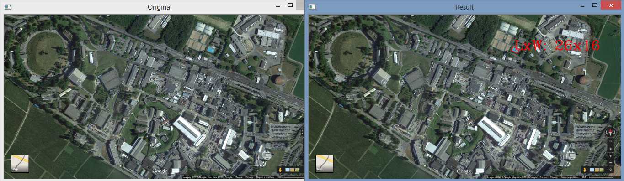

Figure 1. Swimming Pool of 26 meters x 16 meters. Real size, 26m x 15m



Figure 2. Google Maps Scale

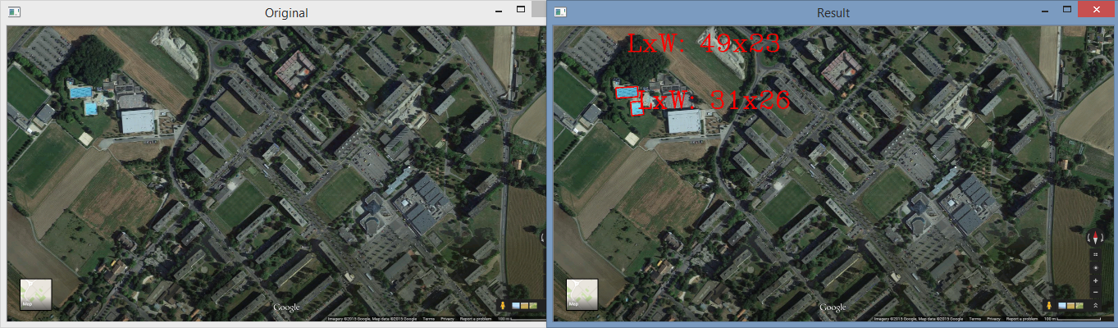

Figure 3. Multiple pools

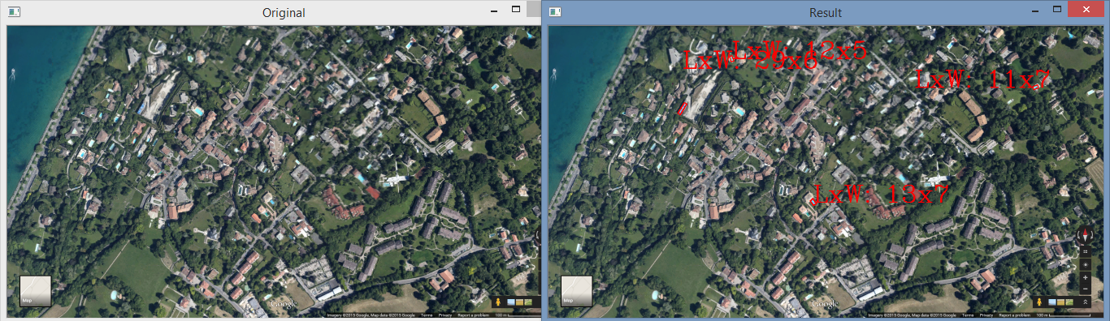

Figure 4. Searching of private swimming pools

About the figure 4, this was not specifically designed, so there is a pool that was not indicated

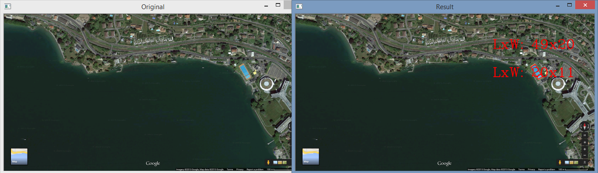

Figure 5. Several pools