Aaron Heumphreus
Project 2
10/21/2024
CS 5130
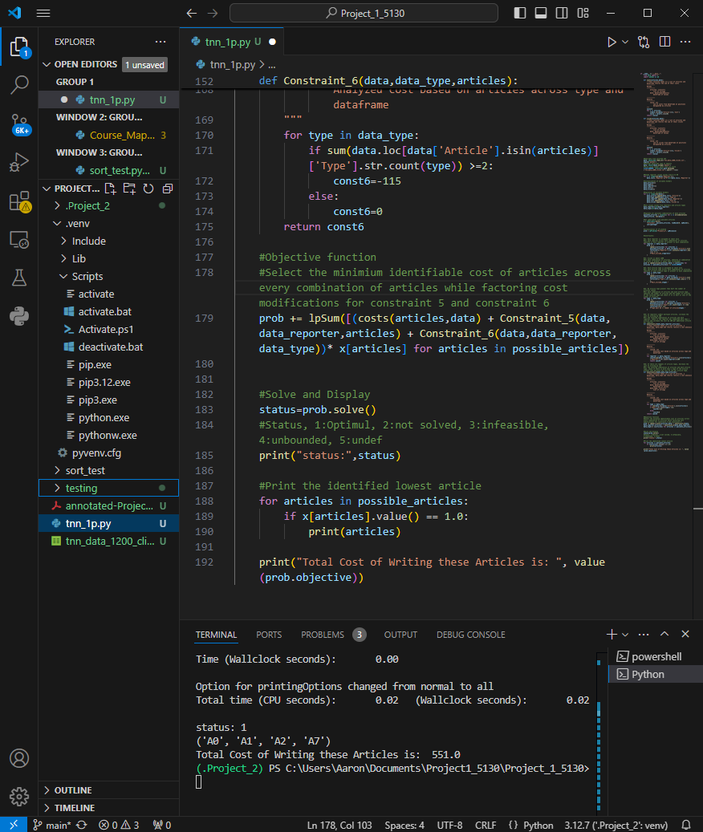
if __name__ == "__main__":
from pulp import *
import pandas as pd

def costs(articles,data):
"""This function takes in a list of articles and dataframe returns the sum of their costs
----------
Params
----------
articles: list[str]
list of strings
data: dataframe[objects]
dataframe of values

----------
Returns
----------
value: int
sum of costs from dataframe at positions designated by articles
"""
value=0
for i in articles:
x=data.loc[data['Article']==i,'Cost']
value = value+x.iloc[0]
return (value)

def clicks(articles,data):
"""This function takes in a list of articles and dataframe and returns the sum of their clicks
----------
Params
----------
articles: list[str]
list of strings
data: dataframe[objects]
dataframe of values

----------
Returns
----------
value: int
sum of clicks from dataframe at positions designated by articles
"""
value=0
for i in articles:
x=data.loc[data['Article']==i,'Clicks']
value = value+x.iloc[0]
return (value)

#Read data from selected CSV
data: object=pd.read_csv('tnn_data_1200_clicks.csv', engine='python')
#Reformat dataframe type to objects
data: object=data.astype('object')
#Parse click number value from csv title
CLICK_NUMBER: int=int(os.path.basename('tnn_data_1200_clicks.csv').split("_")[2])

#Rename reporter column values from # to R#
for i in range(len(data['Reporter'])):
data.loc[i,'Reporter']="R"+str(data.loc[i,'Reporter'])

#Initialization of variable holders
data_article=[]
data_type=[]
data_reporter=[]
data_cost=[]
data_clicks=[]

#Population of variable holders
for i in range(len(data)):
data_article.append(data.loc[i,'Article'])
data_type.append(data.loc[i,'Type'])
data_reporter.append(data.loc[i,'Reporter'])
data_cost.append(data.loc[i,'Cost'])
data_clicks.append(data.loc[i,'Clicks'])

#Pull unique values from reporters and article types
data_reporter=set(data_reporter)
data_type=set(data_type)

#Populate all possible combinations of data articles
possible_articles = [tuple(c) for c in allcombinations(data_article, len(data))]

#Set LpVariables with possible articles
x = LpVariable.dicts(
"articles", possible_articles, lowBound=0, upBound=1, cat=LpInteger
)

#Initalization of LP problem
prob = LpProblem("Project_2", LpMinimize)

#Constraints:

#C1: Each reporter is assigned at least once
#For each reporter across each combination of articles, identify if each reporter is present in each combination
for reporter in data_reporter:
prob += (
lpSum([x[articles] for articles in possible_articles if data.loc[data['Article'].isin(articles)]['Reporter'].str.contains(reporter).any()]) >= 1,
f"Must_include_{reporter}"
)

#C2: Clicks is above 1200
#For each combination of articles, identify if combination of clicks is greater or equal than clicknumber
prob += lpSum([clicks(articles,data) * x[articles] for articles in possible_articles]) >= CLICK_NUMBER

#C3: Each article type is assigned at least once
#For each article type across each combination of articles, identify if each article type is present in each combination
for type in data_type:
prob += (
lpSum([x[articles] for articles in possible_articles if data.loc[data['Article'].isin(articles)]['Type'].str.contains(type).any()] ) >= 1,
f"Must_include_{type}."
)

#C4: No article type greater than half the number of articles chosen
#For each combination of articles and each article type, identify the number of articles and the number of articles of the selected type and check if it is half or less of the number of articles.
for type in data_type:
prob +=(
lpSum([x[articles] for articles in possible_articles if sum(data.loc[data['Article'].isin(articles)]['Type'].str.count(type)) <= (len(articles)/2)]) ==1,
f"Type must be <= number of articles{type}."
)

#C5: If reporters submit multiple articles, increase the cost of writing by 100
#For the selected combination of articles and each reporter, check if the reporter has submitted more than 1 article and increase the cost by 100 per additional article per reporter
def Constraint_5(data,data_reporter,articles):
"""This function takes in a list of articles, a dataframe, data_type and returns returns a cost analysis
----------
Params
----------
articles: list[str]
list of strings
data: dataframe[objects]
dataframe of values
data_type: list[str]
list of strings

----------
Returns
----------
const6: int
Analyzed cost based on articles across type and dataframe
"""
for reporter in data_reporter:
const5=sum(data.loc[data['Article'].isin(articles)]['Reporter'].str.count(reporter))*100
return const5

#C6: If there are repeats of article types, decrease the cost of writing by 115
#For the selected combination of articles and each article type, check if there is more than 1 type of the article present then decrease the cost by 115 per article type.
def Constraint_6(data,data_type,articles):
"""This function takes in a list of articles, a dataframe, data_type and returns returns a cost analysis
----------
Params
----------
articles: list[str]
list of strings
data: dataframe[objects]
dataframe of values
data_type: list[str]
list of strings

----------
Returns
----------
const6: int
Analyzed cost based on articles across type and dataframe
"""
for type in data_type:
if sum(data.loc[data['Article'].isin(articles)]['Type'].str.count(type)) >=2:
const6=-115
else:
const6=0
return const6

#Objective function
#Select the minimium identifiable cost of articles across every combination of articles while factoring cost modifications for constraint 5 and constraint 6
prob += lpSum([(costs(articles,data) + Constraint_5(data,data_reporter,articles) + Constraint_6(data,data_reporter,data_type))* x[articles] for articles in possible_articles])

#Solve and Display
status=prob.solve()
#Status, 1:Optimul, 2:not solved, 3:infeasible, 4:unbounded, 5:undef
print("status:",status)

#Print the identified lowest article
for articles in possible_articles:
if x[articles].value() == 1.0:
print(articles)

print("Total Cost of Writing these Articles is: ", value(prob.objective))
(.Project_2) PS C:\Users\Aaron\Documents\Project1_5130\Project_1_5130> _5130/tnn_1p.py
Welcome to the CBC MILP Solver
Version: 2.10.3
Build Date: Dec 15 2019

command line - C:\Users\Aaron\Documents\Project1_5130\Project_1_5130\.Pps -timeMode elapsed -branch -printingOptions all -solution C:\Users\Aa
At line 2 NAME MODEL
At line 3 ROWS
At line 17 COLUMNS
At line 3414 RHS
At line 3427 BOUNDS
At line 3683 ENDATA
Problem MODEL has 12 rows, 255 columns and 2631 elements
Coin0008I MODEL read with 0 errors
Option for timeMode changed from cpu to elapsed
Continuous objective value is 551 - 0.00 seconds
Cgl0003I 83 fixed, 0 tightened bounds, 0 strengthened rows, 1 substitut
Cgl0004I processed model has 0 rows, 0 columns (0 integer (0 of which b
Cbc3007W No integer variables - nothing to do
Cuts at root node changed objective from 551 to -1.79769e+308
Probing was tried 0 times and created 0 cuts of which 0 were active aft
Gomory was tried 0 times and created 0 cuts of which 0 were active afte
Knapsack was tried 0 times and created 0 cuts of which 0 were active af
Clique was tried 0 times and created 0 cuts of which 0 were active afte
MixedIntegerRounding2 was tried 0 times and created 0 cuts of which 0 w
FlowCover was tried 0 times and created 0 cuts of which 0 were active a
TwoMirCuts was tried 0 times and created 0 cuts of which 0 were active
ZeroHalf was tried 0 times and created 0 cuts of which 0 were active af

Result - Optimal solution found

Objective value: 551.00000000
Time (Wallclock seconds): 0.00

Option for printingOptions changed from normal to all
Total time (CPU seconds): 0.02 (Wallclock seconds): 0.02

status: 1
('A0', 'A1', 'A2', 'A7')
Total Cost of Writing these Articles is: 551.0

Formulation:
