User Manual
  - FINANCE MODULE

  - 

  - All rights reserved-Megaplus Technologies

  - All Rights Reserved: Megaplus Technologies
Table of Contents
Starting work on ERP: 3
➢ Login Screen: 3
Login : 3
➢ Accounts: 4
Chart of Account Level 1: 4
Chart of Account Level 2: 4
Chart of Account Level 3: 5
Chart of Account Level 4: 6
➢ Finance Admin: 6
Voucher Posting: 6
Add New Company: 8
Add Company Rates: 9
➢ Financial Reports: 9
Chart Of Account: 9
Voucher Search: 13
Trial Balance: 14
Voucher Posting: 15
Trial Balance Report: 16
Expense Entry: 17
Profit & Loss Report: 17
Parties Payable & Receivable: 19
Party Ledger Report: 19
Advance Payment: 20
Cashier Receipts & Payments 21
Payment To Vender 22
New Invoice 23
Parties Outstanding 24
Parties Balance Statement 27
Advance Statement 29
Party Tax Deduction 30

Starting work on ERP:
- Open Chrome, Firefox, Safari or Internet Explorer.
- Enter url in URL Bar:
http://192.168.8.94/demo/login.aspx

Login Screen:

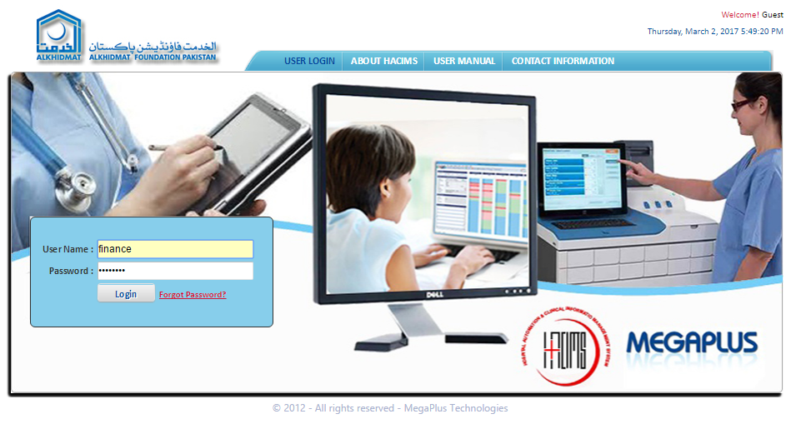

Login :
- Enter login details and click on Login.
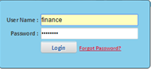

Accounts:

Chart of Account Level 1:
- Click on Accounts from menu bar.
- Select Level 1 for drop down list of Accounts.
- Screen will appear as mention below screen:
- Enter Level 1 Code in level 1 code text box.
- Enter Level 1 Old Code in level 1 old code text box.
- Enter Level 1 Name in level 1 name text box.
- Click on button Save.
- Information will save successfully and show at the bottom of screen.
- To delete Account head level 1 click on Delete.

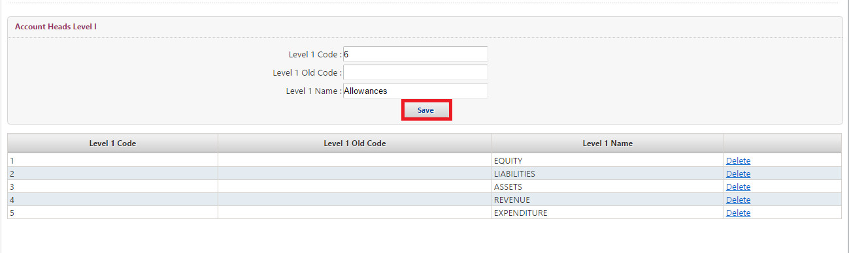

Chart of Account Level 2:
- Click on Accounts from menu bar.
- Select Level 2 from drop down list of Account.
- Screen will appear as mention below screen.
- Select Level Name from drop down list of level name search box.
- Enter Level 2 Code in level 2 code text box.
- Enter Level 2 Old Code in level 2 old code text box.
- Enter Level 2 Name in level 2 name text box.
- Click on save button.
- Information will save successfully and show at the bottom of screen.
- To delete Account head level 2 click on Delete.
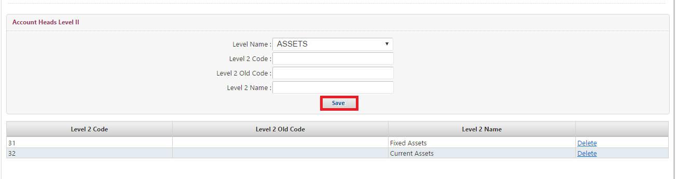

Chart of Account Level 3:
- Click on Accounts from menu bar.
- Select Level 3 from drop down list of Account.
- Screen will appear as mention below screen.
- Select Level 1 Name from drop down list of level 1 name search box.
- Select Level 2 Name from drop down list of level 2 name search box.
- Enter Level 3 Code in level 3 code text box.
- Enter Level 3 Old Code in level 3 old code text box.
- Enter Level 3 Name in level 3 name text box.
- Click on save button.
- Information will save successfully and show at the bottom of screen.
- To delete Account head level 3 click on Delete.
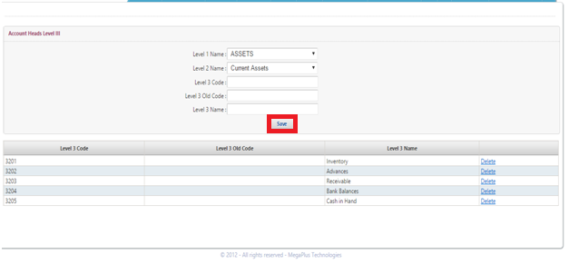

Chart of Account Level 4:
- Click on Accounts from menu bar.
- Select Level 4 from drop down list of Account.
- Screen will appear as mention below screen.
- Select Level 1 Name from drop down list of level 1 name search box.
- Select Level 2 Name from drop down list of level 2 name search box.
- Select Level 3 Name from drop down list of level 3 name search box.
- Enter Level 4 Code in level 4 code text box.
- Enter Level 4 Old Code in level 4 old code text box.
- Enter Level 4 Name in level 4 name text box.
- Click on save button.
- Information will save successfully and show at the bottom of screen.
- To delete Account head level 4 click on Delete.
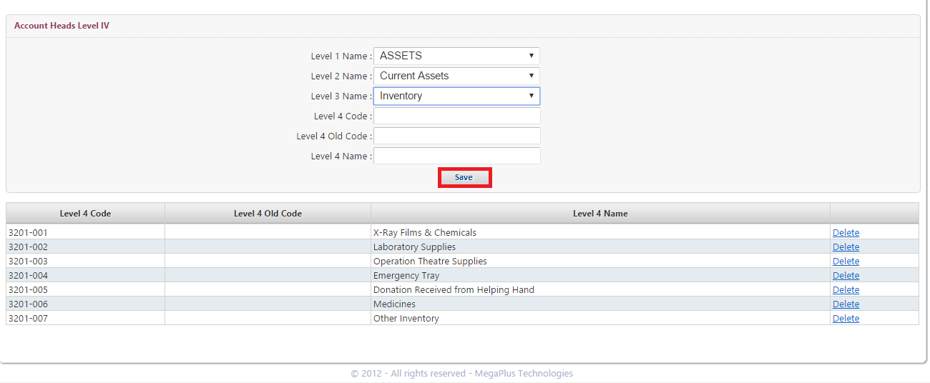

Finance Admin:

Voucher Posting:
- Click on Finance Admin from menu bar.
- Select Voucher Posting from drop down list of Finance Admin.
- Screen will appear as mention below screen.
- Select Company from drop down list of Select Company select box.
- Select Branch from drop down list of Select branch select box.
- Select Group of Companies from drop down list of Group of Companies select box.
- Select Transaction Type from drop down list of Transaction Type select box.
- Enter File No. in File No. text box.
- Select Date from drop down date dialog box.
- Enter Month Code in Month Code text box.
- Select Voucher For from Voucher for list by click on radio button.
- Select Payable to M/s from drop down list of Payable to M/s select box.
- Enter Company in text box.
- Enter Narration in narration text box.
- Enter Account Detail.
- Enter Code in code text box.
- Select Heads (Budget Balance) from drop down list of Heads (Budget Balance) select box.
- Select Company from drop down list of company select box.
- Enter Debit amount in Dr. Text box.
- Enter Credit amount in Cr. Text box.
- Select Prepared By from drop down list of prepared by select box.
- Click on save button.
- Information will save successfully.

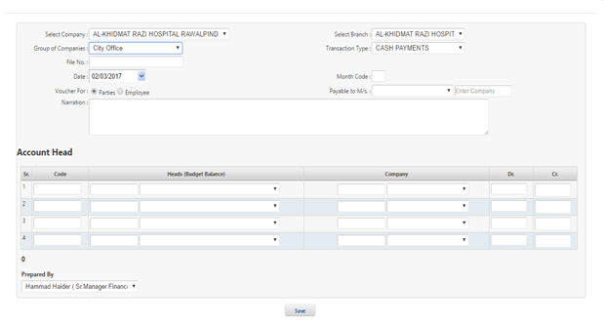

Add New Company:
- Click on Finance Admin from menu bar.
- Select Add New Company from drop down list of Finance Admin.
- Screen will appear as mention below screen.
- Enter Company/Party Name in Company/Party Name text box.
- Search NTN# in NTN# search box.
- Enter City in City text box.
- Enter Address in Address text box.
- Enter Contact Person Name in Contact Person Name text box.
- Enter CNIC in CNIC text box.
- Enter Phone in Phone text box.
- Enter Fax in Fax text box.
- Enter Email in Email text box.
- Enter Website in Website text box.
- Enter STR# in STR# text box.
- Enter Bank A/C No. in Bank A/C No. text box.
- Select Status from drop down list of select box.
- Click on save button.
- Information will save successfully and show at the right side of screen.
- To see and update the information of existing company click on Select form list of Companies.

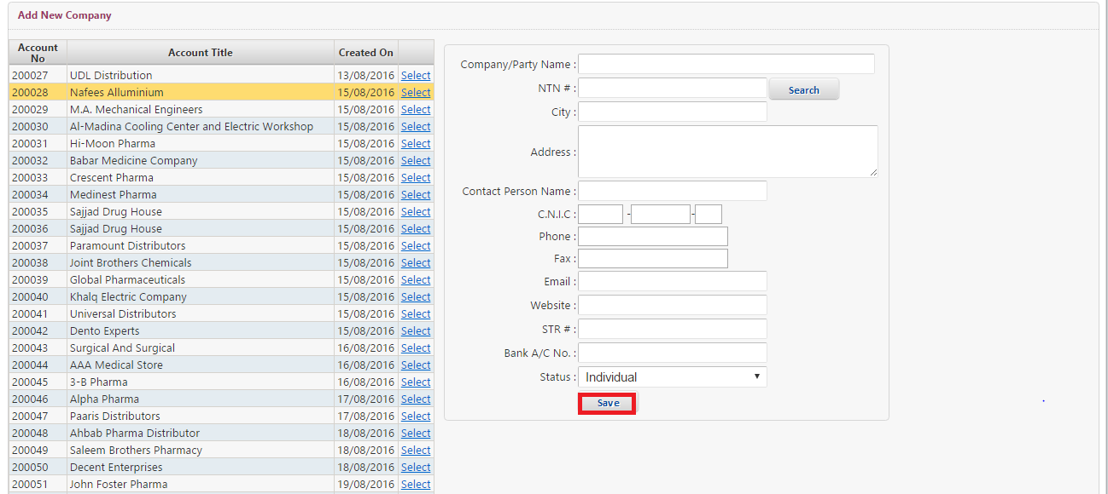

Add Company Rates:
- Click on Finance Admin from menu bar.
- Select Add Company Rates from drop down list of Finance Admin.
- Screen will appear as mention below screen.
- Select Party from drop down list of Party select box.
- Select from Date from drop down from date dialog box.
- Select to Date from drop down To date dialog box.
- Enter Rate in Rate text box.
- Click on Save.
- To delete Patient Billing Party click on cross.
- Information will save successfully and display at the bottom of screen.
- Enter Designation in designation text box.
- Click on Save.
- Information will save successfully and display at the bottom of screen.
- To delete designation click on cross.
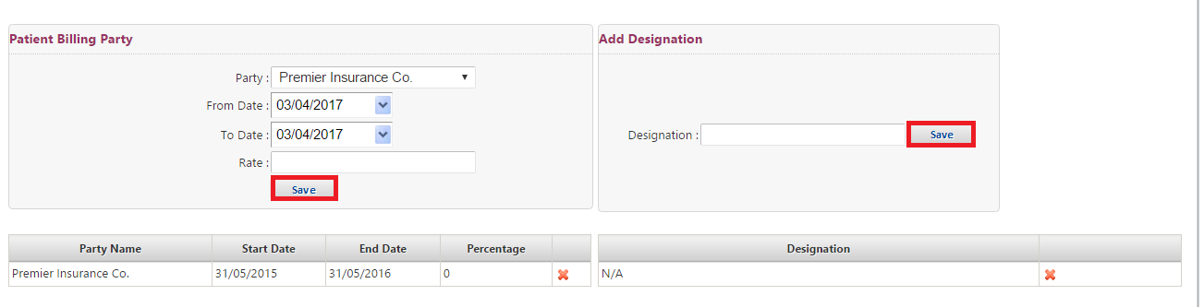

Financial Reports:

Chart Of Account:
- Click on Finance Reports from menu bar.
- Select Chart of Account from drop down list of Finance Reports.
- Screen will appear as mention below screen.
- See the Chart of Account group tree number wise which is on the left side of screen.
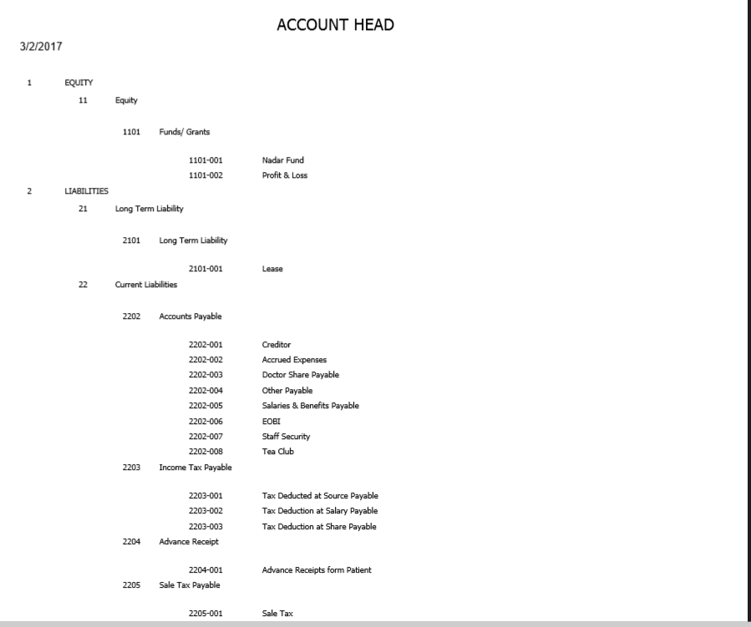
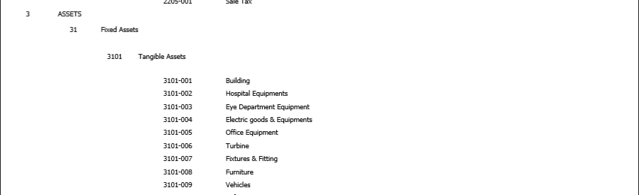

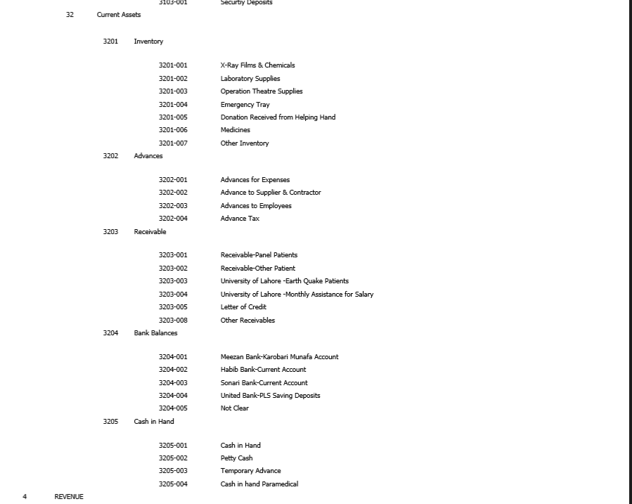
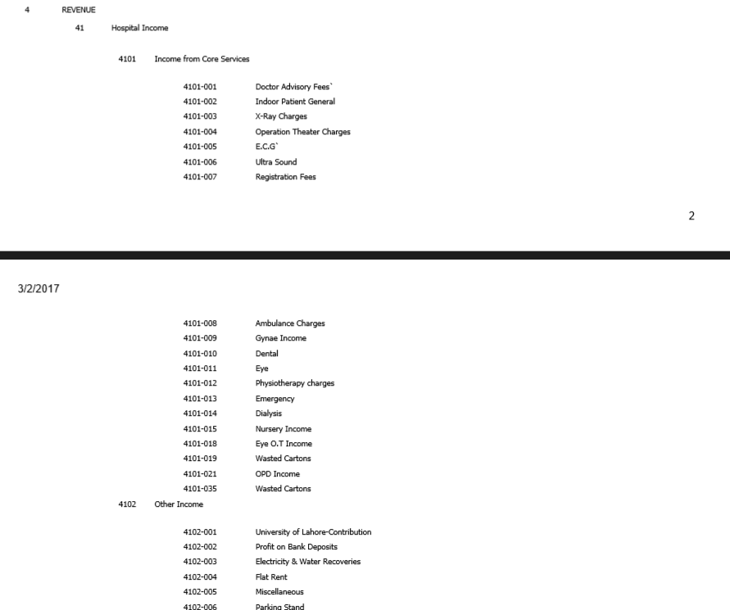
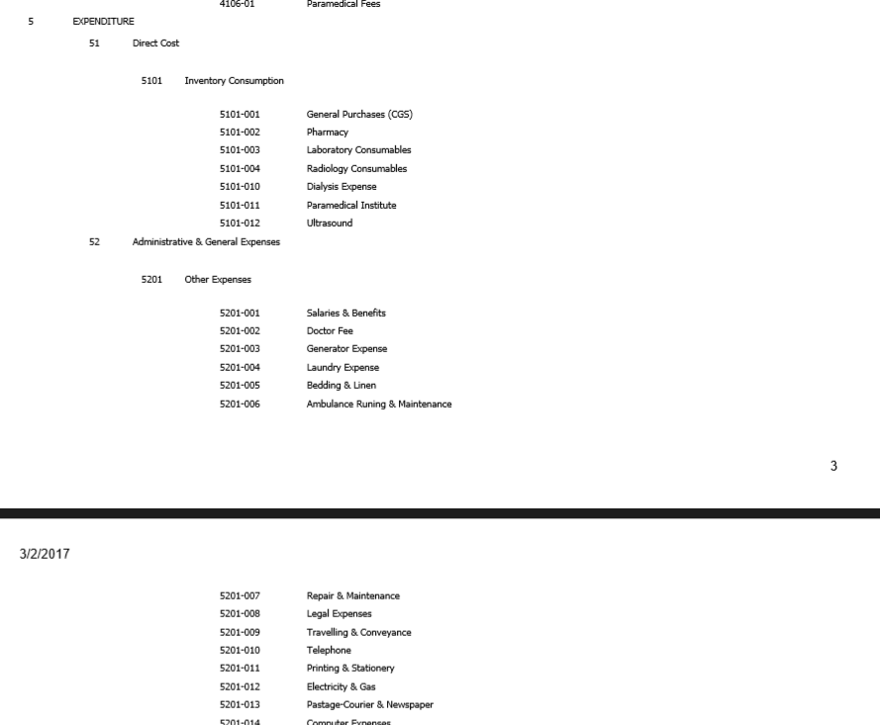

Voucher Search:
- Click on Finance Reports from menu bar.
- Select Voucher Search from drop down list of Finance Reports.
- Screen will appear as mention below screen.
- Search Voucher by different parameters.
- Select Company from drop down list of Select Company select box.
- Select Branch from drop down list of Select Branch select box.
- Select Party from drop down list of Select Party select box.
- Enter Voucher# in voucher text box.
- Select date start From.
- Select date end to.
- Click on Search button.
- Required voucher Information will filter at the bottom of screen.
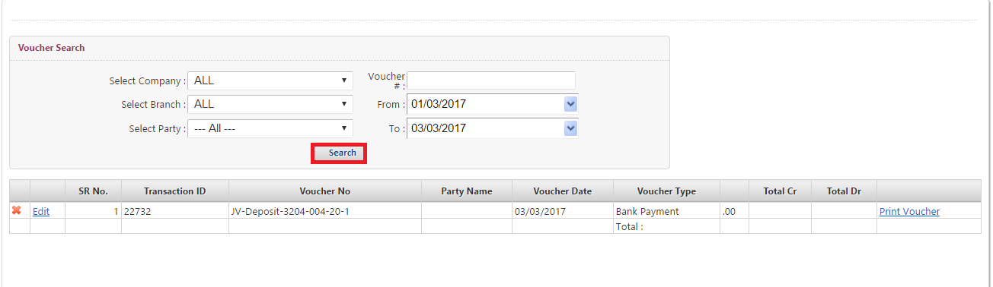

Trial Balance:
- Click on Finance Reports from menu bar.
- Select Trial Balance from drop down list of Finance Reports.
- Screen will appear as mention below screen.
- Search Trial Balance by different parameters.
- Select Company from drop down list of Select Company select box.
- Select Branch from drop down list of Select Branch select box.
- Select Party from drop down list of Select Party select box.
- Select Start Date from drop down Start date dialog box.
- Select End Date from drop down End date dialog box.
- Click on Search button.
- Required voucher Information will filter at the bottom of screen.
- To convert the detail of trial balance into excel file click on Export.
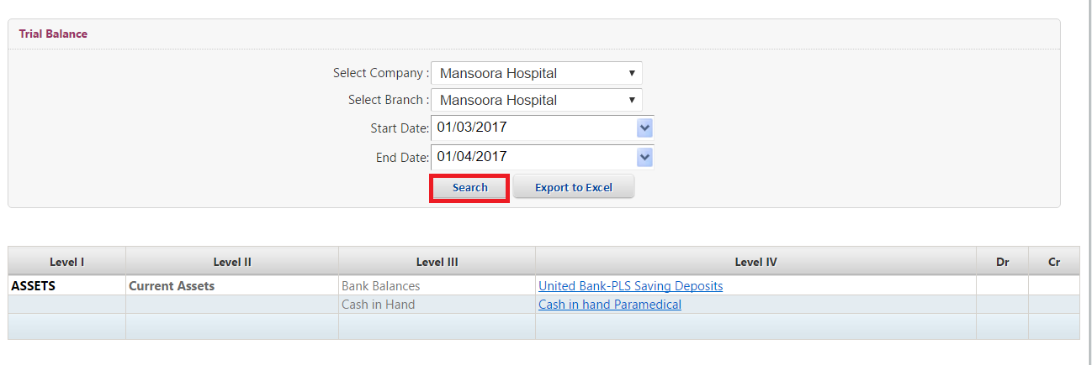

Voucher Posting:
- Click on Finance Reports from menu bar.
- Select Voucher Posting from drop down list of Finance Reports.
- Screen will appear as mention below screen.
- Select Company from drop down list of Select Company select box.
- Select Branch from drop down list of Select branch select box.
- Select Group of Companies from drop down list of Group of Companies select box.
- Select Transaction Type from drop down list of Transaction Type select box.
- Enter File No. in File No. text box.
- Select Date from drop down date dialog box.
- Enter Month Code in Month Code text box.
- Select Voucher For from Voucher for list by click on radio button.
- Select Payable to M/s from drop down list of Payable to M/s select box.
- Enter Company in text box.
- Enter Narration in narration text box.
- Enter Account Detail.
- Enter Code in code text box.
- Select Heads (Budget Balance) from drop down list of Heads (Budget Balance) select box.
- Select Company from drop down list of company select box.
- Enter Debit amount in Dr. Text box.
- Enter Credit amount in Cr. Text box.
- Select Prepared By from drop down list of prepared by select box.
- Click on save button.
- Information will save successfully.


Trial Balance Report:
- Click on Finance Reports from menu bar.
- Select Trial Balance Report from drop down list of Finance Reports.
- Screen will appear as mention below screen.
- Search Trial Balance Report by different parameters.
- Select Company from drop down list of Select Company select box.
- Select Branch from drop down list of Select Branch select box.
- Select Start Date from drop down Start date dialog box.
- Select End Date from drop down End date dialog box.
- Click on Search button.
- Trial Balance Report screen will appear as mention below.
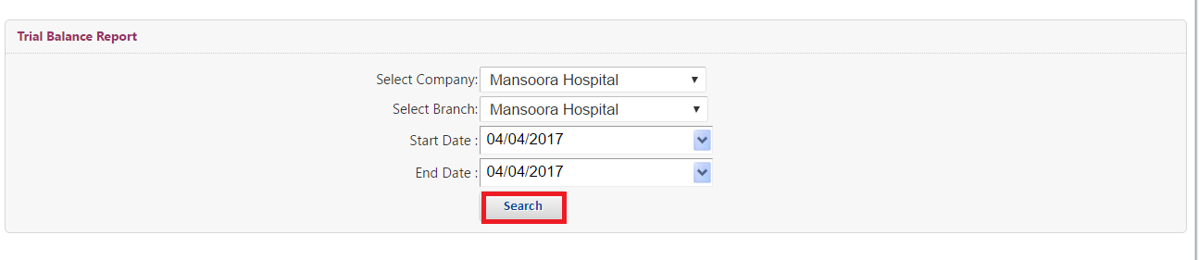
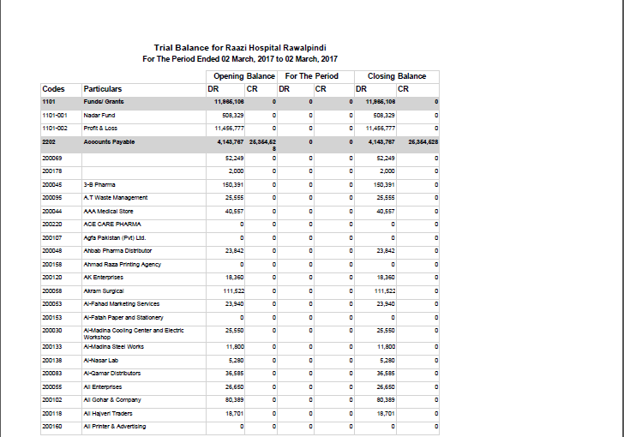

Expense Entry:
- Click on Finance Reports from menu bar.
- Select Expense Entry from drop down list of Finance Reports.
- Screen will appear as mention below screen.
- Select Company from drop down list of Company select box.
- Select Branch from drop down list of Branch select box.
- Select Expense from drop down list of Expense select box.
- Select Expense Date from drop down Expense date dialog box.
- Enter Amount in Amount text box.
- Select BY Employee from drop down list of By Employee select box.
- Enter Description in Description text box.
- Select Account# by click on radio button.
- Select Expense Type from Drop down list of select box.
- Click on save button.
- Expense Entry report will display at the bottom of screen.
- To see Expense Entry report click on View Report which is at the right side of screen.
- To see the existing Expense Entry enter name in Search box.

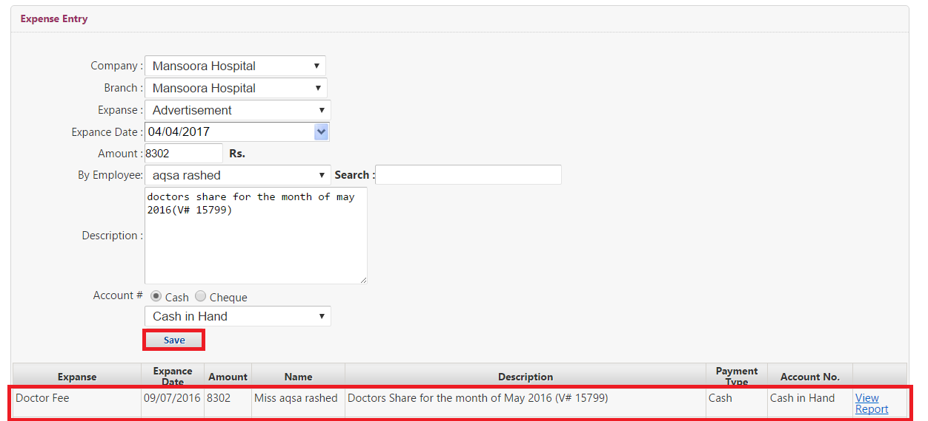

Profit & Loss Report:
- Click on Finance Reports from menu bar.
- Select Profit & Loss Report from drop down list of Finance Reports.
- Screen will appear as mention below screen.
- Search Profit & Loss Report by different parameters.
- Select Company from drop down list of Select Company select box.
- Select Branch from drop down list of Select Branch select box.
- Select Start Date from drop down Start date dialog box.
- Select End Date from drop down End date dialog box.
- Click on Search button.
- Profit & Loss Report screen will appear as mention below.
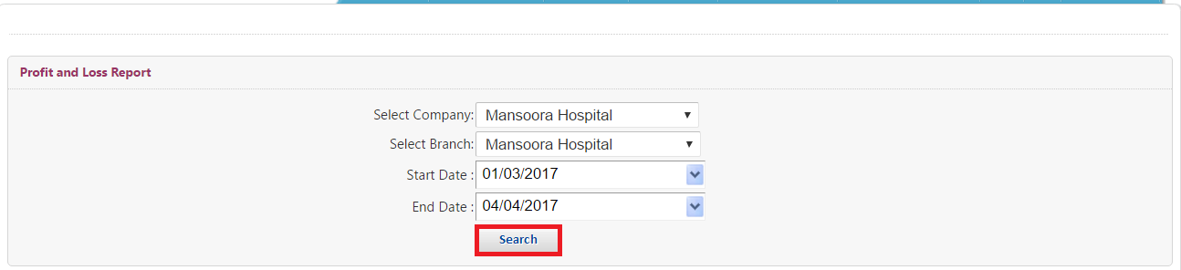
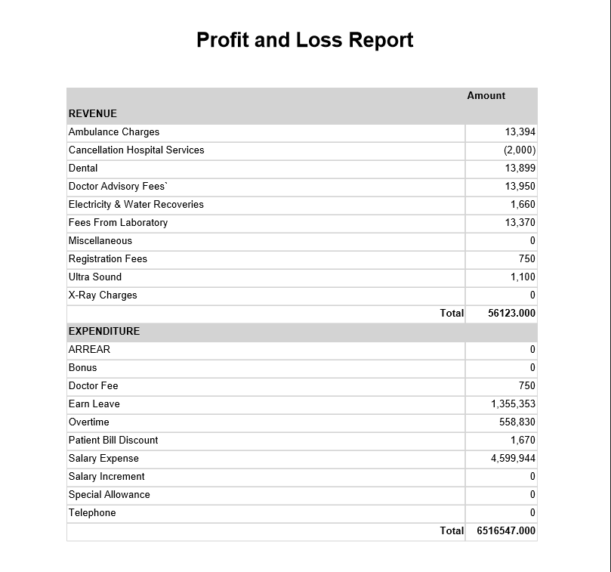

Parties Payable & Receivable:
- Click on Finance Reports from menu bar.
- Select Parties Payable & Receivable from drop down list of Finance Reports.
- Screen will appear as mention below screen.
- Select Company from drop down list of Select Company select box.
- Select Branch from drop down list of Select Branch select box.
- Select From Date from drop down From date dialog box.
- Select To Date from drop down To date dialog box.
- Enter Party Name in Party Name text box.
- Click on Search button.
- Parties Payable & Receivable Report screen will appear at below of screen.

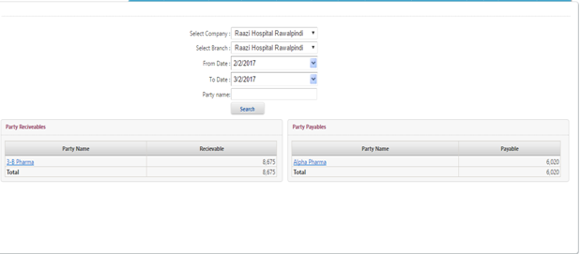

Party Ledger Report:
- Click on Finance Reports from menu bar.
- Select Party Ledger Report from drop down list of Finance Reports.
- Screen will appear as mention below screen.
- Select Company Branch from drop down list of Company Branch select box.
- Select Party from drop down list of select box.
- Select from Date from drop down from date dialog box.
- Select To Date from drop down To date dialog box.
- Click on View Report.
- Party Ledger Report screen will appear at below of screen.

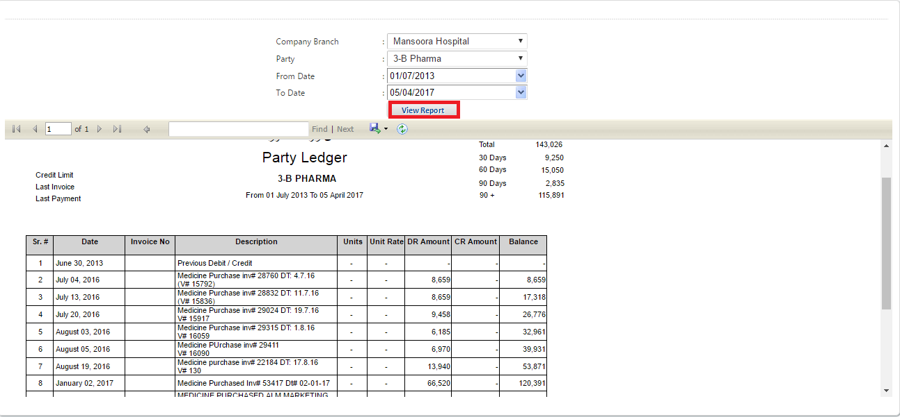

Advance Payment:
- Click on Finance Reports from menu bar.
- Select Advance Payment from drop down list of Finance Reports.
- Screen will appear as mention below screen.
- Select for Branch from drop down list of For Branch select box.
- Select by Branch from drop down list of By Branch select box.
- Select Expense from drop down list of Expense select box.
- Select Expense Date from drop down Expense date dialog box.
- Enter Amount in Amount text box.
- Select Advance to Employee from drop down list of Advance To Employee select box.
- Enter Description in Description text box.
- Select Account# by click on radio button.
- Click on save button.
- Information will display at the bottom of screen.
- To return the advance payment click on Return Advance button.
- To see the existing Detail of Advance Payment enter name in Search box.

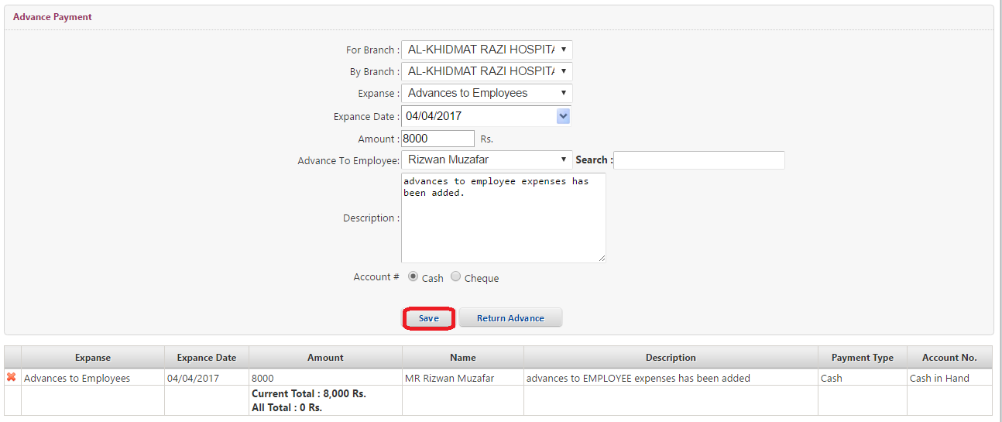
Cashier Receipts & Payments:
- Click on Finance Reports from menu bar.
- Select Cashier Receipts & Payments from drop down list of Finance Reports.
- Screen will appear as mention below screen.
- Select Company from drop down list of Select Company select box.
- Select Branch from drop down list of Select Branch select box.
- Select Mode of Payment from drop down list of Mode Of Payment select box.
- Select Date From drop down From dialog box.
- Select Date To from drop down To dialog box.
- Click on Search button.
- Cashier Receipts & Payments Report screen will appear.
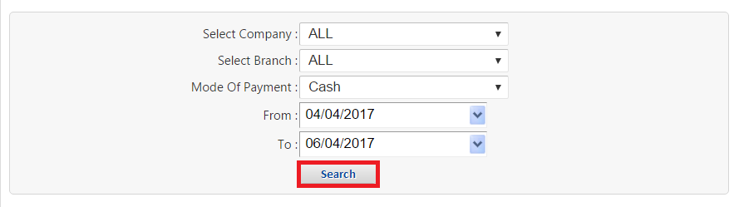
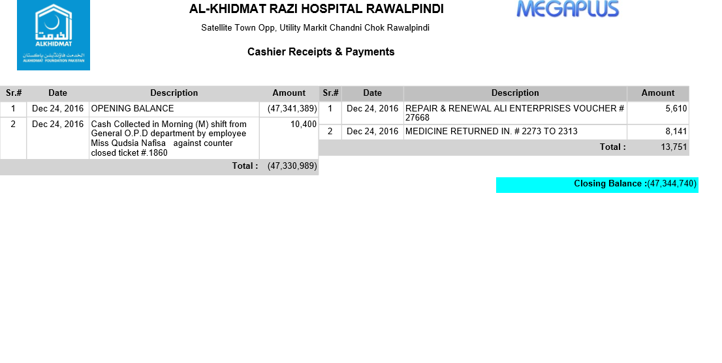
Payment To Vender:
- Click on Finance Reports from menu bar.
- Select Payment to Vender from drop down list of Finance Reports.
- Screen will appear as mention below screen.
- Select Payment from drop down list of payment select box.
- Select Payment Date from drop down Expense date dialog box.
- Enter Amount in Amount text box.
- Enter %GST (Calculated Tax Amount) in %GST text box.
- Enter %WithHolding/Income (Calculated Tax Amount) in %WithHolding/Income text box.
- Enter %Other (Calculated Tax Amount) in %other text box.
- Enter %Final Amount in Final Amount text box.
- Enter Vender Name in Search Vender text box.
- Select Company from drop down list of select box.
- Enter Description in description text box.
- Select Mode of Payment from drop down list of Mode Of Payment select box.
- Select Account Head from drop down list of select Account Head select box.
- Click on Save Button.
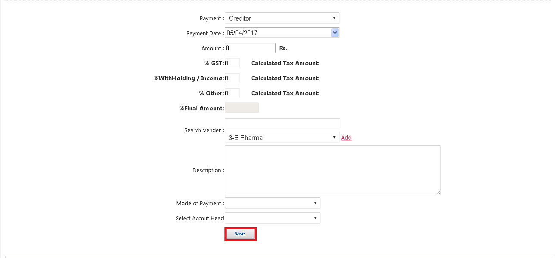

New Invoice:
- Click on Finance Reports from menu bar.
- Select New Invoice from drop down list of Finance Reports.
- Screen will appear as mention below screen.
- Enter Purchase Invoice in Purchase Invoice text box.
- Select Invoice Company from drop down list of Invoice Company select box.
- Enter Invoice# in Invoice# text box.
- Enter Invoice Date in Invoice date text box.
- Enter Invoice Amount in Invoice Amount text box.
- Enter Invoice Description in Invoice Description text box.
- To attach Invoice Attachment Click on Choose File Button.
- To attach other Attachment Click on Choose File Button.
- Click on Save Button.
- Information will save Successfully.
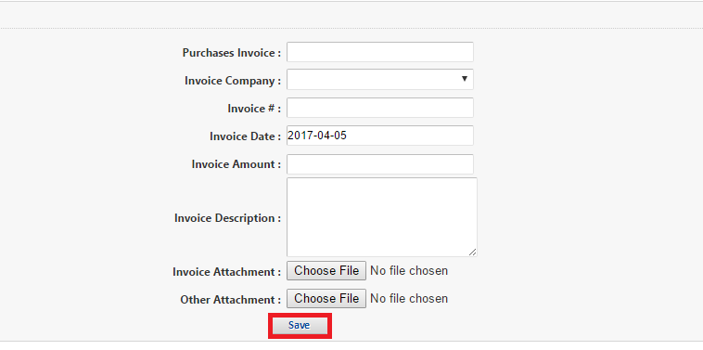

Parties Outstanding:
- Click on Finance Reports from menu bar.
- Select Parties Outstanding from drop down list of Finance Reports.
- Screen will appear as mention below screen.
- Select Financial Company from drop down list of Select financial Company select box.
- Select Branch from drop down list of Select Branch select box.
- Click on Search button.
- Parties Outstanding Report screen will appear.

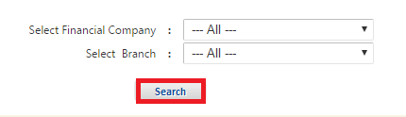
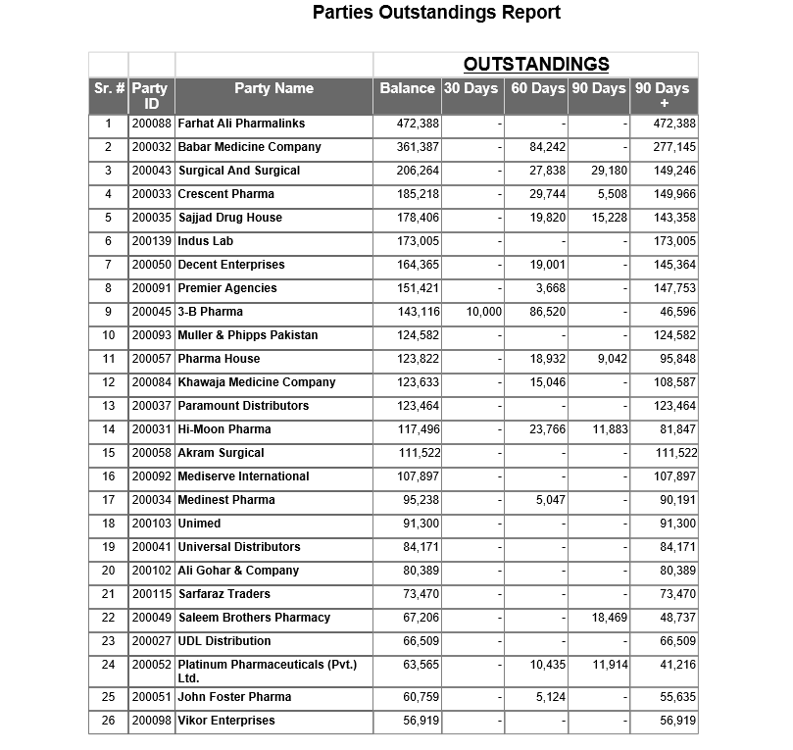
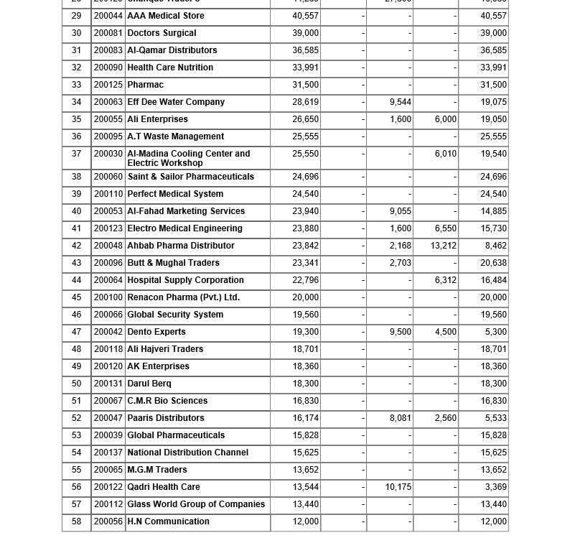
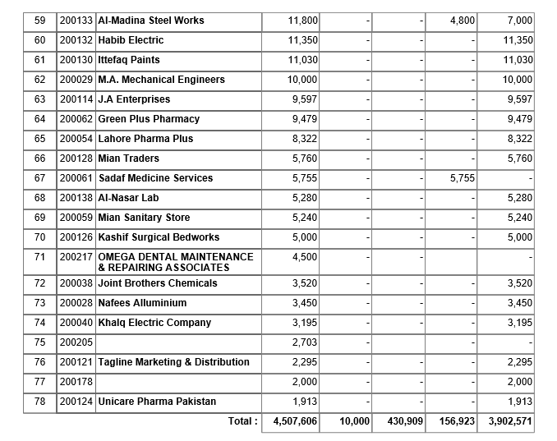

Parties Balance Statement:
- Click on Finance Reports from menu bar.
- Select Parties Balance Statement from drop down list of Finance Reports.
- Screen will appear as mention below screen.
- Select Company from drop down list of Company select box.
- Select Branch from drop down list of Branch select box.
- Select Date from drop down date dialog box
- Click on Search button.
- Parties Balance Statement screen will appear.

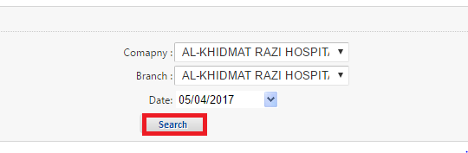
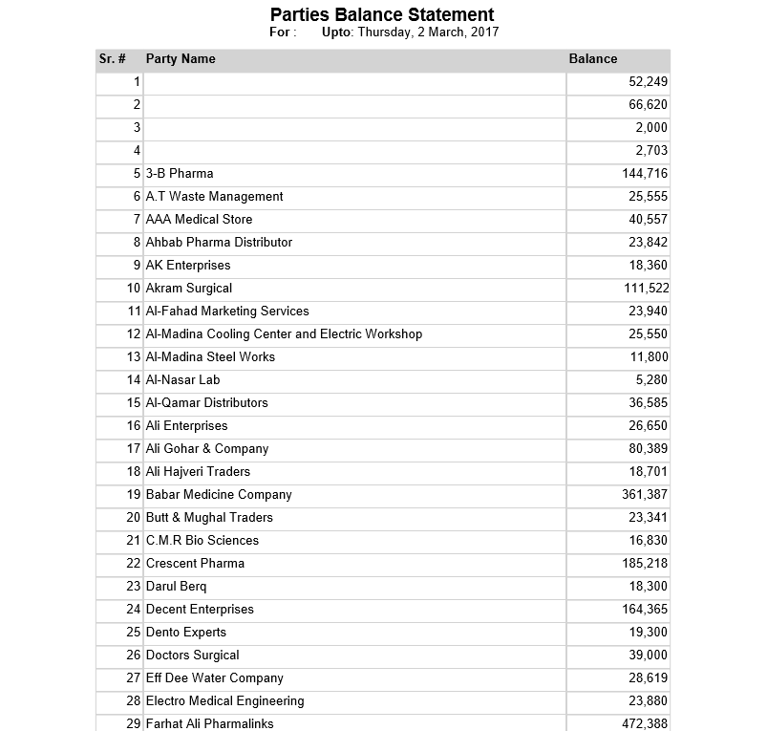
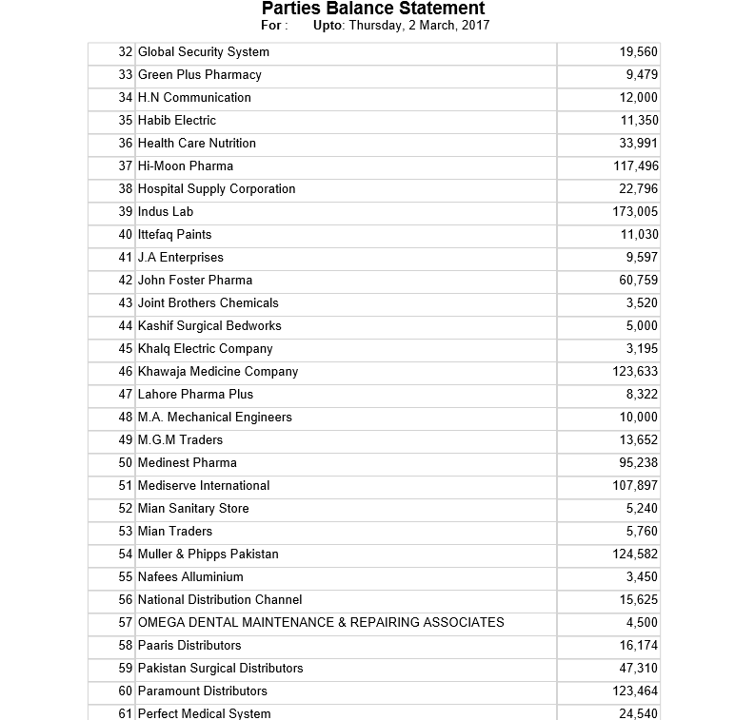

Advance Statement:
- Click on Finance Reports from menu bar.
- Select Advance Statement from drop down list of Finance Reports.
- Screen will appear as mention below screen.
- Select Company from drop down list of company select box.
- Select Branch from drop down list of Branch select box.
- Select Date from drop down date dialog box
- Click on Search button.
- Advance Statement screen will appear.
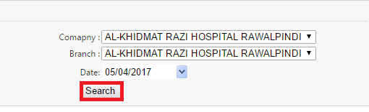

Party Tax Deduction:
- Click on Finance Reports from menu bar.
- Select Party Tax deduction from drop down list of Finance Reports.
- Screen will appear as mention below screen.
- Select Party from drop down list of Party select box.
- Select Date From drop down date From dialog box
- Select Date To from drop down date To dialog box
- Click on Search button.
- Party Tax Deduction screen will appear.
