User Manual
  - IPD PATIENT REGISTRATION MODULE

  - 

  - All Rights Reserved: Megaplus Technologies
Table of Contents
Starting work on ERP: 3
➢ Login Screen: 3
Login : 3
➢ Patient Search: 4
Track Patient History: 4
Edit Patient Information: 5
View Patient Detail: 6
OPD Slip: 6
Admission: 7
➢ Patient Between Dates: 8
Search Patient By Dates: 8
➢ IPD Billing: 9
Medicine Services: 9
Services: 10
OPD Slip: 12
Change Room : 13
➢ Advance Payment: 14
Payment : 14
Advance Payment : 16

Starting work on ERP:
- Open Chrome, Firefox, Safari or Internet Explorer.
- Enter url in URL Bar:
http://192.168.8.94/demo/login.aspx

Login Screen:

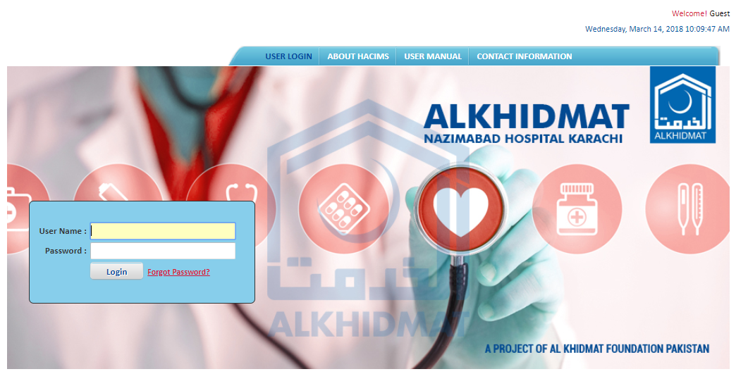

Login :
- Enter login details and click on Login.
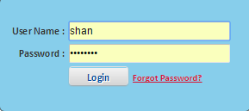

Patient Search:

Track Patient History:
- Select IPD Module from Menu Bar.
- Select Patient Search from menu list.
- Search Patient by different parameters by (MR #, CNIC#, Name, etc)
- See details of patient.
- Click on Track Patient History Image.

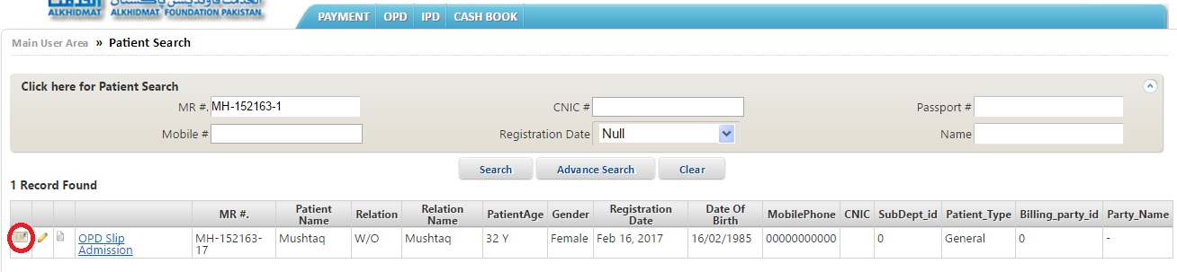

- After select image of Track Patient History .
- See details of patient.

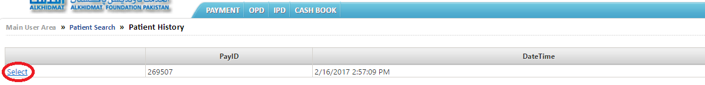

Edit Patient Information:
- Select IPD Module from Menu Bar.
- Select Patient Search from menu list.
- Search Patient by different parameters by (MR #, CNIC#, Name, etc)
- See details of patient.
- Click on Edit Patient Information Image.
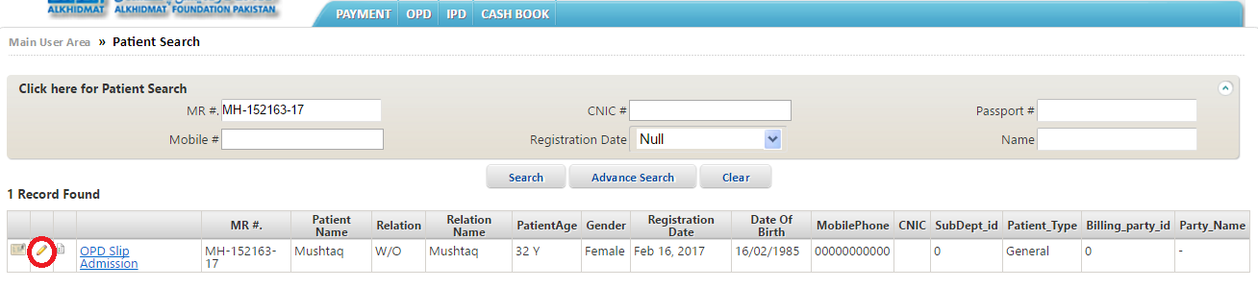
- After select image of Track Patient History .
- See details of patient.
- Edit patient information and click on update.

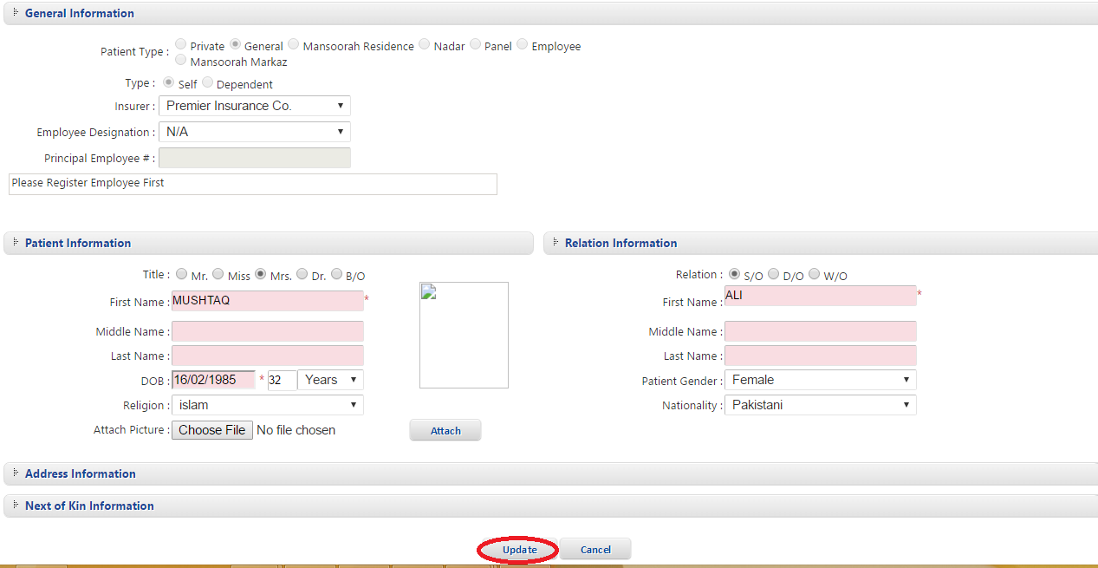

View Patient Detail:
- Select IPD Module from Menu Bar.
- Select Patient Search from menu list.
- Search Patient by different parameters by (MR #, CNIC#, Name, etc)
- See details of patient.
- Click on View Patient Detail Image.

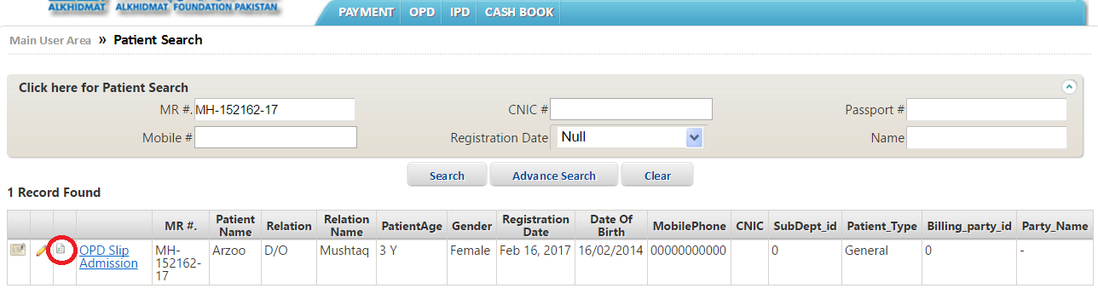
- After select image of View Patient Detail .
- See details of patient.

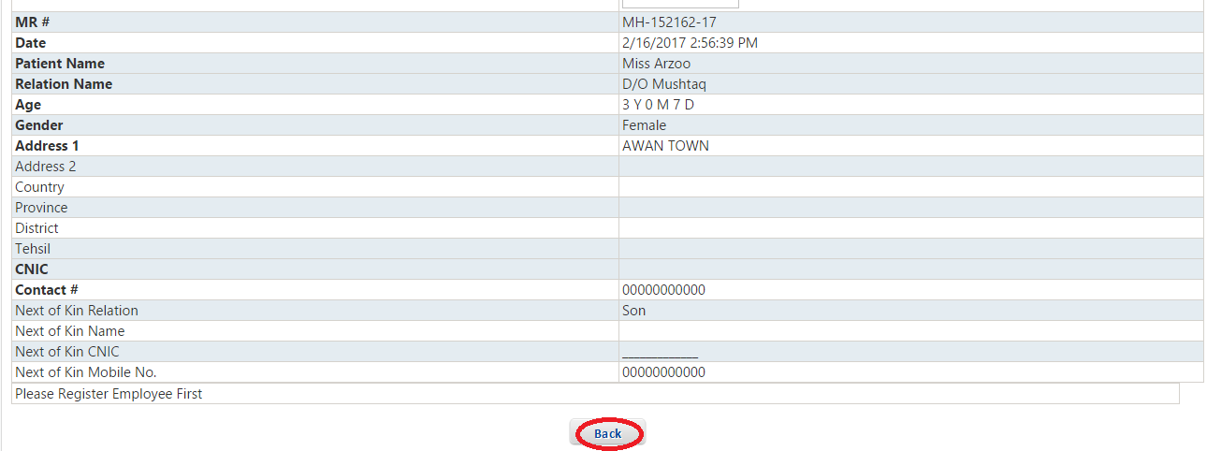

OPD Slip:
- Select IPD Module from Menu Bar.
- Select Patient Search from menu list.
- Search Patient by different parameters by (MR #, CNIC#, Name, etc)
- See details of patient.
- Click on OPD Slip.

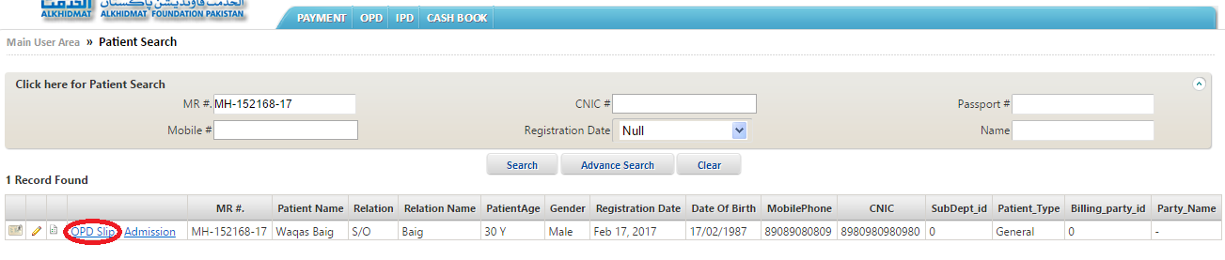

- After select OPD Slip then assign services..
- Enter department name in Sub-Department text box.
- Enter related information in related text box.
- Then click on Save & Print.

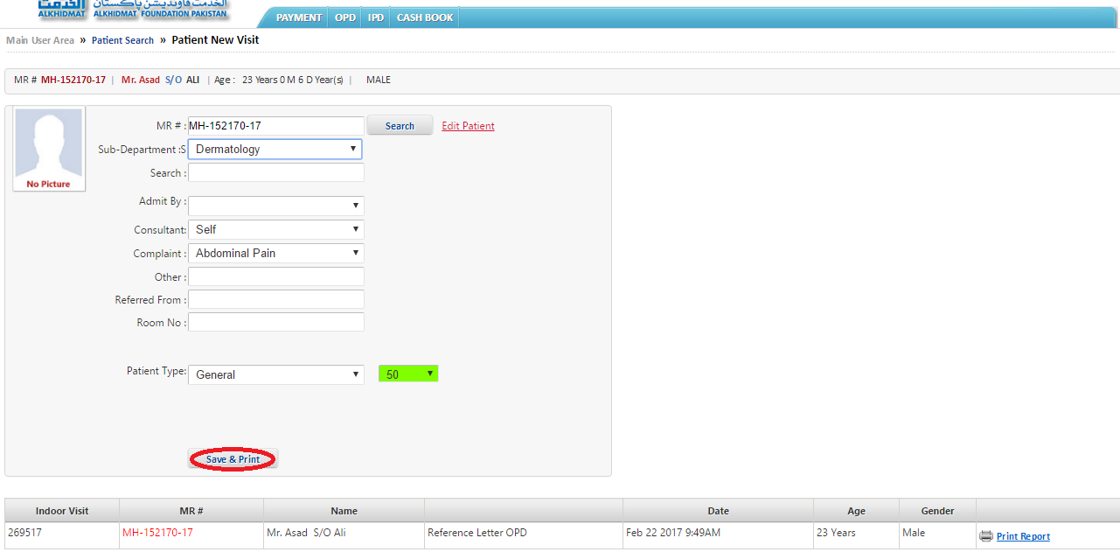

Admission:
- Select IPD Module from Menu Bar.
- Select Patient Search from menu list.
- Search Patient by different parameters by (MR #, CNIC#, Name, etc)
- See details of patient.
- Click on Admission.
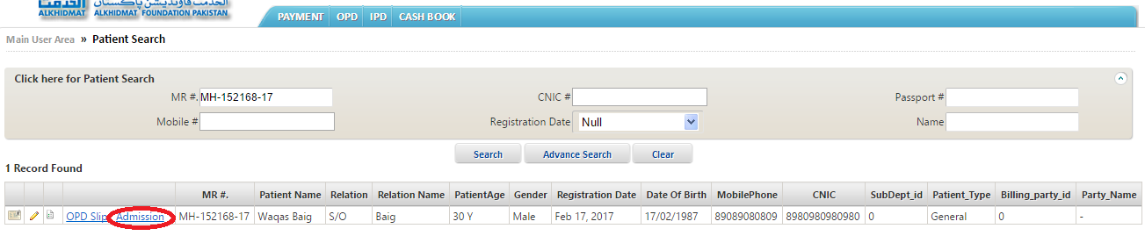
- After select Admission then assign services..
- Enter department name in Sub-Department text box.
- Enter ward, Admit by, room no, complain in related text box.
- Choose advance payment package and way of payment(cheque, cash, credit card)
- Then click on Save & Print.

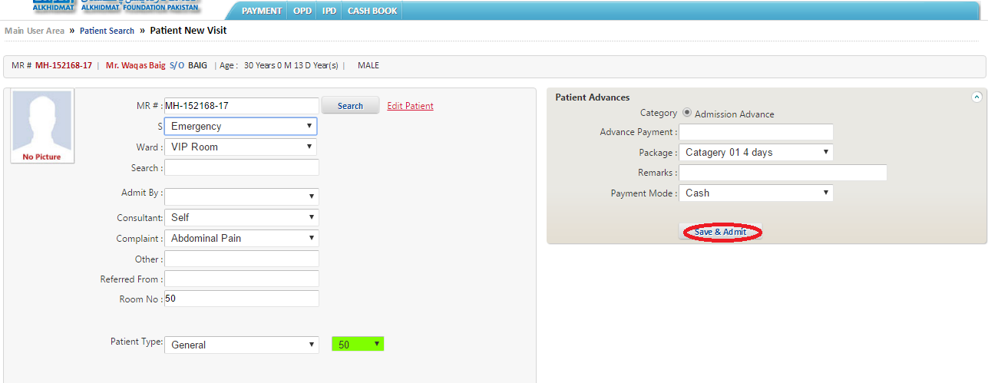

Patient Between Dates:

Search Patient By Dates:
- Select IPD Module from Menu Bar.
- See menu list.
- Select Patient Between Dates from menu list.
- Enter Start date in Start date text box.
- Enter End date in End date text box.
- Click on Search which show on the center of screen.
- See details of patient.
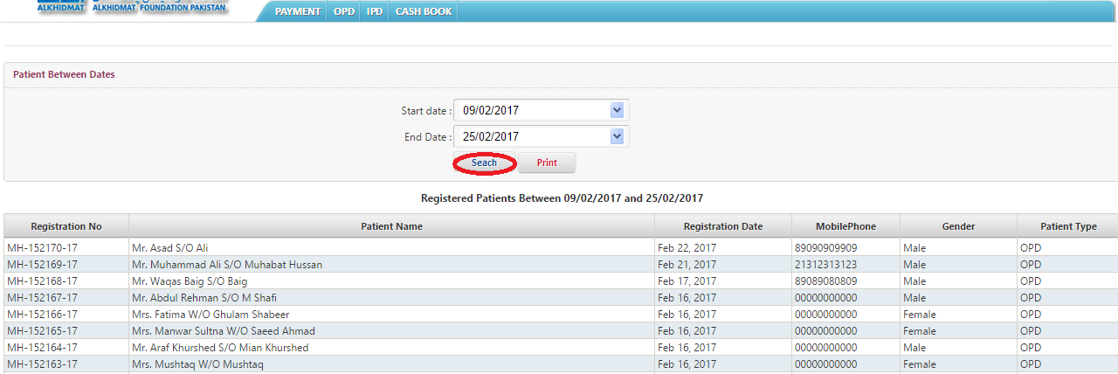

IPD Billing:

Medicine Services:
- Select IPD Module.
- Select IPD billing from IPD menu list.
- Click on search Arrow which show at the right corner of screen.
- Search Patient by different parameters by (Visit #, MR #, Patient Age)
- Add Visit # number of patient and click on Search.
- See details of patient at the bottom of screen.
- Click on Medicine to mark services to patient.

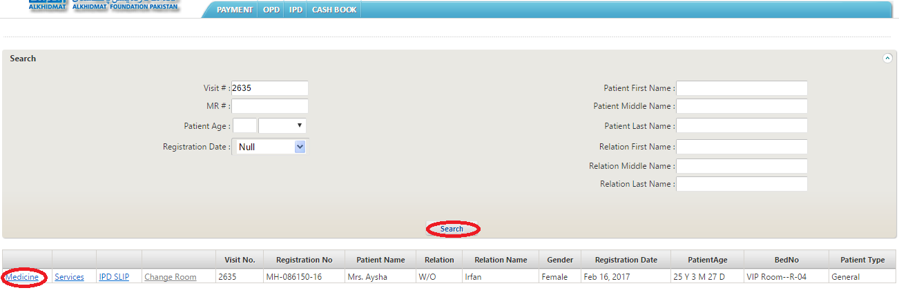

- After select Medicine then assign Medicine services..
- Enter Medicine name in Name text box.
- Enter Medicine code name in Medicine code text box.
- Click on Add to Bill.

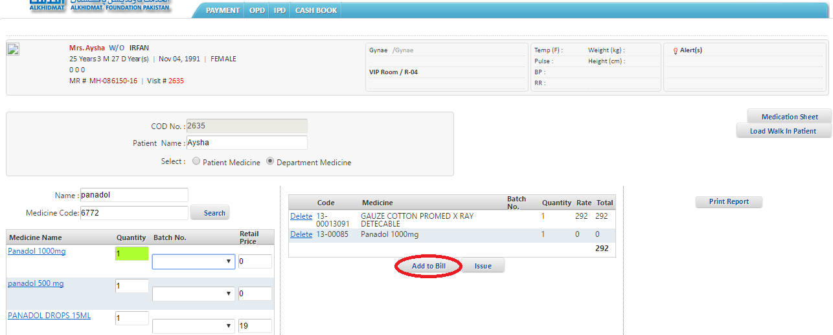

Services:
- Select IPD Module.
- Select IPD billing from IPD menu list.
- Click on search Arrow which show at the right corner of screen.
- Search Patient by different parameters by (Visit #, MR #, Patient Age)
- Add Visit # number of patient and click on Search.
- See details of patient at the bottom of screen.
- Click on services to mark IPD services to patient.

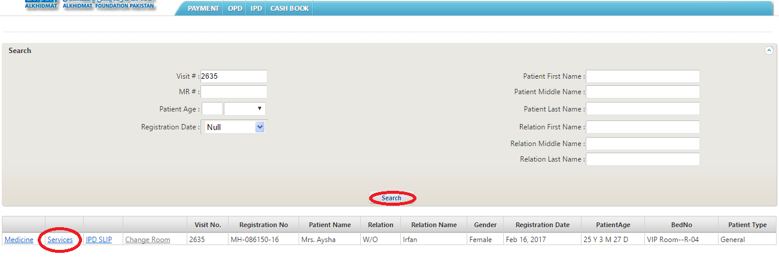
- After mark services then assign services.
- Select All from dropdown list of services category.
- Enter service name in Search service text box.
- Select Test >click payment button to forward test to lab.

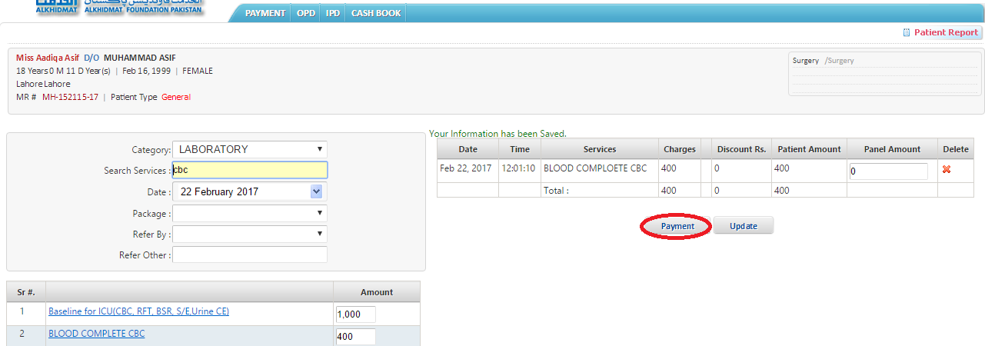

- After assign services.
- Assign payment services (advance payment, allow discount)
- Make Payment by different ways (credit card ,cheque)
- After selecting way for payment Click on Save& Print.

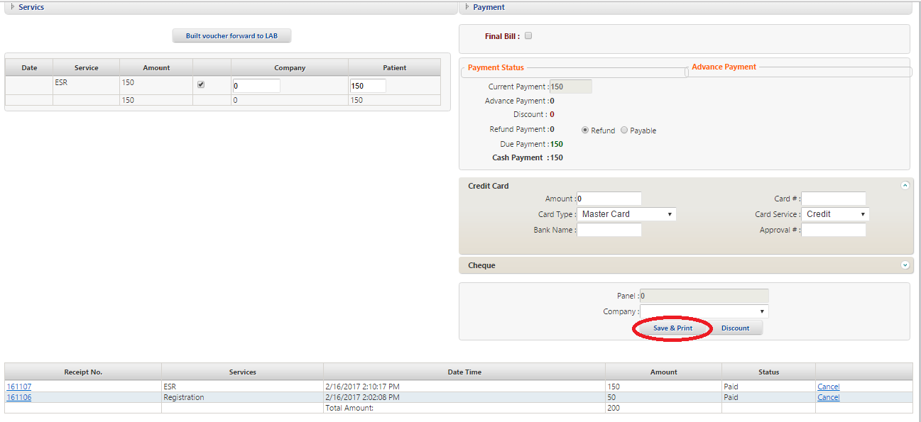

- After Payment receives receipt generate for patient.
- Details of assign test receipt for patient.

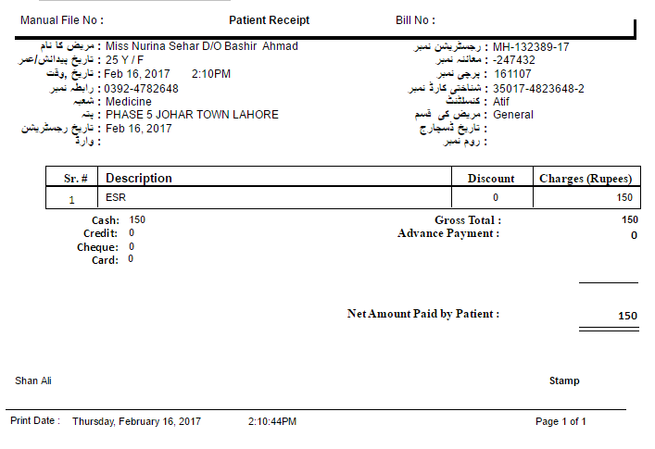

OPD Slip:
- Select IPD Module.
- Select IPD billing from IPD menu list.
- Click on search Arrow which show at the right corner of screen.
- Search Patient by different parameters by (Visit #, MR #, Patient Age)
- Add Visit # number of patient and click on Search.
- See details of patient at the bottom of screen.
- Click on OPD Slip.

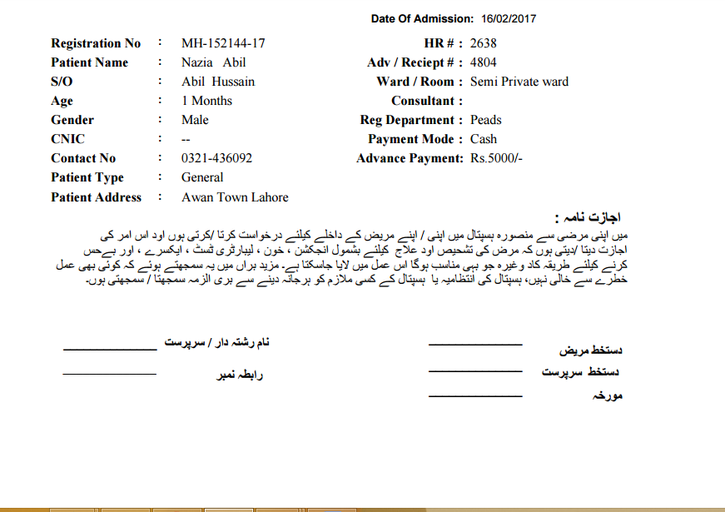

Change Room :
- Select IPD Module.
- Select IPD billing from IPD menu list.
- Click on search Arrow which show at the right corner of screen.
- Search Patient by different parameters by (Visit #, MR #, Patient Age)
- Add Visit # number of patient and click on Search.
- See details of patient at the bottom of screen.
- Click on Change Room.

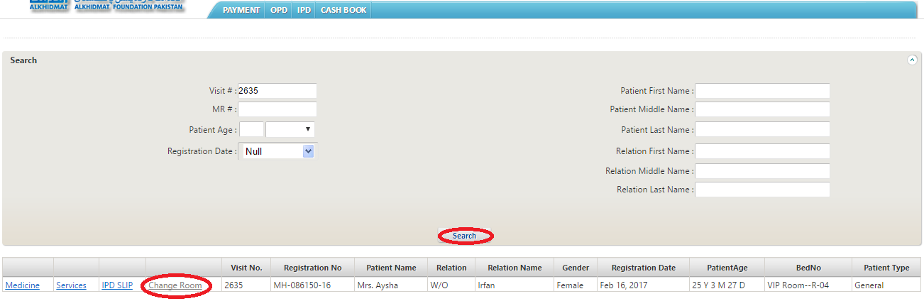.
- After select Change Room then assign Room services.
- Change the room no and related fields.
- Click on Allocate.

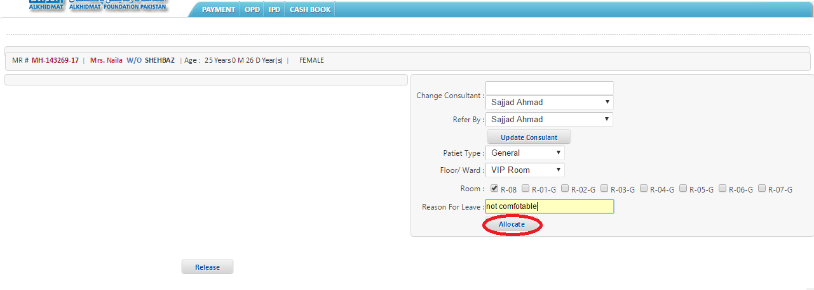

Advance Payment:

Payment :
- Select IPD Module.
- See menu list.
- Select Advance Payment from menu list..
- Search Patient by different parameters by (Visit #, MR #, Patient Age etc)
- Add Visit # number of patient and click on Search.
- See details of patient at the bottom of screen.
- After search patient Click on Payment at the bottom of left side of screen.
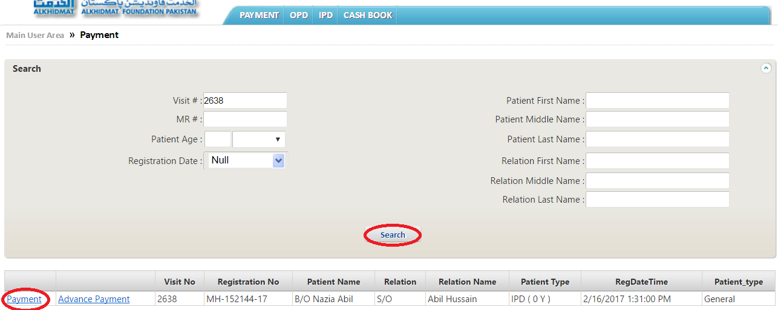

- After selecting Payment.
- Assign payment services (advance payment, allow discount)
- Make Payment by different ways (credit card ,cheque)
- After selecting way for payment Click on Save & Print.

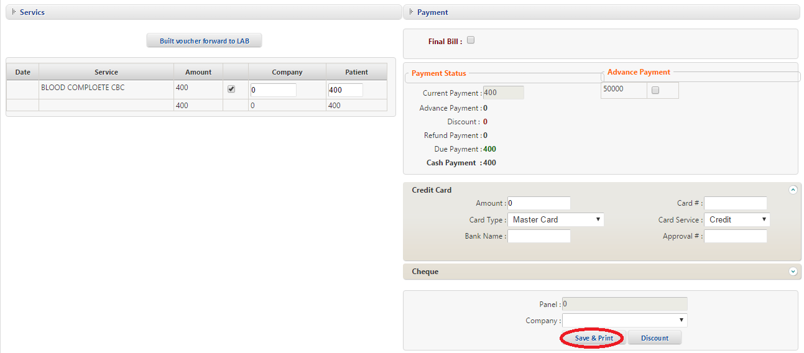

Advance Payment :
- Select IPD Module.
- See menu list.
- Select Advance Payment from menu list.
- Search Patient by different parameters by (Visit #, MR #, Patient Age etc).
- Add Visit # number of patient and click on Search.
- See details of patient at the bottom of screen.
- After search patient Click on Advance Payment at the bottom of left side of screen.

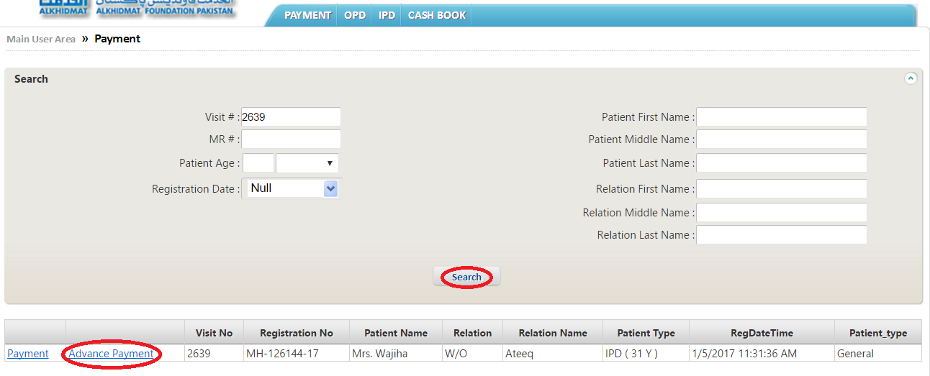

- After selecting Advance Payment.
- Assign Advance Payment services (advance payment, package)
- Make Payment by different ways (credit card, cheque)
- Click on Save & Print

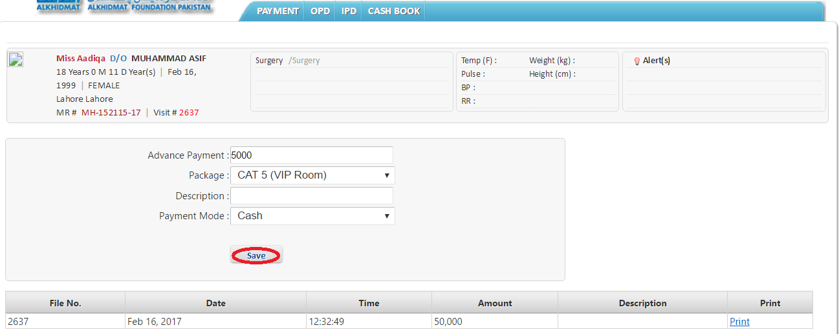

Final bill:

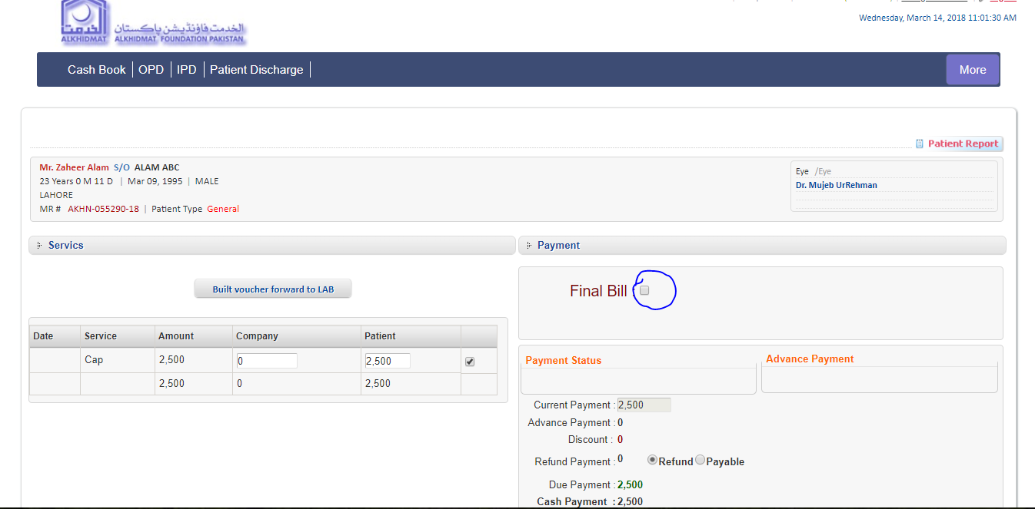
Patient Discharge Bill:
