User Manual
  - OPD PATIENT REGISTRATION MODULE

  - 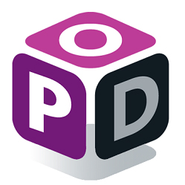

  - All Rights Reserved: Megaplus Technologies
Table of Contents
Starting work on ERP: 3
➢ See a Login Screen: 3
Login : 3
➢ Patient Registration: 4
Patient Registration Screen: 4
Assigning Test : 5
➢ Services Billing: 7
View: 7
Services: 8
Medicine: 10
➢ Walk-In Patient: 11
Assign Services to Walk-In Patient : 11
➢ Update department $ Consultant: 14
Update department $ Consultant for Patient: 14

Starting work on ERP:
- Open Chrome, Firefox, Safari or Internet Explorer.
- Enter url in URL Bar:
http://192.168.8.94/demo/login.aspx

See a Login Screen:

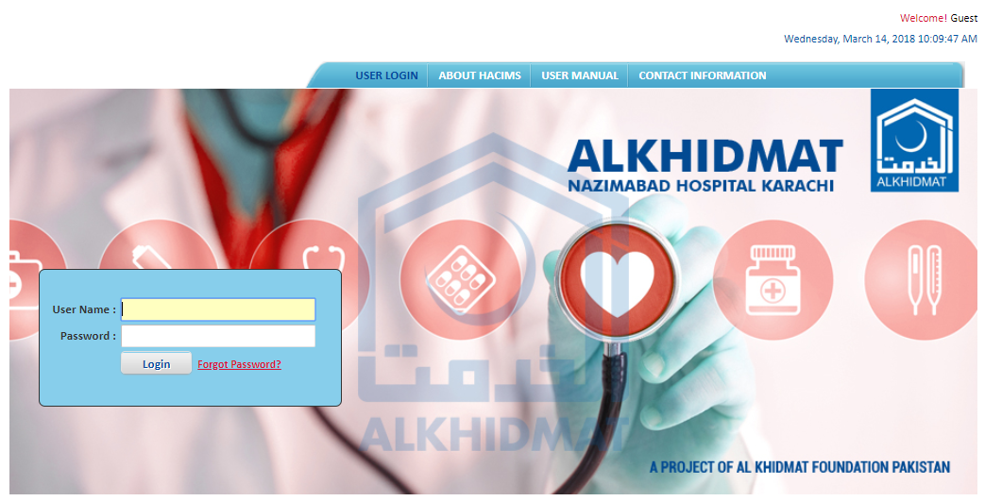

Login :
- Enter login details and click on Login.
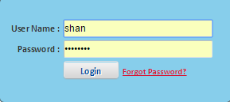

Patient Registration:

Patient Registration Screen:
- Select OPD Module from Menu Bar.
- See menu list.
- Select Patient Registration from OPD menu list.
- Enter information in the Description text boxes.
- When information is entered in boxes then click on Save and Print.
- Patient Information saved.
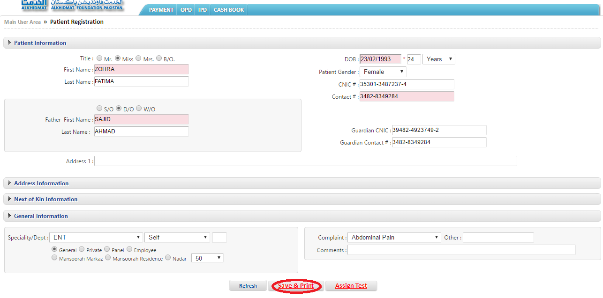
- After patient registration OPD slip generate for correspondence.
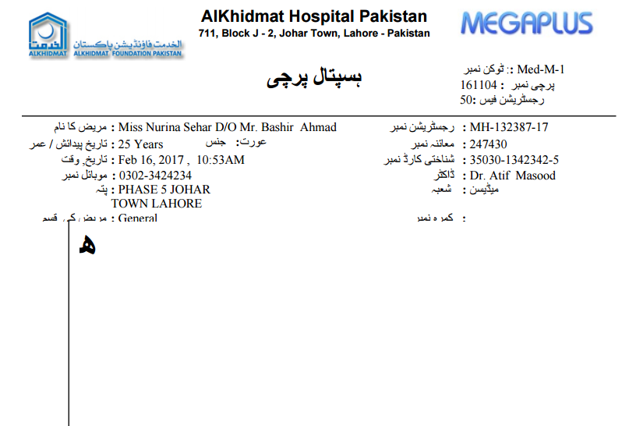

Assigning Test :
- Select OPD Module from Menu Bar.
- See menu list.
- Select Patient Registration from OPD menu list.
- Enter information in the Description text boxes.
- When information is entered in boxes then click on Assign Test.
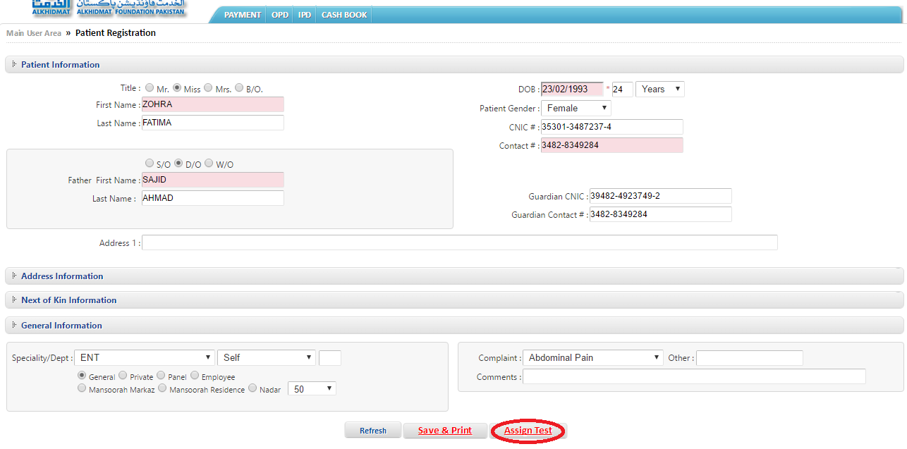
- After Selecting Assign Test then assign Test.
- Select All from dropdown list of services category.
- Enter Test name in Search service text box.
- Select Test >click payment button to forward test to lab.

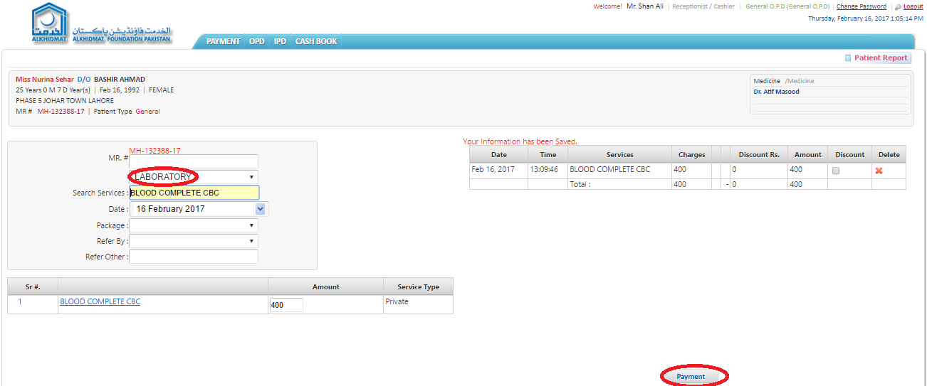

- After assign services.
- Make Payment by different ways.
- After selecting way for payment Click on Save& Print.

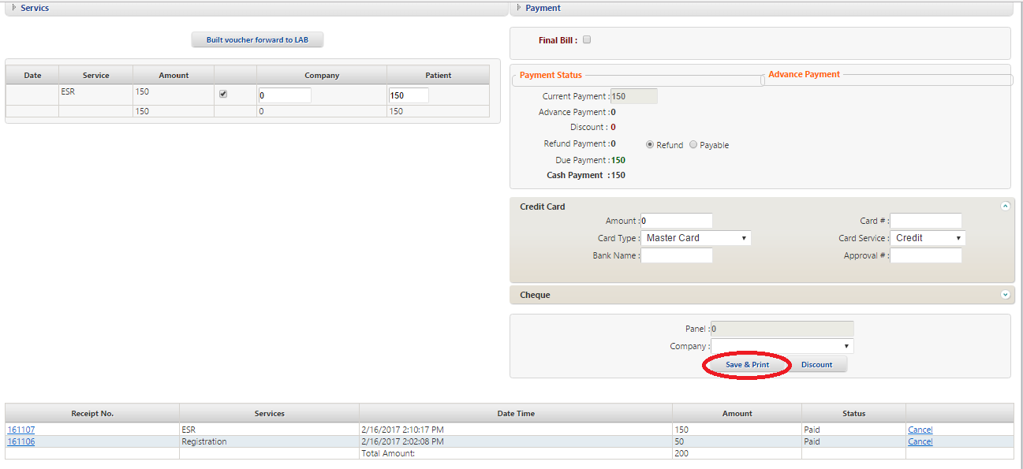

- After Payment receives test mark receipt generate for patient.
- Details of assign test receipt for patient

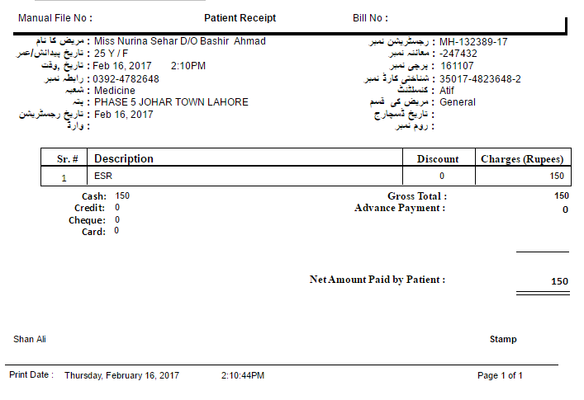

Services Billing:

View:
- Select OPD Module.
- See menu list.
- Select services billing from menu list.
- Search Patient by different parameters by (Visit #, MR #, Patient Age, Registration Date)
- Add Visit # number of patient and click on Search.
- See the bottom of screen.
- See details of patient.
- Click on View to see patient OPD Slip.

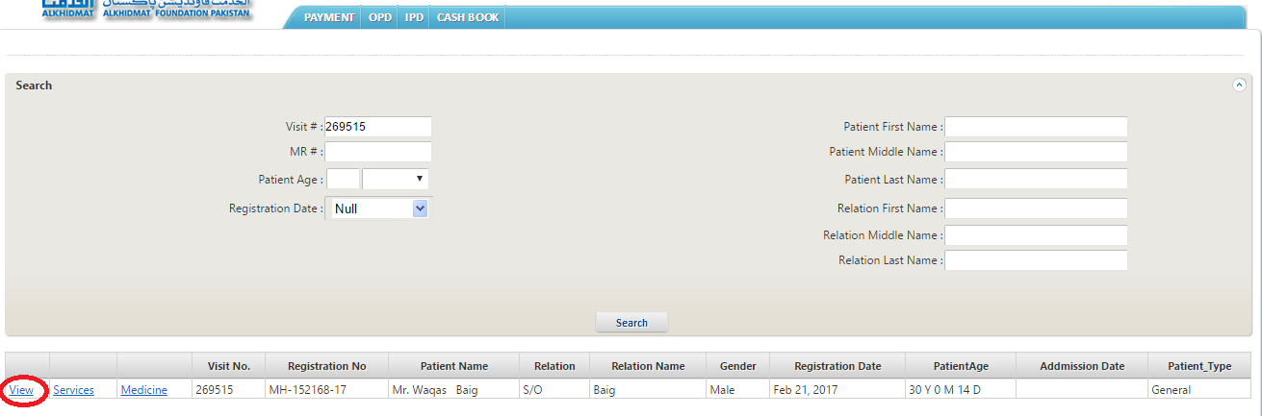
- After selecting view.
- See the OPD Slip of Patient.



Services:
- Select OPD Module.
- See menu list.
- Select services billing from menu list.
- Search Patient by different parameters by (Visit #, MR #, Patient Age, etc)
- Add Visit # number of patient and click on Search.
- See the bottom of screen.
- See details of patient.
- Click on services to mark services to patient.
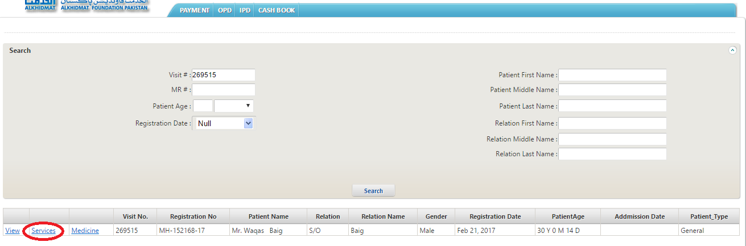
- After mark services then assign services.
- Select All from dropdown list of services category.
- Enter service name in Search service text box.
- Select Test >click payment button to forward test to lab.

- After assign services.
- Make Payment by different ways.
- After selecting way for payment Click on Save& Print.



- After Payment receives test mark receipt generate for patient.
- Details of assign test receipt for patient.



Medicine:
- Select OPD Module.
- See menu list.
- Select services billing from menu list.
- Search Patient by different parameters by (Visit #, MR #, Patient Age, etc)
- Add Visit # number of patient and click on Search.
- See the bottom of screen.
- See details of patient.
- Click on Medicine to mark medicine services to patient.

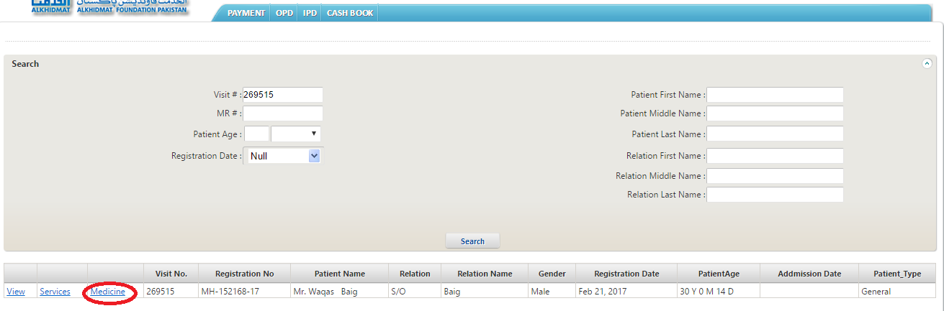
- After select Medicine then assign Medicine services..
- Enter Medicine name in Name text box.
- Enter Medicine code name in Medicine code text box.
- Click on Add to Bill.

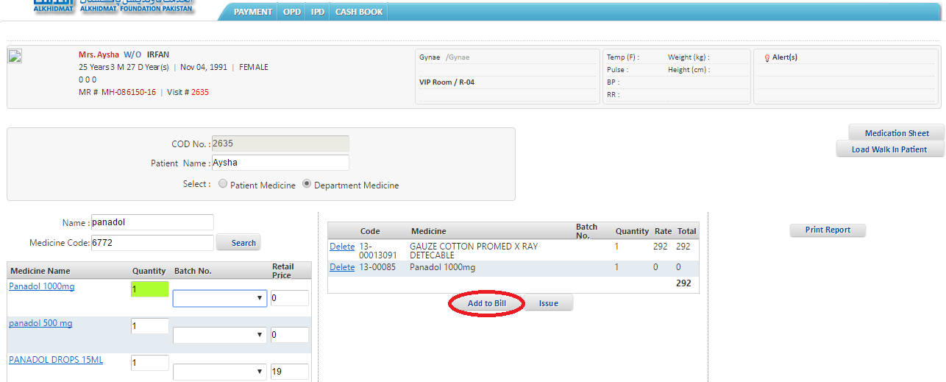

Walk-In Patient:

Assign Services to Walk-In Patient :
- Select OPD Module.
- Select Walk-In-Patient OPD from menu list.
- Search Patient by Registration #.
- After search patient assign services to patient.
- Enter service name in Search service text box.
- Select Test to forward test to lab.
- See the bottom of screen at left side.
- Click on save & forward to make payment.

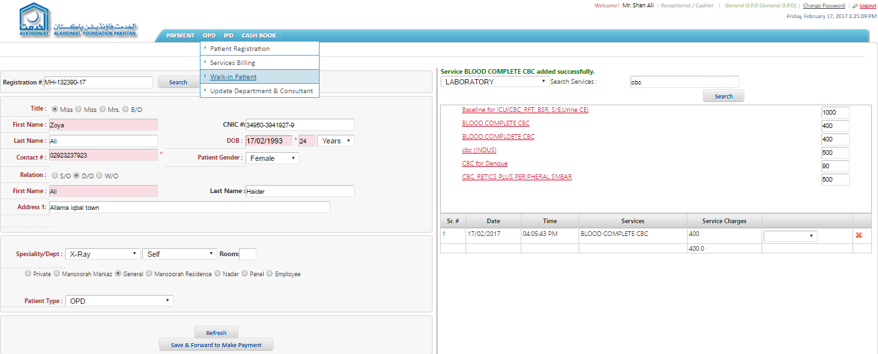
- After assign services.
- Make Payment by different ways.
- After selecting way for payment Click on Save & Print.
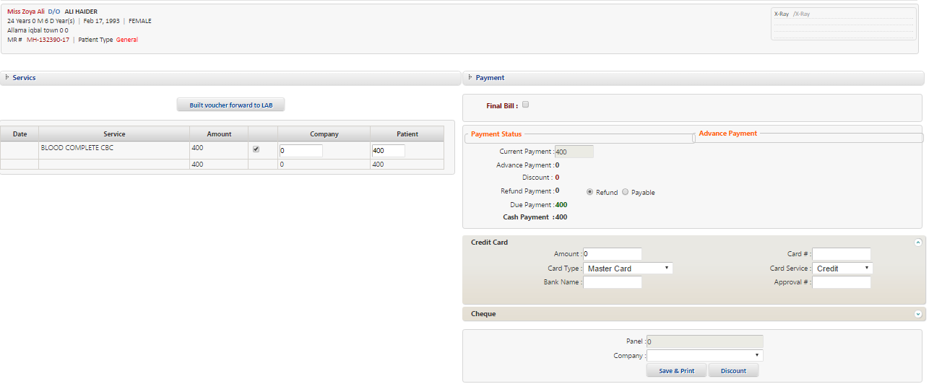

- After Payment receives test mark receipt generate for walk-in-patient patient.
- Details of assign test receipt for patient.

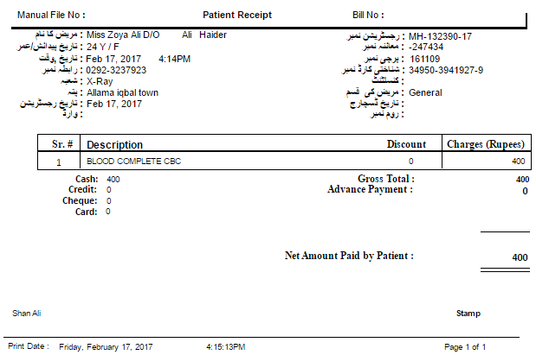

Update department $ Consultant:

Update department $ Consultant for Patient:
- Select OPD Module.
- Select Update department $ Consultant from OPD menu list.
- Click on search which shows on the center of screen.
- Search Patient by different parameters by (Visit #, MR #, Patient Age, Registration Date).
- Add Visit # number of patient and click on Search.
- See the bottom of screen.
- See details of patient.
- Click on Update department $ Consultant to update department of patient.

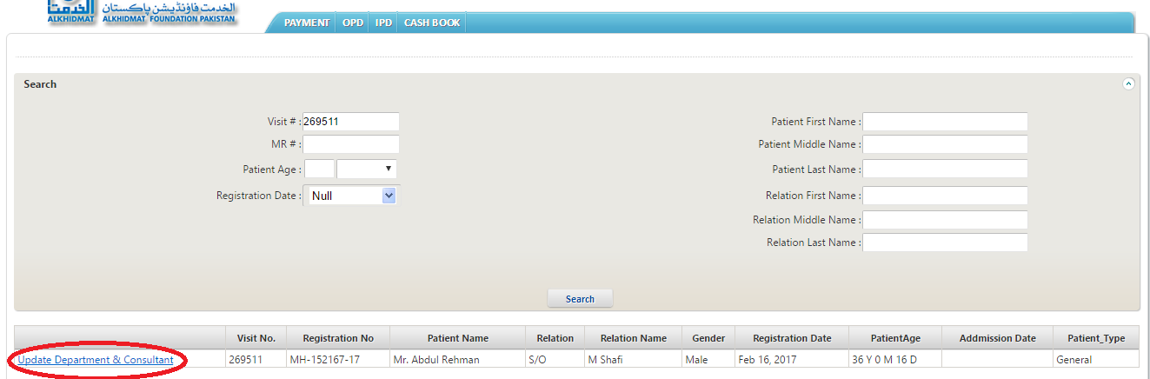

- After selecting Update department $ Consultant from menu list.
- Enter department name in Search department text box.
- After, Enter Doctor, complaints, room no, comments, respectively.
- Click on Reffer to for update department of patient.

