User Manual
  - PAYROLL MODULE

  - 

  - All rights reserved-Megaplus Technologies

  - All Rights Reserved: Megaplus Technologies
Table of Contents
Starting work on ERP: 3
➢ Login Screen: 3
Login : 3
➢ Employee Basic Allowances &Deductions: 4
Edit Employee Information: 4
Allowances & deductions: 6
Add Personal Allowances: 7
Basic Deduction: 8
➢ Employee Overtime: 9
➢ Employee Earn Leave: 10
➢ Arrears of Employee: 11
➢ Employee Attendance: 12
➢ Add Allowances/Deduction: 13
➢ Approve Allowances/Deductions: 14
➢ Make Salary: 15
After Make Salary: 16
➢ View Head Wise Allowances & Deductions: 16
➢ Salary Posting Voucher: 17

Starting work on ERP:
- Open Chrome, Firefox, Safari or Internet Explorer.
- Enter url in URL Bar:
http://192.168.8.94/demo/login.aspx

Login Screen:

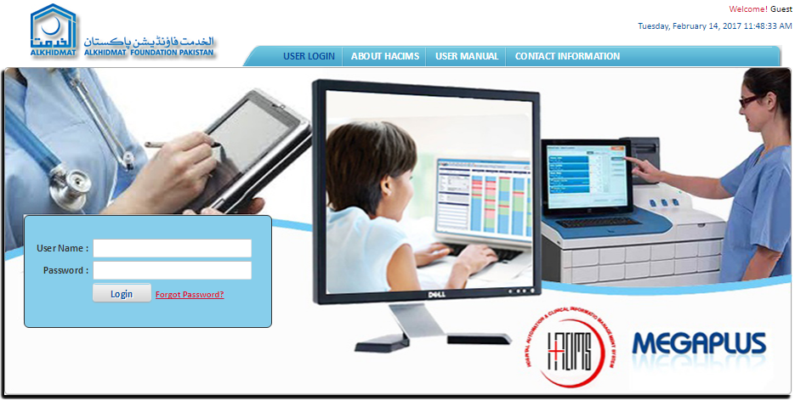

Login :
- Enter login details and click on Login.
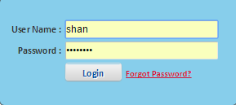

Employee Basic Allowances &Deductions:
- Click on Payroll from menu bar.
- Select Basic Allowance & Deduction for enter employee basic allowance and deduction.
- Screen will appear as mention below screens:
- Select the Department from drop down list of departments.
- Select the Designation from drop down list of designation.
- Select the Department from drop down list from departments.
- Enter Employee Name in employee name text box.
- Enter employee CNIC # in CNIC text box.
- Select Employee Type by click on radio button.
- Click on Search button.
- Required employee information will filter at the bottom of screen.

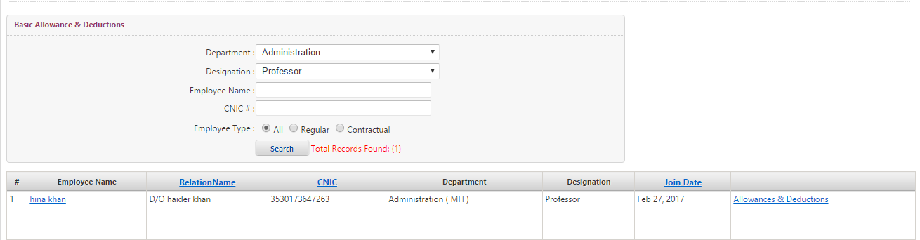

Edit Employee Information:
- Search Employee by different parameters by (Department, Designation, Employee Name, CNIC#, Employee Type).
- When Required Employee Information will be searched.
- Click on Employee Name to Edit and Update further information of employee.

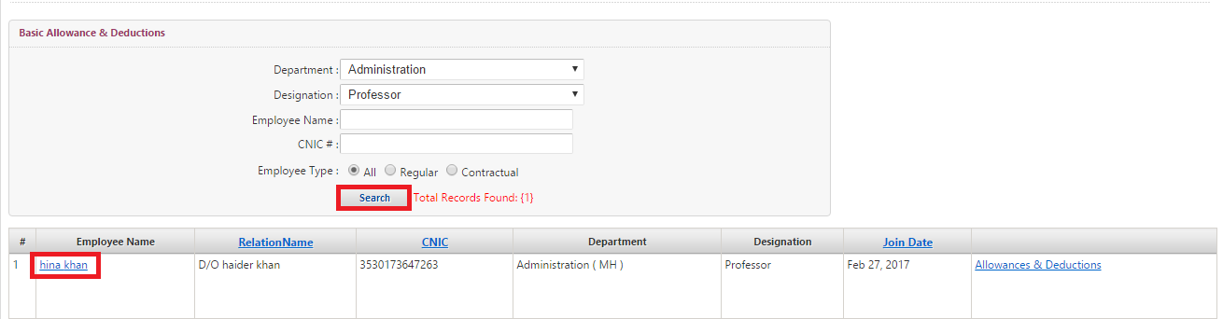

- After selecting Employee Name.
- Edit and Update General Information, Basic Information, Address Information, Employment Information
- Then Click on update.

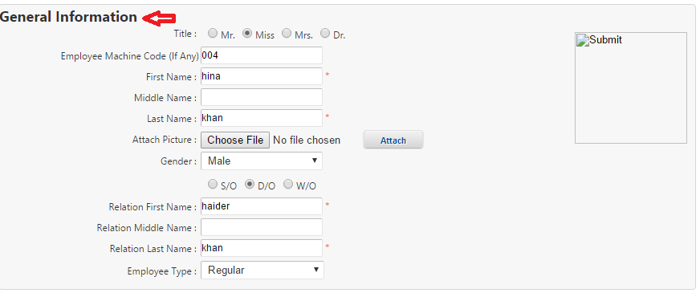
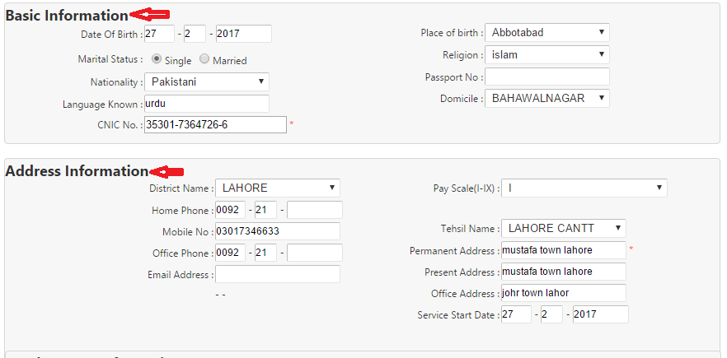
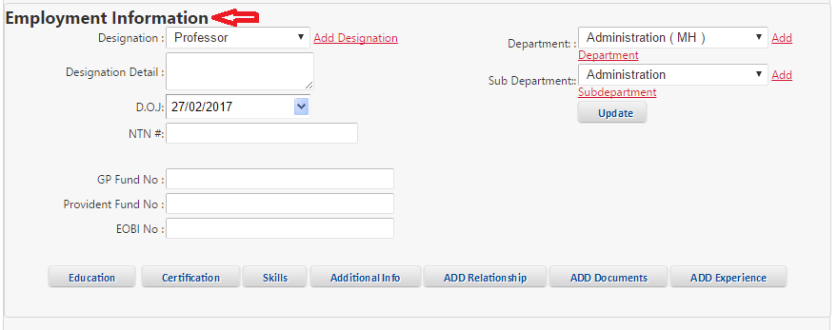

Allowances & deductions:
- Search Employee by different parameters by (Department, Designation, Employee Name, CNIC#, Employee Type.
- When Required Employee Information will be searched.
- Click on Allowances & Deductions.
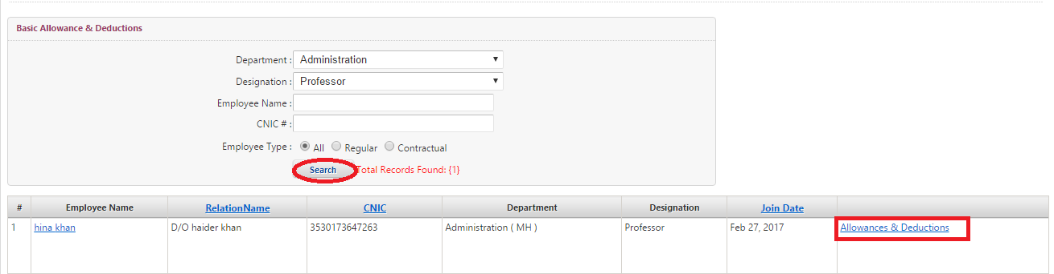

Add Salary and Bank Account #:
- After selecting Allowances & Deductions.
- Screen will appear as mention below.
- Click on Bank Accounts from list to enter bank detail of employee.
- Select Brach Name from drop down list of branch name box.
- Select purpose from drop down list of purpose search box.
- Enter Account Number in account number text box.
- Then Click on Save.
- Information will save successfully.
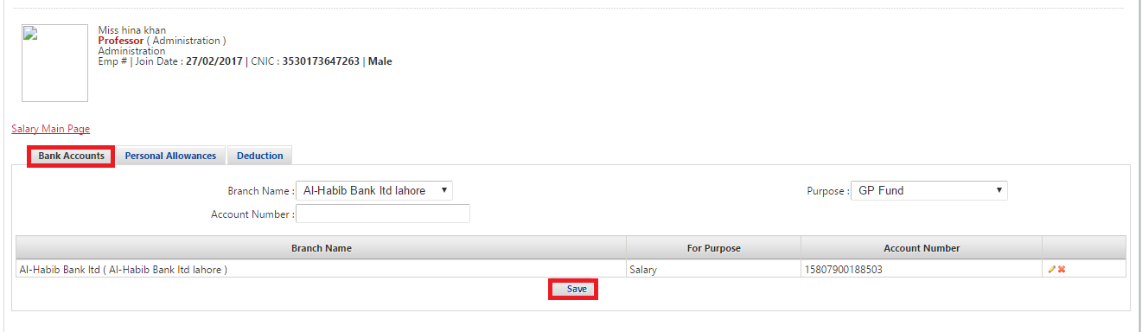

Add Personal Allowances:
- After selecting Allowances & Deductions.
- Screen will appear as mention below.
- Click on Personal Allowances from list to add personal allowances of employee.
- Enter Basic Salary in basic salary text box.
- Enter Bonus in bonus text box.
- Enter Increment in increment text box.
- Enter ARREAR in arrear text box.
- Enter OverTime on overtime text box.
- Enter Qualification Allowance in qualification allowance text box.
- Enter EarnLeave in EarnLeave text box.
- Then Click on Save.
- Information will save successfully.
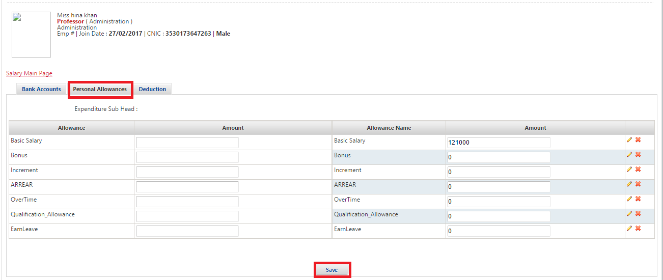

Basic Deduction:
- After selecting Allowances & Deductions.
- Screen will appear as mention below.
- Click on deduction from list to enter deduction of employee.
- Select Deduction from drop down list of deduction search box.
- Enter Amount in amount text box.
- Enter Start Date in start date text box.
- Enter End Date in end date text box.
- Enter Mobilink Bill in mobilink bill text box.
- Enter Income Tax Expense in income tax expense text box.
- Enter EOBI in EOBI text box.
- Enter Advances to Staff in advances to staff text box.
- Enter Security in security text box.
- Enter Electricity in electricity text box.
- Enter Telephone in telephone text box.
- Enter Mess in mess text box.
- Enter MinutLeave in minutleave text box.
- Enter Conveyance in conveyance text box.
- Then Click on Save Deductions.
- Information will save successfully.
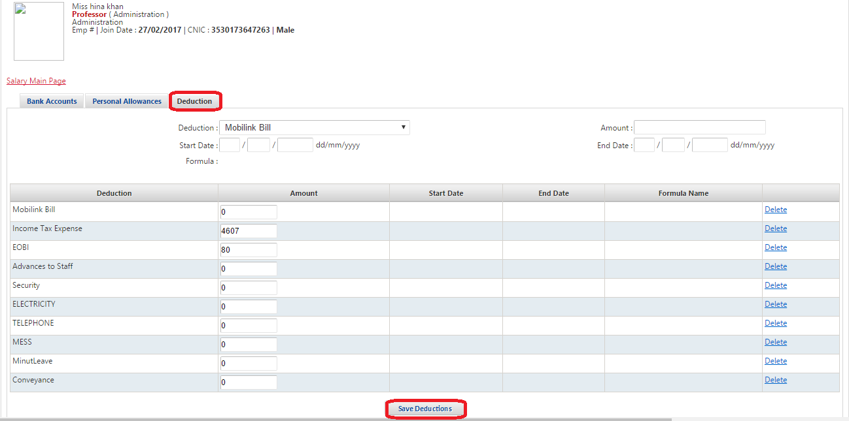

Employee Overtime:
- Click on Payroll from menu bar.
- Select Over Time from drop down list of Payroll module.
- Screen will appear as mention below screen.
- Select the Hospital from drop down list of hospital search text box.
- Select the Department from drop down list of departments.
- SalaryHead will auto selected.
- Select the Salary Month from drop down list of salary month select box.
- Select Salary year from salary year select box.
- Enter Employee No in employee no text box.
- Enter Employee Name in employee name text box.
- Select Search Type by click on radio button.
- Required employee information will filter at the bottom of screen.
- In employee information enter Days of Earn Leave in days of earn leave text box.
- Enter Amount in amount text box.
- Click on save.

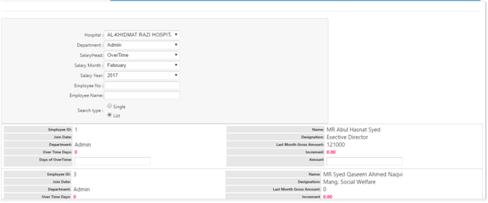

Employee Earn Leave:
- Click on Payroll from menu bar.
- Select Earn Leave Allowance from drop down list of Payroll module.
- Screen will appear as mention below screen.
- Select the Hospital from drop down list of hospital search text box.
- Select the Department from drop down list of departments.
- SalaryHead will auto selected.
- Select the Salary Month from drop down list of salary month select box.
- Select Salary Year from salary year select box.
- Enter Employee No in employee no text box.
- Enter Employee Name in employee name text box.
- Select Search Type by click on radio button.
- Required employee information will filter at the bottom of screen.
- In employee information enter Days of Earn Leave in days of earn leave text box.
- Enter Amount in amount text box.
- Click on Save.
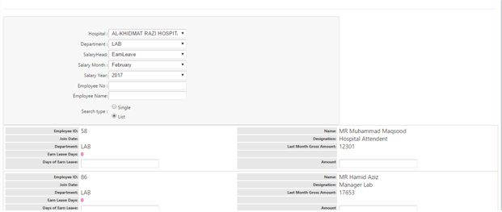

Arrears of Employee:
- Click on Payroll from menu bar.
- Select Arrears Allowance from drop down list of Payroll module.
- Screen will appear as mention below screen.
- Select the Hospital from drop down list of hospital search text box.
- Select the Department from drop down list of departments.
- SalaryHead will auto selected.
- Select the Salary Month from drop down list of salary month select box.
- Select Salary Year from salary year select box.
- Enter Employee No in employee no text box.
- Enter Employee Name in employee name text box.
- Select Search Type by click on radio button.
- Required employee information will filter at the bottom of screen.
- In employee information enter Days of Arrears in days of arrears text box.
- Enter Amount in amount text box.
- Click on Save.

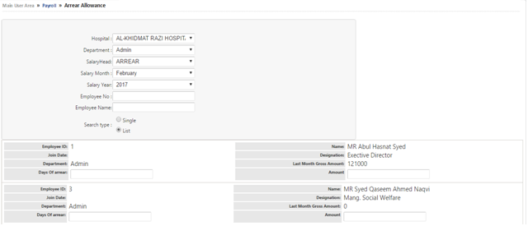

Employee Attendance:
- Click on Payroll from menu bar.
- Select Attendance from drop down list of Payroll module.
- Screen will appear as mention below screen.
- Select the Hospital from drop down list of hospital select box.
- Select the Department from drop down list of departments.
- Select the Month from drop down list of month select box.
- Select Salary Start Date from salary start date select box.
- Select Salary End Date from end date select box.
- Select Attendance Start Date from attendance start date select box.
- Select Attendance End Date from attendance end date select box.
- Enter Days (After Attendance Date) in Days (after attendance date) text box.
- Enter Month Days in Month Days text box.
- Click on Search button.
- Screen will appear below the screen.
- Enter Employee information (other Attendance, Leave Encash, Over Time, Pre. Deduction, Pre. Min, Salary Days, Remarks, System Calculation).
- Click on Calculate Button to calculate attendance of employee.
- Then click on Save after attendance has been calculated.
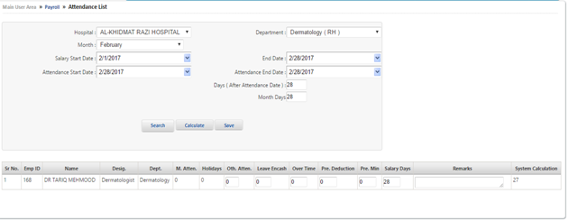

Add Allowances/Deduction:
- Click on Payroll from menu bar.
- Select Allowance and Deduction Entry from drop down list of Payroll module.
- Screen will appear as mention below screen.
- Select the Hospital from drop down list of hospital select box.
- Select the Department from drop down list of departments.
- Select the SalaryHead from drop down list of Salary head select box.
- Select the Salary Month from drop down list of Salary month select box.
- Select the Salary Year from drop down list of Salary year select box.
- Enter Employee No in employee no text box.
- Enter Employee Name in employee name text box.
- Select Search Type by click on radio button.
- Employee information detail will display below the screen.

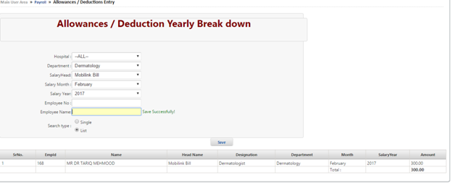

Approve Allowances/Deductions:
- Click on Payroll from menu bar.
- Select Approve Allowance and Deduction from drop down list of Payroll module.
- Screen will appear as mention below screen.
- Select the Hospital from drop down list of hospital select box.
- Select the Department from drop down list of departments.
- Select the SalaryHead from drop down list of Salary head select box.
- Select the Salary Month from drop down list of Salary month select box.
- Enter Remarks in Remarks text box.
- Then click on Approve Button.
- Employee information detail will display below the screen.
- Click on check box to approve which show at the right corner of screen.
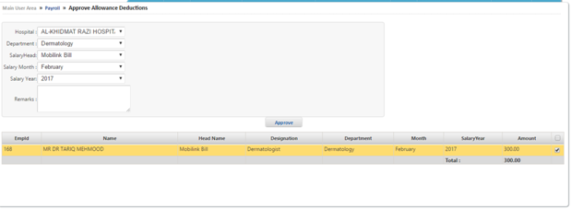

Make Salary:
- Click on Payroll from menu bar.
- Select Make Salary from drop down list of Payroll module.
- Screen will appear as mention below screen.
- Select the Hospital from drop down list of hospital select box.
- Select the Department from drop down list of departments.
- Enter NTN # in NTN# text box.
- Select the For Year from drop down list of for year select box.
- Select the Designation from drop down list of Designation.
- Enter Employee Name in employee name text box.
- Enter CNIC# in CNIC# text box.
- Select the For Month from drop down list of for month year select box.
- Click on Search button to make salary of required employee of all employee.
- Enter Employee information (Gross Salary, Allowances, Arrear, OverTime, E.Leave, Bonus, Deductions).
- Click on Make Salary All.
- To make salary of all employee click on Make salary All.

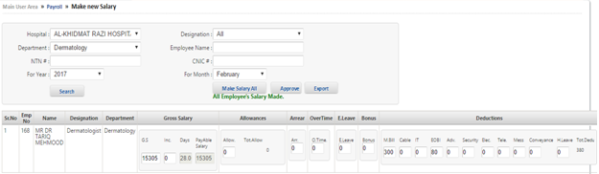

After Make Salary:
- After make salary.
- Click on Approve to approve salary from authority.
- To Convert Employee salary detail in excel format click on Export.
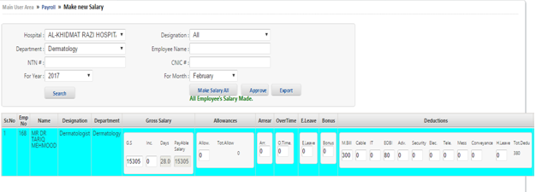

View Head Wise Allowances & Deductions:
- Click on Payroll from menu bar.
- Select Allowance Deduction Report from drop down list of Payroll module.
- Screen will appear as mention below screen.
- Select the Hospital from drop down list of hospital select box.
- Select the Department from drop down list of department select box.
- Select the Month from drop down list of month select box.
- Select the Year from drop down list of year select box.
- Select Employee from drop down list of employee select box.
- Select Employee Type from drop down list of employee type select box.
- Select Payment Type by click on radio button.
- Click on Search button.
- Click on view Report to see the head wise report of employee.

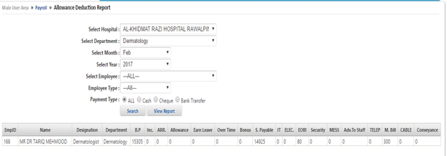

Salary Posting Voucher:
- Click on Payroll from menu bar.
- Select Salary Post Voucher from drop down list of Payroll module.
- Screen will appear as mention below screen.
- Select the Company from drop down list of company select box.
- Select the Branch from drop down list of Branch select box.
- Select the Party from drop down list of Party select box.
- Enter Voucher # in voucher # text box.
- Select the starting date From.
- Select the date To.
- Click on Search button to View the salary post voucher.
- To print salary post voucher click on Print.

