

**Thomas J. Watson School of Engineering & Applied Science**

**Department of Electrical & Computer Engineering**

Neural Network & Deep Learning

(EECE680C)

Homework_1

Solutions

|  |  |
| --- | --- |
| Submitted By | *Alem Haddush Fitwi*  [*afitwi1@binghamton.edu*](mailto:afitwi1@binghamton.edu)  *Graduate Student* |
| Submitted To | *Dr. Xiaohua Li*  *Associate Professor* [xli@binghamton.edu](mailto:xli@binghamton.edu) |
| Submission Date | 06 February 2018 |
|  | |

03 February 2018

Binghamton, New York

1. Find a set of values for weight w and bias b for a single-layer perceptron with input x and output y, where the input-output data are: (x=1,y=0), (x=0,y=1).

*Solution*:

|  |  |  |  |  |
| --- | --- | --- | --- | --- |
| Given: | | | | |
| X | | | Y | |
| 0 | | | 1 | |
| 1 | | | 0 | |
| Compute the values of w and b! | | | | |
| ***Solution***: | | | | |
| The perceptron Inequalities $wx−b>0→y=1$ -- (1) $wx−b≤0→y=0$ -- (2)  From (1) $w∗0−b>0givesb<0$ --(3)  From (2) $w∗1−b≤0givesw≤b$ --(4)  Hence, there are many solutions that satisfy conditions (3) and (4). One possible solution is $b=−0.1∧w=−0.5$ | | | | |
| x | w*x-b | Compare with 0 | | y |
| 0 | 0.1 |  | | 1 |
| 1 | -0.4 |  | | 0 |

1. Considering using the following single-layer perceptron for the 3-class classification problem:

 

Note that if the class is C1, then the output is y1=1, and y2=y3=0. Similarly for the other two classes.

1. Can the single-layer perceptron be able to separate the samples? No need to solve for the weights, but justify your answer.

Solution: yes, they can be separated by the single-layer perceptron for they are linearly separable as depicted in the figure below. There is no overlapping amongst the classes! The lines y=0 and x=0.5 can linearly separate the three classes as portrayed in the figure below, where y belongs to the vertical axis and x belongs to the horizontal axis!

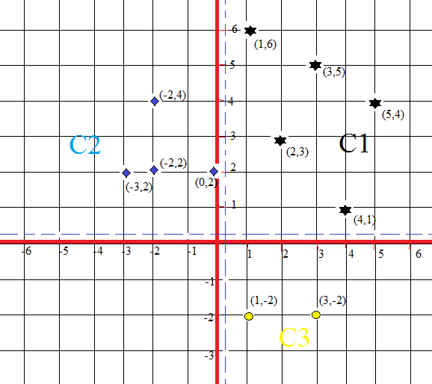

1. Add the sample (-1,6) to class C1. Repeat part (a).

Solution: No, they are not separable using a single layer perceptron! It would be difficult to separate the classes using a single-layer perceptron!

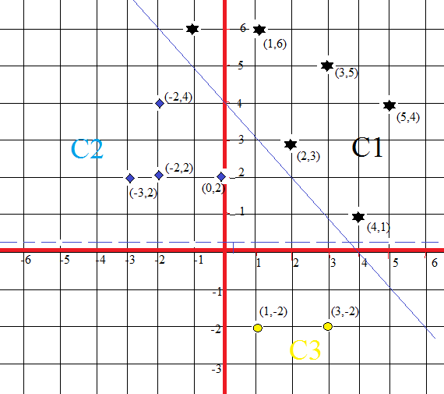

1. Problem 1.3 (a), Page 67. Please solve for the weights and bias.
2. **Python programming**: Problem 1.6, Page 67. You can use the Python source code demonstrated in class, but please change all the outputs from (1,-1) to (1,0). Just submit your results (figures and weights), not need to print the entire Python source code.