Celebrity Face Recognition Using ResNet, Xception, and DenseNet

Abstract
This project explores and compares three popular deep learning architectures—ResNet, Xception, and DenseNet—for the task of celebrity face recognition. The evaluation includes accuracy, recall, precision, F1-score, and ROC-AUC metrics. ResNet was implemented from scratch, while Xception and DenseNet were employed using transfer learning. Results highlight the strengths and weaknesses of each model, offering insights into their performance on the dataset.

Introduction
Face recognition is a critical application in modern artificial intelligence, widely used in security, entertainment, and social media. This project evaluates three state-of-the-art deep learning architectures: ResNet, Xception, and DenseNet. By investigating their performance on celebrity face recognition, we aim to analyze the suitability of each model for the dataset and task.

Analysis
- The dataset comprises celebrity face images from the Celebrity Face Recognition Dataset In Kaggle (In References).
- Preprocessing steps included resizing, normalization, and augmentation.
- Data split: Training, validation, and test sets.

Architectures

ResNet-50
Architecture: ResNet-50 is a convolutional neural network (CNN) based on the concept of residual learning. It employs residual blocks, which allow for the training of extremely deep networks. Each residual block consists of a series of convolutional layers and shortcut connections that enable the network to learn residual functions. This architecture helps alleviate the vanishing gradient problem, allowing for the training of very deep networks.

Key Features:
Residual blocks: These blocks allow for efficient training of deep networks.
Skip connections: These connections enable information to flow directly from earlier layers to later layers.
50 layers: This depth allows for the extraction of complex features from images.

Xception
Architecture: Xception is a deep convolutional neural network that extends the Inception architecture. It replaces the traditional Inception modules with depthwise separable convolutions, which decompose a standard convolution into a depthwise convolution and a pointwise convolution. This approach significantly reduces the number of parameters and computational cost while maintaining accuracy.

Key Features:
Depthwise separable convolutions: These convolutions reduce the number of parameters and computational cost.
Extreme depth: The network has a large number of layers, allowing for the extraction of complex features.
Efficient architecture: The network is designed to be efficient in terms of both memory and computation.

DenseNet
Architecture: DenseNet is a convolutional neural network that connects each layer to every other layer in a feed-forward fashion. This dense connectivity pattern encourages feature reuse and promotes feature propagation throughout the network. DenseNet also uses feature maps of fixed size throughout the network, which helps to reduce the number of parameters and computational cost.

Key Features:
Dense connectivity: Each layer is connected to every other layer in a feed-forward fashion.
Feature reuse: Features extracted in earlier layers are reused in later layers.
Efficient parameter usage: The network uses fewer parameters than other deep networks.

Implementation

ResNet:
Input Layer
Accepts input images of shape (100, 100, 3) (height, width, channels).
Initial Convolution and Pooling
- A Conv2D layer with 64 filters, kernel size 10x10, strides 2x2, and same padding.
- A BatchNormalization layer normalizes the output.
- A ReLU activation function introduces non-linearity.
- A MaxPooling2D layer reduces the spatial dimensions by pooling regions of size 3x3 with strides 2x2.
Residual Blocks

The model uses stacked residual blocks to learn hierarchical representations.
Each block consists of two Conv2D layers with batch normalization and ReLU activation. Skip connections add the input to the output of the convolutional layers.
Downsampling (using strides) is applied when the number of filters increases to reduce the spatial dimensions.
Specific stages:
- Stage 1: Three residual blocks with 64 filters.
- Stage 2: One residual block with 128 filters and downsampling, followed by three residual blocks with 128 filters.
- Stage 3: One residual block with 256 filters and downsampling, followed by five residual blocks with 256 filters.
- Stage 4: One residual block with 512 filters and downsampling, followed by two residual blocks with 512 filters.

Global Average Pooling
A GlobalAveragePooling2D layer reduces each feature map to a single value, summarizing its information.
Dropout
A Dropout layer with a rate of 0.2 reduces overfitting.
Output Layer
A dense layer with num_classes units (softmax activation) outputs the class probabilities.

Model Regularization
- Weight Decay: Applied via kernel_regularizer in the convolutional layers to prevent overfitting.
- Dropout Layer: Introduced before the final output.

Training Configuration
- Loss Function: Likely categorical cross-entropy (not explicitly mentioned but assumed due to softmax activation).
- Optimizer: Not mentioned but typically an adaptive optimizer like Adam or SGD is used.
- Callbacks:
  - EarlyStopping: Monitors validation loss and stops training if it doesn't improve for 10 consecutive epochs.
  - ReduceLROnPlateau: Reduces the learning rate by a factor of 0.5 if the validation loss plateaus for 5 epochs.

Xception:
The model architecture is based on the Xception convolutional neural network, which is a deep CNN model pre-trained on ImageNet. Here's a detailed breakdown of the architecture and the added custom layers:
Input Shape: (128, 128, 3)Weights: Pre-trained on ImageNet (weights='imagenet') or custom weights (weights=weights_x).Include Top: False (The fully connected layers used for ImageNet classification are excluded.)Trainable Parameters: All layers of the base model are frozen (layer.trainable = False), so only the custom layers are trained.Custom Classification HeadGlobalAveragePooling2D:Replaces fully connected layers.Reduces the spatial dimensions (4D tensor) of the base model's output to a single vector per feature map.Dense Layer:Units: 512Activation: ReLUAdds a fully connected layer with 512 neurons.Dropout Layer:Rate: 0.5Randomly drops 50% of the neurons during training to prevent overfitting.Output Layer:Units: len(np.unique(y_train)) (number of unique classes, up to 55 based on the dataset.)Activation: softmaxOutputs class probabilities for multi-class classification.CompilationOptimizer: Adam with a learning rate of 0.0001.Loss Function: sparse_categorical_crossentropy (suitable for multi-class classification with integer labels).Metrics: accuracy.Training DetailsData Augmentation: Augments training images with random transformations (rotation, zoom, flips, etc.).Batch Size: 32.Epochs: 150.Validation Data: A stratified 20% split of the dataset.

Dense:Pre-trained Backbone: The model uses DenseNet121 from the Keras applications module as the feature extractor.Weights: Pre-trained on the ImageNet dataset.Input Shape: (128, 128, 3) (resized input images).Top Layers Excluded: include_top=False ensures the fully connected layers of DenseNet121 are not included.Trainability: All layers of the base model are frozen, meaning their weights are not updated during training to leverage the pre-trained features and avoid overfitting.Custom Classification HeadThis custom head is added on top of the DenseNet121 base model:Global Average Pooling: A GlobalAveragePooling2D layer reduces the spatial dimensions of the output feature map to a single vector per feature channel.Output Shape: (Batch size, feature vector length).Fully Connected Layer:Units: 512 neurons.Activation: ReLU.Dropout Layer:Rate: 50% dropout to reduce overfitting.Output Layer:Units: Equal to the number of unique classes in the dataset (inferred dynamically using np.unique(y_train)).Activation: Softmax, for multi-class classification.Training ConfigurationLoss Function: sparse_categorical_crossentropy is used because the labels are provided as integers, not one-hot encoded vectors.Optimizer: Adam with a learning rate of 0.0001.Metrics: Accuracy to track model performance.Data Augmentation:Random rotations, shifts, shears, zooms, and horizontal flips to increase data diversity.Training ParametersEpochs: 150.Batch Size: 32.Validation Split: 20% of the dataset (stratified by label).Data Generators:Augmented training data using ImageDataGenerator.Validation data passed as-is.

Evaluation Metrics
The models were evaluated based on:
- Accuracy: Percentage of correctly classified samples.
- Precision: Measure of the relevance of positive predictions.
- Recall: Ability to identify all relevant samples.
- F1-Score: Harmonic mean of precision and recall.
- ROC-AUC: Area under the Receiver Operating Characteristic curve.

Results
The following metrics were compared:
Model | Accuracy | Precision | Recall | F1-Score
ResNet | 47% | 0.61 | 0.48 | 0.47
Xception | 35% | 0.36 | 0.35 | 0.34
DenseNet | 41% | 0.42 | 0.41 | 0.40

Percision,Recal,F1-Score Graphs:

ResNet: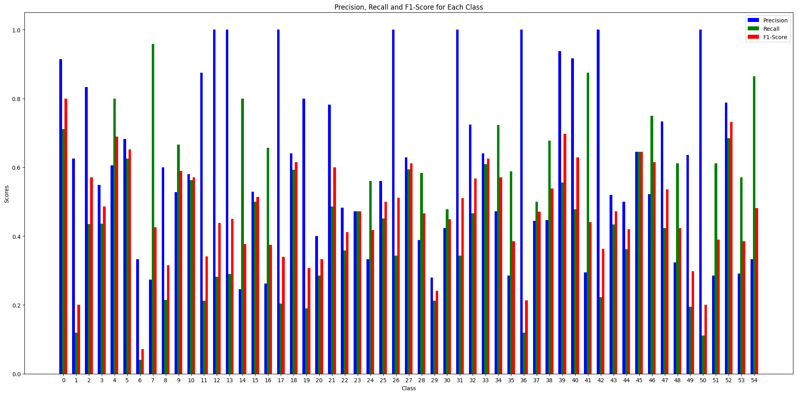
Xception: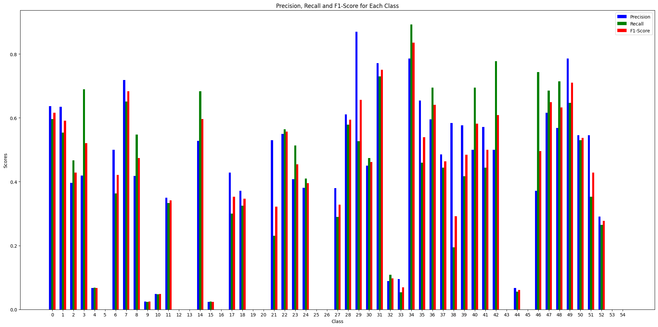

Dense: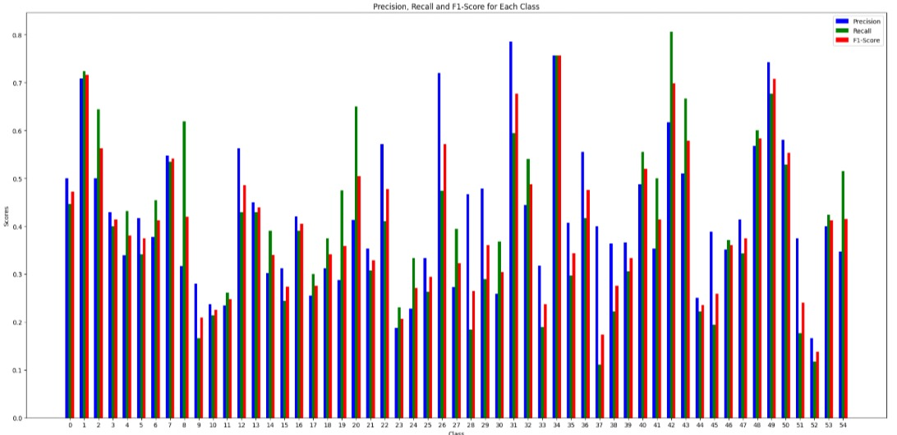

ROC:

ResNet: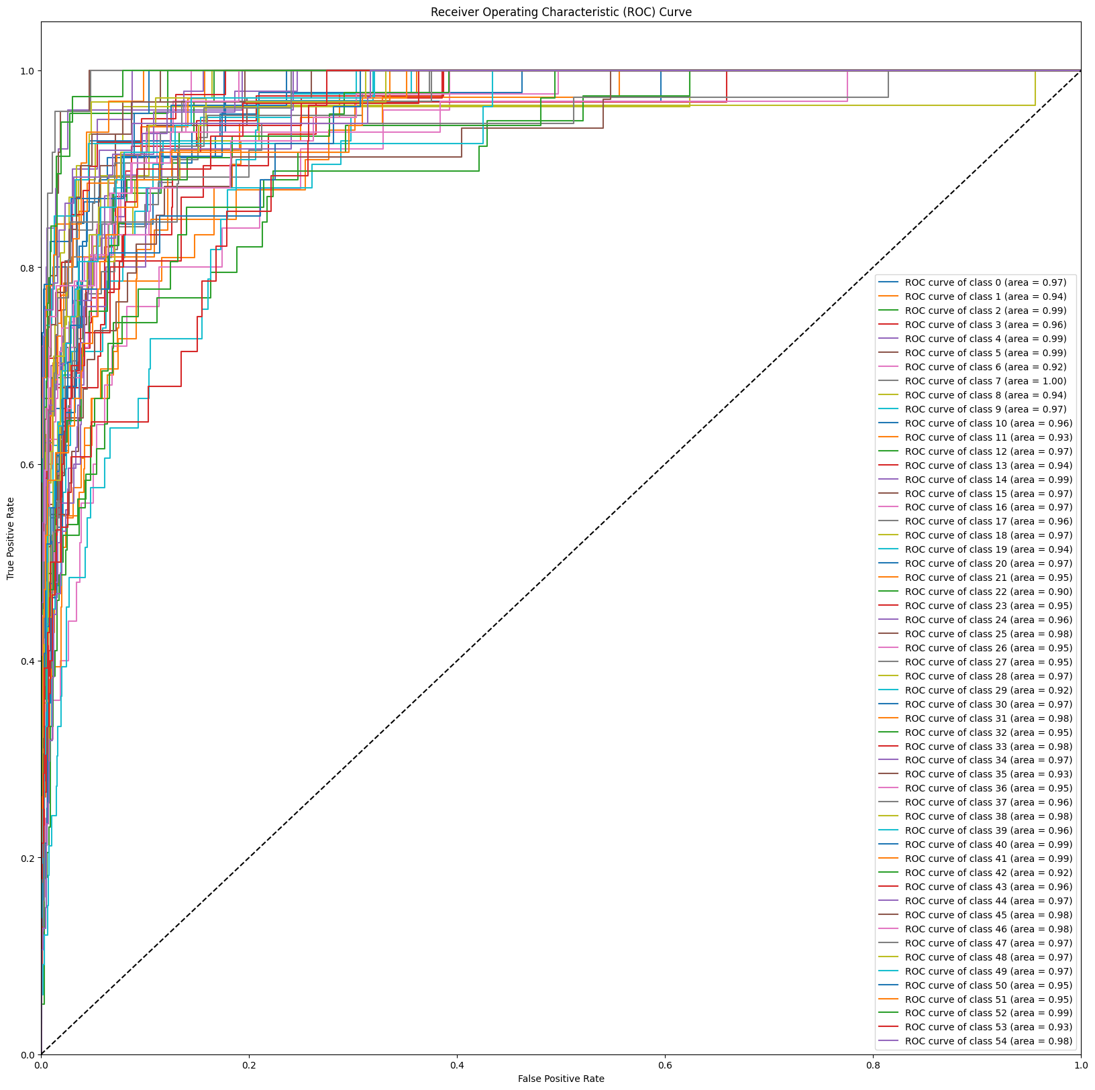

Xception: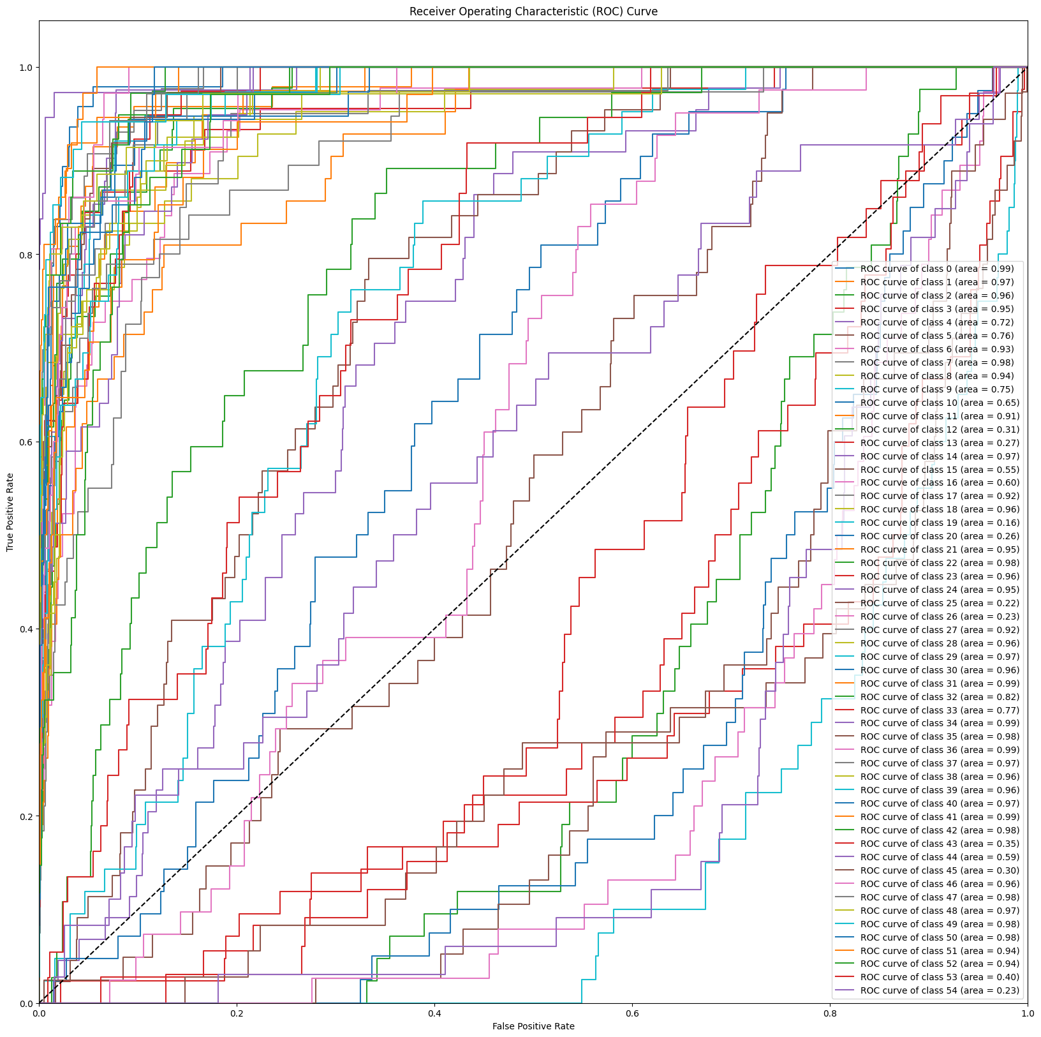

Dense: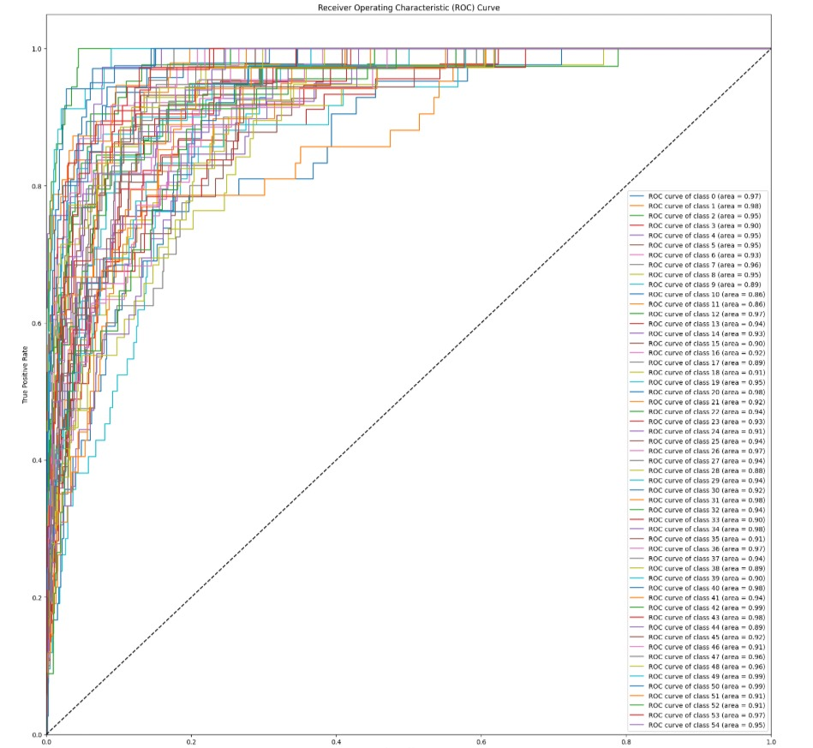

AUC:

ResNet: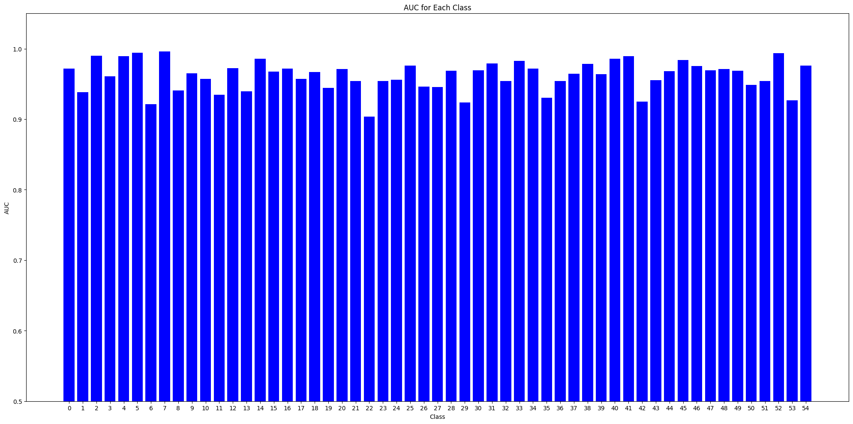

Xception:
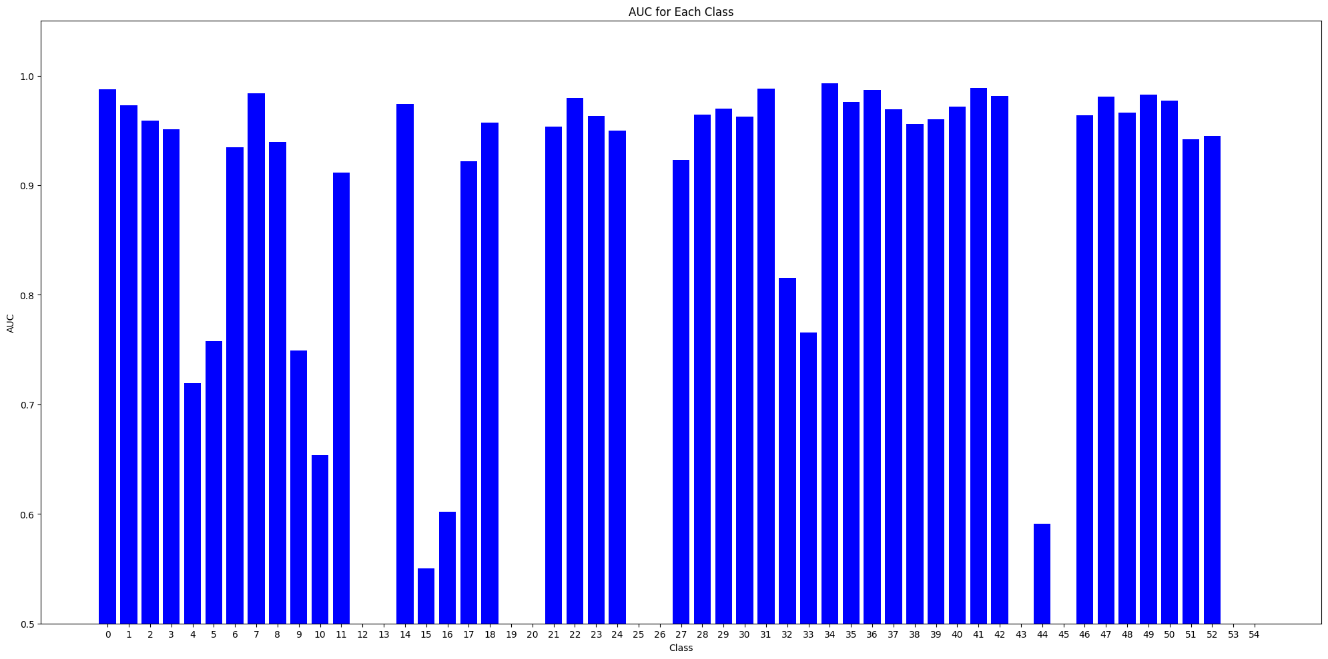
Dense: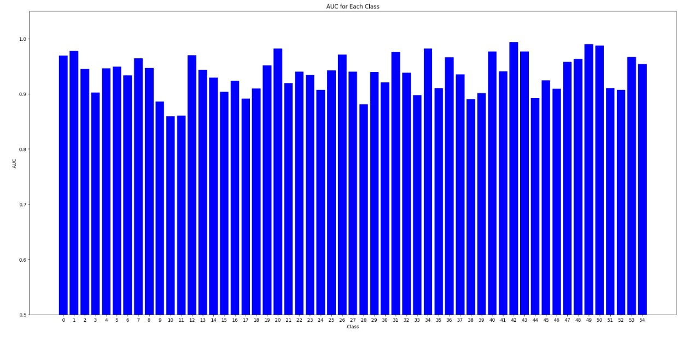

Comparative Analysis
ResNet:
Pros: Solves vanishing gradient problems, robust for deep networks.
Cons: High computational cost.

Xception:
Pros: Computationally efficient, excels in large-scale image tasks.
Cons: May overfit on small datasets.

DenseNet:
Pros: Promotes feature reuse, efficient gradient flow.
Cons: Memory-intensive due to dense connections.

Observations
Dataset size and quality significantly affect performance.
Resource availability, including hardware such as GPUs/TPUs, memory capacity, and storage, as well as dataset size and preprocessing time, significantly influences model training and evaluation times. For instance, DenseNet’s memory-intensive architecture required higher GPU capacity, while ResNet from scratch demanded extensive training time due to its deep layers and lack of pre-trained weights.

Conclusion
This project demonstrates the comparative strengths and weaknesses of ResNet, Xception, and DenseNet architectures for celebrity face recognition. Based on the evaluation metrics, ResNet demonstrated strong performance for deeper networks but required extensive training resources. Xception excelled in computational efficiency and handled large-scale data effectively, while DenseNet stood out for feature reuse and gradient flow. These findings highlight that architecture selection should consider not only performance metrics but also resource constraints and dataset characteristics.

References
- Celebrity Face Recognition Dataset : https://www.kaggle.com/code/vinayakshanawad/celebrity-face-recognition-vggface-model/input?select=105_classes_pins_dataset

- Understanding and Coding a ResNet :https://towardsdatascience.com/understanding-and-coding-a-resnet-in-keras-446d7ff84d33

- Chollet, F. (2017). Xception: Deep Learning with Depthwise Separable Convolutions. arXiv preprint arXiv:1610.02357.

- Huang, G., Liu, Z., Van Der Maaten, L., & Weinberger, K. Q. (2017). Densely Connected Convolutional Networks. arXiv preprint arXiv:1608.06993.

