Strain panel subsampling

In this document, I’ll do a brief writeup of everything that I’ve gotten done since the last time we worked on this project (covering the last four sets of lab notes).

# Partial pooling test

The first writeup was a proof-of-concept draft to test the idea of multilevel modeling for this problem. We ran into an issue with Amanda’s project of trying to combine standard errors across multiple models and decided that a partial pooling approach would be best so of course we had to switch to a Bayesian framework. This document

1. Writes out simple mathematical models for partial pooling;
2. Demonstrates how to fit these Bayesian models to the data; and
3. Compares the three models to each other. All three estimates of the mean were somewhat similar, although the estimates for the no pooling model were clearly more affected by outliers than the other two models. The estimates of the mean were quite similar between the partial pooling and the complete pooling models, although the partial pooling model provides a fair assessment of the variance across individuals, while the complete pooling model has false confidence in its estimate.

|  |
| --- |
| Results from the three model tests on a specific season. |

We decided to use the partial pooling model going forward. We briefly discussed whether to make the model more complicated (by e.g., allowing for correlations between the slope and intercept parameters), but decided that we probably do not need to do that at this point. The simple partial pooling model is good enough for us to make our point.

# Partial pooling across seasons

Next we discussed whether our results should be calculated per-vaccine strain or per-season, pooling all applicable seasons together. At this time, we concluded that the per-strain analysis was fine, but **as of our most recent dissusions in May, 2023**, we now think that pooling across seasons is likely a bad idea, partially inspired by the Skowronski paper that discussed heterogeneity across seasons. Fortunately this change is not that impactful and only affects a few of the analyses, since the strains tended to change frequently. This affects the influenza B analyses more, which we have also decided not to focus on yet (the influenza B analyses can likely be a separate paper).

In this writeup, I also walk through the housekeeping steps of batch loading models and dealing with the marginal predictions. One of the main issues we encountered was having to compile the same model multiple times which is clearly very inefficient and leads to a lot of wasted computational time. On future projects where we need to fit many Bayesian models, **it will not be feasible to use the rethinking package.** We will likely need to switch to invoking rstan or cmdstanr commands directly, after potentially using brms or rethinking to build initial template Stan code. If brms has an option to pre-compile models we might be able to use that as well, but another major problem with brms is that none of us seem to know what it is doing.

# Compiled Model Test

In this document, I work through the code for implementing the pre-compiled models using a combination of rstan and cmdstanr. Eventually this needs to be converted to only using cmdstanr, it just uses rstan right now because it depends on Richard McElreath’s code from rethinking, which only deals with rstan objects.

# Panel Subsampling

IN this document, I started working on what I call the “panel subsampling” experiment. Our hypothesis is that in some way, our magnitude, breadth, and strength metrics are more robust than the commonly used metrics, which are percent of strains seroconverted to and GMT or geometric mean titer increase.

However, this was not the case. In my test analysis (see the document for details).

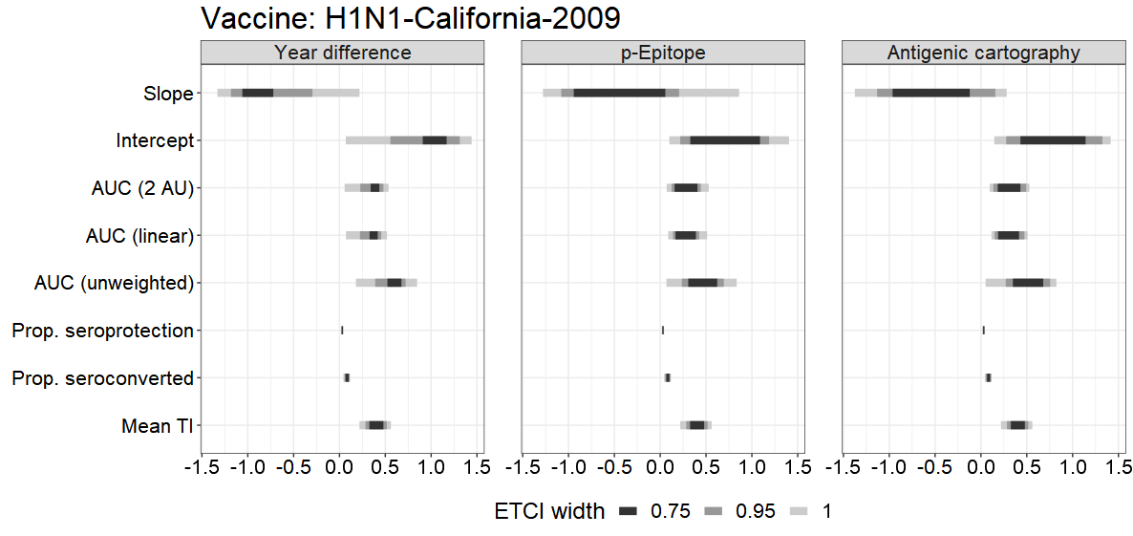

What we need to do now is:

1. determine how we want to run the simulations (since they are computationally intensive);
2. think about why our results look so bad and how we can remedy them;
3. think about how we should look at the simulation results in order to better understand what is going on here; and
4. figure out why it looked good for Amanda’s results but not for mine and what I am doing differently.