Generative simulations for HAI as a function of distance

Zane

2023-05-30

# Basic simulation

First we will attempt to simulate raw titer data, without including antigenic distance in the simulation. The outcome we want this simulation to produce is a semi-realistic distribution of titer values with support on the observed measurement space. We adopt the following model, where $y_{i}$ is the $i$ th individual’s measured titer.

$$\begin{matrix}\log_{2}y_{i} & ∼N\left(μ,σ^{2}\right) \\ y_{i}^{*} & =\left\{\begin{matrix}5 & \log_{2}y_{i}<1 \\ 5⋅⌊2^{y_{i}}⌋ & \log_{2}y_{i}≥1\end{matrix}\right.\end{matrix}$$

We adopt the transformation

$$g\left(y\right)=5⋅2^{y_{i}}$$

because the physical limit of detection (LoD) of the HAI assay is

$$10=5⋅2^{1}$$

and values below this threshold are, by convention, recorded as $5$. So we know those values are below the LoD, but not what the values are. The distributional parameters $μ$, the mean, and $σ^{2}$, the variance, are unknown to us practically and must be estimated from the data.

one_titer_sim <- function(N = 1e4, seed = 370, mean = 3, sd = 1) {  
 set.seed(seed)  
 sim <-  
 tibble::tibble(  
 # Assume log(titer) is drawn from a normal distribution  
 raw_log_titer = rnorm(N, mean, sd),  
 # If we observe a titer with log(titer) < 1 (LOD), mark it as 0  
 trunc_log_titer = ifelse(raw_log_titer >= 1, raw_log_titer, 0),  
 # The assay is dilution based, so we only observe the floor of each  
 # value.  
 rounded_titer = floor(trunc_log_titer),  
 # Now final observed titer is equal to this transformation.  
 sim_titer = 5 * 2 ^ rounded_titer  
 ) |>  
 dplyr::arrange(raw_log_titer)  
}  
  
out <- one_titer_sim(1000, mean = 4, sd = 2)  
#plot(out$raw_log_titer, out$trunc_log_titer)  
#points(out$raw_log_titer, out$rounded_titer, col = "blue")  
barplot(table(out$sim_titer))

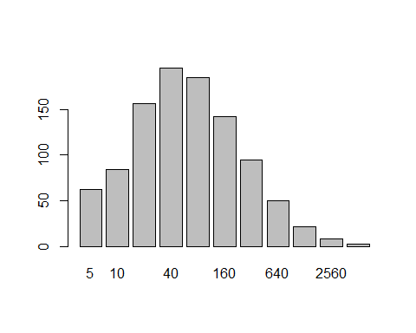

In the above plot, you can see the result of 1000 simulations, where $mu=4$ and $σ^{2}=4$. (Note that the simulation is parametrized in terms of the standard deviation, $σ=+\sqrt{σ^{2}}$.) Notably, while the mean was specified as $4$ (an observed titer of $80$), the mode of the distribution is at $40$ instead.

We can also notice that the observed mean is biased, estimated at $3.61$ on the scale of $y_{i}$ in the above model ( $61.05$ on the observed measurement scale). A [stackexchange post](https://math.stackexchange.com/questions/3662314/statistics-of-a-gaussian-random-variable-with-the-floor-function-transformation) suggested that as long as $sigma^{2}$ is “not small” (suggested as [here](https://mathematica.stackexchange.com/questions/278040/finding-the-mean-and-variance-of-a-distribution/278164#278164)) suggests that $μ−\frac{1}{2}$ is a good approximation to the mean of the transformed random variable (on the log scale), which is close to what we observed.

I guess that this is probably somehow related to a Poisson distribution, but I don’t know or care enough to think more deeply about that.

# Including antigenic distance

We can introduce the antigenic distance into this simple model by taking

$$μ=f\left(d\right)$$

for some function $f$. For the sake of simplicity, we assume that $μ$ is **linearly dependent on distance**. Our model then becomes

$$\begin{matrix}y_{i}^{*} & =\left\{\begin{matrix}5 & \log_{2}y_{i}<1 \\ 5⋅⌊2^{y_{i}}⌋ & \log_{2}y_{i}≥1\end{matrix}\right. \\ \log_{2}y_{i} & ∼N\left(μ,σ^{2}\right) \\ μ & =α+β⋅d\end{matrix}$$

where $d∈\left[0,1\right]$. Under this model, $α$ represents the expected titer value when $d=0$, which corresponds to the response to the homologous vaccine strain in real life. The slope, $β$, should be negative, and thus represents the rate at which expected titers should decrease as strains become more distant. Furthermore, we can note that

$$E\left[y∣x=1\right]−E\left[y∣x=0\right]=μ\left(1\right)−μ\left(0\right)=β.$$

Thus, since $d∈\left[0,1\right]$ we can interpret $β$ as the difference between the expected titer for a completely novel strain and the expected titer for the homologous strain. Imposing the condition that $μ=0$ when $d=1$ is thus equivalent to specifying that $α+β=0$. This would be a standard regression problem with linear constraints with an analytic maximum likelihood solution if the true $y_{i}$ values were observed.

Anyways, as an example, consider the situation when $α=4$ and $β=−3$. For now, we leave the standard deviation as $2$, as in the previous simulation.

set.seed(100)  
ex_dist_sim <-  
 tibble::tibble(  
 d = seq(0, 1, 0.1),  
 mu = 4 - 3 * d  
 ) |>  
 dplyr::mutate(  
 sim = purrr::map(mu, \(x) one_titer_sim(1000, mean = x, sd = 2))  
 )  
  
library(ggplot2)  
plt <- ex_dist_sim |>  
 tidyr::unnest(sim) |>  
 dplyr::mutate(  
 sim_titer = factor(sim_titer),  
 mu = factor(mu) |> forcats::fct_inorder(),  
 distance = factor(d) |> forcats::fct_inorder()  
 ) |>  
 ggplot() +  
 aes(x = sim_titer) +  
 geom_bar(col = "black", fill = "gray") +  
 facet_wrap(~distance, labeller = "label_both") +  
 labs(  
 x = "Observed titer",  
 y = "Count"  
 ) +  
 zlib::theme_ms() +  
 theme(  
 axis.text.x = element_text(angle = 45),  
 plot.background = element_rect(fill = "white")  
 ) +  
 coord_cartesian(  
 ylim = c(0, 700)  
 )  
  
fn <- here::here("Misc", "Lab-Notes", "06-Generative-Sims", "p01.png")  
ggsave(  
 filename = fn,  
 plot = plt,  
 width = 13,  
 height = 8  
)

knitr::include_graphics(fn)

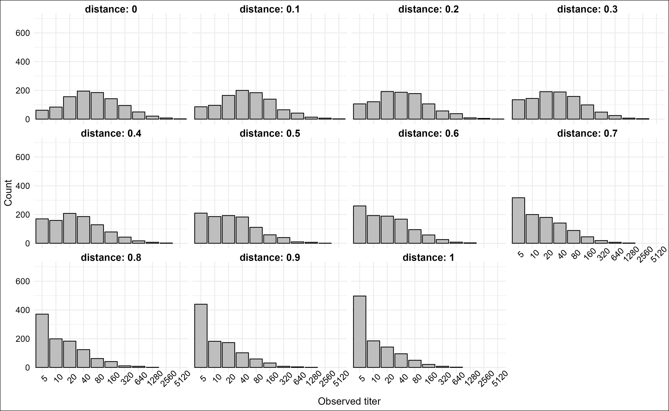

We can also do a more extreme example where we assume $\left|β\right|>α,$ which will cause the titers to decay towards the limit of detection rapidly.

set.seed(100)  
ex_dist_sim <-  
 tibble::tibble(  
 d = seq(0, 1, 0.1),  
 mu = 4 - 6 * d  
 ) |>  
 dplyr::mutate(  
 sim = purrr::map(mu, \(x) one_titer_sim(1000, mean = x, sd = 2))  
 )  
  
plt <- ex_dist_sim |>  
 tidyr::unnest(sim) |>  
 dplyr::mutate(  
 sim_titer = factor(sim_titer),  
 mu = factor(mu) |> forcats::fct_inorder(),  
 distance = factor(d) |> forcats::fct_inorder()  
 ) |>  
 ggplot() +  
 aes(x = sim_titer) +  
 geom_bar(col = "black", fill = "gray") +  
 facet_wrap(~distance, labeller = "label_both") +  
 labs(  
 x = "Observed titer",  
 y = "Count"  
 ) +  
 zlib::theme_ms() +  
 theme(  
 axis.text.x = element_text(angle = 45),  
 plot.background = element_rect(fill = "white")  
 ) +  
 coord_cartesian(  
 ylim = c(0, 700)  
 )  
  
fn <- here::here("Misc", "Lab-Notes", "06-Generative-Sims", "p02.png")  
ggsave(  
 filename = fn,  
 plot = plt,  
 width = 13,  
 height = 8  
)

knitr::include_graphics(fn)

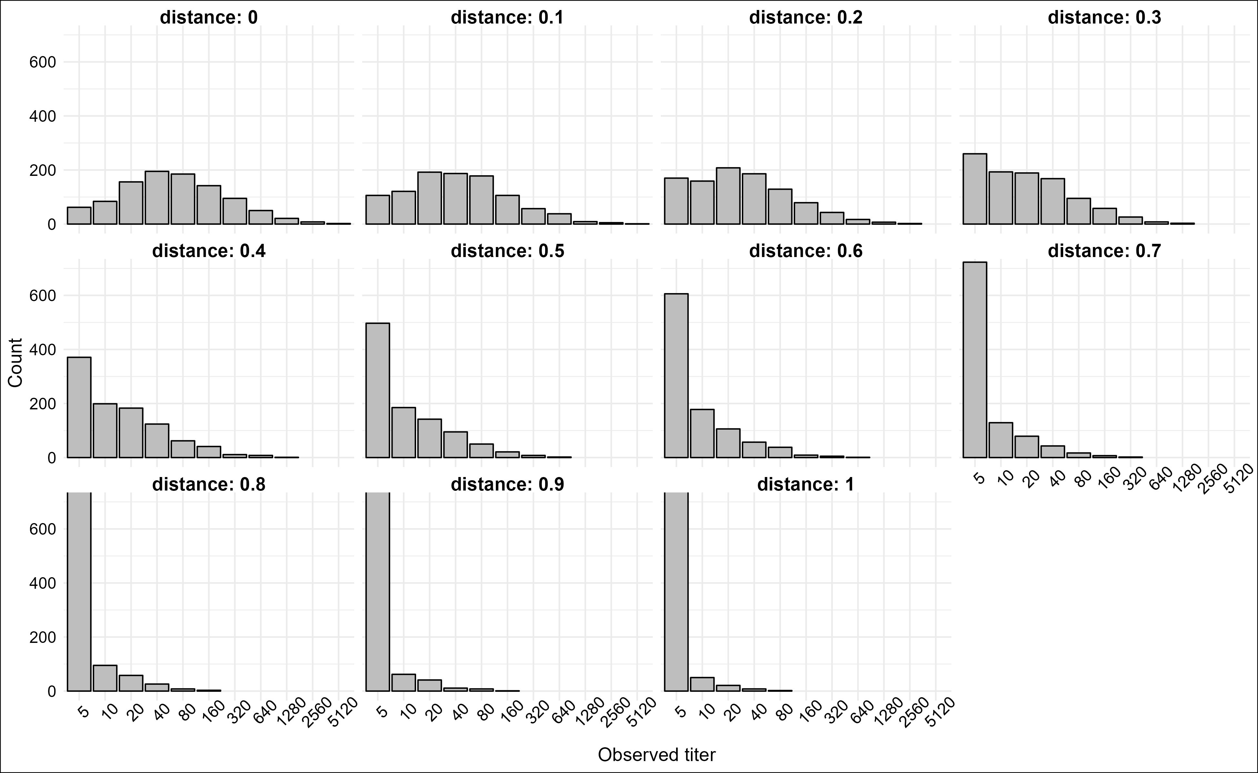

# TODO

* Fit our bayesian model (doesn’t need to be partial pooling right now) to see if we recover parameters.
* Introduce noise to the model and see when parameters are recovered and how noise changes the estimates.
* Calculate the suite of metrics from the model fit under varying levels of noise and parameters and see how much the metrics vary under different settings.
* Need to discuss with Andreas what exactly to do next.

# Individual variations in the mean

Allow

$$\begin{matrix}y_{i}^{*} & =\left\{\begin{matrix}5 & \log_{2}y_{i}<1 \\ 5⋅⌊2^{y_{i}}⌋ & \log_{2}y_{i}≥1\end{matrix}\right. \\ \log_{2}y_{i} & ∼N\left(μ_{i},σ^{2}\right) \\ μ_{i} & =α_{i}+β_{i?}⋅d\end{matrix}$$